5.19 Deploy Angular Application to AWS



This section will guide you to:

* Deploy an Angular application to AWS S3

This guide has mainly two subsections, namely:

5.19.1 Creating a basic Angular application

5.19.2 Deploying the application to AWS S3

**Step 5.19.1:** Creating a basic Angular application

* Install Angular CLI in your local system using the following command in your command line:

**npm install -g @angular/cli**

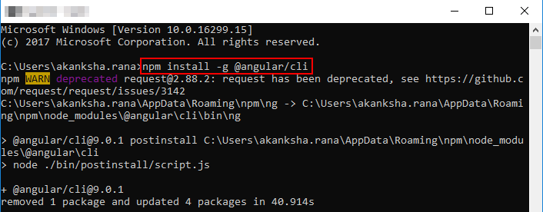

* Create a demo app using the following command:

**ng new the-demo**

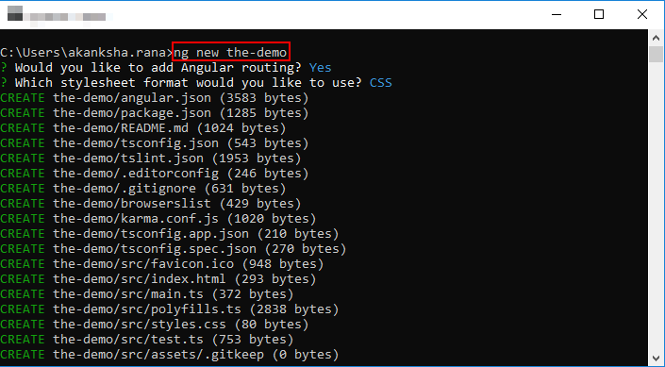

* Use the following command to move into the directory of the demo app:

**cd the-demo**

* Run the demo app using the following command:

**ng serve --open**

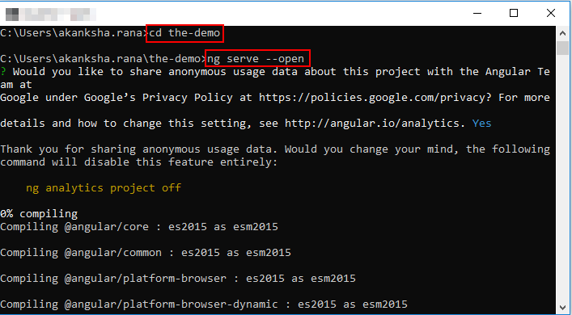

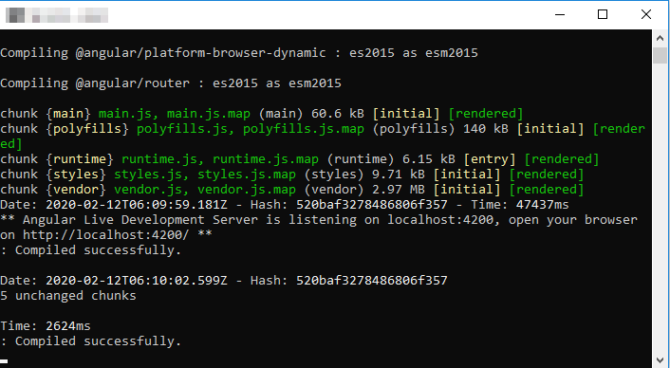

* Open localhost:4200 in your browser. The app should be running as shown in the screenshot below:

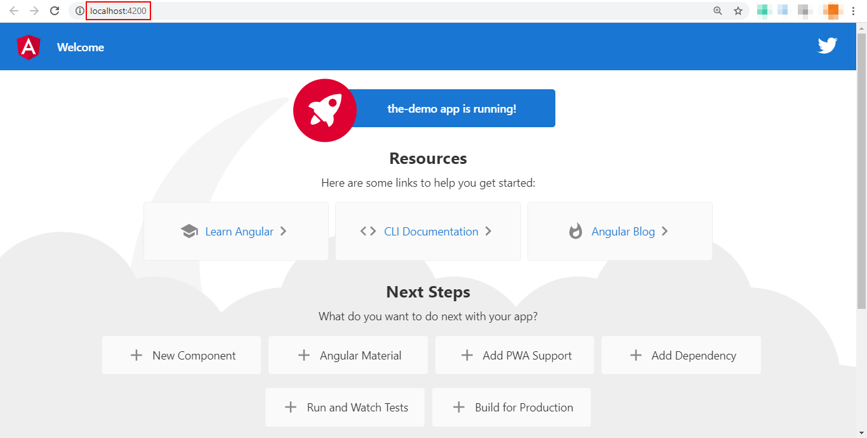

**Step 5.19.2:** Creating a custom Docker image

* Login to the Amazon management console using the credentials given in your practice lab.
* Open S3 dashboard and create a new bucket to deploy the application. Uncheck **Block all public access** checkbox.

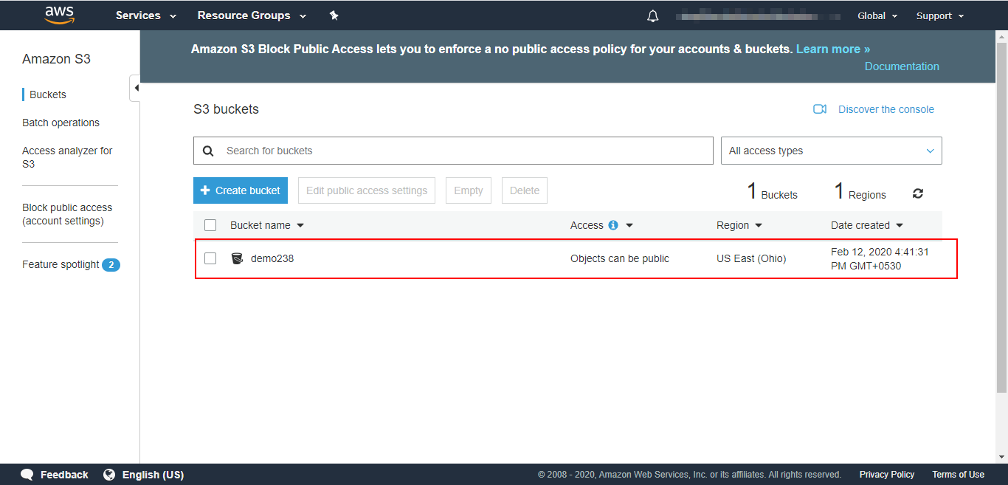

* Go inside the bucket and upload the whole demo app directory that you created in your local system and then click on Next.

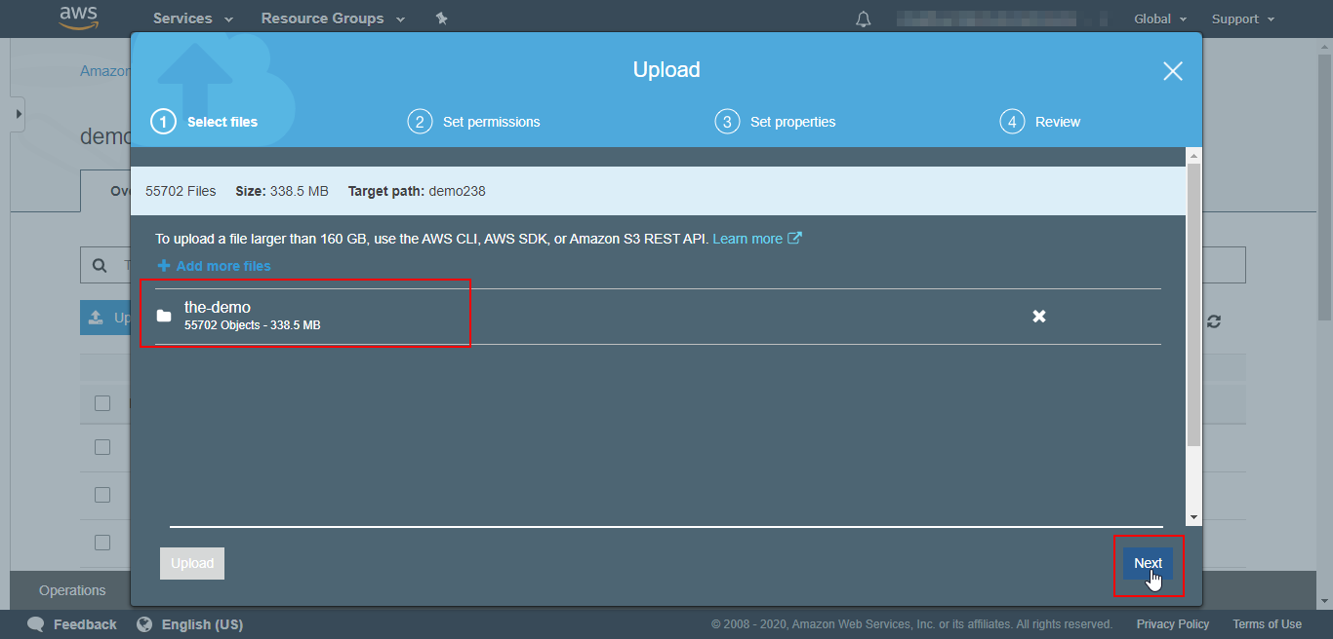

* Grant public access to the files on the next page and click on Next.

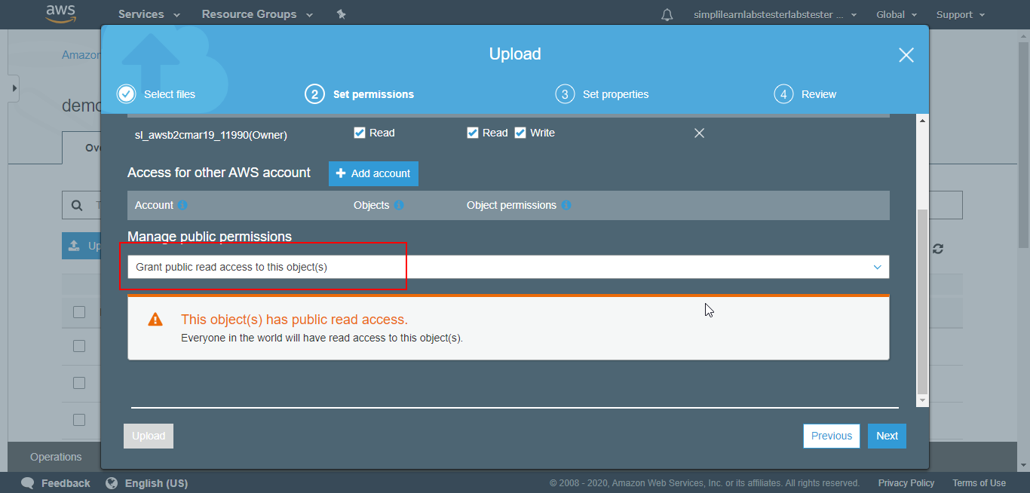

* Click Next through the other options and the folder will be uploaded to the S3 bucket.
* Navigate to the bucket properties and turn on the static website hosting for your bucket.

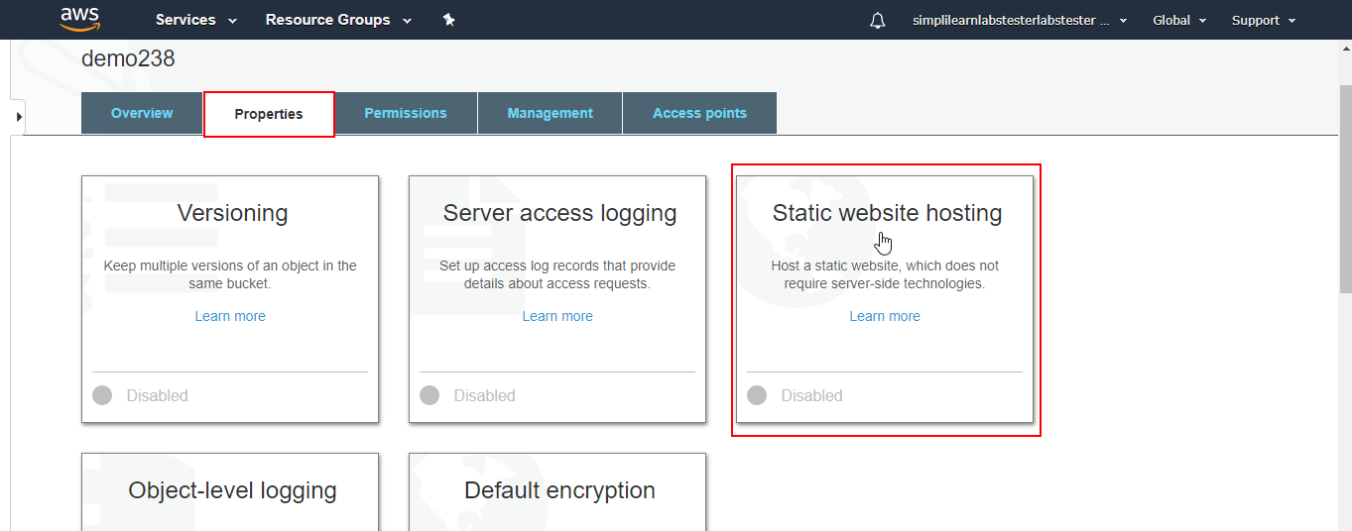

* Provide the name of the entry point of the application. 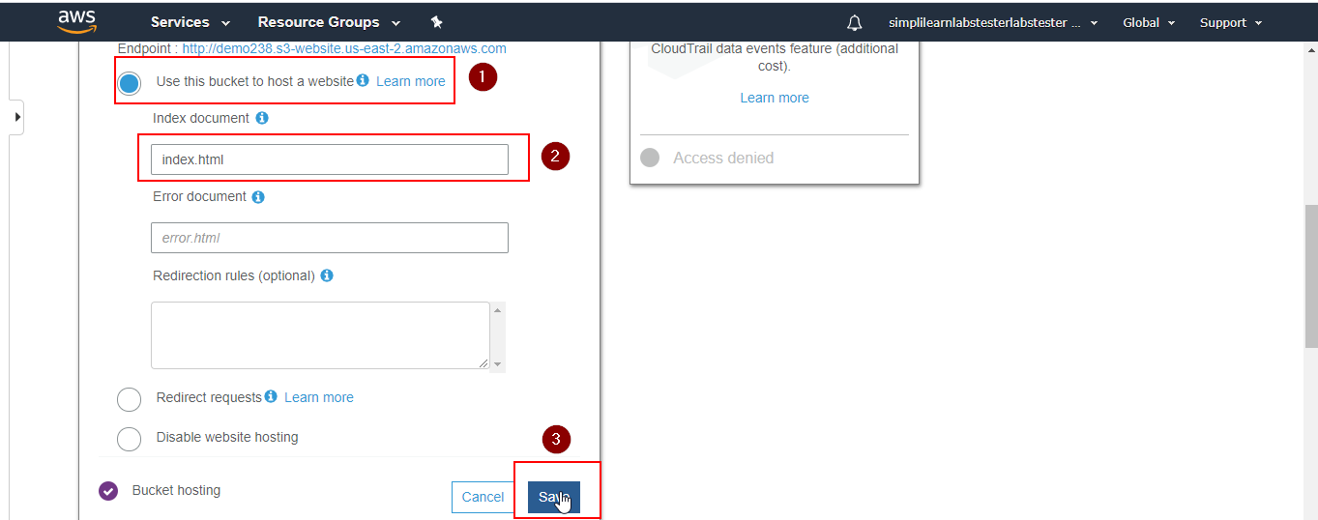
* Navigate to Permissions>Bucket Policy. Copy and Paste the following bucket policy to provide read-only public access to the whole bucket.

**{**

**"Version":"2012-10-17",**

**"Statement":[**

**{**

**"Sid":"PublicRead",**

**"Effect":"Allow",**

**"Principal": "*",**

**"Action":["s3:GetObject"],**

**"Resource":["arn:aws:s3:::examplebucket/*"]**

**}**

**]**

**}**

**Note: Replace the ‘examplebucket’with the name of your bucket.**

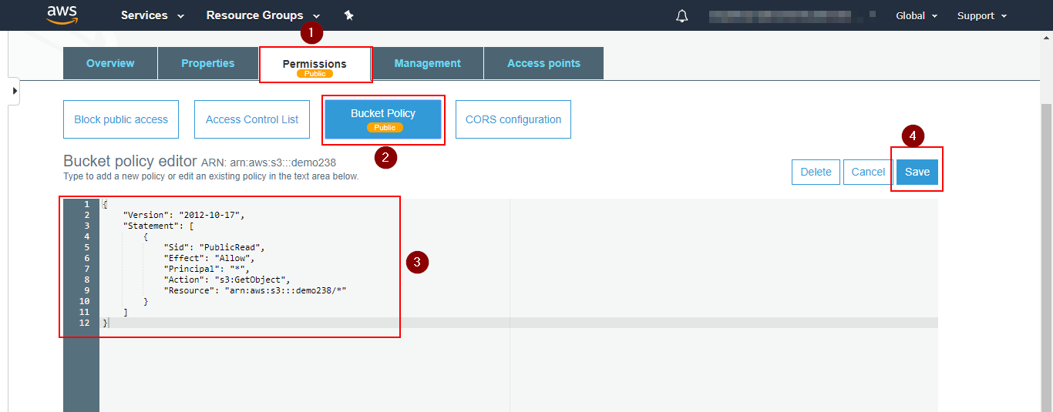

* Copy the endpoint URL from the Static website hosting window and paste it in the browser.

