Forensic Examination Report: USB Drive Investigation
By: Curtis Been
Date: 5/11/2025
Course: CMP_SCI 4700 – Computer Forensics
Client: Dolos Financial Services (via Apex Forensics)
Examiner: Curtis Been

1. Introduction / Background
Dolos Financial Services is a small investment brokerage firm based in St. Louis, Missouri. The firm recently became concerned about the potential unauthorized removal of proprietary data by a former employee, Christopher Gardner, who resigned unexpectedly. While no direct accusations have been made, Gardner's manager, Kurt Aubuchon, noted uncharacteristic behavior from Gardner prior to his departure. A coworker also reported overhearing Gardner on a hushed phone call with someone referred to as “Sharon” or “Cherie,” possibly discussing plans to start a competing financial firm.
Following Gardner’s departure, a 16GB USB flash drive was found in his desk. Although the use of USB drives is generally prohibited at Dolos, enforcement of this policy has been inconsistent. Given the sensitive nature of Dolos' financial and customer data, there is a strong concern that the drive may have been used to exfiltrate confidential information.
Apex Forensics, a private digital investigations firm, was retained to investigate the matter. As a digital forensic examiner at Apex, I was tasked with conducting a full forensic analysis of the USB drive to determine if any proprietary or customer data had been stored on it, and whether there was any evidence of collaboration with internal or external parties.
This report outlines the methodology used to examine the evidence, the findings uncovered, and conclusions regarding potential misuse of Dolos’ confidential data. This report is split into six sections Introduction, Scope, Chain of Custody, findings, conclusions, and appendices.

2. Scope of Investigation

A USB drive image was examined. This Image was formatted in NTFS exFAT format.The Image file was 14.6 Gigabytes. I used Autopsy to mount and Analyze the USB image. This image contained files that I then examined thoroughly.

3. Evidence Handling & Chain of Custody

The USB Image drive was obtained from A USB Drive belonging to Chris Gardener. The Image was then transferred to me. I then mounted the image into Autopsy to analyse the data.

Date | Action
05/07/2025 | Received USB image file and verified its hash to ensure integrity.
05/08/2025 | Opened the image in Autopsy using read-only mode.
05/08/2025 | Identified and reviewed files and metadata on the drive.
05/09/2025 | Extracted and documented relevant evidence, including sensitive files.
05/10/2025 | Took screenshots and began compiling final forensic report.
05/11/2025 | Completed and submitted report to Apex Forensics and Dolos Financial.

4. Findings

A. Directory & File Structure Overview
On inspection via Autopsy some metadata was flagged . There were also deleted “orphanfiles” however these files did not on first inspection contain any relevant data.

B. Recovered or Deleted Files
Meta data for files that where deleted from the USB where recovered. The details of this data are reviewed further in section C.

C. Document Metadata and Content Review
During my metadata analysis of files located on the USB drive (image.001), several sensitive/proprietary documents were identified. Each of these four documents contained financial or investment-related information specific to Dolos Financial Services, and each was marked “CONFIDENTIAL” or “NOT FOR EXTERNAL DISTRIBUTION”. This suggests that these files where not meant to be shared or downloaded onto an external USB.
Key Documents Identified:
File Name | Program Type | Created | Modified | Notable Content
Investment Analysis Report William Busch.docx | Microsoft Word | 2017-06-30 21:39 CDT | 2017-06-30 21:39 CDT | Internal financial analysis. Proprietary and confidential label.
financial_history_and_ratios.xls | Microsoft Excel | 2017-06-30 20:50 CDT | 2017-06-30 20:51 CDT | Detailed financial metrics and customer asset data.
Dolos_stock_analysis_spreadsheet.xlsx | Microsoft Excel | 2017-06-30 20:40 CDT | 2017-06-30 20:41 CDT | Document contains investment insights, links to Smartstockresearch.com, and notes referencing Morningstar.
ADV_SBD_CurrentReport_InvestmentAnalysis.docx | Microsoft Word | 2017-06-30 21:29 CDT | 2017-06-30 21:29 CDT | Authored by Christopher Gardner. Explicitly marked “PROPRIETARY AND CONFIDENTIAL.”
During my autopsy examination of temporary files extracted from the USB image , further corroborating evidence was discovered pointing to the presence of confidential and proprietary financial documents:
1. Document: ADV_SBD_CurrentReport_InvestmentAnalysis.docx
- Located in: /Temp.zip/Temp Files/
- Contents: Includes detailed financial performance analysis such as "Batting Average and Information Ratio", referencing investment benchmarks like a persons ability to beat the markets returns.
2. Document: Investment Analysis Report William Busch.docx
- Contains Embedded Images:
  - A coin/medal image
  - The Dolos Financial Services logo, reinforcing the document's origin.
- Location: /Temp.zip/Temp Files/
- Access Timestamps: Missing or zeroed, suggesting they may have been moved, zipped, or manipulated to strip traces.

This information further strengthens the conclusion that Christopher Grdner downloaded these confidential files onto this USB drive and then tried to hide the traces by hiding details like the times created or altered, and deleting the files. however he filed to get rid of the associated metadata.

Notable Observations:
- The Investment Analysis Report and ADV_SBD Report explicitly identify Christopher Gardner as the author. This links him directly to the files.
- There where not only confidential files with business related data, but also third party links that appeared to be used for research.
- The documents were not only confidential but also appear to contain proprietary investment strategies, financial modeling, and client sector information, making them valuable assets to any competitor.

Risk Implication:
The presence of these documents on an unauthorized USB drive—combined with the authorship attribution to Gardner—strongly indicates potential unauthorized data exfiltration.

D. Keyword Search Results
No relevant keyword Hits for keywords such as Customer, financial, Proprietary , or Sharon
however there where hits for emails in the cache files.

5. Conclusions
In conclusion due to the evidence found such as proprietary files with Chris Gardner's name attached, as well as apparent attempts to hide the data stolen. The files in question had been clearly labeled as “proprietary” or “NOT FOR EXTERNAL DISTRIBUTION”. Some of the files where also stored in a compressed temporary file, pointing to the intent to hide or distribute the data. It appears that this data was attempted to be illegally exfiltrated by Chris Gardner to use for some nefarious purpose. I recommend further investigation into Christopher Gardners communications and Data.

6. Appendices

A. Screenshots
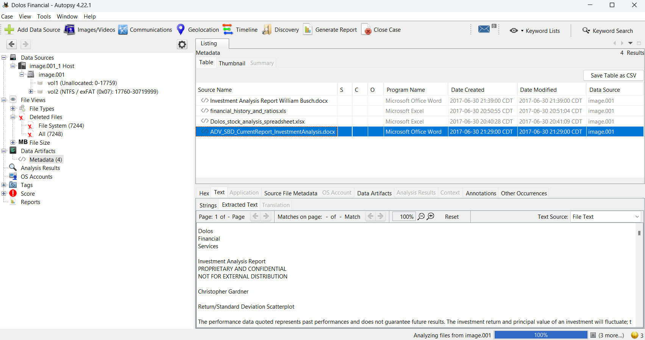

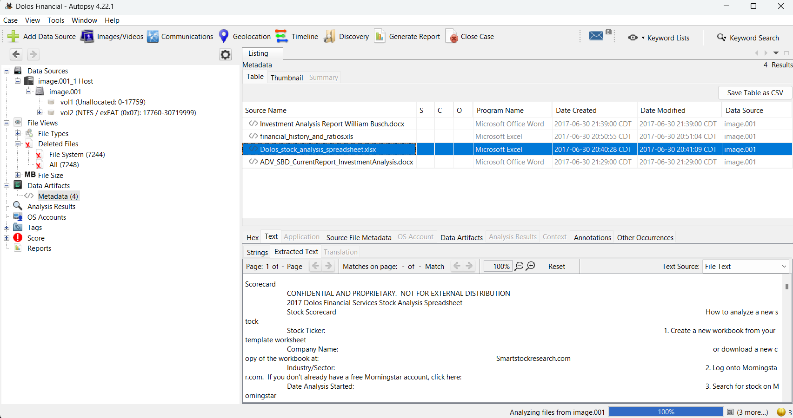
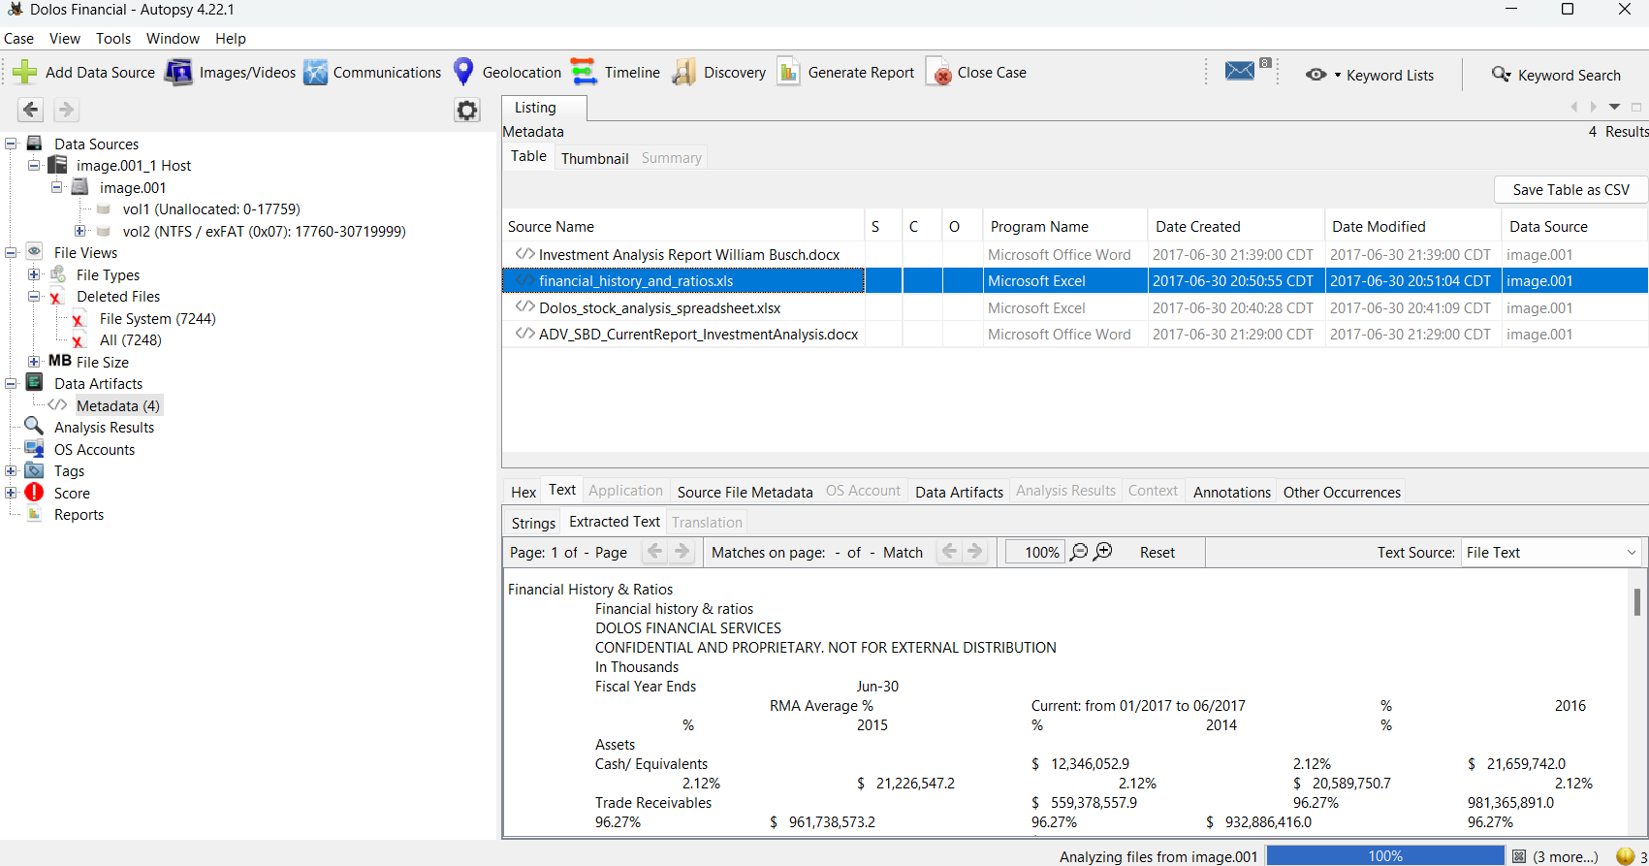
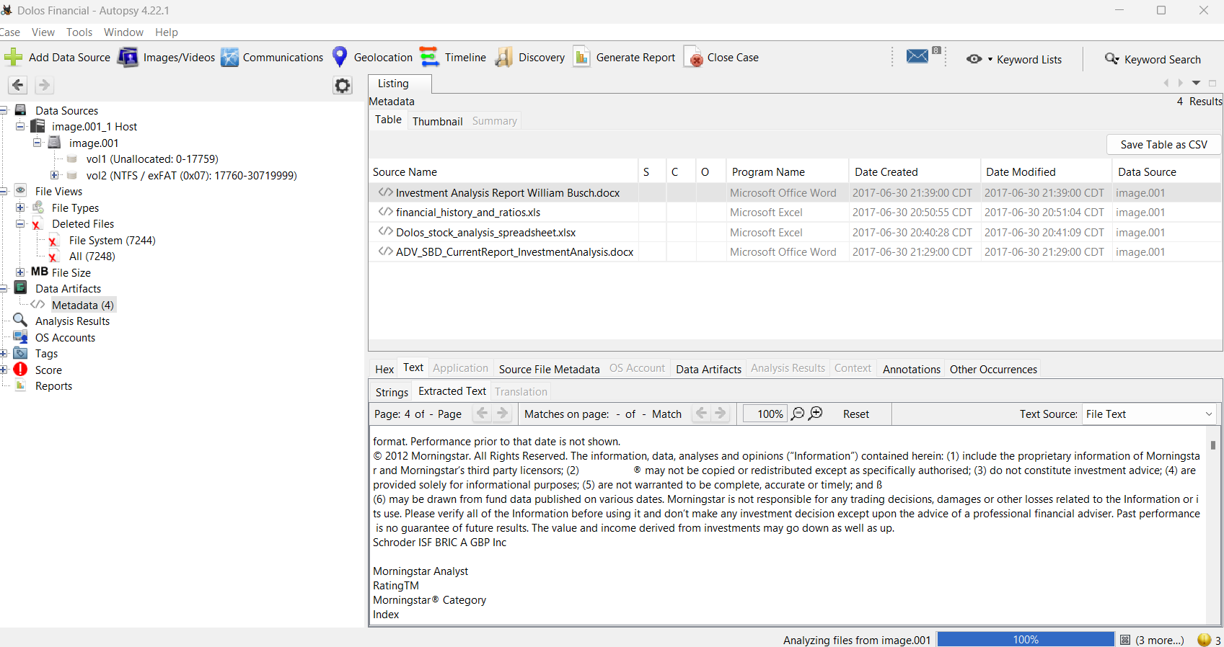

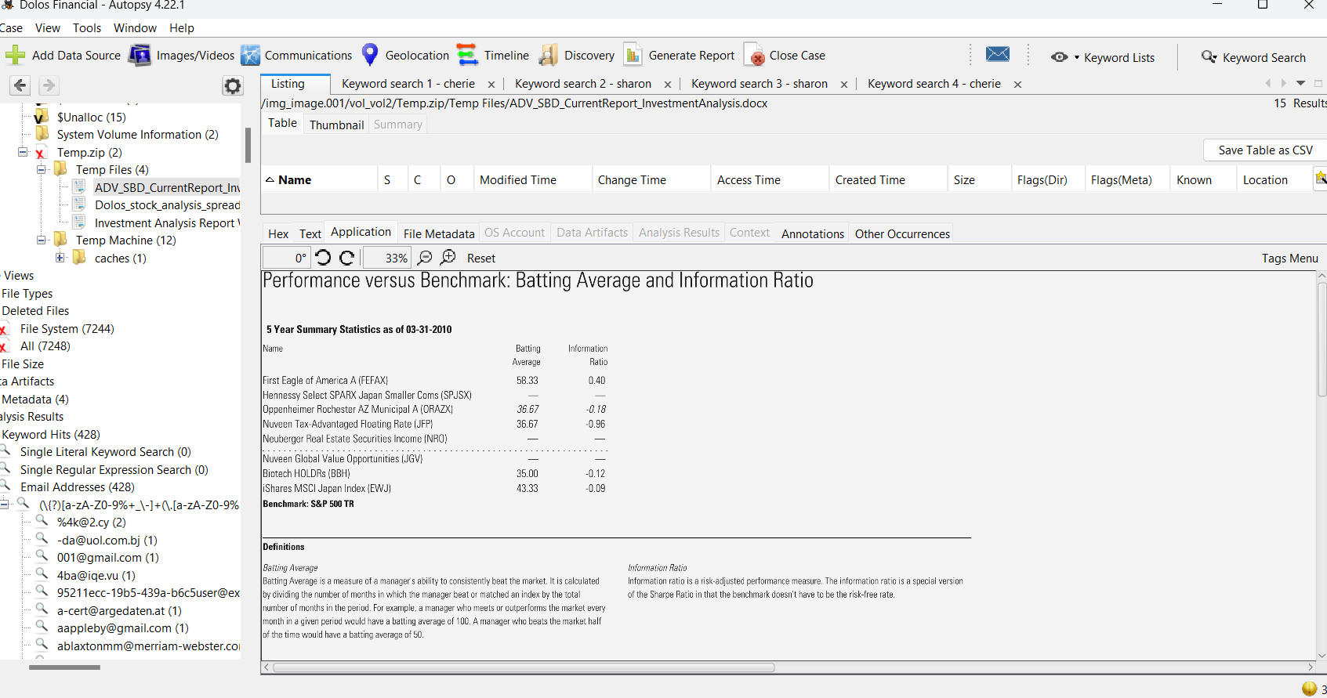

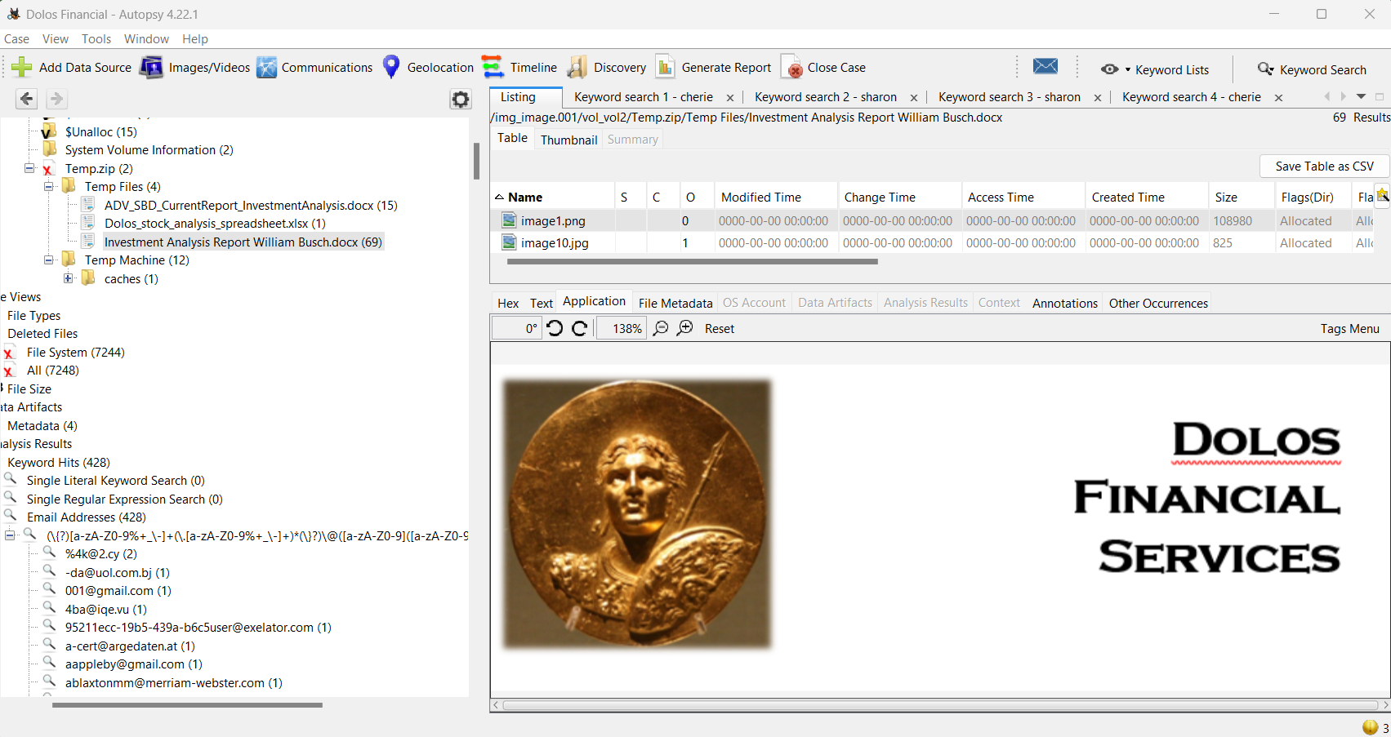
B. Tool output logs
The output for the autopsy report is attached..

