Robert Ottolia

Myles Chatman

Andrew Brown

CS 325 Algorithms

Group 26 Winter 2016

Project 1: Maximum Sum Subarray

**1. Theoretical Run-Time Analysis**

* 1. **Enumeration Algorithm**

**Pseudocode:**

*maxSum* ⬅0

**for** i = 0 to size of array **do**

**for** j = i to size of array **do**

*newSum*⬅sum of array from index i to index j

**if** *newSum > maxSum* **then**

*maxSum*⬅*newSum*

**end if**

**end for**

**end for**

**return** *maxSum*

**Analysis:**

There is no recursion in this algorithm. There is n*n computation done for the nested for-loops. Additionally, there is a summing up of n items within the innermost for-loops. Thus, the running time is **θ**(n3). This is a tight bound because we must sum up all elements in the array in order to accurately gauge the greatest sum.

* 1. **Better Enumeration Algorithm**

**Pseudocode:**

*maxSum* ⬅0

**for** i = 0 to size of the array **do**

*oldSum* ⬅0

**for** j = i to size of array **do**

**if** j = 0 **then**

*newSum*⬅content of the array at index *i*

**else**

*newSum*⬅ *oldSum* + content of the array at index *j*

**end if**

**if** *newSum > maxSum* **then**

*maxSum*⬅ *newSum*

**end if**

*oldSum*⬅ *newSum*

**end for**

**end for**

**return** *maxSum*

**Analysis:**

This algorithm removes the implicit third loop adding up the array elements from index *i* to index *j* in the first algorithm. Thus, this algorithm has a better complexity of **θ**(n2).

* 1. **Divide and Conquer Algorithm**

**Pseudocode:**

function maxSuffix(array):

*reverseArray* ⬅ array is reversed

*max* ⬅first element of reversed array

*sum* ⬅ 0

**for** *i* = 0 to end of *reverseArray* **do**

*sum*⬅ *sum* + *i*

**if** *sum > max* **then**

*max*⬅ *sum*

**endif**

**end for**

**return** *max*

function maxPrefix(array):

*max*⬅first element of array

*sum*⬅0

**for** i = 0 to end of *array* **do**

*sum*⬅ *sum* + *i*

**if** *sum* > *max* **then**

*max*⬅ *sum*

**end if**

**end for**

**return** *max*

function divideAndConquer(array):

**if** size of array <= 1 **then**

**return** first element of array

**else**

*firstHalf* ⬅first half of array

*secondHalf*⬅second half of array

*first*⬅ *divideAndConquer(firstHalf)*

*last*⬅ *divideAndConquer(secondHalf)*

*middle*⬅ *maxSuffix(firstHalf) + maxPrefix(secondHalf)*

**return** max(first, last, middle)

**end if**

**Analysis:**

Assuming the size of the input array is > 1, the division of the array into two halves takes **θ**(1) time. From there, the algorithm has to solve two subarrays of *n*/2. This takes 2*T*(*n*/2) time. We then must look at the case when the maximum subarray could be contained in the suffix of the first half and a prefix of the second half. The two helper algorithms in the code determine the max array sum in these two pieces. It is clear that these two algorithms have to loop through n elements, adding a complexity of **θ** (n), and then the calling function has to combine the results which is a **θ**(1) operation.

Therefore, the overall recurrence is:

*T(n) =* 2*T*(*n*/2) + **θ**(n) + **θ**(n) + **θ**(1)

Combining and dropping constants/low order terms we get the recurrence:

*T(n) =* **θ**(1), if n = 1, and

*T(n) =* 2*T*(*n*/2) + **θ**(n) if n > 1

By using the master theorem, the solution to the recurrence is **θ**(n log n).

* 1. **Linear-Time Algorithm**

**Pseudocode:**

*bestSum*⬅–*MAX* (lowest possible value that can be stored in type int)

*bestStart*⬅ *bestEnd* = -1

*localStart*⬅ *localSum* = 0

**for** *i* = 0 to size of array - 1 **do:**

*localSum*⬅ *localSum +* value at index *i*

**if** *localSum* > *bestSum* **then**

*bestSum*⬅ *localSum*

*bestStart*⬅ *localStart*

*bestEnd*⬅ *i*

**end if**

**if** *localSum <= 0* **then**

*localSum*⬅ *0*

*localStart*⬅ *i* + 1

**Analysis:**

This algorithm iterates through the array, keeping a tally of the current subarray. If the current subarray sum is greater than zero, it will contribute to future subset sums, so it is kept. Otherwise, if the current subset sum is less than or equal to zero, it will not contribute to any future subarray sums so it is discarded and the algorithm starts over with a new sum. From there, all that must be done is update the maximum sum that has been encountered.

The algorithm has one for-loop, looping over all of the elements of the array. The addition of variables are all of complexity **θ**(1), so the overall complexity of this algorithm is **θ**(n).

**2. Experimental Analysis**

**2.1 Enumeration Algorithm**

|  |  |
| --- | --- |
| Enumerative | |
| Input(N) | Time |
| 20 | 0.00008 |
| 50 | 0.000587 |
| 100 | 0.003105 |
| 200 | 0.018828 |
| 300 | 0.052911 |
| 500 | 0.215364 |
| 1000 | 1.461163 |
| 1200 | 2.596658 |
| 1500 | 4.956266 |
| 2000 | 11.66336 |

**2.1.1 Avg. Running Time****2.1.2 Plot of Running Times**

**2.1.3 Function Model**

Given two x-values on our loglog plot, *x0* = 102 and *x1* = 103, and their corresponding y-values, *F0* = 100.1 and *F1* = 10-2.8:

*m* = log (*F1/F0*) / log (*x1/x0*)

= log (1.2589 / 0.001584) / log (1000 / 100)

**≈** 2.900

The graph is exponential and grows quickly as the input grows. Thus, the function that models this relationship could be stated as:

*T(n)* = *cn*2.900

~*T(n)* = (1E-09)*n*2.900

**2.1.4 Discrepancies Between Experimental & Theoretical**

The data matched our theoretical prediction of **θ**(n3) very closely. The small discrepancy could be explained by external factors such as machine load, processors, etc.

**2.1.5 Determining Largest Input for Algorithm**

1 Minute = 60 Seconds:

(Using equation from the graph along with Wolfram Alpha)

http://www4c.wolframalpha.com/Calculate/MSP/MSP25102099aacdef88f50e000028faagh20e17i1d2?MSPStoreType=image/gif&s=36&w=347.&h=18.

**x ≈ 3899**

**2 Minutes = 120 Seconds:**

http://www5b.wolframalpha.com/Calculate/MSP/MSP29231h5bifcbbdc95a61000058e1f466gh7ha48a?MSPStoreType=image/gif&s=1&w=355.&h=18.

x **≈ 4917.1**

**5 Minutes = 300 Seconds:**

http://www5b.wolframalpha.com/Calculate/MSP/MSP4231h5bii15983d8ga20000517cafa9dfh8ag2f?MSPStoreType=image/gif&s=1&w=355.&h=18.

**x ≈ 6679.5**

**2.1.6 Loglog Plot of Running Times**

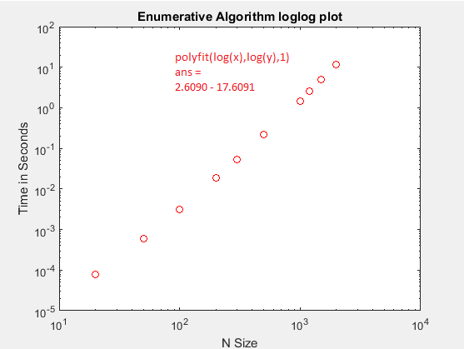

**2.2 Better Enumeration Algorithm**

|  |  |
| --- | --- |
| Iterative | |
| N | Time |
| 20 | 0.0000256 |
| 50 | 0.0001441 |
| 100 | 0.0003382 |
| 200 | 0.0012358 |
| 300 | 0.0024545 |
| 500 | 0.0081496 |
| 1000 | 0.0295787 |
| 1200 | 0.0410674 |
| 1500 | 0.0622348 |
| 2000 | 0.1161804 |

**2.2.1 Avg. Running Time 2.2.2 Plot of Running Times**

**2.2.3 Function Model**

Given two x-values on our loglog plot for this algorithm, and their corresponding values, we arrive at the *m* value:

*m* = log (*F1/F0*) / log (*x1/x0*)

= log (10-1.6/10-3.5) / log (103/102)

**≈ 1.9**

The graph is also exponential, but does not grow as quickly as the first algorithm’s graph. The function that models this relationship could be stated as:

*T(n)* = *cn*1.9

~*T(n)* =(3E-08)*n1.9*

**2.2.4 Discrepancies Between Experimental & Theoretical**

The derived function matches our theoretical analysis of **θ**(n2) extremely well. Once again, the small variances could be explained by external factors. Overall, it was clear by the regression that while still exponential in nature, this algorithm grew at a slower rate than the first.

**2.2.5 Determining Largest Input for Algorithm**

60 Seconds:

http://www5b.wolframalpha.com/Calculate/MSP/MSP1887220aad4a5fh2270700005831c6g6af2177id?MSPStoreType=image/gif&s=39&w=249.&h=18.

x **≈ 44737**

**120 Seconds:**

http://www5b.wolframalpha.com/Calculate/MSP/MSP41981h4gff542g88999b00001a9e1fi675510g6i?MSPStoreType=image/gif&s=11&w=257.&h=18.

x **≈ 63262**

**300 Seconds:**

http://www5b.wolframalpha.com/Calculate/MSP/MSP206520b77d857b91810a0000238if6d320d9e244?MSPStoreType=image/gif&s=61&w=257.&h=18.

x **≈ 100017**

**2.1.6 Loglog Plot of Running Times**

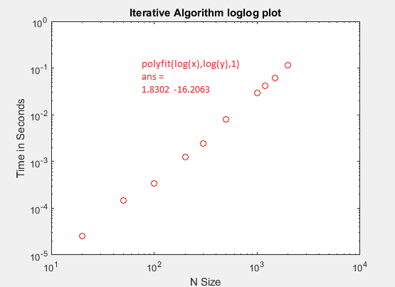

**2.3 Divide And Conquer Algorithm**

|  |  |
| --- | --- |
| Divide & Conquer | |
| N | Time |
| 20 | 0.00006 |
| 50 | 0.000169 |
| 100 | 0.000487 |
| 200 | 0.001543 |
| 300 | 0.003079 |
| 500 | 0.007769 |
| 1000 | 0.030524 |
| 1200 | 0.043727 |
| 1500 | 0.070405 |
| 2000 | 0.127336 |

**2.3.1 Avg. Running Time 2.3.2 Plot of Running Times**

**2.3.3 Function Model**

Using the equation from our regression line best fit:

*y* = 6E-05*x* – 0.0113

We can pick two points (1000, 0.0487), (2000, 0.1087) and then use it to find out *m*:

m = (0.1087/0.0487) / (2000/1000)

m **≈ 1.1**

**The slope then appears to be very close to one. If we use data from our loglog plot instead, we get a slope closer to 1.8. Overall, the regression line on the graph appears to be linear in nature, but is growing faster than a pure linear solution. As such, this algorithm is much more efficient than either of the previous two.**

**We can then rewrite our model function as:**

*T(n)* = 6E-05*n* **= *cn***

**2.3.4 Discrepancies Between Experimental & Theoretical**

The experimental did not match our prediction of **θ**(*n* log *n*) perfectly, but we see that log n is often almost a constant when n is low. We observe this pattern in our graph before the size of n increases.

**2.3.5 Determining Largest Input for Algorithm**

60 Seconds:

60= 6E-05*x* – 0.0113

*x* **≈ 1E6**

120 Seconds:

120= 6E-05x – 0.0113

x **≈ 2E6**

300 Seconds:

300 = 6E-05x – 0.0113

x **≈ 5E6**

**2.3.6 Loglog Plot of Running Times**

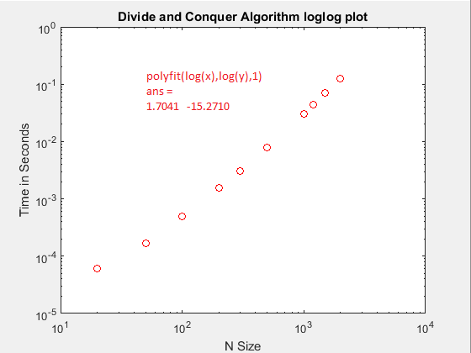

**2.4 Linear Algorithm**

|  |  |
| --- | --- |
| Linear | |
| N | Time |
| 20 | 0.000003 |
| 50 | 0.000005 |
| 100 | 0.00001 |
| 200 | 0.00001 |
| 300 | 0.00002 |
| 500 | 0.00003 |
| 1000 | 0.00007 |
| 1200 | 0.00008 |
| 1500 | 0.000116 |
| 2000 | 0.000169 |

**2.4.1 Avg. Running Time 2.4.2 Plot of Running Times**

**2.4.3 Function Model**

Picking points from the loglog plot we obtain the slope *m:*

*m* = 0.87

*m* **≈ 0.9**

This is a reasonable slope considering for a linear algorithm we would expect to have a slope of 1. We must also note than the slope is lower than in our previous algorithm, the divide and conquer. This means that our experimental data shows that the running time grows slower than even the divide and conquer algorithm, which is what we expected.

*T(n) =* (8E-08)*n = cn*

**2.4.4 Discrepancies Between Experimental & Theoretical**

Our experimental data matched up closely with our theoretical analysis of **θ**(n), and as seen by the graph, the regression line matches the analysis very well. As the input grows, the running times does as well in a linear fashion.

**2.4.5 Determining Largest Input for Algorithm**

60 Seconds:

60 = 8E-08x – 0.000004

x **≈ 7.5E8**

120 Seconds:

120 = 8E-08x – 0.000004

x **≈ 1.5E9**

300 Seconds:

300 = 8E-08x – 0.000004

x **≈ 3.75E9**

**2.3.6 Loglog Plot of Running Times**

