# Initiation PHP

Raccourci CONSOLE **Ctrl + ù**

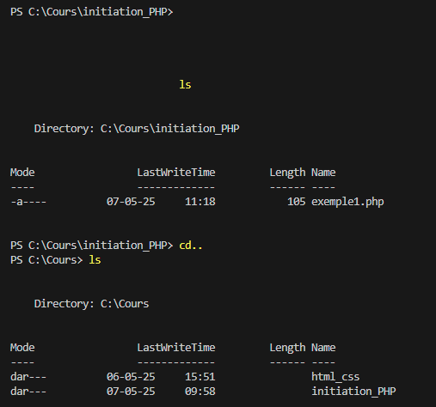

Ne pas oublier le  **;**  après chaque instruction

**\n** Saut à la ligne

En PHP, on concatène avec « **.** » au lieu de *+*

**\n** peut être mis dans une *string*

Pour les **conditions**,

les *paramètres* sont entre *parenthèses* et les *instructions* entre *accolades*

**Readline()** = *input()* en python

