Accessing IT Support Requests Report

Open Jeff-Net Report Runner, application that runs Giles reports (running man icon).
In left pane below, browse to g:\secured\Co_reports\Dist_Crystal_reports\CSR_Reports, if does not open there. In right pane below, select GCPITSupRptUsrStatus.rpt. Verify check is in box for No Security on far right side of window below. Click the View button to generate report.
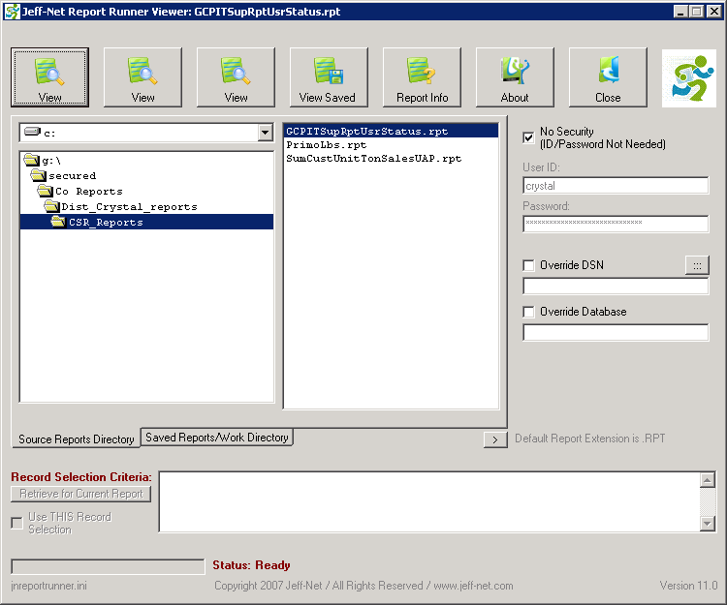

The following window will open to for search criteria to be entered.
Enter the username (first initial last name with no space). Select which ever type of ticket status for report. Hold CTRL and click to select in left pane one or more types of ticket status and use right
arrow button > to move over to right pane. Click OK. The IT Support for User by Status Report with requested criteria will now open in another window.
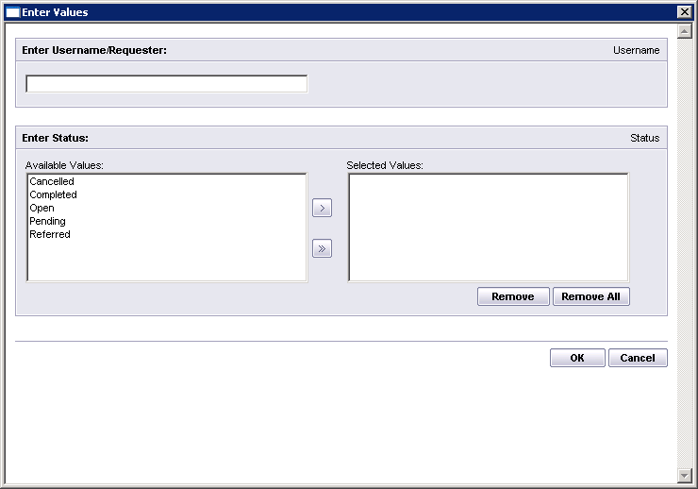
Close all windows by selecting the X in upper right corner of each window when done.

