#206
Product Description: |  |  |  |  |  |  |  |  |  |  |  |  |  |  |  |  |  |  | Product Film Type:
Product Generic ID#: |  | C10U50S |  |  |  |  |  |  |  |  |  |  |  |  |  |  |  |  | 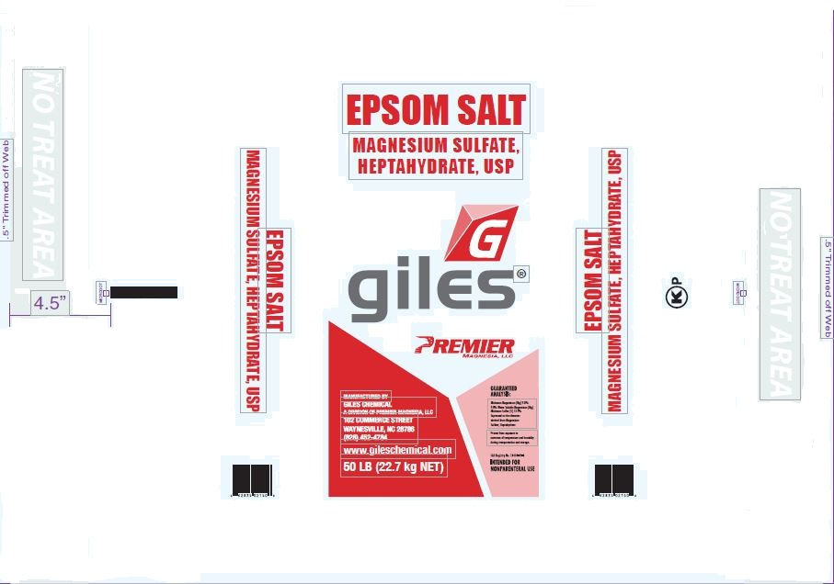
Product Grade: |  | USP
Product Screen: |  | Screened Middles
Packaging Weight: |  | 50lb
Pallet Configuration: |  | 7 X 7
Other: |  | Run product just like ARCH
Quality:
 | - Samples to be taken |  |  |  |  |  |  | Retained for: |  |  |  |  |  | One sample bag from screened salt chute on pallet 1, 6, 12 and 18.
 | - Testing Required |  |  |  |  |  |  | Testing for: |  |  |  |  |  | Crystal/Screen size
 | - Quality Release |  |  |  |  |  |  | Criteria Needed: |  |  |  |  |  | Pass sieve testing. Quality Tech may test and release, Lab will verify.
Production/Packaging:
 | - Shrink Wrap |  |  |  | - Liners Required |  |  |  |  |  |  |  |  |  |  | - Heat Treated Pallets |  |  |  |  |  |  |  |  |  |  | - Stickers Required
 | - Extra Placard or Tag Required: |  |  |  |  |  |  |  |  | Description: |  |  |  |  | Screened Middles Placard
 | - Other Requirements: |  |  |  |  |  | Description: |  |  |  | Customer Supplied Placard (BioLab/Contrapac)

Shipping:
 | - General |  |  | - Air Bags |  |  |  |  |  |  |  |  | - Double Wrap |  |  |  |  |  |  |  |  |  |  | - Corner Boards |  |  |  | - Block & Brace
 | - Must have Quality Approval signature before loading: |  |  |  |  |  |  |  |  |  |  |  |  |  |  |  |  |  |  | Reason:
 |  |  |  |  |  |  |  |  | Signature: |  |  |  |  |  |  |  |  |  |  |  |  |  |  |  |  |  |  | Date:
 | - Must have Management Approval signature before loading: |  |  |  |  |  |  |  |  |  |  |  |  |  |  |  |  |  |  |  | Reason:
 |  |  |  |  |  |  |  |  | Signature: |  |  |  |  |  |  |  |  |  |  |  |  |  |  |  |  |  |  | Date:
 | - Other: |  | SDS sheet must accompany Contrapac/Bio Labs loads.
Change Information: |  |  | Updated to new template, removed Wholesale Feeds.

