LUCAS P. CLARKE

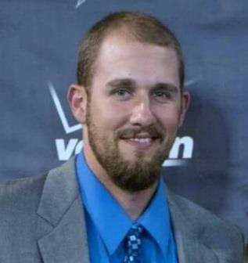

300 Bulldog Dr. Apt. 300

Asheville NC, 28801

(828) 413-3406

[lclarke@unca.edu](mailto:lclarke@unca.edu)

**lucasclarke.com**

UNC Asheville Student Athlete

Passion for web development & design

# WORK HISTORY

08. 2016 - present **ASHDEALS.US** – Asheville, NC

**Senior Project**

* Designed, developed, and tested a site for deals at local Asheville eateries
* Created the entire site including the MySQL database
* Linked the database to site using PHP
* Designed custom CSS for responsive mobile support
* Maintain files remotely using SFTP

04. 2015 – 01. 2016 Waterless Buddy’s – Chapel Hill, NC

**Chief Information Officer at the startup company**

* Create and maintain WordPress-based website
* Work in a fast-paced, demanding, team environment
* Designed logo and promotional material
* Featured in USA Today College
* www.waterlessbuddys.com

10. 2009 – 04. 2013 247 Fitness and athletic training – Hickory, NC

**Assistant IT Coordinator**

* Refined their site and maintain it remotely
* Designed a new logo and promotional ads
* Created a commercial video
* www.247fitfast.com

# EDUCATION

08.2012 – PRESENT UNC asheville

B.S. In Computer Science

* Expected graduation date: December 2016
* Student-Athlete Advisory Committee representative
* Christian Athletes Outreach representative
* 2016 Big South Presidential Honor Roll

# SKILLS

Languages javascript / mysql / php / jquery / html / css

Other Sftp / AMAZON WEB SERVICES / Responsive DESIGN / photoshop/ .htaccess / WORDPRESS / GITHUB