The application design

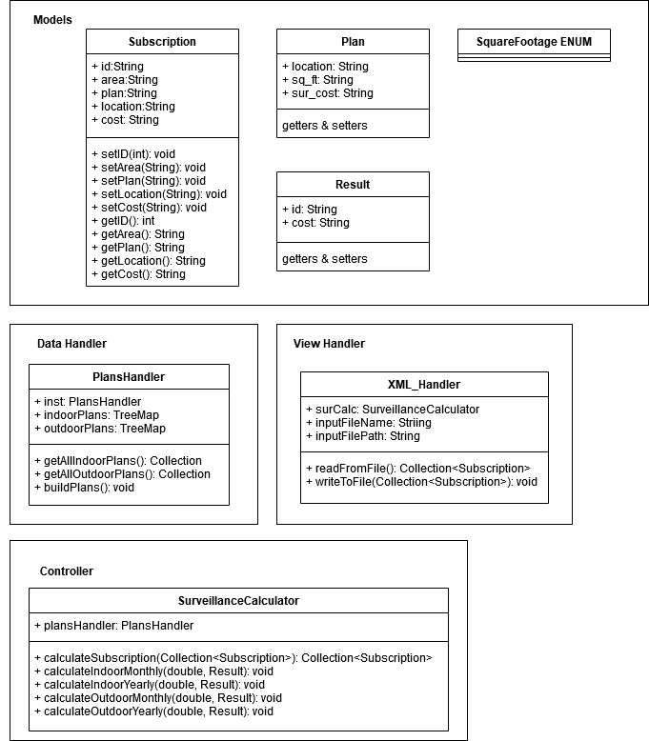

MVC design pattern has been followed for implementation of the app.