On Performance of Sparse Fast Fourier Transform Algorithms Using the Flat Window Filter
zhikang jiang

Abstract：
The problem of computing the Sparse Fast Fourier Transform(sFFT) of a K-sparse signal of size N has received significant attention for a long time. The first stage of sFFT is hashing the frequency coefficients ofinto B(≈K) buckets named frequency bucketization. The process of frequency bucketization is achieved through the use of filters: Dirichlet kernel filter, aliasing filter, flat filter, etc. The frequency bucketization through these filters can decrease runtime and sampling complexity in low dimensions. It is a hot topic about the sFFT Algorithms using the flat filter because of its convenience and efficiency since its emerge and widely application. The next stage of sFFT is the spectrum reconstruction by identifying frequencies that are isolated in their buckets. Up to now, there are more than thirty different sFFT algorithms using the sFFT idea as mentioned above by their unique methods. An important question now is how to analyze and evaluate the performance of these algorithms in theory and practice. In this paper, it is mainly discussed about the SFFT algorithms using the flat filter. In the first part, the paper introduces the techniques in detail including two types of frameworks, five different methods to reconstruct spectrum and corresponding algorithms. We get the conclusion of the performance of these five algorithms including runtime complexity, sampling complexity and robustness in theory. In the second part, we make three categories of experiments for computing the signals of different SNR, different N, and different K by a standard testing platform and record the run time, percentage of signal sampled and L₀,L₁,L₂ error both in exactly sparse case and general sparse case. The result of experiments is consistent with the inferences obtained in theory. It can help us to optimize these algorithms and use them correctly in the right areas.

Index Terms：
Sparse Fast Fourier Transform(sFFT), flat window filter, sub-linear algorithms

I. INTRODUCTION
The Discrete Fourier Transform(DFT) is one of the most important and widely used techniques in signal processing and mathematical computing. The most popular algorithm to compute DFT is the fast Fourier transform(FFT) invented by Cooly and Tukey. The algorithm can compute the DFT of a signal of size N in O(N log N) time and use O(N) samples. FFT greatly simplifies the operation process, however, with the emergence of big data problems, the FFT is no longer fast enough. Furthermore, sometimes it is hard to acquire a sufficient amount of data to compute the DFT. These two problems become the the major computational bottleneck in many applications. It motivates the need for the algorithms that can compute the Fourier transform in sublinear time and that use only a subset of the input data. People thought of many ideas in order to realize such an algorithm. Later, they focused on the study of the characteristics of the signal itself. The research found that a large number of signals are sparse in the frequency domain, only K frequencies are non-zeros or are significantly large. This feature is common and inherent in signals covers many fields (e.g. audio, video data, medical image, etc). In this case, when K<< N ,one can retrieve the information with high accuracy using only the coefficients of the K most significant frequencies. So the sFFT has been proposed and achieved good results. The research of sFFT has been a hot topic in signal processing research since its birth, it was named one of the 10 Breakthrough Technologies in MIT Technology Review in 2012.
The first stage of sFFT algorithm is bucketization such that the value of the bucket is the sum of the values of the frequency coefficients that hash into the bucket. The number of buckets is denoted by B and the size of one bucket is denoted by L. The process of bucketization is achieved through the use of filters. The effect of Dirichlet kernel filter is to make the signal convoluted a rectangular window in the time domain, it can be equivalent to the signal multiply a Dirichlet kernel window of size L (L<<N) in the frequency domain. The typical application using the Dirichlet kernel filter is AAFFT algorithm. The effect of aliasing filter is to make the signal multiply a comb window in the time domain, it can be equivalent to the signal convoluted a comb window of size B(B≈K) in the frequency domain. The typical application using the aliasing filter is FFAST algorithm. The effect of flat filter is to make the signal multiply a mix window in the time domain, it can be equivalent to the signal convoluted a flat window of size L (L<<N) in the frequency domain. The typical application using the flat filter is sFFT1.0 algorithm. After bucketization, the algorithm then focuses on the non-empty buckets and computes the positions and values of the large frequency coefficients in those buckets in what we call the spectrum reconstruction or identifying frequencies. As we can see as follows, there are more than thirty algorithms using the sFFT idea and more than ten sFFT algorithms using the flat filter. A central question now is how to analyze and evaluate the performance of these algorithms for computing signals by the compare of themselves or other types of algorithms. It should be proved whether the runtime complexity, sampling complexity and robustness performance are consistent with the theory or not. Are there any better ways to improve these algorithms when using it in practice? The results of these performance analysis is the guide for us to optimize these algorithms and use them correctly in the different areas. Some answers can be found in this paper.
The first sFFT algorithm with sub-linear runtime and sub-sampling property was given in ^{[1]}, which gave a randomized algorithm with runtime and sampling complexity O(K² poly(logN)). This was later improved to O(K poly(logN))^{[2],[3]} through the use of binary search technique for spectrum reconstruction and the use of unequally-spaced FFTs. The algorithm is so called Ann Arbor fast Fourier transform (AAFFT), the version of them are AAFFT0.5 and AAFFT0.9.
In^{[4],[5]}, an algorithm so called Fast Fourier Aliasing-based Sparse Transform(FFAST) which focuses on exactly K-sparse signals was given. Their approach is based on downsampling of the input signal using a constant number of co-prime downsampling factors guided by CRT. These aliasing patterns of different downsampled signals are formulated as parity-check constraints of good erasure-correcting sparse-graph codes. FFAST costs O(KlogK) to compute the exactly signals and only use O(K) samples. In^{[6],[7]}, the author adapt the FFAST framework to the case where the time-domain samples are corrupted by a white Gaussian noise. The author show that the extended noise robust algorithm R-FFAST computes DFT using O(Klog³N) samples, in O(Klog⁴N) runtime. These two algorithms perform well when N is a product of some smaller prime numbers.
In^{[8]}, an algorithm is proposed and so called sFFT by downsampling in the time domain(sFFT-DT). The idea behind sFFT-DT is to downsample the original input signal first and then all subsequent operations are conducted on the downsampled signals. To overcome aliasing problem, the author consider the locations and values of K non-zero entries as variables and the aliasing problem is found to be equivalent to MPP problem, which can be solved via orthogonal polynomials or syndrome decoding with a compressive sensing(CS) based solver.
In^{[9]}, a deterministic algorithm so called Gopher Fast Fourier Transform(GFFT) which based on CRT was given. The GFFT is a aliasing-based search algorithm. The approximation error bounds in^{[9]} are further improved in^{[10]} . Later, an algorithm so called Christlieb Lawlor Wang Sparse Fourier Transform(CLW-SFT ), which used phase encoding method was given in ^{[11]}. The noiseless version of this algorithm is an adaptive algorithm^{[12]} which has runtime O(KlogK). In^{[11]}, the author developed this algorithm by using the multiscale error-correcting method to cope with high-level noise with runtime O(K²logK). In ^{[13]}, the author evaluate the performance of DMSFT (generated from GFFT) and CLW-DSFT (generated from CLW-SFT) and compare their runtime and robustness characteristics with other algorithms. These four algorithms all have a hypothesis that the algorithms can sample anywhere they want.
In^{[14]}, an algorithm is proposed and so called Deterministic Sparse FFT(DSFFT). In the algorithm K needs not to be known in advance but will be determined during the algorithm. The method is based on the divide-and-conquer approach and may require the solution of a Vandermonde system of size at most K×K at each iteration step j if K² < 2^{j}.
The sFFT algorithms using the flat window filter so called sFFT1.0-sFFT4.0 that can compute the exactly K-sparse signals in time O(KlogN) and general K-sparse signals in time O(KlogNlog(N/K)) were given in^{[15],[16]}. These algorithms leverage characteristic of flat window filter. The sFFT1.0 and sFFT2.0 algorithms can identify and estimate the K largest coefficients in one shot. The sFFT3.0 algorithm can estimate the position by using only two samples of the filtered signal inspired by the frequency offset estimation in the exactly sparse case. Later, a new robust algorithm so called Matrix Pencil FFT(MPFFT) was proposed in ^{[17]} on the basic of sFFT3.0 algorithm. The major new ingredient is a mode collision detector based on the matrix pencil method. This method enables the algorithm to use fewer samples of the input signal.
In^{[28]} the paper proposes an overview of sFFT and summarize a three-step approach in the stage of spectrum reconstruction and provides a standard testing platform that can be used to evaluate different sFFT algorithms. There are also some researches try to conquer the sFFT problem from a lot of aspects: complexity^{[19],[20]}, performance^{[21],[22]}, software^{[23],[24]}, higher dimensions^{[25],[26]}, implementation ^{[27],}, hardware ^{[28]} and special setting ^{[29] [30]} perspectives.
The identification of different sFFT algorithms can be know through a brief analysis as above. The Dirichlet kernel filter is not efficient because it only bins some frequency coefficients into one bucket one time. As to the aliasing filter it is difficult to solve the worst case because there may be many frequency coefficients in the same bucket accidentally if B only can be supposed as a power of two by the reason of the scaling operation is of no use. In comparison to them, using the flat filter is very convenience and efficiency.
This paper is structured as follows. Section II and Section III provides a brief overview of the sFFT technique. Section IV introduce and analyze two frameworks and five spectrum reconstruction method of algorithms. In the one shot framework, sFFT1.0 and sFFT2.0 algorithm use voting method with the help of the stochastic characteristics. In the framework of iteration the sFFT3.0 and sFFT4.0 algorithm use phase encoding method with the help of the time shift characteristics. The MPSFT algorithm use matrix pencil method with the help of prony characteristics. In section V, we do three categories of comparison experiments. The first kind of experiment is to compare them with each other. The second is to compare them with other sFFT algorithms. The third is to compare them of optimization with them without optimization. The analyze of the experiment results satisfy theoretical inference.
II. Notation
In this section, we initially present some notation and basic definitions about sFFT. We use
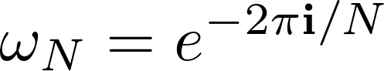 as the N-th root of unify. Let 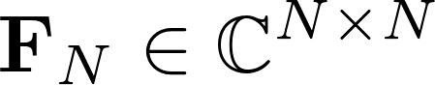 be the DFT matrix of size N defined as follows: 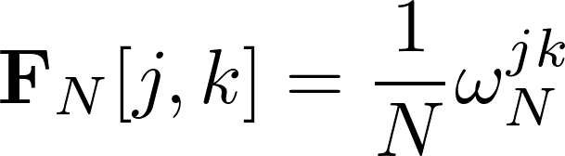 (Equation 1) The DFT of a vector 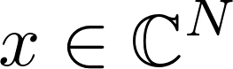 (consider a signal of size N, where N is a power of two) is a vector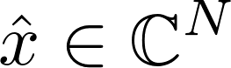 defined as follows:
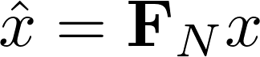 (Equation 2)
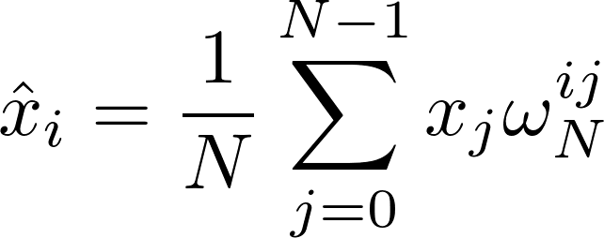 (Equation 3)
It is necessary to consider the inverse of the DFT matrix above. 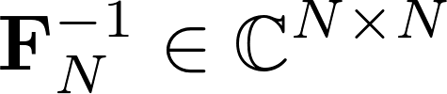 defined as follows:
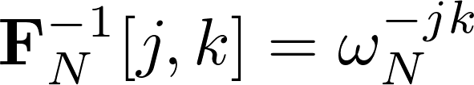 (Equation 4)
The inverse DFT of 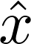 is a vector x defined as follows:
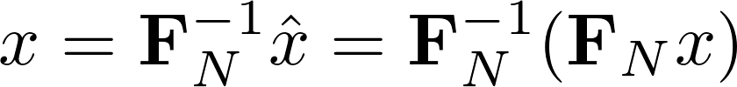 (Equation 5)
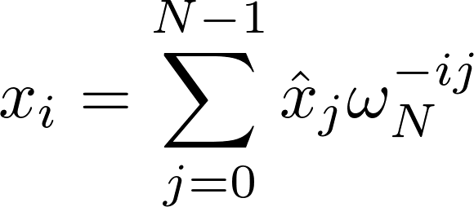 (Equation 6)
For 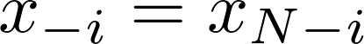, we may define convolution as follows:
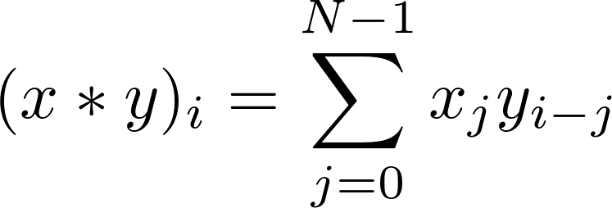 (Equation 7)
For coordinate-wise product 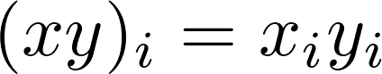 and the DFT of xy is performed as described in Equation (8):
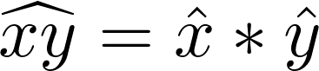 (Equation 8)
For exactly signals, is exactly K-sparse if it has exactly K non-zero frequency coefficients while the remaining N-K coefficients are zero. For general signals, is general K-sparse if the largest K frequency coefficients >> remaining N-K coefficients. The goal of the sFFT is to recover a K-sparse approximation by finding frequency positions f and estimating valuesof the K largest coefficients.
III. Techniques
In this section, we start with an overview of the techniques that we will use in the sFFT.
A Random Spectrum Permutation
The random permutation include two operations, one is shift operation, another is scaling operation. Let 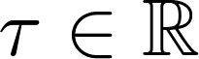 be the offset parameter. Let matrix 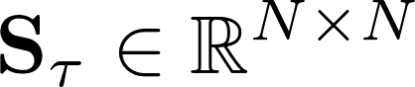 representing the shift operation, is defined as follows:
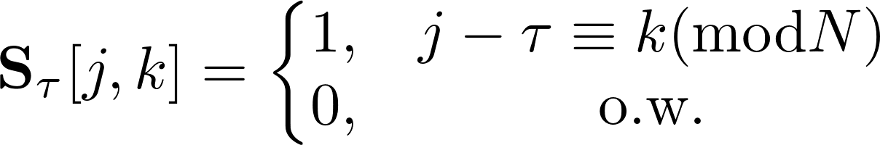 (Equation 9)
Let 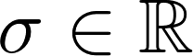 be the scaling parameter. Let matrix 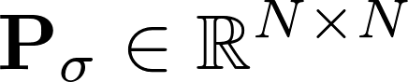 representing the scaling operation, is defined as follows:
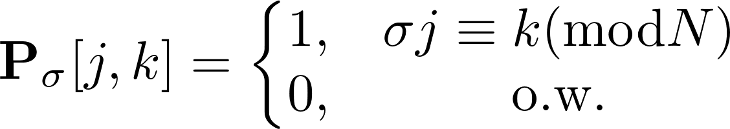 (Equation 10)

Suppose 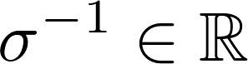 exists mod N, 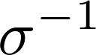 satisfies 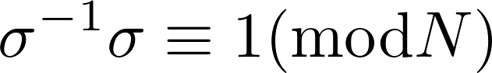. If a vector 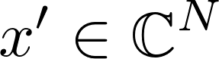,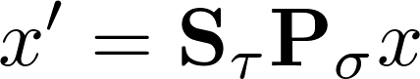 such that:
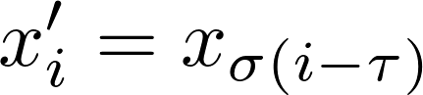 (Equation 11)
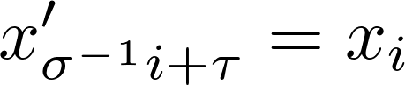
The random permutation isolates spectral components from each other, and it is performed as follows: if , such that:
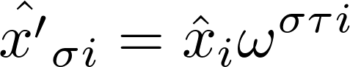 (Equation 12)
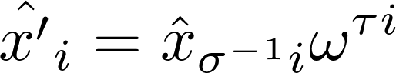

B Window Function
The window funciton is a mathematical tool and can be seen as a matrix multiply the original signal. We introduce three filters used in the sFFT algorithm mentioned in this paper.
The first filter is the frequency aliasing filter. Through the filter, the signal in the time domain is subsampled such that the corresponding signal in the frequency domain is aliased. Let 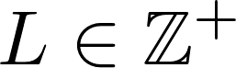 be subsampling factor. Let 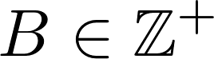 be the subsampling number. Let matrix 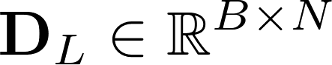, representing the subsampling operator, is defined as follows:
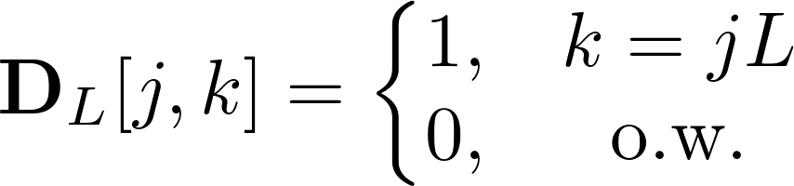 (Equation 13) Let vector 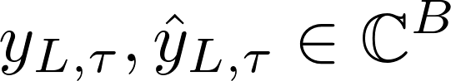, be the filtered signal obtained by shift operation and aliasing filter. If
, we get formula (14) and if 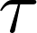=0 we get formula (15).
(formula 14)
(formula 15)
The second filter is the frequency flat filter. We use a filter vector G that is concentrated both in time and frequency domain, G is zero except at a small number of time coordinates with supp(G)⊆[-w/2,w/2], and its Fourier transformis negligible except at a small fraction L (≈εN) of the frequency coordinates (the pass region). The paper^{[10]} claim there exists a standard window function G(ε,ε’,δ,w) satisfies the formula (16). The filter can be obtained by convoluted a Gassian function with a box car window function and supp(G) = w = O(1/ε log(1/δ))). One can potentially use a Dolph-Chebyshev window function with minimal big-Oh constant. In this paper, we use filter G ∈ ℂ^{N} be a (L/N,L/2N,δ,w) flat window. The width of the filter in the time domain is denoted by w, the width of the passband region in the frequency domain is denoted by L, the number of buckets is denoted by B and B = N/L.
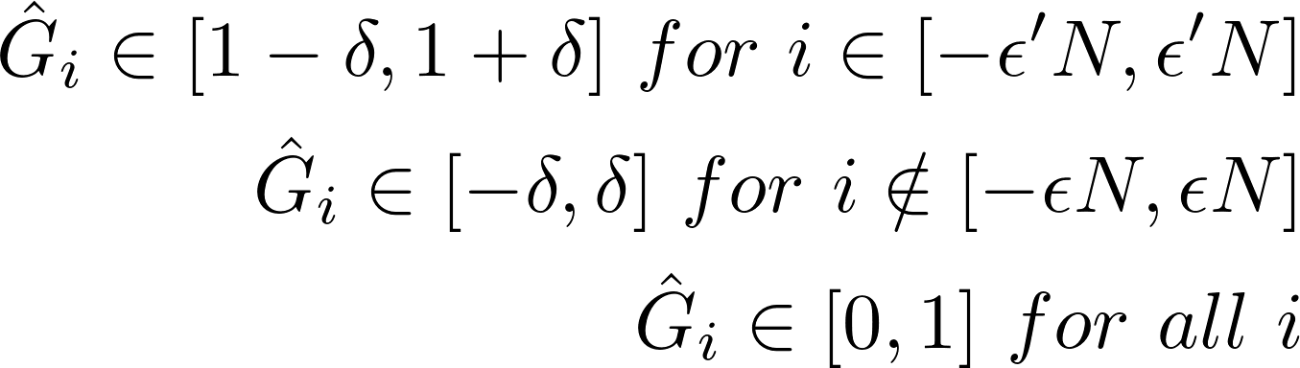 (formula 16)
Let matrix Q_{L} ∈ ℂ^{N×N} be a diagonal matrix whose diagonal entries represent filter coefficients in the time domain, is defined as follows:
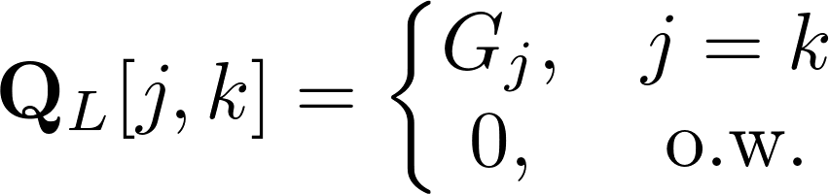 (Equation 17)
The third filter is the frequency subsampled filter. Through the filter, the signal in the time domain is aliased such that the corresponding signal in the frequency domain is subsampled. Let matrix U_{L} ∈ ℝ^{B×N} represents the aliasing operator as follows:
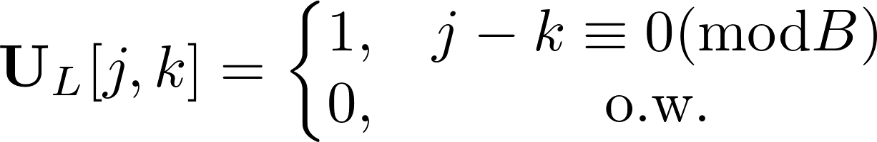 (Equation 18)

Let vector y_{L},∈ℂ^{B}, be the filtered signal obtained by subsampled filter. If,we get formula(19).
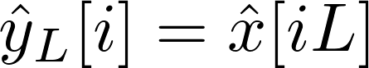 (Equation 19)
C Frequency Bucketization
The process of bucketization in this paper is achieved through the use of flat filter, subsampled filter and shift operation, scaling operation. It can be equivalent to the signal multiply 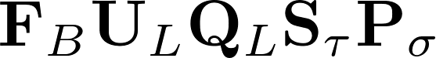. The filtered signal is performed as follows: If 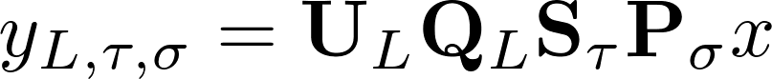, , such that:
(formula 20)
Proof: Please see Appendix
If the set I is a set of coordinates position, the position 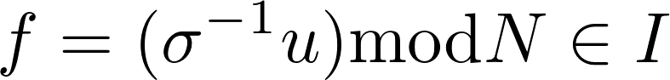, suppose there is no hash collision in the bucket i, i = round(u/L), round() means to make decimals rounded. Through formula(20), we can get the formula(21)
( formula 21)
As we see above, frequency bucketization includes 3 steps: random spectrum permutation(, it cost 0 runtime and unknow samples), flat window filter(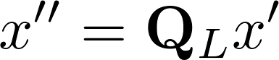, it cost w runtime and w samples), fourier transform of the aliasing signal(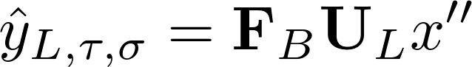, it cost BlogB runtime and 0 samples). So totally frequency bucketization one round cost w+BlogB runtime and w samples
IV. Algorithms analysis
As mentioned above the goal of frequency bucketization is to decrease runtime and sampling complexity in advantage of low dimensions, after bucketization the filtered signal 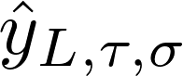 can be obtained by original signal x. In this section, we introduce two frameworks, five methods and corresponding algorithms to recover the spectrumof the filtered signal by their own way.
A The sFFT1.0 algorithm by one-shot framework
The first framework can directly reconstruct the spectrum by one-shot, does not need iteration. The process to reconstruct the spectrum of sFFT1.0 algorithm includes two kinds of rounds, the first are location rounds and another are estimation rounds. Every location round one time generate a list of candidate coordinates I_{r}. Candidate coordinates i ∈ I_{r} have a certain probability of being indices of one of the K significant coefficients in. By running multiple rounds, this probability can be increased so it is certain to vote the candidate coordinates with a high probability after 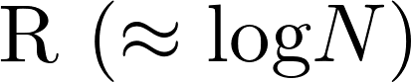 times' round. The next step is to do estimation rounds used to exactly determine the value of identified frequencyisolated in the bucket in the reason of the value of the bucket is approximate the frequency that identified in the bucket if there is no hash collision. The block diagram of the sFFT algorithms system of one-shot framework is shown in Fig. 1.We explain the details as below.
Stage1 Bucketization: Run R times' round for set 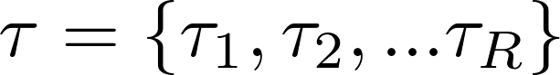 and set 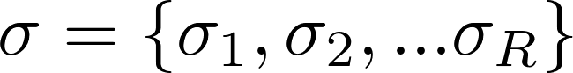, Calculate representing filtered spectrum.
Stage2-Step1 Location rounds: After R times' round, return R sets of coordinates I₁, · · · , I_{R}(set I_{r} representing union of 2K sets J from B sets J {J_{r,0}, J_{r,1},… J_{r,B-1}} in the No.r’ round, set J_{r,i}={). Then do the vote, count the number s_{i} of occurrences of each found coordinate i, that is: 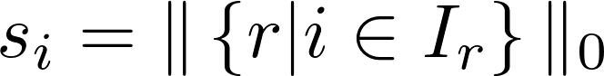(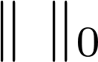 representing 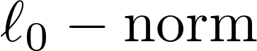). Only keep the coordinates occurred in at least fifty percentage proportion( ).
Stage2-Step2 Estimation rounds: After location rounds the set I can be obtained then estimate R sets of frequency coefficients {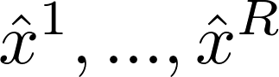}. The method is if position f∈I, we can get the value of position f through formula(21). For identified position f, R different 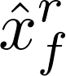 can be obtained in R times' rounds, finally use the median value of the sets as the final estimator.
Figure 1. A system block diagram of one-shot framework
bucketization
x
….
….
….
select 2K
sets of B
sets
….
Vote
….
Estimate
bucketization
Select 2K sets of B sets
x
Stage 1:
bucketization
Stage 2-step 1:
locate loops
Stage 2-
Step 2:
Estimation
Loops

….
Finally we analyze the performance of sFFT1.0 algorithm. In stage1 it cost R·(w+BlogB) runtime, in stage2-step1 it cost 2RK(N/B) runtime, in stage2-step 2 it cost 2RK runtime, totally it cost O(R(w+BlogB+KN/B)) runtime. And in fact the runtime satisfy Lemma 4.1.
Lemma 4.1: Suppose R=O(logN), w=Blog(N/δ), δ=1/(N^{c}), totally it cost 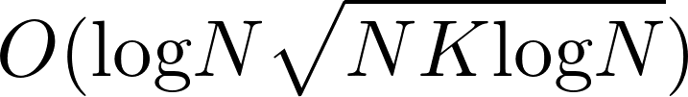 runtime in sFFT1.0 algorithm.
Proof:
In stage 1 it needs w samples one time. In the first round, the signal not chosen is in probability of (N-w)/N, suppose the probability does not change, in average the samples chosen after R times’ round is in the number of 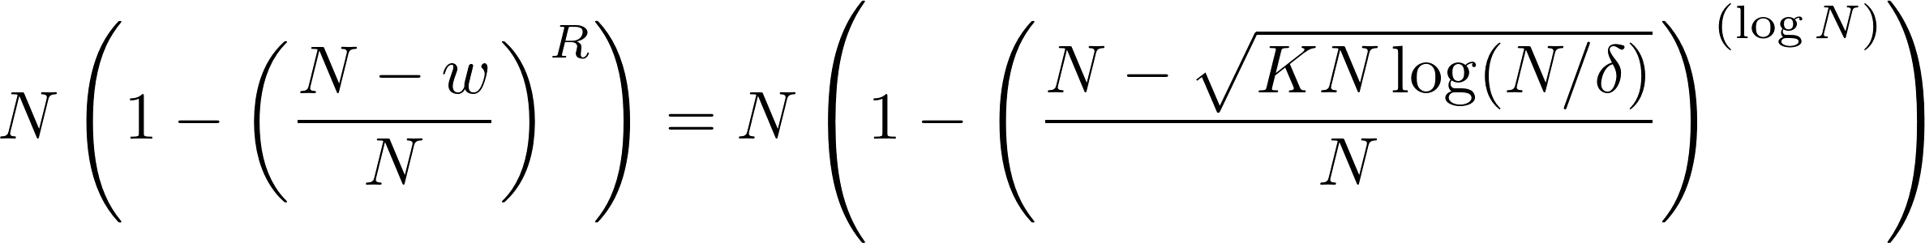.
B The sFFT2.0 algorithm by one-shot framework
As is shown in the Figure 1, sFFT2.0 is very similar to sFFT1.0. Additional another bucketization and location round are used with the frequency aliasing filter to restrict the locations of the large coefficient. Let M be the size of the aliasing filter and M divides N, it does a pre-processing stage as below. Firstly Obtain 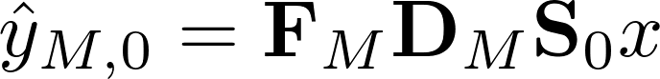, then union of 2K sets from M sets {0,M,...(L-1)M},…,{M-1,2M-1,...N-1} by selecting the 2K largest coefficients of magnitude of , 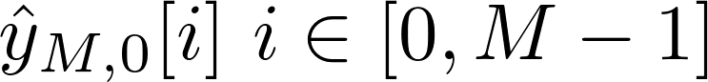 the union of 2K sets is set I’ , assuming that all large coefficients j have j mod M in I’. That is,we restrict out sets I_{r} talked above to contain only coordinates i with i mod M ∈ I’ ,we expect that |I_{r}| ≈ 2K/M·(2KN/B) rather than the previous |I_{r}| ≈ 2KN/B.
Then we analyze the performance of the sFFT2.0. In stage1 it is the same as the sFFT1.0, in stage2-step1 it cost R·(2K/M·2K·(N/B)+M) + MlogM runtime, in stage2-step 2 it is the same, totally it cost O(R·(w+BlogB+K²·N/(B·M)+M)+MlogM) runtime. And in fact the runtime satisfy Lemma 4.2.
Lemma 4.2: Suppose R=O(logN), w=Blog(N/δ), δ=1/(N^{c}), it cost 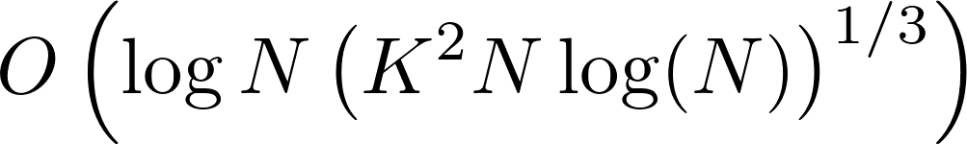runtime in sFFT2.0
(for B=)
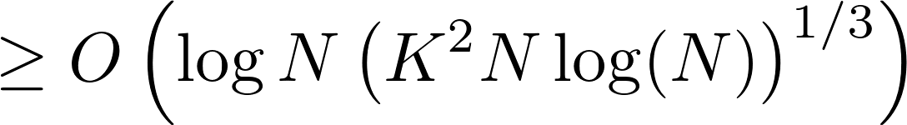 (for M =)
Compared to sFFT1.0, the runtime is factor (NlogN)^{1/6} smaller. In average the sample of sFFT2.0 chosen is in the number of +M=+M, compared to the sFFT1.0, w decreases so that the samples decreases as well.
C The sFFT3.0 algorithm by iterative framework
Compared to the one shot framework the iterative framework has two improvements. The first advantage of iterative framework is that once a frequency coefficient of the signal was found and estimated, it can be subtracted from the signal. This fact can be used to reduce the amount of work to be done in subsequent steps. It is not necessary to update the whole input signal. Instead, it is sufficient to update the B-dimensional buckets. This way the removal of the effects of already found coefficients can be done in O(B) time. The second important improvement in iterative framework is an improved method for finding the signal’s significant frequency coordinates rather than voting method by R times’ rounds. In one-shot framework, R times’ rounds are run and their results combined in order to get correct locations at a high probability. In the iteration algorithms, two or log₂L rounds is enough by their own ways.
In the No.m' iteration, let K_{m} be the expected sparsity, R_{m} be how many rounds in the No.m' iteration, B_{m} be the the number of buckets, L_{m} be the size of one bucket, w_{m} be the support of filter G, be filtered spectrum, be update spectrum, be last result, be spectrum need to recover, be the recovered spectrum, be the new result, set τ ={τ₁ .. τ_{R}}, set σ ={σ₁ .. σ_{R}} be parameter. It can be seen that R_{m} = 2 in sFFT3.0 algorithm, R_{m} = log_{l}L_{m} in sFFT4.0 algorithm and R_{m} = log₂L_{m} in MPSFT algorithm. The detail course in No.m' iteration is shown in Figure2 and explained as follows.
Figure 2. A system block diagram of iteration algorithms
Step1:
x
τ
σ
Step4:
Spectrum
reconstruction

Step2:
obtain
….
Step3: -
….
….
τ
σ
Step5: +
Step1: Run R_{m} bucketization rounds for K_{m}, B_{m}, L_{m}, set τ={τ₁,τ₂,..τ_{R}} and set σ = {σ₁, σ₂,..σ_{R}} to calculate representing filtered spectrum.
Step2: Run R_{m} times’ rounds for, set τ, set σ and formula(21) to obtain representing spectrum have already gained.
Step3: = -representing spectrum need to recover.
Step4: recover the spectrum of by different methods.
Step5: =+representing the result of this iteration.
Step6: If it is last iteration, the final result is, otherwise will be the input to make for the next iteration.
It is sufficient to locate the position only using R=2 in stead of R≈logN rounds by the phase encoding method in sFFT3.0 algorithm in the exactly sparse case. The process is in the first round we set τ₁ =0, and the second round we set τ₂ =1, then suppose in a bucket i, it contains only one large frequency, so we get and, then
, so we can locate the position f = σ⁻¹(u)modN. As to estimate the value identified, it is similar to the process of sFFT1.0 algorithm. Finally we analyze the performance of the sFFT3.0. And in fact it satisfied Lemma 4.3.
Lemma 4.3: In sFFT3.0 algorithm, it cost O(KlogN) runtime and O(KlogN) samples
Proof: In the first iteration, suppose w₁=B₁log(N/δ), K₁=K, it cost 2·(w₁+B₁logB₁+ K₁) = O(B₁logN) runtime and find at least K/2 true frequency, In the second iteration, suppose B₂ =B₁/2, w₂=B₂log(N/δ), K₂=K/2, first step to obtain, it cost 2·(w₂+B₂logB₂) runtime, second step to obtain , it cost 2K₁ runtime, third step to obtainit cost 2B₂, fourth step to recover the spectrum it cost K₂ , fifth step to obtainit cost K₂, it total cost O(w₂+B₂logB₂₊K₁) < O(B₁logN)/2 , so the total cost is O(B₁logN) + O(B₁logN)/2 +… =O(B₁logN) = O(KlogN). As to the sampling complexity, it is clearly that the samples chosen after two rounds in the first iteration is in the number of 2w₁=2B₁log(N/δ) = O(KlogN), as to the samples of the following iterations, it can be ignored because of the decrease of B.
D The sFFT4.0 algorithm by iterative framework
Compared with the sFFT3.0 algorithm, only step 4 of sFFT4.0 algorithm is different. In sFFT3.0 algorithm, it is sufficient to locate the position only running two rounds in the noiseless case in advance of it satisfies Lemma 4.4. In sFFT4.0 algorithm, it is sufficient to locate the position only running R(=log_{l}L) times’ round by the multiscale phase encoding method in advance of it satisfies Lemma 4.5.(let l be the multiscle parameter).
Lemma4.3: In sFFT3.0 algorithm, the algorithm guarantee must be required as Eq(20), S_{τ}[i] is defined as the noisy in the bucket i, it meets Eq(19), S₀[i] is the noisy in the bucket i when τ = 0, S₁[i] is the noisy in the bucket i when τ = 1, the position from the measurement is u’, the real position is u.
(19)
(20)
proof: See the Pic

Lemma4.4: In sFFT4.0 algorithm, the algorithm guarantee must be required as Eq(18), S_{τ} [i] is the noisy in the bucket i , the position from the measuremet is u’, the real position is u, L is the range in this measuremet, l is the multiscle parameter:
(21)
proof: See the Pic
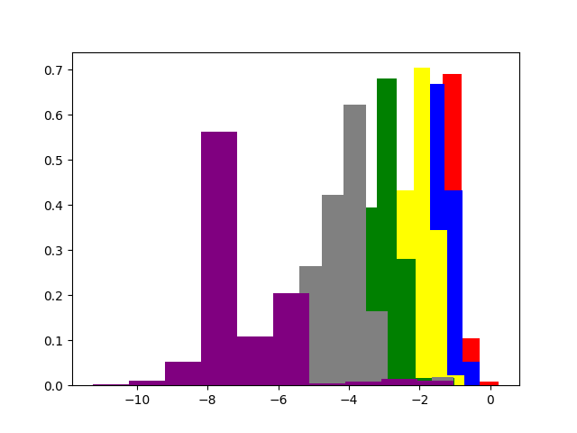
It is clear that the conditions are very harsh in sFFT3.0 when N is large so sFFT3.0 algorithm is not robustness. From the lemma9, it is most robustness when we use binary search (l=2), because the confidence space is very large, but it is not effective. We want to know how to set the confidence space of multiscle parameter l, we do it by Monte Carlo experiment, we do two categories experiments to calculate the logarithm of the error of phase differenceand computing PDF(Probability Distribution Function) of the value by the signals of different K and N under different SNR circumstances if the bucket is not aliasing, then we get the Fig. 3. From the Fig. 3, we can see with the develop of SNR, the the probability of small error variance increases. Compare the two situations of small N and big N with the same K, if N is big, it means in one bucket the noisy has less energy compared with effective signal, it can be concluded both in the theory and in experiments that the error variance becomes smaller when N is big. From the pic3, if we want to keep the probability greater than 0.99, when SNR = -20(red space), the threshold should be more than 10^{0.5} ≈ 3.2 , it seems impossible. When SNR = -10(blue space), the threshold should be more than 10⁰ ≈ 1, it can be solved by binary search method because the confidence space is π/2 ≈ 1.7. When SNR=0(yellow space), the threshold should be more than 10^{-0.5} ≈ 0.3, and when SNR>0, it is certain to keep the the high probability if the threshold is more than 0.3. (Remarks: It is easy to know the PDF of the error of phase difference will not change much of different τ)
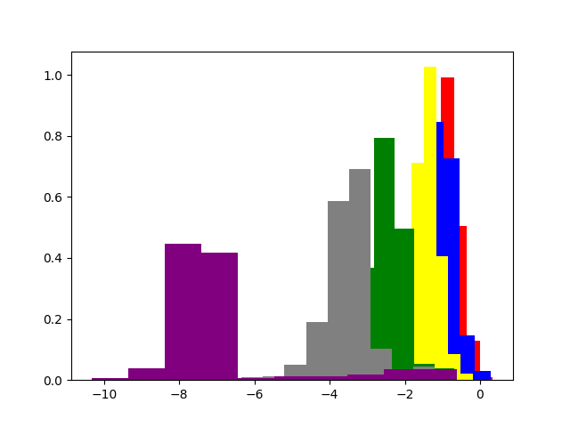
Fig. 3.(a) PDF of the error of phase difference vs SNR when K=50 and N=1048576 Fig. 3.(b) PDF of the error of phase difference vs SNR when K=50 and N=8192
In the real algorithm sFFT4.0, we use l =8, the confidence space is π/8 ≈ 0.4. As to the runtime complexity we can easy to get it should run log_{l}L rounds instead of two rounds in every iteration, so the the runtime and sampling complexity is O(KlogNlog₈(N/K)).
E The Algorithm MPSFT by iteration framework
The matrix pencil method, like the Prony method, is a standard technique in signal processing for mode frequency identification. In this chapter, we use the matrix pencil method into the sFFT4.0 algorithm to achieve two effects. Firstly, it identifies modes much more accurately. Secondly, it helps detect errors in our mode identification step and greatly reduces the number of spurious modes being found. Rely on these, we can use only a little cost to solve the collision problem.
Define that there are a significant frequencies in the bucket i. In most buckets a=0, in a part of buckets a=1, only in a small part of buckets a >=2. Then the Eq(19) can be translated to the Eq(20), the problem to reconstruct spectrum is translated to how to calculate 2a variables as below a amplitudes(,...） and a locations（,...), it needs 2a equations, whereis known and denoted as m_{τ} =, p_{j} represent unknown, z_{j} represent unknown. By taking the above into consideration, the problem can be formulated by BCH codes as Eq(21).
(20)
₌ (21)
(22)
Suppose there are at most a_{m} significant frequencies in the bucket. By doing SVD for the matrix M_{m} defined as Eq(22) in bucket i, then obtain a_{m} singular values for each frequency. For example we can set a_{m} equal to two, then obtain two singular values by doing SVD. If two singular values are both small, it means there is no significant frequency. If there is only one big singular value, it means there is one significant frequency. If both of them are big, it means there are more than one significant frequencies. The way to solve the collision problem is as above, as to distinguish the position of the frequency, the platform is very similar to the sFFT4.0 use binary search and the judgement formula is inspired by the matrix pencil method. The detail can seen the paper[]. It is sufficient to locate the position and estimate the value of frequencies only using R=log₂L rounds in MPSFT, the runtime and sampling complexity in algorithm is approximately equal to O(KlogNlog₂(N/K)).
After analyzing two types of frameworks, five different methods to reconstruct spectrum and corresponding algorithms, Table II can be concluded with the addition information of other sFFT algorithms.
Table II: The performance of the sFFT algorithms in theory
algorithm | runtime complexity | average sampling complexity | robustness
sFFT1.0 |  |  | good robustness
sFFT2.0 |  |  | good robustness
sFFT3.0 | KlogN | KlogN | non robustness
sFFT4.0 | KlogNlog₈(N/K) | KlogNlog₈(N/K) | medium robustness
MPFFT | KlogNlog₂(N/K) | KlogNlog₂(N/K) | good robustness
sFFT-DT | KlogK+N | KlogK+N | good robustness
FFAST | KlogK | KlogK | non robustness
R-FFAST | Klog⁴N | Klog⁴N | good robustness
AAFFT | K poly(log(N)) | K poly(log(N)) | good robustness
FFTW | NlogN | N | good robustness
From the table we can see sFFT3.0 algorithm is lowest runtime and sampling complexity, but it is non robustness. Other algorithms using flat window are good robustness but compare them with other sFFT algorithms it is no advantage in the sampling complexity except sFFT4.0.
V. Experimental Evaluation
In this chapter we evaluate the performance of five sFFT algorithms using flat window filter: sFFT1.0, sFFT2.0, sFFT3.0, sFFT4.0, and MPSFT. All of them were implemented in C++ in order to empirically evaluate their runtime characteristics. We firstly compare these algorithms’ runtime, percentage of signal sampled and robustness characteristics with themselves. Then we compare these algorithms’ characteristics with other algorithms: fftw, sFFT-DT, FFAST and AAFFT. Finally we compare these algorithms’ runtime characteristics with themselves optimized. All experiments are run on a Linux CentOS computer with 3.0GHz CPU, a cache size of 6144 KB and 8 GB of RAM.
A Experimental Setup
In experiment, the test signals are gained in a manner that K frequencies are selected from N frequencies uniformly at random and assigned a magnitude of 1 and a uniformly random phase and the rest frequencies are set to zero in exactly case. When in general sparse case, the test signals are gained similarly but they are combined with additive white Gaussian noise, whose variance varies depending on the SNR required. Each point in the figure is the average result over 5 runs with 5 different instances as desired. The parameters of these algorithms are chosen so that can make a balance between time efficiency and robustness.
B Comparison experiment about different algorithms using the flat filter of themselves
We plot Figure 4(a), 4(b), 4(c) and 4(d), they represent run times vs. Signal Size and vs. Signal Sparsity for sFFT1.0, sFFT2.0, sFFT3.0, sFFT4.0 and MPSFT in exactly sparse case and general sparse case.
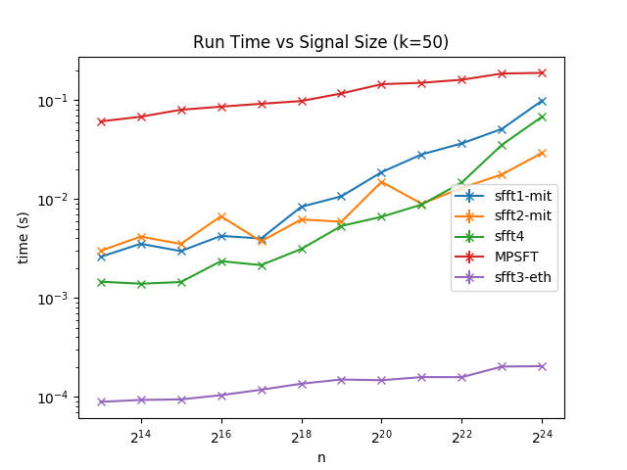
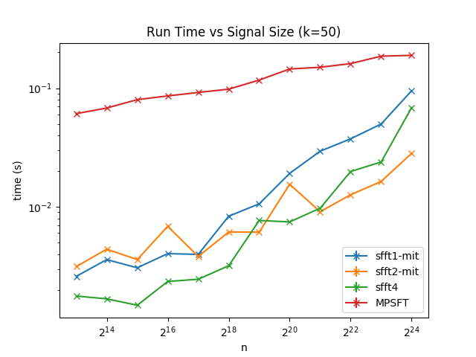
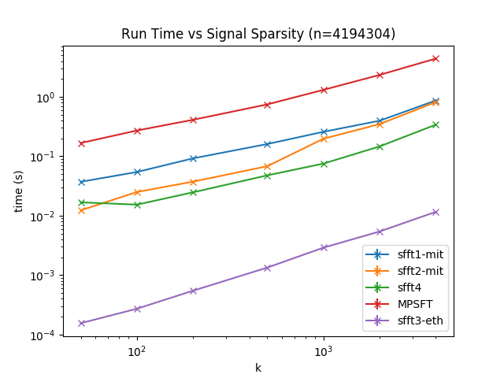
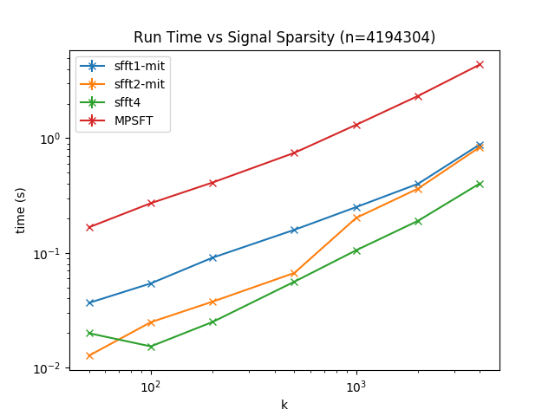
Figure 4(a): Run time vs. Signal Size in the exactly sparse case
Figure 4(b): Run time vs. Signal Size in the general sparse case
Figure 4(c): Run time vs. Signal Sparsity in the exactly sparse case
Figure 4(d): Run time vs. Signal Sparsity in the general sparse case
As mentioned above, runtime is determined by two factors. One is how many rounds(it manly depend on R) and how much time cost in one round(it manly depend on w). So from the Figure4 we can see 1) The run time of these 5 algorithms are approximately linear in the log scale as a function of N and in the standard scale as a function of K. The reason is R and w is with the growth of logN and K. 2) Among these 5 algorithms,the rank of runtime complexity is sFFT3.0 > sFFT4.0 > sFFT2.0 > sFFT1.0 > MPSFT. The reason is their individual’s R is about 2, 2log₈L, approxiate logN, logN and 2log₂L.
We plot Figure 5(a), 5(b), 5(c) and 5(d), they represent percentage of signal sampled vs. Signal Size and vs. Signal Sparsity for sFFT1.0, sFFT2.0, sFFT3.0, sFFT4.0, and MPSFT in exactly sparse case and general sparse case.
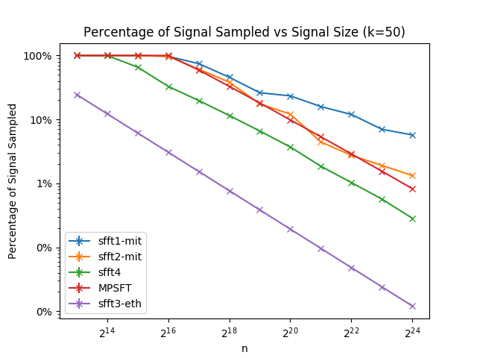
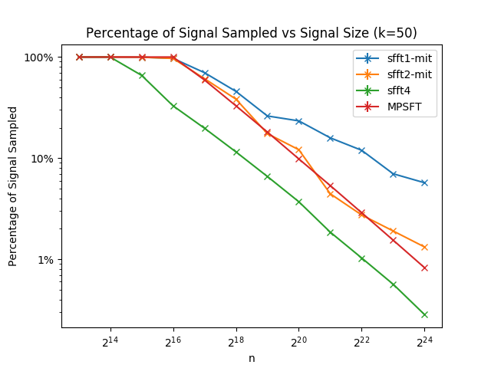
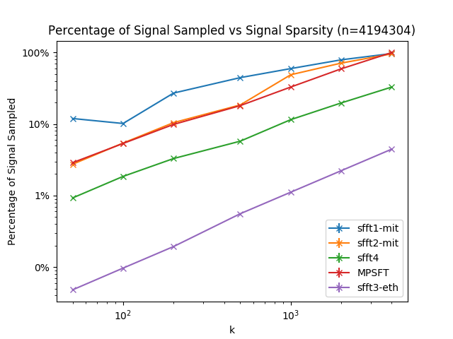
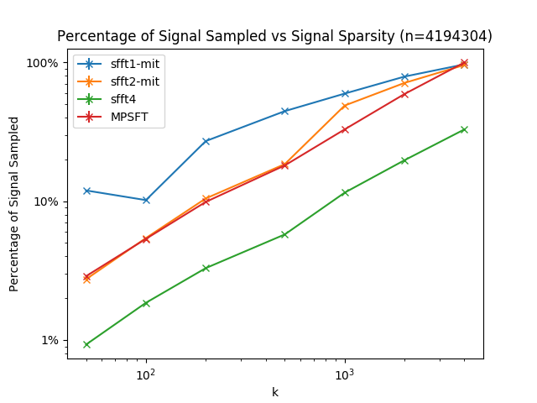
Figure 5(a): Percentage of Signal Sampled vs. Signal Size in the exactly sparse case
Figure 5(b): Percentage of Signal Sampled vs. Signal Size in the general sparse case
Figure 5(c): Percentage of Signal Sampled vs. Signal Sparsity in the exactly sparse case
Figure 5(d): Percentage of Signal Sampled vs. Signal Sparsity in the general sparse case
As mentioned above, percentage of signal sampled is also determined by two factors: how many rounds and how many samples sampled in one round. So from the Figure5 we can see 1) The percentage of signal sampled of these 5 algorithms are approximately linear in the log scale as a function of N and in the standard scale as a function of K. 2) Among these 5 algorithms,the rank of sampling complexity is sFFT3.0 > sFFT4.0 > MPSFT > sFFT2.0 > sFFT1.0 because of the different R.
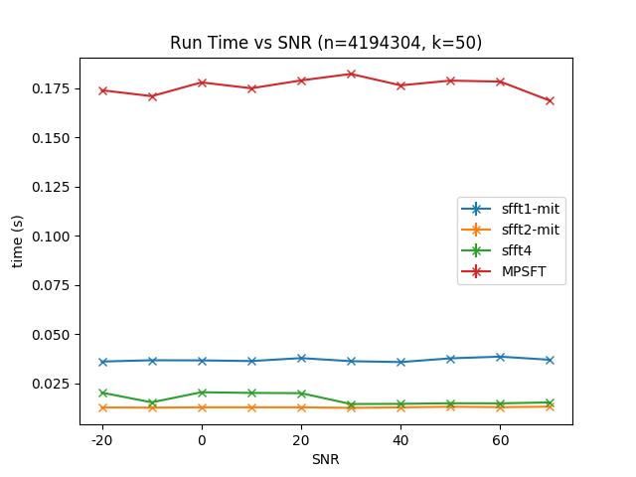
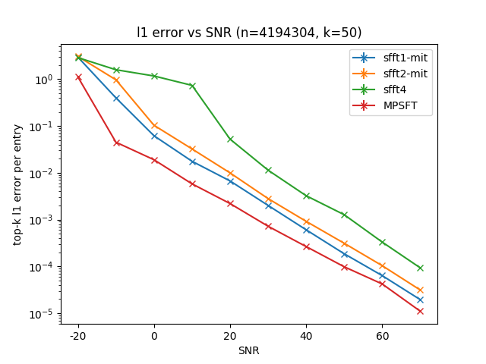
We plot Figure 6(a), 6(b), they represent runtime and L₁-error vs SNR for sFFT1.0, sFFT2.0, sFFT3.0, sFFT4.0, and MPSFT. We plot 6(c) and 6(d), they represent L₀-error vs Signal Sparsity in exactly sparse case and L₁-error vs Signal Sparsity in general sparse case.

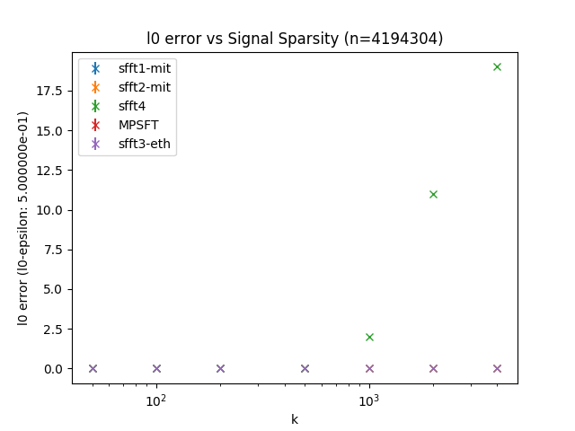
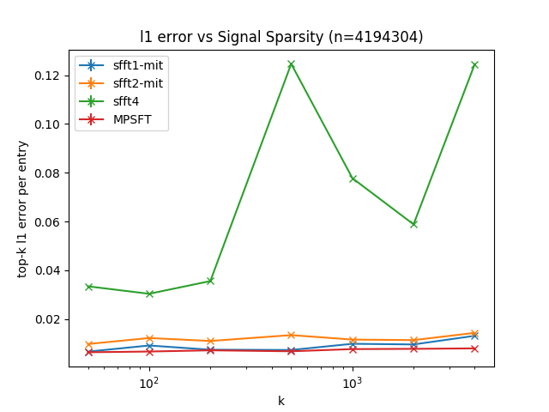
Figure 6(a): Run time vs. SNR in the general sparse case
Figure 6(b): L₁-error vs. SNR in the general sparse case
Figure 6(c): L₀-error vs. Signal Sparsity in the exactly sparse case
Figure 6(d): L₁-error vs. Signal Sparsity in the general sparse case
From the Figure6 we can see 1) the run time is approximately equal vs SNR. 2) To a certain extent these 4 algorithms are all robustness, but when SNR is low, only MPSFT satisfies the ensure of robustness. When SNR is medium, sFFT1.0 and sFFT2.0 can also meet the ensure of robustness. And only when SNR is bigger than 20db, sFFT4.0 can deal with the noise interference. The reason is that the way of binary search is better than voting method under large noisy surrounding. And the way of mulitscale search is not good when it use in noisy situation. 3) the performance of sFFT4.0 is not very good in the exactly sparse case and the general sparse case.
C Comparison experiment about algorithms using the flat filter and other sFFT algorithms
We plot Figure 7(a)and7(b), they represent run times vs. Signal Size and vs. Signal Sparsity for sFFT1.0, sFFT4.0, AAFFT, FFAST, SFFT-DT and fftw in general sparse case.
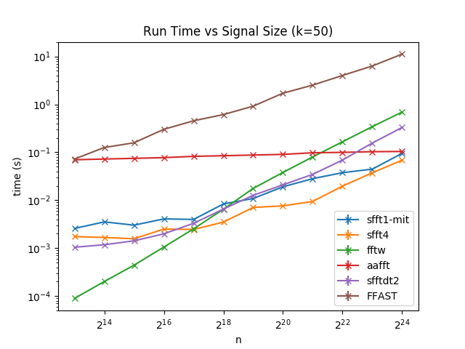
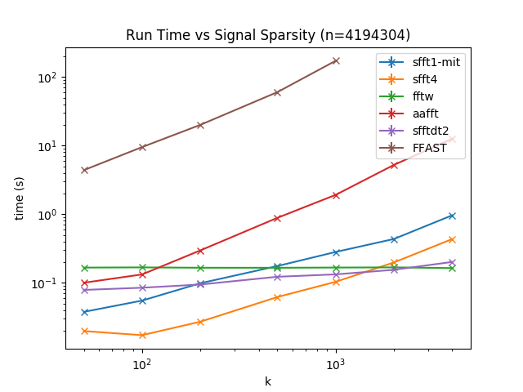
Figure 7(a): Runtime vs. Signal Size in the general sparse case
Figure 7(b): Runtime vs. Signal Sparsity in the general sparse case
From the Figure, we can see 1) These algorithms are approximately linear in the log scale as a function of N except fftw. These algorithms are approximately linear in the standard scale as a function of K except fftw and SFFT-DT. 2) Among these 5 algorithms, the rank of runtime complexity is sFFT4.0 > sFFT1.0 > AAFFT > SFFT-DT > fftw > FFAST when N is large. The reason is LASSO (Least Absolute Shrinkage and Selection Operator)method used in R-FFAST cost a lot of time. And SVD and CS method used in SFFT-DT will also cost a lot of time. 2) Among these 5 algorithms, the rank of runtime complexity is fftw > SFFT-DT > sFFT4.0 > sFFT1.0 > AAFFT > FFAST when K is large. The reason is algorithms using aliasing filter saving the time by using a small number of buckets in the first stage compared to algorithms using flat filter.
We plot Figure 8(a)and8(b), they represent percentage of signal sampled vs. Signal Size and vs. Signal Sparsity for sFFT1.0, sFFT4.0, AAFFT, FFAST, SFFT-DT and fftw in general sparse case.
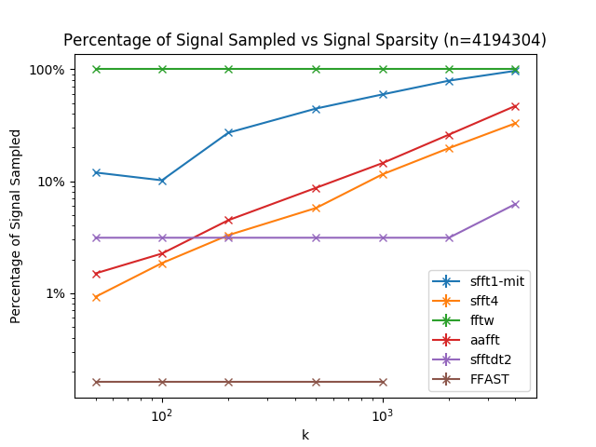
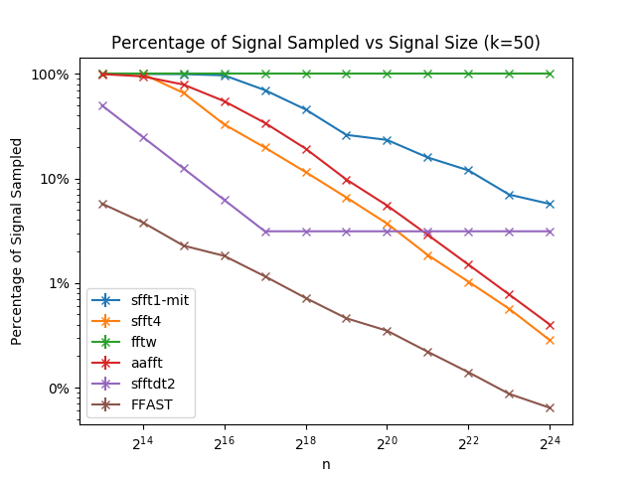
Figure 8(a): Percentage of signal sampled vs. Signal Size in the exactly sparse case
Figure 8(b): percentage of signal sampled vs. Signal Sparsity in the general sparse case
From the Figure, we can see 1) These algorithms are approximately linear in the log scale as a function of N except fftw and SFFT-DT. Because it is a limit to the size of bucket in SFFT-DT by using CS and SVD method. These algorithms are approximately linear in the standard scale as a function of K except FFAST and SFFT-DT. The reason is algorithms using aliasing filter saving the time by using less number of buckets. 2) Among these 5 algorithms, the rank of sampling complexity is FFAST > sFFT4.0 > AAFFT > SFFT-DT > sFFT4.0 > fftw when N is large. 2) Among these 5 algorithms, the rank of sampling complexity is SFFT-DT > sFFT4.0 > AAFFT > sFFT4.0 > fftw when K is large. The reason is that algorithms using aliasing filter need less buckets than other algorithms, the number of the buckets they use is only connect to the prime numbers gained by N.
We plot Figure 9(a), 9(b), they represent runtime and L₁-error vs SNR for sFFT1.0, sFFT4.0, AAFFT, SFFT-DT and fftw.
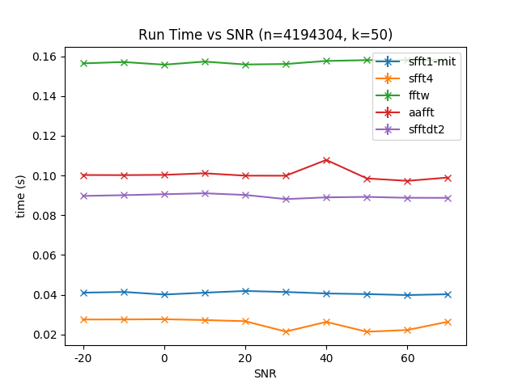
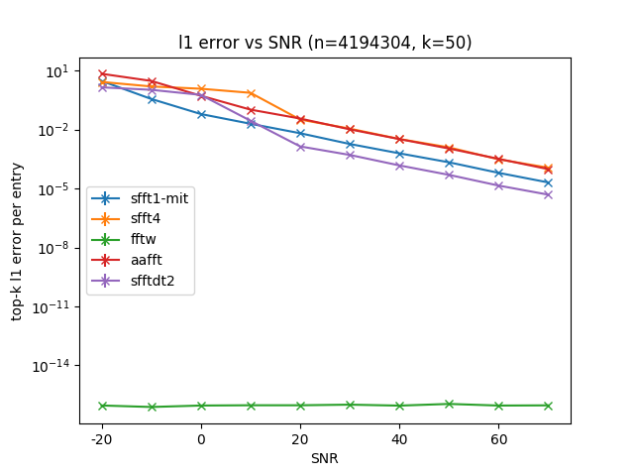
Figure 9(a): Run time vs. SNR in the general sparse case
Figure 9(b): L₁-error vs. SNR in the general sparse case
From the Figure9 we can see 1) the run time is approximately equal vs SNR. 2) To a certain extent these 5 algorithms are all robustness, but when SNR is low, only fftw satisfies the ensure of robustness. When SNR is medium, sFFT1.0, AAFFT and SFFT-DT can also meet the ensure of robustness. And only when SNR is bigger than 20db, sFFT4.0 can deal with the noise interference.
D Comparison experiment about same algorithm of optimization and without optimization
We plot Figure 10(a)and10(b), they represent run times vs. Signal Size and vs. Signal Sparsity for sFFT1.0-mit, sFFT2.0-mit, sFFT1.0-eth and sFFT2.0-eth in general sparse case.
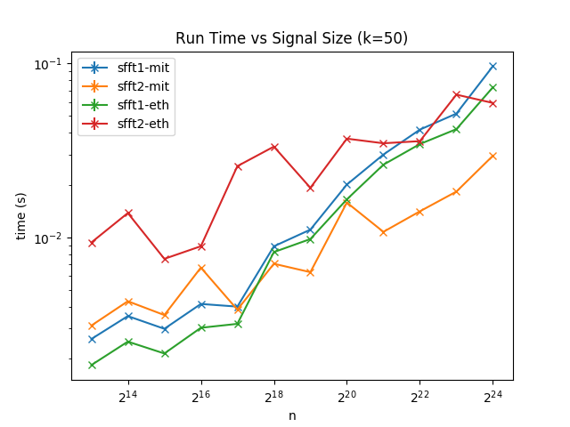
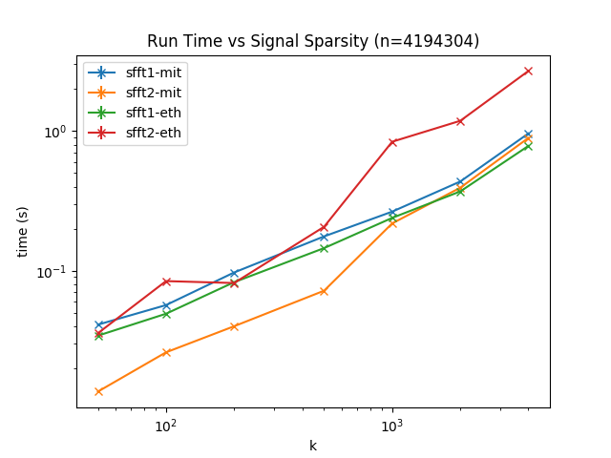
Figure 10(a): Runtime vs. Signal Size in the exactly sparse case
Figure 10(b): Runtime vs. Signal Sparsity in the general sparse case
From the Figure, we can see the run time of a same algorithm is accelerated a lot by the use of software optimization.
VI Conclusion
In the first part, the paper introduces the techniques use in sFFT including random spectrum permutation, window function and frequency bucketization. In the second part, we analyze 5 typical algorithms using flat filter in detail including sFFT1.0 algorithm using voting method, sFFT2.0 algorithm using heuristic vote method by one shot framework and sFFT3.0 algorithm using phase encoding method, sFFT4.0 algorithm using multiscale phase encoding method, MPSFT algorithm using matrix method by iteration framework. We get the conclusion of the performance of these algorithms including runtime complexity, sampling complexity and robustness in theory in Table II. In the third part, we make three categories of experiments for computing the signals of different SNR, different N, and different K by a standard testing platform and record the run time, percentage of signal sampled and L₀,L₁,L₂ error in every different situations both in exactly sparse case and general sparse case. The analyze of the experiment result satisfy theoretical inference.
The main contribution of this paper is 1) develop a standard testing platform which can test more than ten typical sFFT algorithms in different situations on the basic of an old platform 2) get a conclusion of the character and performance of the 5 typical sFFT algorithms using flat filter: sFFT1.0, sFFT2.0, sFFT3.0, sFFT4.0, and MPSFT in theory and in practice.
APPENDIX
A. Proof of Claim 1
Claim 1: if x' ∈ ℂ^{N}, x'= S_{-τ}P_{σ}x, then x_{i}' = x_{σ(i-τ)} and.
Proof:
see the picture1

B. Proof of Lemma 1
Lemma 1: if x' ∈ ℂ^{N}, x'= S_{-τ}P_{σ}x, then and .
Proof:
x'= S_{-τ}P_{σ}x, then x_{i}' = x_{σ(i-τ)}

C. Proof of Lemma 2
Lemma 2: ifthen

Proof:
see the picture2

D. Proof of Lemma 3
Lemma 3: ifthen.
Proof:
see the picture(Haitham书的数的page 27)

E. Proof of Lemma 4
Lemma 3:
(21)
(22) then

Proof:
1)首先,如果x'= S_{-τ}P_{σ}x, then and .

2)其次 计算
3)再有ifthen.

结合1 2 3 得到结论

Pic1:
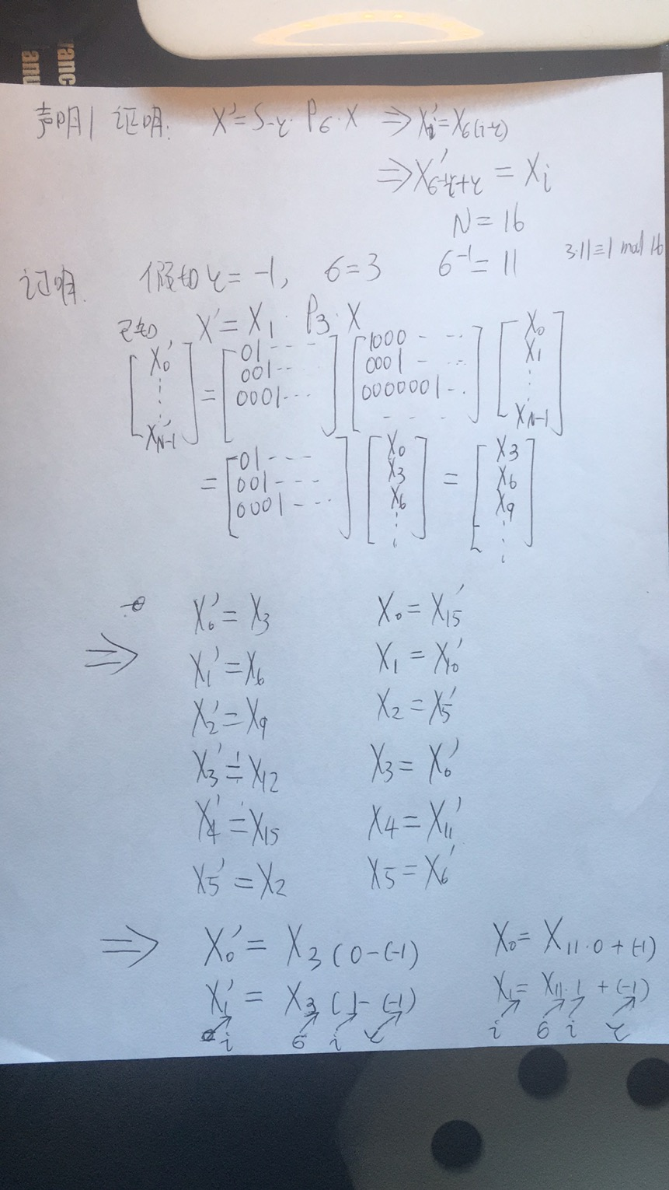

Pic 2
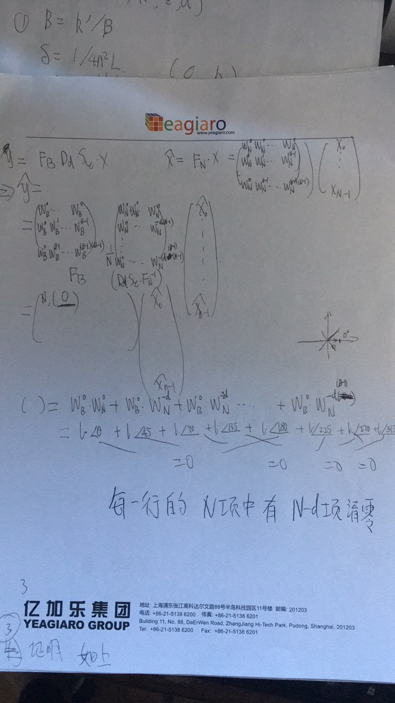
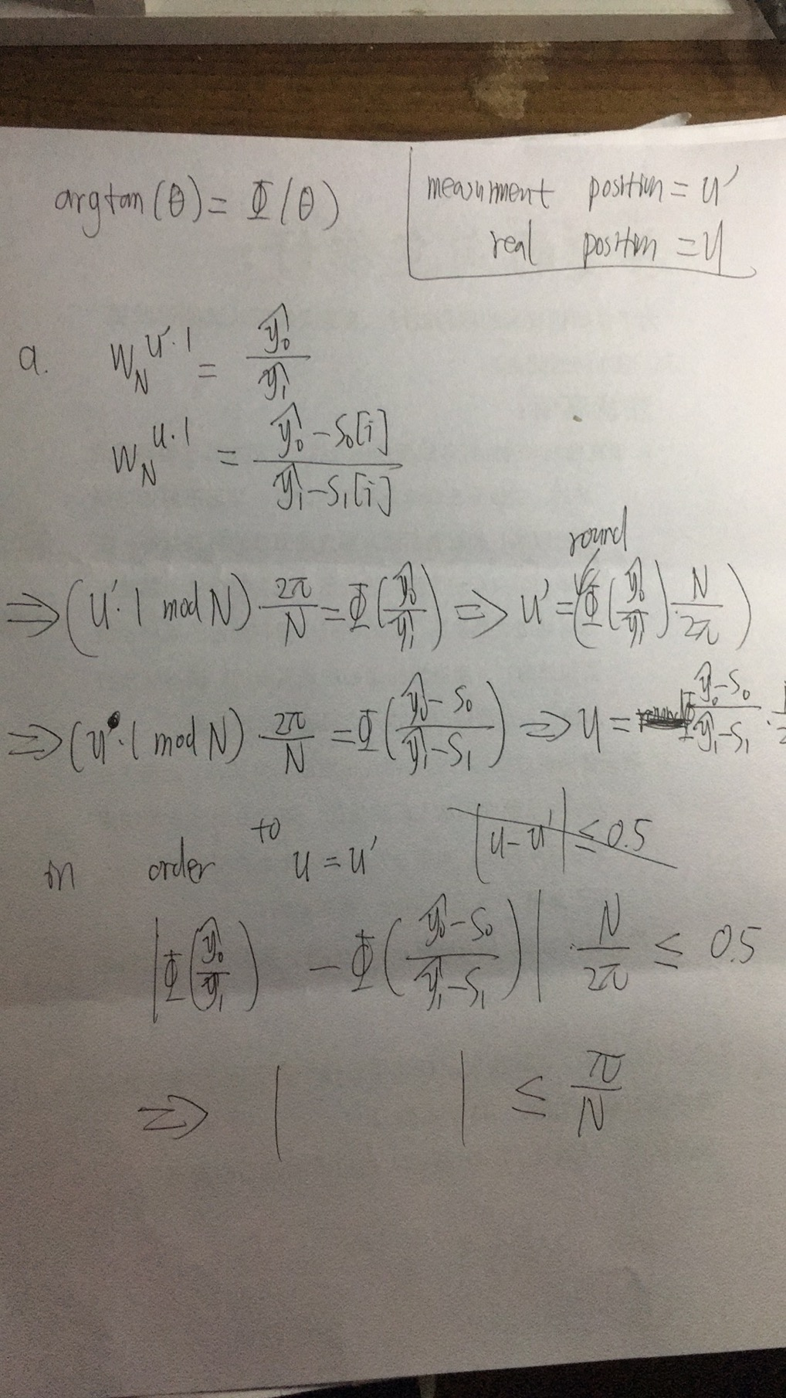
Pic3:
Pic4:
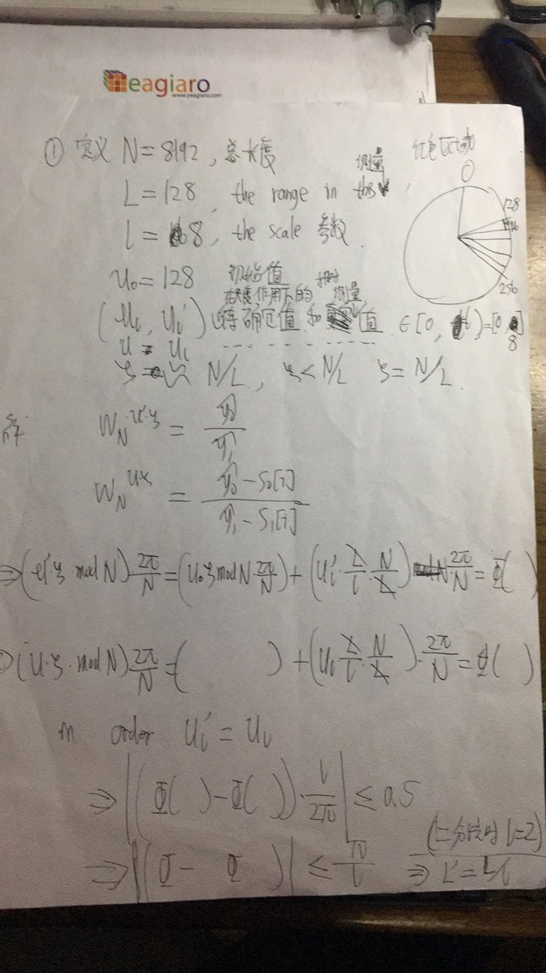
Reference
[1] A. Gilbert, S. Guha, P. Indyk, S. Muthukrishnan, and M. Strauss. Near-optimal sparse Fourier representations via sampling. Symposium on Theory of Computing, 2002, pp. 152-161.
[2] M. Iwen, A. Gilbert, M. Strauss, etal. Empirical evaluation of a sub-linear time sparse dft algorithm. Communications in Mathematical Sciences, 5(4):981–998, 2007.
[3] A. C. Gilbert, M. J. Strauss, and J. A. Tropp. A tutorial on fast fourier sampling. IEEE Signal Processing Magazine, 25(2):57–66, 2008.
[4] Pawar, S., Ramchandran, K.: Computing a k-sparse n-length discrete Fourier transform using at most 4k samples and o(k log k)complexity. In: 2013 IEEE International Symposium on Information Theory, pp. 464–468 (2013). doi:10.1109/ISIT.2013.6620269
[5] Pawar S , Ramchandran K . FFAST: An Algorithm for Computing an Exactly $ k$ -Sparse DFT in $O( k\log k)$ Time[J]. IEEE Transactions on Information Theory, 2017, 64(1):429-450.
[6] Pawar S , Ramchandran K . R-FFAST: A robust sub-linear time algorithm for computing a sparse DFT[J]. IEEE Transactions on Information Theory, 2017:1-1.
[7] A Fast and Robust Paradigm for Fourier Compressed Sensing Based on Coded Sampling
[8] S.-H. Hsieh, C.-S. Lu, and S.-C. Pei, “Sparse fast Fourier transform by downsampling,” Proc. IEEE Int. Conf. Acoust., Speech Signal Process., 2013, pp. 5637–5641.
[9] M. A. Iwen. Combinatorial sublinear-time Fourier algorithms. Foundations of Computational Mathematics,10:303 – 338, 2010.
[10] M. A. Iwen. Improved approximation guarantees for sublinear-time Fourier algorithms. Applied and Computational Harmonic Analysis, 34:57–82, 2013.
[11] Andrew Christlieb, David Lawlor, and Yang Wang. A Multiscale Sub-linear Time Fourier Algorithm for Noisy Data. Submitted, 2013. arXiv:1304.4517
[12] D. Lawlor, Y. Wang, and A. Christlieb. Adaptive sub-linear time Fourier algorithms. Advances in Adaptive Data Analysis, vol. 5, no. 1, 2013.
[13] Merhi S , Zhang R , Iwen M A , et al. A New Class of Fully Discrete Sparse Fourier Transforms: Faster Stable Implementations with Guarantees[J]. Journal of Fourier Analysis and Applications, 2018.
[14] G. Plonka, K. Wannenwetsch, A. Cuyt, and W. shin Lee, “Deterministic sparse FFT for M-sparse vectors,” Numerical Algorithms, 2018.
[15] H. Hassanieh, P. Indyk, D. Katabi, and E. Price, “Simple and practical algorithm for sparse fourier transform,” Proceedings of the Annual ACM-SIAM Symposium on Discrete Algorithms, pp. 1183–1194, 2012.
[16] ——, “Nearly optimal sparse fourier transform,” Proceedings of the Annual ACM Symposium on Theory of Computing, pp. 563–577, 2012.
[17] J. Chiu, “Matrix probing Fourier Transform,” Encyclopedia of Thermal Stresses, pp. 1742–1769, 2014.
[18] A. C. Gilbert, P. Indyk, M. Iwen, and L. Schmidt, “Recent Developments in the Sparse Fourier Transform,” IEEE Signal Processing Magazine, pp.1–21, 2014.
[19] M. Kapralov, “Sample efficient estimation and recovery in sparse FFT via isolation on average,” Annual Symposium on Foundations of Computer Science - Proceedings, vol. 2017-Octob, no. 1, pp. 651–662, 2017.
[20] P. Indyk, M. Kapralov, and E. Price, “(Nearly) sample-optimal sparse fourier transform,” Proceedings of the Annual ACM-SIAM Symposium on Discrete Algorithms, pp. 480–499, 2014.
[21] A. López-Parrado and J. Velasco Medina, “Efficient Software Implementation of the Nearly Optimal Sparse Fast Fourier Transform for the Noisy Case,” Ingeniería y Ciencia, vol. 11, no. 22, pp. 73–94, 2015.
[22] G. L. Chen, S. H. Tsai, and K. J. Yang, “On Performance of Sparse Fast Fourier Transform and Enhancement Algorithm,” IEEE Transactions on Signal Processing, vol. 65, no. 21, pp. 5716–5729, 2017.
[23] J. Schumacher and M. Püschel, “High-performance sparse fast Fourier transforms,” IEEE Workshop on Signal Processing Systems, SiPS: Design and Implementation, 2014.
[24] C. Wang, “CusFFT: A High-Performance Sparse Fast Fourier Transform Algorithm on GPUs,” Proceedings - 2016 IEEE 30th International Parallel and Distributed Processing Symposium, IPDPS 2016, pp. 963–972, 2016.
[25] S. Wang, V. M. Patel, and A. Petropulu, “Multidimensional Sparse Fourier Transform Based on the Fourier Projection-Slice Theorem,” IEEE Transactions on Signal Processing, vol. 67, no. 1, pp. 54–69, 2019.
[26] M. Kapralov, A. Velingker, and A. Zandieh, “Dimension-independent sparse fourier transform,” in Proceedings of the Annual ACM-SIAM Symposium on Discrete Algorithms, 2019.
[27] C. Pang, S. Liu, and Y. Han, “High-speed target detection algorithm based on sparse fourier transform,” IEEE Access, vol. 6, pp. 37 828–37 836, jul2018.
[28] O. Abari, E. Hamed, H. Hassanieh, A. Agarwal, D. Katabi, A. P. Chandrakasan, and V. Stojanovic, “A 0.75-million-point fourier-transform chip for frequency-sparse signals,” in Digest of Technical Papers - IEEE International Solid-State Circuits Conference, 2014.
[29] G. Plonka and K. Wannenwetsch, “A deterministic sparse FFT algorithm for vectors with small support,” Numerical Algorithms, vol. 71, no. 4, pp.889–905, 2016.
[30] ——, “A sparse fast Fourier algorithm for real non-negative vectors,” Journal of Computational and Applied Mathematics, vol. 321, pp. 532539,2017.Online].Available:http://dx.doi.org/10.1016/j.cam

