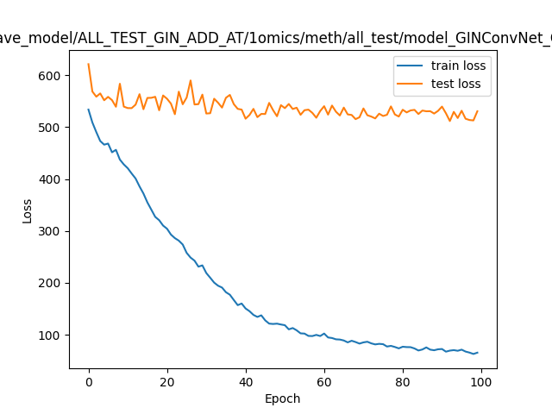
ave_model/ALL_TEST_GIN_ADD_AT/1omics/meth/all_test/model_GINConvNet
600
train loss test loss
Ilraturun
ummmmmmm
SS07
©
20
40
60
80
100
Epoch

