DENVER LAUNCH READINESS
The opening date is the risk | GreenThreads Operations | Analysis date: August 18, 2026
Lucas Diverdi | AI.205: AI Integration in Business I | Prof. Jeff Eyet | Homework #3
DECISION REQUEST: Confirm the required in-store date this week, then place both Vietnam launch orders on exception control. Release expedite or backup-source spend only after a verified milestone slip.
01 THE TIMELINE DOES NOT RECONCILE
Four departments are planning against four different dates, and the earliest one the lease allows falls after the date everyone is building toward. Operations inventory planning and HR training both target October 12, but the lease delivers the space on or about September 1 and states that build-out customarily requires six to eight weeks, which puts the earliest possible opening at October 13. No document in Operations, Finance, or HR states a required in-store date, which is the input OPS-04 step 1 begins with.
Source document | What it establishes | Implied date
SKU catalog (Operations) | Order-by dates plus lead times for all four launch SKUs | October 12 — planning assumption
HR offers + handbook 3.3 | Associates start Sept 28; two weeks paid training required | October 12 — zero slack, 7 of 14 seats filled
Lease §3.1 and §3.4 | Delivery on or about Sept 1; build-out customarily 6–8 weeks | October 13–27 — earliest open is Oct 13
Lease §4.2 | Rent starts on the earlier of opening or 60 days after delivery | October 31 — hard financial deadline
Required in-store date | OPS-04 step 1 requires it before any order is placed | NOT ESTABLISHED in any document
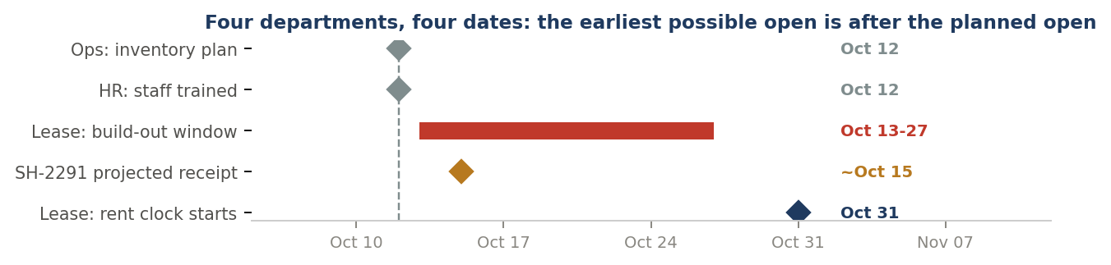
02 WHAT RIDES ON IT
Supplier risk is real but secondary to the date. Song Hong and Mekong were late on 100% of completed orders, averaging 12.1 and 6.9 days, and they supply the Bamboo Joggers and Active Shorts, which carry $143,700 of retail value and $88,800 of gross margin, half the launch. Song Hong's average rests on only 12 completed orders, so treat it as directional. Applying that mean to SH-2291's October 3 promise implies roughly an October 15 receipt, which is a planning inference rather than a forecast. Austin's 134 days of actual trading give the missing common unit: a realized gross margin of 61.4%, closely tracking the 62% the catalog assumes, worth about $3,100 of margin on an average day and $4,300 on a Saturday. Austin is an established store, so opening days should run above that, making it a conservative floor.
03 THE DECISION
Choice | Operating move | Days of selling protected | Trade-off
A. Hold | Keep the current plan and assume the store is ready October 12. | Zero. Leaves $88,800 of launch margin exposed on a date outside the lease window. | No cost today; plans against an unverified date.
B. Control | Confirm the required in-store date, require ex-factory, container-load and weekly milestones on both Vietnam POs, and test the two-week buffer. | Buys roughly two weeks of decision time at no freight cost. | Visibility creates no backup if a milestone slips.
C. Gate | Adopt B, re-baseline to the confirmed date, secure partial-expedite and backup quotes now, release spend only on a verified trigger, and set a standing three-day-late buffer rule. | Protects opening-weekend selling on both at-risk SKUs, roughly $3,100 of gross margin per day at the Austin rate and about $4,300 on a Saturday. | Coordination required; expedite cost stays quote-based until a trigger fires.
Recommendation: Approve Choice C, and treat confirming the required in-store date as action one. Every downstream number, order-by dates, buffer size, expedite triggers, and staffing, is calculated from that single date, and it is the one input no department currently supplies. Operations owns escalation, Procurement owns spend and sourcing, Legal owns contract terms, and the Store Manager confirms the date.
Tools, Method & Verification. Shipment, catalog, Austin sales, lease, and HR files analyzed in ChatGPT Work (reasoning tier) and Claude (Opus / Sonnet 4.6), independently recomputed in Python/pandas, and reproduced as live formulas in the linked workbook. Cleaning found 0 duplicate POs, 0 required-field gaps, 0 date/status conflicts, 0 line-cost errors, 0 catalog-mapping errors, and 0 Days_Late mismatches across 80 received rows; 16 in-transit blanks were preserved as unknowns and measured against the analysis date, and 3 launch buys were flagged as partial cartons for confirmation rather than changed. Limits we could not resolve: no dataset provided contains a Denver store, so all Denver figures are proxy-derived; the required in-store date is absent everywhere; and the HR applicant file lists the store as Denver-LoHi while the lease and offer letter say Cherry Creek North, which must be settled before any PO destination is finalized. Decision rights: AI calculates and flags; a human reviews every trigger and makes the final call.

