Manual for RaspberryShake (RS)

Overview
Step 1: Direct Ethernet connection — completed
Step 2: Access rs.local — completed
Step 3: Verify three-channel seismic data — completed
Step 4: Configure Internet access and time synchronization — completed
Step 5: Connect Ubuntu to the RS3D data stream using SeedLink and Python — completed
Step 6: Implement real-time earthquake detection and alerts — in progress
the manual from RS: https://manual.raspberryshake.org/
The default username and password:
username: myshake
password: shakeme

Step 1: Direct Ethernet connection
What is the RS3D? RS3D = Raspberry Shake 3D: a seismograph with three geophone sensors (vertical, north–south, east–west) and a digitizer, running on a Raspberry Pi 3 Model B. It records ground velocity on three channels EHZ, EHN, EHE at 100 samples per second and serves the data over the network (SeedLink, UDP).
1. Place the Shake on a solid, level floor (ground floor is best), away from doors, fans and footsteps.
2. Connect the Shake's Ethernet port directly to the Ubuntu laptop's wired port (enp2s0) with a network cable.
3. Power the Shake with its own power supply and wait 3–5 minutes for it to boot.
4. Without a DHCP server (no router), the Shake gives itself a link-local address in 169.254.0.0/16. Our device uses 169.254.221.62.
5. Check that the cable link is up on the laptop:
ip -br link show enp2s0 # expect: enp2s0 UP

Step 2: Configuration to access the website
Theo tài liệu chính thức của Raspberry Shake, để kết nối trực tiếp qua dây Ethernet, máy tính nên được cấu hình IP 169.254.8.11, cùng dải với địa chỉ Discovery IP của thiết bị.
1. Add the IP to existed Lan:
sudo ip addr add 169.254.8.11/16 dev enp2s0
2. Check IP address
ip -br addr show enp2s0
3. Ping RS3D
ping -c 4 rs.local

Then you can connect to the website of device: http://rs.local/
4. Make the IP permanent. The ip addr add command above is lost after a reboot. Add the address to the NetworkManager connection of enp2s0 instead:
nmcli -t -f NAME,DEVICE connection show # find the connection name of enp2s0
sudo nmcli connection modify "<connection name>" +ipv4.addresses 169.254.8.11/16
sudo nmcli connection up "<connection name>"
This is required for Step 4: the Shake gets its time from 169.254.8.11. If the laptop loses this IP, the Shake can no longer synchronize its clock.

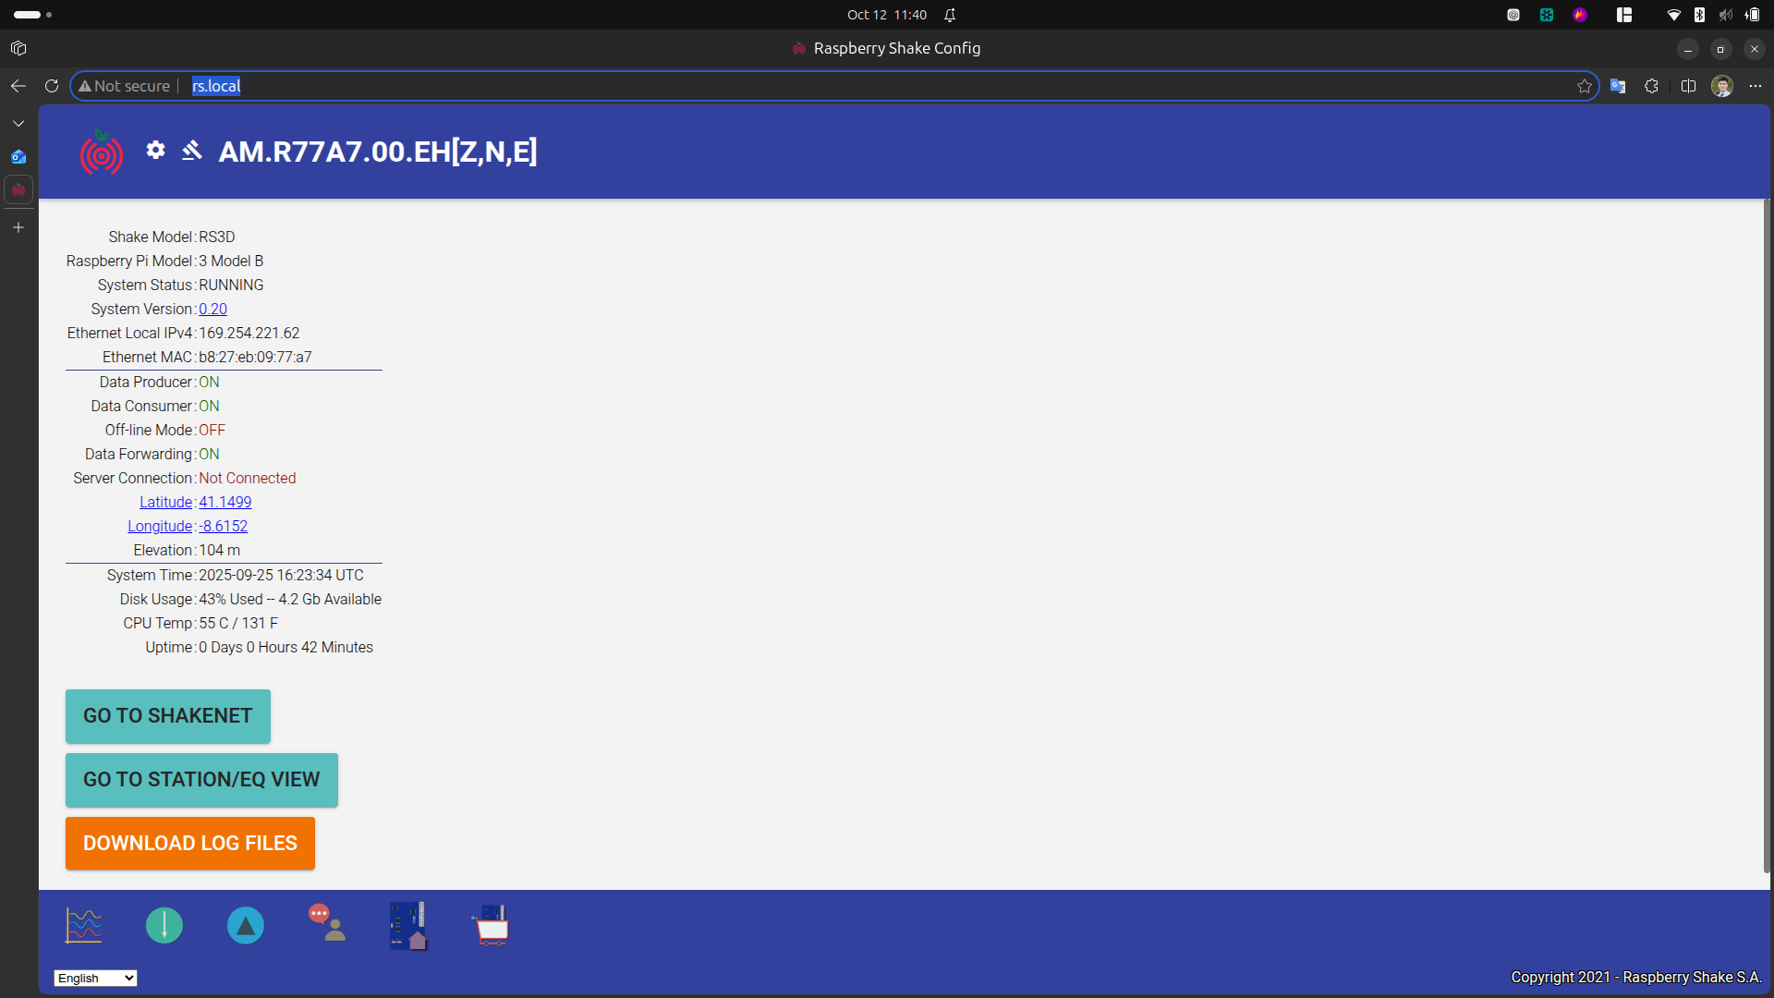Figure 1: The website of RS device

The device name
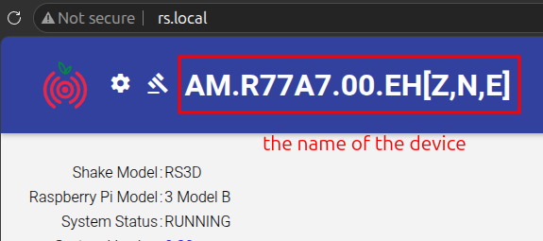Figure 2: The name of the device

Table 1: The meaning of the name.
Thành phần | Giá trị | Ý nghĩa
Network | AM | Mã mạng Raspberry Shake
Station | R77A7 | Mã trạm riêng của thiết bị
Location | 00 | Mã vị trí cảm biến
Channel | EHZ, EHN, EHE | Ba kênh đo địa chấn

Step 3: Verify three-channel seismic data
Goal: confirm that the Shake produces data on all three channels before building anything on top of it.
1. Check that the SeedLink port of the Shake is reachable:
nc -zv -w 3 169.254.221.62 18000
Expected: Connection to 169.254.221.62 18000 port [tcp/*] succeeded!
2. Ask the SeedLink server which streams it has (run in the project folder):
uv run python -c "
from obspy.clients.seedlink.easyseedlink import EasySeedLinkClient
c = EasySeedLinkClient('169.254.221.62:18000', autoconnect=False)
c.conn.timeout = 10
c.connect()
print(c.get_info('STREAMS'))"
3. Download the last 30 seconds of data from all three channels:
from obspy import UTCDateTime
from obspy.clients.seedlink.basic_client import Client
now = UTCDateTime()
client = Client('169.254.221.62', 18000, timeout=10)
st = client.get_waveforms('AM', 'R77A7', '00', 'EH?', now - 40, now - 10)
print(st)
st.plot()
This works with the laptop's current time only because the Shake clock is synchronized (Step 4). Before Step 4 the Shake was more than one year behind and this request returned nothing.
Result (12/10/2026):
Channel | Location | Sampling rate | Samples in 30 s | Status
AM.R77A7.00.EHZ | 00 | 100 Hz | 3001 | OK
AM.R77A7.00.EHN | 00 | 100 Hz | 3001 | OK
AM.R77A7.00.EHE | 00 | 100 Hz | 3001 | OK
4. Tap test: tap the floor next to the Shake while plotting live data (Step 5 or Step 6). A clear spike should appear on all three channels, largest on EHZ for a vertical tap.

Step 4: Configure Internet access and time synchronization
You can get the IP address of the device from the website:
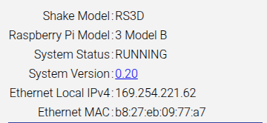Figure 3: The interness acess information from the website
The network need architecture

To check the laptop connect to TCP
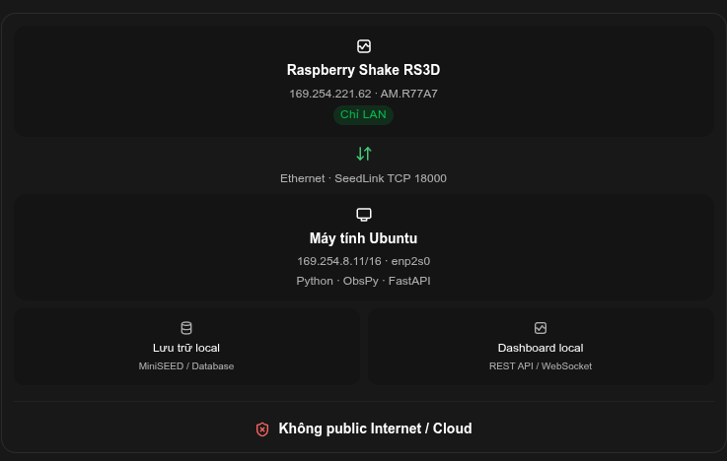Figure 4: the network architecture
nc -zv -w 3 169.254.221.62 18000
see: Connection to 169.254.221.62 18000 port [tcp/*] succeeded!
Please check the status of the device

Status: completed and verified on 12/10/2026. The Shake gets its time from the laptop (offset 0.015 ms) and all three channels carry the correct date.

4.1 Problem: the Shake clock is wrong
Symptoms before the fix:
• The website showed System Time 2025-09-25 while the real date was 2026-10-12.
• All data timestamps (SeedLink, rsudp, miniSEED) were dated 2025-09-25.
• Requests using the real time (UTCDateTime()) returned no data.
Causes:
• The Raspberry Pi has no battery-backed clock. After every boot it restarts from the last saved time and needs an NTP time server to correct it.
• The Shake is LAN-only (Figure 4). The NTP servers in its configuration (debian.pool.ntp.org, GPS, PPS) are all unreachable, so the clock was never corrected.

4.2 Solution: the laptop is the NTP server of the Shake
The laptop already keeps correct time from the Internet with chrony. We let chrony also give that time to the Shake over the Ethernet cable. The Shake keeps its LAN-only design; only the laptop uses the Internet.
Internet NTP servers → laptop: chrony (169.254.8.11) → Shake: ntpd (169.254.221.62)
stratum 2 stratum 3 stratum 4
Item | Laptop (server) | Shake (client)
Time service | chrony | ntpd.service
Config file | /etc/chrony/conf.d/shake-ntp.conf | /etc/ntp.conf
IP / port | 169.254.8.11 UDP 123 | 169.254.221.62
Check command | sudo chronyc clients | ntpq -p

4.3 Part A – On the laptop
A1. Check that the laptop itself has correct time
timedatectl
Expected: System clock synchronized: yes and NTP service: active.
A2. Allow the Shake network to ask chrony for the time
The main file /etc/chrony/chrony.conf contains confdir /etc/chrony/conf.d, so chrony reads every *.conf file in that folder. Create a new file instead of editing the main one:
sudo tee /etc/chrony/conf.d/shake-ntp.conf <<'EOF'
allow 169.254.0.0/16
local stratum 10
EOF
• allow 169.254.0.0/16: by default chrony only takes time and refuses to give it. This line lets every 169.254.x.x address (the Shake is 169.254.221.62) ask for the time.
• local stratum 10: keep serving time to the Shake even when the laptop has no Internet.
Check the address carefully: it is 169.254, not 192.254. A typo here makes chrony silently ignore the Shake (this happened during setup).
A3. Restart chrony
sudo systemctl restart chrony
systemctl is-active chrony # expect: active
A4. Open the NTP port in the firewall
ufw is active on the laptop and blocks incoming traffic. Open UDP 123 only on the cable to the Shake:
sudo ufw allow in on enp2s0 to any port 123 proto udp
A5. Verify
cat /etc/chrony/conf.d/shake-ntp.conf
ss -uln | grep ':123 ' # expect: 0.0.0.0:123

4.4 Part B – On the Shake
B1. Copy the laptop time to the Shake once
The Shake was more than one year behind. Set it close to the right time first, then NTP corrects the remaining seconds. Run on the laptop (login password: shakeme):
ssh myshake@rs.local "echo shakeme | sudo -S date -u -s @$(date +%s.%N)"
Inside double quotes, $(date +%s.%N) is computed on the laptop, so the Shake receives the laptop time. The command prints the new date of the Shake.
B2. Log in and find the time service
ssh myshake@rs.local
date -u; systemctl is-active ntp systemd-timesyncd chrony
ls /etc/ntp.conf /etc/systemd/timesyncd.conf /etc/chrony/chrony.conf
Result on our Shake:
Mon 12 Oct 15:50:21 UTC 2026
failed <- ntp
inactive <- systemd-timesyncd
inactive <- chrony
/etc/ntp.conf /etc/systemd/timesyncd.conf
B3. Understand the two ntp services
The Shake has two services that start ntpd. Only one of them can use UDP port 123:
Service | Origin | State | Use
ntpd.service | Raspberry Shake OS | active (running) | Yes – configure this one
ntp.service | Debian package | failed | No – leave it alone
Why ntp.service fails – its log says the port is already taken by the other ntpd:
sudo journalctl -u ntp -n 15 --no-pager
# ... unable to bind to wildcard address 0.0.0.0 - another process may be running - EXITING
Find the process that owns port 123 and the service that started it:
sudo ss -ulnp | grep ':123 ' # users:(("ntpd",pid=871,...))
systemctl status 871 --no-pager | head -5
# ● ntpd.service - Network Time Service
# ExecStart=/usr/sbin/ntpd -u ntp:ntp -f /etc/ntp.conf -p /run/ntpd.pid
Before the fix, ntpq -p listed only GPS and PPS sources, which never answer (no GPS module):
remote refid st t when poll reach delay offset jitter
==============================================================================
SHM(0) .GPS. 0 l - 16 0 0.000 0.000 0.000
SHM(1) .PPS. 0 l - 16 0 0.000 0.000 0.000
B4. Add the laptop as the preferred time server
sudo cp /etc/ntp.conf /etc/ntp.conf.bak # backup
sudo sed -i '1i server 169.254.8.11 iburst prefer' /etc/ntp.conf
grep -vE '^\s*(#|$)' /etc/ntp.conf
The effective configuration must start with the new line:
server 169.254.8.11 iburst prefer
tinker panic 0
driftfile /var/lib/ntp/ntp.drift
...
server 1.debian.pool.ntp.org iburst
...
server 127.127.28.0 minpoll 4 maxpoll 4 noselect
server 127.127.28.1 minpoll 4 maxpoll 4 prefer
• iburst: send several requests at start, so the first sync takes seconds instead of minutes.
• prefer: choose the laptop when several sources are available.
• tinker panic 0 (already present): accept any offset, even a very large one.
• The debian.pool.ntp.org, GPS and PPS lines stay; they are simply unreachable and do no harm.
B5. Restart the Shake's ntpd
sudo systemctl restart ntpd
systemctl is-active ntpd # expect: active
Restart ntpd (Shake service), not ntp (Debian service). Do not enable or start ntp.service.
B6. Verify on the Shake (wait 1–2 minutes)
ntpq -p
Result on 12/10/2026:
remote refid st t when poll reach delay offset jitter
==============================================================================
*169.254.8.11 (t 185.125.190.123 3 u 16 64 1 0.597 0.015 0.091
SHM(0) .GPS. 0 l - 16 0 0.000 0.000 0.000
SHM(1) .PPS. 0 l - 16 0 0.000 0.000 0.000
Column | Meaning | Good value
* | This source is selected as the time reference | * before 169.254.8.11
st | Stratum: distance from the reference clock | 3
reach | Recent replies received (octal) | not 0; rises to 377
offset | Difference from the laptop, in ms | below about 10 ms

4.5 End-to-end verification
1. On the laptop, the Shake appears as an NTP client:
sudo chronyc clients # 169.254.221.62 is listed
2. The Shake and the laptop show the same UTC time:
date -u; ssh myshake@rs.local date -u
3. System Time on http://rs.local shows today's date.
4. Seismic data carries the correct date. Run the Step 3 request with UTCDateTime(). Result on 12/10/2026:
AM.R77A7.00.EHE | 2026-10-12T15:55:21.19Z - 2026-10-12T15:55:41.20Z | 100.0 Hz, 2002 samples
AM.R77A7.00.EHZ | 2026-10-12T15:55:21.19Z - 2026-10-12T15:55:41.38Z | 100.0 Hz, 2020 samples
AM.R77A7.00.EHN | 2026-10-12T15:55:21.19Z - 2026-10-12T15:55:41.45Z | 100.0 Hz, 2027 samples
A single gap of about 6 s (15:55:15 → 15:55:21) appeared while ntpd corrected the last seconds. It is a one-time effect of the clock step.
Data recorded before 12/10/2026 15:55 UTC keeps the wrong date (2025-09-25) and must not be used for timing analysis.

4.6 Daily operation and maintenance
• After a Shake reboot, ntpd.service starts automatically and syncs from the laptop within about a minute. Requirements: the laptop is on, the cable is plugged in, and the laptop has 169.254.8.11 (make it permanent, Step 2, item 4).
• If the laptop has no Internet, chrony keeps serving its own clock (local stratum 10). The Shake stays aligned with the laptop, but both slowly drift from true time until Internet returns.
• Quick check at any time, from the laptop:
ssh myshake@rs.local ntpq -p
• A Raspberry Shake OS update may replace /etc/ntp.conf. After an update, check that the server 169.254.8.11 line is still there.
Undo the setup
# On the Shake
sudo cp /etc/ntp.conf.bak /etc/ntp.conf && sudo systemctl restart ntpd
# On the laptop
sudo rm /etc/chrony/conf.d/shake-ntp.conf && sudo systemctl restart chrony
sudo ufw delete allow in on enp2s0 to any port 123 proto udp

4.7 Troubleshooting
Symptom | Cause | Fix
reach stays 0 in ntpq -p | Laptop does not answer | Check A2 (169.254, not 192.254), A4 (ufw), and that the laptop has 169.254.8.11
ntp.service is failed | ntpd.service already uses port 123 | Normal – ignore it
Wrong date again after a reboot | Laptop off, or lost 169.254.8.11 | Turn on the laptop, fix the IP (Step 2), then sudo systemctl restart ntpd on the Shake
Laptop's own time is wrong | Laptop not synchronized | Check A1 (timedatectl); connect the laptop to the Internet
Alternative (only if the architecture allows Internet): connect the Shake to a router with Internet access. It then syncs from debian.pool.ntp.org by itself, but gets a new IP from DHCP, so every command and setting in this manual must use that new IP.

Step 5: Connect Ubuntu to the RS3D data stream using SeedLink and Python
SeedLink (TCP port 18000) is the standard protocol for real-time seismic data. The laptop connects to the Shake and asks for the channels it wants. We use the ObsPy library.

Python environment
The project ~/NCREP-RaspberryShake is managed with uv (Python 3.12):
cd ~/NCREP-RaspberryShake
uv sync # install obspy, rsudp, jupyter (dev)
uv run python -c "import obspy; print(obspy.__version__)" # 1.5.1

Option A – live stream: read_rs3d.py
Prints every data packet of EHZ, EHN, EHE as it arrives. Stop with Ctrl+C.
uv run python read_rs3d.py
Expected output:
Listening for data from RS3D...
channel id: AM.R77A7.00.EHZ,
Time: 2026-10-12T15:55:21.194999Z, <- today's date (Step 4)
Samples: ...,
Sampling Rate: 100.0 Hz
Known ObsPy 1.5.1 bug: create_client() connects before a timeout can be set and fails with '<' not supported between instances of 'float' and 'NoneType'. read_rs3d.py therefore uses EasySeedLinkClient(..., autoconnect=False), sets conn.timeout = 10, then calls connect(). Streams are selected with select_stream('AM', 'R77A7', channel).

Option B – a time window: get_waveforms
Simplest way for analysis and notebooks. Returns an ObsPy Stream:
from obspy import UTCDateTime
from obspy.clients.seedlink.basic_client import Client
now = UTCDateTime()
client = Client('169.254.221.62', 18000, timeout=10)
st = client.get_waveforms('AM', 'R77A7', '00', 'EH?', now - 60, now - 10)
st.write('data.mseed', format='MSEED')
The SeedLink server only keeps a short recent buffer. For long-term data use rsudp write (Step 6).

Step 6: Implement real-time earthquake detection and alerts
We use rsudp, the official open-source client from Raspberry Shake. The Shake pushes data over UDP to the laptop; rsudp plots it live, runs an STA/LTA earthquake trigger and can save miniSEED files. Full details: docs/rsudp_setup.odt.

Setup summary
1. Shake website → Settings → Data → UDP Data Streaming: add host 169.254.8.11, port 8888. Do not use the Wi-Fi IP that rs-client suggests in its error message.
2. Open the UDP port on the laptop:
sudo ufw allow in on enp2s0 to any port 8888 proto udp
3. Install rsudp (the setuptools<81 pin is required, rsudp 2.2.1 still uses pkg_resources):
uv add rsudp "setuptools<81"
4. Create the settings file and set station = R77A7, output_dir = /home/thang/NCREP-RaspberryShake/rsudp_out:
uv run rs-client -d default # ~/.config/rsudp/rsudp_settings.json
5. Run:
uv run rs-client

Modules
Module | Function | Now | Recommended
plot | Live waveform and spectrogram | ON | ON
alert | STA/LTA trigger on EHZ (STA 6 s, LTA 30 s, threshold 3.95) | ON | ON
write | Save continuous miniSEED to rsudp_out/data | OFF | ON now (clock fixed)
custom, alertsound, telegram | Actions / notifications when an alert fires | OFF | As needed
Status (12/10/2026): UDP packets from 169.254.221.62 arrive on port 8888 – verified. The clock is fixed (Step 4). Next: enable write, then tune the alert threshold with tap tests and real background noise.

Next steps
• Local storage (Figure 4): keep rsudp write running and read the files with ObsPy (obspy.read).
• Local dashboard (Figure 4): a small Python service (e.g. FastAPI with REST/WebSocket) built on the same SeedLink/rsudp data.

