Manual for RaspberryShake (RS)

Overview
Step 1: Direct Ethernet connection — completed
Step 2: Access rs.local — completed
Step 3: Verify three-channel seismic data — current
Step 4: Configure Internet access and time synchronization
Step 5: Connect Ubuntu to the RS3D data stream using SeedLink and Python
Step 6: Implement real-time earthquake detection and alerts
the manual from RS: https://manual.raspberryshake.org/
The default username and password:
username: myshake
password: shakeme

Step 2: Configuration to access the website
Theo tài liệu chính thức của Raspberry Shake, để kết nối trực tiếp qua dây Ethernet, máy tính nên được cấu hình IP 169.254.8.11, cùng dải với địa chỉ Discovery IP của thiết bị.
1. Add the IP to existed Lan:
sudo ip addr add 169.254.8.11/16 dev enp2s0
2. Check IP address
ip -br addr show enp2s0
3. Ping RS3D
ping -c 4 rs.local

Then you can connect to the website of device: http://rs.local/

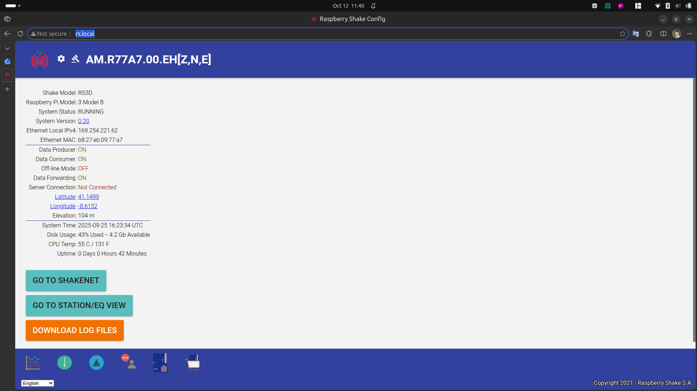Figure 1: The website of RS device

The device name
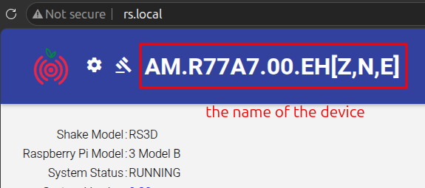Figure 2: The name of the device

Table 1: The meaning of the name.
Thành phần | Giá trị | Ý nghĩa
Network | AM | Mã mạng Raspberry Shake
Station | R77A7 | Mã trạm riêng của thiết bị
Location | 00 | Mã vị trí cảm biến
Channel | EHZ, EHN, EHE | Ba kênh đo địa chấn

Step 3: Configure Internet access and time synchronization
You can get the IP address of the device from the website:
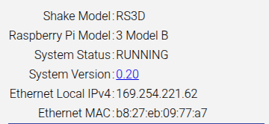Figure 3: The interness acess information from the website
The network need architecture

To check the laptop connect to TCP
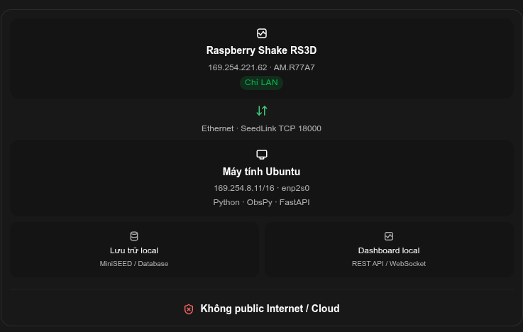Figure 4: the network architecture
nc -zv -w 3 169.254.221.62 18000
see: Connection to 169.254.221.62 18000 port [tcp/*] succeeded!
Please check the status of the device

