Manual for RaspberryShake (RS)

Overview
Step 1: Direct Ethernet connection — completed
Step 2: Access rs.local — completed
Step 3: Verify three-channel seismic data — completed
Step 4: Configure Internet access and time synchronization — current
Step 5: Connect Ubuntu to the RS3D data stream using SeedLink and Python — completed
Step 6: Implement real-time earthquake detection and alerts — in progress
the manual from RS: https://manual.raspberryshake.org/
The default username and password:
username: myshake
password: shakeme

Step 1: Direct Ethernet connection
What is the RS3D? RS3D = Raspberry Shake 3D: a seismograph with three geophone sensors (vertical, north–south, east–west) and a digitizer, running on a Raspberry Pi 3 Model B. It records ground velocity on three channels EHZ, EHN, EHE at 100 samples per second and serves the data over the network (SeedLink, UDP).
1. Place the Shake on a solid, level floor (ground floor is best), away from doors, fans and footsteps.
2. Connect the Shake's Ethernet port directly to the Ubuntu laptop's wired port (enp2s0) with a network cable.
3. Power the Shake with its own power supply and wait 3–5 minutes for it to boot.
4. Without a DHCP server (no router), the Shake gives itself a link-local address in 169.254.0.0/16. Our device uses 169.254.221.62.
5. Check that the cable link is up on the laptop:
ip -br link show enp2s0 # expect: enp2s0 UP

Step 2: Configuration to access the website
Theo tài liệu chính thức của Raspberry Shake, để kết nối trực tiếp qua dây Ethernet, máy tính nên được cấu hình IP 169.254.8.11, cùng dải với địa chỉ Discovery IP của thiết bị.
1. Add the IP to existed Lan:
sudo ip addr add 169.254.8.11/16 dev enp2s0
2. Check IP address
ip -br addr show enp2s0
3. Ping RS3D
ping -c 4 rs.local

Then you can connect to the website of device: http://rs.local/
4. Make the IP permanent. The ip addr add command above is lost after a reboot. Add the address to the NetworkManager connection of enp2s0 instead:
nmcli -t -f NAME,DEVICE connection show # find the connection name of enp2s0
sudo nmcli connection modify "<connection name>" +ipv4.addresses 169.254.8.11/16
sudo nmcli connection up "<connection name>"

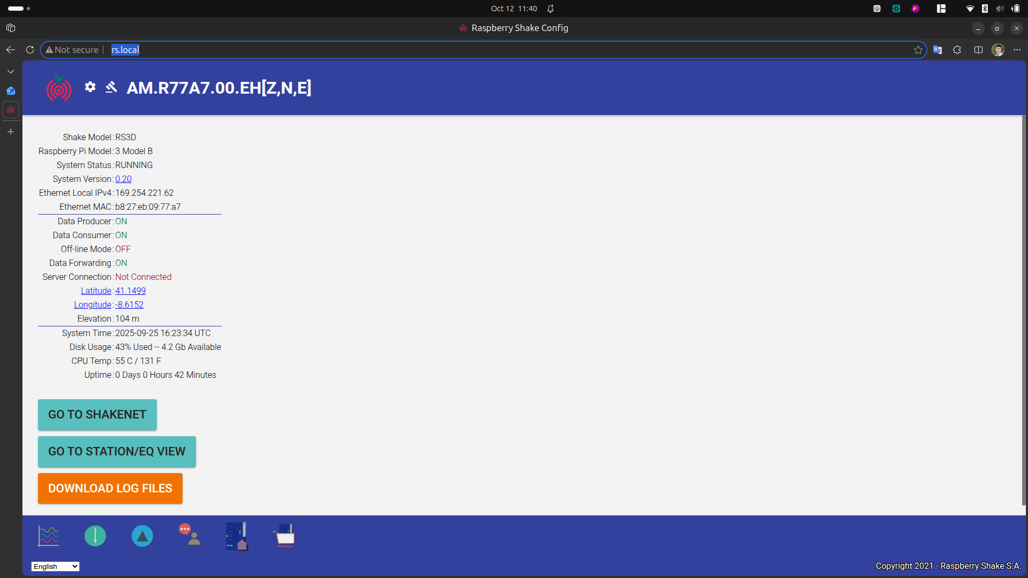Figure 1: The website of RS device

The device name
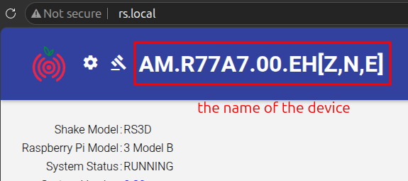Figure 2: The name of the device

Table 1: The meaning of the name.
Thành phần | Giá trị | Ý nghĩa
Network | AM | Mã mạng Raspberry Shake
Station | R77A7 | Mã trạm riêng của thiết bị
Location | 00 | Mã vị trí cảm biến
Channel | EHZ, EHN, EHE | Ba kênh đo địa chấn

Step 3: Verify three-channel seismic data
Goal: confirm that the Shake produces data on all three channels before building anything on top of it.
1. Check that the SeedLink port of the Shake is reachable:
nc -zv -w 3 169.254.221.62 18000
Expected: Connection to 169.254.221.62 18000 port [tcp/*] succeeded!
2. Ask the SeedLink server which streams it has (run in the project folder):
uv run python -c "
from obspy.clients.seedlink.easyseedlink import EasySeedLinkClient
c = EasySeedLinkClient('169.254.221.62:18000', autoconnect=False)
c.conn.timeout = 10
c.connect()
print(c.get_info('STREAMS'))"
3. Download 30 seconds of data from all three channels:
from obspy.clients.seedlink.basic_client import Client
client = Client('169.254.221.62', 18000, timeout=10)
st = client.get_waveforms('AM', 'R77A7', '00', 'EH?', t1, t2)
print(st)
st.plot()
t1, t2 must be in the Shake's own time (see Step 4 – the Shake clock is currently wrong).
Result (12/10/2026):
Channel | Location | Sampling rate | Samples in 30 s | Status
AM.R77A7.00.EHZ | 00 | 100 Hz | 3001 | OK
AM.R77A7.00.EHN | 00 | 100 Hz | 3001 | OK
AM.R77A7.00.EHE | 00 | 100 Hz | 3001 | OK
4. Tap test: tap the floor next to the Shake while plotting live data (Step 5 or Step 6). A clear spike should appear on all three channels, largest on EHZ for a vertical tap.

Step 4: Configure Internet access and time synchronization
You can get the IP address of the device from the website:
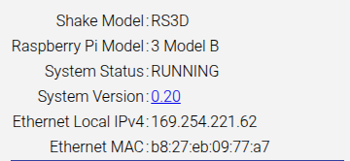Figure 3: The interness acess information from the website
The network need architecture

To check the laptop connect to TCP
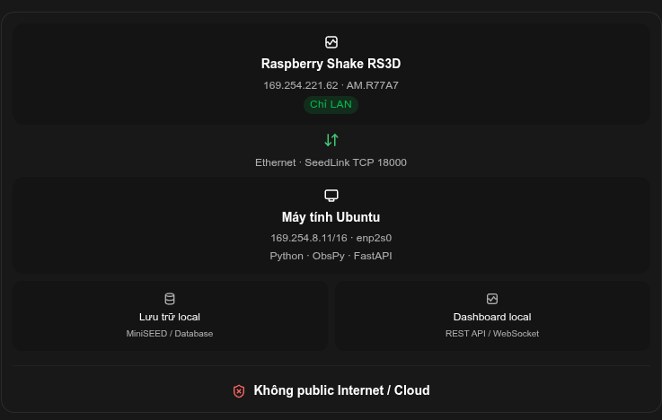Figure 4: the network architecture
nc -zv -w 3 169.254.221.62 18000
see: Connection to 169.254.221.62 18000 port [tcp/*] succeeded!
Please check the status of the device

Problem: the Shake clock is wrong
The website shows System Time 2025-09-25, while the real date is 2026-10-12. The Raspberry Pi has no battery-backed clock, so after every boot it restarts from the last saved time and only corrects it when it can reach an NTP time server. In our architecture (Figure 4) the Shake is LAN-only, with no Internet, so it never gets the correct time. All data timestamps (SeedLink, rsudp, miniSEED) are wrong until this is fixed.

Solution: use the Ubuntu laptop as a local NTP server
The laptop already keeps correct time with chrony (System clock synchronized: yes). We let chrony also serve time to the Shake over the cable.
On the laptop:
1. Allow the link-local network to ask chrony for the time:
sudo tee /etc/chrony/conf.d/shake-ntp.conf <<'EOF'
allow 169.254.0.0/16
local stratum 10
EOF
sudo systemctl restart chrony
local stratum 10 keeps serving time even when the laptop itself is offline.
2. Open the NTP port in the firewall, only on the cable interface:
sudo ufw allow in on enp2s0 to any port 123 proto udp
On the Shake (log in with the default account from the Overview):
3. Connect and find which time service the Shake uses:
ssh myshake@rs.local
systemctl is-active ntp systemd-timesyncd
ls /etc/ntp.conf /etc/systemd/timesyncd.conf
4a. If ntp is active: add the line server 169.254.8.11 iburst prefer to /etc/ntp.conf, then:
sudo systemctl restart ntp
ntpq -p # 169.254.8.11 should appear, marked with *
4b. If systemd-timesyncd is active: set NTP=169.254.8.11 under [Time] in /etc/systemd/timesyncd.conf, then:
sudo systemctl restart systemd-timesyncd
timedatectl timesync-status
Verify:
5. On the laptop, sudo chronyc clients should list 169.254.221.62.
6. System Time on the Shake website should match the laptop (UTC).
7. Run Step 3 again: the data timestamps should now be today's date.
Status: not done yet. Steps 1–2 change the laptop and need sudo; steps 3–4 must be checked on the Shake itself. After the clock is fixed, data recorded before the fix keeps the wrong timestamps.
Alternative (only if the architecture allows Internet): connect the Shake to a router with Internet access. It will then get an IP from DHCP and sync time automatically, but its IP will no longer be 169.254.221.62, so all commands and settings in this manual must use the new IP.

Step 5: Connect Ubuntu to the RS3D data stream using SeedLink and Python
SeedLink (TCP port 18000) is the standard protocol for real-time seismic data. The laptop connects to the Shake and asks for the channels it wants. We use the ObsPy library.

Python environment
The project ~/NCREP-RaspberryShake is managed with uv (Python 3.12):
cd ~/NCREP-RaspberryShake
uv sync # install obspy, rsudp, jupyter (dev)
uv run python -c "import obspy; print(obspy.__version__)" # 1.5.1

Option A – live stream: read_rs3d.py
Prints every data packet of EHZ, EHN, EHE as it arrives. Stop with Ctrl+C.
uv run python read_rs3d.py
Expected output:
Listening for data from RS3D...
channel id: AM.R77A7.00.EHZ,
Time: 2025-09-25T20:12:48.438000Z,
Samples: 162,
Sampling Rate: 100.0 Hz
Known ObsPy 1.5.1 bug: create_client() connects before a timeout can be set and fails with '<' not supported between instances of 'float' and 'NoneType'. read_rs3d.py therefore uses EasySeedLinkClient(..., autoconnect=False), sets conn.timeout = 10, then calls connect(). Streams are selected with select_stream('AM', 'R77A7', channel).

Option B – a time window: get_waveforms
Simplest way for analysis and notebooks. Returns an ObsPy Stream:
from obspy.clients.seedlink.basic_client import Client
client = Client('169.254.221.62', 18000, timeout=10)
st = client.get_waveforms('AM', 'R77A7', '00', 'EH?', t1, t2)
st.write('data.mseed', format='MSEED')
The SeedLink server only keeps a short recent buffer. For long-term data use rsudp write (Step 6).

Step 6: Implement real-time earthquake detection and alerts
We use rsudp, the official open-source client from Raspberry Shake. The Shake pushes data over UDP to the laptop; rsudp plots it live, runs an STA/LTA earthquake trigger and can save miniSEED files. Full details: docs/rsudp_setup.odt.

Setup summary
1. Shake website → Settings → Data → UDP Data Streaming: add host 169.254.8.11, port 8888. Do not use the Wi-Fi IP that rs-client suggests in its error message.
2. Open the UDP port on the laptop:
sudo ufw allow in on enp2s0 to any port 8888 proto udp
3. Install rsudp (the setuptools<81 pin is required, rsudp 2.2.1 still uses pkg_resources):
uv add rsudp "setuptools<81"
4. Create the settings file and set station = R77A7, output_dir = /home/thang/NCREP-RaspberryShake/rsudp_out:
uv run rs-client -d default # ~/.config/rsudp/rsudp_settings.json
5. Run:
uv run rs-client

Modules
Module | Function | Now | Recommended
plot | Live waveform and spectrogram | ON | ON
alert | STA/LTA trigger on EHZ (STA 6 s, LTA 30 s, threshold 3.95) | ON | ON
write | Save continuous miniSEED to rsudp_out/data | OFF | ON, after Step 4
custom, alertsound, telegram | Actions / notifications when an alert fires | OFF | As needed
Status (12/10/2026): UDP packets from 169.254.221.62 arrive on port 8888 – verified. Next: fix the clock (Step 4), enable write, then tune the alert threshold with tap tests and real background noise.

Next steps
• Local storage (Figure 4): keep rsudp write running and read the files with ObsPy (obspy.read).
• Local dashboard (Figure 4): a small Python service (e.g. FastAPI with REST/WebSocket) built on the same SeedLink/rsudp data.

