B1228005 胡樂麒

(12,2,16,30,8,28,4,10,20,6,18)

1.Merge sort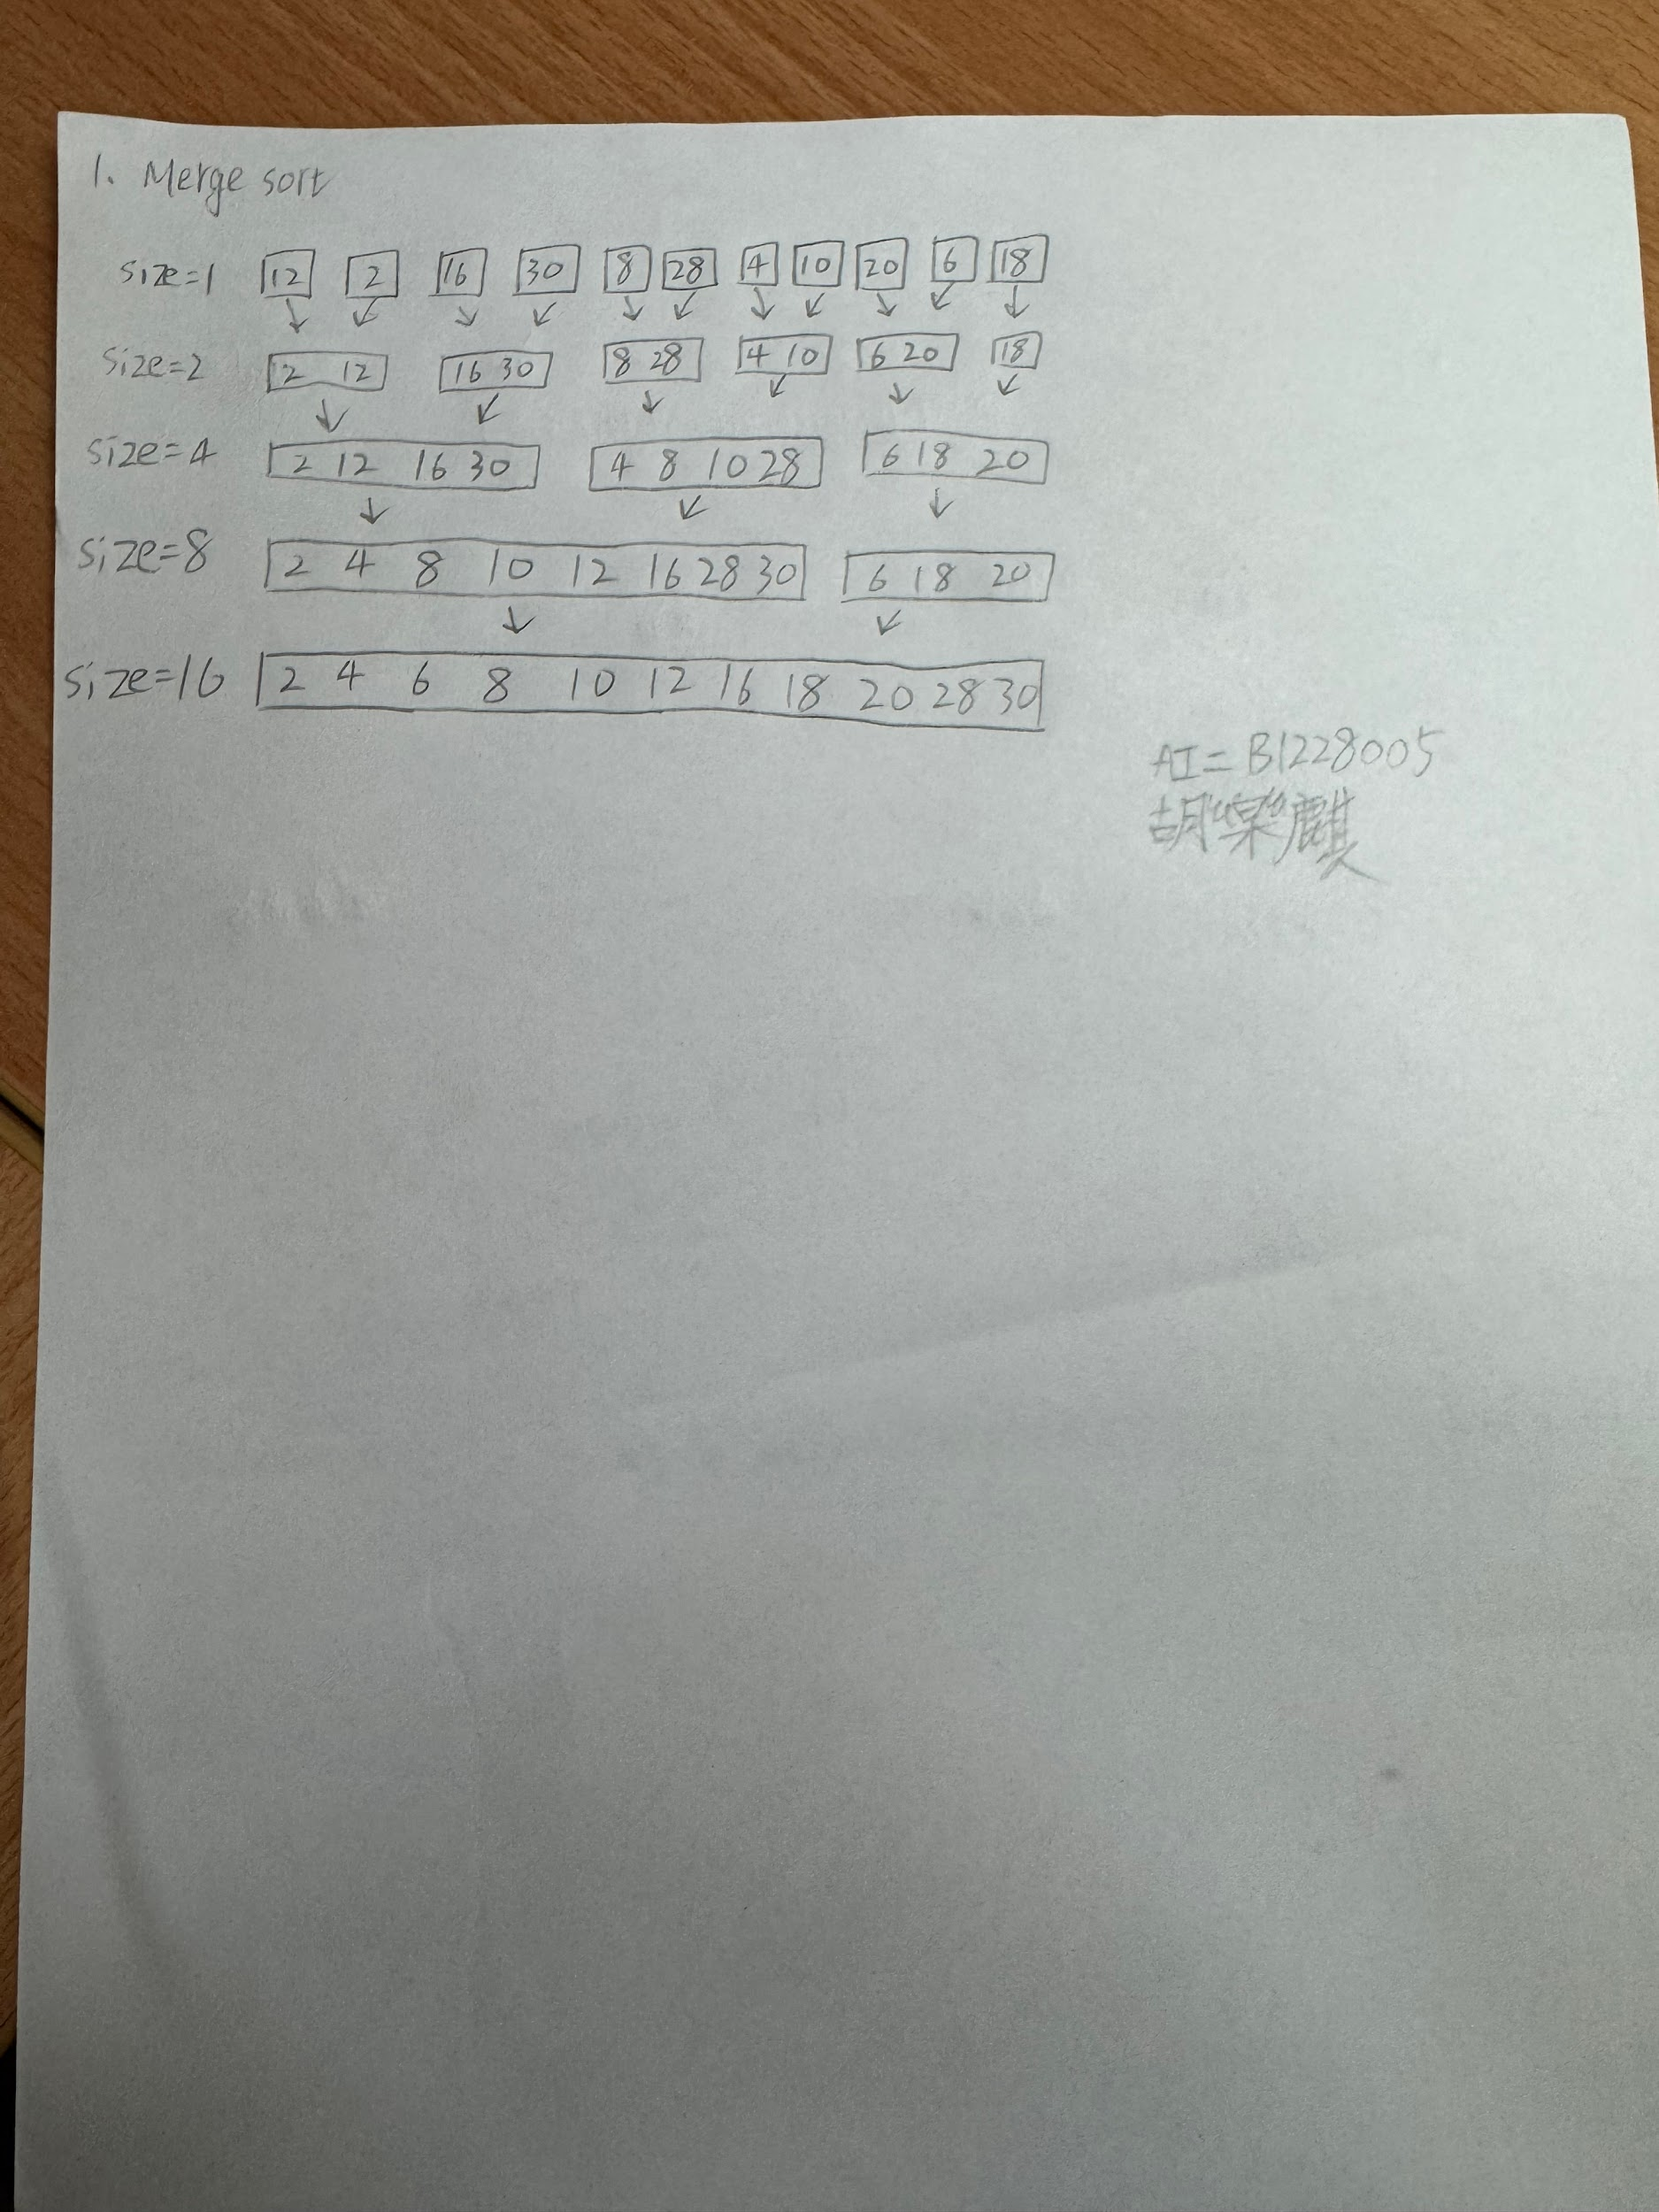

size=1 [12] [2] [16] [30] [8] [28] [4] [10] [20] [6] [18]

size=2 [2 12] [16 30] [8 28] [4 10] [6 20] [18]

size=4 [2 12 16 30] [4 8 10 28] [6 18 20]

size=8 [2 4 8 10 12 16 28 30] [6 18 20]

size=16 [2 4 6 8 10 12 16 18 20 28 30]

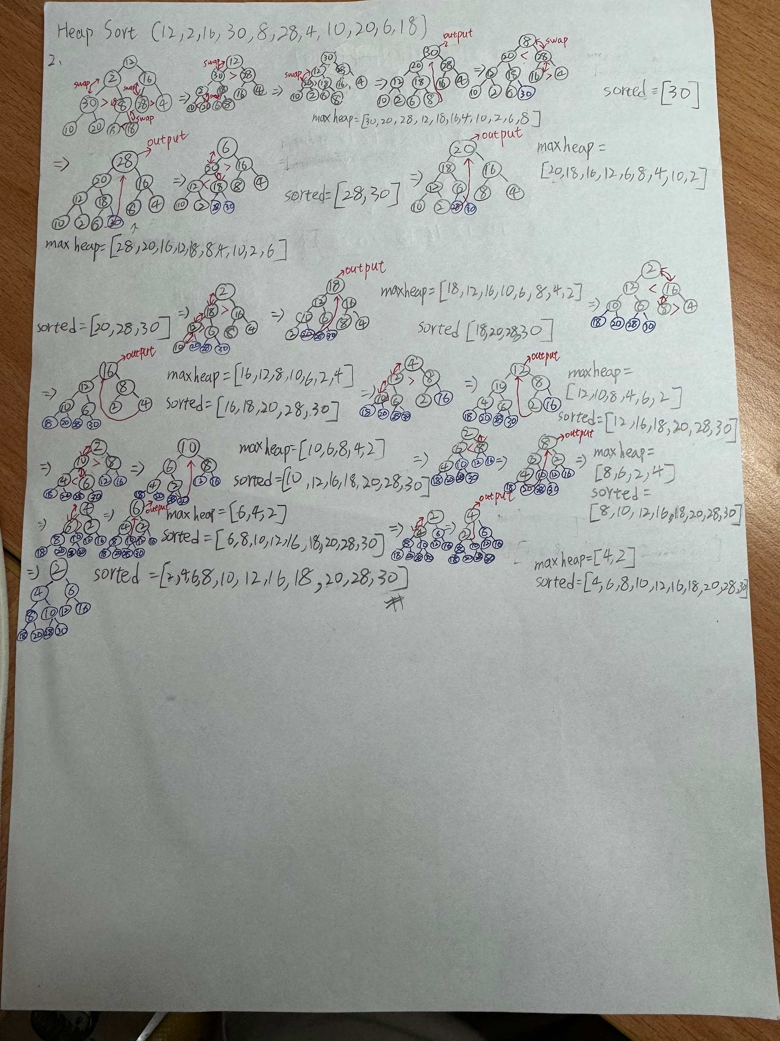

2.Heap sort

max heap:[30,20,28,12,18,16,4,10,2,6,8]

sorted:[30]

max heap:[28,20,16,12,18,8,4,10,2,6]

sorted:[28,30]

max heap:[20,18,16,12,6,8,4,10,2]

sorted:[20,28,30]

max heap:[18,12,16,10,6,8,4,2]

sorted:[18,20,28,30]

max heap:[16,12,8,10,6,2,4]

sorted:[16,18,20,28,30]

max heap:[12,10,8,4,6,2]

sorted:[12,16,18,20,28,30]

max heap:[10,6,8,4,2]

sorted:[10,12,16,18,20,28,30]

max heap:[8,6,2,4]

sorted:[8,10,12,16,18,20,28,30]

max heap:[6,4,2]

sorted:[6,8,10,12,16,18,20,28,30]

max heap:[4,2]

sorted:[4,6,8,10,12,16,18,20,28,30]

max heap:[2]

sorted:[2,4,6,8,10,12,16,18,20,28,30]