ПРИЛОЖЕНИЕ 2

Gerber Files: Top layer, Bottom layer, Top Overlay, Top Solder, Bottom Solder, Mechanical 1

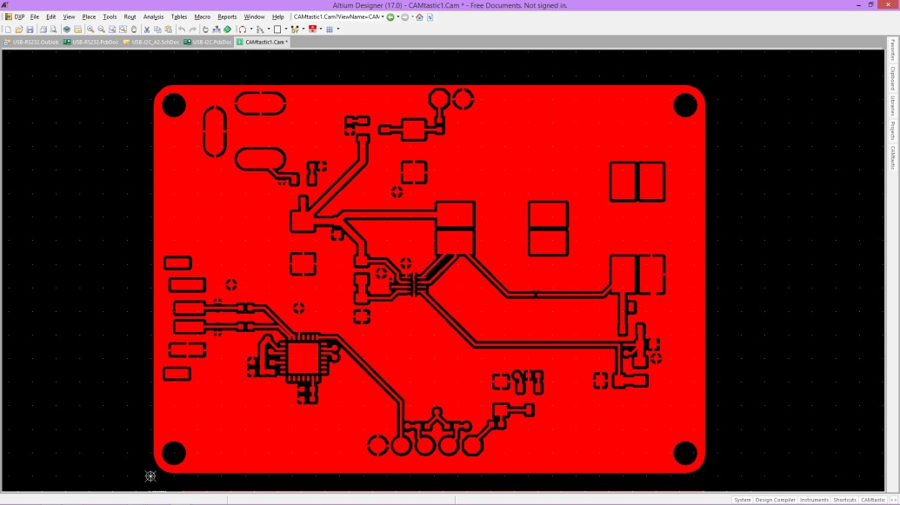 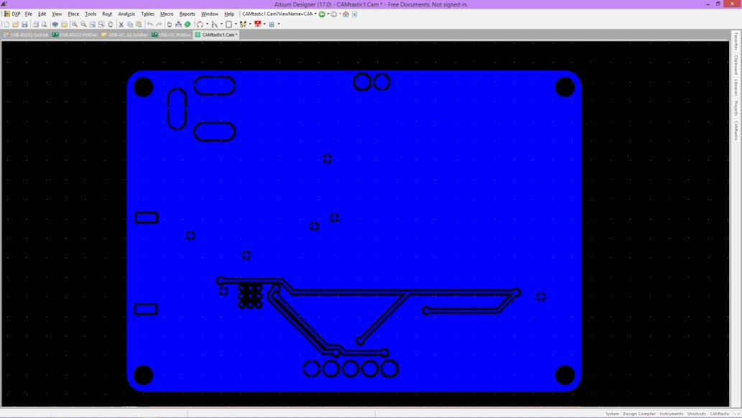

Top layer Bottom layer

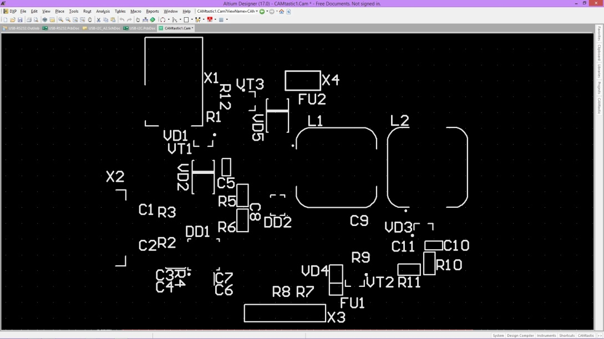 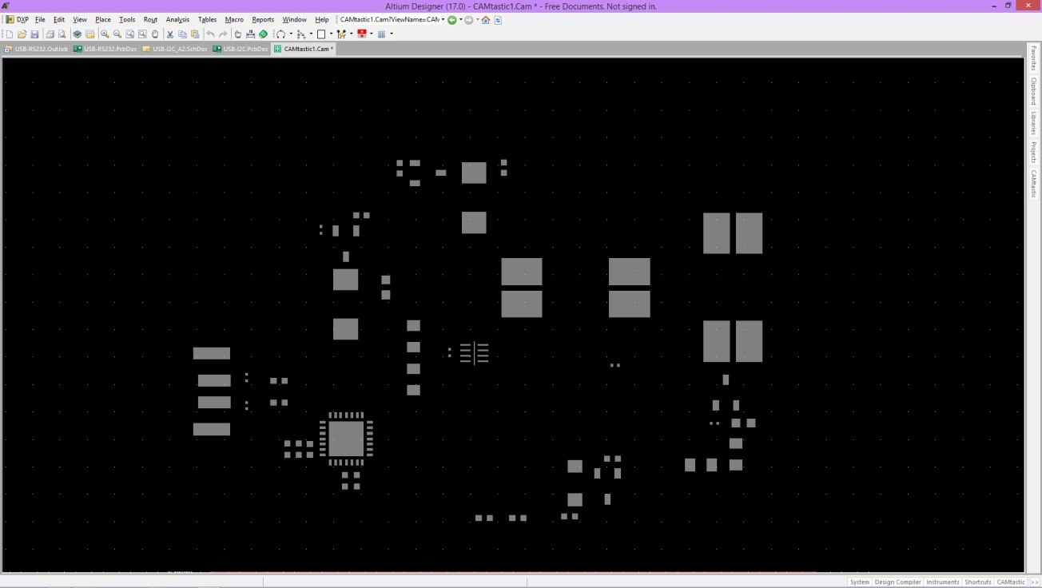

Top Overlay Top Solder

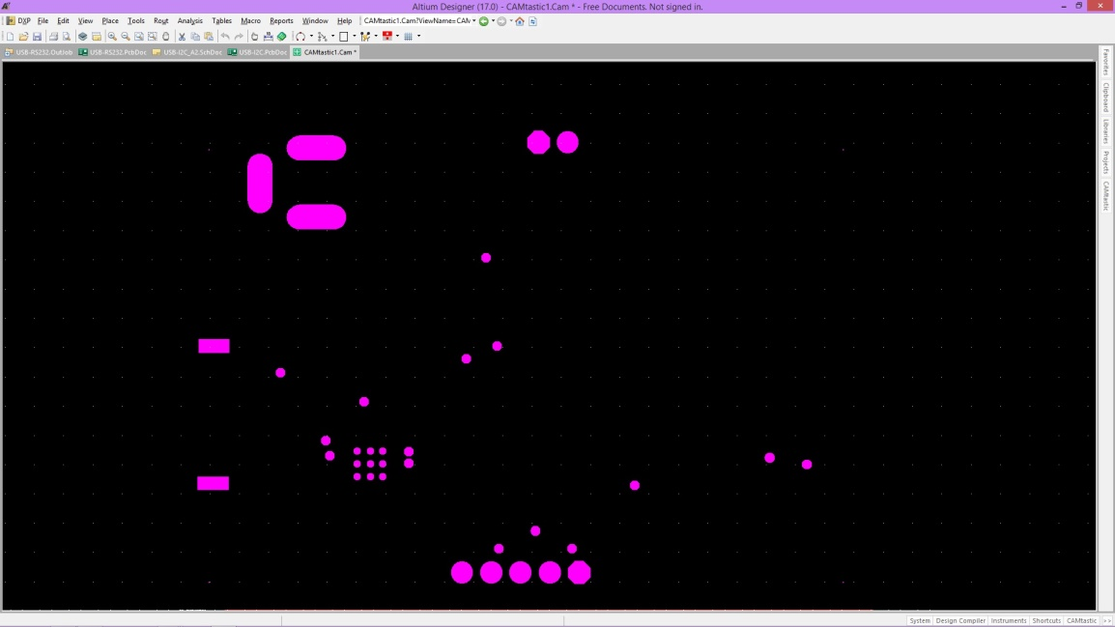 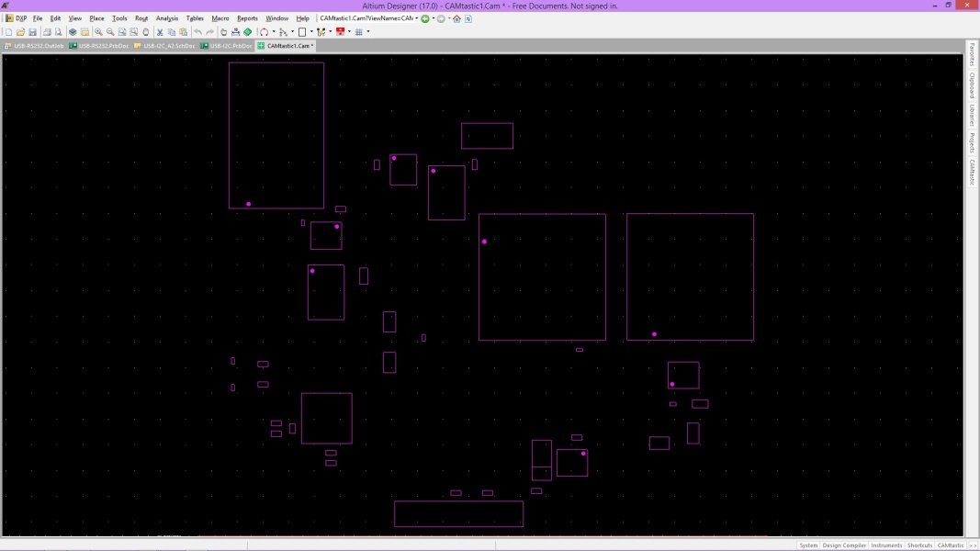

Bottom Solder Mechanical 1