1.

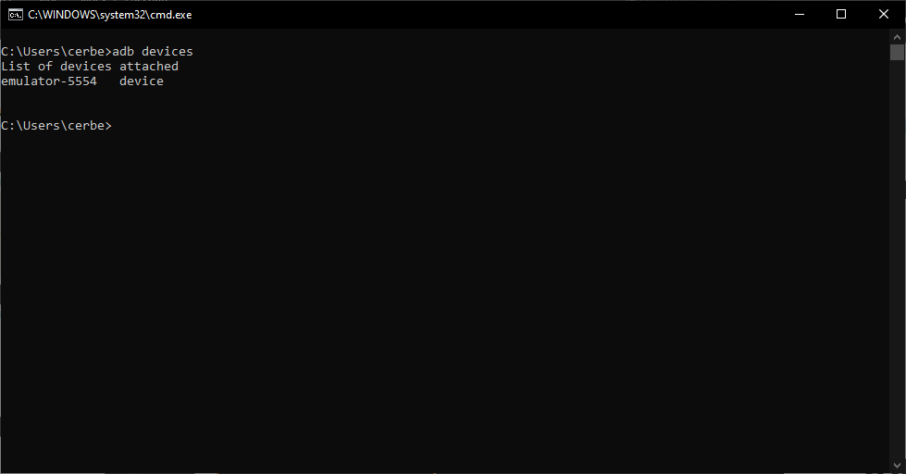**Figure 1**: Output of “adb devices”

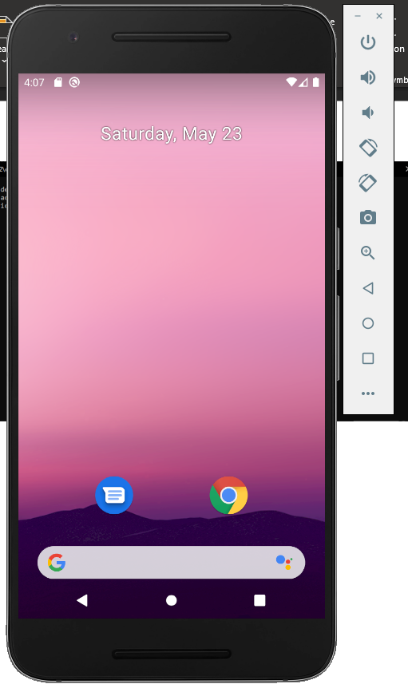

**Figure 2**: AVD appearance

2.

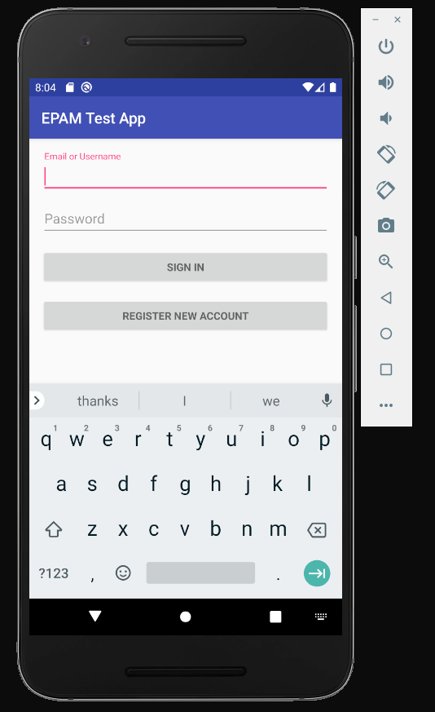

**Figure 3**: EPAM Test App installed

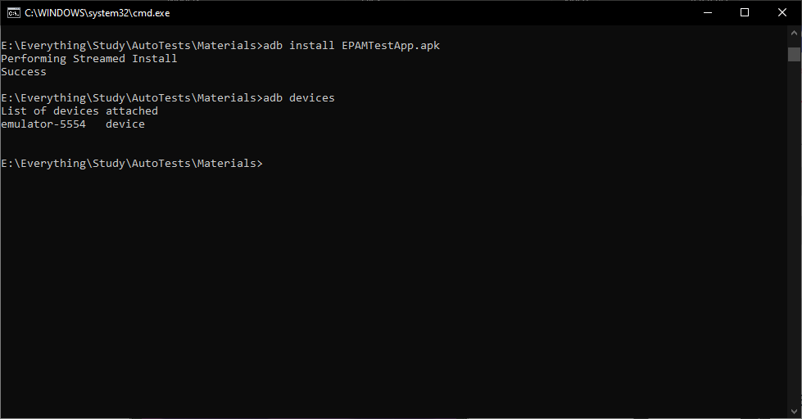

**Figure 4**: adb output after installing EPAMTestApp.apk

3-4.

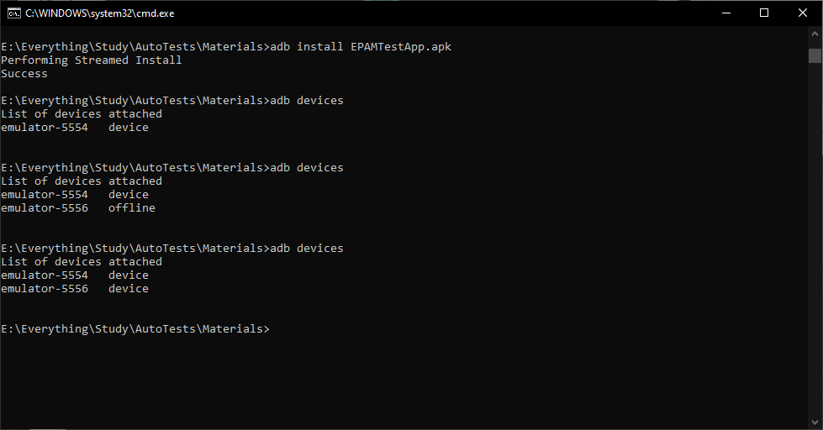

**Figure 5**: adb output for two AVD devices

5-6.

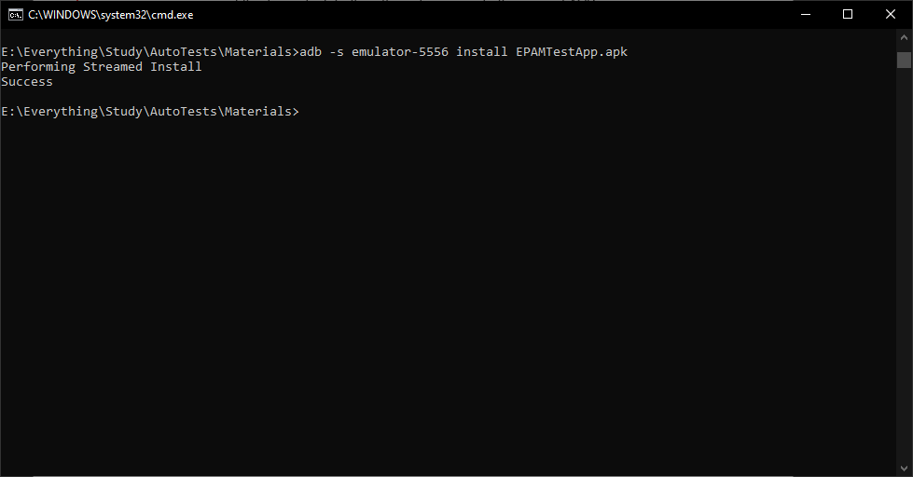

**Figure 6**: output for installation EPAMTestApp.apk to another device

7.

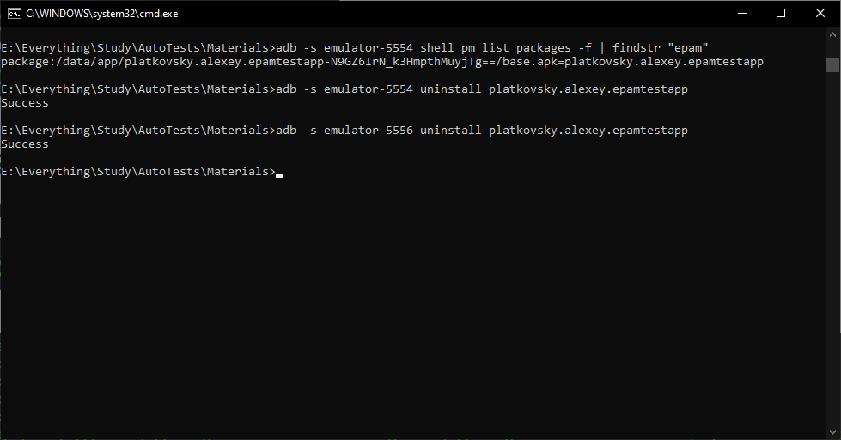

**Figure 7**: uninstalled Epam Test App on both devices

8-10.

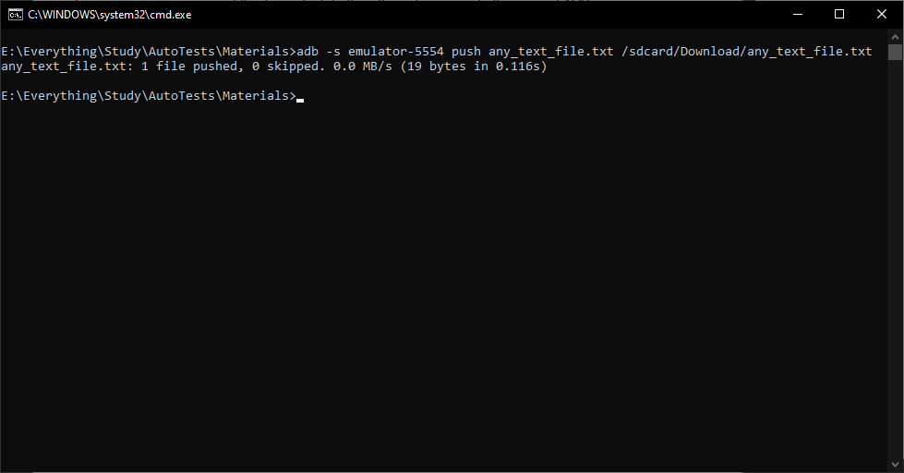

**Figure 8**: pushed text file to AVD device

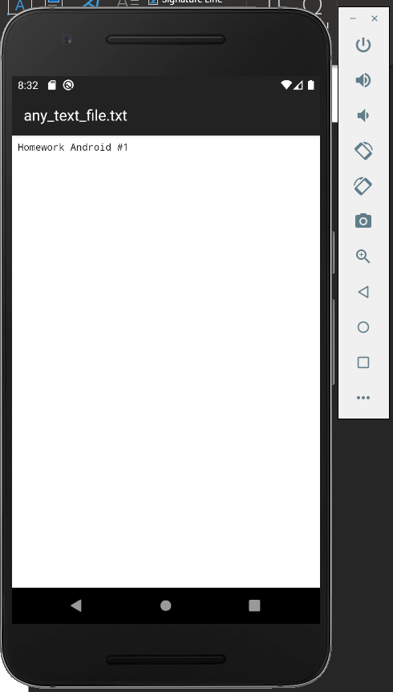

**Figure 9**: opened file on AVD

11.

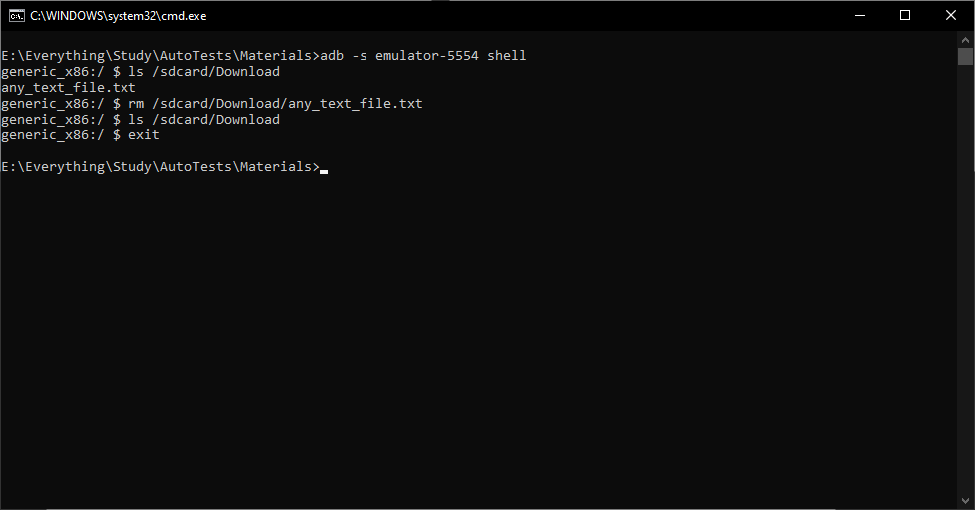

**Figure 10**: Deleted text file on AVD