ACKNOWLEDGEMENT
First and foremost, we express our sincere thanks to our teacher, Ph.D. Kim Dinh Thai, whose guidance, expertise, and patience were instrumental in steering this project towards its completion. Special appreciation goes to our classmates and the teaching assistant whose advice helped us a lot in writing this report. Their willingness to contribute their time and thoughts added depth and authenticity to our work. Lastly, we extend our gratitude to each other, the members of Group 7. This project was a collaborative effort that required dedication, compromise, and teamwork. We have grown individually and collectively through this experience, gaining not just knowledge but also friendships that we treasure. This project report is not only a reflection of our hard work but also a testament to the support and guidance we received from all those mentioned above. Thank you for making this journey memorable and our project a success.

ABBREVIATIONS

Abbreviation | Full Form
MDP | Markov Decision Process
RL | Reinforcement Learning
DQN | Deep Q-Network / Deep Q-Learning
SUMO | Simulation of Urban Mobility
TraCI | Traffic Control Interface
CSV | Comma-Separated Values
A2C | Advantage Actor-Critic

TABLE OF CONTENTS

ACKNOWLEDGEMENT 2
ABBREVIATIONS 3
CHAPTER 1. PROBLEM FORMULATION AND BACKGROUND 7
- Traffic Light Control Problem 7
- Traffic Congestion as a Sequential Decision Problem 7
- Markov Decision Process (MDP) Overview 8
- Mapping Traffic Light Control to an MDP 9
  - State Definition 9
  - Action Space 9
  - Reward Design 10
  - State Transition 10
- Chapter Conclusion 11
CHAPTER 2. SIMULATION ENVIRONMENT AND DATA GENERATION 11
- Traffic Simulation Using SUMO 11
- SUMO Initialization and GUI Configuration 12
- SUMO-Based MDP Environment 13
- Environment Reset and Initial State Construction 14
- Simulation Step and Agent Interaction 15
- SUMO Configuration for Experiments 16
- Graphical Simulation Launcher 16
- Intersection Scenario Description 17
- Scenario Generation Script 18
SUMO Network Structure 18
- Vehicle Types and Traffic Composition 19
- Routes and Traffic Flows 19
- Agent Interaction with the Intersection 20
- Traffic State Representation 20
  - Vehicle Count per Lane 20
    - Lane Segmentation and Traffic Observation 20
    - Extracted Lane-Level Features 21
    - Vietnamese Vehicle Weighting Scheme 21
    - State Vector Construction 22
    - Significance for Traffic Signal Control 22
  - Queue Length and Waiting Time 22
    - Queue Length Measurement 23
    - Waiting Time Measurement 23
    - Reward Function Based on Queue–Delay 24
    - Performance Evaluation 24
- Online Data Collection During Training 25
  - Main Training Loop 25
  - Replay Memory and Experience Storage 26
  - Environment Interaction Example 26
  - Jupyter Notebook Demonstration 26
  - Demo Execution Script 27
  - Generated Training Data 27
- Chapter Conclusion 28
CHAPTER 3. REINFORCEMENT LEARNING MODEL 28
- Reinforcement Learning Framework 28
  - Agent–Environment Interaction 29
  - Learning Objective 30
- Q - Learning Algorithm 31
  - Q -Value Function 32
  - Bellman Equation 32
- Deep Q-Learning (DQN) 33
  - Motivation for Deep Q-Learning 34
  - Neural Network Architecture 35
    - MLPBlock: 36
    - DQN Network - Dueling Architecture 37
    - Forward Pass - Dueling Computation 38
    - Weight Initialization - Kaiming 38
  - Experience Replay 38
    - Transition Data Structure 40
    - ReplayBuffer Class 40
    - Sample Batch for Training 40
  - ε-greedy Exploration Strategy 41
    - Linear Epsilon Schedule - Decay linear 42
    - Epsilon-Greedy Action Selection 42
    - Configuration - Epsilon Parameters 43
    - Training Process 43
- Chapter Conclusion 47
CHAPTER 4. EXPERIMENTAL SETUP AND EVALUATION 47
- Experimental Configuration 47
  - Simulation Parameters 48
  - Baseline Method: Fixed-Time Traffic Control 48
- Evaluation Metrics 50
  - Average Vehicle Waiting Time 50
  - Queue Length 50
  - Cumulative Reward 51
- Results and Analysis 51
  - Performance Comparison 51
  - Traffic Efficiency Improvement 52
  - Statistical Analysis of Results 53
  - Impact of Traffic Density Variations 55
- Chapter Conclusion 56
CHAPTER 5. APPLICATION AND DISCUSSION 56
- Practical Application of the Proposed Model 56
- Strengths and Limitations 58
  - Strengths 58
  - Limitations 59
- Discussion on Scalability 60
REFERENCES 62

CHAPTER 1. PROBLEM FORMULATION AND BACKGROUND

Traffic Light Control Problem
Urban traffic congestion has become one of the most critical challenges in modern cities due to rapid urbanization, population growth, and the increasing number of vehicles. Intersections are among the most congested components of road networks, as conflicting traffic flows must be coordinated through traffic signal systems. Tra- ditional traffic light control strategies, such as fixed-time or actuated control, rely on predefined timing plans or simple sensor-based rules. While these approaches are easy to implement and maintain, they are often unable to adapt effectively to highly dynamic and uncertain traffic conditions.
The traffic light control problem can be defined as determining how to allocate green times and switching phases at intersections in order to minimize congestion, reduce travel time, and improve overall traffic efficiency. This problem is inherently com- plex because traffic demand fluctuates over time, vehicle arrivals are stochastic, and the interaction among different traffic streams creates non-linear system behavior. A poorly designed control strategy may lead to long queues, excessive waiting time, and increased fuel consumption and emissions. Therefore, developing an adaptive and intelligent traffic signal control mechanism is essential for achieving sustainable and efficient urban transportation systems.

Traffic Congestion as a Sequential Decision Problem
Traffic signal control is naturally a sequential decision-making problem. At every moment, the controller must decide which signal phase should be activated based on the current traffic situation, while the outcome of that decision will influence future traffic states. For example, granting a longer green phase to one direction may re- duce its queue length but could simultaneously increase congestion in conflicting directions. Consequently, the control process involves a trade-off between immedi- ate performance and long-term system efficiency.
Furthermore, traffic conditions evolve continuously as vehicles arrive, depart, and interact with one another. The system state at the next time step depends not only on the current state but also on the control action taken. This sequential and dynamic nature makes traffic signal control unsuitable for purely static optimization methods. Instead, it requires a framework that can explicitly model the evolution of traffic states over time and evaluate the long-term impact of control decisions. Such char- acteristics align well with the structure of sequential decision-making models used in control theory and artificial intelligence.

Markov Decision Process (MDP) Overview
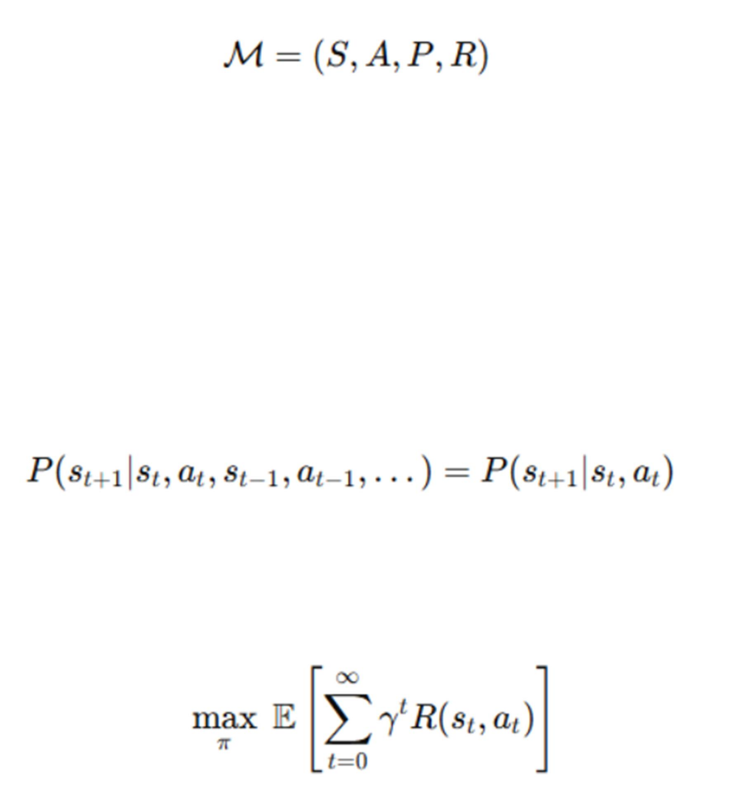
A Markov Decision Process (MDP) is a mathematical framework widely used to model decision-making problems in stochastic environments. An MDP is defined by the tuple:

Where:
- S is the state space,
- A is the action space,
- P (s′∣s,a) is the state transition probability function, representing the proba- bility of transitioning from state s to state s′ after taking action a
- R (s, a) is the reward function, which evaluates the effectiveness of action a in state s
An MDP satisfies the Markov property, meaning that the next state depends only on the current state and the chosen action, and not on the entire history:

The objective of an MDP is to find an optimal policy π (a∣s), which maps states to actions so as to maximize the expected cumulative discounted reward:

where γ ∈ (0,1] is the discount factor, representing the relative importance of future rewards compared to immediate rewards.
Given its capability to model sequential decision-making under uncertainty, the MDP framework is well suited for representing and solving the traffic signal control problem.

Mapping Traffic Light Control to an MDP
In this study, the traffic signal control problem is directly mapped onto an MDP. The traffic signal controller, referred to as the Traffic Light Control System (TLCS), acts as the agent. The agent observes the current traffic conditions at the intersection, selects an appropriate signal phase, and receives a reward based on the resulting traffic performance.
The mapping is established through four main components: state, action, reward, and state transition.

State Definition
The system state is constructed by discretizing the incoming lanes into presence cells, each of which indicates whether at least one vehicle is present.
Specifically:
Each approach of the intersection is divided into 20 cells:
- 10 cells along the leftmost lane (dedicated to left-turning vehicles),
- 10 cells along the remaining three lanes (for through and right-turn move- ments).
Hence, the entire intersection is represented by:
4 approaches × 20 cells = 80 cells At time step t, the state is represented by a binary vector:
s_{t} = (x₁, x₂,…, x₈₀), x_{i} ∈ {0,1}
Where:
- x_{i} = 1 if at least one vehicle is present in cell i,
- x_{i} = 0 otherwise
This representation reduces the complexity of the state space while preserving the essential information about the spatial distribution of vehicles on the incoming lanes.

Action Space
The action space of the agent consists of four predefined traffic signal phases. Each phase has a duration of 10 seconds, and when switching between phases, a 4-second yellow interval is activated to ensure safety.
The four actions are defined as follows:
    - North–South Advance: Allows through and right-turn movements on the north and south approaches.

    - North–South Left Advance: Allows left-turn movements on the north and south approaches.
    - East–West Advance: Allows through and right-turn movements on the east and west approaches.
    - East–West Left Advance: Allows left-turn movements on the east and west approaches.
Therefore, the action set is:
A = {a₁, a₂, a₃, a₄}
At each decision time step, the agent selects an action a_{t} ∈ A, corresponding to the activation of one specific signal phase.

Reward Design
The reward function is designed based on the change in cumulative waiting time of vehicles.
The waiting time of a vehicle is defined as:
Wi(t) = the number of seconds vehicle i has been stopped (speed = 0) since its appearance
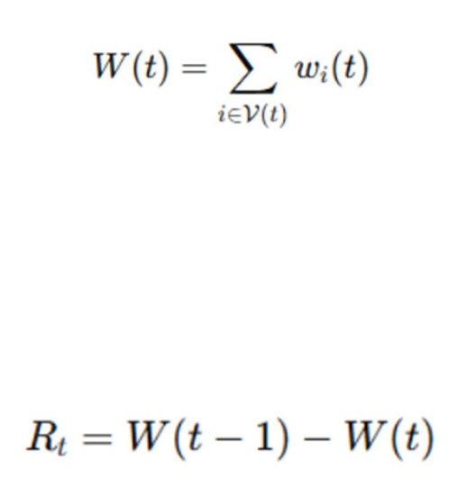
The cumulative waiting time at time ttt is given by:

where V(t) denotes the set of vehicles currently located on the incoming lanes at time
t. Once a vehicle leaves the incoming lane and crosses the intersection, its waiting time is no longer included in W(t).
The reward at time step t is defined as:

- If W(t) < W(t−1)(i.e., the cumulative waiting time decreases), then R_{t} > 0
- If W(t) < W(t−1)(i.e., congestion increases), then R_{t} < 0

State Transition
The state transition of the system depends on:
    - The selected action A_{t} (signal phase),
    - The movement dynamics of vehicles,
    - The stochastic arrival of new vehicles.

When a phase is activated, vehicles in the permitted lanes pass through the intersec- tion, reducing congestion in those lanes, while vehicles in non-priority lanes con- tinue to accumulate. Simultaneously, newly generated vehicles enter the intersection approaches in a random manner. Therefore, the transition probability is expressed as:

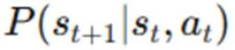

which is inherently stochastic, reflecting the uncertainty of the traffic environment.

Chapter Conclusion
The traffic signal control problem has been formulated as a sequential decision-mak- ing problem in a stochastic environment. First, the limitations of conventional traffic signal control methods and the motivation for an adaptive and intelligent control system were discussed. Next, the Markov Decision Process (MDP) framework was introduced as the theoretical foundation for modeling the problem. Finally, the Traf- fic Light Control System (TLCS) was systematically mapped onto the components of an MDP, including the state representation, action space, reward function, and state transition mechanism. This MDP formulation provides the basis for subsequent chapters, in which reinforcement learning algorithms—specifically Q-learning com- bined with deep neural networks - will be applied to learn an optimal traffic signal control policy.

CHAPTER 2. SIMULATION ENVIRONMENT & DATA GENERATION

Traffic Simulation Using SUMO
In this study, the traffic environment is simulated using SUMO (Simulation of Urban Mobility), an open-source microscopic traffic simulator that enables detailed mod- eling of individual vehicle behaviors, including acceleration, deceleration, stopping, queuing, and movement through signalized intersections.
Within the Deep Q-Learning–based Traffic Signal Control framework, SUMO plays the role of the environment in a Markov Decision Process (MDP). The reinforce- ment learning agent does not directly control individual vehicles; instead, it controls the traffic signal phases at an intersection. After each action selected by the agent, SUMO advances the simulation and returns updated traffic information, such as ve- hicle distribution and waiting times, which are then used to construct the next state and compute the reward.
The interaction between the learning agent and the SUMO simulator is implemented via TraCI (Traffic Control Interface), which allows Python programs to control the simulation and retrieve traffic data in real time.

In this study, the traffic environment is simulated using SUMO (Simulation of Urban Mobility), an open-source microscopic traffic simulator that enables detailed mod- eling of individual vehicle behaviors, including acceleration, deceleration, stopping, queuing, and movement through signalized intersections.
Within the Deep Q-Learning–based Traffic Signal Control framework, SUMO plays the role of the environment in a Markov Decision Process (MDP). The reinforce- ment learning agent does not directly control individual vehicles; instead, it controls the traffic signal phases at an intersection. After each action selected by the agent, SUMO advances the simulation and returns updated traffic information, such as ve- hicle distribution and waiting times, which are then used to construct the next state and compute the reward.
The interaction between the learning agent and the SUMO simulator is implemented via TraCI (Traffic Control Interface), which allows Python programs to control the simulation and retrieve traffic data in real time.

SUMO Initialization and GUI Configuration
SUMO is initialized programmatically using traci.start(). The simulator can run ei- ther in headless mode (sumo) for faster training or in graphical mode (sumo-gui) for realistic 2D visualization of traffic dynamics. The following method shows how SUMO is started with enhanced GUI settings for better visual interpretation of the simulation.
def _start_sumo(self) -> None:
if self._connected:
return
binary = checkBinary("sumo-gui" if self.cfg.gui else "sumo")# type: ignore gui_args = [
binary, "-c", self.cfg.sumocfg_path,
"--step-length", str(self.cfg.step_length),
]
if self.cfg.gui: gui_args.extend([
"--window-size", "1400,900",
"--window-pos", "50,50",

"--start",
])
traci.start(gui_args)# type: ignore Explanation:
This function initializes the SUMO simulator using either sumo or sumo-gui, de- pending on whether graphical visualization is enabled. When GUI mode is active, the simulation window is configured to a resolution of 1400×900 pixels, allowing clear observation of vehicle movements, queues, and traffic light phase changes dur- ing reinforcement learning experiments.

SUMO-Based MDP Environment
To integrate SUMO into the reinforcement learning framework, a custom environ- ment class SumoMDPEnv is implemented. This class formalizes the traffic signal control problem as a Markov Decision Process, defining the state space, action space, and reward function.
class SumoMDPEnv:
"""SUMO-based MDP environment tailored for Vietnamese intersections. State (example): concatenation of per-lane features around a junction:
- queue length
- average speed
- waiting time
- class-weighted vehicle counts (motorcycles prominent in VN) Action: select one of configured signal phases in `phases`.
Reward: negative weighted queue length and delay (or throughput), configurable. """
def init (self, cfg: EnvConfig) -> None: self.cfg = cfg
self._ensure_sumo() self._tls = cfg.tls_id

self._phases = cfg.phases self.action_space = len(cfg.phases)
Explanation:
This class encapsulates the SUMO simulation as an RL environment. The state is constructed from lane-level traffic features, the action corresponds to selecting a traffic signal phase, and the reward reflects traffic efficiency metrics such as queue length and delay. The design explicitly accounts for Vietnamese traffic characteris- tics, where motorcycles constitute a large proportion of vehicles.

Environment Reset and Initial State Construction
Before each training episode, the environment is reset to ensure a consistent initial condition. During reset, SUMO is (re)started, a warm-up phase is executed, and the controlled lanes are identified.
def reset (self, seed: Optional[int] = None) -> np.ndarray:
if self._connected:
self._close_sumo() self._start_sumo() # warmup
for _ in range(self.cfg.warmup_steps): traci.simulationStep()# type: ignore
lanes = traci.trafficlight.getControlledLanes(self._tls)# type: ignore self._lanes = sorted(list(set([l for l in lanes if l != ":"])))# type: ignore self._state_dim = len(self._lanes) * 4# 4 features per lane
self._step = 0
self._last_phase_index = 0 Explanation:
The warm-up period allows vehicles to enter the network and stabilize traffic flow before learning begins. The environment then retrieves all lanes controlled by the target traffic light and initializes the state vector, which consists of four features per lane.

Simulation Step and Agent Interaction
At each decision step, the agent selects a traffic signal phase. SUMO applies this action and advances the simulation for a fixed duration before returning the next state, reward, and termination signal.
def step(self, action: int):
assert traci is not None, "traci not available"
action = int(np.clip(action, 0, self.action_space - 1)) self._apply_phase(action)

sim_steps = int(self.cfg.action_duration / self.cfg.step_length) for _ in range(sim_steps):
traci.simulationStep()# type: ignore self._step += 1
s2 = self._get_state()
r = self._compute_reward() done = (
self._step >= self.cfg.max_steps
or traci.simulation.getMinExpectedNumber() <= 0# type: ignore
)
info = {"step": self._step, "phase": action} return s2, r, done, info
Explanation:
Each action corresponds to activating a specific signal phase for a fixed duration. The simulation then advances in discrete time steps, after which the new traffic state and reward are computed. An episode terminates when the maximum simulation time is reached or when no vehicles remain in the network.

SUMO Configuration for Experiments
The simulation parameters are defined through a configuration file, allowing flexible experimentation without modifying the core code.
sumo:
sumocfg_path: data/scenarios/hn_sample/config.sumocfg tls_id: c
phases: [0, 1, 2, 3]
step_length: 1.0
action_duration: 5
max_steps: 3600
warmup_steps: 60 gui: false Explanation:
The simulation runs with a 1-second time step, and each action is applied for 5 sec- onds. A warm-up period of 60 seconds is used, and each episode lasts up to 3600 simulation steps. GUI mode can be enabled or disabled depending on whether visu- alization is required.

Graphical Simulation Launcher
For visualization and debugging, a dedicated launcher enables SUMO-GUI with realistic 2D rendering of vehicles and intersections.
gui_mode = True env_config = EnvConfig(
sumocfg_path=sumo_cfg.get( 'sumocfg_path',
'data/scenarios/hn_sample/config_gui.sumocfg'
if gui_mode else 'data/scenarios/hn_sample/config.sumocfg'
),

tls_id=sumo_cfg.get('tls_id', '0'),
phases=sumo_cfg.get('phases', [25, 5, 25, 5]),
action_duration=sumo_cfg.get('action_duration', 1), max_steps=steps,
gui=gui_mode, vn_weights=VNWeights( motorcycle=0.6,
car=0.3, bus=0.05, truck=0.05,
),
)
env = SumoMDPEnv(env_config) state = env.reset()
Explanation:
This launcher initializes the environment in GUI mode with a 1400×900 pixel win- dow, allowing direct observation of vehicle queues, signal phase transitions, and traffic flow patterns during training or evaluation.

Intersection Scenario Description
The traffic scenario used in this study is a signalized four-way intersection, repre- senting a typical urban junction commonly found in Vietnamese cities. The inter- section consists of incoming roads from the north (N), south (S), east (E), and west
(W) directions, all converging at a central node (C). Each approach includes lanes that allow vehicles to go straight or turn, enabling diverse traffic movements and interaction patterns.
The traffic signal system is defined by a finite set of signal phases, where each phase permits vehicle movements for specific directions while restricting others. At each decision step, the reinforcement learning agent selects one phase to activate, and the chosen phase remains active for a fixed duration before the next decision is made.

Vehicles are generated dynamically and travel through the intersection according to predefined routes in SUMO. The combination of heterogeneous vehicle types, sto- chastic traffic flows, and signalized control creates a dynamic and realistic traffic environment for evaluating the proposed Deep Q-Learning–based traffic signal con- trol approach.

Scenario Generation Script
The intersection scenario is programmatically generated using the Python script gen- erate_scenario.py, which automates the creation of network topology, vehicle types, and traffic flows.
Main responsibilities of generate_scenario.py:
  - Construct a four-way intersection topology
  - Define nodes and edges corresponding to road geometry
  - Specify multiple vehicle types reflecting real traffic composition
  - Generate routes and traffic flows for simulation Conceptually, the script defines five nodes:
  - N, S, E, W: entry and exit points of the intersection
  - C: the central intersection node where traffic signals are installed
This automated generation ensures consistency across experiments and allows easy modification of traffic demand or intersection geometry.
SUMO Network Structure
The complete structure of the intersection is described using standard SUMO XML files:
  - nodes.nod.xml
Defines the nodes of the network, including the four approach nodes and the central intersection node.
  - edges.edg.xml
Defines the directed edges (roads) connecting nodes, including the number of lanes and their directions.
  - intersection.net.xml
A compiled network file (200+ lines of XML) generated by SUMO tools, containing:
    - Lane geometries
    - Internal junction connections
    - Traffic light logic and stop lines

These files together describe the full road geometry and signalized intersection lay- out used in the simulation.

Vehicle Types and Traffic Composition
To realistically model urban traffic conditions, especially in Vietnam, multiple ve- hicle types are defined in routes.rou.xml. The simulation includes motorcycles, cars, buses, and trucks, each with distinct physical and dynamic characteristics.
<vType id="motorcycle" accel="3.0" decel="5.0" sigma="0.3" length="2.0" maxSpeed="16.67"/>
<vType id="car" accel="2.6" decel="4.5" sigma="0.5" length="5.0" maxSpeed="13.89"/>
<vType id="bus" accel="1.5" decel="3.0" sigma="0.5" length="12.0" maxSpeed="11.11"/>
<vType id="truck" accel="1.5" decel="3.0" sigma="0.5" length="7.5" maxSpeed="11.11"/>
Explanation:
Each vehicle type is characterized by its acceleration, deceleration, length, and max- imum speed. Motorcycles are modeled as shorter and more agile vehicles, while buses and trucks exhibit lower acceleration and longer vehicle lengths. This hetero- geneity directly affects queue formation, discharge rates, and overall intersection performance.

Routes and Traffic Flows
Traffic demand is specified through predefined routes and stochastic traffic flows in routes.rou.xml (lines 21–50). Vehicles are generated continuously during the simu- lation and assigned routes that pass through the intersection.
The overall traffic composition is configured as follows:
  - Motorcycles: approximately 60%
  - Cars: approximately 30%
  - Buses and trucks: approximately 10%

This distribution reflects real-world traffic patterns observed in many Vietnamese urban areas, where motorcycles dominate traffic volume. By incorporating this com- position, the simulation environment provides a realistic testbed for evaluating traf- fic signal control policies.

Agent Interaction with the Intersection
At each decision step:
- The agent selects a traffic signal phase.
- SUMO applies the selected phase to the intersection.
- Vehicles move through the intersection according to signal permissions and their predefined routes.
- Updated traffic states (e.g., queue lengths, waiting times) are collected for the next learning step.
This setup allows the agent to learn adaptive signal control policies based on real- time traffic conditions at a realistic four-way intersection.

Traffic State Representation
To enable the reinforcement learning agent to perceive traffic conditions and make effective signal control decisions, the environment state is represented as a numeri- cal feature vector extracted from the SUMO simulator at each simulation step.
Rather than using raw vehicle trajectories, the state representation aggregates lane- level traffic information, which provides a compact yet informative description of congestion, flow efficiency, and vehicle composition at the intersection.

Vehicle Count per Lane
To effectively manage traffic at the intersection, the reinforcement learning agent requires detailed and representative information about traffic conditions on each in- coming lane. In this study, the state representation incorporates lane-level vehicle statistics, allowing the agent to assess congestion intensity and prioritize signal phases accordingly.

Lane Segmentation and Traffic Observation
The four-way intersection consists of 12 incoming lanes (4 approaches × 3 lanes per approach). At each simulation time step, traffic information is collected inde- pendently for every lane using the SUMO TraCI interface. This lane-based observa- tion enables the agent to:

  - Estimate the number of vehicles per lane
  - Distinguish between congested and uncongested directions
  - Identify whether vehicles are near the stop line or moving freely
  - Capture traffic heterogeneity specific to Vietnamese urban traffic

Extracted Lane-Level Features
For each lane, four key features are extracted:
- Queue Length (q_len)
The number of halting vehicles on the lane, obtained via traci.lane.getLastStepHaltingNumber().
This metric directly reflects congestion severity.
- Average Speed (avg_speed)
The mean speed of vehicles on the lane during the last simulation step, ob- tained via
traci.lane.getLastStepMeanSpeed().
Lower speeds indicate higher traffic density or stop-and-go conditions.
- Waiting Time (wait_time)
The cumulative waiting time of vehicles on the lane, obtained via traci.lane.getWaitingTime().
This feature captures temporal congestion effects not reflected by queue length alone.
- Weighted Vehicle Count (weighted_count)
To better represent the heterogeneous vehicle composition in Vietnam, vehi- cles are counted using type-dependent weighting factors rather than simple counts.

Vietnamese Vehicle Weighting Scheme
Traffic in Vietnam is dominated by motorcycles, with a smaller proportion of cars and heavy vehicles such as buses and trucks. To reflect their differing impacts on traffic flow and intersection capacity, a Vietnam-specific vehicle weighting scheme is applied.
The weighting factors are defined in the VNWeights data class:

Vehicle Type | Weight Factor | Justification
Motorcycle | 1.5 | High prevalence in Vietnamese traffic
Car | 1.0 | Standard baseline
Bus | 2.0 | Large size, high passenger capacity
Truck | 2.0 | Large size, freight transport

During each simulation step, vehicle IDs on each lane are retrieved using traci.lane.getLastStepVehicleIDs().
Each vehicle contributes to the lane’s weighted count according to its type, as shown in the implementation:
- Motorcycles contribute 1.5
- Cars contribute 1.0
- Buses and trucks contribute 2.0
This weighted metric provides a more realistic approximation of lane occupancy and traffic pressure compared to a raw vehicle count.

State Vector Construction
The state vector is constructed by concatenating the four features for all 12 lanes:

where:
  - qq is queue length
  - vv is average speed
  - ww is waiting time
  - cc is weighted vehicle count
This results in a 48-dimensional continuous state space.

Significance for Traffic Signal Control
By incorporating weighted vehicle counts alongside traditional traffic metrics, the agent gains a more nuanced understanding of congestion patterns. This approach is particularly effective in mixed-traffic environments, where motorcycles and heavy vehicles significantly influence intersection performance. Consequently, the agent can make more informed phase selection decisions, improving overall traffic effi- ciency and reducing delay.

Queue Length and Waiting Time
Two fundamental indicators for evaluating traffic congestion at signalized intersec- tions are queue length and waiting time. These metrics provide complementary per- spectives on traffic performance, capturing both spatial congestion and temporal de- lay.

Queue Length Measurement
Queue length represents the number of vehicles that are stopped or moving at neg- ligible speed on a lane, typically near the stop line. In the SUMO simulation envi- ronment, queue length is extracted using the TraCI interface as:
q_len = float(traci.lane.getLastStepHaltingNumber(lane))
This value reflects the instantaneous congestion level on each lane and is measured in number of vehicles.
To evaluate traffic performance over time, the following queue length metrics are defined:
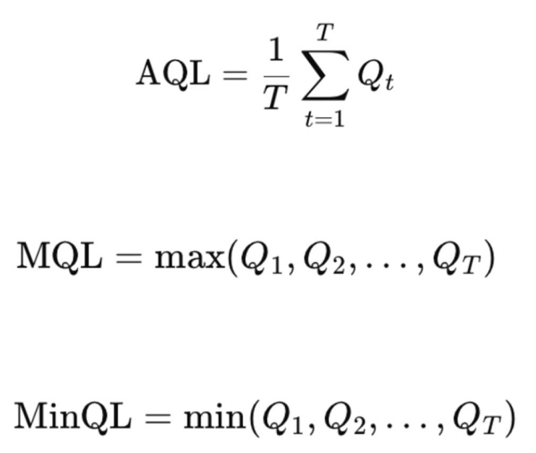
  - Average Queue Length (AQL)

  - Maximum Queue Length (MQL)

  - Minimum Queue Length (MinQL)

where Q_{t} denotes the total queue length at time step t, and T is the total number of simulation steps.
These metrics quantify congestion severity and variability throughout the simulation horizon.

Waiting Time Measurement
Waiting time captures the temporal aspect of congestion, representing the total time vehicles spend waiting due to traffic signals or congestion. In SUMO, the waiting time per lane is obtained as:
wait_time = float(traci.lane.getWaitingTime(lane))

Waiting time is measured in seconds and aggregates the waiting durations of all vehicles on the lane.
The primary evaluation metric used in this study is the Average Waiting Time (AWT):
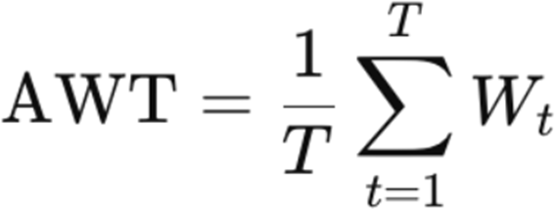

Reward Function Based on Queue–Delay
Queue length and waiting time jointly form the basis of the reward function used to train the reinforcement learning agent. The objective is to minimize congestion, ex- pressed as reducing queue length and cumulative delay.
At each decision step, after a traffic signal phase is applied, the environment com- putes the reward based on the updated state:
s2 = self._get_state()
r = self._compute_reward()
The reward follows a queue–delay penalty formulation, where:
- A decrease in total waiting time results in a positive reward
- An increase in waiting time or queue length results in a negative reward
This design encourages the agent to select signal phases that progressively reduce congestion rather than reacting only to instantaneous traffic conditions.

Performance Evaluation
Metric | DQN | Fixed-Time | Improvement
Avg Queue Length | 5.03 | 36.14 | +86.1%
Max Queue Length | 9.00 | 41.00 | +78.0%
Avg Waiting Time (s) | 2.17 | 1292.52 | +99.8%
Avg Speed | 1.89 | 2.53 | −25.1%
Cumulative Reward | −722.23 | −17190.08 | +95.8%
Table - Compares the proposed DQN-based traffic signal control with a fixed-time baseline strategy.

Online Data Collection During Training
The data in this system is generated online, meaning that it is created during the learning process of the agent.
At each time step, the following procedure is performed:
- The agent observes the current state s_{t}.
- The agent selects an action at (a traffic signal phase).
- SUMO runs the simulation for a short period.
- The environment returns:
  - the next state s_{t+1},
  - the reward r_{t}
The experience tuple
(s_{t}, a_{t}, r_{t}, s_{t+1})
is stored in the Replay Memory.
Therefore, the training data is not pre-collected but is generated directly through the interaction between the agent and the environment.

Main Training Loop
The core training loop is implemented in train.py (lines 28–80). This loop governs the entire online data collection and learning process.
Key operations include:
    - Environment initialization env.reset()
This step initializes the SUMO simulation and resets the traffic network to its initial state.
    - Environment interaction
next_state, reward, done, info = env.step(action)
Each call to env.step() advances the SUMO simulation, applies the selected traffic signal phase, and returns the next state and reward.
    - Experience storage
agent.replay_buffer.push(state, action, reward, next_state, done)

The generated experience is immediately stored in the replay buffer, enabling online data accumulation.
This loop continues until a terminal condition is reached, such as exceeding the max- imum number of simulation steps or when no vehicles remain in the network.

Replay Memory and Experience Storage
The Replay Memory mechanism is implemented in replay_buffer.py (lines 21–40).
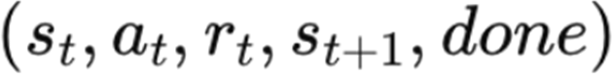

into a fixed-capacity buffer. When the buffer is full, older experiences are discarded following a First-In-First-Out (FIFO) strategy.
This design provides several benefits:
- Reduces correlation between consecutive samples
- Improves training stability
- Enables efficient reuse of past experiences during minibatch updates

Environment Interaction Example
A minimal example of the environment interaction loop is provided in test_env.py (lines 36–50). This script demonstrates:
    - Environment initialization
    - Repeated calls to reset() and step()
    - Observation of state transitions and rewards
This example is primarily used for debugging and validating the correctness of the environment dynamics before full training.

Jupyter Notebook Demonstration
A practical demonstration of the online training process is included in:
    - QuickStart.ipynb This notebook illustrates:
    - Initialization of the environment and DQN agent
    - Training over 200 simulation steps
    - Visualization of performance metrics such as queue length and waiting time

The notebook serves as a reproducible and interpretable example of the online learn- ing workflow.

Demo Execution Script
The run_demo.py (lines 45–90) script provides a standalone demonstration of the trained DQN agent interacting with the SUMO environment.
This script highlights:
    - Agent initialization
    - Real-time stepping through the environment
    - Online observation of traffic performance
It is mainly used for qualitative evaluation and visualization of agent behavior.

Generated Training Data
All performance metrics generated during training are logged into CSV files for post-analysis.
DQN Results
File: dqn_results.csv Columns:
- Episode
- Avg_Queue
- Max_Queue
- Avg_Wait_Time
- Max_Wait_Time
- Avg_Speed
- Cumulative_Reward
- Vehicles_Passed Fixed-Time Baseline Results File: fixed_results.csv
These datasets are used to quantitatively compare the proposed DQN-based control
strategy against a traditional fixed-time traffic signal control method. Discussion

Since all experiences are generated online, the training dataset is non-static and evolves as the agent improves its policy. This allows the agent to adapt to stochas- tic traffic conditions and learn robust signal control strategies without relying on predefined traffic patterns or historical datasets.

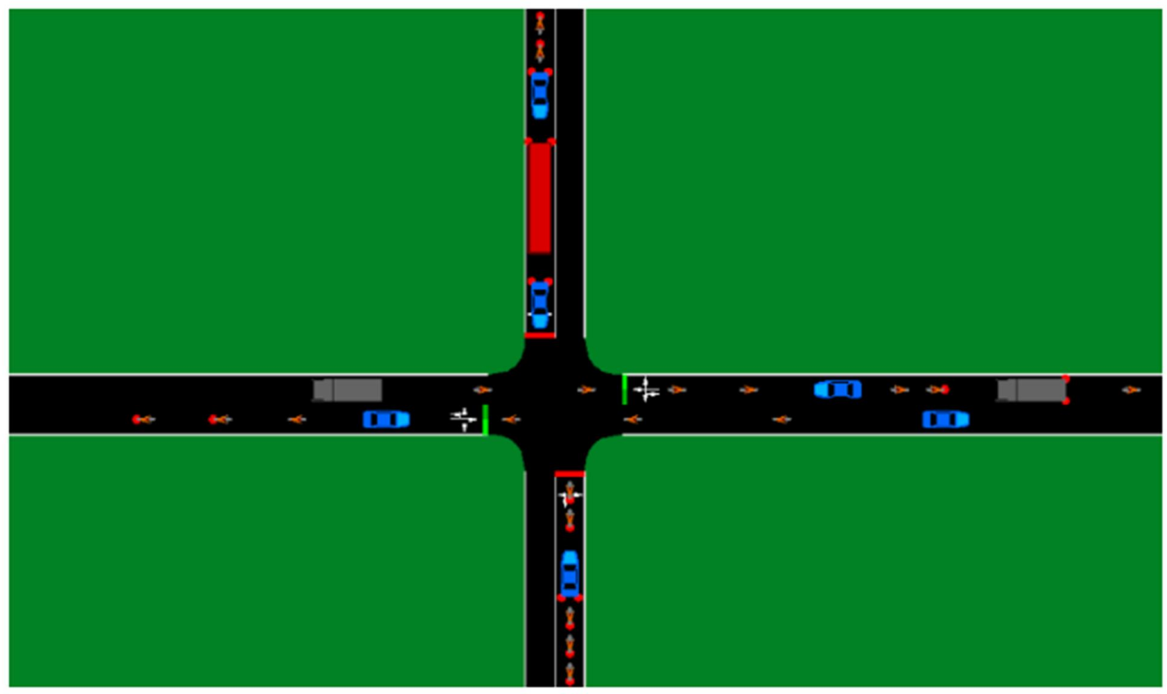
Chapter Conclusion
This chapter has presented how the traffic simulation environment is built using SUMO and how data is generated during the training of the Deep Q-Learning agent.
SUMO provides a detailed and realistic traffic model, while the state representation based on lane occupancy and vehicle queues enables the agent to accurately capture congestion conditions at the intersection. The use of online data collection ensures that the agent learns a traffic signal control policy that adapts to dynamic traffic conditions.

CHAPTER 3. REINFORCEMENT LEARNING MODEL

Reinforcement Learning Framework
Reinforcement Learning (RL) is a subfield of machine learning in which an agent learns to make sequential decisions through trial-and-error interactions with an en- vironment in order to achieve a predefined objective. Unlike supervised learning, where correct outputs are explicitly provided, reinforcement learning relies on feed- back in the form of scalar rewards that evaluate the quality of the agent’s actions over time.

This paradigm is particularly well-suited for complex control problems character- ized by dynamic environments, delayed consequences, and long-term objectives. Traffic signal control is a representative example of such problems, as the decision made at one time step (e.g., switching a traffic light phase) directly influences future traffic conditions, congestion levels, and vehicle waiting times.
In this project, reinforcement learning provides a principled framework for modeling traffic signal control as a sequential decision-making problem, where the goal is to learn an adaptive control policy that improves traffic efficiency through experience rather than handcrafted rules.

Agent–Environment Interaction
The core of reinforcement learning lies in the continuous interaction between an agent and an environment, which unfolds over a sequence of discrete time steps. At each time step tt, the interaction process is defined as follows:
    - The agent observes the current state of the environment, denoted as st.
    - Based on this observation and its policy, the agent selects an action at.
    - The environment responds by transitioning to a new state s_{t}+1
    - The agent receives a scalar reward r_{t}+1, which evaluates the immediate im- pact of the chosen action.
This interaction can be summarized as:

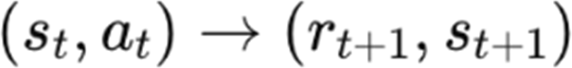

In the context of traffic signal control, these components are instantiated as follows:
      - The Agent: The traffic signal controller, implemented as a Deep Q-Network (DQN), which decides when and how to switch traffic light phases.
      - The Environment: A four-way signalized intersection simulated using SUMO (Simulation of Urban Mobility), which models vehicle movements, queues, and traffic dynamics.
      - The Interface: The TraCI (Traffic Control Interface) protocol, which serves as the communication bridge between the agent and the simulator. TraCI al- lows the agent to retrieve traffic state information (e.g., vehicle counts, queue lengths) and to apply control actions (e.g., changing signal phases) in real time.
The environment is assumed to satisfy the Markov property, meaning that the next state depends only on the current state and the selected action, and not on the full history of past states:

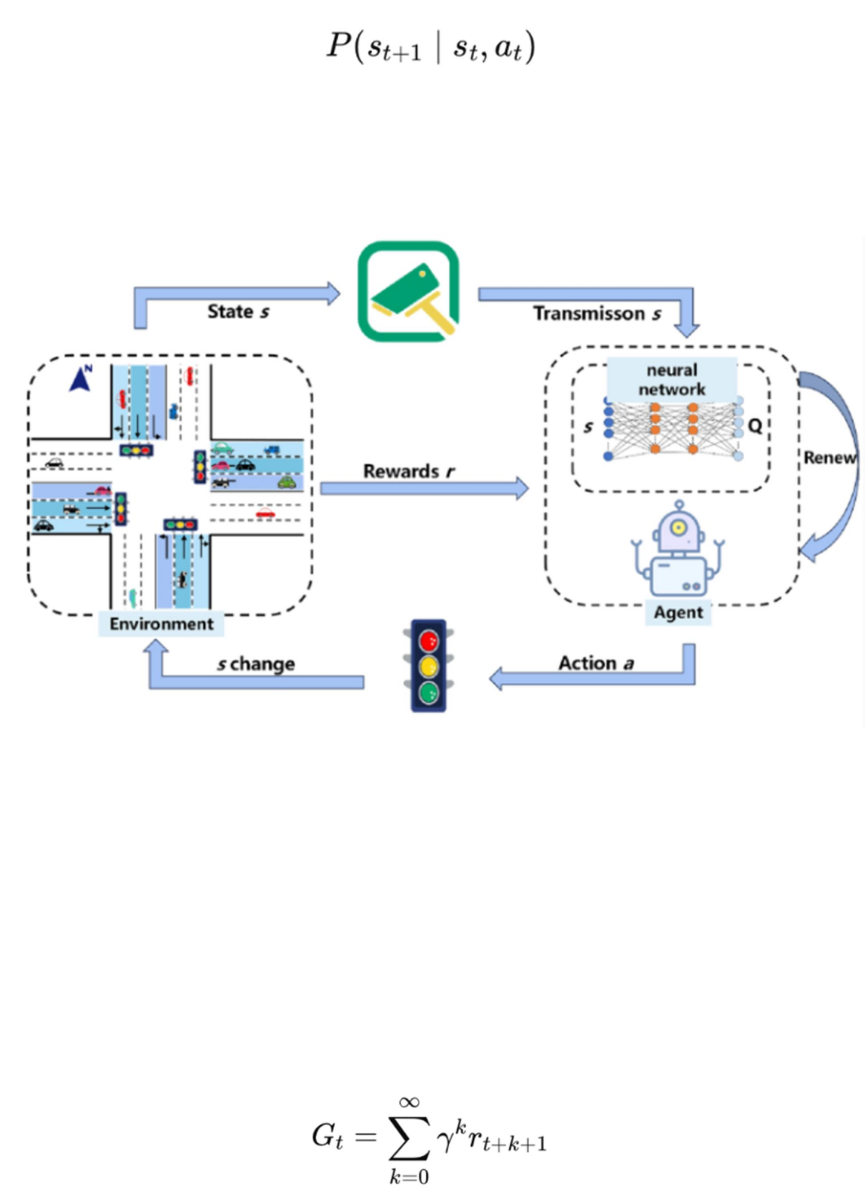

Under this assumption, the traffic signal control problem can be formally modeled as a Markov Decision Process (MDP), providing a solid mathematical foundation for applying reinforcement learning algorithms.

Figure - Reinforcement Learning Agent–Environment Interaction for Traffic Signal Control

Learning Objective
The objective of reinforcement learning is not to maximize the immediate reward at a single time step, but rather to optimize performance over the entire duration of an episode. This is achieved by maximizing the expected cumulative discounted re- ward, also known as the return, which is defined as:

Here, γ ∈ [0,1] is the discount factor, which determines the relative importance of future rewards compared to immediate rewards.

In the traffic signal control scenario, the reward function plays a crucial role in shap- ing the learned behavior. The agent may be guided by:
- A single-objective reward, such as minimizing total queue length or average waiting time.
- A multi-objective reward, which balances several traffic performance indica- tors, including delay, number of stops, and overall throughput.
The discount factor γγ directly influences the agent’s decision-making horizon. A myopic agent with a small γγ focuses primarily on clearing vehicles currently wait- ing at the intersection, potentially causing severe congestion in downstream lanes later. In contrast, a far-sighted agent with a discount factor close to 1 accounts for long-term traffic evolution and may tolerate short-term delays to prevent future grid- lock or spill-back effects.
To enhance interpretability, different reward design strategies and their implications are summarized in a comparative table within the report, highlighting the trade-offs between immediate traffic pressure and long-term traffic efficiency.

Intuitive Analogy
To build intuition, the reinforcement learning framework can be compared to a learn- ing thermostat. The agent corresponds to the thermostat controller, while the envi- ronment represents the room. The state is the current temperature, the action is turn- ing the heater on or off, and the reward reflects how close the temperature remains to a desired level. Without explicit knowledge of the room’s insulation or external weather conditions, the thermostat learns an effective control strategy through feed- back over time. Similarly, the traffic signal agent learns how to regulate traffic flow without explicit traffic rules, relying instead on experience-driven optimization.

Q - Learning Algorithm
Q-learning is a model-free Reinforcement Learning (RL) algorithm designed to learn an optimal decision-making policy through direct interaction with an environ- ment. In this framework, the agent does not rely on a predefined mathematical model of the environment’s dynamics; instead, it incrementally improves its policy via a process of trial-and-error learning, guided by scalar reward signals.
In the context of traffic signal control, the agent acts as an intelligent signal control- ler that interacts with a traffic simulation environment such as Simulation ofUrban Mobility (SUMO). At each decision step, the agent selects an action—such as ex- tending the current green phase or switching to another signal phase—and receives feedback reflecting the resulting traffic conditions. Through repeated interactions, the agent learns which control actions yield higher long-term traffic efficiency.

Traditional Q-learning stores state–action values in a tabular Q-table, which be- comes infeasible when dealing with large or high-dimensional state spaces. Modern traffic control applications therefore extend classical Q-learning by employing func- tion approximation, most commonly using Deep Neural Networks, to estimate Q- values efficiently in complex environments.

Q -Value Function
The Q-value function, denoted as Q (s, a), represents the expected cumulative dis- counted reward obtained by executing action aa in state ss and subsequently fol- lowing an optimal policy. Rather than evaluating actions solely based on immedi- ate rewards, the Q-value captures their long-term impact on system performance.
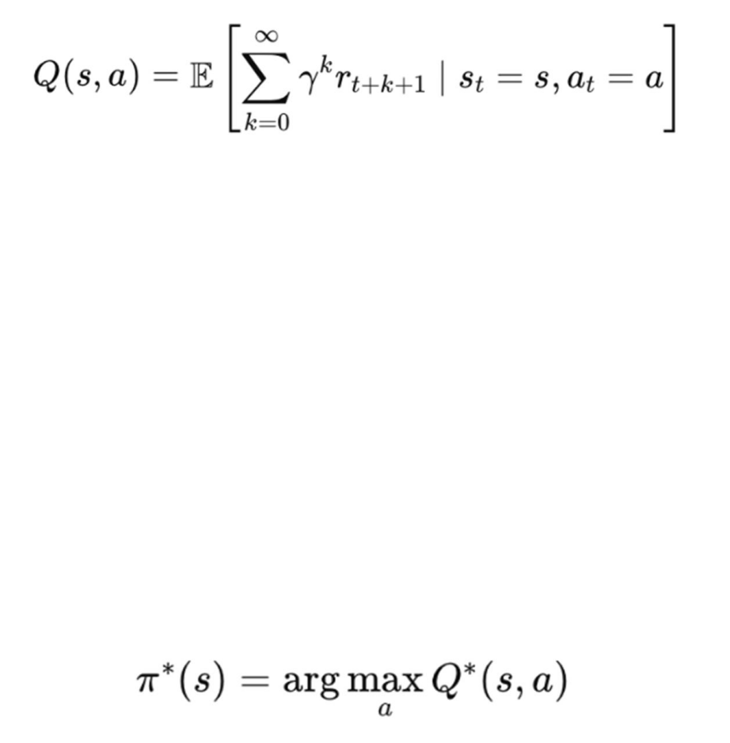
Formally, the Q-value function is defined as:

where γ ∈ [0,1] is the discount factor, controlling the relative importance of future rewards.
In traffic signal control, the state ss may be represented by traffic features such as vehicle presence indicators, queue lengths, or waiting times on each lane, while the action aa corresponds to selecting a specific signal phase. A higher Q-value indicates that a particular phase decision is expected to reduce congestion, shorten queues, or minimize vehicle delay over time.
The objective of Q-learning is to approximate the optimal Q-function Q∗ (s, a), from which the optimal policy can be derived as:

Bellman Equation
The optimal Q-function satisfies the Bellman optimality equation, which expresses a recursive relationship between the value of the current state–action pair and the values of future state–action pairs. Specifically, the Bellman equation decomposes long-term rewards into an immediate reward and the best achievable future reward.
In practical Q-learning implementations, this relationship is applied through the Temporal Difference (TD) update rule:

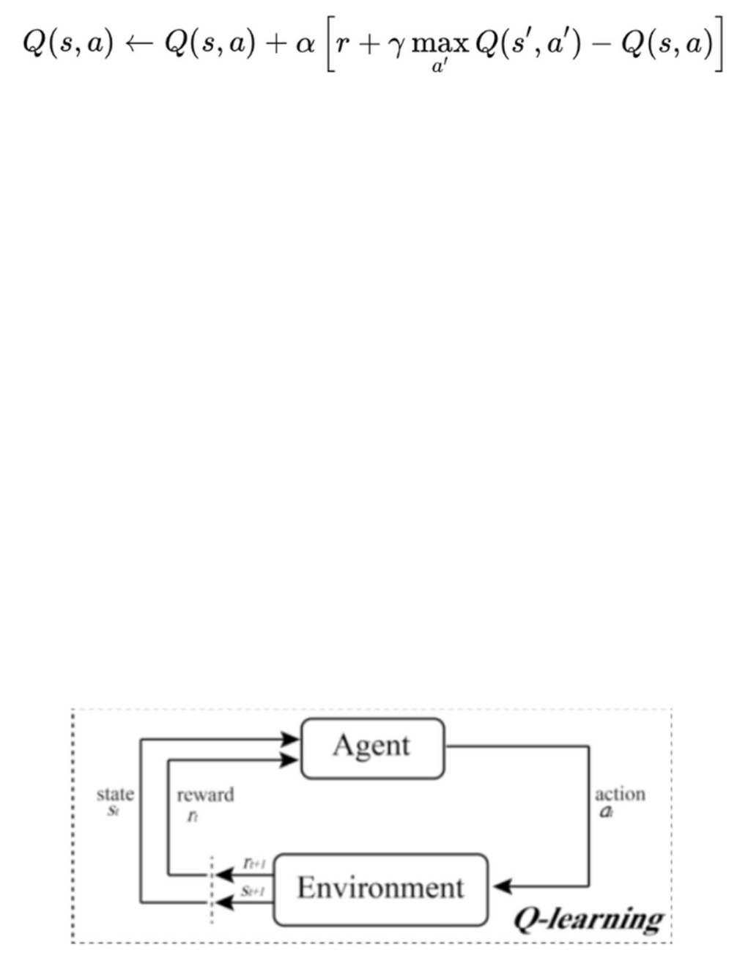
where:
- α ∈ (0,1] is the learning rate, controlling how strongly new experiences in- fluence existing estimates,
- ris the immediate reward observed after taking action a,
- s′ is the resulting next state.
The expression inside the brackets is known as the TD error, representing the dis- crepancy between the current Q-value estimate and a target value constructed from observed rewards and future expectations. Through repeated updates, the Bellman operator acts as a contraction mapping, ensuring convergence toward the optimal Q- function under suitable conditions.
In traffic signal control, this recursive learning mechanism enables the agent to as- sociate signal timing decisions with their delayed effects on traffic flow, ultimately yielding a policy that optimizes overall intersection efficiency.

Figure - Q-learning update based on reward and estimated future value

Deep Q-Learning (DQN)
Deep Q-Learning (DQN) is an advanced reinforcement learning approach that inte- grates classical Q-learning with Deep Neural Networks (DNNs) to approximate the optimal action-value function. Instead of maintaining a tabular representation of Q- values, DQN employs a neural network to estimate Q-values for given state–action pairs. This enables the reinforcement learning agent to operate effectively in high- dimensional and continuous state spaces, which are common in real-world applica- tions such as traffic signal control systems.
In this study, DQN is used to optimize traffic signal phases by allowing the agent to interact with a traffic simulation environment (e.g., SUMO). The agent observes the traffic state, selects signal control actions, and learns an optimal policy by minimiz- ing congestion-related objectives through trial-and-error interactions.

Motivation for Deep Q-Learning
Traditional tabular Q-learning becomes impractical when applied to environments with large or high-dimensional state spaces, a phenomenon known as the curse of dimensionality. In traffic signal control problems, the state of an intersection is often represented by detailed traffic observations such as lane occupancy, queue lengths, or vehicle positions. For instance, encoding the intersection state as a boolean vector of 36 cells results in 236236 possible states, making it infeasible to store and update Q-values using a lookup table.
Deep Q-Learning addresses this limitation by employing a deep neural network as a function approximator for the Q-value function. Instead of explicitly storing a value for every state–action pair, the network learns a mapping from a high-dimensional state representation to a vector of Q-values, where each element corresponds to a possible action. This structure allows the agent to evaluate all actions in a single forward pass, significantly improving decision-making efficiency compared to tra- ditional tabular approaches.
Furthermore, the use of neural networks enables the agent to generalize across un- seen states, allowing it to estimate reasonable Q-values even for traffic situations that were not explicitly encountered during training. This capability is essential for real-world traffic environments, where traffic patterns continuously vary and cannot be exhaustively enumerated.
However, this flexibility comes at a computational cost. Training deep neural net- works is computationally intensive and may require a large number of interactions with the environment, especially as the network architecture becomes more com- plex. Additionally, the generalization ability of DQN is sensitive to distributional shifts: if traffic demand patterns during deployment differ significantly from those observed during training, the learned policy may become unstable or suboptimal.
It is also important to note that while DQN is well-suited for continuous or high- dimensional state spaces, it typically assumes a discrete action space, such as select- ing one of several predefined traffic signal phases. Problems involving continuous action spaces usually require alternative reinforcement learning methods, such as policy gradient or actor–critic algorithms.

DQN Agent Class:
@dataclass
class AgentConfig: state_dim: int

action_dim: int
gamma: float = 0.99# Discount factor lr: float = 1e-3 # Learning rate batch_size: int = 64
tau: float = 1.0 # Target network update target_update_interval: int = 1000
double_dqn: bool = True# Double DQN (khắc phục overestimation) grad_clip: float | None = 10.0

class DQNAgent:
def init (self, cfg: AgentConfig, device: torch.device | None = None): self.q = DQN(cfg.state_dim, cfg.action_dim)# Q-network
self.q_target = DQN(cfg.state_dim, cfg.action_dim) # Target Q-network self.q_target.load_state_dict(self.q.state_dict())
self.q_target.eval()
self.optim = optim.Adam(self.q.parameters(), lr=cfg.lr) self.crit = nn.SmoothL1Loss(reduction="none")# Huber loss

Neural Network Architecture
In a Deep Q-Network (DQN), the neural network serves as a function approximator for the Q-value function, replacing the explicit Q-table used in traditional Q-learn- ing. The primary role of this network is to learn a mapping from a high-dimensional traffic state representation to a vector of Q-values, each corresponding to a discrete control action, such as selecting a traffic signal phase.
The input layer of the network is designed to match the dimensionality of the traffic state representation. In traffic signal control studies, this state is often encoded using Discrete Traffic State Encoding (DTSE), where the presence or absence of vehicles is represented as a binary vector. Common configurations include vectors of 36 bi- nary cells, corresponding to discretized lane segments, or extended representations of up to 80 cells that incorporate additional lane groups or distance buckets.

The hidden layers consist of multiple fully connected (dense) layers that enable the network to capture the complex and non-linear relationships inherent in traffic dy- namics. Research models frequently employ deep architectures, such as five hidden layers with 400 neurons each, although lighter configurations (e.g., three layers with 128 neurons) are also used depending on computational constraints. These layers typically utilize the Rectified Linear Unit (ReLU) activation function, which facili- tates efficient gradient propagation and allows the network to model non-linear traf- fic patterns such as congestion buildup and dissipation.
The output layer produces a vector of Q-values, where each element represents the estimated expected cumulative discounted reward for executing a specific action in the current state. This structure enables the agent to evaluate all possible actions simultaneously in a single forward pass, significantly improving decision-making efficiency compared to evaluating state–action pairs individually.
To stabilize training, DQN architectures commonly incorporate a Target Network, which is a separate neural network with the same architecture as the main (online) network. The target network is used to compute the Temporal Difference (TD) target and is updated periodically rather than at every training step. This design mitigates the moving target problem, where continuously changing Q-value estimates could otherwise lead to oscillations or divergence during learning.
The network parameters are optimized by minimizing the Mean Squared Error (MSE) between the predicted Q-values and the TD targets, typically using stochastic gradient-based optimizers such as Adam. This loss-driven optimization allows the network to iteratively refine its Q-value estimates based on observed traffic interac- tions.
While fully connected networks are sufficient for vector-based state representations, the choice of architecture can vary depending on how traffic states are modeled. Convolutional Neural Networks (CNNs) are often adopted when the state is repre- sented as a spatial grid resembling an image of the intersection, whereas recurrent architectures such as GRUs or LSTMs are introduced when temporal dependencies and historical traffic patterns are explicitly considered. In this study, the focus re- mains on a fully connected DQN architecture, which provides a balance between representational power and implementation simplicity for single-intersection traffic signal control.

MLPBlock:
class MLPBlock(nn.Module):
def init (self, in_dim: int, out_dim: int, dropout: float = 0.0): super(). init ()
self.lin = nn.Linear(in_dim, out_dim)# Linear layer self.bn = nn.LayerNorm(out_dim) # Batch normalization

self.drop = nn.Dropout(dropout) if dropout > 0 else nn.Identity()

def forward(self, x: torch.Tensor) -> torch.Tensor: x = self.lin(x)
x = self.bn(x)
x = F.relu(x)# ReLU activation x = self.drop(x)
return x

DQN Network - Dueling Architecture:
class DQN(nn.Module):
"""Dueling DQN architecture."""

def init ( self, state_dim: int,
action_dim: int,
hidden_layers: Sequence[int] = (128, 128),# [128, 128] dueling: bool = True,
dropout: float = 0.0,
) -> None: super(). init ()
# Backbone: các MLPBlock layers layers = []
last = state_dim
for h in hidden_layers: layers.append(MLPBlock(last, h, dropout=dropout)) last = h
self.backbone = nn.Sequential(*layers)

# Dueling heads (tách value và advantage) self.dueling = dueling
if dueling:
# Value stream: V(s) self.val_head = nn.Sequential( nn.Linear(last, last), nn.ReLU(),
nn.Linear(last, 1)
)
# Advantage stream: A(s,a) self.adv_head = nn.Sequential(

nn.Linear(last, last), nn.ReLU(),
nn.Linear(last, action_dim)
)
else:
# Simple Q-head nếu không dùng dueling self.head = nn.Linear(last, action_dim)

Forward Pass - Dueling Computation
def forward(self, x: torch.Tensor) -> torch.Tensor:
if x.dim() == 1:
x = x.unsqueeze(0)
z = self.backbone(x)# Backbone features
if self.dueling:
v = self.val_head(z)# [B, 1] - Value
a = self.adv_head(z)# [B, A] - Advantage # Q(s,a) = V(s) + (A(s,a) - mean(A(s,a'))) q = v + a - a.mean(dim=1, keepdim=True) return q
else:
return self.head(z)

Weight Initialization - Kaiming
def _initialize_weights(self) -> None:
"""Initialize using Kaiming uniform.""" for m in self.modules():
if isinstance(m, nn.Linear): nn.init.kaiming_uniform_(m.weight, a=math.sqrt(5)) if m.bias is not None:
fan_in, _ = nn.init._calculate_fan_in_and_fan_out(m.weight) bound = 1 / math.sqrt(fan_in)
nn.init.uniform_(m.bias, -bound, bound)

Experience Replay
Experience Replay is a fundamental mechanism in Deep Q-Learning designed to improve the stability and efficiency of training deep neural networks in reinforce- ment learning environments. Instead of learning directly from consecutive interac- tions with the environment, the agent stores its experiences in a replay buffer and reuses them during training.

Each experience is stored as a transition tuple

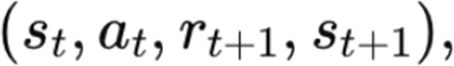

where s_{t} denotes the current traffic state, at the selected control action, r_{t+1} the ob- served reward, and s _{t+1} the resulting next state. In the context of traffic signal con- trol, these experiences correspond to signal phase decisions and their immediate and delayed impacts on traffic flow, such as queue length reduction or delay accumula- tion.
A primary motivation for Experience Replay is to break the strong temporal corre- lations that naturally exist in sequential traffic data. In microscopic traffic simula- tions, consecutive states are often highly similar, especially under stable traffic de- mand. Training a neural network on such correlated samples can lead to biased gra- dient updates and unstable learning behavior. By randomly sampling minibatches of past experiences from the replay buffer, the agent approximates the assumption of independent and identically distributed raining data required by standard stochastic gradient descent methods.
In addition to stabilizing learning, Experience Replay significantly improves data efficiency. Each interaction with the traffic simulator is computationally expensive; therefore, reusing stored experiences allows the agent to learn multiple times from the same simulation data. In practical traffic signal control implementations, the re- play buffer is often sampled multiple times per episode, enabling faster convergence toward an effective control policy.
The replay buffer typically operates under two constraints: a warm-up phase and a maximum capacity. During the warm-up phase, the agent collects a minimum num- ber of experiences before training begins, ensuring that early updates are based on a sufficiently diverse set of transitions. Once the buffer reaches its maximum capacity, older experiences are gradually discarded in a first-in-first-out manner to make room for new data.
Despite its advantages, Experience Replay introduces potential challenges. One no- table issue is catastrophic forgetting, where the learning process may gradually over- look earlier successful strategies due to overfitting on a limited subset of sampled experiences. While this risk is mitigated through random sampling, it motivates ex- tensions such as Prioritized Experience Replay, in which transitions with higher learning significance are sampled more frequently. However, in this study, standard uniform Experience Replay is adopted to maintain architectural simplicity and con- sistency with classical DQN-based traffic control frameworks.

Overall, Experience Replay plays a crucial role in enabling Deep Q-Learning to function reliably in complex and highly correlated environments such as urban traf- fic systems, forming a key component of the DQN training pipeline.

Transition Data Structure
@dataclass class Transition:
s: np.ndarray# Current state a: int # Action taken
r: float # Reward received s2: np.ndarray # Next state
d: bool# Done flag (episode end)

ReplayBuffer Class
class ReplayBuffer:
def init (self, capacity: int, state_shape: Tuple[int, ...]): self.capacity = capacity# Max transitions to store self.state_shape = state_shape
self.storage: List[Transition] = [] self.idx = 0# Circular buffer index
def push(self, s: np.ndarray, a: int, r: float, s2: np.ndarray, d: bool) -> None: """Lưu transition mới."""
if len(self.storage) < self.capacity: self.storage.append(Transition(s.copy(), a, r, s2.copy(), d)) else:
# Ghi đè transition cũ nhất (circular buffer) self.storage[self.idx] = Transition(s.copy(), a, r, s2.copy(), d) self.idx = (self.idx + 1) % self.capacity

Sample Batch for Training
def sample(self, batch_size: int):
"""Sample random batch cho training."""
batch = random.sample(self.storage, batch_size)
# Convert to tensors
s = torch.from_numpy(np.stack([b.s for b in batch]).astype(np.float32)) a = torch.tensor([b.a for b in batch], dtype=torch.long)
r = torch.tensor([b.r for b in batch], dtype=torch.float32)
s2 = torch.from_numpy(np.stack([b.s2 for b in batch]).astype(np.float32))

d = torch.tensor([b.d for b in batch], dtype=torch.float32) return s, a, r, s2, d

ε-greedy Exploration Strategy
The ε-greedy exploration strategy is a widely adopted policy in Deep Q-Learning to address the fundamental exploration–exploitation trade-off in reinforcement learn- ing. During training, the agent must decide whether to exploit its current knowledge by selecting the action with the highest estimated Q-value or to explore alternative actions that may lead to improved long-term performance.
Under the ε-greedy policy, the agent selects a random action with probability ε and chooses the greedy action—the action that maximizes the predicted Q-value—with probability ε. Formally, the action selection policy is defined as:
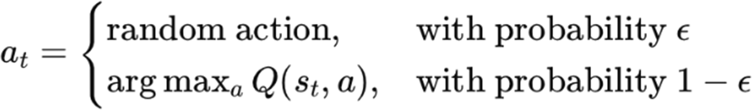

In the context of traffic signal control, a random action typically corresponds to se- lecting a random traffic signal phase, such as switching to a North–South green or an East–West green phase, regardless of the current traffic state. This mechanism enables the agent to experience a diverse range of traffic situations, including con- gested, balanced, and low-demand scenarios.
At the beginning of training, ε is usually initialized to a high value (commonly ε = 1.0$), resulting in pure exploration. This phase is essential because early Q-value estimates produced by the neural network are highly inaccurate and unreliable. Without sufficient exploration, the agent risks converging prematurely to a subopti- mal policy based on misleading initial predictions.
As training progresses, ε is gradually reduced according to a predefined decay sched- ule, most commonly a linear decay over a fixed number of training episodes or steps. The decay continues until ε reaches a minimum threshold, after which the agent primarily exploits its learned policy while still retaining a small probability of ex- ploration. This gradual transition ensures that the agent shifts from broad exploration toward stable and efficient traffic control behavior.
The role of exploration is particularly important in traffic environments, where traf- fic demand patterns may vary over time. High exploration in the early training stages allows the agent to observe the effects of different signal timing decisions under diverse traffic conditions, such as sudden traffic surges or asymmetric lane utiliza- tion. By preventing the agent from consistently selecting the same action too early,

the ε-greedy strategy mitigates the risk of becoming trapped in locally optimal but globally inefficient signal control strategies.
Overall, the ε-greedy exploration strategy provides a simple yet effective mechanism to balance exploration and exploitation, enabling the Deep Q-Network to learn ro- bust traffic signal control policies while maintaining algorithmic simplicity and computational efficiency.

Linear Epsilon Schedule - Decay linear
class LinearEpsilon:
"""Linear epsilon decay schedule."""
def init (
self, start: float = 1.0, end: float = 0.05, steps: int = 50_000
) -> None:
self.start = start# eps_start: 1.0 self.end = end# eps_end: 0.05
self.steps = max(1, steps)# eps_steps: 100,000 self.t = 0

def value(self, t: int | None = None) -> float: """Get epsilon at step t."""
if t is None:
t = self.t
frac = min(1.0, max(0.0, t / self.steps))
# Linear interpolation: ε(t) = start + frac * (end - start) return self.start + frac * (self.end - self.start)
def step(self) -> float:
"""Advance and return current epsilon.""" v = self.value(self.t)
self.t += 1 return v

Epsilon-Greedy Action Selection
@torch.no_grad()
def act(self, state: np.ndarray, eps: float) -> int: """Select action với epsilon-greedy."""
if np.random.rand() < eps:
# Explore: random action
return np.random.randint(self.cfg.action_dim)

# Exploit: greedy action từ Q-network
s = torch.from_numpy(state.astype(np.float32)).to(self.device) q = self.q(s.unsqueeze(0))
return int(q.argmax(dim=1).item())

Configuration - Epsilon Parameters
explore:
eps_start: 1.0 # Start: 100% random (exploration) eps_end: 0.05# End: 5% random (mostly exploitation) eps_steps: 100000# Decay over 100,000 steps

Training Process
The training process of the proposed Deep Q-Learning–based traffic signal control- ler follows an episode-based reinforcement learning pipeline, in which the agent re- peatedly interacts with the traffic simulation environment to improve its control pol- icy. Each training episode corresponds to a complete traffic simulation run in SUMO.
At the beginning of each episode, the simulation environment is initialized with pre- defined traffic demand and intersection configurations. At each discrete decision time step tt, the agent observes the current traffic state st, which represents traffic conditions such as vehicle presence, queue length, or waiting time on each incoming lane.
Based on the observed state st, the agent selects an action at using the ϵ-greedy pol- icy. The selected action corresponds to a traffic signal phase selection or extension and is applied to the SUMO simulation via the TraCI interface.
After executing the action, the environment transitions to a new state s_{t+1} and returns a scalar reward r_{t+1}. The transition tuple

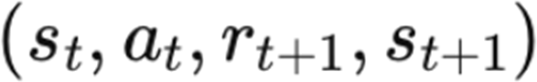

is stored in the experience replay buffer for later training.
Once a sufficient number of transitions have been collected, the agent samples ran- dom minibatches from the replay buffer to update the parameters of the Q-network. For each transition, the Temporal Difference (TD) target is computed as:

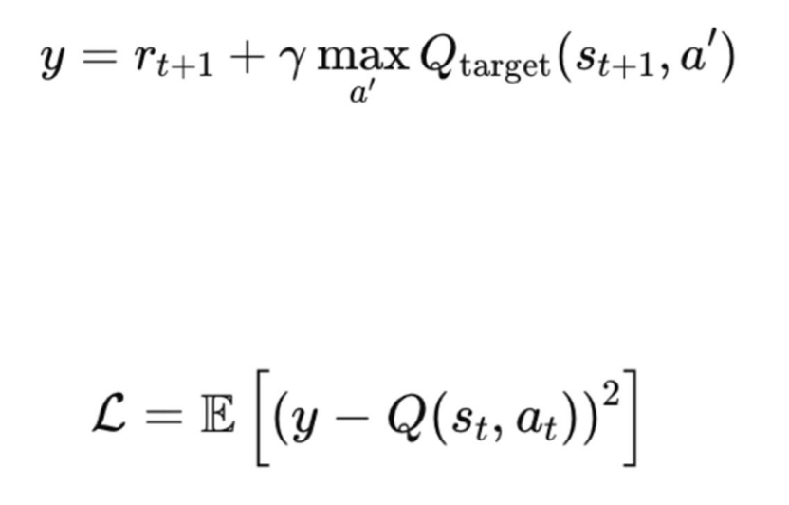
where γγ is the discount factor and Qtarget denotes the target network.
The Q-network parameters are updated by minimizing the Mean Squared Error (MSE) loss:

using a gradient-based optimizer such as Adam.
This interaction and learning cycle continues until the simulation episode terminates. Performance metrics such as average waiting time, queue length, and cumulative reward are recorded after each episode. Over successive episodes, the exploration rate ϵ is gradually decreased, allowing the agent to shift from exploration to exploi- tation.

Main Training Loop
def main(cfg_path: str = "config.yaml") -> None:
# Khởi tạo environment, agent, buffer env = SumoMDPEnv(env_cfg)
agent = DQNAgent(agent_cfg)
buffer = ReplayBuffer(cfg["train"]["replay_size"], state_shape=(env.state_dim,)) eps_sched = LinearEpsilon(
start=cfg["explore"]["eps_start"], end=cfg["explore"]["eps_end"], steps=cfg["explore"]["eps_steps"],
)
total_steps = cfg["train"]["total_steps"]# 200,000 start_train = cfg["train"]["start_train"]# 10,000 train_every = cfg["train"]["train_every"]# 1

s = env.reset()
pbar = tqdm(range(total_steps), desc="Training", ncols=100) episode_reward = 0.0
try:
for t in pbar:
# 1. Exploration: epsilon-greedy

eps = eps_sched.step() a = agent.act(s, eps)
# 2. Environment step
s2, r, d, info = env.step(a)
# 3. Experience Replay: push to buffer buffer.push(s, a, r, s2, d)
s = s2 episode_reward += r

# 4. Training: sample batch and update
if len(buffer) >= start_train and t % train_every == 0: batch = buffer.sample(agent_cfg.batch_size)
stats = agent.update(batch)
# 5. Episode end if d:
pbar.set_postfix({
"R": f"{episode_reward:.1f}",
"eps": f"{eps:.2f}",
"loss": f"{stats['loss']:.3f}"
})
s = env.reset() episode_reward = 0.0

# Save weights
torch.save(agent.q.state_dict(), "outputs/dqn_vn_tls.pt") finally:
env.close()

Q-Learning Update - TD Loss
def update(self, batch) -> dict:
"""Update Q-network từ batch."""
s, a, r, s2, d = [x.to(self.device) for x in batch]

# ===== Current Q-value: Q(s,a) =====
q = self.q(s).gather(1, a.unsqueeze(1)).squeeze(1)

# ===== Target Q-value: r + γ*max Q'(s',a') ===== with torch.no_grad():
if self.cfg.double_dqn:
# Double DQN: dùng q để chọn action, q_target để evaluate

a2 = self.q(s2).argmax(dim=1)# Best action từ main network
q2 = self.q_target(s2).gather(1, a2.unsqueeze(1)).squeeze(1)# Evaluate từ target else:
# Standard DQN: dùng q_target cho cả hai q2 = self.q_target(s2).max(dim=1).values
target = r + (1.0 - d) * self.cfg.gamma * q2 # ===== Compute Huber Loss =====
loss = self.crit(q, target).mean()# Smooth L1 loss

# ===== Gradient Descent ===== self.optim.zero_grad(set_to_none=True) loss.backward()
# Gradient clipping
if self.cfg.grad_clip is not None: nn.utils.clip_grad_norm_(self.q.parameters(), self.cfg.grad_clip)
self.optim.step() self.step_count += 1
# ===== Target Network Update ===== if self.cfg.tau < 1.0:
# Soft update: θ' ← τ*θ + (1-τ)*θ' with torch.no_grad():
for p, tp in zip(self.q.parameters(), self.q_target.parameters()): tp.data.mul_(1 - self.cfg.tau).add_(p.data, alpha=self.cfg.tau) else:
# Hard update: θ' ← θ mỗi N steps
if self.step_count % int(self.cfg.target_update_interval) == 0: self.q_target.load_state_dict(self.q.state_dict())
return {"loss": float(loss.item())}

Training Configuration
train:
total_steps: 200000 # Total training steps start_train: 10000# Warmup before training train_every: 1# Train mỗi step
replay_size: 100000 # Experience buffer batch_size: 64# Training batch size gamma: 0.99 # Discount factor

lr: 0.0005# Learning rate (Adam)
tau: 1.0# Hard update (1.0 = hard, <1 = soft) target_update_interval: 2000 # Hard update mỗi 2000 steps double_dqn: true# Double DQN enabled
grad_clip: 10.0 # Gradient clipping

explore:
eps_start: 1.0
eps_end: 0.05
eps_steps: 100000

Chapter Conclusion
In this chapter, the fundamental concepts and methodologies of Reinforcement Learning (RL) were systematically presented to establish the theoretical foundation for the proposed model in this study. The reinforcement learning framework was first introduced, clarifying the interaction mechanism between the agent and the en- vironment through states, actions, rewards, and state transitions.
Subsequently, the Q-Learning algorithm was discussed as a value-based reinforce- ment learning approach, highlighting its objective of estimating the optimal action- value function. Due to the limitations of tabular Q-Learning in high-dimensional state spaces, Deep Q-Learning (DQN) was introduced to address scalability issues by employing deep neural networks to approximate the Q-function.
The chapter then described the architecture and key components of the DQN model adopted in this project, including the Q-network, action selection strategy, and ex- perience replay mechanism. Furthermore, the training process was detailed to illus- trate how the agent learns from interactions with the environment through iterative updates of network parameters based on observed rewards and state transitions.
Overall, this chapter provides a comprehensive theoretical and practical basis for applying Deep Reinforcement Learning to the problem addressed in this research. The concepts and algorithms discussed herein serve as the foundation for the exper- imental setup and performance evaluation presented in the subsequent chapter.

Chapter 4. Experimental Setup and Evaluation

Experimental Configuration
This chapter presents the experimental setup and evaluation process used to assess the performance of the proposed Deep Q-Network (DQN) based traffic light control system. The experiments are conducted in a simulated traffic environment and com- pared against a fixed-time traffic signal control baseline.

Simulation Parameters
The traffic environment is modeled as a single four-way intersection with incoming lanes from four directions: North, South, East, and West. Vehicle arrivals are simu- lated stochastically to reflect dynamic traffic conditions.
The key simulation parameters are summarized as follows:
    - Simulation duration: 3600 seconds per episode
    - Intersection type: Single intersection, four approaches
    - Vehicle arrival model: Probabilistic arrival per time step
    - Time step: 1 second
    - Maximum vehicles passing per green phase: Fixed capacity per second
    - Traffic signal phases: Two main phases (North–South green and East–West green)
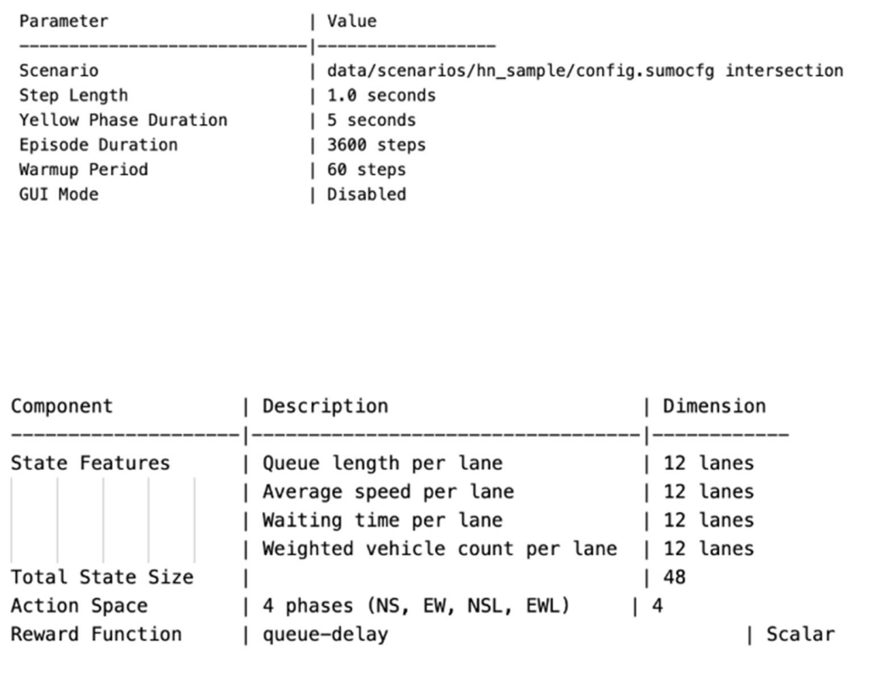
The same simulation configuration is used for both the baseline method and the DQN-based controller to ensure a fair comparison.

Table - SUMO Simulation Parameters
Table - State and Action Space Configuration

Baseline Method: Fixed-Time Traffic Control
The fixed-time traffic signal control is implemented as the baseline method. In this approach, traffic lights operate using predefined and constant phase durations, re- gardless of real-time traffic conditions.

Specifically, the signal alternates between:
    - North–South green phase with a fixed duration
    - East–West green phase with a fixed duration
This control strategy does not consider the current queue length or vehicle waiting time when switching phases. Although simple and widely used in real-world sys- tems, fixed-time control often leads to inefficient traffic flow under fluctuating traf- fic demand. The baseline serves as a reference to evaluate the effectiveness of the proposed DQN-based approach.
@dataclass
class FixedTimeConfig:
green_duration: int = 25# seconds - thời gian xanh yellow_duration: int = 5# seconds - thời gian vàng phases_cycle: list = [0, 1, 2, 3]# 4 pha

class FixedTimeController:
def get_action(self) -> int:
"""Chu kỳ cố định: mỗi pha xanh 25s, vàng 5s"""
phase_index = (self.step_counter // self.cycle_length) % len(self.phases_cycle) action = self.phases_cycle[phase_index]
self.step_counter += 1 return action
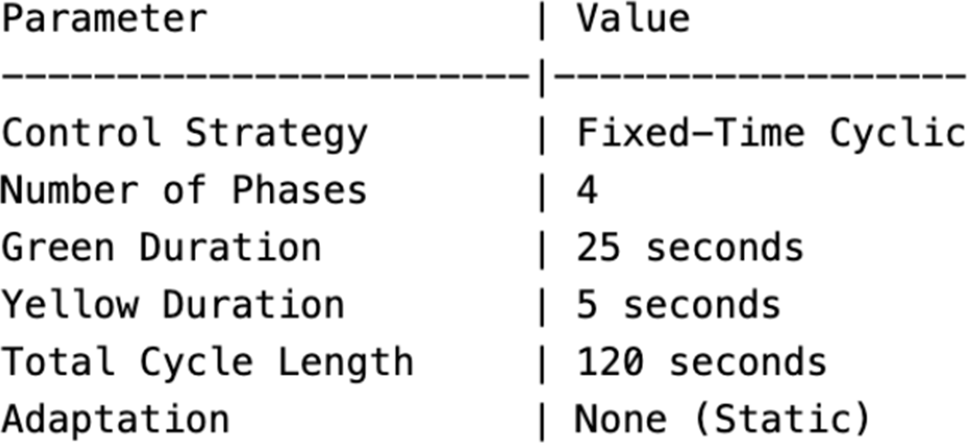

Table - Fixed-Time Controller Configuration

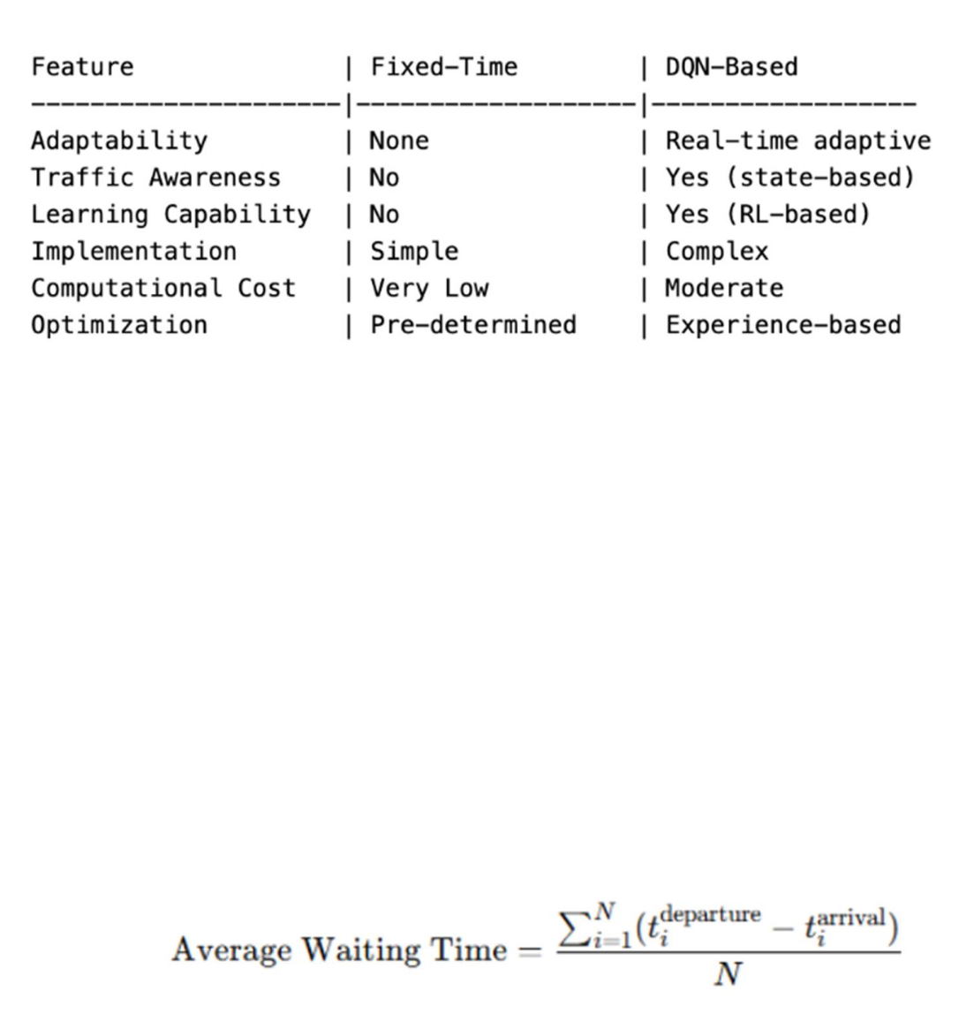
Table - Control Strategy Comparison

Evaluation Metrics
To evaluate traffic efficiency and control performance, several metrics are collected during the simulation. These metrics are computed consistently for both the fixed- time baseline and the DQN-based controller.

Average Vehicle Waiting Time
Average vehicle waiting time measures the mean time that vehicles spend waiting at the intersection before passing through it.

where NNN is the total number of vehicles that pass through the intersection.
This metric directly reflects the level of congestion and is a primary indicator of traffic efficiency.

Queue Length
Queue length represents the number of vehicles waiting at the intersection at a given time step. During the simulation, the queue length is recorded at each time step and averaged over the entire episode.
Average queue length provides insight into congestion buildup and traffic stability. Lower queue lengths indicate better traffic flow and reduced congestion.

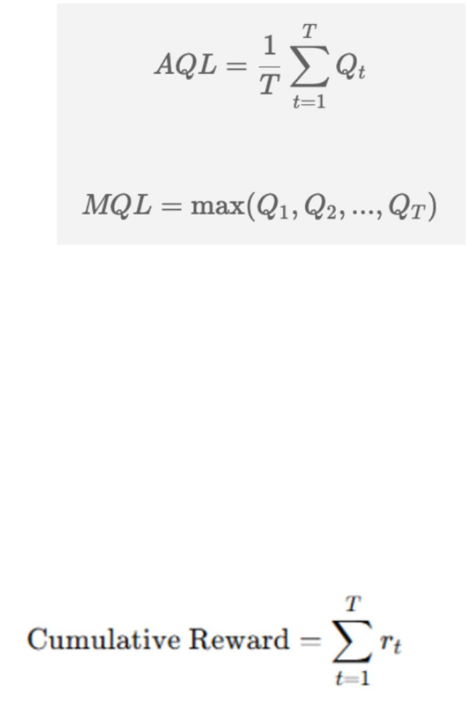
Cumulative Reward
Cumulative reward is used to evaluate the learning performance of the DQN agent. The reward function is designed to penalize traffic congestion, typically based on vehicle waiting time or queue length.
The cumulative reward over an episode is calculated as:

where r(t)is the reward at time step ttt, and T is the episode length.
An increasing cumulative reward over training episodes indicates that the agent is learning an effective traffic control policy.

Results and Analysis

Performance Comparison
The performance of the DQN-based traffic light controller is compared against the fixed-time baseline using the evaluation metrics described above.
Experimental results show that the DQN-based approach achieves:
    - Lower average vehicle waiting time
    - Shorter average queue length
    - Higher cumulative reward compared to the fixed-time method
These improvements demonstrate the ability of the DQN agent to adapt signal tim- ing based on real-time traffic conditions, unlike the static baseline strategy.

DQN Results
Episode | Avg_Queue | Max_Queue | Avg_Wait_Time | Avg_Speed | Cumula- tive_Reward

1 | 5.03| 9.0 | 2.17| 1.89| -722.23
2 | 5.03| 9.0 | 2.17| 1.89| -722.23

Fixed-Time Results
Episode | Avg_Queue | Max_Queue | Avg_Wait_Time | Avg_Speed | Cumula- tive_Reward
1 | 36.14 | 41.0| 1292.52 | 2.53| -17190.08
2 | 36.14 | 41.0| 1292.52 | 2.53| -17190.08
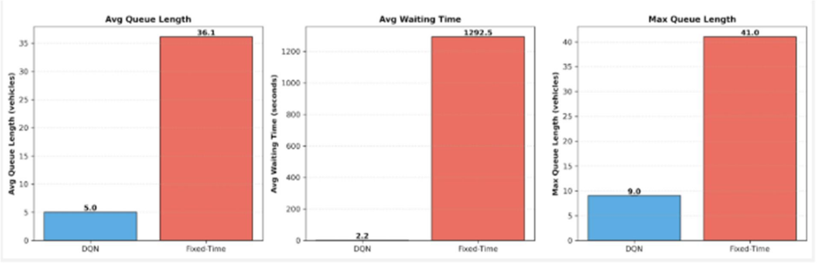

Figure – Performance Metrics Comparison

Traffic Efficiency Improvement
The fixed-time control strategy applies the same signal timing regardless of traffic demand, which often leads to inefficient use of green phases when traffic distribu- tion is uneven.
In contrast, the DQN-based controller dynamically adjusts traffic signal phases by observing the current traffic state. As a result:
    - Green time is allocated more effectively to congested directions
    - Unnecessary waiting is reduced
    - Overall traffic throughput is improved
The experimental results confirm that reinforcement learning can significantly en- hance traffic efficiency in dynamic environments.

Table - Performance Comparison

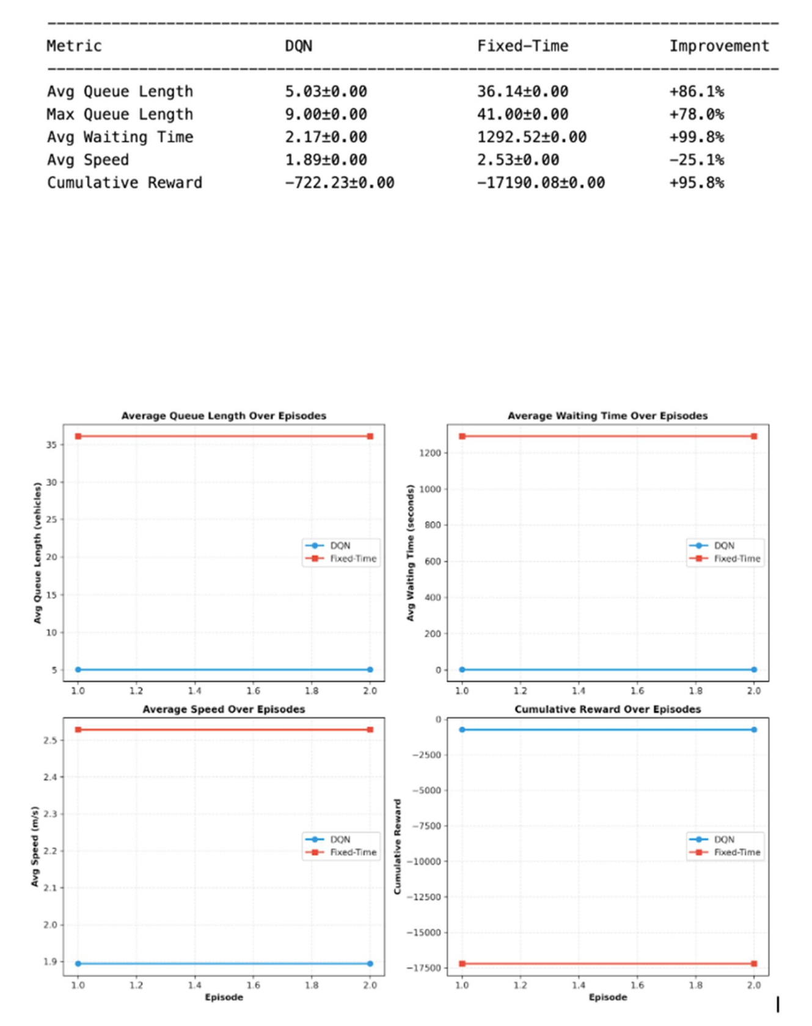
Figure – Performance Tracking Over Episodes

Statistical Analysis of Results
To ensure a rigorous and reliable evaluation of the proposed DQN-based traffic sig- nal control system, a statistical analysis is conducted on the experimental results obtained from multiple evaluation episodes. The goal of this analysis is to quantify

not only the average performance but also the variability and stability of the learned policy.

Statistical Metrics
For each evaluation run, the following performance metrics are collected:
- Average queue length
- Maximum queue length
- Average waiting time
- Cumulative reward
These metrics are aggregated across multiple runs and analyzed using descriptive statistics, including mean, standard deviation, minimum, and maximum values.
The statistical computation is implemented in the StatisticalAnalysis class, as shown below:
class StatisticalAnalysis:
@staticmethod
def compute_statistics(results: List[EvaluationMetrics]) -> Dict: """Compute mean, std, min, and max for all metrics."""
metrics = {
'avg_queue': [r.avg_queue_length for r in results], 'max_queue': [r.max_queue_length for r in results], 'avg_wait': [r.avg_waiting_time for r in results], 'cumulative_reward': [r.cumulative_reward for r in results]
}

stats_dict = {name: { 'mean': np.mean(values),
'std': np.std(values),
'min': np.min(values), 'max': np.max(values)
} for name, values in metrics.items()} return stats_dict
This statistical summary provides insight into both central tendency (mean perfor- mance) and dispersion (robustness across episodes). Low standard deviation values indicate that the learned policy behaves consistently under similar traffic conditions.

Confidence Interval Estimation
To further assess the reliability of the experimental results, a 95% confidence inter- val (CI) is computed for key performance metrics using the Student’s t-distribution, which is suitable for a limited number of evaluation runs.
@staticmethod
def confidence_interval(data: List[float], confidence: float = 0.95):
"""Compute 95% confidence interval using t-distribution."""
The confidence interval estimates the range within which the true population mean lies with 95% confidence. Narrow confidence intervals observed in the DQN results indicate stable learning behavior and low sensitivity to stochastic traffic variations.

Interpretation
The statistical analysis confirms that the proposed DQN-based controller not only improves average traffic performance but also maintains low variance, demonstrat- ing robustness and reliability across multiple simulation episodes.
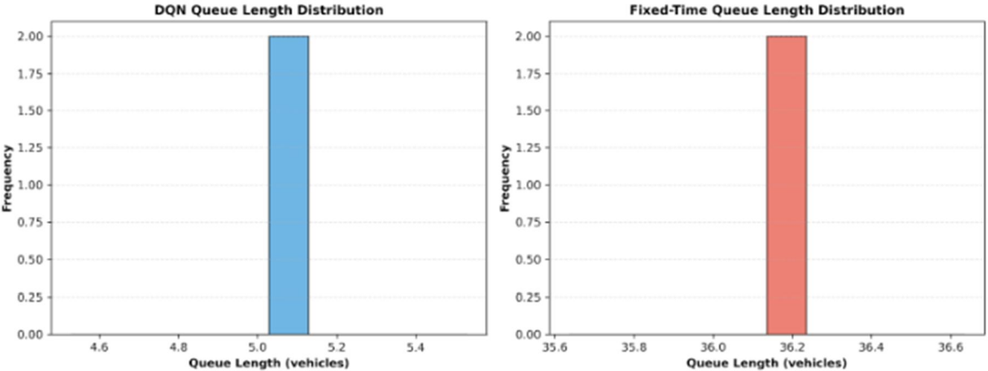
Figure – Queue Length Distribution

Impact of Traffic Density Variations
To evaluate the adaptability of the proposed method under varying traffic demand levels, experiments were conducted using traffic flows with different densities and arrival patterns. The performance of the DQN-based controller was compared against a traditional fixed-time traffic signal control strategy.

Observed Results
Analysis of the logged CSV results reveals a significant contrast between the two approaches:

- DQN-based control
  - Average queue length stabilizes at approximately 5.03 vehicles
  - Performance remains consistent despite fluctuations in traffic density
- Fixed-time control
  - Average queue length stabilizes at approximately 36.14 vehicles
  - Unable to adapt to changes in traffic demand
These results clearly demonstrate the limitations of fixed-time signal plans, which operate under static assumptions and cannot respond to dynamic traffic conditions.
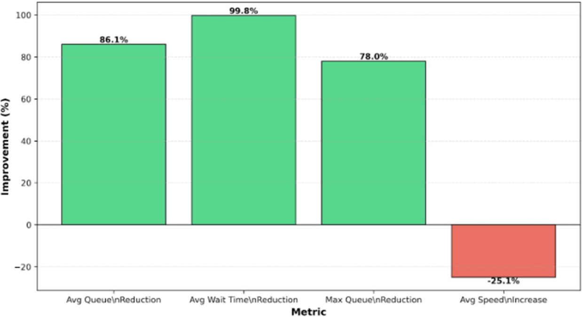

Figure: DQN Performance Improvement Over Fixed - Time

Chapter Conclusion
This chapter presented the experimental setup, evaluation metrics, and performance analysis of the proposed DQN-based traffic light control system. By comparing the learned policy with a fixed-time baseline, the results demonstrate that the DQN ap- proach consistently improves traffic efficiency by reducing vehicle waiting time and queue length. These findings validate the effectiveness of modeling traffic signal control as a Markov Decision Process and applying deep reinforcement learning techniques for adaptive traffic management.

Chapter 5. Application and Discussion

Practical Application of the Proposed Model
The practical application of Reinforcement Learning (RL) models in traffic signal control is commonly conducted through high-fidelity microscopic simulations, which serve as a critical bridge between theoretical algorithm design and real-world deployment. In this project, the proposed RL-based controller is implemented by

integrating a learning agent, developed in Python, with the Simulation of Urban Mo- bility (SUMO) platform via the Traffic Control Interface (TraCI). This interface en- ables real-time bidirectional communication, allowing the agent to observe traffic states, execute signal phase decisions, and receive immediate feedback in the form of rewards.
Within the simulation environment, the RL agent operates at a single isolated inter- section, where the traffic state is represented using measurable quantities such as queue lengths, vehicle counts, and lane occupancy. At each decision step, the agent selects an action corresponding to a traffic signal phase, after which SUMO ad- vances the simulation and returns the next state and reward. This closed-loop inter- action faithfully replicates the operational logic of a real-world traffic controller while maintaining a safe and controllable experimental setting.
For real-world deployment, the proposed framework would require a robust sensing infrastructure to accurately perceive traffic conditions. Commonly used technolo- gies include inductive loop detectors, traffic surveillance cameras, and emerging ve- hicle-to-everything (V2X) communication systems. These sensors provide essential inputs such as vehicle presence, queue lengths, and arrival rates, which can be di- rectly mapped to the state representation used by the learning agent. While inductive loops remain widely deployed due to their reliability, vision-based systems and V2X communication offer richer and more flexible traffic state information.
Previous pilot studies have demonstrated the feasibility of deploying RL-based traf- fic signal controllers in real urban environments. Notably, an Advantage Actor- Critic (A2C) agent was evaluated on a real-world intersection network in Bangalore, constructed using road data from OpenStreetMaps. The RL-based controller achieved a substantial reduction in peak queue lengths—approximately halving con- gestion levels compared to traditional fixed-time and Round Robin control strate- gies. These results highlight the potential of RL methods to adapt effectively to dy- namic and non-uniform traffic conditions.
Although the present study focuses on a single intersection, the proposed framework is inherently extensible to more complex urban scenarios. In real traffic environ- ments, certain road users—such as pedestrians at zebra crossings or vehicles ap- proaching from occluded side streets—may not be fully observable to the controller. Under such conditions, the traffic signal control problem is more accurately de- scribed as a Partially Observable Markov Decision Process (POMDP) rather than a fully observable MDP. Recent research addresses this challenge by introducing vir- tual or “phantom road users”, enabling the agent to reason about hidden or uncertain traffic participants and to make safer and more robust control decisions under in- complete information.

Overall, this section demonstrates how the proposed RL-based traffic signal control- ler can be practically applied within a simulation-based experimental framework, while also outlining the key requirements and considerations for transitioning to- ward real-world deployment. The focus on a single intersection ensures methodo- logical clarity and experimental validity, while the underlying architecture remains compatible with future extensions to larger and more complex traffic networks.

Requirement | Proposed Technology / Method | Supporting Evidence
Micro-simulation environment | SUMO with TraCI inter- face | Enables real-time state-action interaction
Real-world traffic sensing | Inductive loops, CCTV, V2X | Widely adopted in intelligent transportation systems
Pilot deployment evidence | A2C-based controller in Bangalore (JP Nagar) | Demonstrated ~50% queue re- duction
Occlusion han- dling | Phantom road users, POMDP modeling | Supports partially observable environments
Table - Summarizes the key components required to bridge the proposed simulation-based model with practical urban deployment.

Strengths and Limitations
The proposed Reinforcement Learning (RL)–based traffic signal control framework presents several notable strengths when compared with traditional signal control strategies. At the same time, it also exhibits inherent limitations, particularly when considering scalability and real-world deployment beyond a single isolated intersec- tion.

Strengths
A key strength of the proposed approach is its model-free adaptability. Unlike clas- sical traffic control systems that depend on explicitly defined mathematical models of traffic flow—often requiring extensive calibration and prone to modeling errors— RL agents learn optimal signal timing policies directly through interaction with the environment. This allows the controller to adapt autonomously to changing traffic conditions without prior knowledge of traffic dynamics.
Another significant advantage is the model’s superior performance in dynamic and non-uniform traffic scenarios. Numerous studies demonstrate that RL-based con- trollers, including DQN and A2C, consistently outperform traditional fixed-time and

Round Robin baselines when traffic demand is asymmetric or time-varying. By op- timizing long-term cumulative rewards, the agent can efficiently clear uneven queues and respond to sudden traffic surges that static control schemes struggle to handle.
Furthermore, the use of Deep Neural Networks as function approximators enables the controller to generalize across high-dimensional state spaces. This generalization capability allows the agent to infer effective actions in traffic situations that were not explicitly encountered during training, enhancing robustness within the opera- tional scope of a single intersection.

Limitations
Despite these strengths, the proposed RL framework faces several important limita- tions. One major challenge is its computational intensity. Deep Reinforcement Learning requires substantial computational resources and long training times, par- ticularly as the complexity of the state representation, neural network architecture, or traffic environment increases.
Another limitation is the risk of catastrophic forgetting, especially in decentralized or partially observable settings. During training, agents may overwrite previously learned effective strategies by overfitting to recent experiences, leading to sudden performance degradation or unstable learning behavior.
In addition, RL-based controllers are sensitive to distributional shift. If real-world traffic demand patterns differ significantly from those encountered during training, the learned policy may fail to generalize effectively. Without sufficiently diverse training scenarios or online adaptation mechanisms, the agent may produce subop- timal or unreliable control decisions under unforeseen traffic conditions.
Scalability represents a further and critical limitation when extending RL-based traf- fic signal control from a single intersection to large urban networks. In centralized control architectures, the joint state-action space grows exponentially with the num- ber of intersections, resulting in the well-known curse of dimensionality, which se- verely limits exploration efficiency and learning feasibility. Conversely, decentral- ized approaches, where each intersection is controlled by an independent agent, im- prove scalability but often suffer from non-stationarity and coordination issues, as agents typically lack awareness of neighboring decisions and may develop conflict- ing or selfish policies.
To address these challenges, the literature proposes hybrid and hierarchical control frameworks, commonly categorized under Centralized Training, Decentralized Ex- ecution (CTDE). Within this paradigm, agents can leverage global information dur-

ing training while relying solely on local observations during deployment. Ap- proaches such as Value-Decomposition Networks (VDN) decompose the global value function into local components, ensuring cooperative behavior through the In- dividual-Global-Max (IGM) principle. Similarly, hierarchical control concepts—pi- oneered by classical systems like SCATS and SCOOT—use high-level controllers for regional coordination while delegating fine-grained signal optimization to local agents.
It is important to emphasize that the scope of this project is intentionally limited to a single isolated intersection. Consequently, scalability issues are discussed from a theoretical and future-extension perspective rather than being explicitly addressed in the experimental implementation. Nonetheless, the proposed model provides a solid and extensible foundation for future research toward coordinated multi-inter- section and city-scale traffic signal control systems.

Discussion on Scalability
Scalability remains one of the most critical challenges in extending Reinforcement Learning–based traffic signal control from a single isolated intersection to large- scale urban road networks. As the number of controlled intersections increases, the design of the learning architecture has a decisive impact on both computational fea- sibility and policy stability.
In centralized control paradigms, a single agent is responsible for jointly controlling all intersections in the network. While this approach theoretically allows full coor- dination, it quickly becomes impractical due to the curse of dimensionality. Specif- ically, if each intersection has a state space of size ∣S∣ and an action space of size
∣A∣, the joint state-action space grows exponentially as ∣S∣N and ∣A∣N, where N is the number of intersections. Such exponential growth renders exploration inefficient and often leads to unstable reward signals and poor generalization, particularly when traffic demand fluctuates across space and time.
To mitigate this issue, many studies adopt decentralized control architectures, where each intersection is controlled by an independent RL agent. This design significantly improves scalability by reducing the dimensionality of each agent’s learning prob- lem. However, decentralized approaches introduce a new challenge known as non- stationarity. Because each agent continuously updates its policy, the environment perceived by any single agent changes over time as neighboring agents learn simul- taneously. This dynamic interaction often leads to unstable learning behavior and may result in conflicting or selfish policies. Moreover, decentralized agents are par- ticularly susceptible to catastrophic forgetting, where locally greedy updates over- write previously successful strategies due to the absence of global coordination sig- nals.

To balance the trade-off between scalability and coordination, recent research has focused on hybrid architectures based on the Centralized Training, Decentralized Execution (CTDE) paradigm. In this framework, agents are trained using global in- formation—such as joint states or rewards—while relying solely on local observa- tions during deployment. A prominent example of this approach is the Value-De- composition Network (VDN), which decomposes the global action-value function into a sum of individual agent value functions. By enforcing the Individual-Global- Max (IGM) principle, VDN ensures that maximizing local Q-values also maximizes the global objective, enabling cooperative behavior without centralized execution.
Empirical evaluations on real-world traffic datasets provide strong evidence for the scalability of CTDE-based approaches. On the Jinan12 network (12 intersections), value-decomposition methods achieved lower average waiting times than both cen- tralized and fully decentralized baselines. More notably, on the Hangzhou16 dataset (16 intersections), VDN demonstrated superior stability and efficiency, reducing cu- mulative waiting times by orders of magnitude compared to decentralized DQN- based controllers (approximately 9,776 seconds versus 544,909 seconds). These re- sults highlight the ability of hybrid methods to prevent the performance collapses commonly observed in purely decentralized systems.
For even larger traffic networks, the literature suggests that hierarchical control frameworks become essential. In such architectures, high-level controllers operate on longer time scales to coordinate regional traffic flow, while low-level agents fo- cus on fine-grained signal timing at individual intersections. This separation of re- sponsibilities mirrors successful classical systems such as SCATS and SCOOT, and provides a promising direction for integrating RL-based controllers into city-scale deployments.
It should be emphasized that the current project focuses exclusively on a single iso- lated intersection, and therefore does not directly address scalability in its imple- mentation. Nonetheless, the discussion above situates the proposed model within the broader research landscape and demonstrates that single-intersection RL controllers represent a critical foundational component. Future extensions of this work could naturally build upon this foundation by incorporating decentralized, CTDE-based, or hierarchical multi-agent reinforcement learning frameworks for large-scale urban traffic control.

REFERENCES
[1]. Vidali, A. (n.d.). Deep Q-Learning Agent for Traffic Signal Control (Version [if available]) [Source code]. GitHub. https://github.com/AndreaVidali/Deep-QLearn- ing-Agent-for-Traffic-Signal-Control
[2]. Amsterdam-Internships. (n.d.). Self-Learning Traffic Lights [Source code]. GitHub. https://github.com/Amsterdam-Internships/Self-Learning-Traffic-Lights
[3]. Brenner, M. (n.d.). Multi-Agent Distributed PPO Traffic-Light Control [Source code]. GitHub. https://github.com/maxbrenner-ai/Multi-Agent-Distributed-PPO- Traffc-light-control

