2、x=0.01:0.2:10

y=x.^(1./x)

plot(x,y,'r\*')

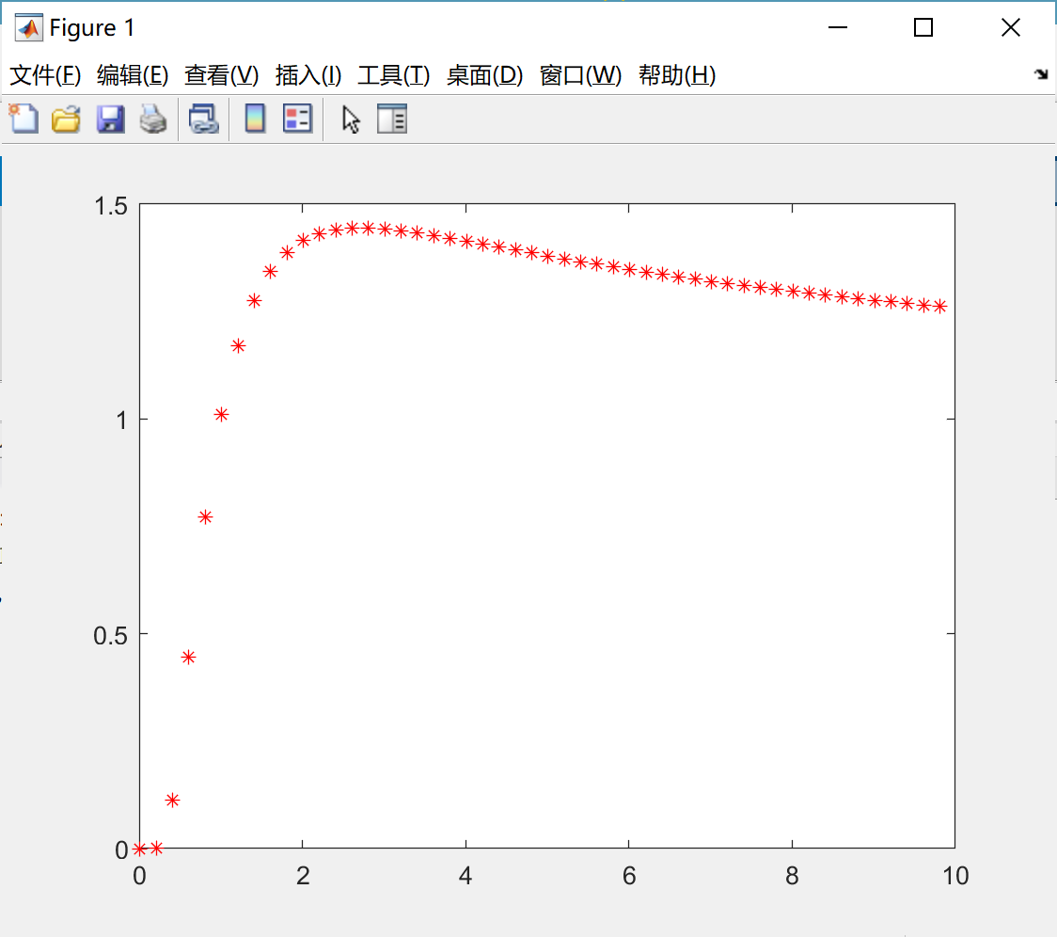

4、

clear

clc

syms x

g=exp(x)

g3=taylor(g,'order',3)

g6=taylor(g)

g9=taylor(g,'order',9)

f=sin(x)

f3=taylor(f,x,'order',3)

f6=taylor(f)

f9=taylor(f,'order',9)

subplot(1,2,1)

fplot(f3,[0,30])

hold on

fplot(f,[0,30])

hold on

fplot(f6,[0,30])

hold on

fplot(f9,[0,30])

hold off

subplot(1,2,2)

fplot(g,[0,30])

hold on

fplot(g3,[0,30])

hold on

fplot(g6,[0,30])

hold on

fplot(g9,[0,30])

hold off

6、

x=-2.5:0.05:2.5

y=exp(-x.^2)

subplot(1,2,1)

bar(x,y)

subplot(1,2,2)

stairs(x,y)



8



y=[7500 7590 7590 8000 8200 8500 9000 9100 9300 9600 10200 10400]

subplot(1,2,1)

bar(y)

subplot(1,2,2)

plot(y)

10

y=[7500 7590 7590 8000 8200 8500 9000 9100 9300 9600 10200 10400]

subplot(1,2,1)

bar(y)

subplot(1,2,2)

plot(y)

