项目名称：控制多个led灯顺序亮灭

小组成员：221512469 向胤兴 213611604 欧阳俊 21421488 黄金阳 214214822 陈珂

项目介绍：通过输入字符，控制多个led灯以一个规定的顺序依次循环发光并熄灭。

代码：

String val = "";

int red = 4;

int green = 2;

int yellow = 3;

void setup() {

  // put your setup code here, to run once:

  Serial.begin(9600);

  pinMode(red, OUTPUT);

  pinMode(green, OUTPUT);

  pinMode(yellow, OUTPUT);

}

void loop() {

  // put your main code here, to run repeatedly:

  if (Serial.available() > 0)

  {

    val += char(Serial.read());

  }

  if (val.compareTo("a") == 0)

  { digitalWrite(green, HIGH);

    delay(2000);

    digitalWrite(green, LOW);

    digitalWrite(red, HIGH);

    delay(2000);

    digitalWrite(red, LOW);

    digitalWrite(yellow, HIGH);

    delay(2000);

    digitalWrite(yellow, LOW);

  }

  if (val.compareTo("b") == 0)

  { digitalWrite(red, HIGH);

    delay(2000);

    digitalWrite(red, LOW);

    digitalWrite(green, HIGH);

    delay(2000);

    digitalWrite(green, LOW);

    digitalWrite(yellow, HIGH);

    delay(2000);

    digitalWrite(yellow, LOW);

  }

  if (val.compareTo("c") == 0)

  { digitalWrite(yellow, HIGH);

    delay(2000);

    digitalWrite(yellow, LOW);

    digitalWrite(green, HIGH);

    delay(2000);

    digitalWrite(green, LOW);

    digitalWrite(red, HIGH);

    delay(2000);

    digitalWrite(red, LOW);

  }

}

图片：

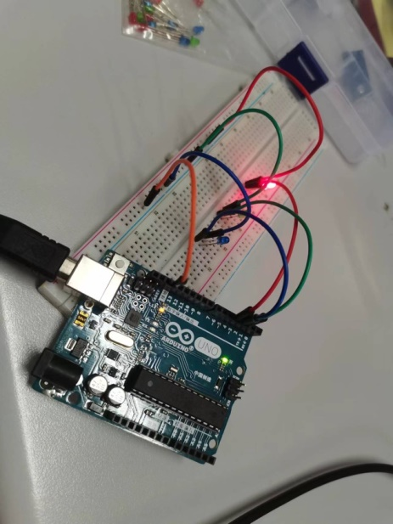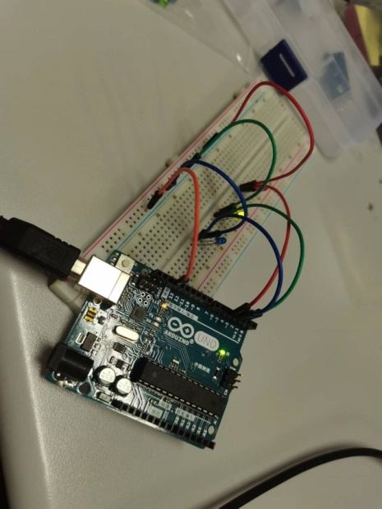 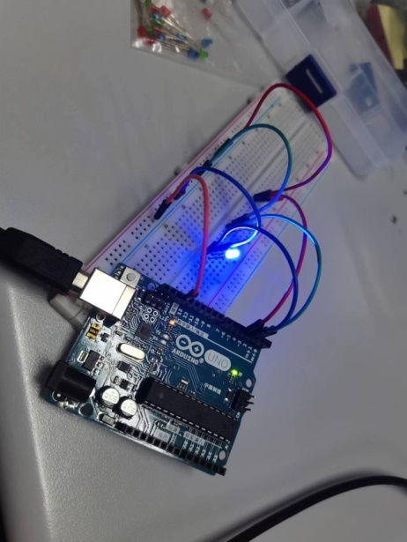

结论：可以通过输入字符使其以一个规定的顺序进行工作。