项目名称:模拟红绿灯

小组成员：2213611604欧阳俊、2215012469向胤兴、2214214880黄金阳

时间：20220627

项目介绍：模拟红绿灯实验，让红灯亮5秒，绿灯5秒，黄灯闪烁3次，红绿灯闪烁2次。

代码：int red=4;

int yellow=2;

int green=3;

void setup() {

// put your setup code here, to run once:

pinMode(red,OUTPUT);

pinMode(yellow,OUTPUT);

pinMode(green,OUTPUT);

}

void loop() {

// put your main code here, to run repeatedly:

int i=1;

if(i=1)

{digitalWrite(green,HIGH);

delay(5000);

digitalWrite(green,LOW);

delay(500);

digitalWrite(green,HIGH);

delay(500);

digitalWrite(green,LOW);

delay(500);

digitalWrite(green,HIGH);

delay(500);

digitalWrite(green,LOW);

delay(500);

i=2;}

if(i=2)

{digitalWrite(red,HIGH);

delay(5000);

digitalWrite(red,LOW);

delay(500);

digitalWrite(red,HIGH);

delay(500);

digitalWrite(red,LOW);

delay(500);

digitalWrite(red,HIGH);

delay(500);

digitalWrite(red,LOW);

delay(500);

i=3;}

if(i=3)

{digitalWrite(yellow,HIGH);

delay(500);

digitalWrite(yellow,LOW);

delay(500);

digitalWrite(yellow,HIGH);

delay(500);

digitalWrite(yellow,LOW);

delay(500);

digitalWrite(yellow,HIGH);

delay(500);

digitalWrite(yellow,LOW);

delay(500);

i=1;}

结果图片：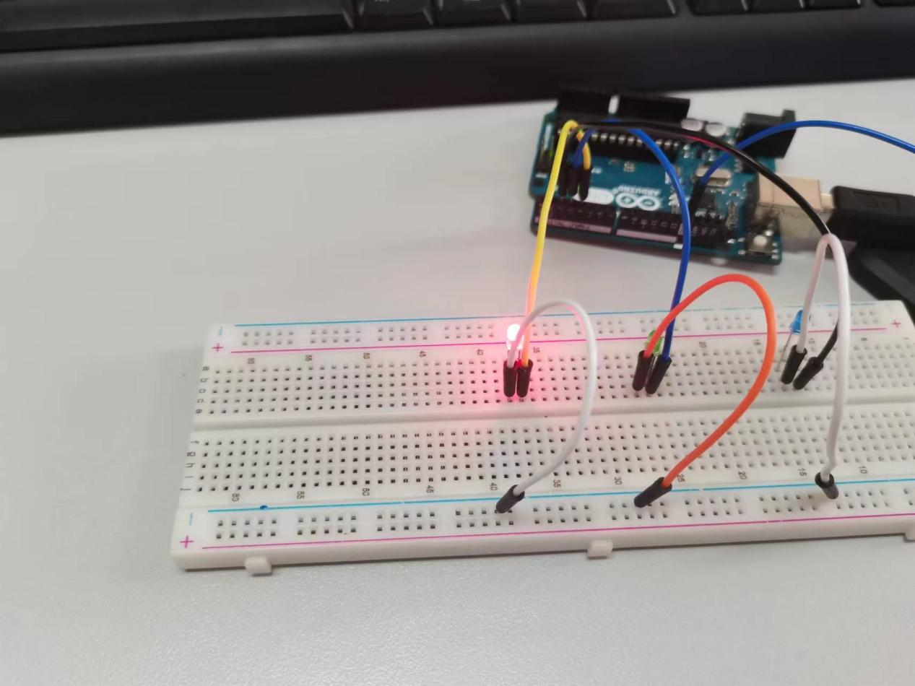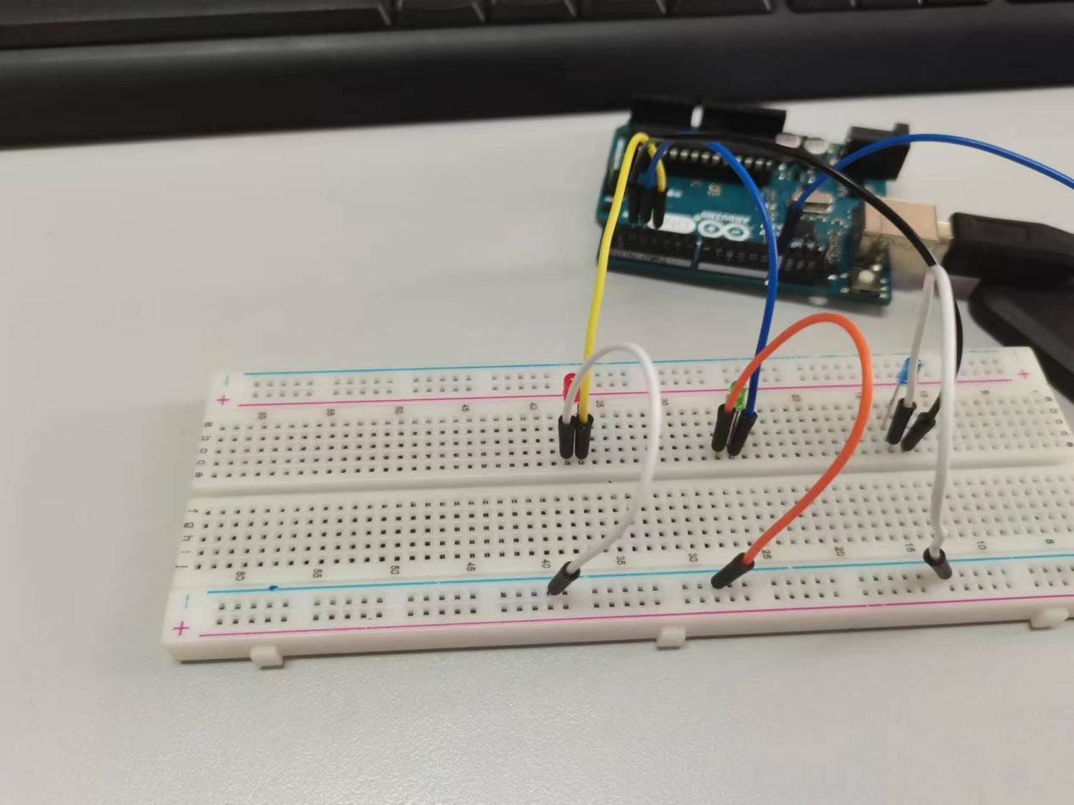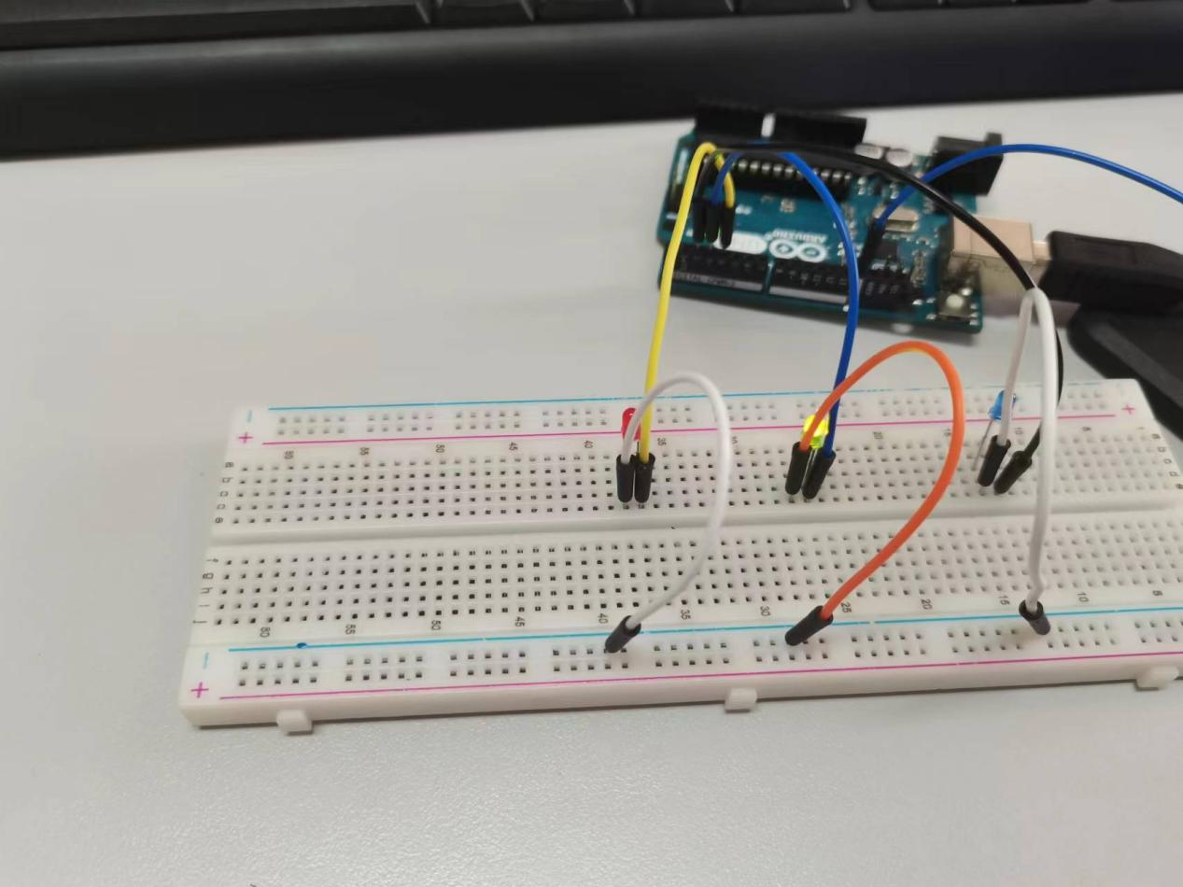

结论：通过相应函数加上if语句实现了仿真情况下的红绿灯模拟，由于现实红绿灯时间间隔过长，因此实验缩短了红绿灯闪烁时间。

}