项目名称：点亮13号灯

小组成员：2213611604欧阳俊

2214214880黄金阳

2215012469向胤兴

所需器材：Arduino板，导线

代码：

void setup() {

// put your setup code here, to run once:

pinMode(13, OUTPUT);

}

void loop() {

// put your main code here, to run repeatedly:

digitalWrite(13, HIGH);

delay(1000);

digitalWrite(13, LOW);

delay(1000);

}

结果图片

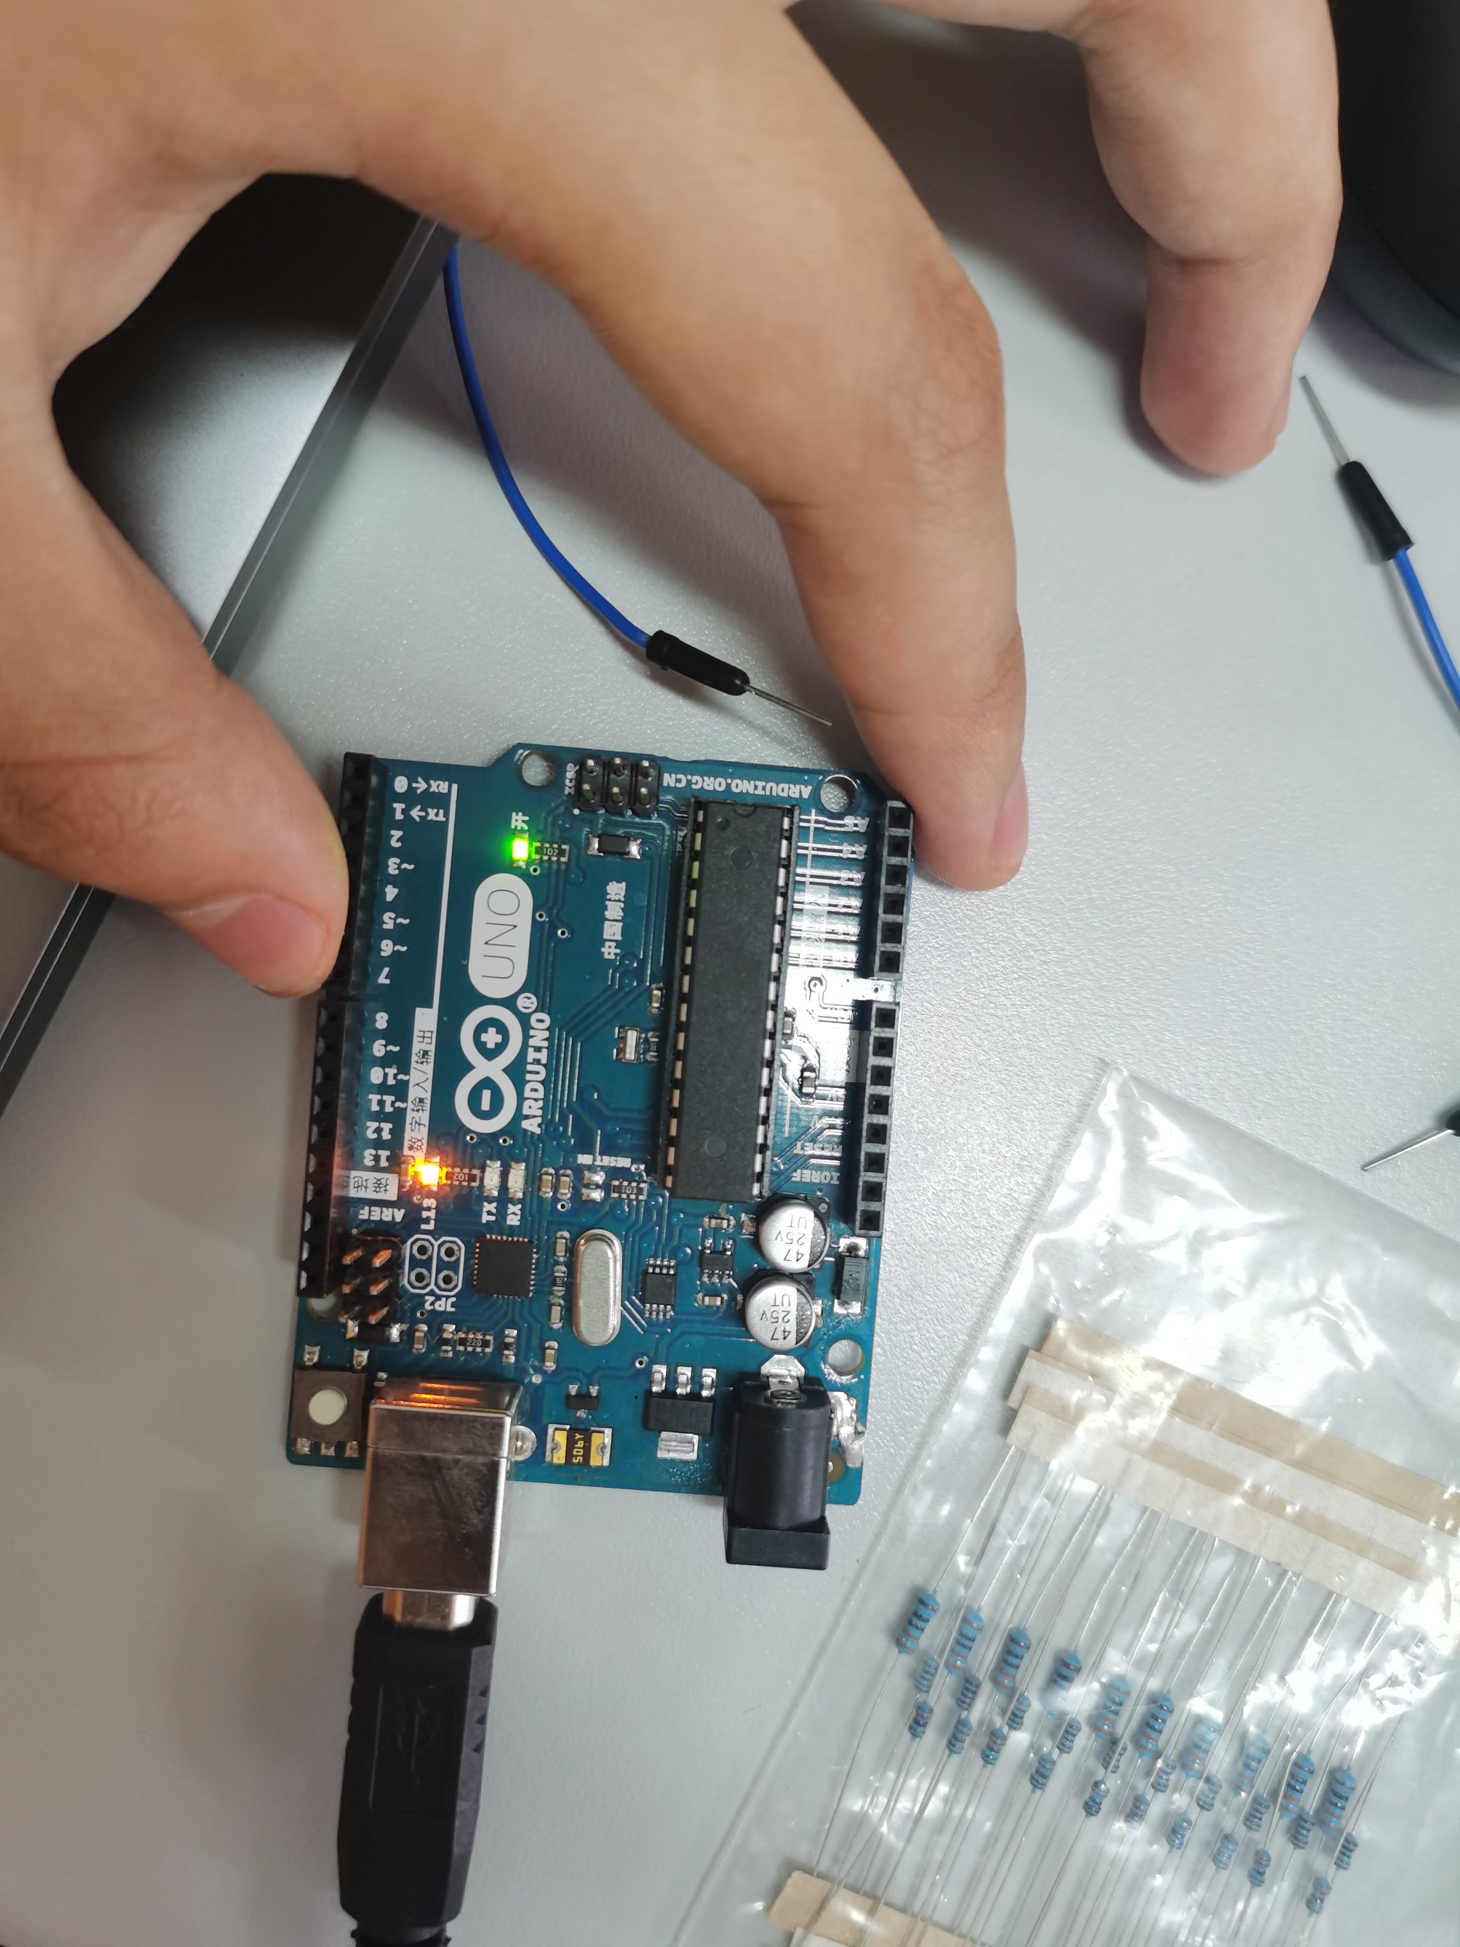

结论：搭建开发环境