Limited effects of thinning and hardwood rotations on laminated root rot induced tree mortality in Douglas-fir forests of the Pacific Northwest, USA

David N. Showalter¹, Shawn McMurtrey¹, Adam Carson¹, Anna Leon², John Browning², Michael McWilliams^{1,3}, (Irene) Blakey Lockman⁴, Everett M. Hansen¹, Jared M. LeBoldus^{1,5}

¹Department of Botany and Plant Pathology, Oregon State University, Corvallis, Oregon, USA.
²Weyerhauser Company, Centralia, WA, USA
³Currently: USDA Forest Service, State and Private Forestry, Pacific Northwest Region, Blue Mountains Service Center, La Grande, OR, USA
⁴USDA Forest Service, State and Private Forestry, Pacific Northwest Region, Portland, OR, USA
⁵Department of Forest Engineering, Resources, and Management, Oregon State University, Corvallis, Oregon, USA.

Keywords: Coniferiporia sulphurascens, laminated root rot, forest management, silviculture, forest pathology, thinning, alternate host rotations, forest vegetation simulator

Abstract
Laminated Root Rot (LRR) caused by the fungal pathogen Coniferiporia sulphurascens is a damaging disease within many Douglas-fir forests of the Pacific Northwest (PNW) of North America. Silvicultural management of these forests in a changing climate may require increased thinning or involve the use of species other than Douglas-fir. Two long-term studies within Oregon, USA provided an opportunity to investigate the effects of these management techniques on disease dynamics in areas of high historical LRR incidence. First, the effects of three thinning prescriptions on tree mortality caused by Coniferiporia sulphurascens were tested on ca. 160 hectares within the Siuslaw National Forest beginning in 1985. The second study evaluated effects of five hardwood rotation treatments on subsequent growth and mortality of planted Douglas-fir across 14 hectares of privately-owned forest in Columbia County beginning in 1975. For both studies, observed data was compared with predictions from the Forest Vegetation Simulator (FVS) and its Western Root Disease Model (WRDM) extension. The first study found no significant effect of thinning treatment on mortality (p = 0.9816, overall mean annual proportion of 0.0141 year⁻¹), nor, unexpectedly, annual basal area increment (p = 0.372141, overall mean BA increment = 0.5876 m²ha⁻¹year⁻¹). When compared with observed data, the FVS was found to over predict growth, while the WRDM extension was consistent with field measurements. In the second study, no effect of hardwood rotation on growth or mortality of Douglas-fir was detected (p = 0.253 and p = 0.172). However, the second study did show sub-lethal growth effects of LRR infection and suppression (p = 0.009 and p = 0.001), and an increase in mortality and decrease in basal area increment in 45-year-old stands with high LRR incidence. Both FVS and the WRDM extension were found to over predict growth and yield within the results of the second study. Together, these results suggest that thinning treatments or alternate species rotations used to meet other silvicultural objectives may not have a strong impact on LRR disease progression at the timescales measured in this study.

1. Introduction
Douglas-fir (Pseudotsuga menziesii (Mirb.)) is a keystone species in the mixed conifer forests of western North America (Cook et al. 2013). In addition to its ecological importance, Douglas-fir is a major contributor, in terms of timber harvest, to the economy of the region (McCauley and Cook 1980, Nelson and Hartman et al. 1975). There are several diseases and insects that impact the management of Douglas-fir. Among them, Coniferiporia sulphurascens (Pilát) L. W. Zhou & Y. C. Dai, a basidiomycete fungus endemic to this region, causes laminated root rot (LRR) (Thies and Sturrock 1995, Leal et al. 2019). Although Douglas-fir is the primary host of C. sulphurascens, many coniferous species are susceptible (Cleary et al. 2013, Thies and Sturrock 1995). Laminated root rot is characterized by specific tree and stand level signs and symptoms with well documented impacts on forest ecosystems (Hansen and Goheen 2010).
Coniferiporia sulphurascens spreads between trees, across root contacts, as ectotrophic mycelium. It penetrates roots through intact bark where it kills the phloem and cambium, initiating decay in the xylem (Thies 1983, Wallis and Reynolds 1965). Both lignin and cellulose are decayed; however, the fungus preferentially utilizes early wood leading to a characteristic laminated pattern of advanced decay (Lewis 2013, Blanchette 1980). Infected trees may take several years to die, declining slowly over time (Wallis and Reynolds 1965). Trees eventually fall over when the supporting root system becomes sufficiently weakened, but usually have green crowns. Large trees can have extensive decay columns in the lower portion of the stem. The decay typically reaches less than 1 meter up the bole but may extend up to 4 meters (Thies and Sturrok 1995). As the fungus spreads from tree to tree the mortality front typically advances an average of 30 cm a year (Bloomberg 1985). Mortality increases in Douglas-fir stands from 30-150 years in age resulting in the development of root disease pockets within the forest (Childs 1970). The development of these pockets is typically uneven resulting from the distribution of susceptible trees, and the sporadic nature of windthrow and bark beetle outbreaks killing and toppling trees as the root disease pocket expands.
Laminated root rot is potentially the most ecologically and economically important disease of mixed conifer forests on the west coast of North America (Goheen and Otrosina 1998, Hadfield 1985, Hadfield et al. 1986, Hagle et al. 1987, Nelson et al. 1981, Scharpf 1993, Thies 1984, Thies and Sturrock 1995, Wallis 1976). This disease has significant impacts on species composition, biodiversity, nutrient cycling, and timber harvest (Boyce and Wagg 1953, Cook et al. 2013). The presence of this disease in most western forests is well documented. For example, in British Columbia, more than 80% of the replanted Douglas-fir forest was infested with LRR (Hansen and Goheen 2000, Bloomberg and Reynolds 1985). In seven large surveys in western Oregon, covering a total of 169,000 ha, on average 8.6% (range 4.7% to 16%) of the Douglas-fir plantations are in LRR pockets (Goheen and Hansen 1993, Hansen and Goheen 2000). Approximately 50% of the Douglas-fir trees in these pockets had been killed by C. sulphurascens (Goheen and Hansen 1993, Hansen and Goheen 2000). While much is known about the biology of this fungus, its impact on timber volume in managed stands has not been well quantified (Lawson et al. 1983). Mortality associated with this disease increases the risk of fire due to fuel loading in affected stands (Parker et al. 2006). The large snags and windblown trees serve as a path for surface fires to reach the canopy (Dickman and Cook 1989, Dickman 1992).
Fire frequency and severity are predicted to increase in western North America over the next century as a result of hotter, drier summers (Law et al. 2013, Bennett et al. 2021, Mote and Salathé 2010). These warmer and dryer conditions, on average, will produce larger, more frequent, and more extensive fires (McKenzie et al. 2004). In response, forest managers have shifted approaches towards improving ecosystem resilience (Vernon et al. 2018, USDA-FS 2011, Franklin and Johnson 2012). These shifts are being conducted through large-scale fuel reduction operations, focusing on low to mid-canopy reductions in basal area and pile burning (Vernon et al. 2018, Agee and Skinner 2005). Planting alternate host species that are more resistant to changes in climate is another proposed strategy (Subramanian et al. 2015). A major question stemming from these shifts in management is understanding how thinning and host rotations will affect major forest pathogens in both plantation and wildland forests.
The effects of thinning and host rotations for management of LRR are not well understood. Although thinning results in forest products and may remove infected trees that eventually contribute to fuel loads, it may also increase the risk of wind damage to trees with weakened root systems (Vandygriff et al. 2015, Lawson 1979). Red alder (Alnus rubra Bong.) is resistant to infection by C. sulphurascens. This is likely due to the phenolics and fatty acids produced by red alder (Trappe 1972, Li et al. 1969, Li et al. 1970). It has been hypothesized that clear cutting LRR sites and then growing pure red alder might starve C. sulphurascens of a viable nutrient source (Harrington 2006). To date this hypothesis has not been tested.
Long-term forest plot studies are powerful sources of information, yet they are scarce for a variety of reasons (Norris et al. 2014). Manipulative experiments, examining the effects of management on forest dynamics, are even more rare in the literature. However, data from these studies can be used to test the effect of management regimes on forest structure and function and to validate models, which were initially developed to circumvent limited data availability, and used to predict the impact of management on forest dynamics (Pretzsch et al. 2014, Pretzsch et al. 2008). The Forest Vegetation Simulator (FVS) is one such model that is commonly used within the United States Forest Service as a tool for developing forest health and management strategies. The Western Root Disease Model (WRDM) is an extension of FVS that is used for investigating the spread of root disease from a below ground perspective (Peet and Hunt 2005). There have been few studies conducted that have used long-term permanent plots to assess the accuracy of the WRDM (Frankel et al. 1998, Maffei et al. 2008) and none specifically examining the impact of LRR, a major biotic disturbance, on stand dynamics.
The overall objective of chapter two was to develop a better understanding of the interaction between forest management practices and C. sulphurascens, the cause of LRR. Specifically, chapter two aimed to determine the effects of commercial thinning treatments and hardwood rotations on growth and mortality of Douglas-fir on sites with high incidence of LRR. The study design for the commercial thinning tested three treatment types, which included a control treatment with no thinning, a lightly thinned treatment, and a heavily thinned treatment. The hardwood rotation study included 12-year and 25-year rotations of red alder and black cottonwood (Populus trichocarpa Torr. and A. Gray ex. Hook) followed by planting with Douglas-fir. The objectives were to: (i) evaluate the effect of thinning on Douglas-fir growth and LRR-induced mortality; (ii) compare the rate of spread of C. sulphurascens in thinned and control stands; (iii) evaluate the effect of hardwood rotations on Douglas-fir growth and LRR-induced mortality; and (iv) validate the ability of the FVS and WRDM to predict growth and yield of stands severely impacted by C. sulphurascens following thinning and alternate host rotation treatments.
2. Methods
2.1 Woods Creek thinning study
2.1.1 Study area
The Woods Creek thinning study was conducted on the northeast slope of Marys Peak in the Coast Range of the Siuslaw National Forest located in western Oregon, USA (44°32'08.3"N 123°32'05.2"W). Forests here are composed of mostly mature and old-growth Douglas-fir, along with various other tree species. In 1990, the study area consisted of 82% Douglas-fir trees, 11% western hemlock (Tsuga heterophylla (Rafn.) Sarg.), and a combination of 7% other species (western red cedar (Thuja plicata Donn ex D. Don), grand fir (Abies grandis (Douglas ex D. Don) Lindley), noble fir (Abies procera, Rehder), bigleaf maple (Acer macrophyllum Pursh), red alder (Alnus rubra Bong.), golden chinquapin (Chrysolepis chrysophylla (Douglas ex Hook.) Hjelmq.), willow (Salix spp. alab L.), and silver birch (Betula pendula Roth)). Mean annual precipitation ranges from 225 - 235 cm (Lan et al. 2019, PRISM Climate Group, Oregon State University 2018). Mean annual temperature is 10.6°C (Lan et al. 2019, PRISM Climate Group, Oregon State University, 2018). The soil types in this region of the study area are mostly gravelly clay loam and gravelly silty clay (Soil Survey Staff 2021). The study site was selected based on the known high incidence of LRR that was assessed by the original investigators using the techniques developed by Bloomberg et al. (1980). The area was clear cut between 1910 and 1920, burned after harvest, and reestablished naturally from seed (Tkacz and Hansen 1982).
To evaluate the effect of thinning on LRR a study was established in 1985 across ca. 162 ha of forestland (Fig. 2.1). The experimental design was a randomized complete block design with three treatments and 5 blocks per treatment (mean = 9.7 ha, range = 6.7 - 14.7 ha) (Fig. 2.1). The treatments included a control where no thinning occurred (BA = 61.4 m²ha⁻¹, quadratic mean diameter (QMD) = 41cm), a light thinning (BA = 43.1 m²ha⁻¹, QMD= 47cm) and a heavy thinning (BA = 35.3 m²ha⁻¹, QMD = 55cm) (Hansen, unpublished data). Prior to any treatments being conducted, a total of 75 circular, fixed radius plots (11.3 m) were established within the study area (Fig. 2.1). There was a total of 25 plots in each of the three different treatment areas with 5 plots in each block. Blocking was assigned based upon previously established incidence of LRR. Plot locations were semi randomized and chosen with respect to access points such as trails and roads. The elevation of the plots ranged from 381 - 634 m (mean = 511 m).

2.1.3 Experimental design and data collection
Beginning in 1985, the plots were surveyed and each tree within the plot was tagged with a tree identification number. The tree species, diameter at breast height (DBH), and tree health condition codes (1 = healthy, 2 = live tree with symptoms, 3 = dead from C. sulphurascens, 4 = dead not from C. sulphurascens) were recorded. Windblown trees or stumps were given a code of 4 if signs of LRR were not present. Ingrowth trees were added to the plot data when they reached a minimum DBH of 15.24 cm. Plots were surveyed in 1990, 1995, 2000, 2009, and 2020.
Confirmation of C. sulphurascens infection was determined in the field by the presence of pitted wood in advanced decay with setal hyphae or the presence of ectotrophic mycelium (Hansen 1979). If the presence of LRR could not be confirmed in the field, samples were collected and plated on Malt Extract Agar (MEA) (1 L sterilized deionized water, 15g malt extract, 15g Bacto agar) and incubated at 18°C for 4 - 6 weeks in an incubator (Precision Scientific Inc., Chicago, IL). Presence of setal hyphae was confirmed by viewing under a dissecting microscope (MZ6, Leica Microsystems, Wetzlar, Germany).

2.1.4 Statistical analysis
Data processing and analysis was conducted in Microsoft Excel and RStudio v. 1.4.1103 (RStudio Team 2021). Over the course of this study, a total of 1,900 trees with more than 7,500 measurements were recorded. For the final analysis, only data collected post thinning (1990 -2020) was used. The reduced dataset included ca. 1,100 different trees with approximately 4,100 measurements. To reach this reduced dataset, data processing was conducted (Github repository: https://github.com/mcmurtrs/WoodsCreek).
A two-factor analysis of variance (ANOVA) was conducted to test the main effects of block and treatment on arcsine square root transformed cumulative proportional stand mortality caused by LRR. Cumulative proportional stand mortality was defined as the number of confirmed dead trees showing LRR symptoms over the total number of trees within the stand. These proportional values were arcsine square root transformed to conform to parametric assumptions of homoscedasticity and normality of the residuals. A multi-factor ANOVA was also used to test the effect of block and treatment (a control treatment with no thinning, a lightly thinned treatment, and a heavily thinned treatment) on mortality while using the relative stand presence of C. sulphurascens. Two-factor analyses of variance (ANOVAs) were conducted to test the main effects of block and treatment on initial and final basal area and annual basal area increment.
All statistical analysis and data visualization was conducted in R v. 4.1.1 using the packages stats (R Core Team 2021), tidyverse (Wickham 2017), and ggplot2 (Wickham 2009). The significance was assessed at α = 0.05. Assumptions of normality and homoscedasticity were assessed using diagnostic plots of residuals and fitted values and Q-Q normality plots (Schützenmeister et al. 2012, Atkinson 1981, Atkinson 1985) as sample sizes were too small for formal tests of these assumptions.

2.1.6 Forest Vegetation Simulator
For the FVS analysis, two comparisons were made; the first comparison involved the observed data from 1990, compared to a default run in FVS. The second comparison included a comparison of the observed data from 1990, with the WRDM extension using default parameters. Individual stand files were each run within FVS v. 3261, RV: 2020.10.10, through the graphical user interface. The stand files included five for the control stands, five for lightly thinned stands, and five control stands. The individual tree data for the five subplots for each stand were included in each of the 15 stand files. The variant used for all modeled runs was the Pacific Northwest Coast (PN) variant. Excel workbook files were formatted for FVS. Underlying data errors were initially checked in FVS using the “stand summary data'' option. The comparison of the modeled data with the collected data was conducted using the stand mean for the five control stands, five lightly thinned stands, and five thinned stands. For the observed data the standard basal area calculation was used to calculate basal area. Thirty simulations were made using FVS and WRDM for the final analysis. All input data files, output data files, and log files can be found at the Github repository previously mentioned.
For reproducibility purposes, the following parameters were used within the WRDM to represent the Woods Creek data. Phellinus root disease was used for the root disease type. The keyword and number for this was RRTYPE = 4. Total stand area in acres was set to 0.5 as each of the 5 plots within each stand was 0.1 acres. The default value of 25% (0.125 acres) was used for total root disease areas. Number of root disease centers was set to the default value of 20. The keyword RRINIT with 20 disease centers was used instead of RRTREIN with damage codes because there were no stem maps or geographical information available for the trees within the plots. As a result, we were unable to know which trees to code as "1" within RRINIT (for trees located within " 30 feet [9.1 m] of a tree with a deteriorating crown or killed by root disease") (David 2018). The number of infected and uninfected trees in disease centers was set at the default value of 50%. Level of root system infected was set at the default value of 10% (David 2018). Default parameters were used for bark beetle presence considering that the Douglas-fir beetle (Dendroctonus pseudotsugae Hopkins) occurs throughout the range of Douglas-fir (Furniss and Kegley 2014).

2.2 Apiary hardwood rotation study
2.2.1 Study area

The Apiary study area was privately owned forest land in the Oregon coast range near the town of Apiary in NW Oregon, USA (46°00'07.2"N 123°04'47.1"W). The stand was situated on a 15% northeast aspect slope with a mean elevation of 335 m. This stand was selected due to the high incidence of LRR (Thies and Westlind 2005). Prior to this study, the site was predominantly Douglas-fir established by natural regeneration. There were also scattered Western hemlock, western red cedar, choke cherry, and red alder trees within the stand (Thies and Westlind 2005). Mean annual precipitation ranged from 1500-1600 mm. Mean annual temperature ranged from 4-10°C (PRISM Climate Group, Oregon State University 2018). The soil is a Bacona silt loam with a surface layer of dark brown silt loam (Thies and Westlind 2005, Langridge 1987).
In March of 1973, the trial area was delimited by establishing a grid of stakes at ca. 2 chain intervals (ca. 40 m) running NE-SW and SE-NW. Each block in the grid was surveyed for evidence of laminated root rot, with each stump, log, or tree showing signs or symptoms recorded along with its diameter, location relative to chain grid, and approximate date of mortality. Signs and symptoms included crescent-shaped decay pockets extending from bole to roots, ring lamination, and presence of setal hyphae (Hansen 1979). The site was clear cut in the autumn of 1973, at which point cut stumps were resurveyed for LRR as described above. Slash was broadcast burned in the spring of 1974.

2.2.2 Experimental design and data collection
The experimental design was a randomized complete block design with five blocks. Blocking occurred based on the incidence of LRR. Five treatments were randomly assigned blocks, with each treatment by block combination occurring five times. The treatments consisted of: A) 12-year rotation of red alder followed by Douglas-fir; B) 12-year rotation of cottonwood followed by Douglas-fir; C) Douglas-fir; D) 25-year red alder followed by Douglas-fir; and E) 25-year cottonwood followed by Douglas-fir. Within each experimental unit five circular 0.02 ha fixed radius plots were established. Each plot was selected to include the maximum number of C. sulphurascens infected stumps while maintaining a 4.8 m buffer from the block boundary. Plot centers were marked with metal stakes and mapped with reference to the chain grid and later using GPS (Fig. 2.2). The study area was blocked by incidence and distribution of LRR. The remaining 20 plots were assigned to an additional 4 blocks based on disease incidence.
Five treatments were randomly assigned to plots in each block. In the fall of 1974 through spring 1975, all plots were planted at 2.4 m x 2.4 m spacing (1700 trees/ ha, 34 trees/subplot) with 1-year old seedlings of the assigned species (Brown Seed Company, Vancouver, WA). Competing vegetation, defined as any plant that was not planted at the time of establishment was removed by mechanical thinning. For the first two years following initial establishment dead seedlings were replanted to maintain stocking levels. In the fall of 1986, the 12-year hardwood rotation plots (Treatments A and B) were harvested and in the spring of 1987 Douglas-fir was planted in those plots at 2.4 m x 2.4 m spacing. Hardwood resprouting was managed by mechanical thinning and herbicide treatment (3% “Crossbow” 2-4-D in diesel oil) in 1990 and again in 1992. In the fall of 1999 and spring of 2000, the 25-year hardwood plots were harvested, and Douglas-fir was again planted with 2.4 m x 2.4 m spacing, and replacement of initial mortality occurred. The site was clearcut in 2020 when the trees in the immediate Douglas-fir treatment were 45 years old, in the 12-year rotation treatment the trees were 33 years old, and in the 25-year rotation treatment the trees were 20 years old.
Tree positions were mapped, diameters measured, and survival status, suppression, and root rot symptoms recorded multiple times: 1986 (DF treatment); 1995 (RA12, CW12 treatments); 2011 (all treatments); and 2020 (all treatments).

2.2.4 Statistical analysis
Douglas-fir replanting was staggered for the different treatments and stand measurements did not occur at consistent ages across all treatments. For these reasons, the measurements were combined into three stand age categories: early, middle, and late (Table 2.1). The slopes (annual increments of proportion mortality and basal area) across the time periods were used as response variables in the statistical analysis of growth and mortality. Additionally, mortality was further divided by suspected cause: unknown/other, laminated root rot, and suppression. Annual rates of these cause-specific mortalities were also used as dependent variables in the statistical analysis.
ANOVAs and likelihood ratio tests of generalized linear mixed models were used to test the fixed effect of treatment and the random effect of block on annual BA increment and annual arcsine square root transformed proportion of mortality across the three time periods of the study (early, middle, late). Tukey’s HSD tests were used to determine significant differences among treatment levels. When models incorporating the random effect of block failed to converge, single factor linear models for the fixed effect of treatment were used. Analyses were performed using the lme4 (Bates et al. 2015) and emmeans (Lenth 2022) packages in R. Estimated marginal means and 95% confidence intervals were reported and used for graphing. Assumptions of normality and homoscedasticity were assessed using diagnostic plots of residuals and fitted values and using Q-Q normality plots (Schützenmeister et al. 2012, Atkinson 1981, Atkinson 1985) as sample sizes were too small for formal tests of these assumptions. The threshold of significance was assessed at α = 0.05
2.1.6 Forest Vegetation Simulator
The FVS and WRDM analysis was conducted using the same methods as the Woods Creek thinning study. The immediate Douglas-fir treatment was the only treatment that was modelled. This was done in order to keep the FVS and WRDM comparisons consistent with the Woods Creek study. Tree diameters measured in 1987 for the immediate Douglas-fir treatment as well as the diameters of dead trees and cut stumps from 1973-1974 survey were entered into the models. Input, output, and log files for each FVS and WRDM run can be found at the same Github repository as the Woods Creek data.

3. Results
3.1 Thinning study, species composition and basal area
By the conclusion of this study, the total species composition for all treatments was 77% Douglas-fir, 17% western hemlock, and 6% other species. Differences between total Douglas-fir basal area from initial to final surveys increased by 21% (16.79 m²ha⁻¹) for the control treatment, a 32% increase (17.01 m²ha⁻¹) for the lightly thinned, and a 29% increase (18.14 m²ha⁻¹) for the thinned treatment (Fig 2.3 and Table 2.2). Mean DBH of all trees was 46.5 cm with a maximum DBH of 165.8 cm belonging to a Douglas-fir tree. The largest western hemlock measured had a DBH of 135 cm. The mean DBH of all snags and dead trees that were recorded was 29.7 cm.

3.2 Thinning study, cumulative proportion mortality of LRR
At the beginning of the study, LRR accounted for 10% of the mortality in the control stands (n = 65/592), 19% in lightly thinned stands (n = 63/321), and 19% in thinned stands (n = 51/265). By the conclusion of the study, LRR had accounted for 25% mortality in control stands (n = 92/361), 36% in lightly thinned stands (n = 72/195), and 34% in thinned stands (n = 60/172). There was no effect of blocking or treatment on annual proportion of mortality (Table 2.3) nor was there an effect when the two thinning treatments were combined and compared to the control (Table 2.3) with an overall mean annual proportion of 0.0141 year⁻¹. There was no effect of block and treatment on initial and final basal area and annual basal area increment (Table 2.4) with an overall mean annual basal area increment of 0.5876 m²ha⁻¹ year⁻¹ . There was no significant difference in model fit between models with or without initial LRR incidence, so the more parsimonious model was used.

3.3 Thinning study, prevalence of root disease
The occurrence of root disease was quantified at the plot and stand levels. When the plots were established, LRR was present within 59% (n = 44/75) of the plots, and in 87% (n = 13/15) of the stands. By the end of the study, the presence of LRR was found within 82% of the plots (n = 62/75; control plots n = 23/25; light thin plot n = 20/25; and thin plot n = 19/25) and in 100% (n = 15/15) of the stands. Within every stand, the prevalence of root disease increased over time. By the conclusion of the study, laminated root rot had been found within at least 40% of the plots in all 15 of the total stands and in 100% (n = 5) of the plots within two of the control stands, two of the stands with light thinning, and one of the thinned stands (Fig. 2.1).
3.3 Thinning study, FVS, and WRDM
In comparison to the FVS model using default parameters, the measured stand mean basal areas over time was more similar to the values predicted by the WRDM using default parameters (Fig. 2.4). The differences between the models were most pronounced within the results from 2020 for the control treatments (Fig. 2.4). The performance of models was similar when considering all species or just Douglas-fir, the species most impacted by LRR. There was no bark beetle kill reported for any of the years that were modelled.

3.4 Rotation study, basal area, and cumulative total mortality
Two stands (blocks 1 and 3) of the 12-year red alder rotation were not harvested on schedule and thus were excluded from all analyses. Basal area increased throughout the study (Fig. 2.5 and Table 2.5), but at a declining rate later in the study (Fig. 2.5). Basal area also increased more slowly or even decreased in blocks with high initial incidence of laminated root rot (data not shown). Annual basal area increment was significantly reduced in the 25-year cottonwood treatment in the early period compared to the 25-year red alder and the 12-year rotation treatments (Fig. 2.5 and Table 2.5). Cumulative total mortality increased consistently through the study (Fig. 2.5 and Table 2.5), and annual mortality was significantly higher in 12-year red alder and 25-year cottonwood rotation treatments in the early measurement period (Fig. 2.5 and Table 2.5). No other significant trends were observed in the growth and overall mortality data.

3.5 Rotation Study, cause-specific mortality and sublethal effects
Dividing the mortality by suspected cause revealed more treatment-dependent patterns. Mortality caused by laminated root rot was significantly lower in 25-year cottonwood rotation in the early measurement period and did not differ significantly between treatments in the middle period (Fig. 2.5 and Table 2.5). Conversely, mortality caused by suppression was significantly higher in 25-year cottonwood rotation in the early measurement period and did not differ significantly between treatments in the middle period (Fig. 2.5 and Table 2.5). In addition to killing trees, both suppression and LRR decreased tree diameter growth while trees were alive (Fig. 2.5). The growth reduction effect of suppression was more severe ranging from 41 - 49% reduction in diameter growth compared to trees with no recorded damage condition in the middle measurement period. Trees with LRR had a 0 - 19% diameter growth reduction in the middle period.
3.6 Rotation study, FVS, and WRDM
At the 2011 time point, the WRDM was more consistent with measured data than the FVS modelled results (Fig. 2.4). The FVS and WRDM both overestimated growth when compared with collected data from 2020. The FVS and WRDM predicted a linear increase in growth from 2011-2020 while the measured data culminated after 2011. The bark beetle mortality report showed no beetle kill for any of the years modeled.

4. Conclusions and discussion
Five important conclusions can be drawn from these two studies: (i.) thinning treatments did not have a statistically significant effect on tree mortality caused by C. sulphurascens; (ii.) thinning treatment did not have a statistically significant effect on annual basal area increment; (iii.) the use of non-host rotations did not have a statistically significant effect on tree mortality caused by C. sulphurascens (iv.) alternate host rotations were not found to have a statistically significant effect on annual basal area increment; (v.) The WRDM extension of the FVS accurately modeled the effects of LRR in mature forests with histories of high LRR incidence. The results of these two studies suggest that thinning treatments or alternate host rotations used for other silvicultural objectives may not have a strong impact on LRR disease progression at the timescales measured in this study.

4.1 Thinning study, cumulative proportional mortality to LRR
Although not statistically significant, the cumulative proportion of mortality from C. sulphurascens at Woods Creek was found to be higher in thinned stands when compared to stands where no thinning occurred. This is consistent with other studies that have shown that changes within forest structure from timber harvesting often increases root disease activity (Cleary et al. 2013, Fairweather et al. 2006, Morrison et al. 1991). Additionally, selective logging and changes in forest landscapes that have occurred from fire suppression efforts, often lead to an increase in host tree species and an increase in local inoculum build-up (Cobb and Metz 2017).
Of the ca. 20% of trees included within this study that were not Douglas-fir, seven were recorded as having mortality from LRR. This included six western hemlock and one western red cedar. The reported western red cedar is a curious result as western red cedar has been shown to be resistant to C. sulphurascens. One study showed that mycelium of C. sulphurascens was not able to grow on a block of western red cedar wood when grown in vitro (Lim et al. 2005). Western red cedar is however highly susceptible to the closely related Coniferiporia weirii (Murrill) L.W. Zhou & Y.C. Dai (McMurtrey et al. 2022, Lim et al. 2005). The Woods Creek study area is beyond the range that C. weirii has been reported, despite the main host species being present and the habitat being suitable for C. weirii survival.
Given the lack of treatment effect on basal area increment, it may not be economically feasible to thin for LRR management and increased growth. Harvesting infected stands should be carefully considered. The conditions and age of a stand will determine whether there will be enough volume to pay for a thinning operation (Lawson 1979).

4.2 Thinning study, basal area and basal area increment
The thinning treatments appeared to be fundamentally different in regard to the size of the trees that were removed as well as the total basal area remaining. Due to the lack of salvage records or detailed information about the nature of the thinning, it is difficult to explain the lack of an expected thinning effect on basal area increment. It is possible that differences in stand age structure and spatial distribution of trees altered the dynamics of growth in the stands independent of effects on laminated root rot incidence and mortality. The block-to-block variation in total basal area, trees per acre, and QMD was very high for the lightly thinned treatments, while it was more consistent for the control and thinned treatments. When looking at all stands together, the expected negative relationship between starting basal area and basal area increment was observed (data not shown). Overall, we found no evidence to support that thinning decreased incidence or mortality of LRR and may increase it. We did not observe the expected positive basal area growth impact of thinning seen in other studies (Berg 1978, Lawson 1983). A potential explanation for this might be that thinning and LRR had offsetting effects on tree mortality and growth, resulting in no overall effect.

4.3 Alternate host study, cumulative proportional mortality to LRR
The Apiary hardwood rotation study illustrated a challenge associated with forest management, which is potential tradeoffs between effectiveness and cost of interventions. Several plots of the hardwood rotation treatments experienced high levels of hardwood resprouting following harvest and establishment of Douglas-fir seedlings. Periodic mechanical and chemical removal of these resprouts were required and even these interventions did not completely control all suppressive effects of the hardwood resprouts. So, while hardwood rotation sometimes resulted in modest reduction of Douglas-fir mortality caused by laminated root rot in this study, it was accompanied by Douglas-fir mortality resulting from suppression. Additionally, trees that are most resistant to C. sulphurascens such as hardwoods, pines, and western red cedar are often not viable economic alternatives for stands in this region (Trappe 1972).
In the late measurement period of this study (36-45 year old Douglas-fir) the rates of mortality and basal area were diverging across blocks, with the highest initial incidence blocks suffering the greatest losses. The rotation treatments were not allowed to reach this level of maturity. It is possible that rotation effects on basal area and LRR mortality may have been more pronounced if the slow-developing disease had been observed for a longer time. Together, these observations suggest that hardwood rotations for short rotation forestry (<40 years) should not be recommended, given potential costs associated with vegetation management, and the delayed expression of the disease. This comes with the caveat that yield in this study was measured purely as basal area, the effect of internal heart and butt rot on merchantable timber volume could not be completely evaluated. However, previous studies have shown similar levels of basal area and volume loss to LRR (Bloomberg and Reynolds 1985).

4.4 Forest Vegetation Simulator
Woods Creek modelled predictions were correlated with the measured changes when the WRDM was used along with the FVS model. Using the FVS model alone tended to underpredict the impact of LRR. This in turn caused an overprediction of growth and yield for the stands. This finding was consistent with the findings from Maffei et al. (2008). It is worth noting that accuracy would likely continue to decrease over longer time periods. The time span of 30 years is arguably a relatively short time in terms of forest ecosystems, and root rot development. Varying results are also expected to occur dependent upon more or less accurate root disease descriptions used to initialize the WRDM (i.e., hectares of root disease area or number of infected trees). For example, it can be hard to delineate the size of root rot pockets. Larger plot sizes may influence the accuracy of the models by providing additional data but unfortunately, plot sizes were not accounted for within the scope of this study.
The results from the WRDM within the Woods Creek study produced the most consistent results. There have been other studies conducted that have analyzed different forest models that have similarly predicted relatively consistent trends (Canavan and Ramm 2000; Woods and Watts 2019). The Apiary modelled forecasts did not show a strong correlation with measured changes. The FVS and WRDM recommend using both height and diameter measurements for small trees (Dixon 2002, Frankel 1998) like those used within this study. This suggestion is based on the importance of competition for light in tree development (Dixon 2002). Heights were not reliably recorded and thus not used in the model, which may account for differences between measured and predicted growth. Additionally, models do not always account for amounts of inoculum within the soil, rate of disease spread, or expected tree loss. There are also many alternate compounding variables that influence forest health and disease spread, such as temperature, soil moisture, and pH levels (Lattin 1998; Angwin 1985; Hansen et al. 1983). These variables have not been adequately accounted for within this study. Further reproducible studies are needed to better understand FVS and WRDM calibrations, and to assist with refining parameterization and initializing the models for similar forest stands (Maffei et al. 2008).

4.5 Management Strategies for LRR
Managing for LRR has been a long-standing dilemma that has frustrated land managers and forest pathologists for many decades. This disease can be hard to detect and monitor as it primarily occurs below ground. Mechanical management options such as thinning, trenching, or removing stumps from the soil are time consuming and costly. Harvesting Douglas-fir and planting alternate hosts might not be effective or economically feasible in some areas. Selective breeding for desired genotypes within conifers takes many years. In contrast to annuals and horticulture crops, where the molecular controls of pathogen defense and resistance are well understood, the response in trees (both angiosperms and gymnosperms) is still largely unknown (Veluthakkal and Dasgupta 2010, Franceschi et al. 2005). From the results of these studies, mechanical thinning and alternate host rotations do not seem to be viable management options for LRR. This does come with the caveat that the results of the Apiary study may have been different if the vegetation were properly controlled. Potential future management solutions for LRR might involve selective breeding for resistance, with the identification of genetic markers through SNPs or single sequence repeats (SSRs). These methods have been used with success for resistance in crops and livestock (Cook et al. 2013). Another molecular finding worth further investigating is the recombinant protein PmPR-10 from western white pine which has been reported as inhibiting growth of Coniferiporia sulphurascens (Williams et al. 2014). More high-resolution genomic data from both C. sulphurascens and Douglas-fir will allow for better understanding of the interactions and infection mechanisms. Until the breeding or development of Douglas-fir resistance to C. sulphurascens, cutting Douglas-fir and replanting infected sites with Douglas-fir will likely continue the cycle of mortality and reduced yields from LRR.
There is uncertainty related to global environmental change and the effects it might have on forest pathogens. Management strategies such as the impacts of thinning on LRR, have not been adequately studied, and should continue to be investigated with the use of conventional forestry measurements (Cook et al. 2013). Additional thinning and alternate host rotation studies are further needed to better understand different forest management strategies for areas with a high incidence of forest pathogens. More information on current distribution of accurately identified pathogens is also critically needed (Klopfenstein et al. 2009). This is imperative within a rapidly changing climate as the host/pathogen interactions will need to be observed and monitored. Adaptations will also need to be made to what might be considered traditional silviculture regimes, such as harvesting Douglas-fir and replanting with only Douglas-fir. Better understanding of management systems surrounding LRR can help to increase land expectation value and reduce the risk of fire. Through this study, new insight was gained on LRR incidence with respect to thinning and alternate host rotation management strategies.

Data Availability Statement
All files used for FVS and WRDM (input files, output files, and log files) can be found at the following Github repository: https://github.com/mcmurtrs/WoodsCreek. Additional data will be made available upon request.

Acknowledgements
Funding for these two studies was provided by the Agricultural Research Foundation at Oregon State University. Logging, regeneration, and funding was provided by the International Paper Co.. Funding was also provided by the Crown Zellerbach Corp.. The Weyerhaeuser Co. provided logging and access to the land. The authors would like to thank Ralph Shay for providing contacts at International Paper Co. and subsequently initiating the Apiary study. Earl Nelson assisted with the study report and establishing the Apiary study. The authors would also like to thank Wendy Sutton, Paul Reeser, and all others responsible for establishing the plot networks and helping to collect data over the years at the Woods Creek study site. We also would like to thank Katherine Tallan and James Molyneux for statistical recommendations and consultation. Finally, the authors extend their gratitude to Patrick Bennett, Lance David, and the FVS staff for guidance on FVS and WRDM modeling.
David Showalter and Shawn McMurtrey contributed equally to this work and are considered co-first authors.
Literature cited
Agee, J.K, Skinner, C.N., 2005. Basic principles of forest fuel reduction treatments.
Forest Ecology and Management, 211(1), pp. 83-96.

Angwin, P.A., 1985. Environmental factors influencing the rate of spread of Phellinus weirii(Murr.) Gilbertson in young-growth Douglas-fir. M.S. thesis, Oregon State University.

Atkinson, A.C., 1981. Two graphical displays for outlying and influential observations in regression. Biometrika, 68:13–20.

Atkinson, A.C., 1985. Plots, transformations, and regression. Oxford: Oxford University Press.

Bates D., Maechler M., Bolker B., Walker S., 2015. Fitting linear mixed-effects models using lme4. Journal of Statistical Software, 67(1), pp. 1-48.

Bennett, P.I., Tabima, J.F., Leon A.L., Browning J., Wingfield M.J., LeBoldus J.M., 2021. Spatial genetic structure of the insect-vectored conifer pathogen Leptographium wageneri suggests long distance gene flow among Douglas-fir plantations in western Oregon. Frontiers in Forests and Global Change, 4:695981.

Berg, A.B., 1978. Net production for selected plots at Black Rock. Unpublished file copy, p. 1.

Blanchette, R.A., 1980. Wood decomposition by Phellinus (Fomes) pini: a scanning electron microscopy study. Canadian Journal of Botany, 58:1496–1503.

Bloomberg, W. J., Cumberbirch, P. M., Wallis, G.W. 1980. A ground survey method for estimating loss caused by Phellinus weirii root rot. Survey procedures and data analysis. Canadian Forest Service B.C., Pacific Forestry Research Centre Report BC-R-4.

Bloomberg, W.J., Reynolds, G. 1985. Growth loss and mortality in laminated root rot infection centers in second-growth P. menziesii on Vancouver Island. Forest Science, 31(2), 497- 508.

Boyce J.S., Wagg J.W. 1953. Conk rot of old-growth Douglas-fir in western Oregon. Oregon Forest Products Laboratory Bulletin 4.

Canavan, S.J., Ramm, C.W., 2000. Accuracy and precision of 10 year predictions for Forest Vegetation Simulator—Lake States. Northern Journal of Applied Forestry, 17(2), pp. 62-70.

Childs, T.W.,1970. Laminated root rot of Douglas-fir in western Oregon and Washington. Pacific Northwest Forest and Range Experiment Station, US Department of Agriculture, Forest Service, vol. 102.

Cleary, M.R., Arhipova, N., Morrison, D. J., Thomsen, I.M., Sturrock, R. N., Vasaitis, R., Gaitnieks T., Stenlid, J., 2013. Stump removal to control root disease in Canada and Scandinavia: A synthesis of results from long-term trials. Forest Ecology and Management, 290, pp. 5-14.

Cobb, R.C., Metz, M.R., 2017. Tree diseases as a cause and consequence of interacting forest disturbances. Forests, 8(5), 147.

Cook, R.J., Edmonds, R.L., Klopfenstein, N.B., Littke, W., McDonald, G., Omdahl, D., Zambino, 2013. Opportunities for addressing laminated root rot caused by Phellinus sulphurascens in Washington's forests: a report from the Washington State Academy of Sciences in cooperation with the Washington State Department of Natural Resources. Olympia, WA: Washington State Academy of Sciences, p. 110.

David, L.R., 2018. User friendly user’s guide to the Western Root Disease Model version 3.0. Forest Management Service Center. Fort Collins, CO. pp. 29-30.

Dickman, A., 1992. Plant pathogens and long-term ecosystem changes. The fungal community: its organization and role in the ecosystem. Mycology Series vol. 9 (ed. by G. C. Carroll and D. T. Wicklow), Marcel Dekker, New York, NY pp. 499-520.

Dickman, A., Cook, S., 1989. Fire and fungus in a mountain hemlock forest. Canadian Journal of Botany, 67, 2005-16.

Dixon, G.E., 2002. Essential FVS: A user's guide to the Forest Vegetation Simulator. Fort Collins, CO, US Department of Agriculture, Forest Service, Forest Management Service Center.

Fairweather, M.L., McMillin, J., Rogers, T., Conklin, D., Fitzgibbon, B. 2006. Field guide to insects and diseases of Arizona and New Mexico forests. US Department of Agriculture, Forest Service, Southwestern Region.

Franceschi, V.R., Krokene, P., Christiansen, E., Krekling, T. 2005. Anatomical and chemical defenses of conifer bark against bark beetles and other pests. New Phytologist, 167(2), 353-376.

Frankel, S. J., 1998. User’s guide to the Western Root Disease Model, version 3.0. General technical report PSW-GTR-165. Albany, CA: Pacific Southwest Research Station, US Department of Agriculture, Forest Service, p. 166.

Frankel, S.J., Wilson, L.J., Slaughter, G., 1998. A comparison between western root disease model predictions and real data. In: Frankel, S.J., ed. User’s guide to the Western Root Disease Model, Version 3.0 Gen. Tech. Rep. PSW-GTR-165. Albany, CA: US Department of Agriculture, Forest Service, Pacific Southwest Research Station: pp. 131-138.

Franklin, J.F., Johnson, K.N., 2012. A restoration framework for federal forests in the Pacific Northwest Journal of Forestry, 110, pp. 429-439.

Furniss, M.M., Kegley, S.J., 2014. Forest Insect and Disease Leaflet 5, US Department of Agriculture, Forest Service.

Goheen, D.J., Hansen, E.M., 1993. Effects of pathogens and bark beetles on forests. Beetle-Pathogen Interactions in Conifer Forests. T.D. Schowalter and G.M Filip, eds. Academic Press. San Diego, pp. 175-196.

Goheen, D.J., Otrosina, W.J., 1998. Characteristics and consequences of root diseases in forests of western North America. In: Frankel, Susan J., tech. coord. User’s guide to the western root disease model, version 3.0. Gen. Tech. Rep. PSW-GTR 165. Albany, CA: Department of Agriculture, Forest Service, Pacific Southwest Station: 3-8 p.

Hadfield, J.S., 1985. Laminated root rot : a guide for reducing and preventing losses in Oregon and Washington forests (vol. 1985). Portland, OR: US Department of Agriculture, Forest Service, Pacific Northwest Region, p. 13.
Hadfield, J.S., Goheen, D.J., Filip, G.M., Schmitt, C.L., Harvey, R.D., 1986. Root diseases in Oregon and Washington conifers. Portland, OR: US Department of Agriculture, Forest Service, Pacific Northwest Region, p. 27.
Hagle, S.K., Tunnock, S.T., Gibson, K.E., Gilligan, C.J., 1987. Field guide to diseases and insect pests of Idaho and Montana forests. United States: US Department of Agriculture, Forest Service, State and Private Forestry, Northern Region, p. 123.

Hansen, E.M., 1979. Survival of Phellinus weirii in Douglas-fir stumps after logging. Canadian Journal of Forest Research, 9(4): 484-488.

Hansen, E.M., Reynolds K., Angwin P., 1983. Factors influencing the spread of Phellinus weirii in Douglas-fir. Proc. 6th mt. Conf. On Root and Butt Rots in Forest Trees. Melbourne, Victoria, Gympie, Australia.

Hansen, E.M., Goheen, E.M., 2000. Phellinus weirii and other native root pathogens as determinants of forest structure and process in western North America. Annual Review of Phytopathology, 38(1), 515-539.

Harrington, C.A., 2006. Biology and ecology of red alder. US Department of Agriculture, Forest Service General Technical Report PNW, 669, 21.

Klopfenstein, N.B., Kim, M.-S., Hanna, J.W., Richardson, B.A., Lundquist, J.E., 2009. Approaches to predicting potential impacts of climate change on forest disease: an example with Armillaria root disease. Res. Pap. RMRS- RP-76. Fort Collins, CO: U.S. Department of Agriculture, Forest Service, Rocky Mountain Research Station p. 10.

Lan, Y.H., Shaw, D.C., Beedlow, P.A., Lee, E.H., Waschmann, R.S., 2019. Severity of Swiss needle cast in young and mature Douglas-fir forests in western Oregon, USA. Forest Ecology and Management, 442, pp. 79-95.

Langridge, R.W., 1987. Soil survey of Linn County Area, Oregon. USDA Soil Conservation Service, Washington, DC.

Lattin, P.D., 1998. Spatial analysis of Phellinus wierii infection centers in the Central Cascades of Oregon: Inferring ecological processes from patterns. M.S. thesis Oregon State University.

Law, B. E., Hudiburg, T. W., and Luyssaert, S., 2013. Thinning effects on forest productivity: consequences of preserving old forests and mitigating impacts of fire and drought. Plant Ecology and Diversity, 6(1), 73-85.

Lawson, T.T., 1979. Some silvicultural impacts of Phellinus weirii on a managed forest in the interior coast range of Oregon. M.S. thesis Oregon State University.

Lawson, TT., Berg, A.B., Hansen, E.M., 1983. Damage from laminated root rot at the Black Rock Forest Management Research Area in western Oregon. (Res. Note 75). Corvallis, OR: Oregon State University, Forest Research Laboratory.

Leal I., Bergeron, M.J., Feau, N., Tsui, C.K.M., Foord, B., Pellow, K., Sturrock, R.N., 2019. Cryptic speciation in western North America and eastern Eurasia of the pathogens responsible for laminated root rot. Phytopathology, 109(3), 456-468.

Length, R.V., 2022. Emmeans: estimated marginal means, aka least-squares means. R package version 1.7.4-1.

Lewis, K.J., 2013. Laminated and tomentosus root rots. Infectious forest diseases.
Wallingford: CAB International, pp. 178-196.

Lim, Y.W., Yeung, Y.C.A., Sturrock, R., Leal, I., Breuil, C., 2005. Differentiating the two closely related species, Phellinus weirii and P. sulphurascens. Forest Pathology, 35(4), 305-314.

Li, C.Y., Lu, K.C., Nelson, E.E., Bollen, W.B., Trappe, J.M., 1969. Effect of phenolic and other compounds on growth of Poria weirii in vitro. Microbios, 3, 305-311.

Li, C.Y., Lu, K.C., Trappe J.M., Bollen, W.B., 1970. Inhibition of Poria weirii and Fomes annosus by linoleic acid. Forest Science 16:329.330.

Maffei, H.M., Filip, G.M., Chadwick, K.L., David, L., 2008. Western root disease model simulation versus plot remeasurement: 11 years of change in stand structure and density induced by Armillaria root disease in central Oregon. Third Forest Vegetation Simulator Conference: Fort Collins, CO, February 13-15, 2007. US Department of Agriculture, Forest Service, Rocky Mountain Research Station, p. 55.

McCauley, K.J., Cook, S.A., 1980. Phellinus weirii infestation of two mountain hemlock
forests in the Oregon Cascades. Forest Science, 26:23-29

McKenzie, D., Gedalof, Z. E., Peterson, D.L., Mote, P., 2004. Climatic change, wildfire, and conservation. Conservation Biology, 18(4), 890-902.

McMurtrey S., Alcalá-Briseño, R.I., Showalter, D.N., LeBoldus, J.M., 2022. Draft genome resource for forest pathogen Coniferiporia weirii - a facultative pathogen of Thuja plicata and Callitropsis nootkatensis. Plant Disease.

Morrison, D.J., Merler, H., Norris, D., 1991. Detection, recognition, and management of Armillaria and Phellinus root disease in the southern interior of British Columbia. Forestry Canada and BC Ministry of Forests, Victoria, BC FRDA Rep. 179.

Mote, P.W., Salathé, E.P, 2010. Future climate in the Pacific Northwest. Climatic Change 102, 29-50.

Nelson, E. E., Hartman, T., 1975. Estimating spread of Pori weirii in a high-elevation, mixed conifer stand. Journal of Forestry, 73(3), 141-142.

Nelson, E.E., Martin, N.E., Williams, R.E., 1981. Laminated root rot of western conifers. Forest Insect and Disease Leaflet 159. Washington, DC: US Department of Agriculture, Forest Service, p. 6.

Norris, C.E., Hogg, K.E., Maynard, D.G., Curran, M.P., 2014. Stumping trials in British Columbia-organic matter removal and compaction effects on tree growth from seedlings to mid rotation stands. Canadian Journal of Forest Research, 44(11), 1402-1418.

Parker, T.J., Clancy, K.M., Mathiasen, R.L., 2006. Interactions among fire, insects, and pathogens in coniferous forests of the interior western United States and Canada. Agricultural and Forest Entomology, 8(3), 167-189.

Peet, F.G., Hunt, R.S. 2005. A new simulator for the spread of forest root diseases by individual root contacts. Forest Science, 51(5), 425-437.

Pretzsch, H., Grote, R., Reineking, B., Rötzer, T., Seifert, S., 2008. Models for forest ecosystem management: a European perspective. Annals of Botany 101, 1065–1087.

Pretzsch, H., Biber, P., Schütze, G., Uhl, E., Rötzer, T., 2014. Forest stand growth dynamics in central Europe have accelerated since 1870. Nature Communications, 5(1), 1-10.

PRISM Climate Group, Oregon State University, 2018. https://prism.oregonstate.edu.

R Core Team, 2021. R: A language and environment for statistical computing. R Foundation for Statistical Computing, Vienna, Austria. https://www.R-project.org/.

RStudio Team, 2021. RStudio: integrated development environment for R. RStudio, PBC, Boston, MA.

Scharpf, R.F., 1993. Diseases of Pacific Coast conifers. Agriculture handbook (No. PB-95-160800/XAB; AGRICULTURE/HB-521). Forest Service, Albany, CA (United States). Pacific Southwest Research Station.
Schützenmeister, A., Jensen, U., Piepho, H.-P., 2012. Checking normality and homoscedasticity in the general linear model using diagnostic plots. Communications in Statistics - Simulation and Computation, 41(2), 141-154.

Soil Survey Staff, 2021. Natural Resources Conservation Service, US Department of Agriculture, Web Soil Survey.

Subramanian, N., Bergh, J., Johansson, U., Nilsson, U., Sallnäs, O., 2015. Adaptation of forest management regimes in southern Sweden to increased risks associated with climate change. Forests, 7(1), 8.

Thies, W.G., 1983. Determination of growth reduction in Douglas-fir infected by Phellinus weirii. Forest Science, 29(2), 305-315.

Thies, W.G., 1984. Laminated root rot, the quest for control. Journal of Forestry S2: 345-356.

Thies, W.G., Sturrock R.N., 1995. Laminated root rot in western North America. US Department of Agriculture, Forest Service, Pacific Northwest Research Station, Portland Oregon, General Technical Report, PNW-GTR-349. Published in cooperation with: Natural Resources Canada, Canadian Forest Service, Pacific Forestry Centre, Victoria, British Columbia.

Thies, W.G., Westlind, D.J., 2005. Stump removal and fertilization of five Phellinus weirii-infested stands in Washington and Oregon affect mortality and growth of planted Douglas-fir 25 years after treatment. Forest Ecology and Management, 219(2-3), 242-258.

Tkacz, B.M., Hansen, E.M., 1982. Damage by laminated root rot in two succeeding stands of Douglas-fir. Journal of Forestry, 80(12), 788-791.

Trappe, J.M., 1972. Regulation of soil organisms by red alder: a potential biological system for control of Poria weirii. In Oregon State University For. Symp (vol. 3, pp. 35-51).

USDA-FS, 2011. Region Five ecological restoration: leadership intent. US Forest Service, Pacific Southwest Region, Albany, California, USA.

Vandygriff, J.C., Hansen, E.M., Bentz, B.J., Allen, K.K., Amman, G. D., Rasmussen, L.A. 2015. Long-term efficacy of diameter-limit cutting to reduce mountain pine beetle-caused tree mortality in a lodgepole pine forest. The Forestry Chronicle, 91(4), 444-456.

Veluthakkal, R., Dasgupta, M.G., 2010. Pathogenesis-related genes and proteins in forest tree species. Trees, 24(6), 993-1006.

Vernon, M.J., Sherriff, R.L., van Mantgem, P., Kane, J.M., 2018. Thinning, tree-growth, and resistance to multi-year drought in a mixed-conifer forest of northern California. Forest Ecology and Management, 422, 190-198.

Wallis G.W., Reynolds G., 1965. The initiation and spread of Poria weirii root rot of Douglas-fir. Canadian Journal of Botany 43:1

Wallis, G.W., 1976. Phellinus (Poria) weirii root rot: detection and management proposals in Douglas-fir stands (vol. 12). Canadian Forestry Service, Pacific Forest Research Centre, Department of the Environment.

Wickham, H., 2016. Data analysis. in ggplot2. Springer, Cham. pp. 189-291.
Wickham, H., 2017. Tidyverse: Easily install and load the “tidyverse”.
Williams, H.L., Sturrock, R.N., Islam, M.A., Hammett, C., Ekramoddoullah, A.K., Leal, I., 2014. Gene expression profiling of candidate virulence factors in the laminated root rot pathogen Phellinus sulphurascens. BMC genomics, 15(1), 1-17.

Woods, A.J., Watts, M.. 2019. The extent to which an unforeseen biotic disturbance can challenge timber expectations. Forest Ecology and Management, 453, 117558.

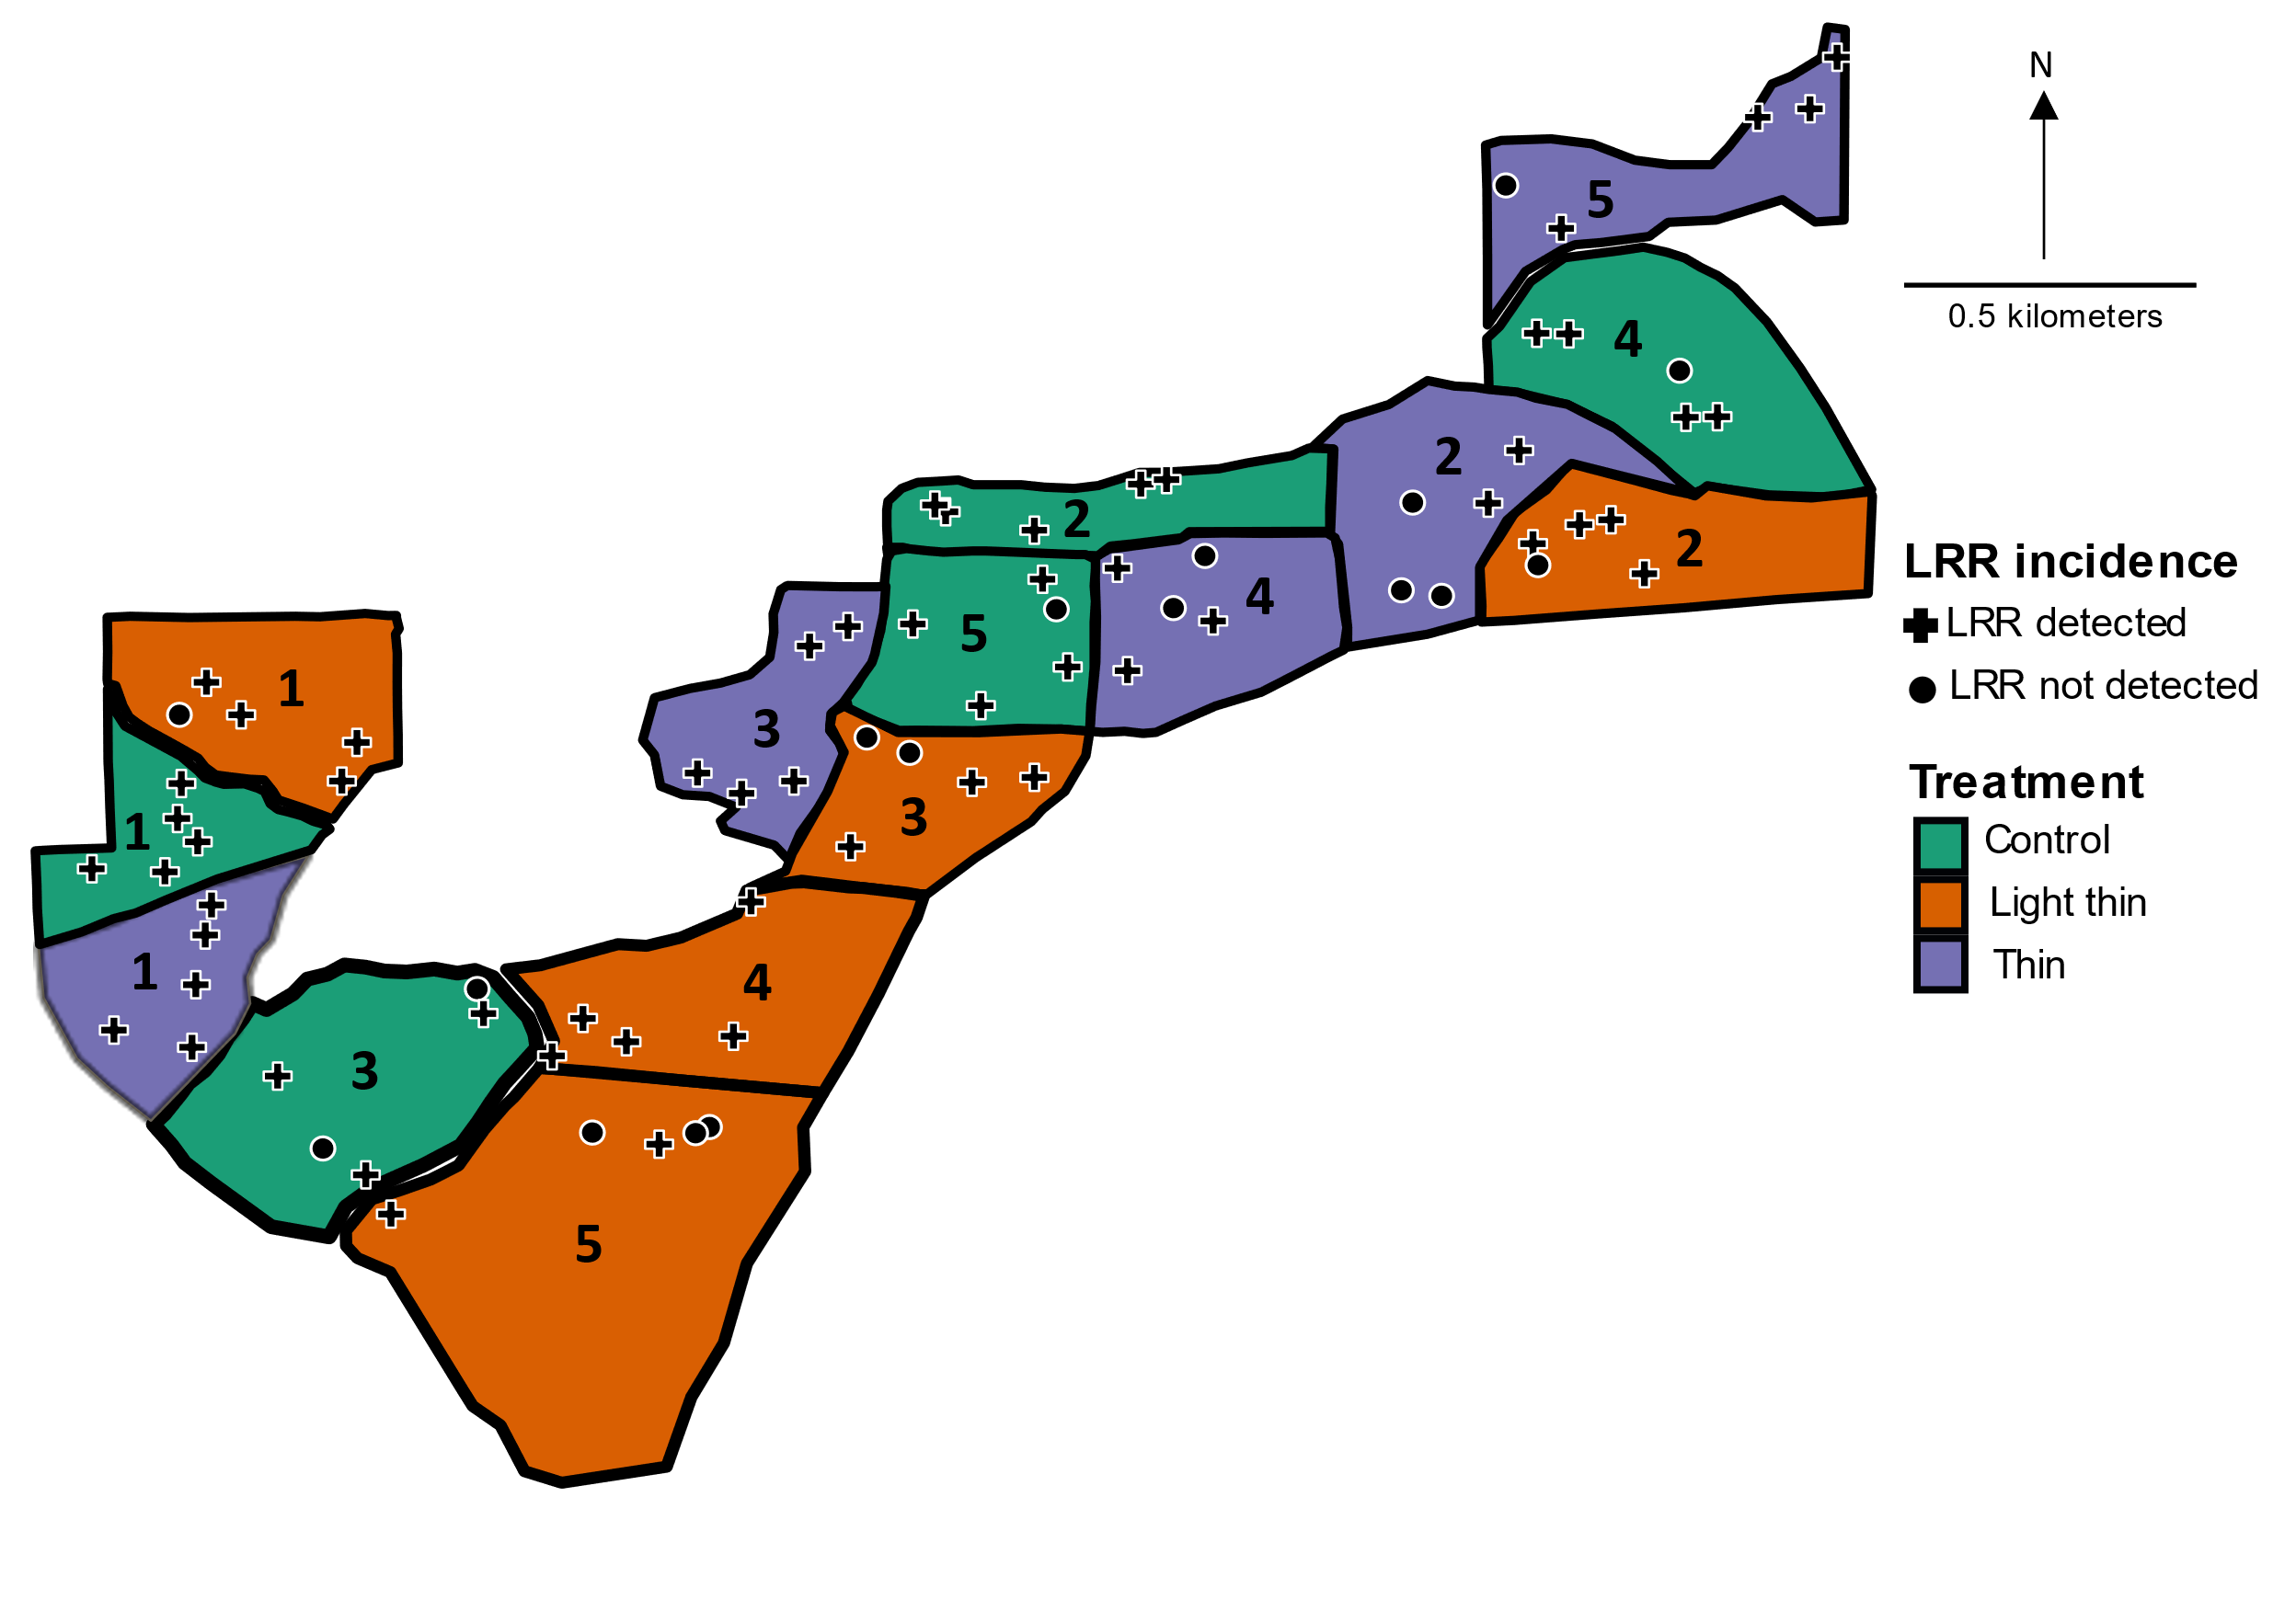
Figure 2.1: The Woods Creek study area was located along Woods Creek Road, within the Siuslaw National Forest in western Oregon. Crosses represent plots where LRR was detected (n = 62), circles represent plots where LRR was not detected (n = 13) over the 30-year duration of the study. Numbers within treatments represent blocks.

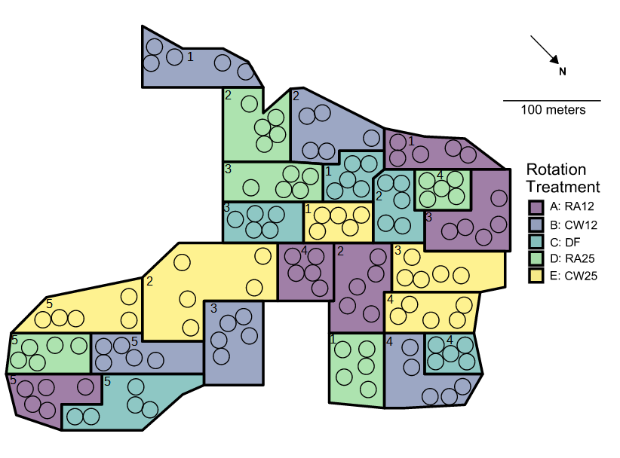
Figure 2.2. Hardwood rotation site near Apiary, OR. Colored polygons delimit plots (experimental units) to which rotation treatments were applied following 1973 clearcut of site: Purple (A), 12-year rotation with red alder before replanting Douglas-fir; Blue (B), 12- year rotation with western cottonwood before replanting with Douglas-fir; Aqua (C), immediate replanting of Douglas-fir; Green (D), 25-year with red alder and replanting with Douglas-fir; Yellow (E), 25-year rotation with western cottonwood and replanting with Douglas-fir. Black circles denote 8m fixed radius measurement subplots. Numbers denote blocks assigned by increasing incidence of LRR before 1973 clearcut.

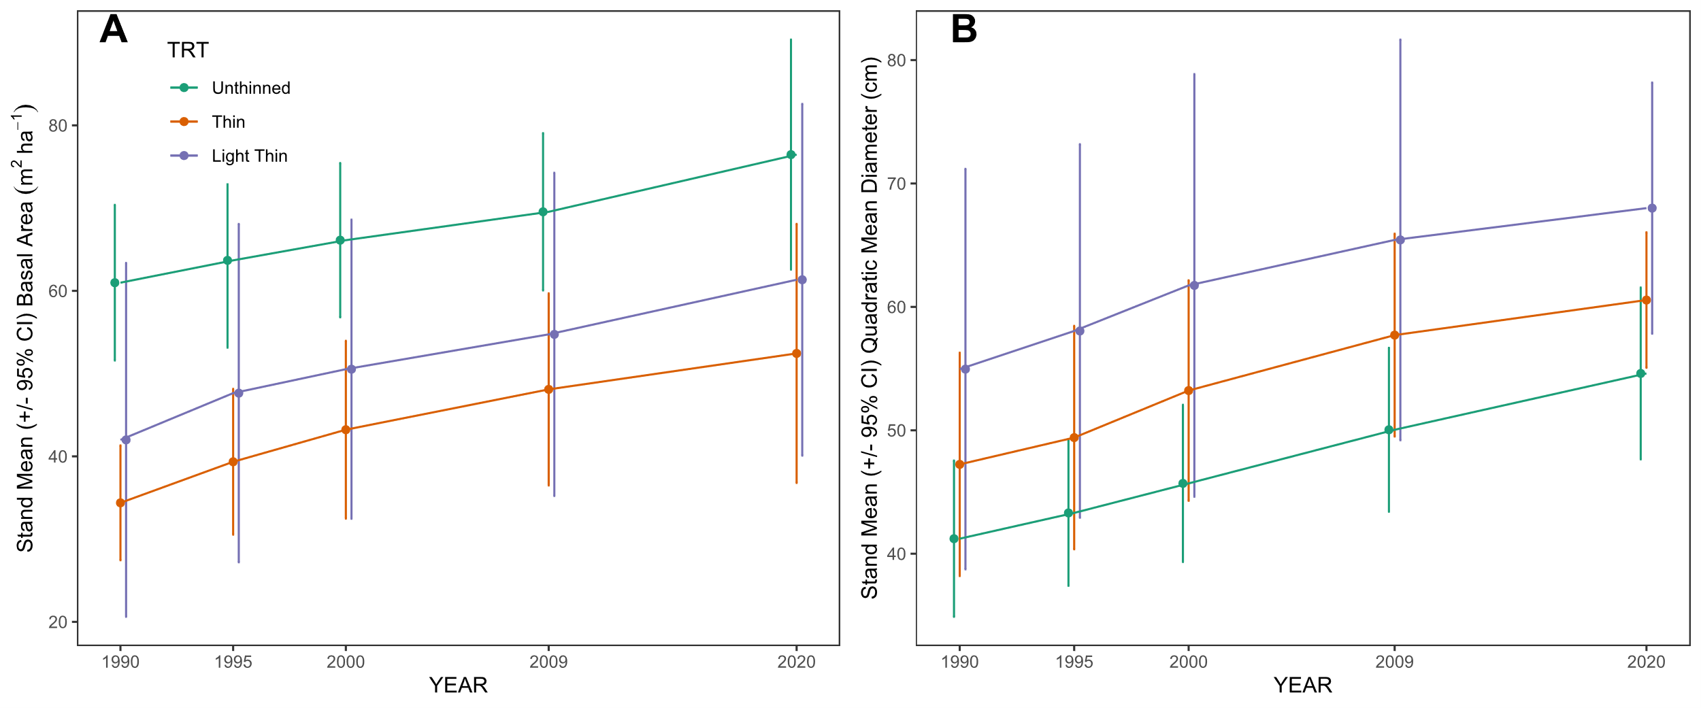
Figure 2.3. (A) Stand mean basal area of the three different treatments over time. (B) Stand mean quadratic mean diameter of the three treatments over time. The error bars are representative of 95% confidence intervals.

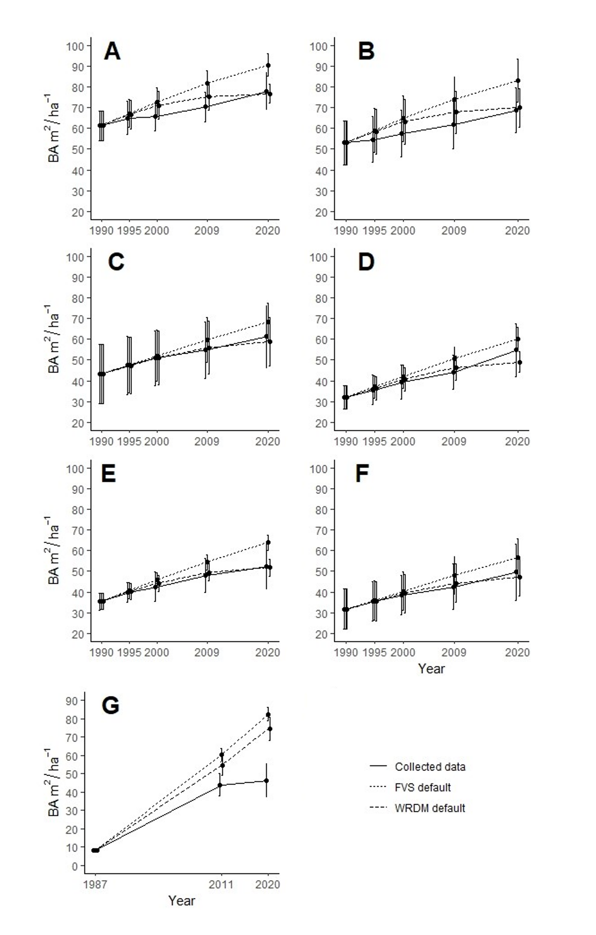
Figure 2.4: Measured data compared with modelled data within FVS and WRDM. (A) Woods Creeks control stands, all species; (B) Woods Creek control stands, DF only; (C) Woods Creek light thin stands, all species; (D) Woods Creek light thin stands, DF only; (E) Woods Creek thin, all species; (F) Woods Creek thin, DF only; (G) Apiary DF only. Error bars are representative of 95% confidence intervals. 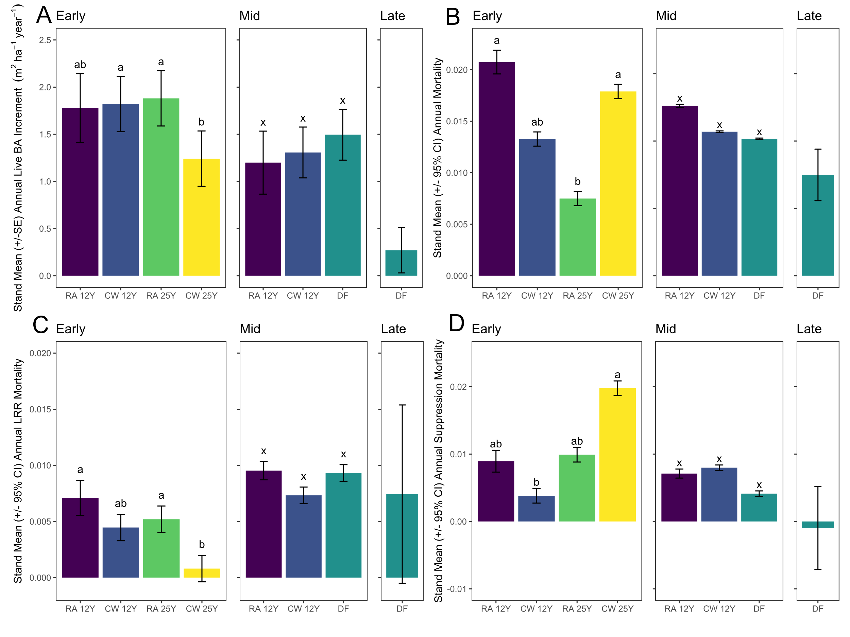

Figure 2.5. (A) Stand mean (+/- 95% CI) annual live BA increment by treatment across early, middle, and late measurement periods in the Apiary study. For all panels purple, 12-year rotation with red alder before replanting Douglas-fir; Blue, 12- year rotation with western cottonwood before replanting with Douglas-fir; Aqua, immediate replanting of Douglas-fir; Green, 25-year rotation with red alder and replanting with Douglas-fir; Yellow, 25-year rotation with western cottonwood and replanting with Douglas-fir. Treatment bars with different letters within a panel indicate significant differences by Tukey’s HSD post-hoc test performed on arcsine square root transformed proportions. (B) Stand mean (+/- 95% CI) annual mortality proportion by treatment across early, middle, and late measurement periods in the Apiary study. (C) Stand mean (+/- 95% CI) annual mortality proportion attributed to laminated root rot by treatment across early, middle, and late measurement periods in the Apiary study (D) Stand mean (+/- 95% CI) annual mortality proportion attributed to suppression by treatment across early, middle, and late measurement periods in the Apiary study. Treatment bars with different letters within a panel indicate significant differences by Tukey’s HSD post-hoc test performed on arcsine square root transformed proportions.

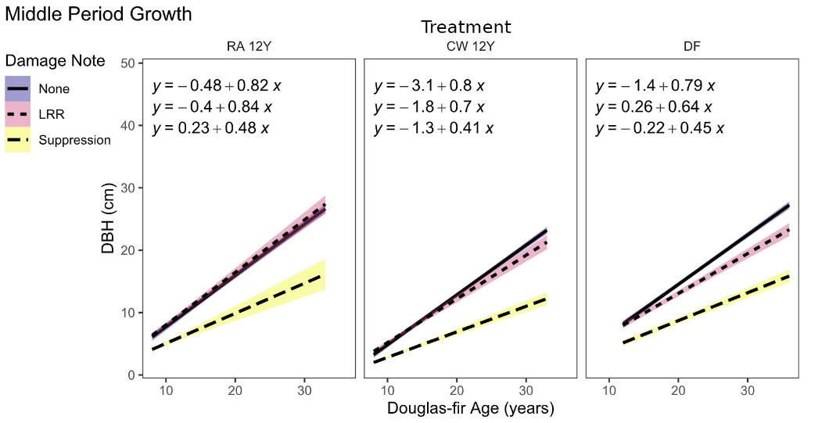
Figure 2.6. Diameter growth of live Douglas-fir over time in continuous Douglas-fir treatment vs. 12-year rotation treatments in the middle time period of the Apiary study. Linear regressions are fitted to trees grouped by damage notes recorded at any point during the study.

Table 2.1. Stand ages (years) defining the beginning and end of early, middle, and late measurement periods across rotation treatments. RA12 = red alder 12-year rotation, CW12 = cottonwood 12-year rotation, RA25 = red alder 25-year rotation, CW25 = cottonwood 25-year rotation, NA = not applicable.
 | Period
Treatment | Early | Middle | Late
RA12, CW12 | 8-24 | 8-33 | NA
DF | NA | 12-36 | 36-45
RA25, CW25 | 11-20 | NA | NA

Table 2.2. Initial and final stand summary statistics for the Woods Creek study. BA = basal area, CI = 95% confidence interval.
 |  | No thin |  |  |  | Light thin |  |  |  | Thin |  |  |  | Total
 |  | 1990 |  | 2020 |  | 1990 |  | 2020 |  | 1990 |  | 2020 |  | 1990 |  | 2020
Number of | Mean | 77 |  | 53.4 |  | 35.6 |  | 28 |  | 28.2 |  | 23.6 |  | 46.9 |  | 35
live Douglas-fir | CI | 31.3 |  | 23.2 |  | 6.9 |  | 8.2 |  | 9.9 |  | 8.4 |  | 15.2 |  | 10.5
trees | Total | 385 |  | 267 |  | 178 |  | 140 |  | 141 |  | 118 |  | 704 |  | 525
Number of live western hemlock  trees | Mean | 10.6 |  | 10.2 |  | 2.8 |  | 5.8 |  | 5.4 |  | 8.4 |  | 5.87 |  | 7.62
Number of live western hemlock  trees | CI | 11.8 |  | 8.1 |  | 4.0 |  | 6.2 |  | 6.6 |  | 7.7 |  | 4.4 |  | 3.9
Number of live western hemlock  trees | Total | 53 |  | 51 |  | 14 |  | 29 |  | 27 |  | 42 |  | 94 |  | 122
Number of live other tree species | Mean | 7.6 |  | 3.6 |  | 3 |  | 2.4 |  | 2 |  | 1.2 |  | 4.13 |  | 2.4
Number of live other tree species | CI | 7.3 |  | 5.0 |  | 4.4 |  | 0.9 |  | 2.2 |  | 1.1 |  | 3.2 |  | 1.2
Number of live other tree species | Total | 38 |  | 18 |  | 15 |  | 12 |  | 10 |  | 6 |  | 63 |  | 36
Total  live trees | Mean | 95.2 |  | 69.4 |  | 43 |  | 36.2 |  | 35.6 |  | 32.8 |  | 18.7 |  | 14.8
Total  live trees | CI | 19.8 |  | 13.8 |  | 8.5 |  | 6.6 |  | 7.1 |  | 6.0 |  | 7.7 |  | 5.5
Total  live trees | Total | 476 |  | 336 |  | 207 |  | 182 |  | 178 |  | 166 |  | 860 |  | 683
Total live BA of Douglas-fir  (m²ha⁻¹) | Mean  CI | 9.3  1.08 |  | 12.6  3.52 |  | 5.43  0.71 |  | 9.72  1.33 |  | 5.9  1.8 |  | 9.5  1.8 |  | 6.9  1.0 |  | 10.6  1.4
Douglas-fir as percentage | Total | 81% |  | 79% |  | 86% |  | 77% |  | 79% |  | 71% |  | 82% |  | 77%
of total trees

Table 2.3: A two-way ANOVA testing effects of block and thinning treatment on total tree mortality from LRR.
Source of Variation | df | Sum of Squares | Mean Square | F | p-Value
Block | 4 | 0.063847 | 0.0159617 | 1.0795 | 0.4274
Treatment | 2 | 0.000550 | 0.0002751 | 0.0186 | 0.9816
Residuals | 8 | 0.118286 | 0.0147858

Table 2.4: Results of two-way ANOVAs testing effects of block and thinning treatment on initial and final stand basal area and annuals basal area increment. Asterisk indicates significant difference (p < 0.05).
 |  | 1990 BA |  | 2020 BA |  | BA increment
Source of Variation | df | F | p-Value | F | p-Value | F | p-Value
Block | 4 | 0.8130 | 0.5509 | 1.6000 | 0.26460 | 11.2602 | 0.002275*
Treatment | 2 | 6.8606 | 0.0184* | 4.6041 | 0.04671* | 1.1213 | 0.372141
Residuals | 8

Table 2.5: Stand level summary statistics for the Apiary study. CI = 95% confidence interval.

 |  | 12y Red Alder |  |  |  |  | 12y Cottonwood |  |  |  |  | 25y Red Alder |  |  |  |  | 25y Cottonwood |  |  |  |  | Immediate Douglas-fir
Live  stems | Year | 1987 | 1995 | 2011 | 2020 |  | 1987 | 1995 | 2011 | 2020 |  | 1987 | 1995 | 2011 | 2020 |  | 1987 | 1995 | 2011 | 2020 |  | 1987 | 1995 | 2011 | 2020
Live  stems | Age | NA | 8 | 24 | 33 |  | NA | 8 | 24 | 33 |  | NA | NA | 11 | 20 |  | NA | NA | 11 | 20 |  | 12 | NA | 36 | 45
Live  stems | mean | NA | 163.0 | 106.7 | 57.0 |  | NA | 161.4 | 127.0 | 74.6 |  | NA | NA | 131.6 | 121.0 |  | NA | NA | 164.8 | 132.6 |  | 157.6 | NA | 73.2 | 55.6
Live  stems | CI | NA | 11.4 | 24.1 | 6.6 |  | NA | 7.6 | 16.1 | 19.2 |  | NA | NA | 32.6 | 28.2 |  | NA | NA | 27.1 | 15.6 |  | 21.4 | NA | 13.2 | 11.3
Live  stems | Total | NA | 489 | 320 | 171 |  | NA | 807 | 635 | 373 |  | NA | NA | 658 | 605 |  | NA | NA | 824 | 663 |  | 788 | NA | 366 | 278
Basal area (m²ha⁻¹)
Basal area (m²ha⁻¹) | mean | NA | 4.7 | 33.9 | 33.3 |  | NA | 1.4 | 30.6 | 34.1 |  | NA | NA | 10.8 | 27.8 |  | NA | NA | 7.9 | 19.1 |  | 8.1 | NA | 44.0 | 46.4
Basal area (m²ha⁻¹) | CI | NA | 2.1 | 9.5 | 3.0 |  | NA | 0.8 | 9.5 | 12.0 |  | NA | NA | 2.5 | 5.1 |  | NA | NA | 1.8 | 4.1 |  | 1.5 | NA | 8.7 | 12.7

Tables 2.6. ANOVA and likelihood ratio test statistics and probabilities for linear (mixed) models of block and treatment effects on annual basal area growth (m²ha⁻¹year⁻¹), total proportional mortality, and cause specific proportional mortalities across early, middle, and late measurement periods. *Test statistic: random effect of block= LRT; fixed effect of treatment = F. Probabilities <0.05 in bold. Mixed effect models for variables without test statistics for block effect did not converge and thus linear models of the fixed effect of treatment only were fitted.
 | Annual BA increment |  |  |  | Annual total mortality |  |  |  | Annual LRR mortality |  |  |  | Annual suppression mortality
 |  | Test |  |  |  | Test |  |  |  | Test |  |  |  | Test
Source | df | stat* | p |  | df | stat* | p |  | df | stat* | p |  | df | stat* | p
EARLY
Block | 1 | 1.112 | 0.292 |  | NA | NA | NA |  | 1 | 6.492 | 0.011 |  | 1 | 3.017 | 0.082
Treatment
(A, B, D, E) | 3 | 6.098 | 0.008 |  | 3 | 3.71 | 0.037 |  | 3 | 5.811 | 0.009 |  | 3 | 9.269 | 0.001
Error | 13 |  |  |  | 13 |  |  |  | 13 |  |  |  | 13
MIDDLE
Block | 1 | 0.62 | 0.431 |  | NA | NA | NA |  | 1 | 10.29 | 0.001 |  | NA | NA | NA
Treatment
(A, B, D, E) | 2 | 1.641 | 0.253 |  | 2 | 2.113 | 0.172 |  | 2 | 1.969 | 0.2 |  | 2 | 2.107 | 0.172
Error | 8 |  |  |  | 10 |  |  |  | 8 |  |  |  | 10

