Limited effects of thinning and hardwood rotations on laminated root rot induced tree mortality in Douglas-fir forests of the Pacific Northwest, USA

Shawn McMurtrey¹, David N. Showalter¹, Adam Carson¹, Anna Leon², John Browning², Michael McWilliams^{1,3}, (Irene) Blakey Lockman⁴, Everett M. Hansen¹, Jared M. LeBoldus^{1,5}

¹Department of Botany and Plant Pathology, Oregon State University, Corvallis, Oregon, USA.
²Weyerhauser Company, Centralia, WA, USA
³Currently: USDA Forest Service, State and Private Forestry, Pacific Northwest Region, Blue Mountains Service Center, La Grande, OR, USA
⁴USDA Forest Service, State and Private Forestry, Pacific Northwest Region, Portland, OR, USA
⁵Department of Forest Engineering, Resources, and Management, Oregon State University, Corvallis, Oregon, USA.

Keywords: Coniferiporia sulphurascens, laminated root rot, forest management, forest pathology, thinning, alternate host rotations, forest vegetation simulator

Abstract

Laminated Root Rot (LRR) caused by the pathogen Coniferiporia sulphurascens is a damaging disease within many Douglas-fir forests of the Pacific Northwest (PNW) of North America. This disease increases the probability of fire due to the high mortality rates and fuel accumulations. There has been much debate over possible control techniques for LRR. Two independent studies within Oregon, USA provided a rare opportunity to investigate different LRR management options. These studies looked at the effects of thinning practices and hardwood rotation on Douglas-fir mortality caused by laminated root rot. Both study sites were chosen for high incidence of laminated root rot. For the first study, three different thinning prescriptions were applied across ~160 hectares within the Siuslaw National Forest to investigate the interaction between commercial thinning practices and tree mortality caused by Coniferiporia sulphurascens. Treatments included five stands that were thinned to 43.1 m²ha⁻¹ of basal area, five stands that were thinned to 35.3 m²ha⁻¹ of basal area, and five control stands where no thinning occurred. A network of 75 fixed radius plots, 0.04 ha in size, were established in 1985 within the 15 stands. Inventories were conducted approximately every 5 years with a final evaluation being conducted in 2020. The second study consisted of five different rotation treatments that were applied across 14 hectares of privately-owned forest in Columbia County beginning in 1975. The five rotation treatments were A) 12 year rotation of red alder followed by Douglas-fir; B) 12 year rotation of cottonwood followed by Douglas-fir; C) 25 year red alder to Douglas-fir; D) 25 year cottonwood to Douglas-fir; and E) immediate planting of Douglas-fir. There were 125 plots established within 25 different stands. Surveying was conducted sporadically every 8-24 years.For both studies observed data was compared with anticipated data produced by the Forest Vegetation Simulator and Western Root Disease Models. Results from the first study showed that thinned areas had higher levels of tree mortality from LRR when compared to stands where no thinning had occurred. The incidence of total tree mortality from LRR was found to be between 9.4% – 11.5% higher in thinned stands when compared to the control stands where no thinning had occurred. An analysis of variance examination determined that there was not a significant difference among treatments (p = 0.628). When compared with observed data, the modelled data was found to over predict growth and yield when using the Forest Vegetation Simulator. The Western Root Disease Model was a more statistically reliable indicator of growth and yield. From the results of the first study, commercial thinning treatments do not seem to have a significant effect on reducing tree mortality caused by Coniferiporia sulphurascens. The results of the second study showed basal area increases throughout the study, but at a declining rate later in the study. This was particularly prevalent in blocks with high initial incidence of LRR. Annual basal area increment was reduced in the 25-year cottonwood treatment in the early period. Cumulative total mortality increased consistently through the study, and annual mortality was significantly higher in 12-year red alder and 25-year cottonwood rotation treatments. Modelled data was found to over predict growth and yield for both the Forest Vegetation Simulator and the Western Root Disease Model. From the results of these two independent studies, mechanical thinning and alternate host rotations do not seem to be a viable management option for LRR.

1. Introduction
Coniferiporia sulphurascens (Pilát) L. W. Zhou and Y. C. Dai is a basidiomycete fungus endemic to North America, that causes laminated root rot(LRR) in the highly susceptible Douglas-fir (Pseudotsuga menziesii (Mirb.)) (Thies and Sturrock, 1995). Douglas-fir is a keystone species which is both ecologically and economically important (Cook et al., 2013). It is a valuable tree within the timber industry, producing more timber than any other species in North America (Hanna et al., 2016). Although Douglas-fir is the primary host of C. sulphurascens, most coniferous species within Canada and the Pacific Northwest of the United States of America (USA) are affected (Cleary et al., 2013; Thies and Sturrock, 1995). Coniferiporia sulphurascens is one of the most damaging root rot pathogens affecting Douglas-fir within North America (Leal et al., 2019). It is likely the most important coastal forest tree disease in the Pacific Northwest and has significant effects on inland forests as well (Goheen and Otrosina, 1998; Hadfield, 1985; Hadfield et al., 1986; Hagle et al., 1987; Nelson et al., 1981; Scharpf, 1993; Thies, 1984; Thies and Sturrock, 1995; Wallis, 1976). Furthermore, laminated root disease increases the risk of fire through high tree mortality and increased fuel buildup (Parker et al., 2006). Root disease pockets are usually characterized by large snags and windblown trees. This results in a substantial fuel loads and a path for surface fire to reach the crown layer (Dickman & Cook, 1989; Dickman, 1992).
Global environmental change is anticipated to increase global temperatures, create changes in precipitation regimes, and exacerbate disturbances from wildfires, pests, and pathogens (Law et al., 2013). As a result, within the Pacific Northwest of North America, summers are projected to get both hotter and drier (Bennett et al., 2021; Mote and Salathé, 2010). These warmer and dryer conditions, on average, will produce larger, more frequent, and more extensive fires within forest ecosystems (McKenzie et al., 2004). In response, forest managers have shifted management strategies towards improving forest ecosystem resiliency (Vernon et al., 2018; USDA-FS, 2011, Franklin and Johnson, 2012). These shifts are being conducted through large-scale fuel reduction techniques which is focused on low to mid-canopy reductions of basal area and piled burning (Vernon et al., 2018; Agee and Skinner, 2005). Planting alternate host species that are more resistant to changes in climate is also an adaptive management strategy being used in some areas (Subramanian et al., 2015). A major question stemming from these shifts in management techniques is understanding how thinning and alternate host rotations will affect major forest pathogens.
Historically, conventional management practices for forests within the Pacific Northwest, USA has been clearcutting and planting Douglas-fir (Lawson et al., 1983). This management strategy is not typically effective when a disease of the site, such as LRR, has been established. Mechanical thinning was one hypothesis that was proposed and briefly tested. Thinning operations at a LRR research area in western Oregon, USA showed an increase of net production by 10% in thinned plots when compared to unthinned plots (Berg 1978). Mechanical thinning provides forest products and removes infested trees that are contributing to an increase of fuel loads (Vandygriff et al., 2015). Thinning however could increase the risk of wind damage, which is often the mortality event for root diseased trees with weakened root systems (Lawson, 1979). The Woods Creek study was established to investigate the thinning the impacts of thinning operations on LRR.
Another management strategy when dealing with a disease of the site is planting of alternate resistant hosts. Red alder (Alnus rubra Bong.) has been shown to resist attack from C. sulphurascens. This is likely due to the phenolics and fatty acids produced by red alder(Trappe, 1972; Li et al., 1969; Li et al., 1970). Aside from resistance, the wood value of red alder has increased within recent years and sawlogs are able to be produced within short rotations (Harrington, 2006). These findings led to a hypothesis that clear cutting LRR sites and then growing purely red alder might starve out the C. sulphurascens after several decades(Harrington, 2006). The study design for the Apiary site was centered around this hypothesis.
Root disease fungi create losses of forest carbon storage within forests that are as great as losses that occur from wildfire and harvesting of timber (Woods and Watts 2019; Healey et al., 2016). These pathogens are not readily detected on a site based on above-ground symptoms (Klopfenstein et al., 2009). Certain forest pathogens such as Phytophthora ramorum Werres et al., the causal agent of Sudden Oak Death or Phaeocryptopus gaeumannii (T.Rohde) Petrak, which is responsible for Swiss needle cast, can be monitored and detected through aerial surveys. The only way to confirm the presence of C. sulphurascens and to reliably determine the distribution and disease severity within a stand, is through ground-based surveys (Sturrock and Garbutt, 1994). While much is known about the biology of this fungus, its impact on timber volume in managed stands is unknown (Lawson et al., 1983). Prior to these two studies, basal area yield or volume data of host species in areas infected with root disease was not readily available (Morrison et al., 2014).
Long-term forest plot studies can be powerful sources of information, yet they have been scarce and often lack incremental or detailed data over long periods of time (Norris et al., 2014). Data from these studies can be valuable for better understanding the spread and impact of forest pathogens in response to climate change. These studies might influence management options, to adjust for alternative forest products or reduced profits (Hansen and Goheen, 2000; Thies and Sturrock, 1995). The long-term forest plot studies provide valuable data that can be used statistically alongside with models, to make predictions and to further understand forest dynamics.
Models are typically used within forest management to circumvent limited data availability (Pretzsch et al., 2014; Pretzsch et al., 2008). These growth models have been created to aid in the decision-making process for forest management by synthesizing the interplay between complicated biological processes and silvicultural techniques (Woods and Watts, 2019; Skovsgaard and Vanclay, 2008). The Forest Vegetation Simulator (FVS) is one such model that is commonly used within the United States Forest Service (USFS) as a tool for developing forest health and management strategies. The Western Root Disease Model (WRDM) is an extension of FVS that is used for investigating the spread of root disease from a below ground perspective (Peet and Hunt, 2005).
There have been few studies conducted that have used long-term permanent plots to assess the accuracy of the WRDM. Up until 2008, none of these studies had been published to assess the precision of the WRDM within central Oregon, USA (Maffei et al., 2008). Whereas Maffei et al., 2008 and Frankel et al., 1998 provided studies on the effects of Amillaria (Fr.) Staude and annosus (Fr.) Bref. (1888) root disease respectively, to the best of the authors’ knowledge, there has not been a long-term study to assess quality control for the WRDM and LRR caused by C. sulphurascens.

The overall aim of these two studies was to develop a better understanding of the interaction between forest management practices and C. sulphurascens, the cause of LRR. Specifically, the studies aimed to determine the effects of commercial thinning treatments and hardwood rotations on growth and mortality of Douglas-fir on sites with high incidence of LRR. The objectives were to: (i) evaluate the effect of thinning on Douglas-fir growth and LRR-induced mortality; (ii) compare the rate of spread of C. sulphurascens in thinned and unthinned stands; (iii) evaluate the effect of hardwood rotations on Douglas-fir growth and LRR-induced mortality; (iv) validate the ability of the Forest Vegetation Simulator and Western Root Disease Model to predict growth and yield of stands severely impacted by C. sulphurascens following thinning and alternate host rotation treatments.

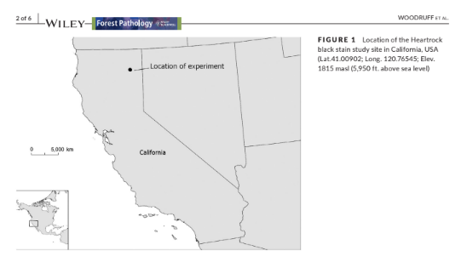
We could potentiall add one more map similar to this one to show the location of the two study areas? I think it would help paint the picture for the two studies and then I could remove my inset map from the woods creek study area. Thoughts?
2. Methods
2.1 Woods Creek thinning study
2.1.1 Study area
This study was conducted in the Coast Range of the Siuslaw National Forest located in western Oregon, USA. Forests here contain mostly mature and old-growth Douglas-fir, along with various other trees species to include western hemlock (Tsuga heterophylla (Rafn.) Sarg.), western redcedar (Thuja plicata Donn ex D. Don), grand fir (Abies grandis (Douglas ex D. Don) Lindley), noble fir (Abies procera, Rehder), bigleaf maple (Acer macrophyllum Pursh), red alder (Alnus rubra Bong.), golden chinquapin (Chrysolepis chrysophylla (Douglas ex Hook.) Hjelmq.), willow (Salix alab L.), and silver birch (Betula pendula Roth). Mean annual precipitation of this area is 225 - 235 cm (Lan et al., 2019; PRISM Climate Group, Oregon State University, 2018). Mean annual temperature is 10.6 degrees C (Lan et al., 2019; PRISM Climate Group, Oregon State University, 2018), with soil types of the study area containing mostly gravelly clay loam and gravelly silty clay (Soil Survey Staff, 2021)

The Woods Creek study area within the Siuslaw National Forest was chosen with prior knowledge that there was a high incidence rate of LRR. This was based upon a line intercept survey (Bloomberg et al., 1980) that was conducted in 1978. The area was clear cut between 1910 and 1920, burned after reharvest, and reestablished naturally from seed (Tkacz and Hansen, 1982). The study area encompassed 15 stands (mean = 9.7 hectares, range = 6.7 - 14.7 hectares) across ~162 hectares (Figure 1). The stands were thinned in 1986 - 1990, which reduced the overall basal area by about ⅓; trees per 0.4 hectares were also reduced by about 40% (Hansen, unpublished data).

Three categories of treatment areas were originally designed for this study, with five replicates for each treatment. The treatment categories included the control, that contained five stands where no thinning occurred. The basal area of the control stands was 61.4 m²ha⁻¹ in 1990 with a stand mean quadratic mean diameter of 41 cm. The lightly thinned treatment area was made up of five stands that were thinned to 43.1 m²ha⁻¹ of basal area with a stand mean quadratic mean diameter of 47 cm . The thinned treatment area was made up of five stands that were thinned to 35.3 m²ha⁻¹ of basal area with a stand mean quadratic mean diameter of 55 cm.
2.1.2 Plot network
In 1985, prior to any treatments being conducted, a total of 75 circular, fixed radius plots were established (Figure 1). The plot network contained 25 plots in each of the three different treatment areas. The location of the plots was on the northeast slope of Mary’s Peak, Oregon, USA. Plots were semi randomized and chosen with respect to access points such as trails and roads. Each plot was 0.04 hectares with a plot radius of 11.3 m. The elevation of the plots ranged from 381 - 634m (mean = 511m). Elevation was found by using a Digital Elevation Model (DEM) in ArcGIS Pro 2.8.0 (ESRI, 2011). The DEM was downloaded from the USGS Earth Explorer online website (http://earthexplorer.usgs.gov).

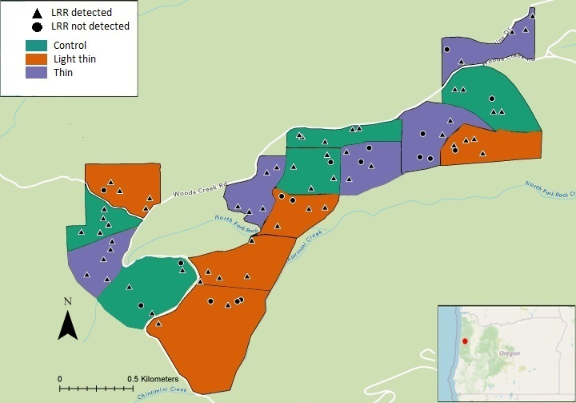
Figure 1: The Woods Creek study area was located along Woods Creek Road, within the Siuslaw National Forest in western Oregon, USA (Latitude 44.53263, Longitude -123.53433). Triangles represent plots where LRR was detected (n = 62), circles represent plots where LRR was not detected (n = 13) over the 30-year duration of the study.

2.1.3 Data collection
Beginning in 1985, the plots were surveyed and each tree within the plot was tagged with a tree identification number. The tree species, diameter at breast height (DBH) measurements, and tree health condition codes were recorded. DBH was taken ~1.37 m from the highest point of the surface of the soil, on the uphill side of the tree. A line had been spray painted at breast height from previous surveys, to ensure consistent measurements were replicated. The breakpoint DBH was 15.24 cm and all ingrown trees that were > 15.24 cm were added to the plots. Tree health conditions were assigned a code from 1 - 4 (1 = healthy, 2 = live tree with symptoms, 3 = dead from C. sulphurascens, 4 = dead not from C. sulphurascens). Windblown trees or stumps were given a code of 4 if signs of LRR were not present. Plots were surveyed in 1990, 1995, 2000, 2009, and 2020.
Confirmation of C. sulphurascens was determined in the field by observation of pitted wood in advanced decay and setal hyphae under a hand lens (Hansen, 1979). If determination could not be identified in the field, samples were brought back to the lab and grown on malt extract agar (1.5% malt extract, 1.5% Bacto agar) in a low temperature incubator 815 (Precision Scientific Inc., Chicago, IL) at 20°C for 4 - 6 weeks. Confirmation of setal hyphae was later confirmed by viewing under a dissecting microscope.

2.1.4 Data cleaning and analysis
Extensive data cleaning and validation was required to identify data entry errors, inconsistencies in variable names or values, to identify missing data, and to make sure that data from different years adhered to the same format. Data was also subset and reshaped (wide to long) and stand-level summary statistics were generated to facilitate statistics and visualization for specific questions such as mean DBH. The data was primarily cleaned in Microsoft Excel and RStudio (v. 1.4.1103, RStudio Team, 2021). First, formatting was done for all years to make the data consistent. Next the sheet was sorted to ensure that there were no measurements included within the data that had < 15.24cm DBH. All data with < 15.24cm DBH were deleted, and a list was made to document all the trees that were removed. There were several large trees that were within the plots and added as part of the 2020 data collection. These trees had not been accounted for during any of the previous years. Any of these trees that were > 25cm were also removed as part of the data cleaning process to account for larger outlier trees that might skew the data. Condition codes for all trees were then recorded if any were missing and could be positively identified from previous/current years or through the notes documented from previous years. Detailed steps of the data cleaning methods can be found at the Github repository: https://mcmurtrs.github.io/WoodsCreek/.

Over the course of this study, data were collected on over 1,900 trees with more than 7,500 tree measurements being recorded. For the final analysis, only data from 1990 - 2020 was used, as this was the years after the thinning treatments had been completed. The reduced dataset included around 1,100 different trees with approximately 4,100 DBH measurements.

2.1.5 Statistical analysis
A one-way analysis of variance (ANOVA) was conducted to test the main effect of treatment on arcsine sqaure root transformed cumulative proportional stand mortality caused by LRR. Cumulative proportional stand mortality was defined as number of confirmed dead trees showing LRR symptoms over the total number of trees within the stand. A two-way ANOVA was also used to test the effect of treatment on mortality while using the relative stand presence of C. sulphurascens (stands with fungus present/ stands without fungus present) as a covariate. . Data cleaning and visualization were performed in R using packages tidyverse (Wickham, 2017) and ggplot2 (Wickham, 2009). ANOVA tests were performed in R using the stats package. The threshold for significance was set at α = 0.05.
Cumulative Stand Mortality ~ Treatment (+ P/A)

2.1.6 Forest Vegetation Simulator
Individual stand files were each run within FVS v. 3261, RV: 2020.10.10, through the graphical user interface. The variant used for all modelled runs was the Pacific Northwest Coast (PN) variant. Cleaned excel files were formatted to work with FVS. Underlying data errors were initially checked in FVS using the “stand summary data'' option. For the FVS analysis, two comparisons were made; the first comparison involved the observed data compared to a default run in FVS. The second comparison included a comparison of the observed data with the WRDM extension using default parameters.
The data runs used the data collected from 1990, which included individual tree level, plot level, and stand level data. This data was run with default parameters from 1990-2020 and summarized at the stand level. For the observed data the standard basal area calculation was used to calculate basal area. For the WRDM, default parameters were used based upon sensitivity analysis testing and guidance from previous investigators (Maffei et al., 2008; Goheen and Thompson, 1998; Marsden, 1992a; Smith and Zhang ,1997).
For the WRDM, Phellinus root disease was used for the root disease type. The keyword and number for this was RRTYPE = 4. Total stand area in acres was set to 0.5 as each of the 5 plots within each stand was 0.1 acres. The default value of 25% (0.125 acres) was used for total root disease areas. Number of root disease centers was set to the default value of 20. The number of infected and uninfected trees in disease centers was set at the default value of 50%. Level of root system infected was set at the default value of 10% (David 2018). Default parameters were used regarding bark beetles considering that the Douglas-fir beetle (Dendroctonus pseudotsugae Hopkins) occurs throughout the extensive range of Douglas-fir (Furniss and Kegley, 2014).
Outputs of the modelled data tables were exported from FVS and used within R Studio for downstream analysis. Over 30 separate runs were made using FVS and WRDM for the final analysis. For reproducibility purposes, all input data files, output data files, and log files can be found at https://github.com/mcmurtrs/WoodsCreekFVS

2.2 Apiary hardwood rotation study
2.2.1 Study area
The Apiary study area was a14 hectare privately owned stand of predominately 40-year-old Douglas-fir located near the town of Apiary in NW Oregon, USA.When the study area was first established, it was owned by the International Paper Company. Forests in this region had been managed via clear cutting that was then followed by planting of Douglas-fir (Zabowski et al., 2008). The stands lay on a 15% NE slope with a mean elevationof 335 m (Thies & Westlind 2005).. Mean annual precipitation at this site is 150 – 160 cm. Mean annual temperature is 4 - 10°c (PRISM Climate Group, Oregon State University, 2018). The soil of the study is a Bacona silt loam with a surface layer of dark brown silt loam (Thies & Westlind 2005; Langridge 1987).

Like the Woods Creek study area, this location was also selected based on high incidence of LRR. In March of 1973, the experimental area was delimited by establishing a grid of stakes at 2-chain (40 m) intervals running NE-SW and SE-NW. Each grid block was surveyed for evidence of laminated root rot, with each stump, log, or tree showing signs or symptoms recorded along with its diameter, location relative to chain grid, and approximate date of mortality. Signs and symptoms included crescent-shaped decay pockets extending from bole to roots, ring lamination, and presence of setal hyphae (Hansen 1979). The site was harvested in the autumn of 1973, at which point cut stumps were surveyed for presence of laminated root rot and recorded as before. Slash was broadcast burned in the spring of 1974.

2.2.2 Plot network
Twenty-five plots were established and blocked by incidence and distribution of LRR. One block included the five plots at the eastern corner of the site based on high incidence and density of LRR in the area (plots with “0” as first number in the lower left corner of Figure 2). The remaining 20 plots were assigned to an additional 4 blocks based on disease incidence. Five treatments were randomly assigned to plots in each disease severity block: A) 12 year rotation of red alder followed by Douglas-fir; B) 12 year rotation of cottonwood followed by Douglas-fir; C) immediate planting of Douglas-fir; D) 25 year red alder to Douglas-fir; and E) 25 year cottonwood to Douglas-fir. Five .02 hectare ( 8 m fixed radius) survey subplots were established within in each plot to include the maximum number of C. sulphurascens infected stumps while maintaining a 4.8m buffer from the plot boundary (Figure 2). Plot centers were marked with metal stakes and mapped in reference to chain grid and later using GPS.

In the fall of 1974 through spring 1975, all plots were stocked at 2.4m x 2.4m spacing (680 trees/ 0.4 hectare , 34 trees/subplot) with 1-year old seedlings of their respective species. Stocking density was chosen to accommodate disease transmission via root proximity while allowing some room for growth over 10 years. Regenerating hardwoods were removed from Douglas-fir plots and vice versa. For a duration of two years dead seedlings were replaced within and near subplots to maintain stocking levels during establishment.

In the fall of 1986, the 12-year hardwood rotation plots (except red alder plots 1 and 3 which were missed) were harvested and in spring 1987 Douglas-fir was planted in those plots with the same 2.4mx 2.4m spacing and replacement of initial mortality. Extensive re-sprouting of hardwoods occurred following harvest, and thus suppression of these sprouts using cutting and herbicide was conducted in 1990 and 1992. In the fall of 1999 and spring of 2000 the 25-year hardwood plots were harvested, and Douglas-fir was again planted with 2.4m x 2.4m spacing and replacement of initial mortality. The site was clearcut in 2020 when the first Douglas-fir replanted were 45 years old.

2.2.3 Data collection
Tree positions were mapped, diameters measured, and conditions recorded multiple times across the study: 1986 (immediate Douglas-fir plots only); 1995 (Douglas-fir following 12-year hardwood rotation plots); 2011 (all plots); and 2020 (all plots).
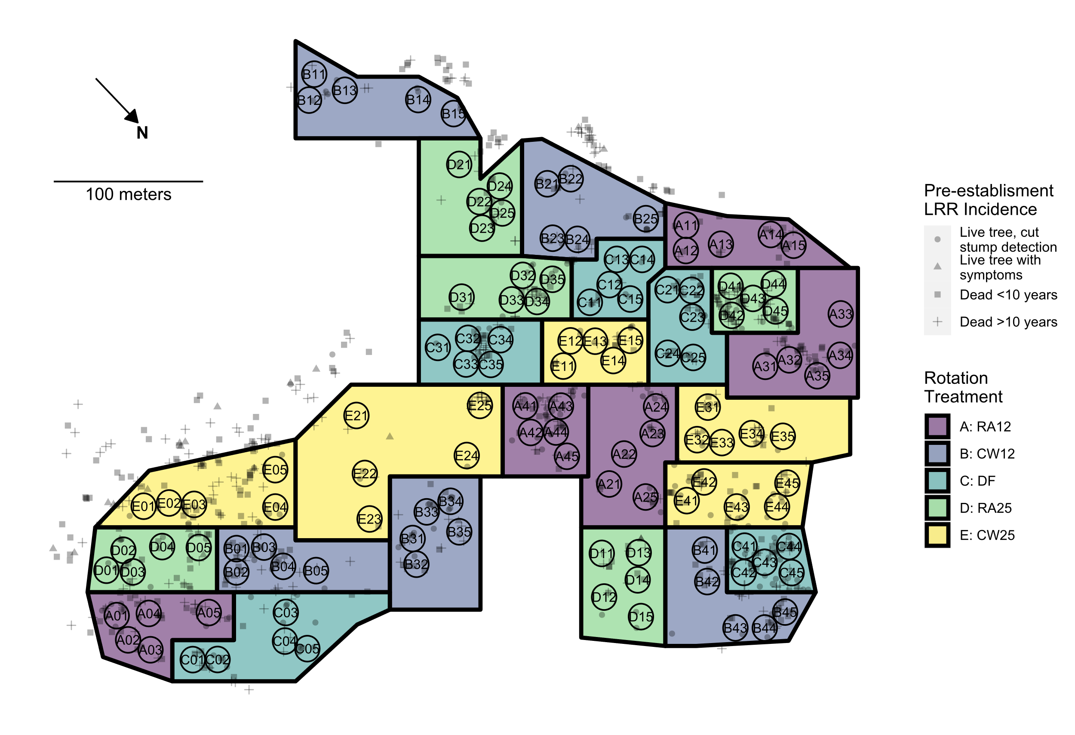
Figure 2. Hardwood rotation site near Apiary, OR. Colored polygons delimit plots (experimental units) to which rotation treatments were appliled following 1973 clearcut of site: Purple (A), 12-year rotation with red alder before replanting Douglas-fir; Blue (B), 12- year rotation with western cottonwood before replanting with Douglas-fir; Aqua (C), immediate replanting of Douglas-fir; Green (D), 25-year red alder; Yellow (E), 25-year wester cottonwood. Black circles denote 8m fixed radius measurement subplots. Letter and two numerical digits within each plot indicate treatment, block, and subplot number. Semitransparent shapes indicate the location and status of trees with LRR symptoms prior to the 1973 clearcut: Cross, tree dead > 10 years with signs of LRR ; Square, tree dead < 10 years with signs of LRR; Triangle, live tree showing LRR symptoms; Circle, live tree with symptoms detected only following clear cut.
2.2.4 Data cleaning and analysis
Because Douglas-fir replanting was staggered for the different rotation treatments and stand measurements were not at consistent ages across all treatments, the measurements were binned into three periods: early, middle, and late. The starting and ending measurements for the early period were age 8 and 24 years for the 12-year hardwood rotation treatments and age 11 and 20 years for the 25-year hardwood rotation treatments. The starting and ending measurements for the middle period were age 8 and 33 years for the 12-year hardwood rotation treatments and age 12 and 36 years for the immediate Douglas-fir treatment. The starting and ending measurements for the late period were age 36 and 45 years for the immediate Douglas-fir treatment. Slopes (annual increments) across the time periods were used as response variables in the statistical analysis of growth and mortality.

2.1.5 Statistical analysis
Analyses of variance (ANOVAs) based on generalized linear mixed models were used to test the random effect of block and the fixed effect of rotation treatment on annual basal area increment and annual arcsine square root transformed proportion of mortality across the tree time periods of the study (early, middle, late). Tukey’s HSD tests were used to determine significant differences between treatment levels. Analyses were performed using the lme4 (Bates et al. 2015) and emmeans (Lenth 2022) packages in R. Back-transformed (estimated marginal) means and 95% confidence intervals were reported and used for graphing.

2.1.6 Forest Vegetation Simulator
FVS analysis was conducted using the same methods as the Woods Creek study. Measured 1987 diameters for the immediate Douglas fir treatment as well as the diameters of dead trees and cut stumps from 1973-4 survey were entered into the models. Input, output, and log files for each FVS and WRDM run can be found at the same Github repository as the Woods Creek data.

3. Results
3.1 Thinning Study, Species compositionand basal area
In 1990, the Woods Creek study area was made up of 82% Douglas-fir trees, 11% western hemlock, and 7% a combination of other species. By the conclusion of this study, 77% were Douglas-fir, 17% were western hemlock, and 6% were other species. In total C. sulphurascens was responsible for the death of __________ Douglas-fir, ________ western hemlock, and _____ western red cedar. Differences between total Douglas-fir basal area from initial to final surveys was 16.79 m²ha⁻¹ (21% increase) for the unthinned treatment, 17.01 m²ha⁻¹ (32% increase) for the lightly thinned, and 18.14 m²ha⁻¹ (29% increase) for the thinned treatment (Figure 3).

Table 1: Initial and final stand summary statistics for the Woods Creek study. BA = basal area, CI = 95% confidence interval.
 |  | Unthinned |  |  |  | Light thin |  |  |  | Thin |  |  |  | TOTAL
 |  | 1990 |  | 2020 |  | 1990 |  | 2020 |  | 1990 |  | 2020 |  | 1990 |  | 2020
 | Mean | 77 |  | 53.4 |  | 35.6 |  | 28 |  | 28.2 |  | 23.6 |  | 46.9 |  | 35
Live Douglas-fir | CI | 31.34 |  | 23.22 |  | 6.91 |  | 8.24 |  | 9.96 |  | 8.46 |  | 15.29 |  | 10.58
 | Total | 385 |  | 267 |  | 178 |  | 140 |  | 141 |  | 118 |  | 704 |  | 525
Live Western hemlock | Mean | 10.6 |  | 10.2 |  | 2.8 |  | 5.8 |  | 5.4 |  | 8.4 |  | 5.87 |  | 7.62
Live Western hemlock | CI | 11.8 |  | 8.11 |  | 4.08 |  | 6.24 |  | 6.66 |  | 7.7 |  | 4.45 |  | 3.96
Live Western hemlock | Total | 53 |  | 51 |  | 14 |  | 29 |  | 27 |  | 42 |  | 94 |  | 122
Live other species | Mean | 7.6 |  | 3.6 |  | 3 |  | 2.4 |  | 2 |  | 1.2 |  | 4.13 |  | 2.4
Live other species | CI | 7.34 |  | 5.01 |  | 4.46 |  | 0.99 |  | 2.23 |  | 1.14 |  | 3.29 |  | 1.22
Live other species | Total | 38 |  | 18 |  | 15 |  | 12 |  | 10 |  | 6 |  | 63 |  | 36
Total  live trees | Mean | 95.2 |  | 69.4 |  | 43 |  | 36.2 |  | 35.6 |  | 32.8 |  | 18.7 |  | 14.8
Total  live trees | CI | 19.83 |  | 13.85 |  | 8.55 |  | 6.63 |  | 7.16 |  | 6.02 |  | 7.74 |  | 5.52
Total  live trees | Total | 476 |  | 336 |  | 207 |  | 182 |  | 178 |  | 166 |  | 860 |  | 683
Total BA of | Mean | 9.3 |  | 12.6 |  | 5.43 |  | 9.72 |  | 5.9 |  | 9.5 |  | 6.9 |  | 10.6
Douglas-fir  (m²ha⁻¹) | CI | 1.08 |  | 3.52 |  | 0.71 |  | 1.33 |  | 1.8 |  | 1.8 |  | 1.0 |  | 1.4
Douglas-fir as percentage | Total | 81% |  | 79% |  | 86% |  | 77% |  | 79% |  | 71% |  | 82% |  | 77%
of total trees

3.2 Thinning Study, Cumulative proportional mortality to LRR
The one-way analysis of variance showed no significant of effect of treatment on (arcsine square root transformed) proportion of mortality (F_{2,12} = 0.484, p = 0.628 ). There was also no significance found when the two thinned treatment areas were combined and compared against the control stands (F_{1,13} = 0.295, p = 0.596). Within the two-way analysis of variance, no significant was found from tree mortality induced by C. sulphurascens across treatment areas (Table 2).

Table 2: A two way ANOVA testing effect on tree mortality from LRR considering relative presence of LRR in the stand.
Source of Variation | Degrees of Freedom | Sum of Squares | Mean Square | F | p-Value
Treatment | 2 | 0.01048 | 0.00524 | 0.460 | 0.643
LRR presence | 1 | 0.00467 | 0.004672 | 0.411 | 0.535
Residuals | 11 | 0.12518 | 0.011380

3.3 Thinning Study, Prevalence of root disease
Within every stand, the prevalence of root disease increased over time. At the conclusion of the study, the proportion of total tree mortality from LRR was less in control stands when compared to stands where thinning occurred.

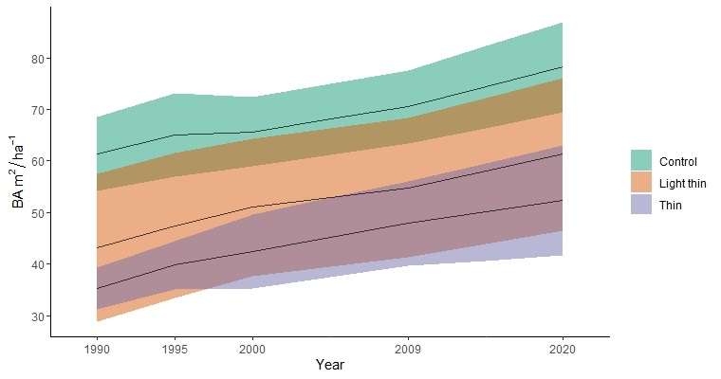
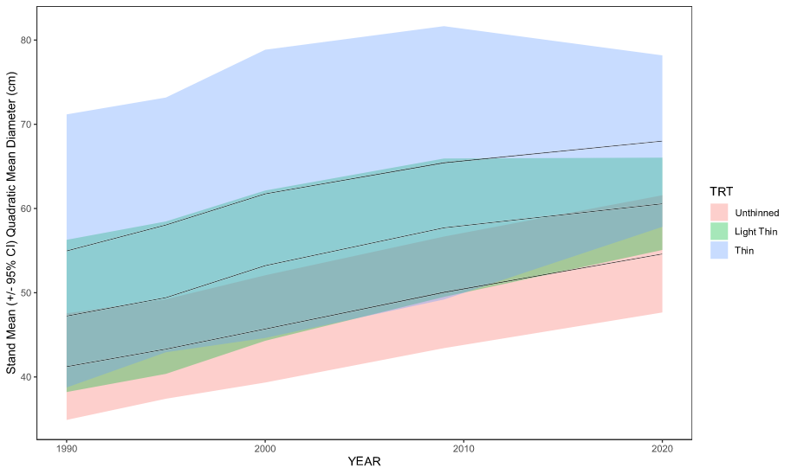
Figure 3. A) Stand mean basal area of the three different treatments over time. B) Stand mean quadratic mean diameter of the three treatments over time. The ribbons are represented of 95% confidence intervals.

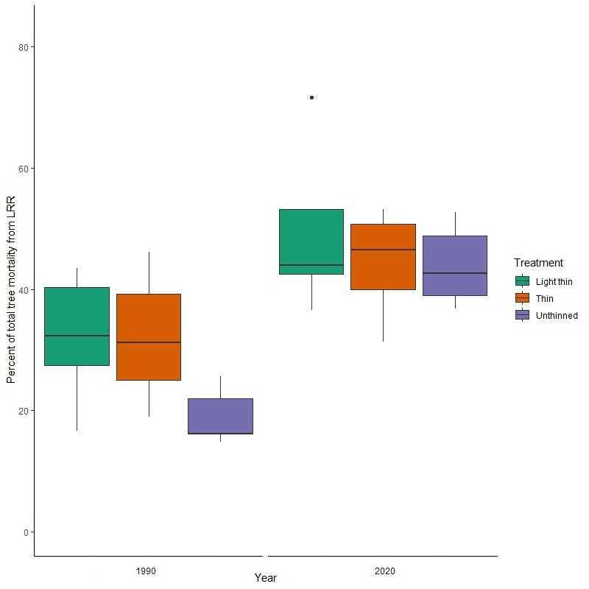
Figure 2: Percent of total tree mortality from LRR at initial and final time points.

LRR was found within at least 40% of the plots in all 15 of the total stands (Figure 1). By the time the study concluded, LRR had been found in 100% of the plots within two of theunthinned stands, two of the stands with light thinning, and one of the thinned stands. When the plots were established, LRR was present within 59% (n = 44/75) of the plots. By the end of the study, it had been found within 83% (n=62/75) of the plots At the stand level, 92% (n = 23/25) of the plots in the unthinned stands, 80% (n = 20/25) of the plots in the lightly thinned stands, and 76% (n = 19/25) of the plots in the thinned stands had confirmed LRR by the end of the study period. In total, 83% (n = 62/75) of the plots had confirmed LRR at the conclusion of the study.

3.3 Forest Vegetation Simulator and Western Root Disease Models
Within the results of the modeled data, the mean values of the measured data were found to correspond more closely to the WRDM model run that was made using default parameters. The data determined by the FVS simulation, was not found to be statistically significant for the years of 2009 and 2020 in both the control and thinned stands . The basal area predictions made by the WRDM was statistically significant when compared with observed data for all three treatment areas in 2020.

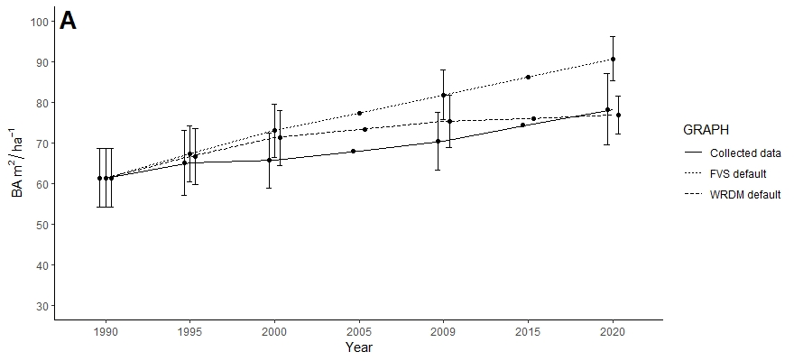

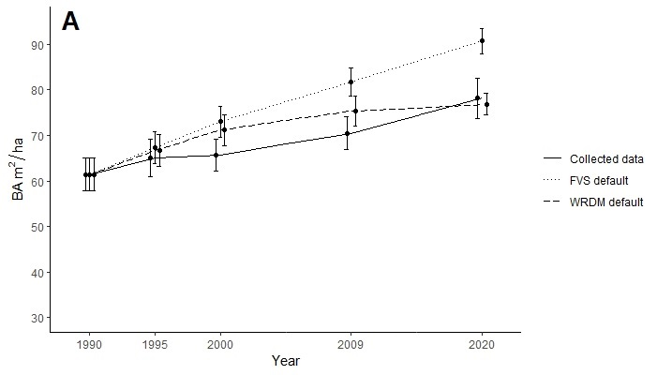
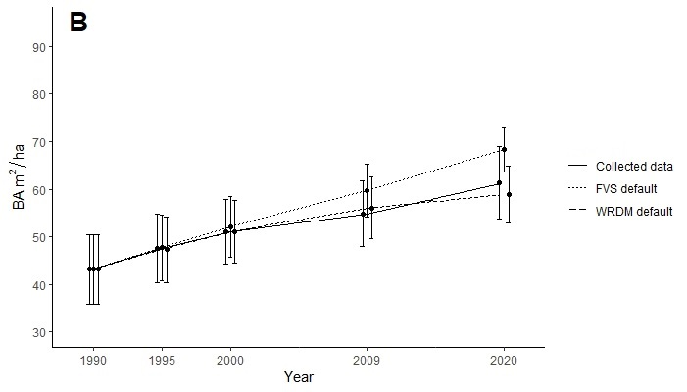
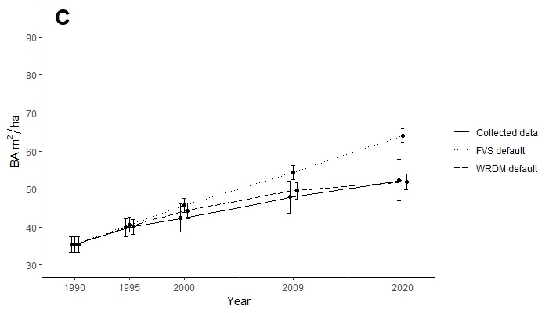
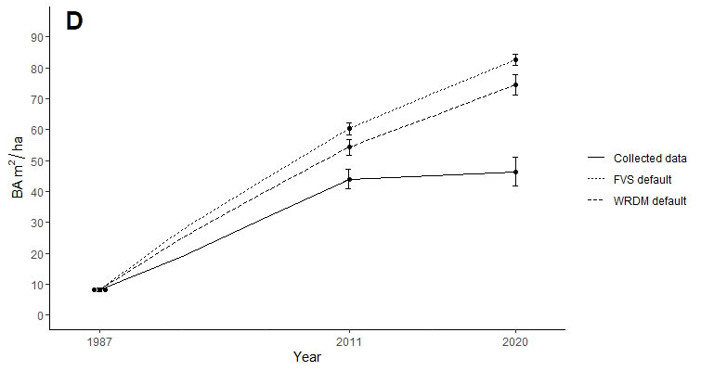

Figure 4: Measured data compared with modelled data depicting mean basal area of the 15 stands. A = unthinned stands (61.4 m²ha⁻¹ basal area in 1990), B = lightly thinned stands (thinned to 42.1 m²ha⁻¹ of basal area), C = thinned stands (thinned to 34.5 m²ha⁻¹ of basal area), D = Immediate Douglas-fir planting treatment in rotation study. The thinning treatments took place between 1985-1990. Error bars are representative of the standard error but will get changed to confidence intervals.

3.4 Rotation Study, Basal area and cumulative total mortality
Basal area increased throughout the study (Table 3, Figure 4A), but at a declining rate later in the study (Figure 5) and in blocks with high initial incidence of laminated root rot (Supplement X). Annual basal area increment was reduced in the 25-year cottonwood treatment in the early period (Figure 5, Table 4). Cumulative total mortality increased consistently through the study (Table 3, Figure 4B), and annual mortality was significantly higher in 12-year red alder and 25-year cottonwood rotation treatments in the early measurement period (Figure 6, Table 4).

3.5 Rotation Study, Cause-specific mortality and sublethal effets
Binning the mortality by suspected cause revealed more treatment-depended patterns. Mortality caused by laminated root rot was significantly lower in 25-year cottonwood rotation in the early measurement period and did not differ significantly between treatments in the middle period (Figure 7, Table 4). Conversly, mortality caused by suppression was significantly higher in 25-year cottonwood rotation in the early measurement period and did not differ significantly between treatments in the middle period (Figure 8, Table 4).

In addition to killing trees, both suppression and laminated root rot decreased tree diameter growth while trees were alive (Figure 9). The growth reduction effect of suppression was most severe showing a 41-49% reduction in diamter growth compared to trees with no recorded damage condition in the middle measurement period. Tree with LRR showed 0-19% diameter growth reduction.

Table 3: Stand level summary statistics for the Apiary study. SE = standard error.
 |  | 12y Red Alder |  |  |  |  | 12y Cottonwood |  |  |  |  | 25y Red Alder |  |  |  |  | 25y Cottonwood |  |  |  |  | Immediate Douglas-fir
Live  stems | Year | 1987 | 1995 | 2011 | 2020 |  | 1987 | 1995 | 2011 | 2020 |  | 1987 | 1995 | 2011 | 2020 |  | 1987 | 1995 | 2011 | 2020 |  | 1987 | 1995 | 2011 | 2020
Live  stems | Age | NA | 8 | 24 | 33 |  | NA | 8 | 24 | 33 |  | NA | NA | 11 | 20 |  | NA | NA | 11 | 20 |  | 12 | NA | 36 | 45
Live  stems | mean | NA | 163.0 | 106.7 | 57.0 |  | NA | 161.4 | 127.0 | 74.6 |  | NA | NA | 131.6 | 121.0 |  | NA | NA | 164.8 | 132.6 |  | 157.6 | NA | 73.2 | 55.6
Live  stems | SE | NA | 2.6 | 5.6 | 1.5 |  | NA | 2.7 | 5.8 | 6.9 |  | NA | NA | 11.7 | 10.2 |  | NA | NA | 9.7 | 5.6 |  | 7.7 | NA | 4.5 | 4.1
Live  stems | Total | NA | 489 | 320 | 171 |  | NA | 807 | 635 | 373 |  | NA | NA | 658 | 605 |  | NA | NA | 824 | 663 |  | 788 | NA | 366 | 278
Basal area (m²ha⁻¹)
Basal area (m²ha⁻¹) | mean | NA | 4.7 | 33.9 | 33.3 |  | NA | 1.4 | 30.6 | 34.1 |  | NA | NA | 10.8 | 27.8 |  | NA | NA | 7.9 | 19.1 |  | 8.1 | NA | 44.0 | 46.4
Basal area (m²ha⁻¹) | SE | NA | 0.5 | 2.2 | 0.7 |  | NA | 0.3 | 3.4 | 4.3 |  | NA | NA | 0.9 | 1.8 |  | NA | NA | 0.7 | 1.5 |  | 0.5 | NA | 3.1 | 4.6

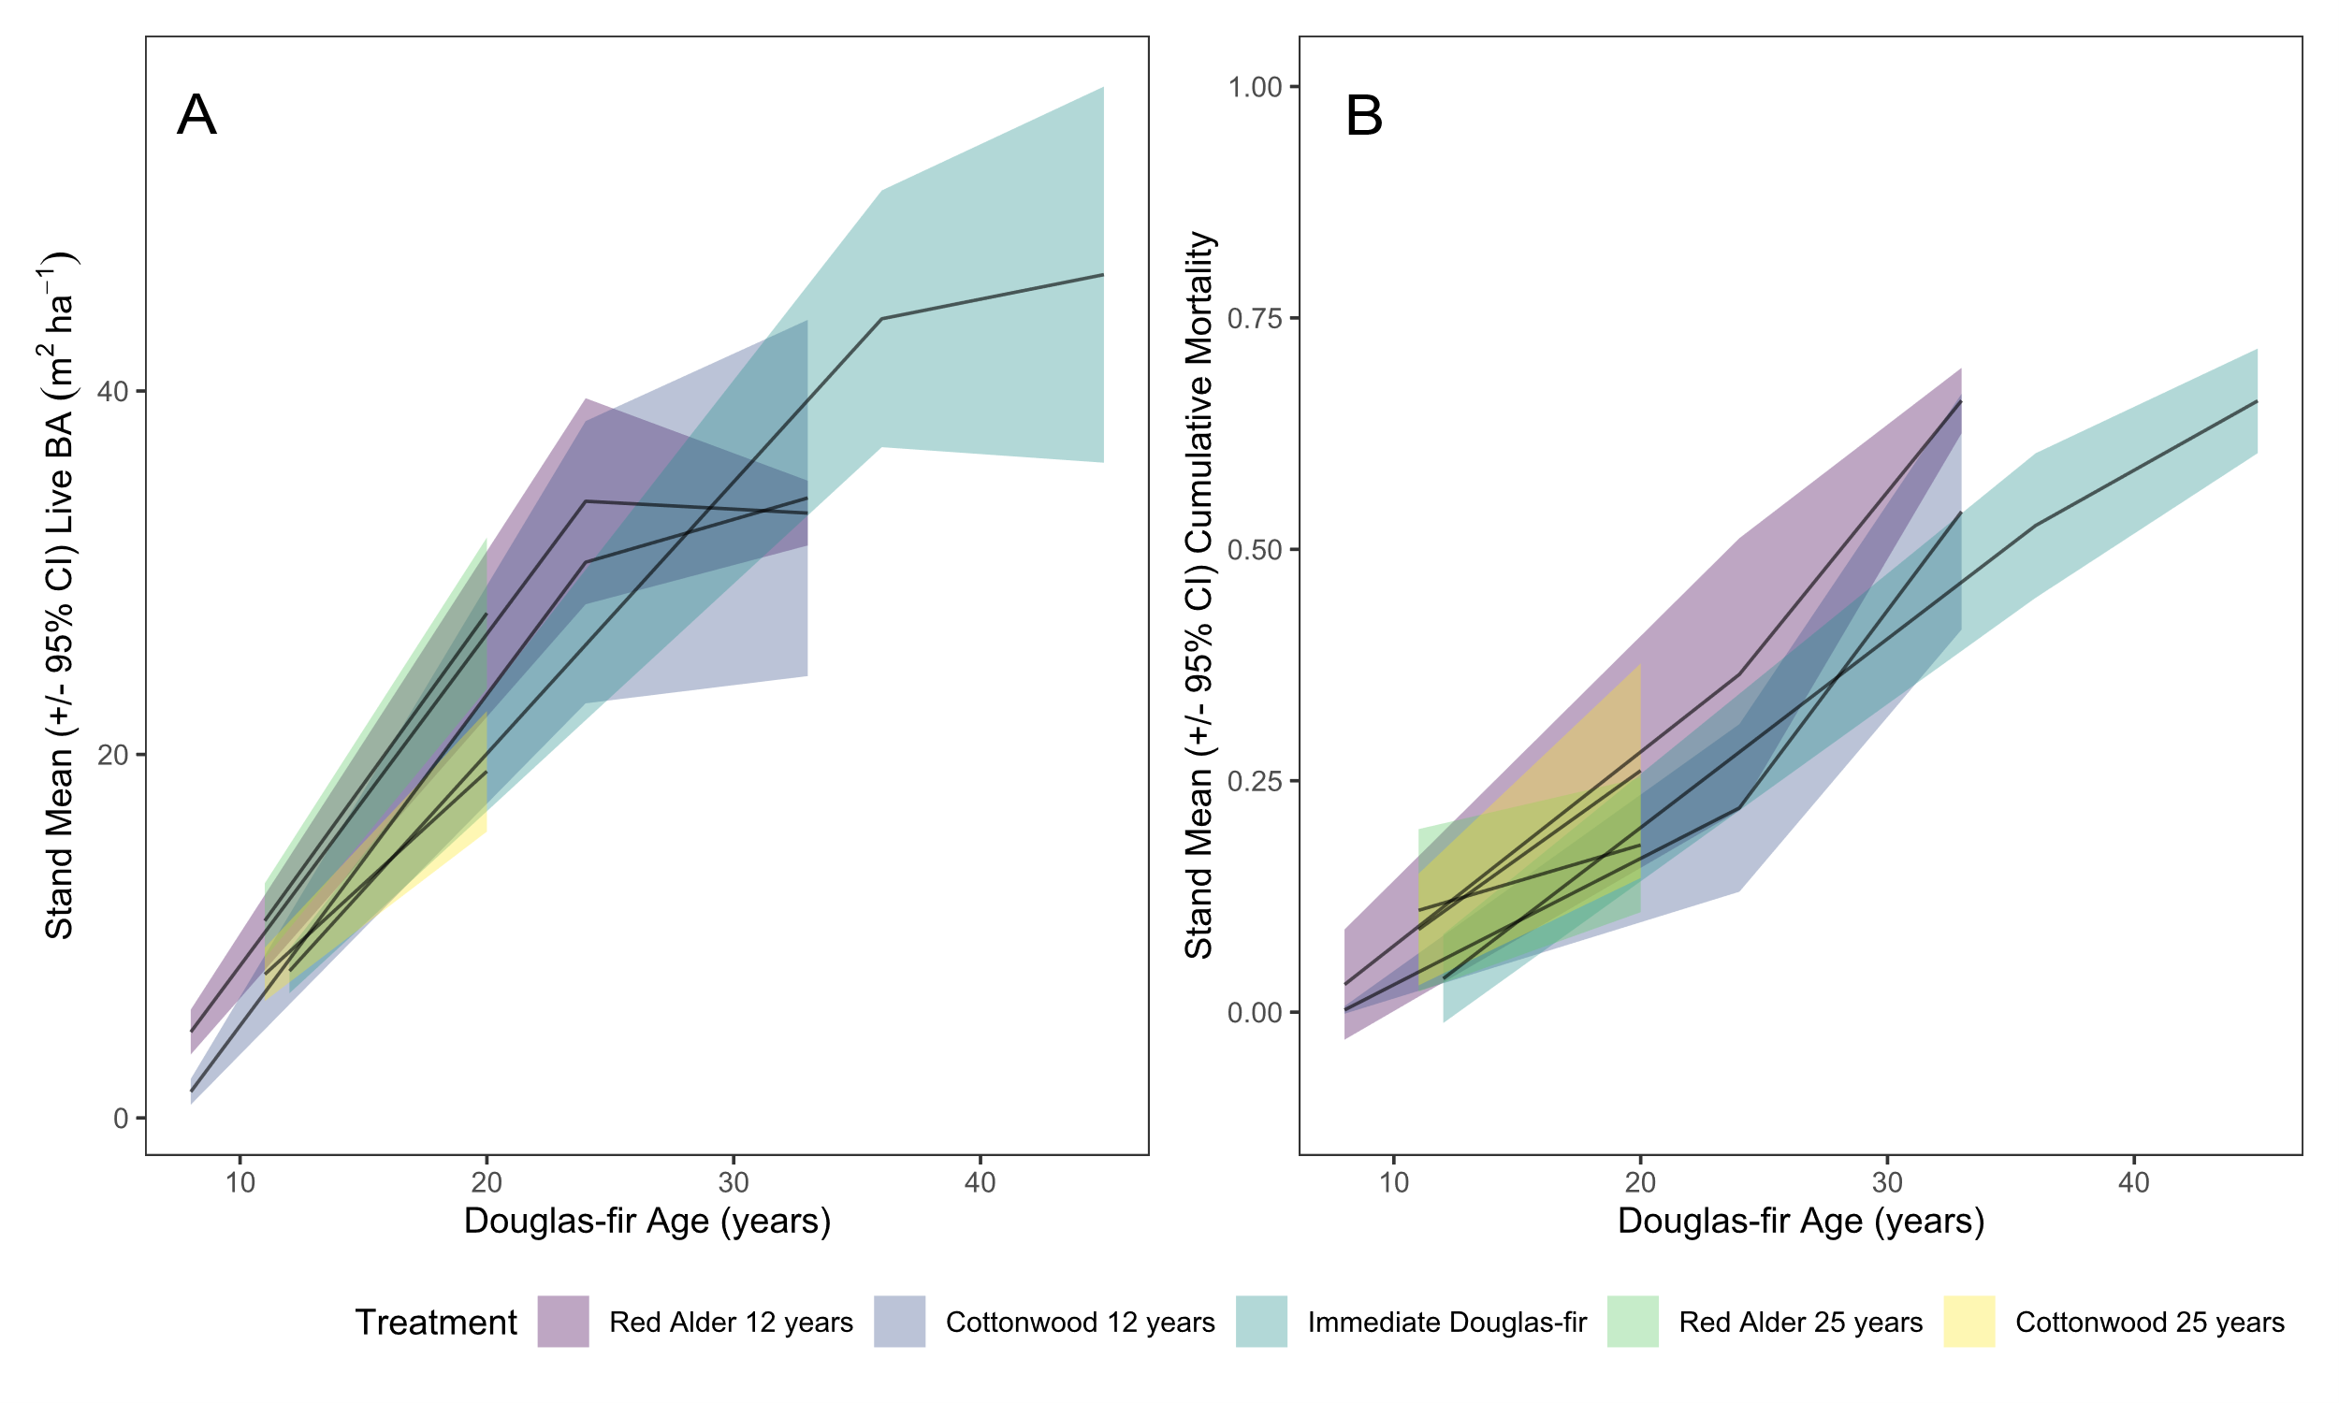
Figure 4. Stand mean +/- 95% CI basal area (A) and cumulative proportion of mortality (B) by tree age and rotation treatment in the Apiary study. Purple, 12-year rotation with red alder before replanting Douglas-fir; Blue, 12- year rotation with western cottonwood before replanting with Douglas-fir; Aqua, immediate replanting of Douglas-fir; Green, 25-year red alder; Yellow, 25-year wester cottonwood.

 | annual BA increment |  |  |  | annual total mortality |  |  |  | annual LRR  Mortality |  |  |  | annual suppression mortality
Source | df | Test stat.* | p |  | df | Test stat.* | p |  | Df | Test stat.* | p |  | df | Test stat.* | p
EARLY
Block | 1 | 1.1120 | 0.2916 |  |  | NA | NA |  | 1 | 6.492 | 0.0108 |  | 1 | 3.0168 | 0.0824
Treatment (A,B,D,E) | 3 | 6.0979 | 0.0080 |  | 3 | 3.7098 | 0.0374 |  | 3 | 5.8110 | 0.0093 |  | 3 | 9.2687 | 0.0014
Error | 13 |  |  |  | 13 |  |  |  | 13 |  |  |  | 13
MIDDLE
Block | 1 | 0.6195 | 0.4312 |  |  | NA | NA |  | 1 | 10.287 | 0.00134 |  |  | NA | NA
Treatment (A,B,C) | 2 | 1.6408 | 0.2530 |  | 2 | 2.1129 | 0.1716 |  | 2 | 1.9691 | 0.2004 |  | 2 | 2.1071 | 0.1723
Error | 8 |  |  |  | 10 |  |  |  | 8 |  |  |  | 10

Table 4. ANOVA and likelihood ratio test statistics and probabilities for linear (mixed) models of block and treatment effects on annual basal area growth (m²ha⁻¹year⁻¹), total proportional mortality, and cause-specific proportional mortalities across early, middle, and late measurement periods. *Test statistic: random effect of block= LRT; fixed effect of treatment = F. Probabilities <0.05 in bold. Mixed effect models for variables without test statistics for block effect did not converge and thus linear models of the fixed effect of treatment only were fitted.
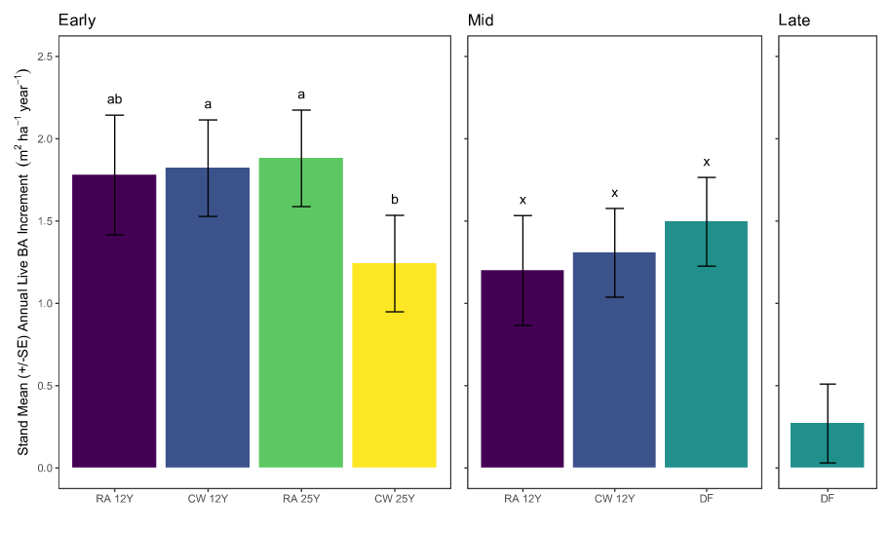
Figure 5. Stand mean (+/- SE) annual live basal area increment by treatment across early, middle, and late measurement periods in the Apiary study. Purple, 12-year rotation with red alder before replanting Douglas-fir; Blue, 12- year rotation with western cottonwood before replanting with Douglas-fir; Aqua, immediate replanting of Douglas-fir; Green, 25-year red alder; Yellow, 25-year wester cottonwood. Treatment bars with different letters within a panel indicate significant differences by Tukey’s HSD post-hoc test.
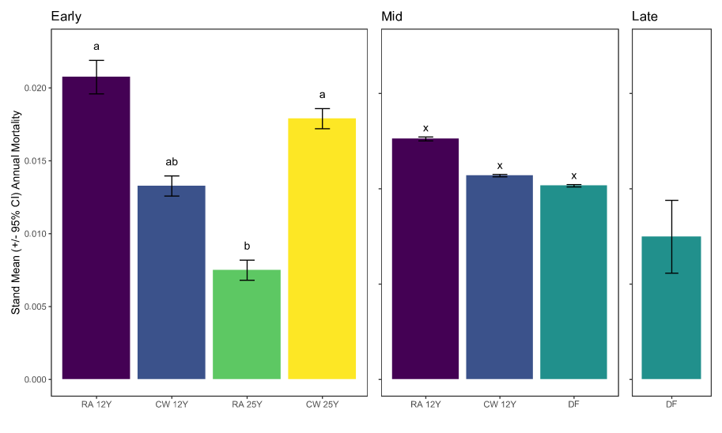

Figure 6. Stand mean (+/- 95% CI) annual mortality proportion by treatment across early, middle, and late measurement periods in the Apiary study. Purple, 12-year rotation with red alder before replanting Douglas-fir; Blue, 12- year rotation with western cottonwood before replanting with Douglas-fir; Aqua, immediate replanting of Douglas-fir; Green, 25-year red alder; Yellow, 25-year wester cottonwood. Treatment bars with different letters within a panel indicate significant differences by Tukey’s HSD post-hoc test performed on arcsine square root transformed proportions.
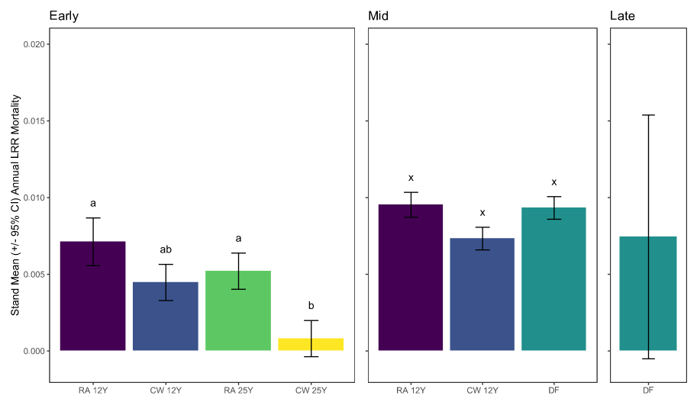
Figure 7. Stand mean (+/- 95% CI) annual mortality proportion attributed to laminated root rot by treatment across early, middle, and late measurement periods in the Apiary study. Purple, 12-year rotation with red alder before replanting Douglas-fir; Blue, 12- year rotation with western cottonwood before replanting with Douglas-fir; Aqua, immediate replanting of Douglas-fir; Green, 25-year red alder; Yellow, 25-year wester cottonwood. Treatment bars with different letters within a panel indicate significant differences by Tukey’s HSD post-hoc test performed on arcsine square root transformed proportions.
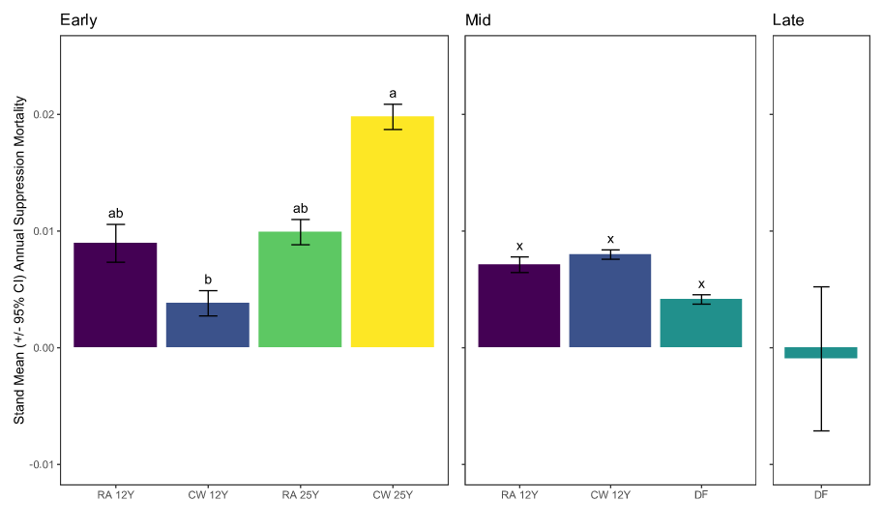
Figure 8. Stand mean (+/- 95% CI) annual mortality proportion attributed to suppression by treatment across early, middle, and late measurement periods in the Apiary study. Purple, 12-year rotation with red alder before replanting Douglas-fir; Blue, 12- year rotation with western cottonwood before replanting with Douglas-fir; Aqua, immediate replanting of Douglas-fir; Green, 25-year red alder; Yellow, 25-year wester cottonwood. Treatment bars with different letters within a panel indicate significant differences by Tukey’s HSD post-hoc test performed on arcsine square root transformed proportions.
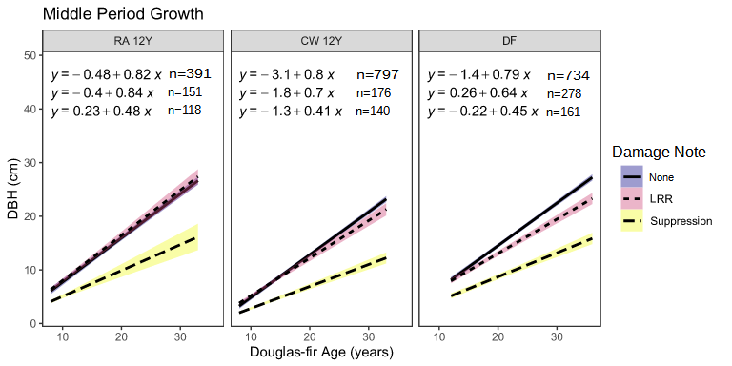
Figure 9. Diameter growth of live Douglas-fir over time in continuous Douglas-fir treatment vs 12-year rotation treatments in the middle time period of the Apiary study. Linear regressions are fitted to trees grouped by damage notes recorded at any point during the study.

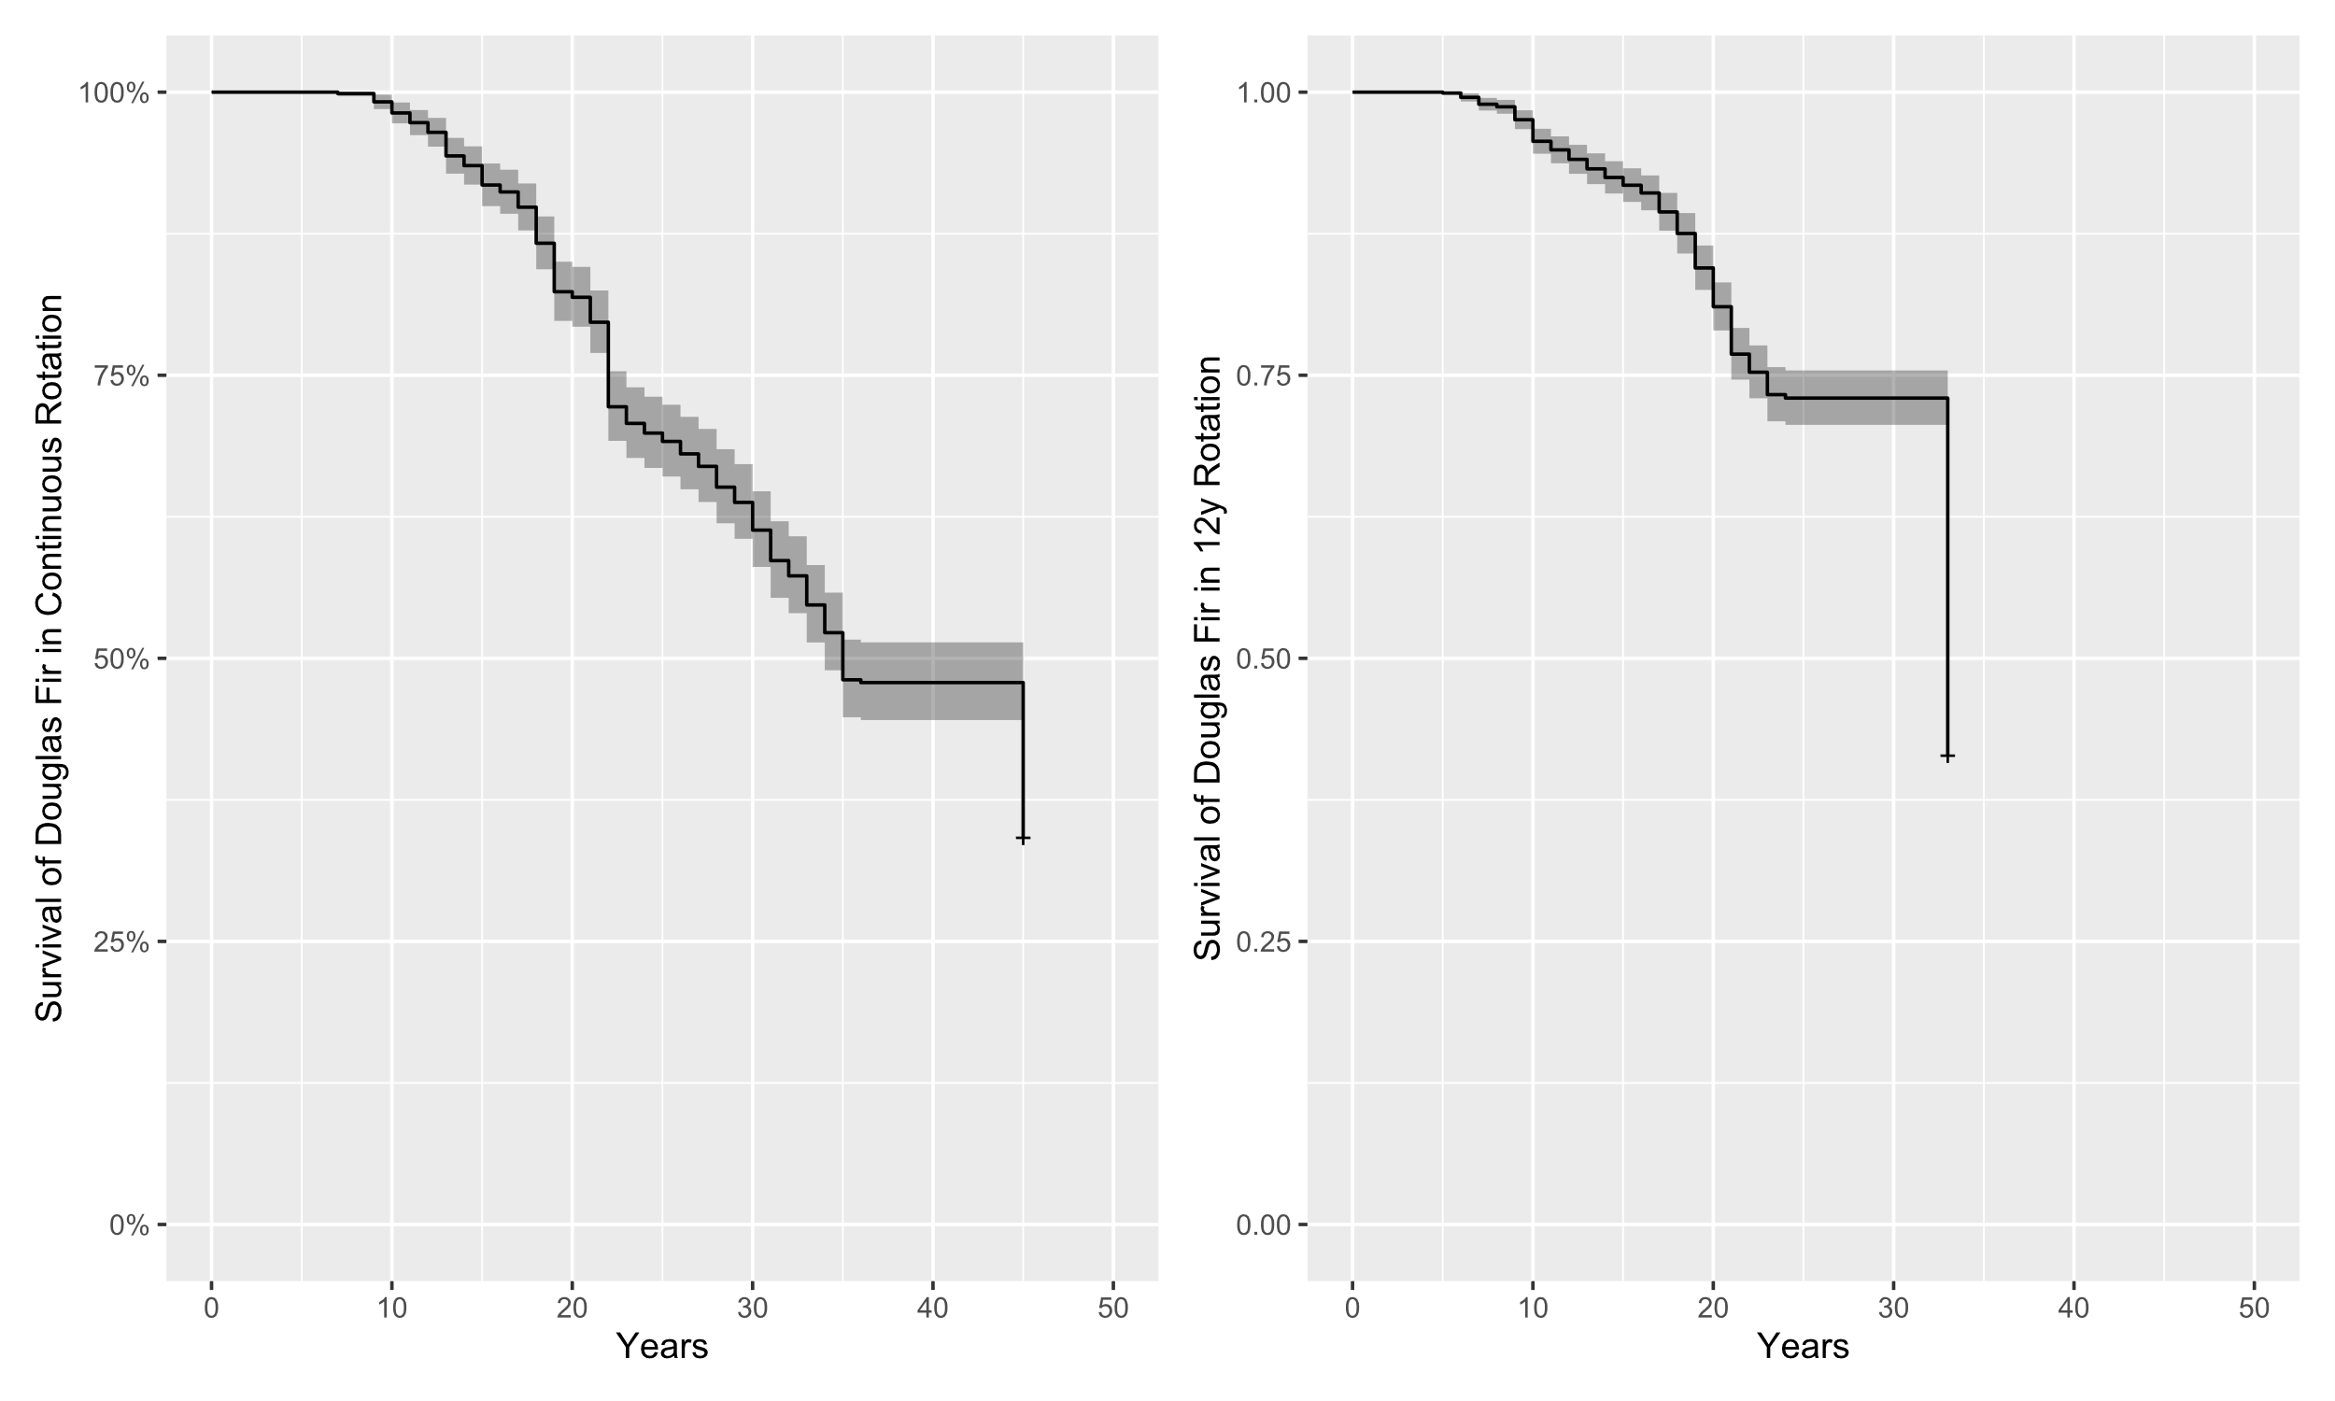
Figure 10. Douglas-fir survival over time (+/- 95% CI) in immediate Douglas-fir treatment vs 12-year hardwood rotation treatments. in the Apiary study.
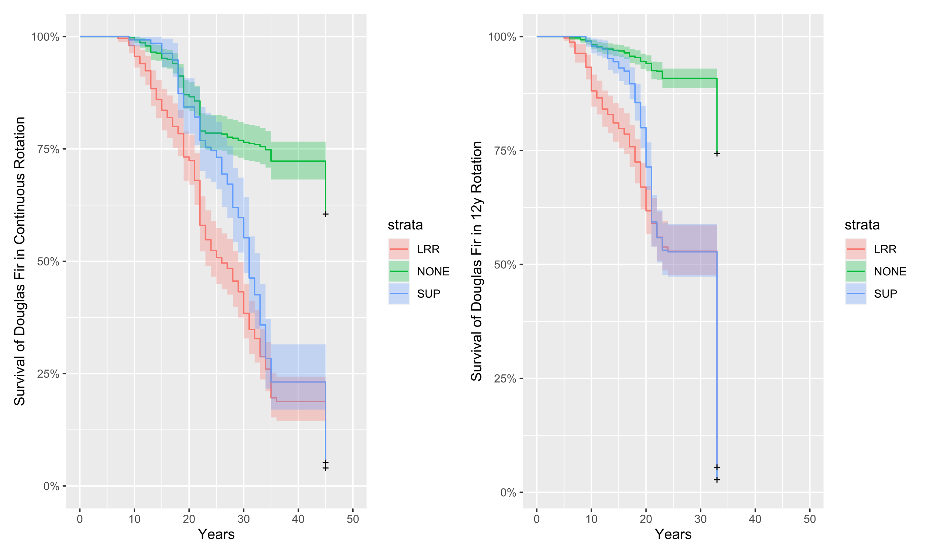
Figure 11. Douglas-fir survival (+/- 95% CI) over time in continuous DF treatment vs 12-year rotation treatments. in the Apiary study. Mortality is divided by suspected cause (LRR= laminated root rot, SUP= suppression)
4. Conclusions and discussion
From the results of these two studies, two important conclusions were made. First, the effects of the thinning did not seem to have a statistically significant difference with respect to increasing basal area or tree mortality caused by C. sulphurascens. Secondly, the use of non-host rotations did not have a statistically significant effect on increasing growth and yield or reducing tree mortality caused by C. sulphurascens. The results of these two studies do not suggest that thinning treatments or alternate host rotations are viable control alternatives for C. sulphurascens. The mechanical thinning treatments did not change the characteristics of the site. As a result, C. sulphurscens was able to cause reinfection. There was no evidence found to show that the hardwood trees that are most resistant to C. sulphurascens reduced the amount of inoculum within the forest stands. Additionally, the alternate hosts had a negative impact on Douglas-fir growth and yield through suppression.
4.1 Thinning Study, Cumulative proportional mortality to LRR
The one-way analysis of variance showed no significant of effect of treatment on (arcsine square root transformed) proportion of mortality (F_{2,12} = 0.484, p = 0.628 ). There was also no significance found when the two thinned treatment areas were combined and compared against the control stands (F_{1,13} = 0.295, p = 0.596). Within the two-way analysis of variance, no significant was found from tree mortality induced by C. sulphurascens across treatment areas (Table 2).
The results of the Woods Creek study showed that the proportion of mortality from C. sulphurascens was found to be higher in thinned stands when compared to stands where no thinning occurred. This is consistent with other studies that have shown that changes within forest structure from timber harvesting often increases root disease activity (Cleary et al., 2013; Fairweather et al., 2006; Morrison et al., 1991). Additionally, selective logging and changes in forest landscapes that have occurred from fire suppression efforts, often lead to an increase in host tree species that are more prone to root disease (Fairweather et al., 2006).
The impact that C. sulphurascens had on overall growth and yield could not be reliably concluded without records of the salvage operations. If the thinning treatment was a commercial thin, it likely would have resulted in higher overall timber production. Timber would be harvest between 1985 and 1990 and the thinned areas had a higher percentage of growth and yield by 2020 when compared to the control.
At the beginning of the study Douglas-fir trees accounted for 82% of all live trees. By the conclusion of the study this percentage had been reduced to 77% (Table X). Of the ~20% of species that were not Douglas-fir there were six trees that were recorded as having mortality from LRR. This included six western hemlock and 1 western red cedar. The reported western red cedar is a curious result as western red cedar has been shown to be resistant to C. sulphurascens (Lim et al., 2005). Western red cedar is however highly susceptible to the closely related Coniferiporia weirii (McMurtrey et al., 2022). The Woods Creek study area is beyond the range that C. weirii has been reported at despite the main host species being present and the habitat being suitable for C. weirii survival.

4.2 Alternate host Study, Cumulative proportional mortality to LRR
The Apiary hardwood rotation study illustrated a challenge associated with forest management, which is potential tradeoffs between effectiveness and cost of interventions. Several plots of the hardwood rotation treatments experience high levels of hardwood resprouting following harvest and establishment of Douglas-fir seedlings. Periodic mechanical and chemical removal of these resprouts was required and even these interventions did not completely control all suppressive effects of the hardwood resprouts. So, while hardwood rotation sometimes resulted in modest reduction of Douglas-fir mortality caused by laminated root rot in this study, it was accompanied by Douglas-fir mortality resulting from suppression. Additionally, trees that are most resistance to C. sulphurascens such as hardwoods, pines, and western redcedar are often not viable alternatives for stands in this region in terms of adaptability and value (Trappe, 1972).
In the late measurement period of this study (36-45 year old Douglas-fir) the rates of mortality and basal area were diverging across blocks, with the highest initial incidence blocks suffering the greatest losses. Also, the rotation treatments were not allowed to reach this level of maturity. It is possible that rotation effects on basal area and LRR mortality may have been more pronounced if the slow-developing disease had been observed for a longert time. Together, these observations suggest that hardwood rotations for short rotation forestry (<40 years) may not be recommended, given potential costs associated with vegetation management, and the delayed expression of the disease. This comes with the caveat that thee effect of heart and but rot on merchantable timber in this study could not be determined, and may be significant (search literature for estimate).

4.3 Forest Vegetation Simulator
Woods Creek modelled predictions were more highly correlated with the measured changes when the WRDM was used along with the FVS model. Using the FVS model alone tended to underpredict the impact of LRR. This in turn caused an overprediction of growth and yield for the stands. This finding was consistent with the findings from Maffei et al., 2008. It is worth noting that accuracy would likely continue to decrease over longer time periods. The time span of 30 years is arguably a relatively short time in terms of a timber rotations and forest ecosystems. Varying results are also expected to occur dependent upon more or less stringent root disease settings used to initialize the WRDM (i.e. hectares of root disease area or number of infected trees). It should also be taken into consideration that t larger stand sizes might decrease the accuracy of the models.
The results from the WRDM within the Woods Creek study produced the most optimistic results. There have been other studies conducted that have analyzed different forest models that have similarly predicted relatively optimistic trends (Canavan and Ramm, 2000; Woods and Watts, 2019). The Apiary modelled forecasts did not show a strong correlation with measured changes. It should be noted that the seed source was unknown for the Apiary site and that this could have influenced growth and yield at the site. Additionally, models don’t always account for amounts of inoculum within the soil, rate of disease spread, or expected tree loss. There are also many alternate compounding variables that influence forest health, disease spread such as temperature, soil moisture, and pH levels (Lattin 1998; Angwin, 1985; Hansen et al.,1983). These variables have not been adequately accounted for within this study. Further reproducible studies are needed to better understand FVS and WRDM calibrations, and to assist with refining parameterization and initializing the models for similar forest stands (Maffei et al., 2008).

4.4 Management strategies for LRR
Managing for LRR has been a long-standing dilemma that has frustrated land managers and forest pathologists for many decades. This disease can be hard to detect and monitor as it primarily occurs under the ground. Mechanical management options such as thinning, trenching, or removing stumps from the soil are time consuming and costly. Removing all of the inoculum source from the soil of a stie is going to be nearly impossible. Harvesting Douglas-fir and planting alternate hosts might not be effective or economically feasible in some areas. From the results of this paper, mechanical thinning and alternate host rotations do not seem to be viable management options for LRR. Potential future solutions might be modifying the genome of Douglas-fir through a customized transcription activator-like effector (TALE) protein that has been used with success for resistance in crops and livestock (Cook et al., 2013). More high-resolution genomic data from both C. sulphurascens and the Douglas-fir will allow for better understanding of the interactions and infection mechanisms. Until the breeding or development of Douglas-fir resistance to C. sulphurascens, replacing infected sites with only Douglas-fir is going to continue the cycle of mortality from LRR and reduced yields.
There is much uncertainty related to global environmental change and the effects it might have on forest pathogens. Management strategies such as the impacts of thinning on LRR, have not been adequately studied, and should continue to be investigated with the use of conventional forestry measurements (Cook et al., 2013). Additionally, alternate host rotation studies are further needed to better understand different forest management strategies for areas with a high presence of forest pathogens. More information on current distribution of accurately identified pathogens is also critically needed (Klopfenstein et al., 2009). This is imperative within a rapidly changing climate as the host/pathogen interactions will need to be observed and monitored. Adaptations will also need to be made to deviations of what was once considered more consistent management.
Guidelines drawn up from publications can serve as a basis for facilitating better management of infected stands. Better understanding of management systems surrounding LRR can help to increase land expectation value and reduce the risk of fire. . Through this study, new insight was gained on LRR incidence with respect to thinning for drought and fire suppression. An increased knowledge was also gained concerning alternate host rotations for LRR forest management strategies.

Data Availability Statement
Raw data files, cleaned data files, and detailed data cleaning methods for the Woods Creek study can be found at the following Github repository: https://github.com/mcmurtrs/WoodsCreek. All details and files used for FVS and WRDM (parameters used, input files, output files, and log files) can be found at the same Github repository. Additional data will be made available upon request.

Acknowledgements
Funding for these two studies was provided by the Agricultural Research Foundation at Oregon State University and USFS grant ___________. The Weyheiser Co. provided _______________. Logging, regeneration, data collection, and funding was provided by the International Paper Co.. The authors would like to thank Wendy Sutton, Paul Reeser, and all others responsible for establishing the plot networks and helping to collect data over the years. We also would like to thank Katherine Tallan and James Molyneux for statistical recommendations and consultation. The authors also extend their gratitude to Patrick Bennett, Lance David, and the FVS staff for guidance on FVS and WRDM modeling.

References
Agee J.K, and Skinner C.N. (2005). Basic principles of forest fuel reduction treatments.
For. Ecol. Manage., 211 (1) , pp. 83-96. https://doi.org/10.1016/j.foreco.2005.01.034

Angwin, P. A. (1985). Environmental factors influencing the rate of spread of Phellinus weirii(Murr.) Gilbertson in young-growth Douglas-fir. Oregon State University, Corvallis, Oregon, master’s thesis. 107 p., https://ir.library.oregonstate.edu/concern/graduate_thesis_or_dissertations/k930c098s

Douglas Bates, Martin Maechler, Ben Bolker, Steve Walker (2015). Fitting Linear Mixed-Effects Models Using lme4. Journal of
Statistical Software, 67(1), 1-48. doi:10.18637/jss.v067.i01.

Bennett, P.I., Tabima, J.F., Leon A.L., Browning J., Wingfield M.J. and LeBoldus J.M. (2021). Spatial Genetic Structure of the Insect-Vectored Conifer Pathogen Leptographium wageneri Suggests Long Distance Gene Flow Among Douglas-fir Plantations in Western Oregon. Front. For. Glob. Change 4:695981. https://doi.org/10.3389/ffgc.2021.695981

Bloomberg, W. J., Cumberbirch, P. M., and Wallis, G. W. (1980). A ground survey method for estimating loss caused by Phellinus weirii root rot, Can. For. Serv. Pacific For. Res. Cent., Victoria, B C. (BC-R-3; BC-R-4).

Canavan, S. J., & Ramm, C. W. (2000). Accuracy and precision of 10 year predictions for Forest Vegetation Simulator—Lake States. Northern Journal of Applied Forestry, 17(2), 62-70 pp.

Cleary, M. R., Arhipova, N., Morrison, D. J., Thomsen, I. M., Sturrock, R. N., Vasaitis, R., ... and Stenlid, J. (2013). Stump removal to control root disease in Canada and Scandinavia: A synthesis of results from long-term trials. Forest Ecology and Management, 290, 5-14 pp. https://doi.org/10.1016/j.foreco.2012.05.040

Cook, R. J., Edmonds, R. L., Klopfenstein, N. B., Littke, W., McDonald, G., Omdahl, D., ... and Zambino, P. (2013). Opportunities for addressing laminated root rot caused by Phellinus sulphurascens in Washington's forests: A Report from the Washington State Academy of Sciences in cooperation with the Washington State Department of Natural Resources. Olympia, WA: Washington State Academy of Sciences, p. 110. https://www.fs.usda.gov/treesearch/pubs/46886

David, L. R. (2018). User Friendly User’s Guide To the Western Root Disease Model Version 3.0. Forest management Service Center. Fort Collins, CO. 29-30 pp. https://www.fs.fed.us/foresthealth/technology/pdfs/WesternRootDiseaseModelV3-0UserGuide2018.pdf
Dickman, A. (1992) Plant pathogens and long-term ecosystem changes. The Fungal Community: Its Organization and Role in the Ecosystem Mycology Series V 9 (ed. by G. C. Carroll and D. T. Wicklow), pp. 499 – 520. Marcel Dekker, New York, New York.
Dickman, A. & Cook, S. (1989) Fire and fungus in a mountain hemlock forest. Canadian Journal of Botany, 67, 2005 – 16
ESRI (2011) ArcGIS desktop: version 2.8.0 [computer software]. Environme91ntal Systems Research Institute, Redlands, California.

Fairweather, M. L., McMillin, J., Rogers, T., Conklin, D., Fitzgibbon, B. (2006). Field guide to insects and diseases of Arizona and New Mexico forests. USDA Forest Service, Southwestern Region. https://www.fs.usda.gov/Internet/FSE_DOCUMENTS/fsbdev3_020984.pdf

Frankel, S. J., technical coordinator. (1998). User’s guide to the Western Root Disease Model, version 3.0. Gen. Tech. Rep. PSW-GTR-165. Albany, CA: Pacific Southwest Research Station, Forest Service, U.S. Department of Agriculture. 166 p. https://doi.org/10.2737/PSW-GTR-165

Franklin J.F. and Johnson K.N. (2012). A restoration framework for federal forests in the Pacific Northwest. J. Forest., 110 (2012), pp. 429-439. https://doi.org/10.5849/jof.10-006

Furniss, M. M. and Kegley, S. J. (2014). Forest Insect and Disease Leaflet 5. US Department of Agriculture, Forest Service.

Goheen, D. J., and Otrosina, W. J. (1998). Characteristics and consequences of root diseases in forests of western North America. In: Frankel, Susan J., tech. coord. User’s guide to the western root disease model, version 3.0. Gen. Tech. Rep. PSW-GTR 165. Albany, CA: US Department of Agriculture, Forest Service, Pacific Southwest Station: 3-8 p. https://www.fs.usda.gov/treesearch/pubs/1087

Hadfield, J. S., and Region., (1985). Laminated root rot : a guide for reducing and preventing losses in Oregon and Washington forests (Vol. 1985). [Portland, Or.] : U.S. Dept. of Agriculture, Forest Service, Pacific Northwest Region. 13 p. https://www.biodiversitylibrary.org/bibliography/178892
Hadfield, J. S., Goheen, D. J., Filip, G. M., Schmitt, C. L., Harvey, R.D., (1986). Root diseases in Oregon and Washington conifers. Portland, OR: USDA Forest Service, Pacific Northwest Region. 27 p. https://www.fs.usda.gov/detail/r6/forest-grasslandhealth/?cid=fsbdev2_027376
Hagle, S. K., Tunnock, S. T., Gibson, K. E., Gilligan, C. J., (1987). Field Guide to Diseases and Insect Pests of Idaho and Montana Forests. United States: U.S. Department of Agriculture, Forest Service, State and Private Forestry, Northern Region. 123 p.

Hanna, J., Warwell, M. V., Maffei, H., Fairweather, M. L., Blodgett, J. T., Zambino, P. J., ... and Klopfenstein, N. (2016). Bioclimatic modeling predicts potential distribution of Armillaria solidipes and Pseudotsuga menziesii (Douglas-fir) under contemporary and changing climates in the interior western USA. In In: Ramsey, Amy; Palacios, Patsy, comps. Proceedings of the 63rd Annual Western International Forest Disease Work Conference; September 21-25, 2015; Newport, OR. Olympia, WA: Washington Department of Natural Resources; Logan, UT: Utah State University, Quinney College of Natural Resources. p. 117-123. https://www.fs.usda.gov/treesearch/pubs/52098

Hansen, E. M. (1979). Survival of Phellinusweirii in Douglas-fir stumps after logging. Canadian Journal of Forest Research. 9(4): 484-488. https://doi.org/10.1139/x79-078

Hansen, E. M., Reynolds K., Angwin P., (1983). Factors influencing the spread of Phellinus weirii in Douglas-fir. Proc. 6th mt. Conf. On Root and Butt Rots in Forest Trees. Melbourne, Victoria, Gympie, Australia.

Hansen, E. M., and Goheen, E. M. (2000). Phellinus weirii and other native root pathogens as determinants of forest structure and process in western North America. Annual review of phytopathology, 38(1), 515-539. http://dx.doi.org/10.1146/annurev.phyto.38.1.515

Harrington, C. A. (2006). Biology and ecology of red alder. United States Department of Agriculture Forest Service General Technical Report PNW, 669, 21.

Healey, S. P., Raymond, C. L., Lockman, I. B., Hernandez, A. J., Garrard, C., and Huang, C. (2016). Root disease can rival fire and harvest in reducing forest carbon storage. Ecosphere, 7(11), e01569. https://doi.org/10.1002/ecs2.1569

Klopfenstein, N. B., Kim, M.-S.; Hanna, J. W.; Richardson, B. A.; Lundquist, J. E. (2009). Approaches to predicting potential impacts of climate change on forest disease: an example with Armillaria root disease. Res. Pap. RMRS- RP-76. Fort Collins, CO: U.S. Department of Agriculture , Forest Service, Rocky Mountain Research Station . 10 p. https://www.fs.fed.us/rm/pubs/rmrs_rp076.pdf

Lan, Y. H., Shaw, D. C., Beedlow, P. A., Lee, E. H., and Waschmann, R. S. (2019). Severity of Swiss needle cast in young and mature Douglas-fir forests in western Oregon, USA. Forest ecology and management, 442, 79-95 p. https://doi.org/10.1016/j.foreco.2019.03.063

Langridge, R.W., 1987. Soil survey of Linn County Area, Oregon. USDA Soil Con. Ser., Washington, DC.

Lattin, P.D. 1998. Spatial analysis of Phellinus wierii infection centers in the Central Cascades of Oregon: Inferring ecological processes from patterns. M.S. Thesis Oregon State University.

Law, B. E., Hudiburg, T. W., and Luyssaert, S. (2013). Thinning effects on forest productivity: consequences of preserving old forests and mitigating impacts of fire and drought. Plant Ecology and Diversity, 6(1), 73-85. https://doi.org/10.1080/17550874.2012.679013

Lawson, T. T. (1979). Some silvicultural impacts of Phellinus weirii on a managed forest in the interior Coast Range of Oregon (Master’s thesis). Oregon State University, Corvallis, OR.

Lawson, T. T., Berg, A. B., & Hansen, E. M. (1983). Damage from laminated root rot at the Black Rock Forest Management Research Area in western Oregon.

Leal I., Bergeron, M. J., Feau, N., Tsui, C. K. M., Foord, B., Pellow, K., ... and Sturrock, R. N. (2019). Cryptic Speciation in Western North America and Eastern Eurasia of the Pathogens Responsible for Laminated Root Rot. Phytopathology, 109(3), 456-468.

Lim, Y. W., Yeung, Y. C. A., Sturrock, R., Leal, I., & Breuil, C. (2005). Differentiating the two closely related species, Phellinus weirii and P. sulphurascens. Forest Pathology, 35(4), 305–314. doi:10.1111/j.1439-0329.2005.00410.x

McMurtrey S., Alcalá-Briseño R.I., Showalter D.N., LeBoldus J.M. 2022. Draft Genome Resource for Forest Pathogen Coniferiporia weirii – a Facultative Pathogen of Thuja plicata and Callitropsis nootkatensis. Plant Disease.
Russell V. Lenth (2022). emmeans: Estimated Marginal Means, aka Least-Squares Means. R package version 1.7.4-1.
https://CRAN.R-project.org/package=emmeans

Li, C. Y., Lu, K. C., Nelson, E. E., Bollen, W. B., & Trappe, J. M. (1969). Effect of phenolic and other compounds on grovvth of. Microbios, 3, 305-311.

LI, C. Y., K. C. LU, J. M. TRAPPE, and W. B. BOLLEN. "Inhibition of Poria weirii and Fomes annosus by Linoleic Acid." Forest Sci. 16: 329.330. 1970.

Lockman, I. B., and Kearns, H. S. (2016). Forest root diseases across the United States. Gen. Tech. Rep. RMRS-GTR-342. Ogden, UT: US Department of Agriculture, Forest Service, Rocky Mountain Research Station. 342. 55 p. https://doi.org/10.1094/PHYTO-12-17-0399-R

Maffei, H. M., Filip, G. M., Chadwick, K. L., and David, L., (2008). Western root disease model simulation versus plot remeasurement: 11 years of change in stand structure and density induced by Armillaria root disease in Central Oregon. In Third Forest Vegetation Simulator Conference: Fort Collins, CO, February 13-15, 2007. US Department of Agriculture, Forest Service, Rocky Mountain Research Station. 55 p. https://www.fs.fed.us/rm/pubs/rmrs_p054/rmrs_p054_055_067.pdf

Marsden, M. A., (1992). Sensitivity of the Western Root Disease Model: inventory of root disease (Vol. 303). USDA, Forest Service, Rocky Mountain Forest and Range Experiment Station.

McKenzie, D., Gedalof, Z. E., Peterson, D. L., and Mote, P. (2004). Climatic change, wildfire, and conservation. Conservation biology, 18(4), 890-902.
https://doi.org/10.1111/j.1523-1739.2004.00492.x

Morrison, D.J., Merler, H., Norris, D., (1991). Detection, Recognition and Management of Armillaria and Phellinus Root Disease in the Southern Interior of British Columbia. Forestry Canada and BC Ministry of Forests, Victoria, BC FRDA Rep. 179.

Morrison, D. J., Cruickshank, M. G., and Lalumière, A. (2014). Control of laminated and Armillaria root diseases by stump removal and tree species mixtures: Amount and cause of mortality and impact on yield after 40 years. Forest ecology and management, 319. 75-98 p. https://doi.org/10.1016/j.foreco.2014.02.007

Mote, P.W., Salathé, E.P (2010). Future climate in the Pacific Northwest. Climatic Change 102, 29–50. https://doi.org/10.1007/s10584-010-9848-z

Nelson, E. E. (1980). Laminated root rot damage in a young Douglas-fir stand [Pseudotsuga menziesii, root rot, Phellinus weirii]. PNW research note-United States Department of Agriculture.

Nelson, E.l E.; Martin, Neil E.; Williams, Ralph E. (1981). Laminated root rot of western conifers. Forest Insect and Disease Leaflet 159. Washington, DC: USDA Forest Service; 6 p.

Norris, C. E., Hogg, K. E., Maynard, D. G., and Curran, M. P. (2014). Stumping trials in British Columbia—organic matter removal and compaction effects on tree growth from seedlings to mid rotation stands. Canadian Journal of Forest Research, 44(11), 1402-1418. https://doi.org/10.1139/cjfr-2014-0168

Parker, T. J., Clancy, K. M., & Mathiasen, R. L. (2006). Interactions among fire, insects and pathogens in coniferous forests of the interior western United States and Canada. Agricultural and Forest Entomology, 8(3), 167-189.
https://doi.org/10.1111/j.1461-9563.2006.00305.x

Peet, F. G., and Hunt, R. S. (2005). A new simulator for the spread of forest root diseases by individual root contacts. Forest Science, 51(5), 425-437. https://doi.org/10.1093/forestscience/51.5.425

Pretzsch, H., Grote, R., Reineking, B., Rötzer, T. and Seifert, S. Models for forest ecosystem management: A European perspective. Ann. Bot. 101, 1065–1087 (2008). https://doi.org/10.1093/aob/mcm246

Pretzsch, H., Biber, P., Schütze, G., Uhl, E., and Rötzer, T. (2014). Forest stand growth dynamics in Central Europe have accelerated since 1870. Nature communications, 5(1), 1-10. 10.1038/ncomms5967

PRISM Climate Group, Oregon State University, (2018). https://prism.oregonstate.edu/

RStudio Team (2021). RStudio: Integrated Development Environment for R. RStudio, PBC, Boston, MA. http://www.rstudio.com/

Scharpi, Robert F., technical coordinator. 1993. Diseases of Pacific Coast conifers. Agric. Handb. 521. Washington, DC: Forest Service, U.S. Department of Agriculture; 199 p,l

Skovsgaard and Vanclay, 2008 J.P. Skovsgaard, J.K. Vanclay. 2008. Forest site productivity: a review of the evolution of dendrometric concepts for even-aged stands. Forestry, pp. 13-31. https://doi.org/10.1093/forestry/cpm041

Smith, E.L.; Zhang, S. 1997. Sensitivity analysis of insect and disease model extensions . In : Tech , R.; Moeur, M; Adams, J. , comps. 1997 proceedings ; Forest Vegetation Simulator conference; (1997) February 3–7; Fort Collins, CO. Gen Tech. Rep. INT- GTR-373 . Ogden, UT: U.S. Department of Agriculture, Forest Service, Intermountain Research Station: 213–215. https://www.fs.usda.gov/treesearch/pubs/30958

Soil Survey Staff, (2021). Natural Resources Conservation Service, United States Department of Agriculture, Web Soil Survey. http://websoilsurvey.sc.egov.usda.gov

Sturrock, R. N., and Garbutt, R. W. (1994). Laminated root rot of Douglas-fir. Canadian Forest Service, Forest Insect and Disease Survey, Pacific Forestry Centre.

Subramanian, N., Bergh, J., Johansson, U., Nilsson, U., & Sallnäs, O. (2015). Adaptation of forest management regimes in southern Sweden to increased risks associated with climate change. Forests, 7(1), 8.

Teck, R. M., Moeur, M., and Adams, J. (1997). Proceedings: Forest Vegetation Simulator Conference: Fort Collins, CO, February 3-7, 1997 (Vol. 373). US Department of Agriculture, Forest Service, Intermountain Research Station.

Thies, Walter G. 1984. Laminated root rot, the quest for control. Journal of Forestry S2: 345-356.

Thies, W. G., and Sturrock R. N. 1995. Laminated Root Rot in Western North America. U.S. Department of Agriculture, Forest Service, Pacific Northwest Research Station, Portland Oregon, General Technical Report, PNW-GTR-349. Published in cooperation with: Natural Resources Canada, Canadian Forest Service, Pacific Forestry Centre, Victoria, British Columbia.

Thies, W. G., & Westlind, D. J. (2005). Stump removal and fertilization of five Phellinus weirii-infested stands in Washington and Oregon affect mortality and growth of planted Douglas-fir 25 years after treatment. Forest Ecology and Management, 219(2-3), 242-258.

Tkacz, B. M., and Hansen, E. M. (1982). Damage by laminated root rot in two succeeding stands of Douglas-fir. Journal of Forestry, 80(12), 788-791.

Trappe, J. M. (1972). Regulation of soil organisms by red alder: a potential biological system for control of Poria weirii. In Oreg. State Univ. For. Symp (Vol. 3, pp. 35-51)

USDA-FS, 2011. Region Five ecological restoration: leadership intent. March (2011). U.S. Forest Service, Pacific Southwest Region, Albany, California, USA.

Vandygriff, J. C., Hansen, E. M., Bentz, B. J., Allen, K. K., Amman, G. D., & Rasmussen, L. A. (2015). Long-term efficacy of diameter-limit cutting to reduce mountain pine beetle-caused tree mortality in a lodgepole pine forest. The Forestry Chronicle, 91(4), 444-456.
Vernon, M. J., Sherriff, R. L., van Mantgem, P., and Kane, J. M. (2018). Thinning, tree-growth, and resistance to multi-year drought in a mixed-conifer forest of northern California. Forest Ecology and Management, 422, 190-198. https://doi.org/10.1016/j.foreco.2018.03.043

Wallis, G. W. (1976). Phellinus (Poria) weirii root rot: detection and management proposals in Douglas-fir stands (Vol. 12). Canadian Forestry Service, Pacific Forest Research Centre, Department of the Environment.

Wickham, H. (2009). ggplot2: Elegant Graphics for Data Analysis. Springer-Verlag. http://ggplot2.org/

Wickham, H. (2016). ggplot2: Elegant Graphics for Data Analysis. Springer-Verlag New York. ISBN 978-3-319-24277-4, https://ggplot2.tidyverse.org

Wickham, H. (2017). Tidyverse: Easily install and load the “tidyverse”. https://CRAN.R-project.org/package=tidyverse

Woods, A. J., and Watts, M. (2019). The extent to which an unforeseen biotic disturbance can challenge timber expectations. Forest Ecology and Management, 453, 117558. https://doi.org/10.1016/j.foreco.2019.117558

Zabowski, D., Chambreau, D., Rotramel, N., & Thies, W. G. (2008). Long-term effects of stump removal to control root rot on forest soil bulk density, soil carbon and nitrogen content. Forest Ecology and Management, 255(3-4), 720-727.

