Effects of thinning on
laminated root rot induced tree mortality in a mature Douglas-fir forest of the Pacific Northwest, USA

Shawn B. McMurtrey¹, David N. Showalter¹, Adam Carson¹, Everett M. Hansen¹, Jared M. LeBoldus^{1,2}

¹Department of Botany and Plant Pathology, Oregon State University, Corvallis, Oregon, USA.
²Department of Forest Engineering, Resources, and Management, Oregon State University, Corvallis, Oregon, USA.

Keywords: Coniferiporia sulphurascens, laminated root rot, forest management, forest pathology

Abstract
Within recent years, mechanical thinning for fire suppression and drought has become a primary focus of forest management practices within North America. These thinning practices, aim to enhance resiliency of forest ecosystems in response to climate change. The role that these thinning strategies has on major forest pathogens, has not been adequately studied. A long-term forest plot study within Oregon, USA, provided a rare opportunity to investigate the interaction between commercial thinning practices and tree mortality caused by Coniferiporia sulphurascens. Three different thinning prescriptions were applied across ~160 hectares within the Siuslaw National Forest. Treatments included five stands that were thinned to 34.5 m²/ha of basal area, five stands that were thinned to 42.1 m²/ha of basal area, and five control stands where no thinning occurred. A network of 75 fixed radius plots, 0.04 ha in size, were established in 1985 within the 15 stands. Inventories were conducted approximately every 5 years with a final evaluation being conducted in 2020. Observed data was compared with anticipated data produced by the Forest Vegetation Simulator and Western Root Disease Models. An analysis of variance examination determined that there was not a significant difference among treatments (p = 0.628). Results showed that thinned areas had higher levels of tree mortality from LRR when compared to stands where no thinning had occurred. The incidence of total tree mortality from LRR was found to be between 9.4% – 11.5% higher in thinned stands when compared to the control stands where no thinning had occurred. Modelled data was found to reliably predict observed data for both the Forest Vegetation Simulator and Western Root Disease Models. From the results of this study, commercial thinning treatments do not seem to have a significant effect on reducing tree mortality caused by Coniferiporia sulphurascens.

1. Introduction
Global environmental change is anticipated to increase global temperatures, create changes in precipitation regimes, and exacerbate disturbances from pests, pathogens, and wildfire (Law et al., 2013). As a result, within the Pacific Northwest, USA, summers are projected to get both hotter and drier (Bennett et al., 2021; Mote and Salathé, 2010). These warmer and dryer conditions, on average, will produce larger, more frequent, and more extensive fires within forest ecosystems (McKenzie et al., 2004). In response, forest managers have shifted management strategies towards improving forest ecosystem resiliency (Vernon et al., 2018; USDA-FS, 2011, Franklin and Johnson, 2012). This resistance towards climate change is being conducted through large-scale fuel reduction techniques which is focused on low to mid-canopy reductions of basal area and piled burning (Vernon et al., 2018; Agee and Skinner, 2005). A major question stemming from these shifts in management techniques is understanding how thinning will affect major forest pathogens.
Coniferiporia sulphurascens (Pilát) L. W. Zhou and Y. C. Dai is an indigenous root disease fungus of North America, that causes laminated root rot (LRR) in the highly susceptible Douglas-fir (Pseudotsuga menziesii (Mirb.)) (Thies and Sturrock, 1995). Douglas-fir is a keystone species which is both ecologically and economically important (Cook et al., 2013). It is a valuable tree within the timber industry, producing more timber than any other species in North America (Hanna et al., 2016). Although Douglas-fir is the primary host of C. sulphurascens, most coniferous species within Canada and the Pacific Northwest of the United States of America (USA) are affected (Cleary et al., 2013; Thies and Sturrock, 1995). C. sulphurascens is one of the most damaging root rot pathogens affecting Douglas-fir within North America (Leal et al., 2019). It is likely the most important coastal forest tree disease in the Pacific Northwest and has significant effects on inland forests as well (Goheen and Otrosina, 1998; Hadfield, 1985; Hadfield et al., 1986; Hagle et al., 1987; Nelson et al., 1981; Scharpf, 1993; Thies, 1984; Thies and Sturrock, 1995; Wallis, 1976).

Root disease fungi create losses of forest carbon storage within forests that are as great as losses that occur from wildfire and harvesting of timber (Woods and Watts 2019; Healey et al., 2016). These pathogens are not readily detected on a site based on above-ground symptoms (Klopfenstein et al., 2009). Certain forest pathogens such as Phytophthora ramorum Werres et al., the causal agent of Sudden Oak Death or Phaeocryptopus gaeumannii (T.Rohde) Petrak, which causes Swiss needle cast, can be monitored and detected through aerial surveys. The only way to confirm the presence of C. sulphurascens and to reliably determine the distribution and disease severity within a stand, is through ground-based surveys (Sturrock and Garbutt, 1994). While much is known about the biology of this fungus, its impact on timber volume in managed stands is unknown (Lawson et al., 1983). Prior to this study, basal area yield or volume data of host species in areas infected with root disease was not readily available (Morrison et al., 2014).

Long term forest plot studies can be powerful sources of information, yet they have been scarce and often lack incremental or detailed data over long periods of time (Norris et al., 2014). Data from these studies can be valuable for better understanding the spread and impact of forest pathogens in response to climate change. These studies might influence management options, to adjust for alternative forest products or reduced profits (Hansen and Goheen, 2000; Thies and Sturrock, 1995). The long-term forest plot studies provide valuable data that can be used statistically alongside with models, to make predictions and to further understand forest dynamics.

Models are typically used within forest management to circumvent limited data availability (Pretzsch et al., 2014; Pretzsch et al., 2008). These growth models have been created to aid in the decision-making process for forest management by synthesizing the interplay between complicated biological processes and silvicultural techniques (Woods and Watts, 2019; Skovsgaard and Vanclay, 2008). The Forest Vegetation Simulator (FVS) is one such model that is commonly used within the United States Forest Service (USFS) as a tool for developing forest health and management strategies. The Western Root Disease Model (WRDM) is an extension of FVS that is used for investigating the spread of root disease from a below ground perspective (Peet and Hunt, 2005).

There have been few studies conducted that have used long-term permanent plots to assess the accuracy of the WRDM. Up until 2008, none of these studies had been published to assess the precision of the WRDM within central Oregon, USA (Maffei et al., 2008). Whereas Maffei et al., 2008 and Frankel et al., 1998 provided studies on the effects of Amillaria (Fr.) Staude and annosus (Fr.) Bref. (1888) root disease respectively, to the best of the author’s knowledge, there has not been a long term study to assess quality control for the WRDM and LRR caused by C. sulphurascens.
The Siuslaw National Forest produces one of the highest quantities of wood fiber of all the national forests within the USA (USDA, 1990). This national forest also has the highest number of miles of streams inhabited by anadromous fish outside the US state of Alaska (USDA, 1990). This forest is home to a diverse plethora of wildlife that includes the Oregon silverspot butterfly (Speyeria zerene hippolyta Swainson) and the northern spotted owl (Strix occidentalis caurina Xantus de Vesey), both threatened species (USDA, 1990). The study area within the Siuslaw National Forest was chosen with prior knowledge that there was a high incidence rate of LRR. This was based upon a line intercept survey (Bloomberg et al., 1980) that was conducted in 1978. Our study is unique in that it provides insight into the comparison of collected data and modelled data of an area heavily infected with LRR.

The overall aim of this study was to develop a better understanding of the interaction between forest management practices and C. sulphurascens, the cause of laminated root rot. The specific objectives were to: (i) evaluate the effect of thinning on C. sulphurascens induced mortality; (ii) compare the rate of C. sulphurascens in thinned and unthinned stands; and (iii) validate the ability of the Forest Vegetation Simulator and Western Root Disease Model to predict growth and yield of thinned and unthinned stands impacted by C. sulphurascens.
2. Methods
2.1 Study area
This study was conducted in the Coast Range of the Siuslaw National Forest located in western Oregon, USA. Forests here contain mostly mature and old-growth Douglas-fir, along with various other trees species to include western hemlock (Tsuga heterophylla (Rafn.) Sarg.), western redcedar (Thuja plicata Donn ex D. Don), grand fir (Abies grandis (Douglas ex D. Don) Lindley), noble fir (Abies procera, Rehder), bigleaf maple (Acer macrophyllum Pursh), red alder (Alnus rubra Bong.), golden chinquapin (Chrysolepis chrysophylla (Douglas ex Hook.) Hjelmq.), willow (Salix alab L.), and silver birch (Betula pendula Roth). Mean annual precipitation of this area is 225 - 235 cm (Lan et al., 2019; PRISM Climate Group, Oregon State University, 2018). Mean annual temperature is 10.6 degrees C (Lan et al., 2019; PRISM Climate Group, Oregon State University, 2018), with soil types of the study area containing mostly gravelly clay loam and gravelly silty clay (Soil Survey Staff, 2021).

The location provides a unique ecosystem for surveying of LRR. The area was clear cut between 1910 and 1920, burned after reharvest, and reestablished naturally from seed (Tkacz and Hansen, 1982). The study area encompassed 15 stands (mean = 9.7 hectares, range = 6.7 - 14.7 hectares) across ca. ~162 hectares (Fig. 1).
Three categories of treatment areas were originally designed for this study, with five replicates for each treatment. The treatment categories included treatment 1 (TMT 1), which was the control, that contained five stands where no thinning occurred. Treatment 2 (TMT 2) was made up of five stands that were thinned to 34.5 m²/ha of basal area. Treatment 3 (TMT 3) was made up of five stands that were thinned to 42.1 m²/ha of basal area. The stands were thinned in 1986 - 1990, which reduced the overall basal area by about ⅓; trees per 0.4 hectares were also reduced by about 40% (Hansen, unpublished data).
2.2 Plot network
In 1985, prior to any treatments being conducted, a total of 75 circular, fixed radius plots were established (Fig. 1). The plot network contained 25 plots in each of the three different treatment areas. The location of the plots was on the northeast slope of Mary’s Peak, Oregon, USA. Plots were semi randomized and chosen with respect to access points such as trails and roads. Each plot was 0.04 hectares with a plot radius of 11.3 m. The elevation of the plots ranged from 381 - 634m (mean = 511m). Elevation was found by using a Digital Elevation Model (DEM) in ArcGIS Pro 2.6 (ESRI, 2011). The DEM was downloaded from the USGS Earth Explorer online website (http://earthexplorer.usgs.gov).

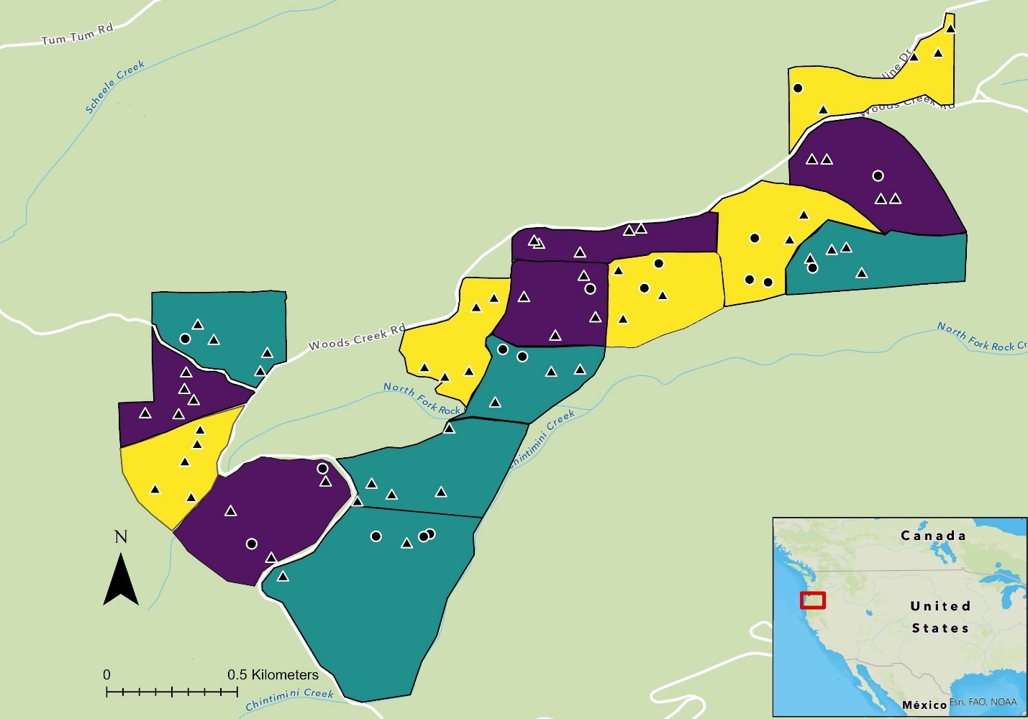
Figure 1: Study area was located along Woods Creek Road, within the Siuslaw National Forest in western Oregon, USA (Latitude 44.53263, Longitude 123.53433). TMT 1 = no thin (indigo), TMT 2 = light thin (gold), TMT 3 = thin (cyan). Triangles represent plots where LRR was detected (n = 62), circles represent plots where LRR was not detected (n = 13) over the 30-year duration of the study.

2.3 Data collection
Beginning in 1985, the plots were surveyed and each tree within the plot was tagged with a tree identification number. The tree species, diameter at breast height (DBH) measurements, and tree health condition codes were recorded. DBH was taken ~1.37 m from the highest point of the surface of the soil, on the uphill side of the tree. A line had been spray painted at breast height from previous surveys, to ensure consistent measurements were replicated. The breakpoint DBH was 15.24 cm and all ingrown trees that were > 15.24 cm were added to the plots. Tree health conditions were assigned a code from 1 - 4 (1 = healthy, 2 = live tree with symptoms, 3 = dead from C. sulphurascens, 4 = dead not from C. sulphurascens). Windblown trees or stumps were given a code of 4 if signs of LRR were not present. Plots were surveyed in 1990, 1995, 2000, 2009, and 2020.
Confirmation of C. sulphurascens was determined in the field by observation of pitted wood in advanced decay and setal hyphae under a hand lens (Hansen, 1979). If determination could not be identified in the field, suspicious samples were brought back to the lab and grown on malt extract agar (1.5% malt extract, 1.5% Bacto agar) in a low temperature incubator 815 (Precision Scientific Inc., Chicago, IL) at 20°C for 4 - 6 weeks. Confirmation of setal hyphae was later confirmed by viewing under a dissecting microscope.

2. 4 Data cleaning and analysis
Extensive data cleaning and validation was required to identify data entry errors, inconsistencies in variable names or values, to identify missing data, and to make sure that data from different years adhered to the same format. Data was also subset and reshaped (wide to long) and stand-level summary statistics were generated to facilitate statistics and visualization for specific questions such as mean DBH. The data was primarily cleaned in Microsoft Excel and RStudio (v. 1.4.1103, RStudio Team, 2021). First, formatting was done for all years to make the data consistent. Next the sheet was sorted to ensure that there were no measurements included within the data that had < 15.24cm DBH. All data with < 15.24cm DBH were deleted, and a list was made to document all the trees that were removed. There were several large trees that were within the plots and added as part of the 2020 data collection. These trees had not been accounted for during any of the previous years. Any of these trees that were > 25cm were also removed as part of the data cleaning process to account for larger outlier trees that might skew the data. Condition codes for all trees were then recorded if any were missing and could be positively identified from previous/current years or through the notes documented from previous years. Detailed steps of the data cleaning methods can be found here https://mcmurtrs.github.io/WoodsCreek/

Over the course of this study, data were collected on over 1,900 trees with more than 7,500 tree measurements being recorded. For the final analysis, only data from 1990 - 2020 was used, as this was when the thinning treatments had been completed. The reduced dataset included around 1,100 different trees with approximately 4,100 DBH measurements.

2.5 Statistical analysis
A one-way analysis of variance (ANOVA) was conducted to test the main effect of cumulative stand mortality (dead/total) by treatment. A two-way ANOVA was also used to test for an effect of treatment by presence (P) over absence (A) of C. sulphurascens. Cumulative stand mortality was defined as number of confirmed dead trees from LRR over total number of trees within the stand. ANOVA tests were performed in R with packages tidyverse (Wickham, 2017) and ggplot2 (Wickham, 2009).
Cumulative Stand Mortality ~ Treatment + P/A

2. 6 Forest Vegetation Simulator
Individual stand files were each run within FVS version 3261, RV: 2020.10.10, through the graphical user interface. The variant used for all modelled runs was the Pacific Northwest Coast (PN) variant. Cleaned excel files were formatted to work with FVS and converted to a database file using the USFS Sqlite3 database builder website (https://forest.moscowfsl.wsu.edu/FVSDataConvert/). Underlying data errors were initially checked in FVS using the “stand summary data '' option. For the FVS analysis, two comparisons were made; the first comparison involved the observed data compared to a default run in FVS. The second comparison included a comparison of the observed data with the WRDM extension.
The default data run used the data collected from 1990, which included individual tree level, plot level, and stand level data. This data was run with default parameters from 1990-2020 and summarized at the stand level. For the observed data run, data from each year in which data was collected was run within FVS to ensure that algorithms used to make calculations such as basal area or trees per acre were consistent with modelled projections. For the WRDM, initial parameters were used based upon sensitivity analysis and guidance from previous investigators (Maffei et al., 2008; Goheen and Thompson, 1998; Marsden, 1992a; Smith and Zhang ,1997).
For the WRDM, Phellinus root disease was used for the root disease type. The keyword and number for this was RRTYPE = 4. Total stand size projections were estimated from transcribing hand drawn maps into shape files in ArcGIS Pro. The proportion of plots within a stand in which LRR was detected was used as total root disease parameter. This was calculated by multiplying the percentage of plots within the stand where Coniferiporia was found by the total stand size in acres. The keyword RRINT was used for this projection. Number of root disease centers were not readily detected on the ground during the final survey. As a result, all stands were modeled with a value of one for the number of disease centers (Maffei et al., 2008).

Parameters for the RRInit keyword, proportion of roots infected was estimated at a 0.4 overall and used as the standard. This was taking into consideration that 0.1 (10%) is considered light infection and that tree mortality will occur well before 100% of roots become infected depending on the disease type. The proportion of root system infected was estimated but was not based upon any measurements or data collected. Default parameters were used regarding bark beetles considering that the Douglas-fir beetle (Dendroctonus pseudotsugae Hopkins) occurs throughout the extensive range of Douglas-fir (Furniss and Kegley, 2014). Outputs of the modelled data tables were exported from FVS and used within R Studio for downstream analysis. Over 30 separate runs were made using FVS and WRDM for the final analysis. For reproducibility purposes, input data files, output data files, and log files can be found at https://github.com/mcmurtrs/WoodsCreekFVS

3. Results
3.1 Species composition
In 1990, the study area was made up of 82% Douglas-fir trees, 11% western hemlock, and a combination of 7% other species. By the conclusion of this study, 77% were Douglas-fir, 17% were western hemlock, and 6% were other species. Differences between total Douglas-fir basal area from initial to final surveys was 17.3 m²/ha for TMT 1, 15.3 m²/ha for TMT 2, and 17.9 m²/ha for TMT 3 (Table 1). The mean mortality DBH for all trees was 29.7 cm. Mean DBH of all trees was 46.5 cm with a maximum DBH of 165.8 cm belonging to a Douglas-fir tree. The largest western hemlock measured had a DBH of 135 cm.

Table 1: Summary statistics at the stand level for 1990 and 2020. BA = basal area, SD = standard deviation.
 |  | TMT 1 |  |  |  | TMT 2 |  |  |  | TMT 3 |  |  |  | TOTAL
 |  | 1990 |  | 2020 |  | 1990 |  | 2020 |  | 1990 |  | 2020 |  | 1990 |  | 2020
 | Mean | 77 |  | 54.8 |  | 37.2 |  | 28 |  | 28.2 |  | 23.4 |  | 47.47 |  | 35.4
Live Douglas-fir | SD | 37.48 |  | 22.43 |  | 7.5 |  | 9.43 |  | 10.99 |  | 10.78 |  | 30.55 |  | 20.19
 | Total | 385 |  | 274 |  | 186 |  | 140 |  | 141 |  | 117 |  | 712 |  | 531
 | Mean | 10.6 |  | 10.2 |  | 2.8 |  | 5.8 |  | 5.4 |  | 8.4 |  | 6.27 |  | 8.13
Live Western hemlock | SD | 13.63 |  | 10.57 |  | 6.26 |  | 6.69 |  | 7.8 |  | 10.11 |  | 9.64 |  | 8.8
 | Total | 53 |  | 51 |  | 14 |  | 29 |  | 27 |  | 42 |  | 94 |  | 122
 | Mean | 7.6 |  | 4.4 |  | 3 |  | 2.4 |  | 2 |  | 1 |  | 4 |  | 2.6
Live other species | SD | 10.88 |  | 4.34 |  | 5.61 |  | 2.51 |  | 2.55 |  | 1 |  | 7.13 |  | 3.09
 | Total | 38 |  | 22 |  | 15 |  | 12 |  | 10 |  | 5 |  | 60 |  | 39
 | Mean | 95.2 |  | 69.4 |  | 43 |  | 36.2 |  | 35.6 |  | 32.8 |  | 57.93 |  | 46.13
Total  live trees | SD | 25.87 |  | 14.06 |  | 7.07 |  | 7.6 |  | 7.13 |  | 2.86 |  | 31.21 |  | 19.17
 | Total | 476 |  | 347 |  | 215 |  | 181 |  | 178 |  | 164 |  | 869 |  | 692
Total BA of | Mean | 10.6 |  | 14.1 |  | 6.6 |  | 9.7 |  | 6.1 |  | 9.7 |  | 7.8 |  | 11.2
Douglas-fir  (m²/ha) | SD | 2.5 |  | 2.5 |  | 1.3 |  | 2.3 |  | 2.1 |  | 3.1 |  | 2.8 |  | 3.2
 | Total | 53 |  | 70.3 |  | 33.2 |  | 48.5 |  | 30.7 |  | 48.6 |  | 116.8 |  | 167.4
Douglas-fir as proportion | Total | 81% |  | 79% |  | 87% |  | 77% |  | 79% |  | 71% |  | 82% |  | 77%
of total trees

3.2 Statistical analysis
There were no significant effects found in any of the statistical models for proportion of mortality (arcsine transformed). The one-way analysis of variance showed no significance of effect on treatment (Table 2). There was also no significance found when the two thinned treatment areas were combined and compared against the control stands. Within the two-way analysis of variance, no significance was found from tree mortality induced by C. sulphurascens across treatment areas.

Table 2: A one way ANOVA testing whether there was an effect on tree mortality from LRR determined by treatment.
Source of Variation | Degrees of Freedom | Sum of Squares | Mean Square | F | p-Value
Treatment | 2 | 0.01048 | 0.00524 | 0.484 | 0.629
Residuals | 12 | 0.12985 | 0.01082

3.3 Prevalence rate of root disease
Within every stand, the prevalence of root disease increased over time (Fig. 2). At the conclusion of the study, the proportion of total tree mortality from LRR was less in control stands when compared to stands where thinning occurred. Total tree mortality from LRR in TMT 1 stands was 25.4% (n = 92/361), 36.9% (n=72/195) in TMT 2, and 34.8% (n = 60/172) in TMT 3. These values were calculated by taking cumulative LRR mortality from 1990 – 2020 over total live tree counts from 2020.

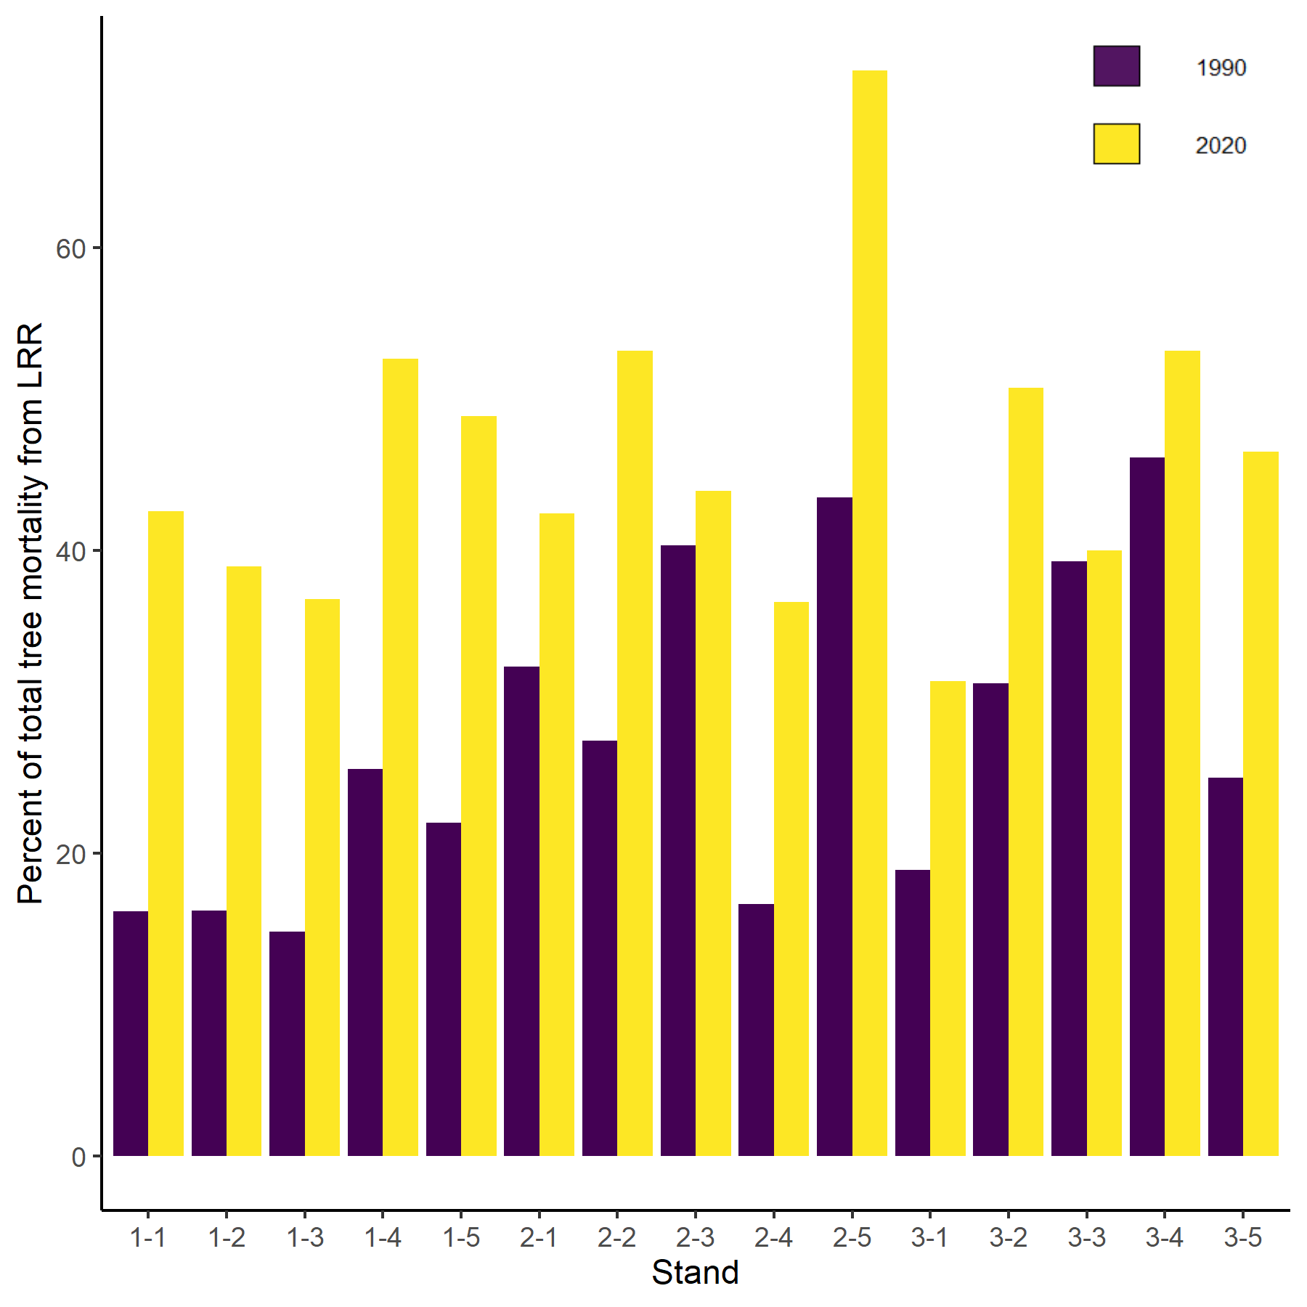
Figure 2: Proportion of tree mortality by stand occurring from LRR at initial and final time points. The beginning number of stand values represents which treatment each stand was in.

LRR was found within at least 40% of the plots in all 15 of the total stands. In two of the TMT 1 stands, two of the TMT 2 stands, and one of the TMT 3 stands, it had been found within 100% of the plots by the conclusion of the study. When the plots were established in 1985, LRR was present within 59% (n = 44/75) of the plots. By the end of the study, it had been found within 83% (n=62/75) of the plots (Table 3).

Table 3: Mean basal area (m²/ha) from final survey in 2020 (observed) and projections made using FVS and WRDM. The last column represents percentage of plots by treatment area in which LRR was found over the duration of the study.

Treatment | Observed | FVS | WRDM | Confirmed LRR
TMT 1 | 78.62609 | 78.92028 | 74.95442 | 92% (n = 23/25)
TMT 2 | 52.24491 | 53.50427 | 51.62076 | 80% (n = 20/25)
TMT 3 | 61.32342 | 58.64272 | 56.66864 | 76% (n = 19/25)
Total | 192.19442 | 191.06727 | 183.24382 | 83% (n = 62/75)

3.3 Forest Vegetation Simulator and Western Root Disease Models
Within the results of the modeled data, the mean values of the measured data were found to correspond more closely to the FVS model run that was made using default parameters. The data determined by the WRDM simulation, was not found to be as accurate as the FVS model but was not statistically significant (Figure 3 and Table 3).
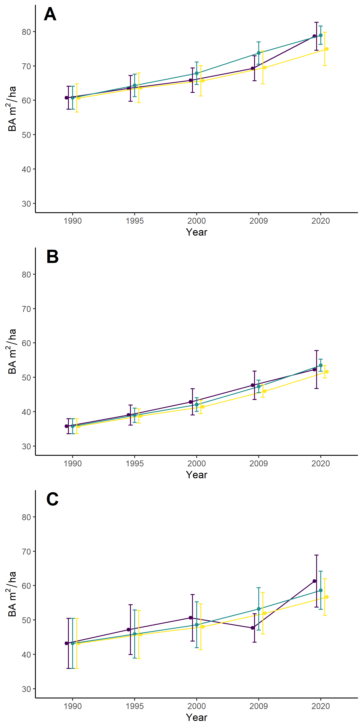
Figure 3: Definitive data compared with modelled data depicting mean basal area of the 15 stands. A = TMT 1 stands, B = TMT 2 stands, C = TMT 3 stands. The indigo line represents observed data that was collected through surveys. The cyan line depicts the FVS model with default parameters. The gold line is the FVS model run with the WRDM extension. Error bars are representative of the standard error.

4. Conclusions and discussion
From the results of this study, three important conclusions were made. Firstly, the effects of the thinning did not seem to have a significant difference within tree mortality caused by C. sulphurascens. Secondly, the proportion of tree mortality caused by C. sulphurascens in thinned stands was higher when compared to unthinned stands. Lastly, on average, FVS and the WRDM predicted lower growth and yield volumes when compared with observed data.

This is the paragraph about the ANOVA and statistical analysis but I don’t really know what to say about it. It is noteworthy that although all statistical tests showed no signs of significance, future studies might… (assess linear regression models, design studies with statistical analysis in mind?).

The proportion of mortality from C. sulphurascens was found to be higher in thinned stands when compared to stands where no thinning occurred. This is consistent with other studies that have shown that changes within forest structure from timber harvesting often increases root disease activity (Cleary et al., 2013; Fairweather et al., 2006; Morrison et al., 1991). Additionally, selective logging and changes in forest landscapes that have occurred from fire suppression efforts, often lead to an increase in host tree species that are more prone to root disease (Fairweather et al., 2006).
Modelled predictions were found to be qualitatively accurate within this study.
FVS alone was a better indicator of observed data when compared to the use of FVS with WRDM. The WRDM tended to over predict the impact of LRR. This finding was consistent with the findings from Maffei et al., 2008. It is worth noting that accuracy would likely continue to decrease over longer time periods. The time span of 30 years is relatively short in terms of a forest ecosystem. Varying results are also expected to occur dependent upon more or less stringent root disease settings used to initialize the WRDM (i.e. hectares of root disease area or number of infected trees). It should also be taken into consideration that the low percentages of differences in growth and yield might be significant if applied to larger stand sizes.

Whereas other studies conducted analyzing different forest models have predicted
relatively optimistic trends (Canavan and Ramm, 2000; Woods and Watts, 2019), the
results of this study were converse. Models depicting optimistic
trends don’t always account for amounts of inoculum within the soil, rate of disease
spread, or expected tree loss. There are also many alternate compounding variables
that influence forest health, disease spread, and tree mortality, such as
temperature, soil moisture, and pH levels (Lattin 1998; Angwin, 1985; Hansen et al.,
1983). These variables have not been adequately accounted for within
this study. Further reproducible studies are needed to better understand FVS and WRDM calibrations, and to assist with refining parameterization and initializing the models for similar forest stands (Maffei et al., 2008).

There is much uncertainty related to global environmental change and the effects it might have on forest pathogens. Management strategies such as the impacts of thinning on LRR, have not been adequately studied, and should continue to be investigated with the use of conventional forestry measurements (Cook et al., 2013). More information on current distribution of accurately identified pathogens is critically needed (Klopfenstein et al., 2009). This is imperative within a rapidly changing climate as the host/pathogen interactions will need to be observed, monitored, and adaptations will need to be made to deviations of what was once considered more consistent management.

Guidelines drawn up from publications can serve as a basis for facilitating better management of infected stands. Better understanding of management systems surrounding LRR can help to increase efficiency, while also helping to preserve biodiversity and forest ecosystems. Through this study, new insight was gained on LRR incidence with respect to thinning for drought and fire suppression.

Acknowledgements
Funding was provided by the _________________. Funding was also provided by the Agricultural Research Foundation at Oregon State University. The authors would like to thank Wendy Sutton, Paul Reeser, and all others responsible for establishing the plot network and helping to collect data over the years. We also like to thank Katherine Tallan and James Molyneux for statistical recommendations and consultation. The authors also extend their gratitude to Irene Lockman, Patrick Bennett, Lance David, Erin Smith-Mateja, Chad Keyser, and the FVS staff for guidance on FVS and WRDM modeling.

References
Agee J.K, and Skinner C.N. (2005). Basic principles of forest fuel reduction treatments.
For. Ecol. Manage., 211 (1) , pp. 83-96. https://doi.org/10.1016/j.foreco.2005.01.034

Angwin, P. A. (1985). Environmental factors influencing the rate of spread of Phellinus weirii(Murr.) Gilbertson in young-growth Douglas fir. Oregon State University, Corvallis, Oregon, master’s thesis. 107 p., https://ir.library.oregonstate.edu/concern/graduate_thesis_or_dissertations/k930c098s

Bennett, P.I., Tabima, J.F., Leon A.L., Browning J., Wingfield M.J. and LeBoldus J.M. (2021). Spatial Genetic Structure of the Insect-Vectored Conifer Pathogen Leptographium wageneri Suggests Long Distance Gene Flow Among Douglas-fir Plantations in Western Oregon. Front. For. Glob. Change 4:695981. https://doi.org/10.3389/ffgc.2021.695981

Bloomberg, W. J., Cumberbirch, P. M., and Wallis, G. W. (1980). A ground survey method for estimating loss caused by Phellinus weirii root rot, Can. For. Serv. Pacific For. Res. Cent., Victoria, B C. (BC-R-3; BC-R-4).

Canavan, S. J., & Ramm, C. W. (2000). Accuracy and precision of 10 year predictions for Forest Vegetation Simulator—Lake States. Northern Journal of Applied Forestry, 17(2), 62-70 pp.

Cleary, M. R., Arhipova, N., Morrison, D. J., Thomsen, I. M., Sturrock, R. N., Vasaitis, R., ... and Stenlid, J. (2013). Stump removal to control root disease in Canada and Scandinavia: A synthesis of results from long-term trials. Forest Ecology and Management, 290, 5-14 pp. https://doi.org/10.1016/j.foreco.2012.05.040

Cook, R. J., Edmonds, R. L., Klopfenstein, N. B., Littke, W., McDonald, G., Omdahl, D., ... and Zambino, P. (2013). Opportunities for addressing laminated root rot caused by Phellinus sulphurascens in Washington's forests: A Report from the Washington State Academy of Sciences in cooperation with the Washington State Department of Natural Resources. Olympia, WA: Washington State Academy of Sciences, p. 110. https://www.fs.usda.gov/treesearch/pubs/46886
ESRI (2011) ArcGIS desktop: version 2.6.2 [computer software]. Environme91ntal Systems Research Institute, Redlands, California.

Fairweather, M. L., McMillin, J., Rogers, T., Conklin, D., Fitzgibbon, B. (2006). Field guide to insects and diseases of Arizona and New Mexico forests. USDA Forest Service, Southwestern Region. https://www.fs.usda.gov/Internet/FSE_DOCUMENTS/fsbdev3_020984.pdf

Frankel, S. J., technical coordinator. (1998). User’s guide to the Western Root Disease Model, version 3.0. Gen. Tech. Rep. PSW-GTR-165. Albany, CA: Pacific Southwest Research Station, Forest Service, U.S. Department of Agriculture. 166 p. https://doi.org/10.2737/PSW-GTR-165

Franklin J.F. and Johnson K.N. (2012). A restoration framework for federal forests in the Pacific Northwest. J. Forest., 110 (2012), pp. 429-439. https://doi.org/10.5849/jof.10-006

Furniss, M. M. and Kegley, S. J. (2014). Forest Insect and Disease Leaflet 5. US Department of Agriculture, Forest Service.

Goheen, D. J., and Otrosina, W. J. (1998). Characteristics and consequences of root diseases in forests of western North America. In: Frankel, Susan J., tech. coord. User’s guide to the western root disease model, version 3.0. Gen. Tech. Rep. PSW-GTR 165. Albany, CA: US Department of Agriculture, Forest Service, Pacific Southwest Station: 3-8 p. https://www.fs.usda.gov/treesearch/pubs/1087

Hadfield, J. S., and Region., (1985). Laminated root rot : a guide for reducing and preventing losses in Oregon and Washington forests (Vol. 1985). [Portland, Or.] : U.S. Dept. of Agriculture, Forest Service, Pacific Northwest Region. 13 p. https://www.biodiversitylibrary.org/bibliography/178892
Hadfield, J. S., Goheen, D. J., Filip, G. M., Schmitt, C. L., Harvey, R.D., (1986). Root diseases in Oregon and Washington conifers. Portland, OR: USDA Forest Service, Pacific Northwest Region. 27 p. https://www.fs.usda.gov/detail/r6/forest-grasslandhealth/?cid=fsbdev2_027376
Hagle, S. K., Tunnock, S. T., Gibson, K. E., Gilligan, C. J., (1987). Field Guide to Diseases and Insect Pests of Idaho and Montana Forests. United States: U.S. Department of Agriculture, Forest Service, State and Private Forestry, Northern Region. 123 p.

Hanna, J., Warwell, M. V., Maffei, H., Fairweather, M. L., Blodgett, J. T., Zambino, P. J., ... and Klopfenstein, N. (2016). Bioclimatic modeling predicts potential distribution of Armillaria solidipes and Pseudotsuga menziesii (Douglas-fir) under contemporary and changing climates in the interior western USA. In In: Ramsey, Amy; Palacios, Patsy, comps. Proceedings of the 63rd Annual Western International Forest Disease Work Conference; September 21-25, 2015; Newport, OR. Olympia, WA: Washington Department of Natural Resources; Logan, UT: Utah State University, Quinney College of Natural Resources. p. 117-123. https://www.fs.usda.gov/treesearch/pubs/52098

Hansen, E. M. (1979). Survival of Phellinusweirii in Douglas-fir stumps after logging. Canadian Journal of Forest Research. 9(4): 484-488. https://doi.org/10.1139/x79-078

Hansen, E. M., Reynolds K., Angwin P., (1983). Factors influencing the spread of Phellinus weirii in Douglas-fir. Proc. 6th mt. Conf. On Root and Butt Rots in Forest Trees. Melbourne, Victoria, Gympie, Australia.

Hansen, E. M., and Goheen, E. M. (2000). Phellinus weirii and other native root pathogens as determinants of forest structure and process in western North America. Annual review of phytopathology, 38(1), 515-539. http://dx.doi.org/10.1146/annurev.phyto.38.1.515

Healey, S. P., Raymond, C. L., Lockman, I. B., Hernandez, A. J., Garrard, C., and Huang, C. (2016). Root disease can rival fire and harvest in reducing forest carbon storage. Ecosphere, 7(11), e01569. https://doi.org/10.1002/ecs2.1569

Klopfenstein, N. B., Kim, M.-S.; Hanna, J. W.; Richardson, B. A.; Lundquist, J. E. (2009). Approaches to predicting potential impacts of climate change on forest disease: an example with Armillaria root disease. Res. Pap. RMRS- RP-76. Fort Collins, CO: U.S. Department of Agriculture , Forest Service, Rocky Mountain Research Station . 10 p. https://www.fs.fed.us/rm/pubs/rmrs_rp076.pdf

Lan, Y. H., Shaw, D. C., Beedlow, P. A., Lee, E. H., and Waschmann, R. S. (2019). Severity of Swiss needle cast in young and mature Douglas-fir forests in western Oregon, USA. Forest ecology and management, 442, 79-95 p. https://doi.org/10.1016/j.foreco.2019.03.063

Lattin, P.D. 1998. Spatial analysis of Phellinus wierii infection centers in the Central Cascades of Oregon: Inferring ecological processes from patterns. M.S. Thesis Oregon State University.

Law, B. E., Hudiburg, T. W., and Luyssaert, S. (2013). Thinning effects on forest productivity: consequences of preserving old forests and mitigating impacts of fire and drought. Plant Ecology and Diversity, 6(1), 73-85. https://doi.org/10.1080/17550874.2012.679013

Lawson, T. T., Berg, A. B., & Hansen, E. M. (1983). Damage from laminated root rot at the Black Rock Forest Management Research Area in western Oregon.

Leal I., Bergeron, M. J., Feau, N., Tsui, C. K. M., Foord, B., Pellow, K., ... and Sturrock, R. N. (2019). Cryptic Speciation in Western North America and Eastern Eurasia of the Pathogens Responsible for Laminated Root Rot. Phytopathology, 109(3), 456-468.

Lockman, I. B., and Kearns, H. S. (2016). Forest root diseases across the United States. Gen. Tech. Rep. RMRS-GTR-342. Ogden, UT: US Department of Agriculture, Forest Service, Rocky Mountain Research Station. 342. 55 p. https://doi.org/10.1094/PHYTO-12-17-0399-R

Maffei, H. M., Filip, G. M., Chadwick, K. L., and David, L., (2008). Western root disease model simulation versus plot remeasurement: 11 years of change in stand structure and density induced by Armillaria root disease in Central Oregon. In Third Forest Vegetation Simulator Conference: Fort Collins, CO, February 13-15, 2007. US Department of Agriculture, Forest Service, Rocky Mountain Research Station. 55 p. https://www.fs.fed.us/rm/pubs/rmrs_p054/rmrs_p054_055_067.pdf

Marsden, M. A., (1992). Sensitivity of the Western Root Disease Model: inventory of root disease (Vol. 303). USDA, Forest Service, Rocky Mountain Forest and Range Experiment Station.

McKenzie, D., Gedalof, Z. E., Peterson, D. L., and Mote, P. (2004). Climatic change, wildfire, and conservation. Conservation biology, 18(4), 890-902.
https://doi.org/10.1111/j.1523-1739.2004.00492.x

Morrison, D.J., Merler, H., Norris, D., (1991). Detection, Recognition and Management of Armillaria and Phellinus Root Disease in the Southern Interior of British Columbia. Forestry Canada and BC Ministry of Forests, Victoria, BC FRDA Rep. 179.

Morrison, D. J., Cruickshank, M. G., and Lalumière, A. (2014). Control of laminated and Armillaria root diseases by stump removal and tree species mixtures: Amount and cause of mortality and impact on yield after 40 years. Forest ecology and management, 319. 75-98 p. https://doi.org/10.1016/j.foreco.2014.02.007

Mote, P.W., Salathé, E.P (2010). Future climate in the Pacific Northwest. Climatic Change 102, 29–50. https://doi.org/10.1007/s10584-010-9848-z

Nelson, E. E. (1980). Laminated root rot damage in a young Douglas-fir stand [Pseudotsuga menziesii, root rot, Phellinus weirii]. PNW research note-United States Department of Agriculture.

Nelson, E.l E.; Martin, Neil E.; Williams, Ralph E. (1981). Laminated root rot of western conifers. Forest Insect and Disease Leaflet 159. Washington, DC: USDA Forest Service; 6 p.

Norris, C. E., Hogg, K. E., Maynard, D. G., and Curran, M. P. (2014). Stumping trials in British Columbia—organic matter removal and compaction effects on tree growth from seedlings to mid rotation stands. Canadian Journal of Forest Research, 44(11), 1402-1418. https://doi.org/10.1139/cjfr-2014-0168

Peet, F. G., and Hunt, R. S. (2005). A new simulator for the spread of forest root diseases by individual root contacts. Forest Science, 51(5), 425-437. https://doi.org/10.1093/forestscience/51.5.425

Pretzsch, H., Grote, R., Reineking, B., Rötzer, T. and Seifert, S. Models for forest ecosystem management: A European perspective. Ann. Bot. 101, 1065–1087 (2008). https://doi.org/10.1093/aob/mcm246

Pretzsch, H., Biber, P., Schütze, G., Uhl, E., and Rötzer, T. (2014). Forest stand growth dynamics in Central Europe have accelerated since 1870. Nature communications, 5(1), 1-10. 10.1038/ncomms5967

PRISM Climate Group, Oregon State University, (2018). https://prism.oregonstate.edu/

RStudio Team (2021). RStudio: Integrated Development Environment for R. RStudio, PBC, Boston, MA. http://www.rstudio.com/

Scharpi, Robert F., technical coordinator. 1993. Diseases of Pacific Coast conifers. Agric. Handb. 521. Washington, DC: Forest Service, U.S. Department of Agriculture; 199 p,l

Skovsgaard and Vanclay, 2008 J.P. Skovsgaard, J.K. Vanclay. 2008. Forest site productivity: a review of the evolution of dendrometric concepts for even-aged stands. Forestry, pp. 13-31. https://doi.org/10.1093/forestry/cpm041

Smith, E.L.; Zhang, S. 1997. Sensitivity analysis of insect and disease model extensions . In : Tech , R.; Moeur, M; Adams, J. , comps. 1997 proceedings ; Forest Vegetation Simulator conference; (1997) February 3–7; Fort Collins, CO. Gen Tech. Rep. INT- GTR-373 . Ogden, UT: U.S. Department of Agriculture, Forest Service, Intermountain Research Station: 213–215. https://www.fs.usda.gov/treesearch/pubs/30958

Soil Survey Staff, (2021). Natural Resources Conservation Service, United States Department of Agriculture, Web Soil Survey. http://websoilsurvey.sc.egov.usda.gov

Sturrock, R. N., and Garbutt, R. W. (1994). Laminated root rot of Douglas-fir. Canadian Forest Service, Forest Insect and Disease Survey, Pacific Forestry Centre.

Teck, R. M., Moeur, M., and Adams, J. (1997). Proceedings: Forest Vegetation Simulator Conference: Fort Collins, CO, February 3-7, 1997 (Vol. 373). US Department of Agriculture, Forest Service, Intermountain Research Station.

Thies, Walter G. 1984. Laminated root rot, the quest for control. Journal of Forestry S2: 345-356.

Thies, W. G., and Sturrock R. N. 1995. Laminated Root Rot in Western North America. U.S. Department of Agriculture, Forest Service, Pacific Northwest Research Station, Portland Oregon, General Technical Report, PNW-GTR-349. Published in cooperation with: Natural Resources Canada, Canadian Forest Service, Pacific Forestry Centre, Victoria, British Columbia.

Tkacz, B. M., and Hansen, E. M. (1982). Damage by laminated root rot in two succeeding stands of Douglas-fir. Journal of Forestry, 80(12), 788-791.

USDA-FS, 2011. Region Five ecological restoration: leadership intent. March (2011). U.S. Forest Service, Pacific Southwest Region, Albany, California, USA.
Vernon, M. J., Sherriff, R. L., van Mantgem, P., and Kane, J. M. (2018). Thinning, tree-growth, and resistance to multi-year drought in a mixed-conifer forest of northern California. Forest Ecology and Management, 422, 190-198. https://doi.org/10.1016/j.foreco.2018.03.043

Wallis, G. W. (1976). Phellinus (Poria) weirii root rot: detection and management proposals in Douglas-fir stands (Vol. 12). Canadian Forestry Service, Pacific Forest Research Centre, Department of the Environment.

Wickham, H. (2009). ggplot2: Elegant Graphics for Data Analysis. Springer-Verlag. http://ggplot2.org/

Wickham, H. (2016). ggplot2: Elegant Graphics for Data Analysis. Springer-Verlag New York. ISBN 978-3-319-24277-4, https://ggplot2.tidyverse.org

Wickham, H. (2017). Tidyverse: Easily install and load the “tidyverse”. https://CRAN.R-project.org/package=tidyverse

USDA (1990), Land and Resource Management Plan Siuslaw National Forest. https://www.fs.usda.gov/Internet/FSE_DOCUMENTS/fsbdev7_007057.pdf

Woods, A. J., and Watts, M. (2019). The extent to which an unforeseen biotic disturbance can challenge timber expectations. Forest Ecology and Management, 453, 117558. https://doi.org/10.1016/j.foreco.2019.117558

