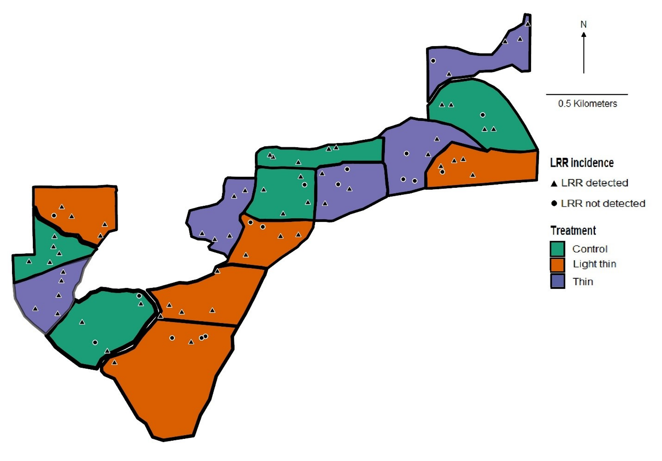
Figure 2.1: The Woods Creek study area was located along Woods Creek Road, within the Siuslaw National Forest in western Oregon. Triangles represent plots where LRR was detected (n = 62), circles represent plots where LRR was not detected (n = 13) over the 30-year duration of the study.

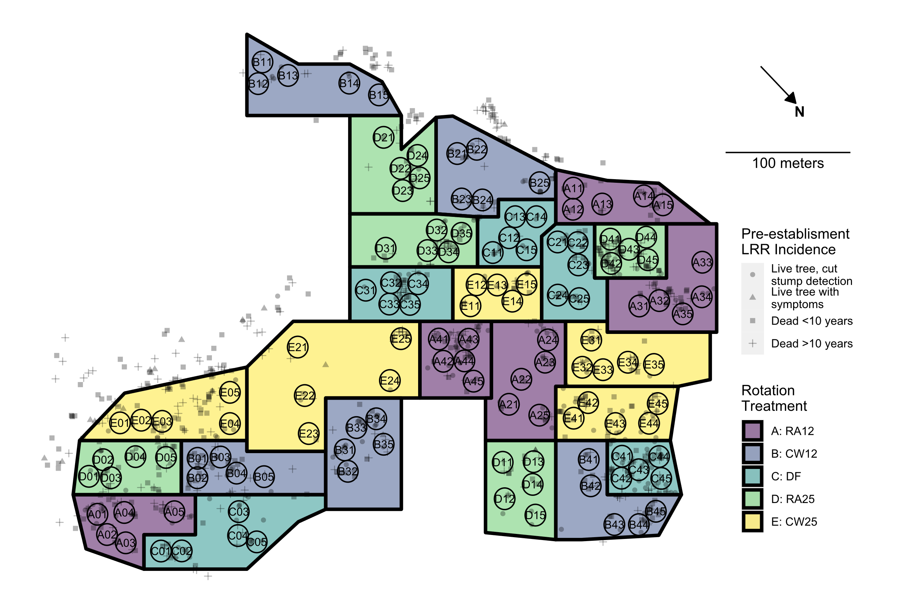
Figure 2.2. Hardwood rotation site near Apiary, OR. Colored polygons delimit plots (experimental units) to which rotation treatments were applied following 1973 clearcut of site: Purple (A), 12-year rotation with red alder before replanting Douglas-fir; Blue (B), 12- year rotation with western cottonwood before replanting with Douglas-fir; Aqua (C), immediate replanting of Douglas-fir; Green (D), 25-year red alder; Yellow (E), 25-year wester cottonwood. Black circles denote 8m fixed radius measurement subplots. Letter and two numerical digits within each plot indicate treatment, block, and subplot number. Semitransparent shapes indicate the location and status of trees with LRR symptoms prior to the 1973 clearcut: Cross, tree dead > 10 years with signs of LRR; Square, tree dead < 10 years with signs of LRR; Triangle, live tree showing LRR symptoms; Circle, live tree with symptoms detected only following clear cut.

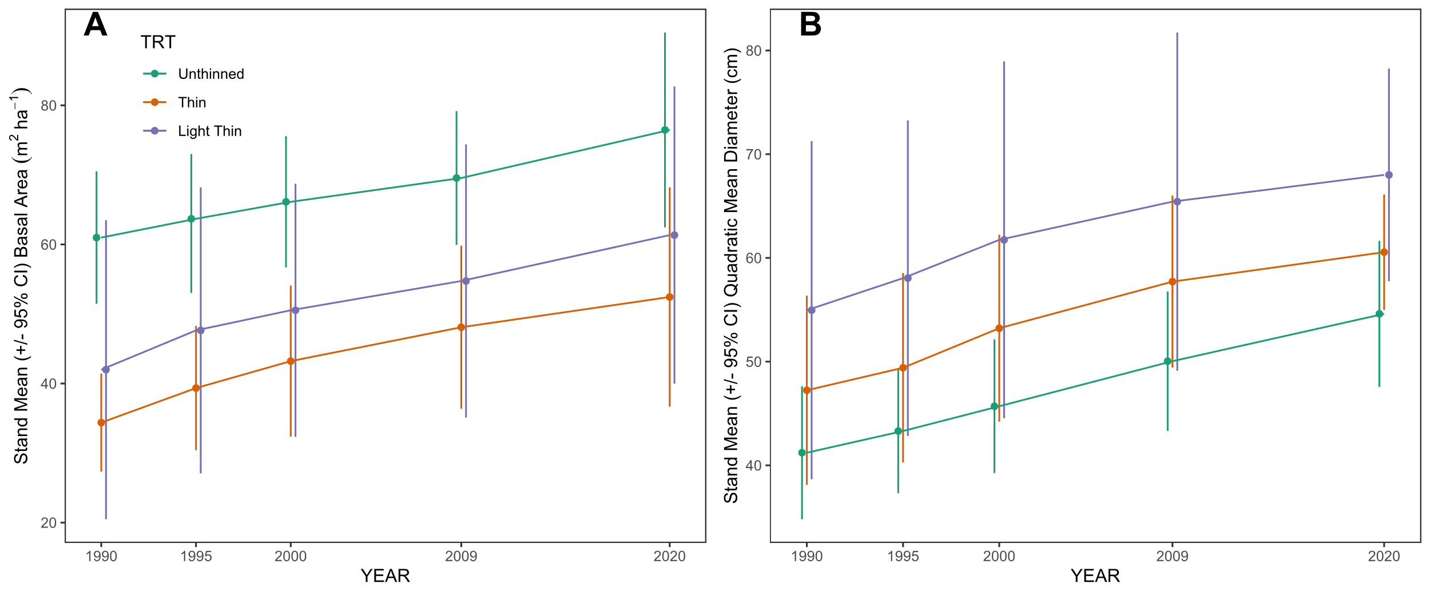
Figure 2.3. (A) Stand mean basal area of the three different treatments over time. (B) Stand mean quadratic mean diameter of the three treatments over time. The error bars are representative of 95% confidence intervals.

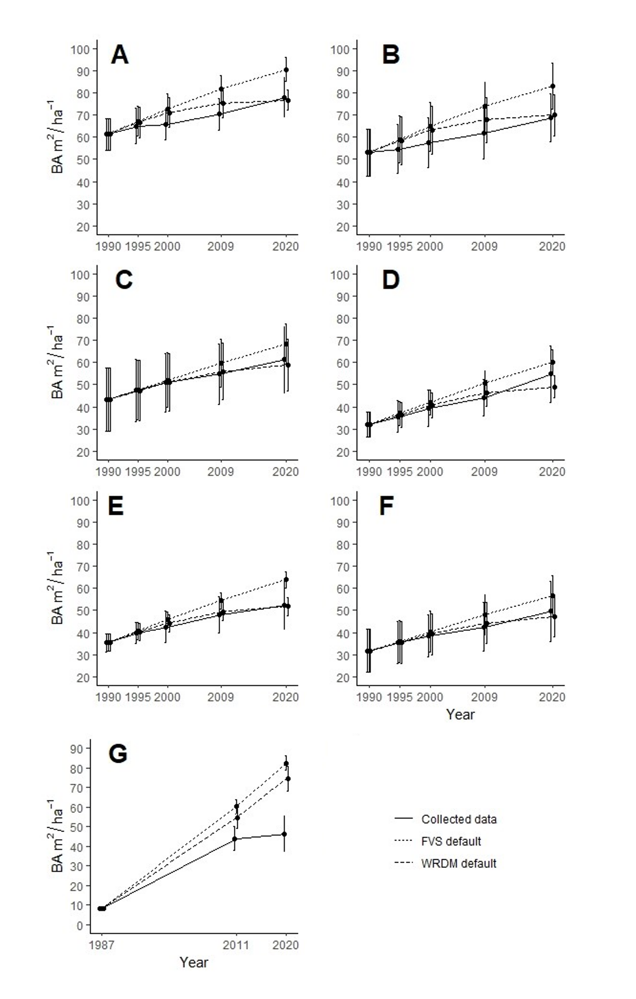
Figure 2.4: Measured data compared with modelled data within FVS and WRDM. (A) Woods Creeks unthinned stands, all species; (B) Woods Creek unthinned stands, DF only; (C) Woods Creek light thin stands, all species; (D) Woods Creek light thin stands, DF only; (E) Woods Creek thin, all species; (F) Woods Creek thin, DF only; (G) Apiary DF only. Error bars are representative of 95% confidence intervals. 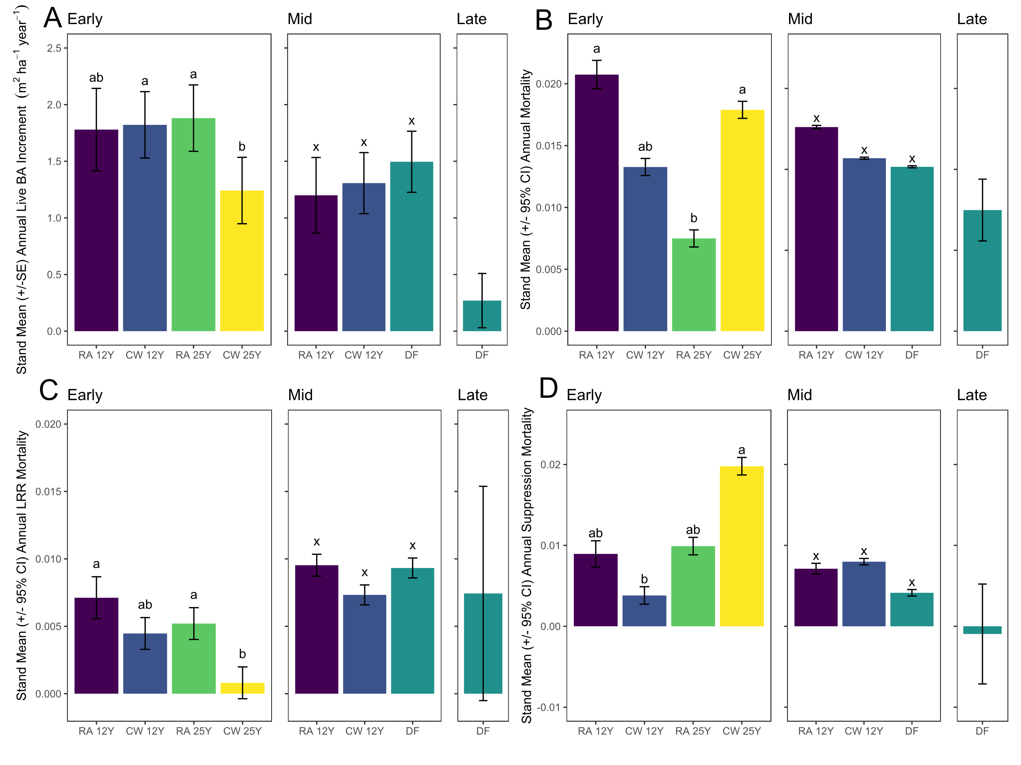

Figure 2.5. (A) Stand mean (+/- 95% CI) annual live BA increment by treatment across early, middle, and late measurement periods in the Apiary study. For all panels purple, 12-year rotation with red alder before replanting Douglas-fir; Blue, 12- year rotation with western cottonwood before replanting with Douglas-fir; Aqua, immediate replanting of Douglas-fir; Green, 25-year red alder; Yellow, 25-year wester cottonwood. Treatment bars with different letters within a panel indicate significant differences by Tukey’s HSD post-hoc test performed on arcsine square root transformed proportions. (B) Stand mean (+/- 95% CI) annual mortality proportion by treatment across early, middle, and late measurement periods in the Apiary study. (C) Stand mean (+/- 95% CI) annual mortality proportion attributed to laminated root rot by treatment across early, middle, and late measurement periods in the Apiary study (D) Stand mean (+/- 95% CI) annual mortality proportion attributed to suppression by treatment across early, middle, and late measurement periods in the Apiary study. Treatment bars with different letters within a panel indicate significant differences by Tukey’s HSD post-hoc test performed on arcsine square root transformed proportions.

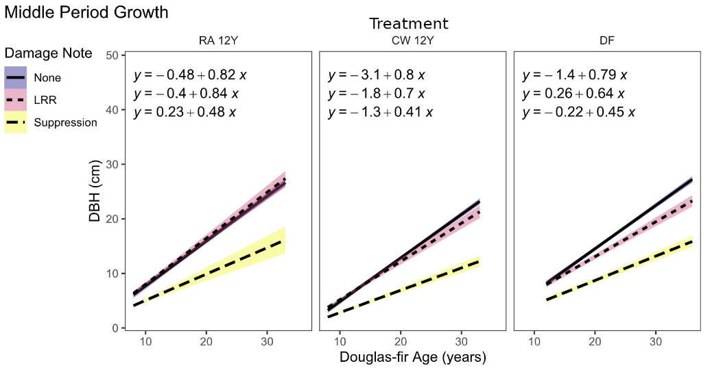

Figure 2.6. Diameter growth of live Douglas-fir over time in continuous Douglas-fir treatment vs 12-year rotation treatments in the middle time period of the Apiary study. Linear regressions are fitted to trees grouped by damage notes recorded at any point during the study.

Table 2.1. Stand ages (years) defining the beginning and end of early, middle and late measurement periods across rotation treatments.
 | Period
Treatment | Early | Middle | Late
RA12, CW12 | 8-24 | 8-33 | NA
DF | NA | 12-36 | 36-45
RA25, CW25 | 11-20 | NA | NA

Table 2.2. Initial and final stand summary statistics for the Woods Creek study. BA = basal area, CI = 95% confidence interval.

 |  | Unthinned |  |  |  | Light thin |  |  |  | Thin |  |  |  | TOTAL
 |  | 1990 |  | 2020 |  | 1990 |  | 2020 |  | 1990 |  | 2020 |  | 1990 |  | 2020
 | Mean | 77 |  | 53.4 |  | 35.6 |  | 28 |  | 28.2 |  | 23.6 |  | 46.9 |  | 35
Live Douglas-fir | CI | 31.3 |  | 23.2 |  | 6.9 |  | 8.2 |  | 9.9 |  | 8.4 |  | 15.2 |  | 10.5
 | Total | 385 |  | 267 |  | 178 |  | 140 |  | 141 |  | 118 |  | 704 |  | 525
Live Western hemlock | Mean | 10.6 |  | 10.2 |  | 2.8 |  | 5.8 |  | 5.4 |  | 8.4 |  | 5.87 |  | 7.62
Live Western hemlock | CI | 11.8 |  | 8.1 |  | 4.0 |  | 6.2 |  | 6.6 |  | 7.7 |  | 4.4 |  | 3.9
Live Western hemlock | Total | 53 |  | 51 |  | 14 |  | 29 |  | 27 |  | 42 |  | 94 |  | 122
Live other species | Mean | 7.6 |  | 3.6 |  | 3 |  | 2.4 |  | 2 |  | 1.2 |  | 4.13 |  | 2.4
Live other species | CI | 7.3 |  | 5.0 |  | 4.4 |  | 0.9 |  | 2.2 |  | 1.1 |  | 3.2 |  | 1.2
Live other species | Total | 38 |  | 18 |  | 15 |  | 12 |  | 10 |  | 6 |  | 63 |  | 36
Total  live trees | Mean | 95.2 |  | 69.4 |  | 43 |  | 36.2 |  | 35.6 |  | 32.8 |  | 18.7 |  | 14.8
Total  live trees | CI | 19.8 |  | 13.8 |  | 8.5 |  | 6.6 |  | 7.1 |  | 6.0 |  | 7.7 |  | 5.5
Total  live trees | Total | 476 |  | 336 |  | 207 |  | 182 |  | 178 |  | 166 |  | 860 |  | 683
Total live BA of | Mean | 9.3 |  | 12.6 |  | 5.43 |  | 9.72 |  | 5.9 |  | 9.5 |  | 6.9 |  | 10.6
Douglas-fir  (m²ha⁻¹) | CI | 1.08 |  | 3.52 |  | 0.71 |  | 1.33 |  | 1.8 |  | 1.8 |  | 1.0 |  | 1.4
Douglas-fir as percentage | Total | 81% |  | 79% |  | 86% |  | 77% |  | 79% |  | 71% |  | 82% |  | 77%
of total trees

Table 2.3: A two-way ANOVA testing effects of block and thinning treatment on total tree mortality from LRR.
Source of Variation | df | Sum of Squares | Mean Square | F | p-Value
Block | 4 | 0.063847 | 0.0159617 | 1.0795 | 0.4274
Treatment | 2 | 0.000550 | 0.0002751 | 0.0186 | 0.9816
Residuals | 8 | 0.118286 | 0.0147858

Table 2.4: Results of two-way ANOVAs testing effects of block and thinning treatment on initial and final stand basal area and annuals basal area increment. Asterisk indicates significant difference (p < 0.05).
 |  | 1990 BA |  | 2020 BA |  | BA increment
Source of Variation | df | F | p-Value | F | p-Value | F | p-Value
Block | 4 | 0.8130 | 0.5509 | 1.6000 | 0.26460 | 11.2602 | 0.002275*
Treatment | 2 | 6.8606 | 0.0184* | 4.6041 | 0.04671* | 1.1213 | 0.372141
Residuals | 8

Table 2.5: Stand level summary statistics for the Apiary study. 95CI = 95% Confidence Interval.

 |  | 12y Red Alder |  |  |  |  | 12y Cottonwood |  |  |  |  | 25y Red Alder |  |  |  |  | 25y Cottonwood |  |  |  |  | Immediate Douglas-fir
Live  stems | Year | 1987 | 1995 | 2011 | 2020 |  | 1987 | 1995 | 2011 | 2020 |  | 1987 | 1995 | 2011 | 2020 |  | 1987 | 1995 | 2011 | 2020 |  | 1987 | 1995 | 2011 | 2020
Live  stems | Age | NA | 8 | 24 | 33 |  | NA | 8 | 24 | 33 |  | NA | NA | 11 | 20 |  | NA | NA | 11 | 20 |  | 12 | NA | 36 | 45
Live  stems | mean | NA | 163.0 | 106.7 | 57.0 |  | NA | 161.4 | 127.0 | 74.6 |  | NA | NA | 131.6 | 121.0 |  | NA | NA | 164.8 | 132.6 |  | 157.6 | NA | 73.2 | 55.6
Live  stems | 95CI | NA | 11.4 | 24.1 | 6.6 |  | NA | 7.6 | 16.1 | 19.2 |  | NA | NA | 32.6 | 28.2 |  | NA | NA | 27.1 | 15.6 |  | 21.4 | NA | 13.2 | 11.3
Live  stems | Total | NA | 489 | 320 | 171 |  | NA | 807 | 635 | 373 |  | NA | NA | 658 | 605 |  | NA | NA | 824 | 663 |  | 788 | NA | 366 | 278
Basal area (m²ha⁻¹)
Basal area (m²ha⁻¹) | mean | NA | 4.7 | 33.9 | 33.3 |  | NA | 1.4 | 30.6 | 34.1 |  | NA | NA | 10.8 | 27.8 |  | NA | NA | 7.9 | 19.1 |  | 8.1 | NA | 44.0 | 46.4
Basal area (m²ha⁻¹) | 95CI | NA | 2.1 | 9.5 | 3.0 |  | NA | 0.8 | 9.5 | 12.0 |  | NA | NA | 2.5 | 5.1 |  | NA | NA | 1.8 | 4.1 |  | 1.5 | NA | 8.7 | 12.7

Tables 2.6. ANOVA and likelihood ratio test statistics and probabilities for linear (mixed) models of block and treatment effects on annual basal area growth (m²ha⁻¹year⁻¹), total proportional mortality, and cause specific proportional mortalities across early, middle, and late measurement periods. *Test statistic: random effect of block= LRT; fixed effect of treatment = F. Probabilities <0.05 in bold. Mixed effect models for variables without test statistics for block effect did not converge and thus linear models of the fixed effect of treatment only were fitted.
 | Annual BA increment |  |  |  | Annual total mortality |  |  |  | Annual LRR mortality |  |  |  | Annual suppression mortality
 |  | Test |  |  |  | Test |  |  |  | Test |  |  |  | Test
Source | df | stat* | p |  | df | stat* | p |  | df | stat* | p |  | df | stat* | p
EARLY
Block | 1 | 1.112 | 0.292 |  | NA | NA | NA |  | 1 | 6.492 | 0.011 |  | 1 | 3.017 | 0.082
Treatment
(A, B, D, E) | 3 | 6.098 | 0.008 |  | 3 | 3.71 | 0.037 |  | 3 | 5.811 | 0.009 |  | 3 | 9.269 | 0.001
Error | 13 |  |  |  | 13 |  |  |  | 13 |  |  |  | 13
MIDDLE
Block | 1 | 0.62 | 0.431 |  | NA | NA | NA |  | 1 | 10.29 | 0.001 |  | NA | NA | NA
Treatment
(A, B, D, E) | 2 | 1.641 | 0.253 |  | 2 | 2.113 | 0.172 |  | 2 | 1.969 | 0.2 |  | 2 | 2.107 | 0.172
Error | 8 |  |  |  | 10 |  |  |  | 8 |  |  |  | 10

Table 2: C. sulphurascens isolate metadata.
Isolate | Host | Origin | Date Collected | Latitude | Longitude | Collector
A-2 | P. menziesii | Apiary, OR, USA | 2/1/2020 | 46.0026361 | -123.081297 | LeBoldus J.
A-3 | P. menziesii | Apiary, OR, USA | 2/1/2020 | 46.00285 | -123.0827 | LeBoldus J.
AP01 | P. menziesii | Apiary, OR, USA | 10/1/2020 | 46.0017333 | -123.07755 | McMurtrey S., Leon A., Browning J., LeBoldus J.
AP07 | P. menziesii | Apiary, OR, USA | 10/1/2020 | 46.0019667 | -123.07805 | McMurtrey S., Leon A., Browning J., LeBoldus J.
AP09 | P. menziesii | Apiary, OR, USA | 10/1/2020 | 46.0020333 | -123.078217 | McMurtrey S., Leon A., Browning J., LeBoldus J.
AP12 | P. menziesii | Apiary, OR, USA | 10/1/2020 | 46.0036333 | -123.081383 | McMurtrey S., Leon A., Browning J., LeBoldus J.
AP14 | P. menziesii | Apiary, OR, USA | 10/1/2020 | 46.0036667 | -123.081233 | McMurtrey S., Leon A., Browning J., LeBoldus J.
AP15 | P. menziesii | Apiary, OR, USA | 10/1/2020 | 46.0035667 | -123.081383 | McMurtrey S., Leon A., Browning J., LeBoldus J.
AP23 | P. menziesii | Apiary, OR, USA | 10/1/2020 | 46.00175 | -123.0822 | McMurtrey S., Leon A., Browning J., LeBoldus J.
AP27 | P. menziesii | Apiary, OR, USA | 10/1/2020 | 46.0015167 | -123.0808 | McMurtrey S., Leon A., Browning J., LeBoldus J.
AP29 | P. menziesii | Apiary, OR, USA | 10/1/2020 | 46.0015667 | -123.080617 | McMurtrey S., Leon A., Browning J., LeBoldus J.
AP31 | P. menziesii | Apiary, OR, USA | 10/1/2020 | 46.002 | -123.07975 | McMurtrey S., Leon A., Browning J., LeBoldus J.
AP36 | P. menziesii | Apiary, OR, USA | 10/1/2020 | 46.00193 | -123.07745 | McMurtrey S., Leon A., Browning J., LeBoldus J.
Mat 763-2 | P. menziesii | Matlock, WA, USA | 3/29/1991 | 47.237884 | -123.407488 | Thies W.
MAT91 1-13 | P. menziesii | Matlock, WA, USA |  |  |  | Thies W.
MAT91 490-3 | P. menziesii | Matlock, WA, USA |  |  |  | Thies W.
MAT91 10-3 | P. menziesii | Matlock, WA, USA |  |  |  | Thies W.
MAT91 1-12 | P. menziesii | Matlock, WA, USA |  |  |  | Thies W.
MAT366-2 | P. menziesii | Matlock, WA, USA | 3/29/1991 |  |  | Thies W.
MAT91 7-2 | P. menziesii | Matlock, WA, USA |  |  |  | Thies W.
MAT91 1-11 | P. menziesii | Matlock, WA, USA |  |  |  | Thies W.
Mat 761-1 (41) | P. menziesii | Matlock, WA, USA |  |  |  | Thies W.
Mat 91 5-11 | P. menziesii | Matlock, WA, USA |  |  |  | Thies W.
Mat91 1021 | P. menziesii | Matlock, WA, USA | 3/29/1991 |  |  | Thies W.
Mat 20-4 (5) | P. menziesii | Matlock, WA, USA |  |  |  | Thies W.
SH9 | P. menziesii | Sweet Home, OR, USA |  |  |  | Hansen E.
SH41 | P. menziesii | Sweet Home, OR, USA |  |  |  | Hansen E.
SH20 | P. menziesii | Sweet Home, OR, USA |  |  |  | Hansen E.
SH40 | P. menziesii | Sweet Home, OR, USA |  |  |  | Hansen E.
SH33 | P. menziesii | Sweet Home, OR, USA |  |  |  | Hansen E.
SH24 | P. menziesii | Sweet Home, OR, USA |  |  |  | Hansen E.
SH21 | P. menziesii | Sweet Home, OR, USA |  |  |  | Hansen E.
SH3 | P. menziesii | Sweet Home, OR, USA |  |  |  | Hansen E.
SH4 | P. menziesii | Sweet Home, OR, USA |  |  |  | Hansen E.
SH7 | P. menziesii | Sweet Home, OR, USA |  |  |  | Hansen E.
SH49 | P. menziesii | Sweet Home, OR, USA |  |  |  | Hansen E.
W-IA2 | T. mertensiana | Waldo Lake, OR, USA |  | 43.74709 | -122.004 | Hansen E.
WIB2 | T. mertensiana | Waldo Lake, OR, USA |  | 43.74783 | -122.004 | Hansen E.
W-IC2 | T. mertensiana | Waldo Lake, OR, USA |  | 43.74779 | -122.003 | Hansen E.
WIIA2 | T. mertensiana | Waldo Lake, OR, USA |  | 43.74793 | -122.006 | Hansen E.
WIIB2 | T. mertensiana | Waldo Lake, OR, USA |  | 43.74855 | -122.005 | Hansen E.
WIVA1 | T. mertensiana | Waldo Lake, OR, USA |  | 43.74822 | -122.002 | Hansen E.
WIIIA1 | T. mertensiana | Waldo Lake, OR, USA |  | 43.74753 | -122.006 | Hansen E.
WIVC3 | T. mertensiana | Waldo Lake, OR, USA |  | 43.74753 | -122 | Hansen E.
W-VE1 | T. mertensiana | Waldo Lake, OR, USA |  | 43.74404 | -121.999 | Hansen E.
WVL2 | T. mertensiana | Waldo Lake, OR, USA |  | 43.74554 | -121.995 | Hansen E.
WIIID2 | T. mertensiana | Waldo Lake, OR, USA |  | 43.74718 | -122.005 | Hansen E.
WVA1 | T. mertensiana | Waldo Lake, OR, USA |  | 43.74565 | -122.003 | Hansen E.
W ID2 | T. mertensiana | Waldo Lake, OR, USA |  | 43.74704 | -122.003 | Hansen E.
WIIB3 | T. mertensiana | Waldo Lake, OR, USA |  | 43.74846 | -122.005 | Hansen E.
MP-11 | P. menziesii | Marys Peak, OR, USA | 08/1991 | 44.536103 | -123.534319
MP1 | P. menziesii | Marys Peak, OR, USA | 11/1984 | 44.535544 | -123.53622 | Angwin P.
MP12 | P. menziesii | Marys Peak, OR, USA | 08/1991 | 44.536208 | -123.53490
MP13 | P. menziesii | Marys Peak, OR, USA | 08/1991 | 44.536044 | -123.534636
MP14 | P. menziesii | Marys Peak, OR, USA | 08/1991
MP15 | P. menziesii | Marys Peak, OR, USA | 08/1991 | 44.535753 | -123.53347
MP17 | P. menziesii | Marys Peak, OR, USA | 08/1991 | 44.535522 | -123.53503
MP19 | P. menziesii | Marys Peak, OR, USA | 08/1991
MP2 | P. menziesii | Marys Peak, OR, USA | 11/1984 | 44.535206 | -123.53583 | Angwin P.
MP5 | P. menziesii | Marys Peak, OR, USA | 08/1991 | 44.534908 | -123.53454
MP6 | P. menziesii | Marys Peak, OR, USA | 08/1991 | 44.535386 | -123.53290
MP8 | P. menziesii | Marys Peak, OR, USA | 08/1991 | 44.535597 | -123.533658
S1S1 | P. menziesii | Marys Peak, OR, USA | 2/6/2020 | 44.5355 | -123.535 | McMurtrey S., Hansen E., LeBoldus J.
MP16 | P. menziesii | Marys Peak, OR, USA |  | 44.535775 | -123.534489

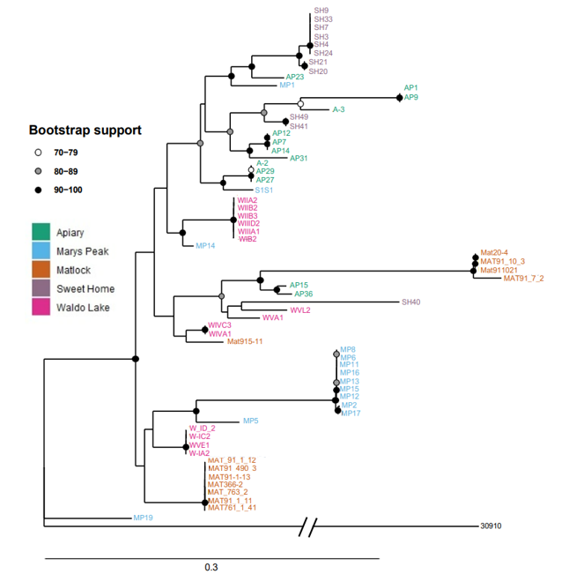

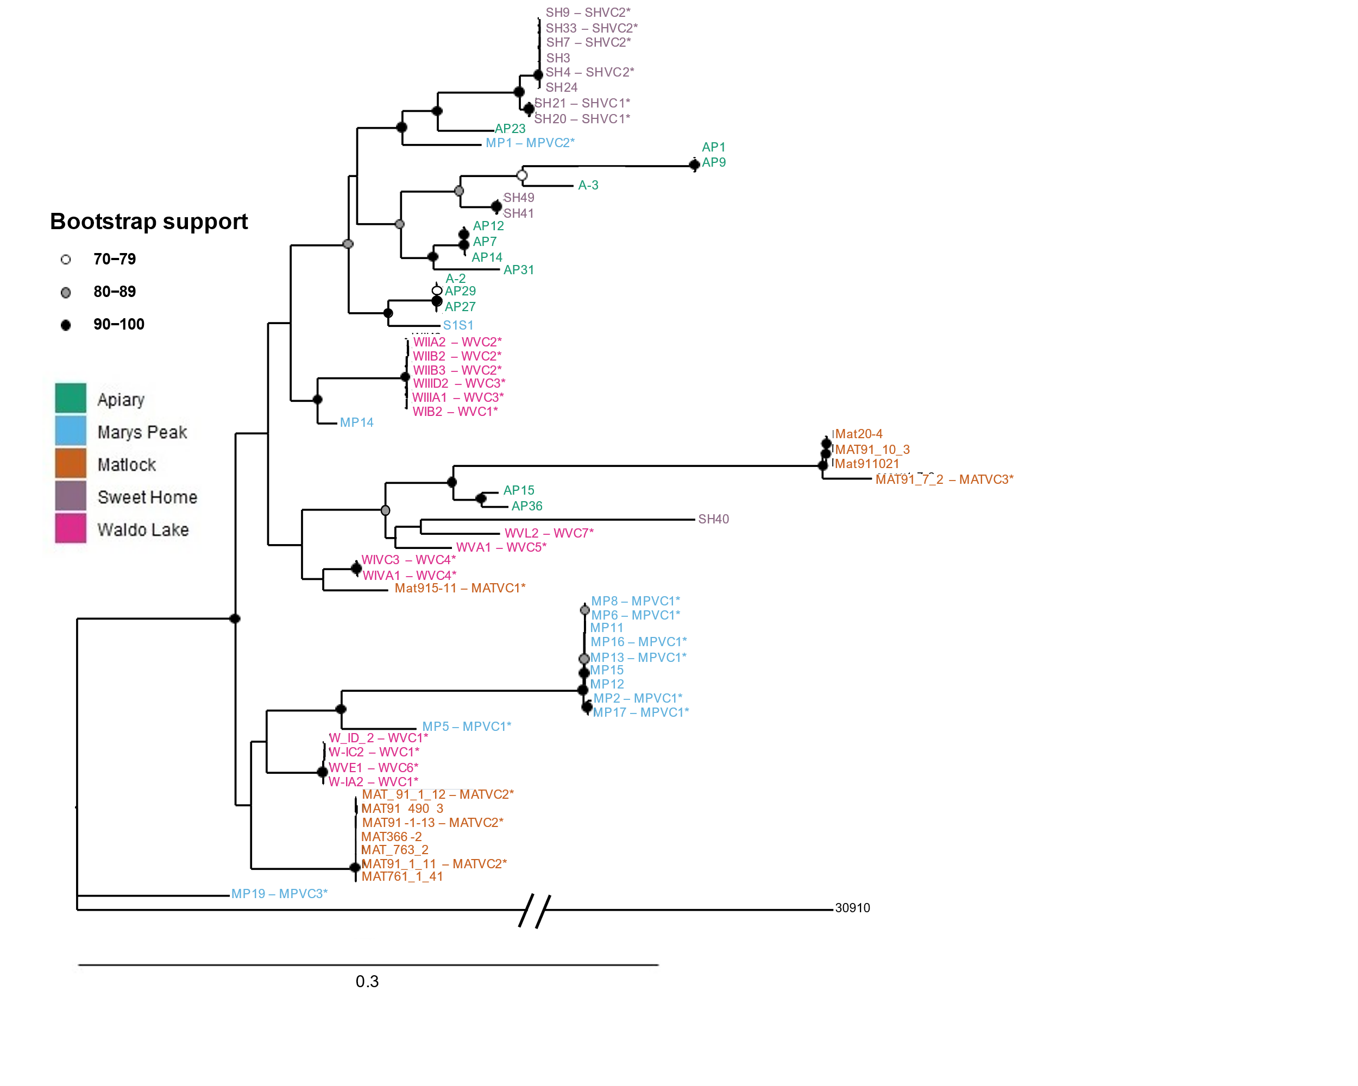
Figure 2: Maximum likelihood phylogenetic tree using SNP data. The tree is rooted using Coniferiporia weirii isolate number 30910 as the outgroup. Samples with asterisk have previously established vegetative combability groups assigned.

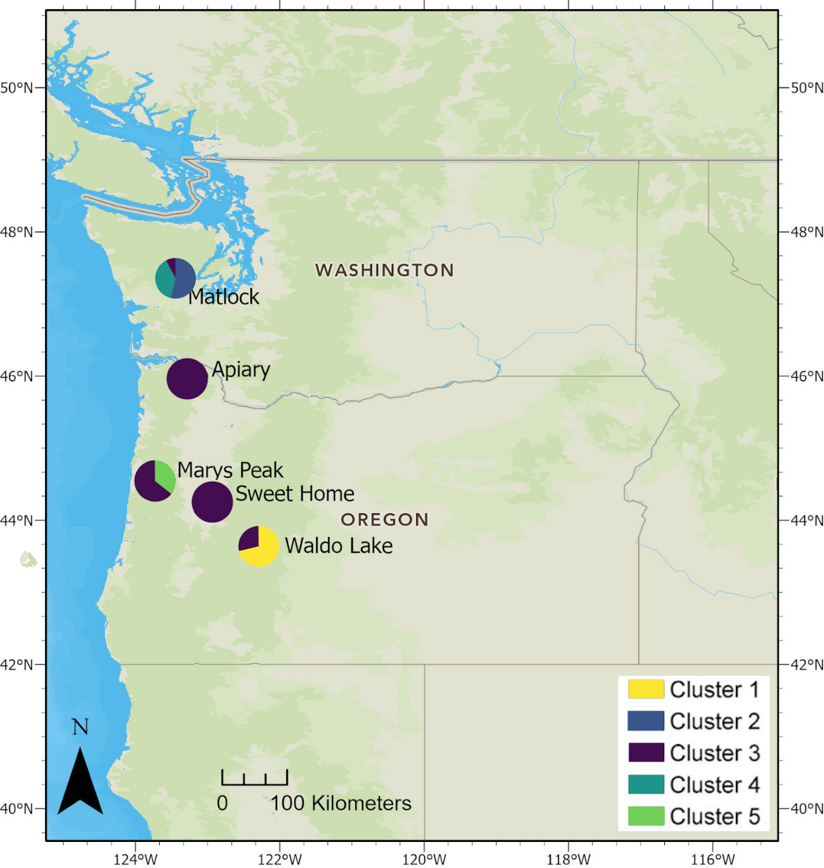

Figure 3: Map of the five populations with pie charts that correspond to the proportion of isolates that belong to each of the five genetic clusters. Genetical clusters were assigned to all Coniferiporia sulphurascens samples using K-means clustering algorithms.

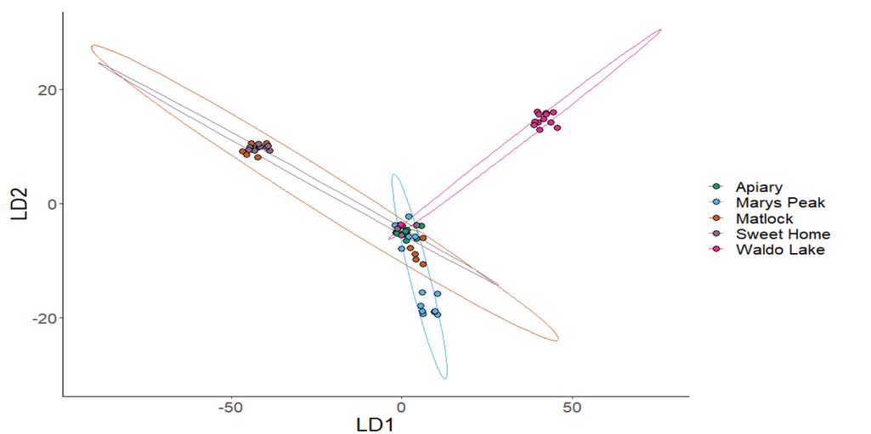
Figure 4: Discriminant analysis of principal components (DAPC) performed with 64 samples. The clusters and ellipses are representative of the five different sampling populations.

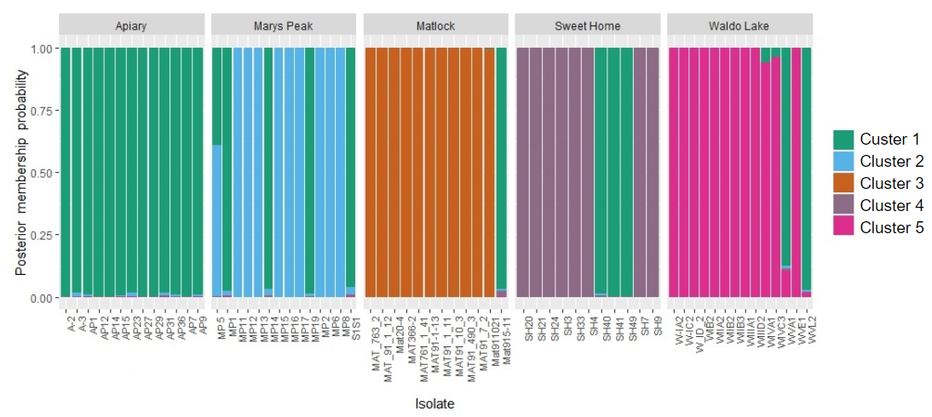

Figure 5: Composite plot showing probability of posterior membership.

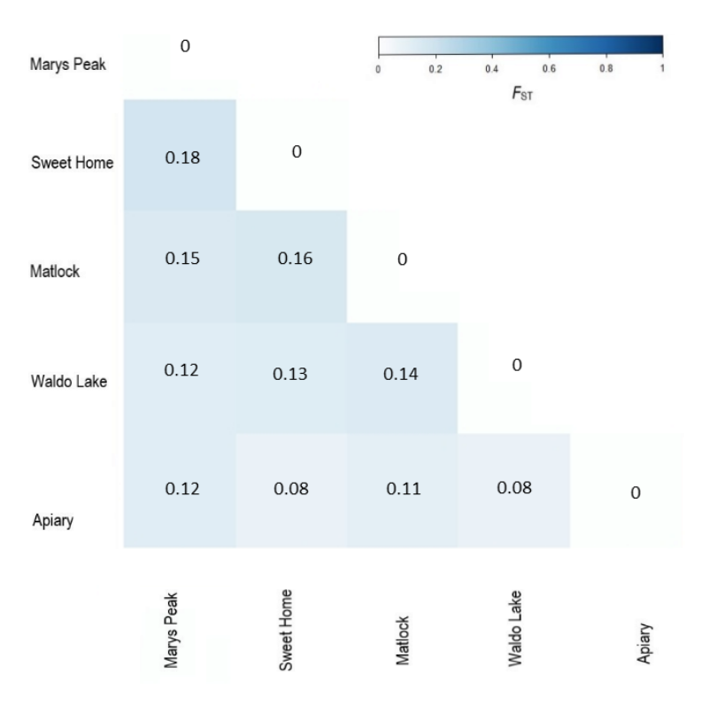
Figure 6: Pairwise F-statistics (F_{ST}) values for the five sampling locations.

