2 Limited effects of thinning and hardwood rotations on laminated root rot induced tree mortality in Douglas-fir forests of the Pacific Northwest, USA

Shawn McMurtrey¹, David N. Showalter¹, Adam Carson¹, Anna Leon², John Browning², Michael McWilliams^{1,3}, (Irene) Blakey Lockman⁴, Everett M. Hansen¹, Jared M. LeBoldus^{1,5}

¹Department of Botany and Plant Pathology, Oregon State University, Corvallis, Oregon, USA.
²Weyerhauser Company, Centralia, WA, USA
³Currently: USDA Forest Service, State and Private Forestry, Pacific Northwest Region, Blue Mountains Service Center, La Grande, OR, USA
⁴USDA Forest Service, State and Private Forestry, Pacific Northwest Region, Portland, OR, USA
⁵Department of Forest Engineering, Resources, and Management, Oregon State University, Corvallis, Oregon, USA.

Keywords: Coniferiporia sulphurascens, laminated root rot, forest management, forest pathology, thinning, alternate host rotations, forest vegetation simulator

Abstract
Laminated Root Rot (LRR) caused by the fungal pathogen Coniferiporia sulphurascens is a damaging disease within many Douglas-fir forests of the Pacific Northwest (PNW) of North America. Silvicultural management of these forests in a changing climate may require increased thinning or involve the use of species other than Douglas-fir. Two long-term studies within Oregon, USA provided an opportunity to investigate the effects of these management techniques on disease dynamics in areas of high historical LRR incidence. First, the effects of three thinning prescriptions on tree mortality caused by Coniferiporia sulphurascens were tested on ca. 160 hectares within the Siuslaw National Forest beginning in 1985. The second study evaluated effects of five hardwood rotation treatments on subsequent growth and mortality of planted Douglas-fir across 14 hectares of privately-owned forest in Columbia County beginning in 1975. For both studies, observed data was compared with predictions from the Forest Vegetation Simulator (FVS) and its Western Root Disease Model (WRDM) extension. The first study found no significant of effect of thinning treatment on proportion of mortality, nor, unexpectedly, annual basal area increment. When compared with observed data, the FVS was found to over predict growth, while the WRDM extension was highly consistent with observations. The results of the second study showed no clear overall effect of hardwood rotation treatments on growth or mortality of Douglas-fir. However, the study did show sub-lethal growth effects of LRR infection and suppression, and an increase in mortality and decrease in basal area increment in 45-year-old stands with high LRR incidence. Both FVS and the WRDM extension were found to over predict growth and yield for the small trees in this study. Together, these results suggest that thinning treatments or alternate host rotations used for other silvicultural objectives may not have a strong impact on LRR disease progression at the timescales measured in this study.

1. Introduction
Douglas-fir (Pseudotsuga menziesii (Mirb.)) is a keystone species in the mixed conifer forests of western North America (Cook et al. 2013). In addition to its ecological importance Douglas-fir is a major contributor, in terms of timber harvest, to the economy of the region (McCauley and Cook 1980, Nelson and Hartman 1975 et al.). There are several diseases and insects that impact the management of Douglas-fir. Among them, Coniferiporia sulphurascens (Pilát) L. W. Zhou and Y. C. Dai, a basidiomycete fungus endemic to this region, causes laminated root rot (LRR) (Thies and Sturrock 1995, Leal et al. 2019). Although Douglas-fir is the primary host of C. sulphurascens, many coniferous species are susceptible (Cleary et al. 2013, Thies and Sturrock 1995). Laminated root rot is characterized by specific tree and stand level signs and symptoms with well documented impacts on forest ecosystems (Hansen and Goheen 2010).
Coniferiporia sulphurascens spreads between trees, across root contacts, as ectotrophic mycelia. It penetrates roots through intact bark where it kills the phloem and cambium, initiating decay in the xyelm (Thies 1983, Wallis and Reynolds 1965). Both lignin and cellulose are decayed; however, the fungus preferentially utilizes early wood leading to a characteristic laminated pattern of advanced decay (Lewis 2013, Blanchette 1980). Infected trees may take several years to die, declining slowly overtime (Wallis and Reynolds 1965). Trees eventually fall over when the supporting root system becomes sufficiently weakened, but usually have green crowns. Large trees can have extensive decay columns in the lower stem. The decay is usually less than 1 meter up the bole but may extend up to 4 meters (Thies and Sturrok 1995). As the fungus spreads from tree to tree the mortality front typically advances an average of 30 cm a year (Bloomberg 1985). Mortality increases in Douglas-fir stands from 30-150 years in age resulting in the development of root disease pockets (Childs 1970). The development of these pockets is typically uneven resulting from the distribution of susceptible trees, and the sporadic nature of windthrow and bark beetle outbreaks, killing and toppling trees as the root disease pocket expands.
Laminated root rot is potentially the most ecologically and economically important disease of mixed conifer forests on the west coast of North America (Goheen and Otrosina 1998, Hadfield 1985, Hadfield et al.1986, Hagle et al.1987, Nelson et al.1981, Scharpf 1993, Thies 1984, Thies and Sturrock 1995, Wallis 1976). This disease has significant impacts on species composition, biodiversity, nutrient cycling, and timber harvest (Boyce and Wagg 1953, Cook et al. 2013). The presence of this disease in most western forests is well documented. For example, in British Columbia, more than 80% of the replanted Douglas-fir forest is infested with LRR (Hansen and Goheen 2000, Bloomberg and Reynolds 1985). In seven large surveys in western Oregon, covering a total of 169,000 ha, on average 8.6% (range 4.7% to 16%) of the Douglas-fir plantations are in LRR pockets (Goheen and Hansen 1993, Hansen and Goheen 2000). An average, of 50% of the Douglas-fir trees in these pockets had been killed by C. sulphurascense (Goheen and Hansen 1993, Hansen and Goheen 2000). While much is known about the biology of this fungus, its impact on timber volume in managed stands is unknown (Lawson et al. 1983). Mortality associated with this disease increases the risk of fire due to fuel loading in affected stands (Parker et al. 2006). The large snags and windblown trees serve as a path for surface fires to reach the canopy (Dickman and Cook 1989, Dickman 1992).
Fire frequency and severity are predicted to increase in western North America over the next century as a result of hotter drier summers (Law et al. 2013, Bennett et al. 2021, Mote and Salathé 2010). These warmer and dryer conditions, on average, will produce larger, more frequent, and more extensive fires (McKenzie et al. 2004). In response, forest managers have shifted approaches towards improving ecosystem resilience (Vernon et al. 2018, USDA-FS 2011, Franklin and Johnson 2012). These shifts are being conducted through large-scale fuel reduction operations, focusing on low to mid-canopy reductions in basal area and piled burning (Vernon et al. 2018, Agee and Skinner 2005). Planting alternate host species that are more resistant to changes in climate is another proposed strategy (Subramanian et al. 2015). A major question stemming from these shifts in management is understanding how thinning and host rotations will affect major forest pathogens in both plantation and wildland forests.
The effects of thinning and host rotations for management of LRR are not well understood. Although thinning provides forest products and may remove infected trees that eventually contribute to fuel loads, it may also increase the risk of wind damage to trees with weakened root systems (Vandygriff et al. 2015, Lawson 1979). Red alder (Alnus rubra Bong.) is resistant to infection by C. sulphurascens. This is likely due to the phenolics, and fatty acids produced by red alder (Trappe 1972, Li et al. 1969, Li et al.1970). It has been hypothesized that clear cutting LRR sites and then growing purely red alder might starve out the C. sulphurascens after several decades (Harrington 2006). To date this hypothesis has not been tested.
Long-term forest plot studies are powerful sources of information, yet they are scarce for a variety of reasons (Norris et al. 2014). Manipulative experiments, examining the effects of management on forests dynamics, are even more rare in the literature. However, data from these studies can be used to test the effect of management regimes on forest structure and function and to validate models, which were initially developed to circumvent limited data availability, and used to predict the impact of management on forest dynamics (Pretzsch et al. 2014, Pretzsch et al. 2008). The Forest Vegetation Simulator (FVS) is one such model that is commonly used within the United States Forest Service (USFS) as a tool for developing forest health and management strategies. The Western Root Disease Model (WRDM) is an extension of FVS that is used for investigating the spread of root disease from a below ground perspective (Peet and Hunt 2005). There have been few studies conducted that have used long-term permanent plots to assess the accuracy of the WRDM (Frankel et al.1998, Maffei et al. 2008) and none specifically examining the impact of LRR on stand dynamics.
The overall aim of this study was to develop a better understanding of the interaction between forest management practices and C. sulphurascens, the cause of LRR. Specifically, the studies aimed to determine the effects of commercial thinning treatments and hardwood rotations on growth and mortality of Douglas-fir on sites with high incidence of LRR. The study design for the commercial thinning tested three treatment types which included a control treatment with no thinning, a lightly thinned treatment, and a heavily thinned treatment. The hardwood rotation study included 12-year and 25-year rotations of red alder and black cottonwood (Populus trichocarpa Torr. and A. Gray ex. Hook) followed by planting of Douglas-fir. The objectives were to: (i) evaluate the effect of thinning on Douglas-fir growth and LRR-induced mortality; (ii) compare the rate of spread of C. sulphurascens in thinned and unthinned stands; (iii) evaluate the effect of hardwood rotations on Douglas-fir growth and LRR-induced mortality; (iv) validate the ability of the FVS and WRDM to predict growth and yield of stands severely impacted by C. sulphurascens following thinning and alternate host rotation treatments.
2. Methods
2.1 Woods Creek thinning study
2.1.1 Study area
The Woods Creek thinning study was conducted on the northeast slope of Marys Peak in the Coast Range of the Siuslaw National Forest located in western Oregon, USA (44°32'08.3"N 123°32'05.2"W). Forests here are composed of mostly mature and old-growth Douglas-fir, along with various other tree species including western hemlock (Tsuga heterophylla (Rafn.) Sarg.), western red cedar (Thuja plicata Donn ex D. Don), grand fir (Abies grandis (Douglas ex D. Don) Lindley), noble fir (Abies procera, Rehder), bigleaf maple (Acer macrophyllum Pursh), red alder (Alnus rubra Bong.), golden chinquapin (Chrysolepis chrysophylla (Douglas ex Hook.) Hjelmq.), willow spp. (Salix alab L.), and silver birch (Betula pendula Roth). In 1990, the study area was made up of 82% Douglas-fir trees, 11% western hemlock, and a combination of 7% other species. Mean annual precipitation ranges from 225 - 235 cm (Lan et al.2019, PRISM Climate Group, Oregon State University 2018). Mean annual temperature is 10.6°C (Lan et al. 2019, PRISM Climate Group, Oregon State University, 2018). The soil types in this region of the study area are mostly gravelly clay loam and gravelly silty clay (Soil Survey Staff 2021). The study site was selected based on the known incidence of LRR (Bloomberg et al.1980). The area was clear cut between 1910 and 1920, burned after harvest, and reestablished naturally from seed (Tkacz and Hansen 1982).
To evaluate the effect of thinning on LRR a study was established in 1985 across ca. 162 ha of forest land (Fig. 2.1). The experimental design was a randomized complete block design with three treatments and 5 blocks per treatment (mean = 9.7 ha, range = 6.7 - 14.7 ha) (Fig. 2.1). The treatments included an unthinned control (BA = 61.4 m²ha⁻¹, quadratic mean diameter (QMD) = 41cm), a light thinning (BA = 43.1 m²ha⁻¹, QMD= 47cm) and a thinning (BA = 35.3 m²ha⁻¹, QMD = 55cm) (Hansen, unpublished data). Prior to any treatments being conducted, a total of 75 circular, fixed radius plots (11.3 m) were established within the study area (Fig. 2.1). There was a total of 25 plots in each of the three different treatment areas with 5 plots in each block. The location of the plots was on the northeast slope of Mary’s Peak, Oregon, USA. Plot locations were semi randomized and chosen with respect to access points such as trails and roads. The elevation of the plots ranged from 381-634m (mean = 511m).

2.1.3 Data collection
Beginning in 1985, the plots were surveyed and each tree within the plot was tagged with a tree identification number. The tree species, diameter at breast height (DBH), and tree health condition codes (1 = healthy, 2 = live tree with symptoms, 3 = dead from C. sulphurascens, 4 = dead not from C. sulphurascens) were recorded. Windblown trees or stumps were given a code of 4 if signs of LRR were not present. New seedlings were added to the plots when they reached a minimum DBH of 15.24 cm. Plots were surveyed in 1990, 1995, 2000, 2009, and 2020.
Confirmation of C. sulphurascens was determined in the field by the presence pitted wood in advanced decay with setal hyphae or the presence of ectotrophic mycelium (Hansen 1979). If the presence of LRR could not be confirmed in the field, samples were collected and plated on Malt Extract Agar (1 L sterilized deionized water, 15g malt extract, 15g Bacto agar) and incubated at 18°C for 4 - 6 weeks in an incubator (Precision Scientific Inc., Chicago, IL). Presence of setal hyphae was confirmed by viewing under a dissecting microscope (MZ6, Leicia Microsystems, Wetzlar, Germany).

2.1.4 Statistical analysis
Data processing and analysis was conducted in Microsoft Excel and RStudio v. 1.4.1103 (RStudio Team 2021). Over the course of this study, a total of 1,900 trees with more than 7,500 measurements were recorded. For the final analysis, only data collected post thinning (1990-2020) was used. The reduced dataset included ca. 1,100 different trees with approximately 4,100 measurements. To reach this reduced dataset, detailed steps of the data processing can be found at the Github repository: https://mcmurtrs.github.io/WoodsCreek/.
A two-factor analysis of variance (ANOVA) was conducted to test the main effects of block and treatment on arcsine square root transformed cumulative proportional stand mortality caused by LRR. Cumulative proportional stand mortality was defined as number of confirmed dead trees showing LRR symptoms over the total number of trees within the stand, and these proportional values were arcsine square root transformed to conform to parametric assumptions of homoscedasticity and normality of residuals. A multi-factor ANOVA was also used to test the effect of block and treatment on mortality while using the relative stand presence of C. sulphurascens. Two-factor analyses of variance (ANOVAs) were conducted to test the main effects of block and treatment on initial and final basal area and annual basal area increment.
All statistical analysis and data visualization was conducted in R (version 4.1.1) using the packages stats (R Core Team 2021), tidyverse (Wickham 2017), and ggplot2 (Wickham 2009). The significance was assessed at α = 0.05. Assumptions of normality and homoscedasticity were assessed using diagnostic plots of residuals and fitted values and using Q-Q normality plots (Schützenmeister et al. 2012, Atkinson 1981, Atkinson 1985) as sample sizes were too small for formal tests of these assumptions.

2.1.6 Forest Vegetation Simulator
For the FVS analysis, two comparisons were made; the first comparison involved the observed data from 1990, compared to a default run in FVS. The second comparison included a comparison of the observed data from 1990, with the WRDM extension using default parameters. Individual stand files were each run within FVS v. 3261, RV: 2020.10.10, through the graphical user interface. The stand files included five for the unthinned stands, five for lightly thinned stands, and five control stands. The individual tree data for the five subplots for each stand were included in each of the 15 stand files. The variant used for all modelled runs was the Pacific Northwest Coast (PN) variant. Cleaned excel files were formatted to work with FVS. Underlying data errors were initially checked in FVS using the “stand summary data'' option. The comparison of the modelled data with the collected data was conducted using the stand mean for the five control stands, five lightly thinned stands, and five thinned stands. For the observed data the standard basal area calculation was used to calculate basal area. Over 30 separate runs were made using FVS and WRDM for the final analysis. All input data files, output data files, and log files can be found at the Github repository previously mentioned.
For reproducibility purposes, the following parameters were used within the WRDM to represent the Woods Creek data. Phellinus root disease was used for the root disease type. The keyword and number for this was RRTYPE = 4. Total stand area in acres was set to 0.5 as each of the 5 plots within each stand was 0.1 acres. The default value of 25% (0.125 acres) was used for total root disease areas. Number of root disease centers was set to the default value of 20. The keyword RRINIT with 20 disease centers was used instead of RRTREIN with damage codes because there was not stem maps or geographical information available for the trees within the plots. As a result, we were unable to know which trees to code as "1" within RRINIT (for trees located within " 30 feet [9.1 m] of a tree with a deteriorating crown or killed by root disease") (David 2018). The number of infected and uninfected trees in disease centers was set at the default value of 50%. Level of root system infected was set at the default value of 10% (David, 2018). Default parameters were used regarding bark beetles considering that the Douglas-fir beetle (Dendroctonus pseudotsugae Hopkins) occurs throughout the range of Douglas-fir (Furniss and Kegley 2014).

2.2 Apiary hardwood rotation study
2.2.1 Study area

The Apiary study area was privately owned forest land in the Oregon coast range near the town of Apiary in NW Oregon, USA (46°00'07.2"N 123°04'47.1"W). The stand was situated on a 15% NE aspect slope with a mean elevation of 335 m and was selected based on the high incidence of LRR (Thies and Westlind 2005). Prior to this study, the site had a predominately Douglas-fir natural regeneration, with fewer amounts of Western hemlock, western red cedar, choke cherry, and red alder (Thies & Westlind 2005). Mean annual precipitation ranged from 1500-1600mm. Mean annual temperature ranged from 4-10°C (PRISM Climate Group, Oregon State University 2018). The soil is a Bacona silt loam with a surface layer of dark brown silt loam (Thies and Westlind 2005, Langridge 1987).
In March of 1973, the trial area was delimited by establishing a grid of stakes at ca. 2 chain (40 m) intervals running NE-SW and SE-NW. Each block in the grid was surveyed for evidence of laminated root rot, with each stump, log, or tree showing signs or symptoms recorded along with its diameter, location relative to chain grid, and approximate date of mortality. Signs and symptoms included crescent-shaped decay pockets extending from bole to roots, ring lamination, and presence of setal hyphae (Hansen 1979). The site was clear cut in the autumn of 1973, at which point cut stumps were resurveyed for LRR as described above. Slash was broadcast burned in the spring of 1974.

2.2.2 Experimental design and data collection
The experimental design was a randomized complete block design with five blocks. Blocking occurred based on the incidence of LRR. Five treatments were randomly assigned blocks, with each treatment by block combination occurring five times. The treatments consisted of: A) 12-year rotation of red alder followed by Douglas-fir; B) 12-year rotation of cottonwood followed by Douglas-fir; C) Douglas-fir; D) 25-year red alder followed by Douglas-fir; and E) 25-year cottonwood followed by Douglas-fir. Within each block five circular 0.02 ha fixed radius plots were established. Each plot was selected to include the maximum number of C. sulphurascens infected stumps while maintaining a 4.8 m buffer from the block boundary. Plot centers were marked with metal stakes and mapped in reference to chain grid and later using GPS (Fig. 2.2). were established and blocked by incidence and distribution of LRR. One block included the five plots at the eastern corner of the site based on high incidence and density of LRR in the area (plots with “0” as first number in the lower left corner of Fig. 2.2). The remaining 20 plots were assigned to an additional 4 blocks based on disease incidence.
Five treatments were randomly assigned to plots in each disease severity block. In the fall of 1974 through spring 1975, all plots were planted at 2.4 m x 2.4 m spacing (1700 trees/ hectare, 34 trees/subplot) with 1-year old seedlings of the different species (Brown Seed Company, Vancouver, WA). Competing vegetation, defined as any plant that was not planted at the time of establishment was removed by mechanical thinning. For the first two years following initial establishment dead seedlings were replanted to maintain stocking levels. In the fall of 1986, the 12-year hardwood rotation plots (Treatments A and B) were harvested and in the spring of 1987 Douglas-fir was planted in those plots at 2.4 m x 2.4 m spacing. Hardwood resprouting was managed by mechanical thinning and herbicide treatment (3% “Crossbow” 2-4-D in diesel oil) in 1990 and again in 1992. In the fall of 1999 and spring of 2000, the 25-year hardwood plots were harvested, and Douglas-fir was again planted with 2.4 m x 2.4 m x spacing and replacement of initial mortality. The site was clearcut in 2020 when the first Douglas-fir replanted were 45 years old.
Tree positions were mapped, diameters measured, and survival status, suppression, and root rot symptoms recorded multiple times: 1986 (DF treatment); 1995 (RA12, CW12 treatments); 2011 (all treatments); and 2020 (all treatments).

2.2.4 Statistical analysis
Douglas-fir replanting was staggered for the different treatments and stand measurements did not occur at consistent ages across all treatments. For these reasons, the measurements were combined into three stand age categories: early, middle, and late (Table 2.1). Slopes (annual increments) across the time periods were used as response variables in the statistical analysis of growth and mortality. Additionally, mortality was further divided by suspected cause: unknown/other, laminated root rot, and suppression. Annual rates of these cause-specific mortalities were also used as dependent variables in the statistical tests.
Analyses of variance (ANOVAs) and likelihood ratio effects based on generalized linear mixed models were used to test the fixed effect of treatment and the random effect of block and on annual BA increment and annual arcsine square root transformed proportion of mortality across the tree time periods of the study (early, middle, late). Tukey’s HSD tests were used to determine significant differences between treatment levels. When models incorporating the random effect of block failed to converge, single factor linear models for the fixed effect of treatment were used. Analyses were performed using the lme4 (Bates et al. 2015) and emmeans (Lenth 2022) packages in R. Back transformed (estimated marginal) means and 95% confidence intervals were reported and used for graphing. Assumptions of normality and homoscedasticity were assessed using diagnostic plots of residuals and fitted values and using Q-Q normality plots (Schützenmeister et al. 2012, Atkinson 1981, Atkinson 1985) as sample sizes were too small for formal tests of these assumptions.

2.1.6 Forest Vegetation Simulator
FVS analysis was conducted using the same methods as the Woods Creek thinning study. Tree diameters measured in 1987 for the immediate Douglas-fir treatment as well as the diameters of dead trees and cut stumps from 1973-1974 survey were entered into the models. Input, output, and log files for each FVS and WRDM run can be found at the same Github repository as the Woods Creek data.

3. Results
3.1 Thinning study, species composition and basal area
By the conclusion of this study, the total species composition for all treatments was 77% Douglas-fir, 17% western hemlock, and 6% other species. Differences between total Douglas-fir basal area from initial to final surveys was a 21% increase (16.79 m²ha⁻¹) for the unthinned treatment, a 32% increase (17.01 m²ha⁻¹) for the lightly thinned, and a 29% increase (18.14 m²ha⁻¹) for the thinned treatment (Fig 2.3 and Table 2.2). Mean DBH of all trees was 46.5 cm with a maximum DBH of 165.8 cm belonging to a Douglas-fir tree. The largest western hemlock measured had a DBH of 135 cm. The mean mortality DBH for all trees was 29.7 cm.

3.2 Thinning study, cumulative proportion mortality of LRR
At the beginning of the study, LRR accounted for 10% of the mortality in unthinned stands (n = 65/592), 19% in lightly thinned stands (n = 63/321), and 19% in thinned stands (n = 51/265). By the conclusion of the study, LRR had accounted for 25% mortality in unthinned (n = 92/361), 36% in lightly thinned stands (n = 72/195), and 34% in thinned stands (n = 60/172).
The multi-level ANOVA showed that there was no effect of blocking or treatment on proportion of mortality (Table 2.3) nor was there an effect when the two thinning treatments were combined and compared to the control (Table 2.3). The two-factor ANOVA showed no effect of block and treatment on initial and final basal area and annual basal area increment (Table 2.4). There was no significant difference in model fit between models with or without initial LRR incidence, so we favored the more parsimonious models without.

3.3 Thinning study, prevalence of root disease
The occurrence of root disease was quantified at the plot and stand levels. When the plots were established, LRR was present within 59% (n = 44/75) of the plots, and in 87% (n = 13/15) of the stands. By the end of the study, the presence of LRR was found within 82% of the plots (n = 62/75; unthinned plot n = 23/25; light thin plot n = 20/25; and thin plot n = 19/25) and in 100% (n = 15/15) of the stands. Within every stand, the prevalence of root disease increased over time. Laminated root rot was found within at least 40% of the plots in all 15 of the total stands (Fig. 2.1). By the time the study concluded, LRR had been found in 100% (n = 5) of the plots within two of the unthinned stands, two of the stands with light thinning, and one of the thinned stands (Fig. 2.1).

3.3 Thinning study, Forest Vegetation Simulator, and Western Root Disease Models
Measured stand mean basal areas over time were consistently more similar to the values predicted by the WRDM run using default parameters than to the base FVS model using default parameters (Fig. 2.4). The differences between the models were most pronounced within the results from 2020 for unthinned treatments (Fig. 2.4). thinned treatments (Fig. 2.4). The performance of models was similar when considering all species or just Douglas-fir, the species most impacted by LRR.

3.4 Rotation study, basal area and cumulative total mortality
Two stands (blocks 1 and 3) of the 12-year red alder rotation were not harvested on schedule and thus were excluded from all analyses. Basal area increased throughout the study (Fig. 2.5 and Table 2.5), but at a declining rate later in the study (Fig. 2.5). Basal area also increased more slowly or even decreased in blocks with high initial incidence of laminated root rot (data not shown). Annual basal area increment was significantly reduced in the 25-year cottonwood treatment in the early period compared to the 25-year red alder and the 12-year rotation treatments (Fig. 2.5 and Table 2.5). Cumulative total mortality increased consistently through the study (Fig. 2.5 and Table 2.5), and annual mortality was significantly higher in 12-year red alder and 25-year cottonwood rotation treatments in the early measurement period (Fig. 2.5 and Table 2.5). No other significant trends were observed in the growth and overall mortality data.

3.5 Rotation Study, cause-specific mortality and sublethal effects
Dividing the mortality by suspected cause revealed more treatment-dependent patterns. Mortality caused by laminated root rot was significantly lower in 25-year cottonwood rotation in the early measurement period and did not differ significantly between treatments in the middle period (Fig. 2.5 and Table 2.5). Conversely, mortality caused by suppression was significantly higher in 25-year cottonwood rotation in the early measurement period and did not differ significantly between treatments in the middle period (Fig. 2.5 and Table 2.5).
In addition to killing trees, both suppression and LRR decreased tree diameter growth while trees were alive (Fig. 2.5). The growth reduction effect of suppression was more severe showing a 41-49% reduction in diameter growth compared to trees with no recorded damage condition in the middle measurement period. Trees with LRR showed 0-19% diameter growth reduction in the middle period.
3.6 Rotation study, FVS and WRDM
At the 2011 time point, the WRDM was more consistent with measured data than the FVS modelled results (Fig. 2.4). The FVS and WRDM were both found to overcalculate growth when compared with collected data from 2020. Forest Vegetation Simulator and WRDM predicted a more linear increase in growth from 2011-2020 while the measured data leveled off after 2011.

4. Conclusions and discussion
Five important conclusions can be drawn from these two studies: (i.) thinning treatments did not have a statistically significant effect on tree mortality caused by C. sulphurascens; (ii.) thinning treatment did not have a statistically significant effect on annual basal area increment; (iii.) the use of non-host rotations did not have a statistically significant effect on tree mortality caused by C. sulphurascens (iv.) alternate host rotations were not found to have a statistically significant effect on annual basal area increment; (v.) The WRDM extension of the FVS accurately modeled the effects of LRR in mature forests with histories of high LRR incidence. The results of these two studies suggest that thinning treatments or alternate host rotations used for other silvicultural objectives may not have a strong impact on LRR disease progression at the timescales measured in this study.

4.1 Thinning study, cumulative proportional mortality to LRR
The results of the Woods Creek study showed that the cumulative proportion of mortality from C. sulphurascens was found to be higher in thinned stands when compared to stands where no thinning occurred. This is consistent with other studies that have shown that changes within forest structure from timber harvesting often increases root disease activity (Cleary et al. 2013, Fairweather et al. 2006, Morrison et al. 1991). Additionally, selective logging and changes in forest landscapes that have occurred from fire suppression efforts, often lead to an increase in host tree species that are more prone to root disease (Fairweather et al. 2006).
Of the ca. 20% of trees included within this study that were not Douglas-fir, seven were recorded as having mortality from LRR. This included six western hemlock and one western red cedar. The reported western red cedar is a curious result as western red cedar has been shown to be resistant to C. sulphurascens (Lim et al.2005). Western red cedar is however highly susceptible to the closely related Coniferiporia weirii (McMurtrey et al. 2022, Lim et al. 2005). The Woods Creek study area is beyond the range that C. weirii has been reported with in, despite the main host species being present and the habitat being suitable for C. weirii survival.
Given the lack of treatment effect on basal area effect, it may not be economically feasible to thin for LRR management and increased growth. Harvesting infected stands should be carefully considered. Whether there will be enough volume to pay for the salvage operation depends on the conditions and age of the stand (Lawson 1979). The feasibility of the Woods Creek treatments could not be reliably concluded without records of the salvage operations.

4.2 Thinning study, basal area and basal area increment
The thinning treatments appeared to be fundamentally different in regards to the size of the trees that were removed as well as the total basal area remaining. Due to the lack of salvage records or detailed information about the nature of the thinning, it is difficult to explain the lack of an expected thinning effect on basal area increment. It is possible that differences in stand age structure and spatial distribution of trees altered the dynamics of growth in the stands independent of effects on laminated root rot incidence and mortality. The block-to-block variation in total basal area, trees per acre, and QMD was very high for the lightly thinned treatments, while it was more consistent for the unthinned and thinned treatments. When looking at all stands together, the expected negative relationship between starting basal area and basal area increment was observed (data not shown). Overall, we found no evidence to support that thinning decreased incidence or mortality of LRR. We did not observe the expected positive basal area growth impact of thinning seen in other studies (Berg 1978, Lawson 1983).

4.3 Alternate host study, cumulative proportional mortality to LRR
The Apiary hardwood rotation study illustrated a challenge associated with forest management, which is potential tradeoffs between effectiveness and cost of interventions. Several plots of the hardwood rotation treatments experienced high levels of hardwood resprouting following harvest and establishment of Douglas-fir seedlings. Periodic mechanical and chemical removal of these resprouts were required and even these interventions did not completely control all suppressive effects of the hardwood resprouts. So, while hardwood rotation sometimes resulted in modest reduction of Douglas-fir mortality caused by laminated root rot in this study, it was accompanied by Douglas-fir mortality resulting from suppression. Additionally, trees that are most resistant to C. sulphurascens such as hardwoods, pines, and western red cedar are often not viable alternatives for stands in this region in terms of adaptability and value (Trappe 1972).
In the late measurement period of this study (36-45 year old Douglas-fir) the rates of mortality and basal area were diverging across blocks, with the highest initial incidence blocks suffering the greatest losses. The rotation treatments were not allowed to reach this level of maturity. It is possible that rotation effects on basal area and LRR mortality may have been more pronounced if the slow-developing disease had been observed for a longer time. Together, these observations suggest that hardwood rotations for short rotation forestry (<40 years) may not be recommended, given potential costs associated with vegetation management, and the delayed expression of the disease. This comes with the caveat that the effect of heart and butt rot on merchantable timber in this study could not be determined and may be significant

4.4 Forest Vegetation Simulator
Woods Creek modelled predictions were more highly correlated with the measured changes when the WRDM was used along with the FVS model. Using the FVS model alone tended to underpredict the impact of LRR. This in turn caused an overprediction of growth and yield for the stands. This finding was consistent with the findings from Maffei et al.2008. It is worth noting that accuracy would likely continue to decrease over longer time periods. The time span of 30 years is arguably a relatively short time in terms of timber rotations, forest ecosystems, and root rot development. Varying results are also expected to occur dependent upon more or less accurate root disease settings used to initialize the WRDM (i.e., hectares of root disease area or number of infected trees). The root rot pockets can be hard to delineate and account for. It should also be taken into consideration that larger stand sizes might decrease the accuracy of the models.
The results from the WRDM within the Woods Creek study produced the most consistent results. There have been other studies conducted that have analyzed different forest models that have similarly predicted relatively consistent trends (Canavan and Ramm 2000; Woods and Watts 2019). The Apiary modelled forecasts did not show a strong correlation with measured changes. The FVS and WRDM recommend using both height and diameter measurements for small trees (Dixon 2002, Frankel 1998) like those used within this study. This is because a driving force for tree development is competition for light and vertical growing space (Dixon 2002). Heights were not reliably recorded and thus not used in the model which may account for differences between measured and predicted growth. Additionally, models don’t always account for amounts of inoculum within the soil, rate of disease spread, or expected tree loss. There are also many alternate compounding variables that influence forest health, disease spread, such as temperature, soil moisture, and pH levels (Lattin 1998; Angwin 1985; Hansen et al.1983). These variables have not been adequately accounted for within this study. Further reproducible studies are needed to better understand FVS and WRDM calibrations, and to assist with refining parameterization and initializing the models for similar forest stands (Maffei et al.2008).

4.5 Management Strategies for LRR
Managing for LRR has been a long-standing dilemma that has frustrated land managers and forest pathologists for many decades. This disease can be hard to detect and monitor as it primarily occurs under the ground. Mechanical management options such as thinning, trenching, or removing stumps from the soil are time consuming and costly. Harvesting Douglas-fir and planting alternate hosts might not be effective or economically feasible in some areas. Selective breeding for desired genotypes within conifers takes many years. In contrast to annuals and horticulture crops, where the molecular controls of pathogen defense and resistance are well understood, the response in trees (both angiosperms and gymnosperms) is still largely unknown (Veluthakkal and Dasgupta 2010, Franceschi et al. 2005). From the results of this paper, mechanical thinning and alternate host rotations do not seem to be viable management options for LRR. Potential future management solutions for LRR might involve selective breeding for resistance, with the identification of genetic markers through SNPs or single sequence repeats (SSRs) or modifying the genome of Douglas-fir through a customized transcription activator-like effector (TALE) protein. Both methods have been used with success for resistance in crops and livestock (Cook et al. 2013). Another molecular finding worth further investigating is the recombinant protein PmPR-10 from western white pine which has been reported as inhibiting growth of Coniferiporia sulphurascens (Williams et al. 2014). More high-resolution genomic data from both C. sulphurascens and the Douglas-fir will allow for better understanding of the interactions and infection mechanisms. Until the breeding or development of Douglas-fir resistance to C. sulphurascens, cutting Douglas-fir and replanting infected sites with Douglas-fir will likely continue the cycle of mortality and reduced yields from LRR.
There is much uncertainty related to global environmental change and the effects it might have on forest pathogens. Management strategies such as the impacts of thinning on LRR, have not been adequately studied, and should continue to be investigated with the use of conventional forestry measurements (Cook et al. 2013). Additional thinning and alternate host rotation studies are further needed to better understand different forest management strategies for areas with a high presence of forest pathogens. More information on current distribution of accurately identified pathogens is also critically needed (Klopfenstein et al. 2009). This is imperative within a rapidly changing climate as the host/pathogen interactions will need to be observed and monitored. Adaptations will also need to be made to deviations of what was once considered more consistent management.
Guidelines drawn up from publications can serve as a basis for facilitating better management of infected stands. Better understanding of management systems surrounding LRR can help to increase land expectation value and reduce the risk of fire. Through this study, new insight was gained on LRR incidence with respect to thinning and alternate host rotation management strategies.

Data Availability Statement
Raw data files, cleaned data files, and detailed data cleaning methods for the Woods Creek study can be found at the following Github repository: https://github.com/mcmurtrs/WoodsCreek. All details and files used for FVS and WRDM (parameters used, input files, output files, and log files) can be found at the same Github repository. Additional data will be made available upon request.

Acknowledgements
Funding for these two studies was provided by the Agricultural Research Foundation at Oregon State University. Logging, regeneration, and funding was provided by the International Paper Co.. Funding was also provided by the Crown Zellerbach Corp.. The Weyerhaeuser Co. provided logging and access to the land. The authors would like to thank Ralph Shay for providing contacts at International Paper Co. and subsequently initiating the Apiary study. The authors would also like to thank Wendy Sutton, Paul Reeser, and all others responsible for establishing the plot networks and helping to collect data over the years at the Woods Creek study site. We also would like to thank Katherine Tallan and James Molyneux for statistical recommendations and consultation. Finally, the authors extend their gratitude to Patrick Bennett, Lance David, and the FVS staff for guidance on FVS and WRDM modeling.

References
Agee J.K, and Skinner C.N. (2005). Basic principles of forest fuel reduction treatments.
For. Ecol. Manage., 211 (1) , pp. 83-96.

Angwin, P. A. (1985). Environmental factors influencing the rate of spread of Phellinus weirii(Murr.) Gilbertson in young-growth Douglas-fir. Oregon State University, Corvallis, Oregon, master’s thesis. 107 p.

Atkinson, A. C. (1981). Two graphical displays for outlying and influential observations in regression. Biometrika 68:13–20.

Atkinson, A. C. (1985). Plots, Transformations and Regression. Oxford: Oxford University Press.

Douglas Bates, Martin Maechler, Ben Bolker, Steve Walker (2015). Fitting Linear Mixed-Effects Models Using lme4. Journal of Statistical Software, 67(1), 1-48.

Bennett, P.I., Tabima, J.F., Leon A.L., Browning J., Wingfield M.J. and LeBoldus J.M. (2021). Spatial Genetic Structure of the Insect-Vectored Conifer Pathogen Leptographium wageneri Suggests Long Distance Gene Flow Among Douglas-fir Plantations in Western Oregon. Front. For. Glob. Change 4:695981.

Berg, A. B. (1978). Net production for selected plots at Black Rock. Unpublished file copy. 1 p.

Blanchette, R. A. 1980: Wood decomposition by Phellinus (Fomes) pini: a scanning electron microscopy study. Can. J. Bot. 58: 1496–1503

Bloomberg, W. J., Cumberbirch, P. M., and Wallis, G. W. (1980). A ground survey method for estimating loss caused by Phellinus weirii root rot, Can. For. Serv. Pacific For. Res. Cent., Victoria, B C. (BC-R-3; BC-R-4).

Bloomberg, W. J., & Reynolds, G. (1985). Growth loss and mortality in laminated root rot infection centers in second-growth P. menziesii on Vancouver Island. Forest science, 31(2), 497-508.

Boyce JS, Wagg JWB. 1953. Conk rot of old-growth Douglas-fir in western Oregon. OR. For. Prod. Lab. Bull. 4. 96 pp.

Canavan, S. J., & Ramm, C. W. (2000). Accuracy and precision of 10 year predictions for Forest Vegetation Simulator—Lake States. Northern Journal of Applied Forestry, 17(2), 62-70 pp.

Childs TW. 1970. Laminated root rot of Douglas-fir in western Oregon and Washington. USDA For. Serv. Res. Pap. PNW-102. 27 pp.

Cleary, M. R., Arhipova, N., Morrison, D. J., Thomsen, I. M., Sturrock, R. N., Vasaitis, R., ... and Stenlid, J. (2013). Stump removal to control root disease in Canada and Scandinavia: A synthesis of results from long-term trials. Forest Ecology and Management, 290, 5-14 pp.

Cook, R. J., Edmonds, R. L., Klopfenstein, N. B., Littke, W., McDonald, G., Omdahl, D., ... and Zambino, P. (2013). Opportunities for addressing laminated root rot caused by Phellinus sulphurascens in Washington's forests: A Report from the Washington State Academy of Sciences in cooperation with the Washington State Department of Natural Resources. Olympia, WA: Washington State Academy of Sciences, p. 110.

David, L. R. (2018). User Friendly User’s Guide To the Western Root Disease Model Version 3.0. Forest management Service Center. Fort Collins, CO. 29-30 pp.

Dickman, A. (1992) Plant pathogens and long-term ecosystem changes. The Fungal Community: Its Organization and Role in the Ecosystem Mycology Series V 9 (ed. by G. C. Carroll and D. T. Wicklow), pp. 499 – 520. Marcel Dekker, New York, New York.

Dickman, A. & Cook, S. (1989) Fire and fungus in a mountain hemlock forest. Canadian Journal of Botany, 67, 2005 – 16

Dixon, G. E. (2002). Essential FVS: A user's guide to the Forest Vegetation Simulator (p. 226). Fort Collins, CO, USA: US Department of Agriculture, Forest Service, Forest Management Service Center.

ESRI (2011) ArcGIS desktop: version 2.8.0 [computer software]. Environme91ntal Systems Research Institute, Redlands, California.

Fairweather, M. L., McMillin, J., Rogers, T., Conklin, D., Fitzgibbon, B. (2006). Field guide to insects and diseases of Arizona and New Mexico forests. USDA Forest Service, Southwestern Region.

Franceschi, V. R., Krokene, P., Christiansen, E., & Krekling, T. (2005). Anatomical and chemical defenses of conifer bark against bark beetles and other pests. New phytologist, 167(2), 353-376.

Frankel, S. J., technical coordinator. (1998). User’s guide to the Western Root Disease Model, version 3.0. Gen. Tech. Rep. PSW-GTR-165. Albany, CA: Pacific Southwest Research Station, Forest Service, U.S. Department of Agriculture. 166 p.

Frankel, S.J.; Wilson, L.J.; Slaughter, G. 1998. A comparison between western root disease model predictions and real data. In: Frankel, S.J., ed. User’s guide to the Western Root Disease Model, Version 3.0 Gen. Tech. Rep. PSW-GTR-165. Albany, CA: U.S. Department of Agriculture, Forest Service, Pacific Southwest Research Station: 131–138

Franklin J.F. and Johnson K.N. (2012). A restoration framework for federal forests in the Pacific Northwest. J. Forest., 110 (2012), pp. 429-439.

Furniss, M. M. and Kegley, S. J. (2014). Forest Insect and Disease Leaflet 5. US Department of Agriculture, Forest Service.

Goheen, D. J., and Otrosina, W. J. (1998). Characteristics and consequences of root diseases in forests of western North America. In: Frankel, Susan J., tech. coord. User’s guide to the western root disease model, version 3.0. Gen. Tech. Rep. PSW-GTR 165. Albany, CA: US Department of Agriculture, Forest Service, Pacific Southwest Station: 3-8 p.

Hadfield, J. S., and Region., (1985). Laminated root rot : a guide for reducing and preventing losses in Oregon and Washington forests (Vol. 1985). [Portland, Or.] : U.S. Dept. of Agriculture, Forest Service, Pacific Northwest Region. 13 p.
Hadfield, J. S., Goheen, D. J., Filip, G. M., Schmitt, C. L., Harvey, R.D., (1986). Root diseases in Oregon and Washington conifers. Portland, OR: USDA Forest Service, Pacific Northwest Region. 27 p.
Hagle, S. K., Tunnock, S. T., Gibson, K. E., Gilligan, C. J., (1987). Field Guide to Diseases and Insect Pests of Idaho and Montana Forests. United States: U.S. Department of Agriculture, Forest Service, State and Private Forestry, Northern Region. 123 p.

Hanna, J., Warwell, M. V., Maffei, H., Fairweather, M. L., Blodgett, J. T., Zambino, P. J., ... and Klopfenstein, N. (2016). Bioclimatic modeling predicts potential distribution of Armillaria solidipes and Pseudotsuga menziesii (Douglas-fir) under contemporary and changing climates in the interior western USA. In In: Ramsey, Amy; Palacios, Patsy, comps. Proceedings of the 63rd Annual Western International Forest Disease Work Conference; September 21-25, 2015; Newport, OR. Olympia, WA: Washington Department of Natural Resources; Logan, UT: Utah State University, Quinney College of Natural Resources. p. 117-123.

Hansen, E. M. (1979). Survival of Phellinusweirii in Douglas-fir stumps after logging. Canadian Journal of Forest Research. 9(4): 484-488.

Hansen, E. M., Reynolds K., Angwin P., (1983). Factors influencing the spread of Phellinus weirii in Douglas-fir. Proc. 6th mt. Conf. On Root and Butt Rots in Forest Trees. Melbourne, Victoria, Gympie, Australia.

Hansen, E. M., and Goheen, E. M. (2000). Phellinus weirii and other native root pathogens as determinants of forest structure and process in western North America. Annual review of phytopathology, 38(1), 515-539.

Harrington, C. A. (2006). Biology and ecology of red alder. United States Department of Agriculture Forest Service General Technical Report PNW, 669, 21.

Healey, S. P., Raymond, C. L., Lockman, I. B., Hernandez, A. J., Garrard, C., and Huang, C. (2016). Root disease can rival fire and harvest in reducing forest carbon storage. Ecosphere, 7(11), e01569.

Klopfenstein, N. B., Kim, M.-S.; Hanna, J. W.; Richardson, B. A.; Lundquist, J. E. (2009). Approaches to predicting potential impacts of climate change on forest disease: an example with Armillaria root disease. Res. Pap. RMRS- RP-76. Fort Collins, CO: U.S. Department of Agriculture , Forest Service, Rocky Mountain Research Station . 10 p.

Lan, Y. H., Shaw, D. C., Beedlow, P. A., Lee, E. H., and Waschmann, R. S. (2019). Severity of Swiss needle cast in young and mature Douglas-fir forests in western Oregon, USA. Forest ecology and management, 442, 79-95 p.

Langridge, R.W., 1987. Soil survey of Linn County Area, Oregon. USDA Soil Con. Ser., Washington, DC.

Lattin, P.D. 1998. Spatial analysis of Phellinus wierii infection centers in the Central Cascades of Oregon: Inferring ecological processes from patterns. M.S. Thesis Oregon State University.

Law, B. E., Hudiburg, T. W., and Luyssaert, S. (2013). Thinning effects on forest productivity: consequences of preserving old forests and mitigating impacts of fire and drought. Plant Ecology and Diversity, 6(1), 73-85.

Lawson, T. T. (1979). Some silvicultural impacts of Phellinus weirii on a managed forest in the interior Coast Range of Oregon (Master’s thesis). Oregon State University, Corvallis, OR.

Lawson, T. T., Berg, A. B., & Hansen, E. M. (1983). Damage from laminated root rot at the Black Rock Forest Management Research Area in western Oregon. (Res. Note 75). Corvallis, OR: Oregon State University, Forest Research Laboratory

Leal I., Bergeron, M. J., Feau, N., Tsui, C. K. M., Foord, B., Pellow, K., ... and Sturrock, R. N. (2019). Cryptic Speciation in Western North America and Eastern Eurasia of the Pathogens Responsible for Laminated Root Rot. Phytopathology, 109(3), 456-468.

Lewis, K. J. (2013). Laminated and tomentosus root rots. Infectious forest diseases.
Wallingford: CAB International, 178-196.

Lim, Y. W., Yeung, Y. C. A., Sturrock, R., Leal, I., & Breuil, C. (2005). Differentiating the two closely related species, Phellinus weirii and P. sulphurascens. Forest Pathology, 35(4), 305–314.

McCauley KJ, Cook SA. 1980. Phellinus weirii infestation of two mountain hemlock
forests in the Oregon Cascades. For. Sci. 26:23–29

McMurtrey S., Alcalá-Briseño R.I., Showalter D.N., LeBoldus J.M. 2022. Draft Genome Resource for Forest Pathogen Coniferiporia weirii – a Facultative Pathogen of Thuja plicata and Callitropsis nootkatensis. Plant Disease.

Nelson EE, Hartman T. 1975. Estimating spread of Poria weirii in a high elevation mixed conifer stand. J. For. 73:141–

Russell V. Lenth (2022). emmeans: Estimated Marginal Means, aka Least-Squares Means. R package version 1.7.4-1.

Li, C. Y., Lu, K. C., Nelson, E. E., Bollen, W. B., & Trappe, J. M. (1969). Effect of phenolic and other compounds on grovvth of. Microbios, 3, 305-311.

LI, C. Y., K. C. LU, J. M. TRAPPE, and W. B. BOLLEN. "Inhibition of Poria weirii and Fomes annosus by Linoleic Acid." Forest Sci. 16: 329.330. 1970.

Lockman, I. B., and Kearns, H. S. (2016). Forest root diseases across the United States. Gen. Tech. Rep. RMRS-GTR-342. Ogden, UT: US Department of Agriculture, Forest Service, Rocky Mountain Research Station. 342. 55 p.

Maffei, H. M., Filip, G. M., Chadwick, K. L., and David, L., (2008). Western root disease model simulation versus plot remeasurement: 11 years of change in stand structure and density induced by Armillaria root disease in Central Oregon. In Third Forest VegAPetation Simulator Conference: Fort Collins, CO, February 13-15, 2007. US Department of Agriculture, Forest Service, Rocky Mountain Research Station. 55 p.

Marsden, M. A., (1992). Sensitivity of the Western Root Disease Model: inventory of root disease (Vol. 303). USDA, Forest Service, Rocky Mountain Forest and Range Experiment Station.

McKenzie, D., Gedalof, Z. E., Peterson, D. L., and Mote, P. (2004). Climatic change, wildfire, and conservation. Conservation biology, 18(4), 890-902.

Morrison, D.J., Merler, H., Norris, D., (1991). Detection, Recognition and Management of Armillaria and Phellinus Root Disease in the Southern Interior of British Columbia. Forestry Canada and BC Ministry of Forests, Victoria, BC FRDA Rep. 179.

Morrison, D. J., Cruickshank, M. G., and Lalumière, A. (2014). Control of laminated and Armillaria root diseases by stump removal and tree species mixtures: Amount and cause of mortality and impact on yield after 40 years. Forest ecology and management, 319. 75-98 p.

Mote, P.W., Salathé, E.P (2010). Future climate in the Pacific Northwest. Climatic Change 102, 29–50.

Nelson, E. E. (1980). Laminated root rot damage in a young Douglas-fir stand [Pseudotsuga menziesii, root rot, Phellinus weirii]. PNW research note-United States Department of Agriculture.

Nelson, E.l E.; Martin, Neil E.; Williams, Ralph E. (1981). Laminated root rot of western conifers. Forest Insect and Disease Leaflet 159. Washington, DC: USDA Forest Service; 6 p.

Norris, C. E., Hogg, K. E., Maynard, D. G., and Curran, M. P. (2014). Stumping trials in British Columbia—organic matter removal and compaction effects on tree growth from seedlings to mid rotation stands. Canadian Journal of Forest Research, 44(11), 1402-1418.

Parker, T. J., Clancy, K. M., & Mathiasen, R. L. (2006). Interactions among fire, insects and pathogens in coniferous forests of the interior western United States and Canada. Agricultural and Forest Entomology, 8(3), 167-189.

Peet, F. G., and Hunt, R. S. (2005). A new simulator for the spread of forest root diseases by individual root contacts. Forest Science, 51(5), 425-437.

Pretzsch, H., Grote, R., Reineking, B., Rötzer, T. and Seifert, S. Models for forest ecosystem management: A European perspective. Ann. Bot. 101, 1065–1087 (2008).

Pretzsch, H., Biber, P., Schütze, G., Uhl, E., and Rötzer, T. (2014). Forest stand growth dynamics in Central Europe have accelerated since 1870. Nature communications, 5(1), 1-10.

PRISM Climate Group, Oregon State University, (2018). https://prism.oregonstate.edu/

R Core Team (2021). R: A language and environment for statistical computing. R Foundation for Statistical Computing, Vienna, Austria. URL https://www.R-project.org/.

RStudio Team (2021). RStudio: Integrated Development Environment for R. RStudio, PBC, Boston, MA.

Scharpi, Robert F., technical coordinator. 1993. Diseases of Pacific Coast conifers. Agric. Handb. 521. Washington, DC: Forest Service, U.S. Department of Agriculture; 199 p,l

Schützenmeister, A., Jensen, U., & Piepho, H.-P. (2012). Checking Normality and Homoscedasticity in the General Linear Model Using Diagnostic Plots. Communications in Statistics - Simulation and Computation, 41(2), 141–154.

Skovsgaard and Vanclay, 2008 J.P. Skovsgaard, J.K. Vanclay. 2008. Forest site productivity: a review of the evolution of dendrometric concepts for even-aged stands. Forestry, pp. 13-31.

Smith, E.L.; Zhang, S. 1997. Sensitivity analysis of insect and disease model extensions . In : Tech , R.; Moeur, M; Adams, J. , comps. 1997 proceedings; Forest Vegetation Simulator conference; (1997) February 3–7; Fort Collins, CO. Gen Tech. Rep. INT- GTR-373 . Ogden, UT: U.S. Department of Agriculture, Forest Service, Intermountain Research Station: 213–215.

Soil Survey Staff, (2021). Natural Resources Conservation Service, United States Department of Agriculture, Web Soil Survey.

Sturrock, R. N., and Garbutt, R. W. (1994). Laminated root rot of Douglas-fir. Canadian Forest Service, Forest Insect and Disease Survey, Pacific Forestry Centre.

Subramanian, N., Bergh, J., Johansson, U., Nilsson, U., & Sallnäs, O. (2015). Adaptation of forest management regimes in southern Sweden to increased risks associated with climate change. Forests, 7(1), 8.

Teck, R. M., Moeur, M., and Adams, J. (1997). Proceedings: Forest Vegetation Simulator Conference: Fort Collins, CO, February 3-7, 1997 (Vol. 373). US Department of Agriculture, Forest Service, Intermountain Research Station.

Thies, W. G. (1983). Determination of growth reduction in Douglas-fir infected by Phellinus weirii. Forest Science, 29(2), 305-315.

Thies, Walter G. 1984. Laminated root rot, the quest for control. Journal of Forestry S2: 345-356.

Thies, W. G., and Sturrock R. N. 1995. Laminated Root Rot in Western North America. U.S. Department of Agriculture, Forest Service, Pacific Northwest Research Station, Portland Oregon, General Technical Report, PNW-GTR-349. Published in cooperation with: Natural Resources Canada, Canadian Forest Service, Pacific Forestry Centre, Victoria, British Columbia.

Thies, W. G., & Westlind, D. J. (2005). Stump removal and fertilization of five Phellinus weirii-infested stands in Washington and Oregon affect mortality and growth of planted Douglas-fir 25 years after treatment. Forest Ecology and Management, 219(2-3), 242-258.

Tkacz, B. M., and Hansen, E. M. (1982). Damage by laminated root rot in two succeeding stands of Douglas-fir. Journal of Forestry, 80(12), 788-791.

Trappe, J. M. (1972). Regulation of soil organisms by red alder: a potential biological system for control of Poria weirii. In Oreg. State Univ. For. Symp (Vol. 3, pp. 35-51)

USDA-FS, 2011. Region Five ecological restoration: leadership intent. March (2011). U.S. Forest Service, Pacific Southwest Region, Albany, California, USA.

Vandygriff, J. C., Hansen, E. M., Bentz, B. J., Allen, K. K., Amman, G. D., & Rasmussen, L. A. (2015). Long-term efficacy of diameter-limit cutting to reduce mountain pine beetle-caused tree mortality in a lodgepole pine forest. The Forestry Chronicle, 91(4), 444-456.

Veluthakkal, R., & Dasgupta, M. G. (2010). Pathogenesis-related genes and proteins in forest tree species. Trees, 24(6), 993-1006.

Vernon, M. J., Sherriff, R. L., van Mantgem, P., and Kane, J. M. (2018). Thinning, tree-growth, and resistance to multi-year drought in a mixed-conifer forest of northern California. Forest Ecology and Management, 422, 190-198.

Wallis GW, Reynolds G. 1965. The initiation and spread of Poria weirii root rot of Douglas-fir. Can. J. Bot. 43:1 doi:10.1139/b65-001

Wallis, G. W. (1976). Phellinus (Poria) weirii root rot: detection and management proposals in Douglas-fir stands (Vol. 12). Canadian Forestry Service, Pacific Forest Research Centre, Department of the Environment.

Wickham, H. (2009). ggplot2: Elegant Graphics for Data Analysis. Springer-Verlag.

Wickham, H. (2016). ggplot2: Elegant Graphics for Data Analysis. Springer-Verlag New York. ISBN 978-3-319-24277-4,

Wickham, H. (2017). Tidyverse: Easily install and load the “tidyverse”.
Williams, H. L., Sturrock, R. N., Islam, M. A., Hammett, C., Ekramoddoullah, A. K., & Leal, I. (2014). Gene expression profiling of candidate virulence factors in the laminated root rot pathogen Phellinus sulphurascens. BMC genomics, 15(1), 1-17.

Woods, A. J., and Watts, M. (2019). The extent to which an unforeseen biotic disturbance can challenge timber expectations. Forest Ecology and Management, 453, 117558.

Zabowski, D., Chambreau, D., Rotramel, N., & Thies, W. G. (2008). Long-term effects of stump removal to control root rot on forest soil bulk density, soil carbon and nitrogen content. Forest Ecology and Management, 255(3-4), 720-727.

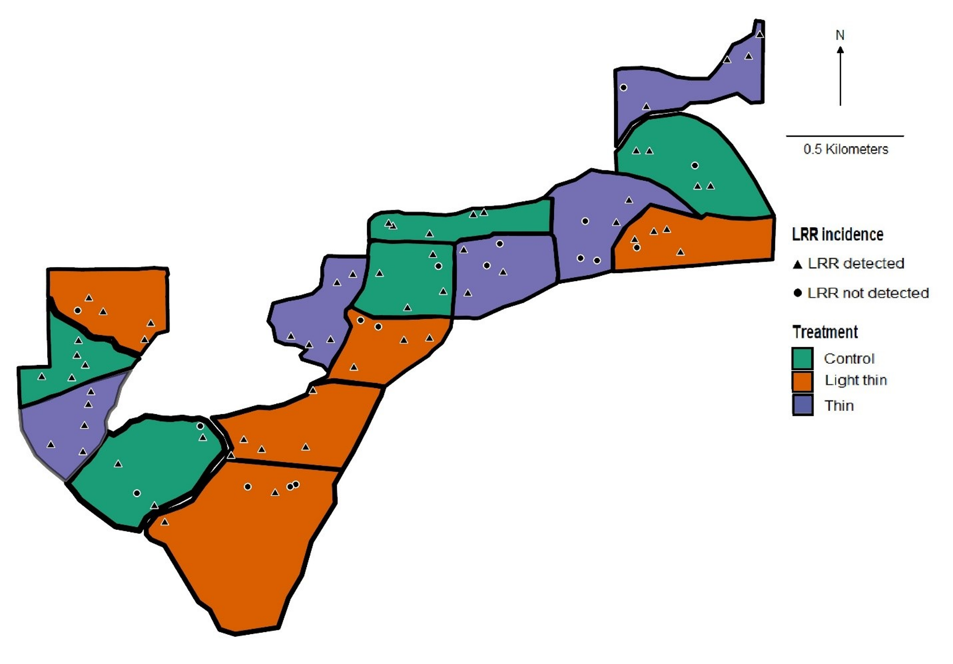
Figure 2.1: The Woods Creek study area was located along Woods Creek Road, within the Siuslaw National Forest in western Oregon. Triangles represent plots where LRR was detected (n = 62), circles represent plots where LRR was not detected (n = 13) over the 30-year duration of the study.

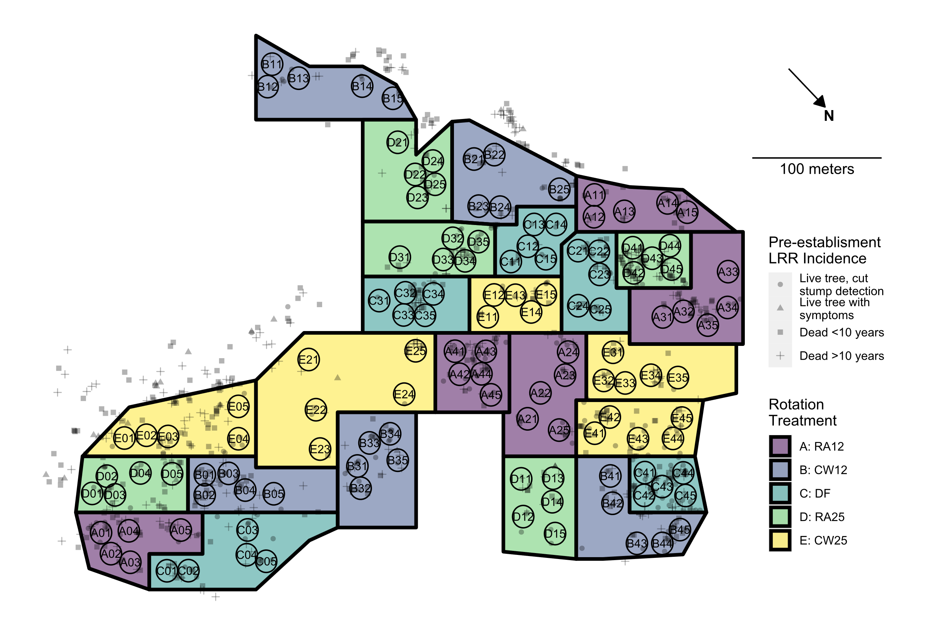
Figure 2.2. Hardwood rotation site near Apiary, OR. Colored polygons delimit plots (experimental units) to which rotation treatments were applied following 1973 clearcut of site: Purple (A), 12-year rotation with red alder before replanting Douglas-fir; Blue (B), 12- year rotation with western cottonwood before replanting with Douglas-fir; Aqua (C), immediate replanting of Douglas-fir; Green (D), 25-year red alder; Yellow (E), 25-year wester cottonwood. Black circles denote 8m fixed radius measurement subplots. Letter and two numerical digits within each plot indicate treatment, block, and subplot number. Semitransparent shapes indicate the location and status of trees with LRR symptoms prior to the 1973 clearcut: Cross, tree dead > 10 years with signs of LRR; Square, tree dead < 10 years with signs of LRR; Triangle, live tree showing LRR symptoms; Circle, live tree with symptoms detected only following clear cut.

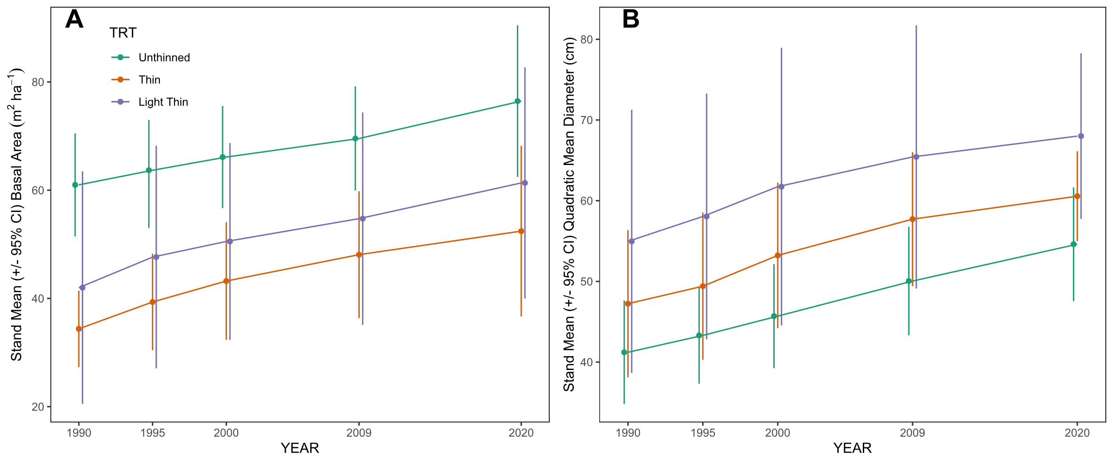
Figure 2.3. (A) Stand mean basal area of the three different treatments over time. (B) Stand mean quadratic mean diameter of the three treatments over time. The error bars are representative of 95% confidence intervals.

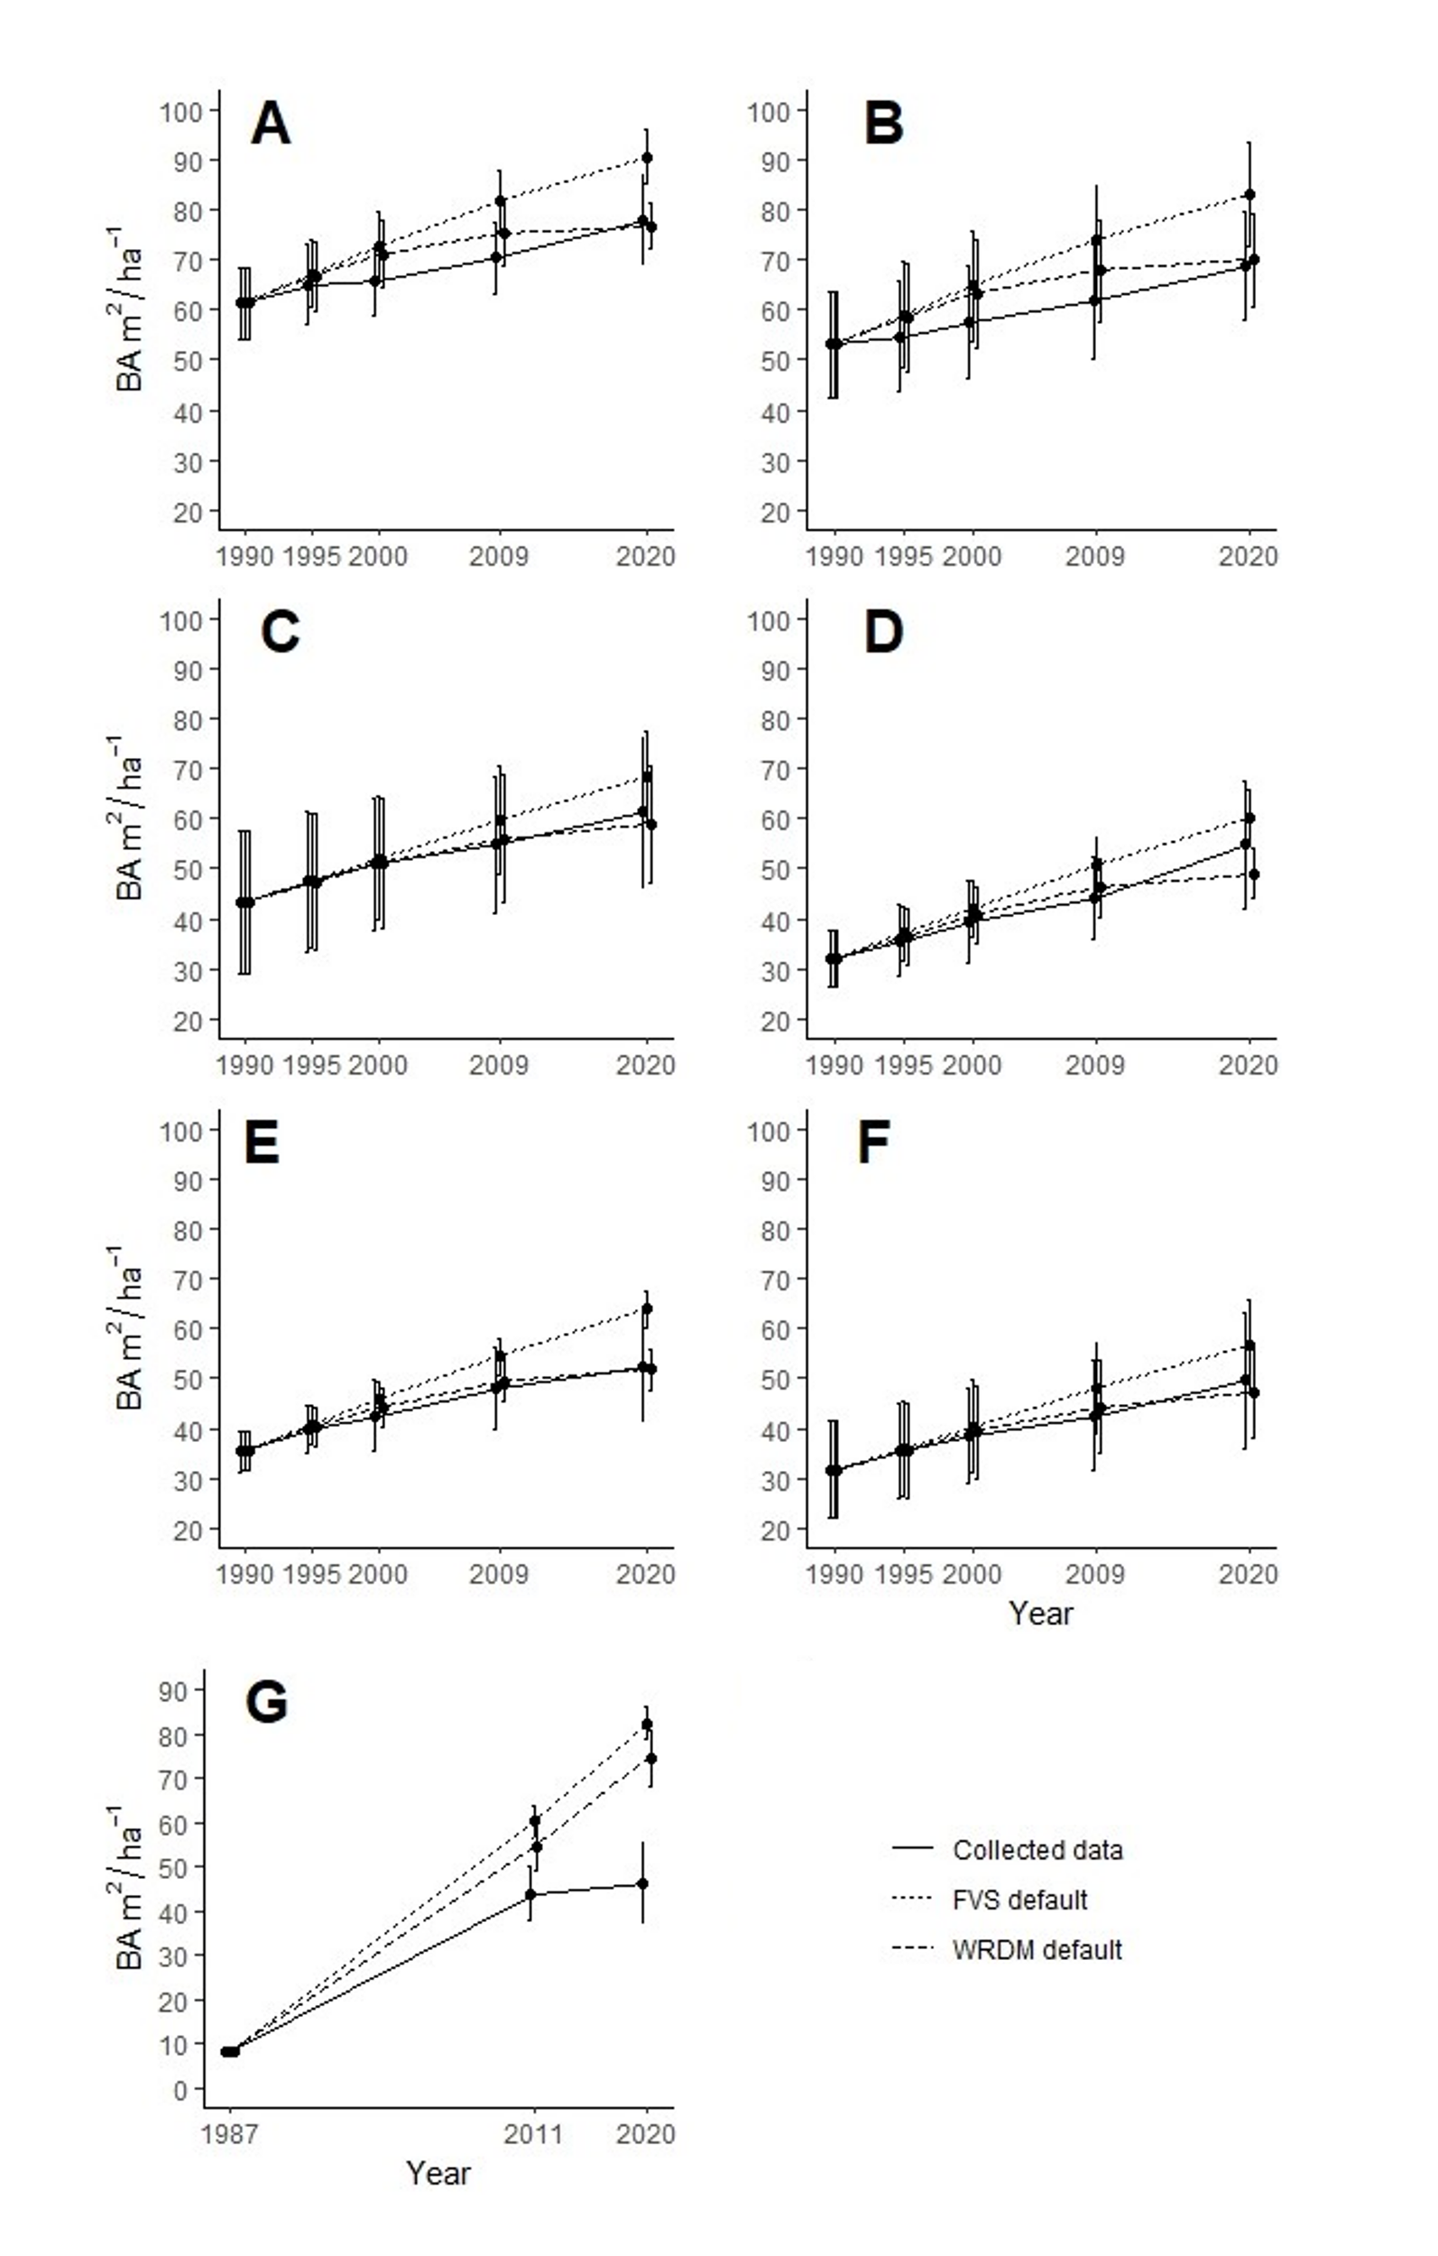
Figure 2.4: Measured data compared with modelled data within FVS and WRDM. (A) Woods Creeks unthinned stands, all species; (B) Woods Creek unthinned stands, DF only; (C) Woods Creek light thin stands, all species; (D) Woods Creek light thin stands, DF only; (E) Woods Creek thin, all species; (F) Woods Creek thin, DF only; (G) Apiary DF only. Error bars are representative of 95% confidence intervals. 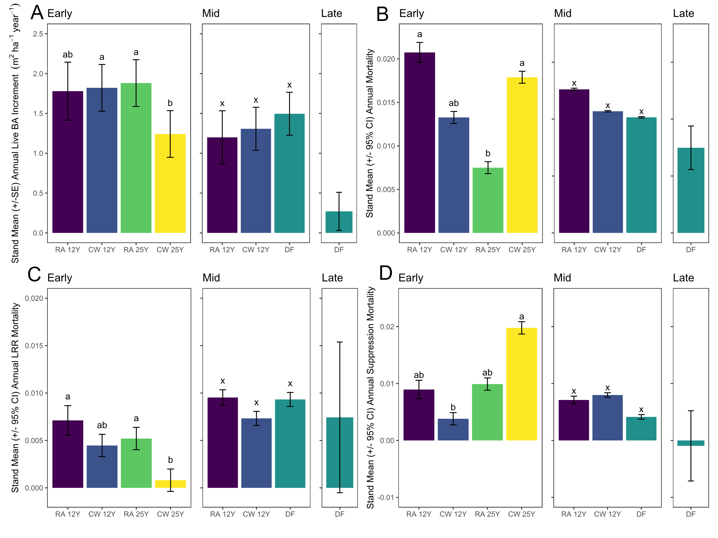

Figure 2.5. (A) Stand mean (+/- 95% CI) annual live BA increment by treatment across early, middle, and late measurement periods in the Apiary study. For all panels purple, 12-year rotation with red alder before replanting Douglas-fir; Blue, 12- year rotation with western cottonwood before replanting with Douglas-fir; Aqua, immediate replanting of Douglas-fir; Green, 25-year red alder; Yellow, 25-year wester cottonwood. Treatment bars with different letters within a panel indicate significant differences by Tukey’s HSD post-hoc test performed on arcsine square root transformed proportions. (B) Stand mean (+/- 95% CI) annual mortality proportion by treatment across early, middle, and late measurement periods in the Apiary study. (C) Stand mean (+/- 95% CI) annual mortality proportion attributed to laminated root rot by treatment across early, middle, and late measurement periods in the Apiary study (D) Stand mean (+/- 95% CI) annual mortality proportion attributed to suppression by treatment across early, middle, and late measurement periods in the Apiary study. Treatment bars with different letters within a panel indicate significant differences by Tukey’s HSD post-hoc test performed on arcsine square root transformed proportions.

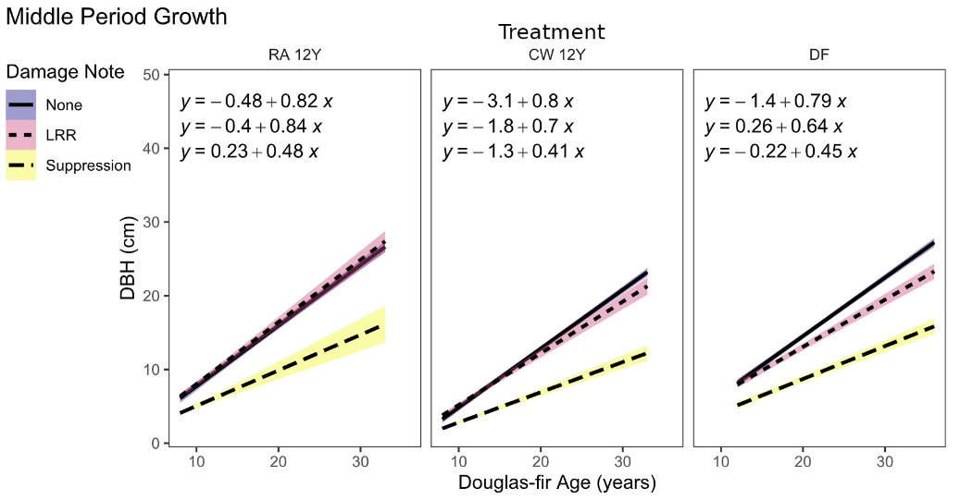

Figure 2.6. Diameter growth of live Douglas-fir over time in continuous Douglas-fir treatment vs 12-year rotation treatments in the middle time period of the Apiary study. Linear regressions are fitted to trees grouped by damage notes recorded at any point during the study.

Table 2.1. Stand ages (years) defining the beginning and end of early, middle, and late measurement periods across rotation treatments.
 | Period
Treatment | Early | Middle | Late
RA12, CW12 | 8-24 | 8-33 | NA
DF | NA | 12-36 | 36-45
RA25, CW25 | 11-20 | NA | NA

Table 2.2. Initial and final stand summary statistics for the Woods Creek study. BA = basal area, CI = 95% confidence interval.

 |  | Unthinned |  |  |  | Light thin |  |  |  | Thin |  |  |  | TOTAL
 |  | 1990 |  | 2020 |  | 1990 |  | 2020 |  | 1990 |  | 2020 |  | 1990 |  | 2020
 | Mean | 77 |  | 53.4 |  | 35.6 |  | 28 |  | 28.2 |  | 23.6 |  | 46.9 |  | 35
Live Douglas-fir | CI | 31.3 |  | 23.2 |  | 6.9 |  | 8.2 |  | 9.9 |  | 8.4 |  | 15.2 |  | 10.5
 | Total | 385 |  | 267 |  | 178 |  | 140 |  | 141 |  | 118 |  | 704 |  | 525
Live Western hemlock | Mean | 10.6 |  | 10.2 |  | 2.8 |  | 5.8 |  | 5.4 |  | 8.4 |  | 5.87 |  | 7.62
Live Western hemlock | CI | 11.8 |  | 8.1 |  | 4.0 |  | 6.2 |  | 6.6 |  | 7.7 |  | 4.4 |  | 3.9
Live Western hemlock | Total | 53 |  | 51 |  | 14 |  | 29 |  | 27 |  | 42 |  | 94 |  | 122
Live other species | Mean | 7.6 |  | 3.6 |  | 3 |  | 2.4 |  | 2 |  | 1.2 |  | 4.13 |  | 2.4
Live other species | CI | 7.3 |  | 5.0 |  | 4.4 |  | 0.9 |  | 2.2 |  | 1.1 |  | 3.2 |  | 1.2
Live other species | Total | 38 |  | 18 |  | 15 |  | 12 |  | 10 |  | 6 |  | 63 |  | 36
Total  live trees | Mean | 95.2 |  | 69.4 |  | 43 |  | 36.2 |  | 35.6 |  | 32.8 |  | 18.7 |  | 14.8
Total  live trees | CI | 19.8 |  | 13.8 |  | 8.5 |  | 6.6 |  | 7.1 |  | 6.0 |  | 7.7 |  | 5.5
Total  live trees | Total | 476 |  | 336 |  | 207 |  | 182 |  | 178 |  | 166 |  | 860 |  | 683
Total live BA of | Mean | 9.3 |  | 12.6 |  | 5.43 |  | 9.72 |  | 5.9 |  | 9.5 |  | 6.9 |  | 10.6
Douglas-fir  (m²ha⁻¹) | CI | 1.08 |  | 3.52 |  | 0.71 |  | 1.33 |  | 1.8 |  | 1.8 |  | 1.0 |  | 1.4
Douglas-fir as percentage | Total | 81% |  | 79% |  | 86% |  | 77% |  | 79% |  | 71% |  | 82% |  | 77%
of total trees

Table 2.3: A two-way ANOVA testing effects of block and thinning treatment on total tree mortality from LRR.
Source of Variation | df | Sum of Squares | Mean Square | F | p-Value
Block | 4 | 0.063847 | 0.0159617 | 1.0795 | 0.4274
Treatment | 2 | 0.000550 | 0.0002751 | 0.0186 | 0.9816
Residuals | 8 | 0.118286 | 0.0147858

Table 2.4: Results of two-way ANOVAs testing effects of block and thinning treatment on initial and final stand basal area and annuals basal area increment. Asterisk indicates significant difference (p < 0.05).
 |  | 1990 BA |  | 2020 BA |  | BA increment
Source of Variation | df | F | p-Value | F | p-Value | F | p-Value
Block | 4 | 0.8130 | 0.5509 | 1.6000 | 0.26460 | 11.2602 | 0.002275*
Treatment | 2 | 6.8606 | 0.0184* | 4.6041 | 0.04671* | 1.1213 | 0.372141
Residuals | 8

Table 2.5: Stand level summary statistics for the Apiary study. 95CI = 95% Confidence Interval.

 |  | 12y Red Alder |  |  |  |  | 12y Cottonwood |  |  |  |  | 25y Red Alder |  |  |  |  | 25y Cottonwood |  |  |  |  | Immediate Douglas-fir
Live  stems | Year | 1987 | 1995 | 2011 | 2020 |  | 1987 | 1995 | 2011 | 2020 |  | 1987 | 1995 | 2011 | 2020 |  | 1987 | 1995 | 2011 | 2020 |  | 1987 | 1995 | 2011 | 2020
Live  stems | Age | NA | 8 | 24 | 33 |  | NA | 8 | 24 | 33 |  | NA | NA | 11 | 20 |  | NA | NA | 11 | 20 |  | 12 | NA | 36 | 45
Live  stems | mean | NA | 163.0 | 106.7 | 57.0 |  | NA | 161.4 | 127.0 | 74.6 |  | NA | NA | 131.6 | 121.0 |  | NA | NA | 164.8 | 132.6 |  | 157.6 | NA | 73.2 | 55.6
Live  stems | 95CI | NA | 11.4 | 24.1 | 6.6 |  | NA | 7.6 | 16.1 | 19.2 |  | NA | NA | 32.6 | 28.2 |  | NA | NA | 27.1 | 15.6 |  | 21.4 | NA | 13.2 | 11.3
Live  stems | Total | NA | 489 | 320 | 171 |  | NA | 807 | 635 | 373 |  | NA | NA | 658 | 605 |  | NA | NA | 824 | 663 |  | 788 | NA | 366 | 278
Basal area (m²ha⁻¹)
Basal area (m²ha⁻¹) | mean | NA | 4.7 | 33.9 | 33.3 |  | NA | 1.4 | 30.6 | 34.1 |  | NA | NA | 10.8 | 27.8 |  | NA | NA | 7.9 | 19.1 |  | 8.1 | NA | 44.0 | 46.4
Basal area (m²ha⁻¹) | 95CI | NA | 2.1 | 9.5 | 3.0 |  | NA | 0.8 | 9.5 | 12.0 |  | NA | NA | 2.5 | 5.1 |  | NA | NA | 1.8 | 4.1 |  | 1.5 | NA | 8.7 | 12.7

Tables 2.6. ANOVA and likelihood ratio test statistics and probabilities for linear (mixed) models of block and treatment effects on annual basal area growth (m²ha⁻¹year⁻¹), total proportional mortality, and cause specific proportional mortalities across early, middle, and late measurement periods. *Test statistic: random effect of block= LRT; fixed effect of treatment = F. Probabilities <0.05 in bold. Mixed effect models for variables without test statistics for block effect did not converge and thus linear models of the fixed effect of treatment only were fitted.
 | Annual BA increment |  |  |  | Annual total mortality |  |  |  | Annual LRR mortality |  |  |  | Annual suppression mortality
 |  | Test |  |  |  | Test |  |  |  | Test |  |  |  | Test
Source | df | stat* | p |  | df | stat* | p |  | df | stat* | p |  | df | stat* | p
EARLY
Block | 1 | 1.112 | 0.292 |  | NA | NA | NA |  | 1 | 6.492 | 0.011 |  | 1 | 3.017 | 0.082
Treatment
(A, B, D, E) | 3 | 6.098 | 0.008 |  | 3 | 3.71 | 0.037 |  | 3 | 5.811 | 0.009 |  | 3 | 9.269 | 0.001
Error | 13 |  |  |  | 13 |  |  |  | 13 |  |  |  | 13
MIDDLE
Block | 1 | 0.62 | 0.431 |  | NA | NA | NA |  | 1 | 10.29 | 0.001 |  | NA | NA | NA
Treatment
(A, B, D, E) | 2 | 1.641 | 0.253 |  | 2 | 2.113 | 0.172 |  | 2 | 1.969 | 0.2 |  | 2 | 2.107 | 0.172
Error | 8 |  |  |  | 10 |  |  |  | 8 |  |  |  | 10

