**Experiment-5**

**Plotting the data to draw the points:**

#plot points using x,y variables

>x <- c(1, 2, 3, 4, 5)

> y <- c(5, 7, 2, 8, 3)

> plot(x,y)

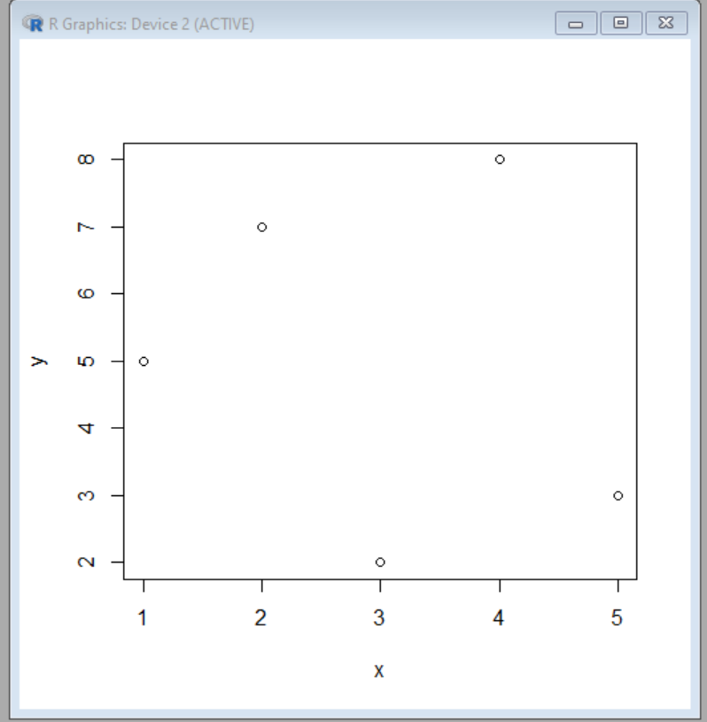

#plot points using slicing

plot(1:10,main="Slicing",xlab="X-axis",ylab="Y-axis")

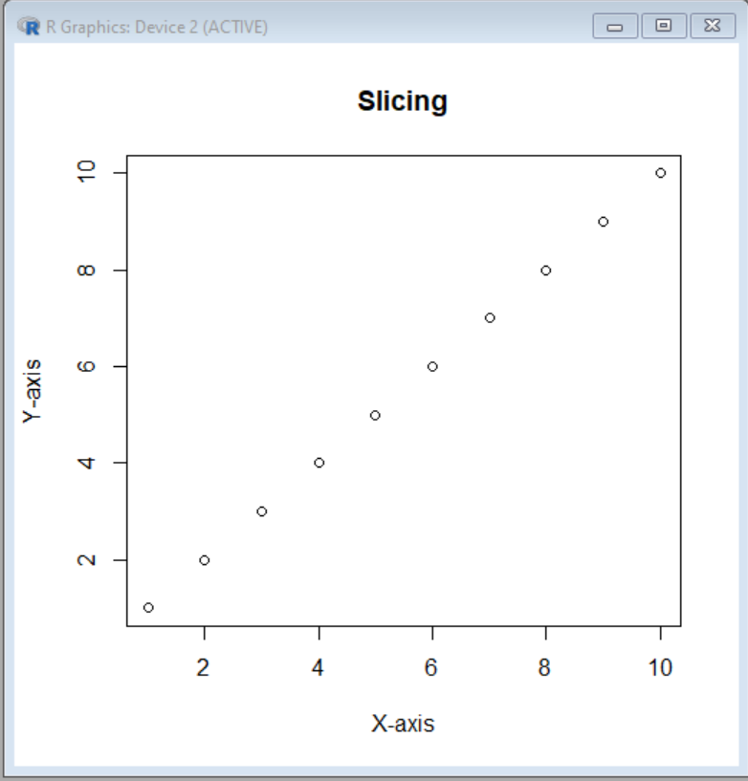

**#Step-Plot using “type” parameter**

Plot(1:10,type=”s”)

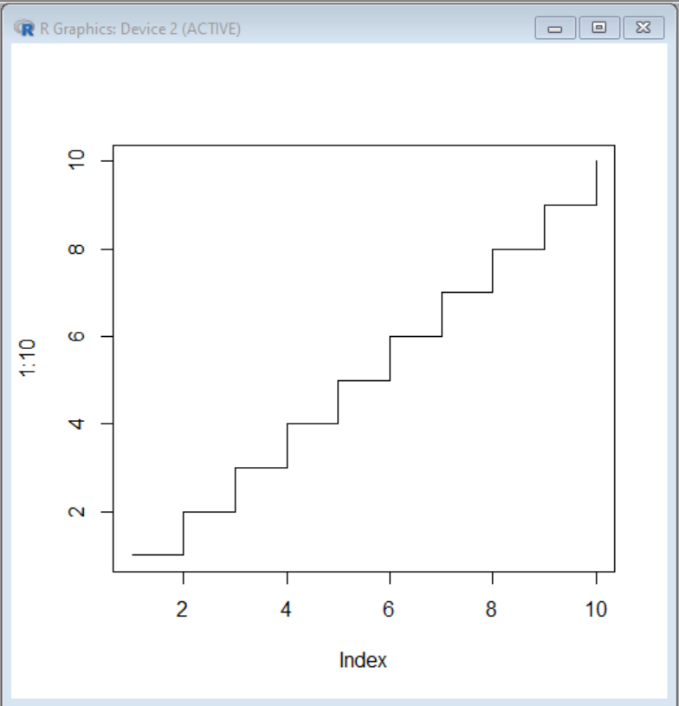

**#Adding color ,size and shape to the point**

plot(1:7,type="p",col="green",cex=2,pch=3,main="Point graph",xlab="X-axis",ylab="Y-axis")

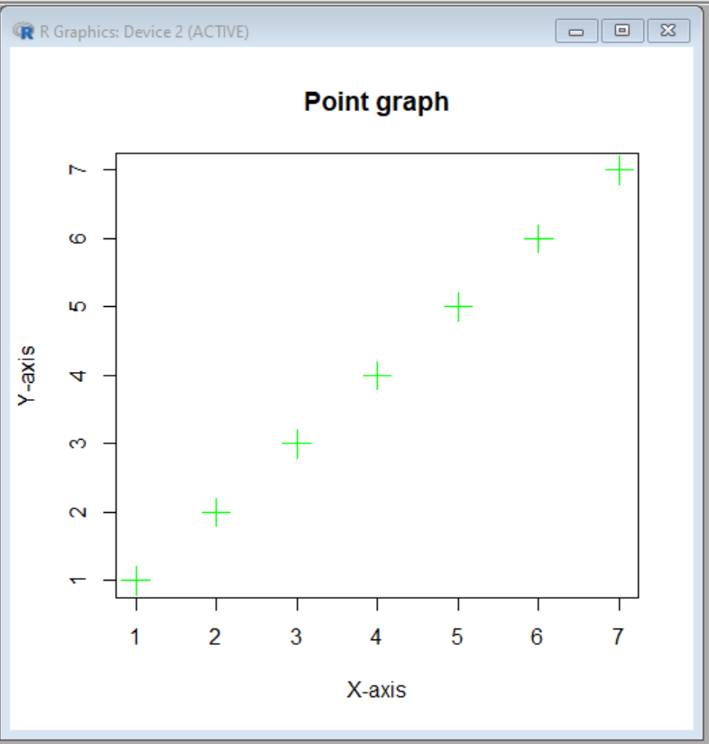

**Experiment-6**

**Viewing And Manipulating data:**

**#Load data from CSV file**

data<-read.csv("Employ.csv")

> data

**Output:**

Id Name Department Salary JoiningDate

1 1 John Doe HR 50000 2023-01-15

2 2 Jane Smith IT 60000 2022-08-20

3 3 Michael Johnson Finance 55000 2023-03-10

4 4 Emily Brown Marketing 48000 2022-11-05

5 5 David Wilson IT 62000 2023-02-28

**#View,head,tail commands**

View(data)

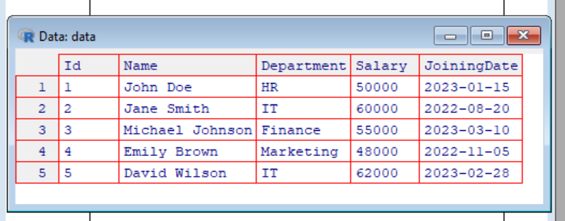

head(data)

**output:**

Id Name Department Salary JoiningDate

1 1 John Doe HR 50000 2023-01-15

2 2 Jane Smith IT 60000 2022-08-20

3 3 Michael Johnson Finance 55000 2023-03-10

4 4 Emily Brown Marketing 48000 2022-11-05

> tail(data)

**Output:**

Id Name Department Salary JoiningDate

2 2 Jane Smith IT 60000 2022-08-20

3 3 Michael Johnson Finance 55000 2023-03-10

4 4 Emily Brown Marketing 48000 2022-11-05

5 5 David Wilson IT 62000 2023-02-28

> nrow(data)

[1] 5

> ncol(data)

[1] 5

**#Min,Max & Mean**

> minimum_salary <- min(data$Salary)

> cat("Minimum Salary:", minimum_salary, "\n")

Minimum Salary: 48000

> maximum_salary <- max(data$Salary)

> cat("Maximum Salary:", maximum_salary, "\n")

Maximum Salary: 62000

> average_salary <- mean(data$Salary)

> cat("Average Salary:", average_salary, "\n")

Average Salary: 55000

**#Subsetting**

> data1<-subset(data,Department=="IT")

> data1

**Output:**

Id Name Department Salary JoiningDate

2 2 Jane Smith IT 60000 2022-08-20

5 5 David Wilson IT 62000 2023-02-28

**#filtering**

>print(data$Id==5)

[1] FALSE FALSE FALSE FALSE TRUE

> print(data$Salary==55000)

[1] FALSE FALSE TRUE FALSE FALSE

**Experiment-7**

**#barplot**

> x <- c("A", "B", "C", "D")

> y <- c(2, 4, 6, 8)

> barplot(y, names.arg = x, col = "red")

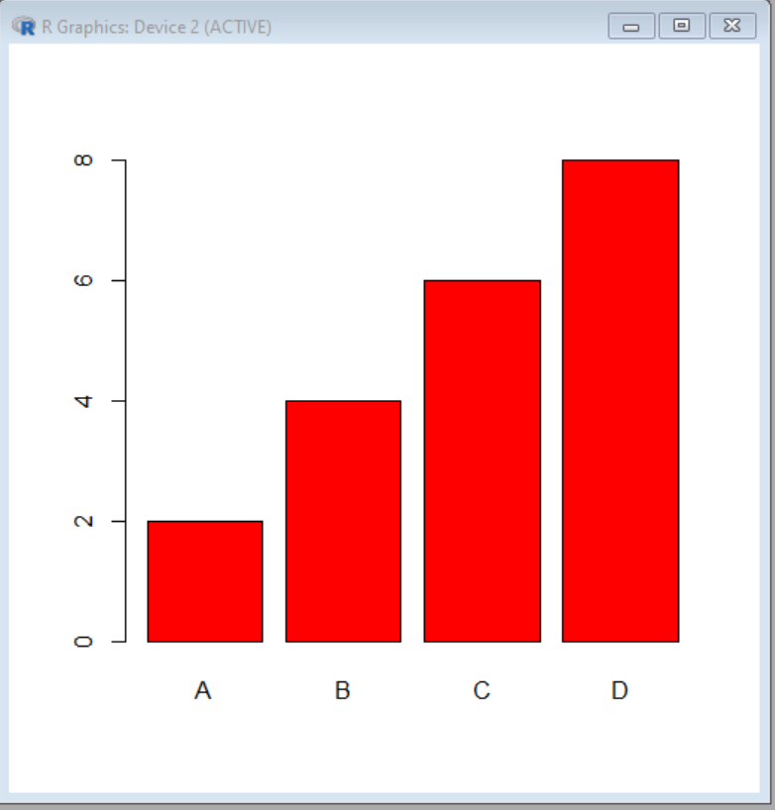

> x <- c("A", "B", "C", "D")

> y <- c(2, 4, 6, 8)

> barplot(y, names.arg = x, horiz = TRUE,width=c(1,2,3,4))

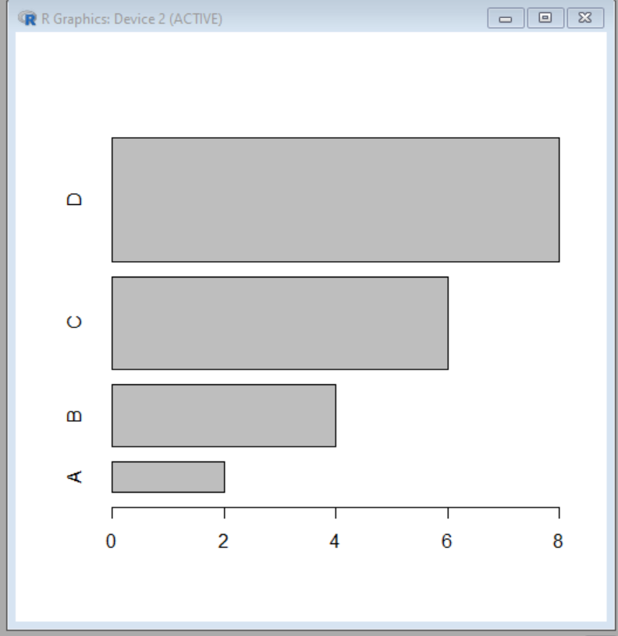

**#Pie charts**

> mylabel <- c("Apples", "Bananas", "Cherries", "Dates")

> colors <- c("blue", "yellow", "green", "black")

> pie(x, label = mylabel, main = "Fruits", col = colors,angle=0)

legend("bottomright",mylabel,fill=colors)

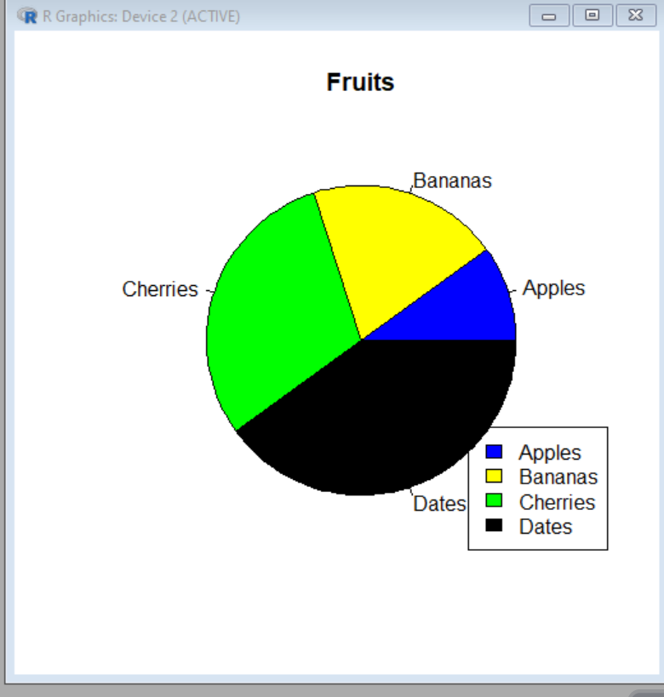

**#Scatter plot**

> x <- c(5,7,8,7,2,2,9,4,11,12,9,6)

> y <- c(99,86,87,88,111,103,87,94,78,77,85,86)

> plot(x, y, main="Observation of Cars", xlab="Car age", ylab="Car speed",col="blue")

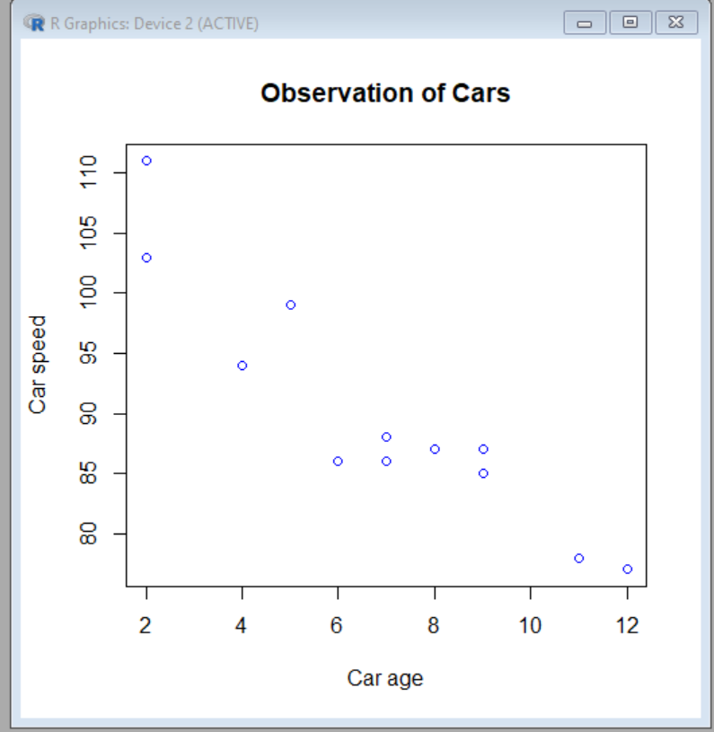

**#Box plot**

>subject <- rep(c("Math", "Science", "English", "History"), each = 20)

> scores <- c(85, 70, 90, 65, 75, 60, 88, 72, 78, 92, 55, 68, 82, 75, 80, 68, 90, 77, 85, 58,70, 75, 85, 62, 92, 67, 80, 73, 98, 78, 82, 50, 72, 85, 95, 62, 75, 87, 75, 83)

> data <- data.frame(Subject = subject, Scores = scores)

> boxplot(Scores ~ Subject, data = data, col = "lightblue", main = "Test Scores by Subject",xlab = "Subject", ylab = "Scores")

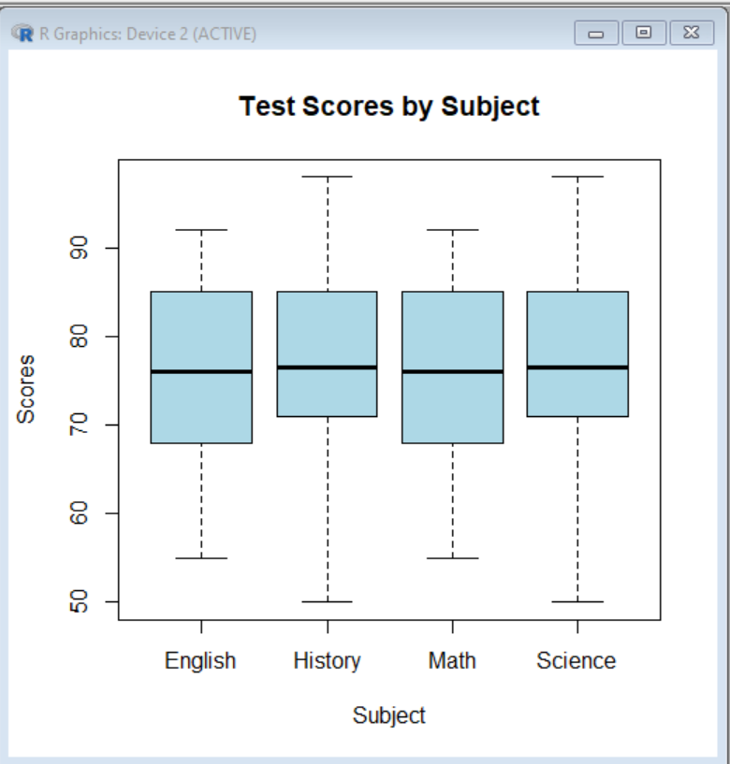

**#Histogram**

scores <- c(75, 85, 60, 92, 78, 55, 88, 72, 68, 90, 81, 73, 95, 87, 79)

hist(scores, breaks = 5, col = "purple", border = "black",main = "Exam Scores Distribution", xlab = "Scores", ylab = "Frequency")

