

SOFTWARE REQUIREMENT SPECIFICATION
Website UniLap(ULP)

– Hanoi, May 2026 –
Table of Contents
I. Software Requirement Specification 4
1. Overall Requirements 4
1.1 Context Diagram 4
1.2 Main Business Processes 5
1.3 User Requirements 21
1.4 System Functionalities 34
1.5 Entity Relationship Diagram 41
2. Use Case Specifications 50
2.0 Authentication & Account Management 50
2.1 Product Discovery 53
2.2 AI Assistant 56
2.3 Shopping Cart & Checkout 57
2.4 Order Management 61
2.5 Warranty Management 63
2.6 Staff Operations 65
2.7 Product Inventory Management 69
2.8 Voucher Management 71
2.9 Dashboard & Reporting 72
2.10 Admin Management 73
2.11 AI Governance 82
2.12 Warranty Policy Management 84
3. Functional Requirements 87
3.1 Storefront 87
3.2 Admin 108
4. Non-Functional Requirements 126
4.1 External Interfaces 126
4.2 Quality Attributes 127
5. Requirement Appendix 131
5.1 Business Rules 131
5.2 System Messages 132
5.3 Validation R 134
I. Record of Changes
Date | A*  M, D | In charge | Change Description
25/5 | A | Whole team | Write down demo SRS 1st
26/5 | A/M | Whole team | Completing all SRS to the right projects
5/6 | A/M | Usecase  specific | Completing usecasespecif and screen
*A - Added M - Modified D - Deleted

I. Software Requirement Specification

1. Overall Requirements

1.1 Context Diagram
The Technology Products E-Commerce Website is a new software system that replaces the current fragmented sales processes on third-party e-commerce platforms and social networks for small and medium-sized laptop retail shops. The context diagram below illustrates the external entities and system interfaces for the initial releases, focusing on core shopping experiences, multi-method checkouts, and basic inventory tracking. The system is expected to evolve over several iterations, ultimately connecting to an intelligent, rule-based Chatbot suggestion system tailored for students, automated e-invoice generation via email, a comprehensive online warranty tracking system, and advanced financial analytics dashboards.

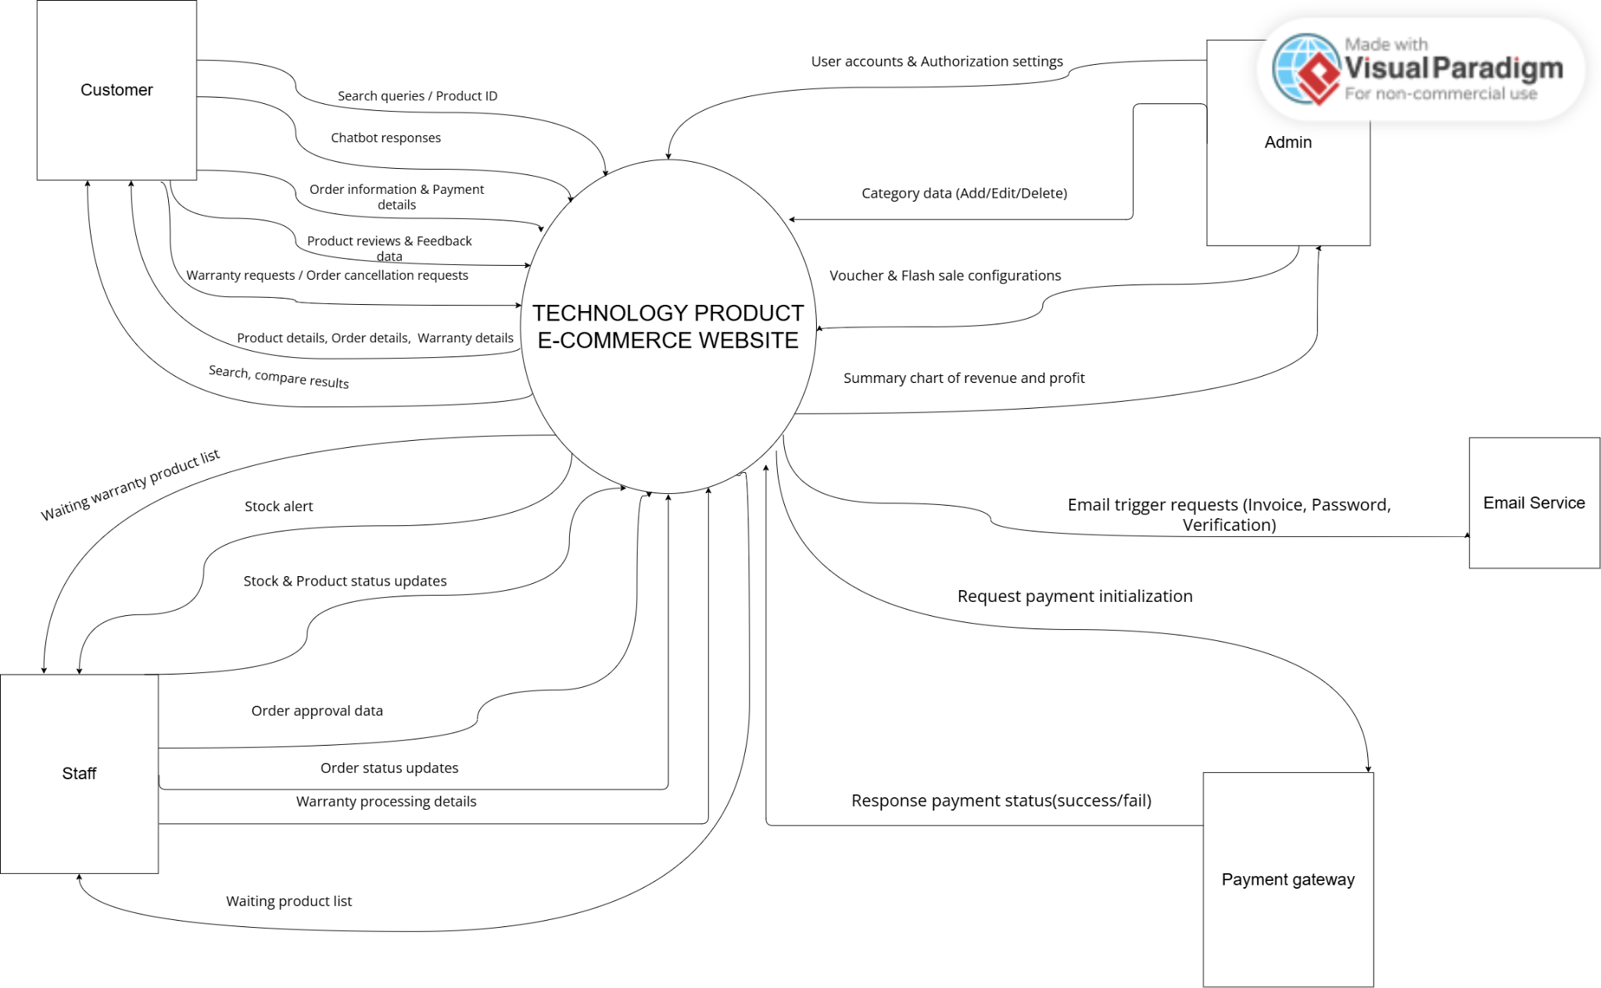

1.2 Main Business Processes
1.2.1 Authentication & Account Management
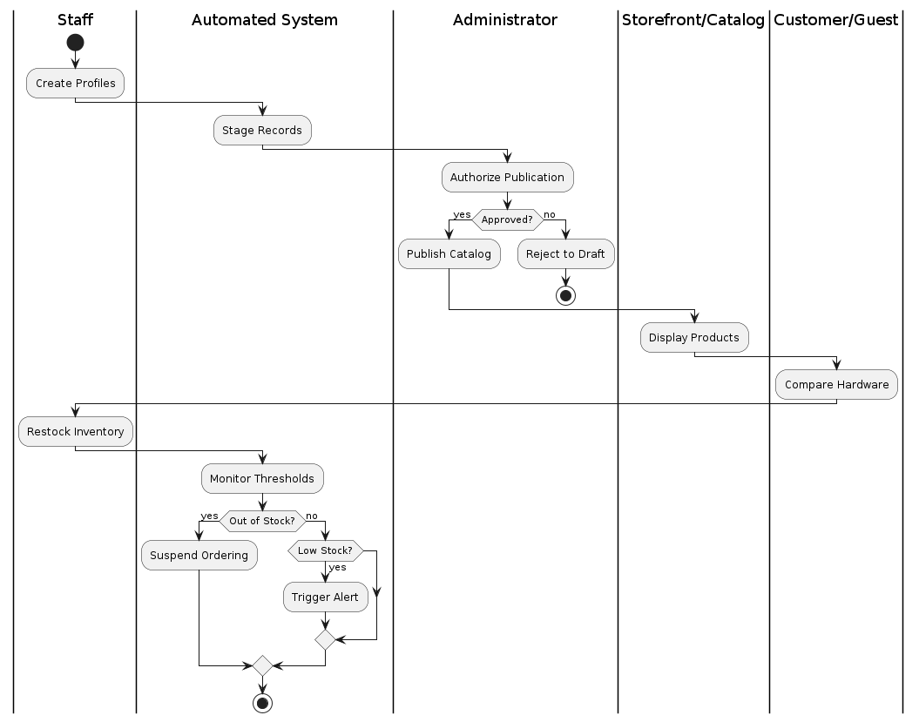

1.2.2. Online Shopping & Order Processing
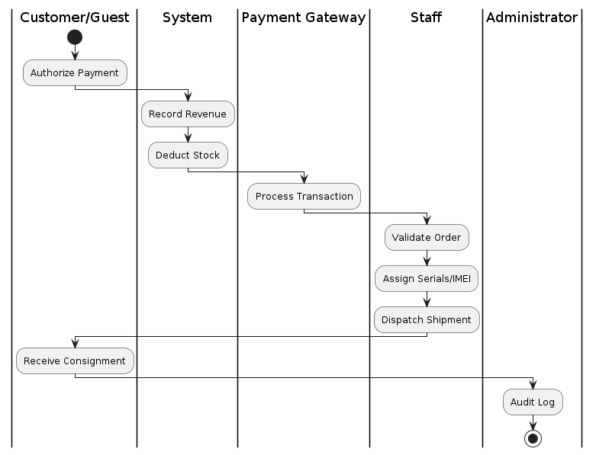

1.2.3. Customer Experience & Promotion
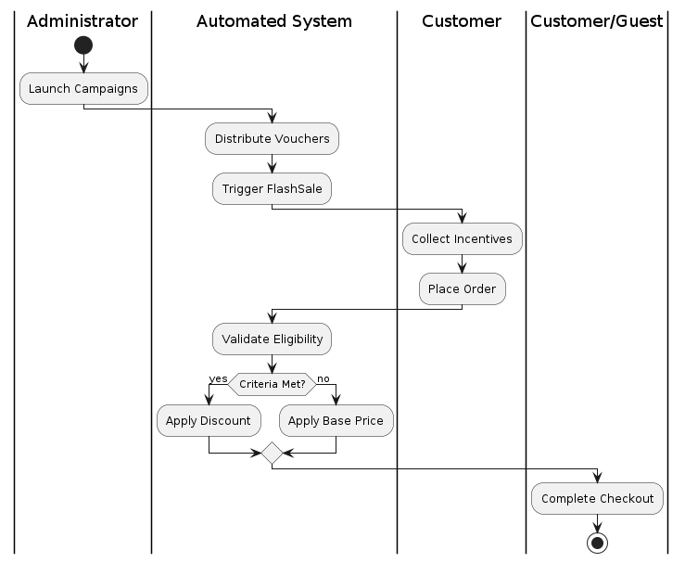

1.2.4. Product & Inventory Management


1.2.5. Warranty, Return & Analytics
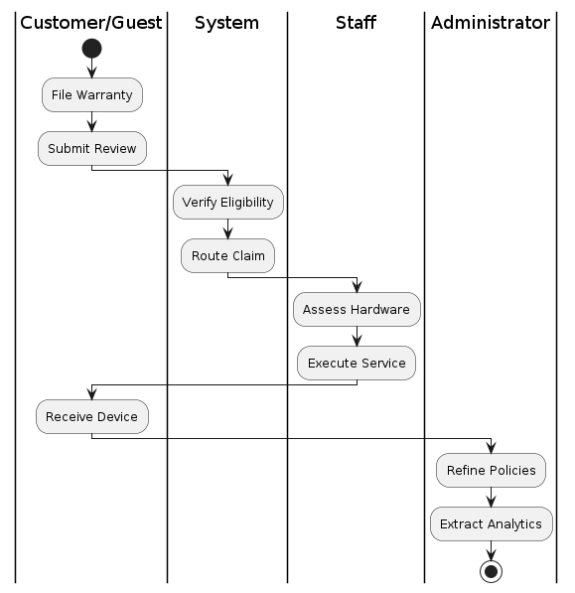

1.3 User Requirements

1.3.1 Actors
# | Actor | Description
1 | Guest | Unauthenticated public user browsing the storefront. Can search products, read specs
2 | USER | Any authenticated account that has successfully logged into the system. Acts as the base role for Customers, Staff, and Administrators to manage common actions (e.g., Login, Logout, Update Profile)
3 | Customer | Authenticated user who has registered an account. Can manage shopping carts, consult the AI assistant ,apply vouchers, place orders, and track shipments.
4 | Staff | Internal operational employee responsible for validating orders, packing hardware items, and monitoring daily inventory balances.
5 | Administrator | Supreme administrative manager. Governs user permissions, alters product files, manages vouchers, reviews sales ledger analytics, and mitigates AI chatbot abuse.
6 | AI ServiceProvider | External system (e.g., OpenAI or Google Gemini API) providing automated natural language understanding models to drive custom PC consultation.

1.3.2 Use Cases (UC)

ID | Feature | Actor | Use Case | Use Case Description
UC01 | Authentication & Access | Guest | Register Account | Allow a new visitor to create a unique customer account within the system.
UC02 | Authentication & Access | User | Login | Verify user credentials and grant system access based on assigned roles (Customer/Staff/Admin).
UC03 | Authentication & Access | User | Logout | End the current user session and invalidate the active secure access token.
UC04 | Authentication & Access | User | Request Password Reset | Allow users to request a password recovery link via email when credentials are forgotten.
UC05 | Account Management | User | Update Profile | Modify personal contact details, account profile information, and update security passwords.
UC06 | E-Commerce Operations | Guest | Browse & Search Products | Explore product catalogs, search via keywords, and filter hardware components by brand, price, or specifications.
UC07 | E-Commerce Operations | Guest | View Product Detail | View comprehensive specifications, explicit pricing, real-time stock availability, and descriptions of a component.
UC08 | E-Commerce Operations | Guest | Compare Products | Select and evaluate multiple 2-3 hardware products side-by-side on a single interface for technical and price comparison.
UC09 | Public Information | Guest | View Shop Information | Review general store policies, explicit warranty terms, contact guidelines, and sample electronic invoices.
UC10 | Account Management | Customer | Manage Delivery Address | Add, edit, remove, or set default delivery addresses for subsequent order checkouts.
UC11 | E-Commerce Operations | Customer | Manage Cart | Add selected components to the shopping cart, adjust quantities, or remove items in a single operational view.
UC12 | Booking & Checkout | Customer | Checkout Order | Consolidated flow: Apply vouchers, verify delivery info, choose payment method (COD/Online), and submit the order.
UC13 | Booking & Checkout | Customer | Track & Manage Order | View order details, monitor real-time shipping progress, or cancel an order if it is within the allowed timeframe.
UC14 | AI System Integration | Customer | Interact with AI Assistant | Query the AI assistant for custom hardware configuration recommendations and component compatibility checks.
UC15 | Warranty Operations | Customer | Submit Warranty Request | Verify warranty eligibility for past orders and submit a claim form with attached media evidence (images/videos).
UC16 | Warranty Operations | Customer | Track Warranty Status | Monitor the evaluation progress of a warranty claim or cancel the request before staff processing begins.
UC17 | Service Operations | Staff | Process Order | Review pending orders, approve or reject them, and progress the execution status (Confirmed, Packed, Shipped).
UC18 | Service Operations | Staff | Handle Order Cancellation | Assess customer-submitted order cancellation requests to explicitly approve or deny them based on status.
UC19 | Warranty Operations | Staff | Process Warranty Claim | Examine submitted media evidence and update warranty execution statuses (In Progress, Completed, Rejected).
UC20 | Inventory Management | Staff | Manage Product Catalog | Create new hardware profiles or modify existing product specifications, pricing, imagery, and structural info.
UC21 | Inventory Management | Staff | Update Stock Inventory | Manually adjust physical stock counts for items and review automated stock-shortage alert triggers.
UC22 | Inventory Management | Staff | Disable Product | Hide or temporarily disable out-of-stock or discontinued products from appearing to public consumers.
UC23 | Reporting & Analytics | Staff | View Operational Reports | Access general charts summarizing daily/monthly revenue, total orders processed, and conversion rate indicators.
UC24 | Employee & User Admin | Admin | Manage Users | Browse the global user directory, audit account profiles, and activate or deactivate violating user accounts.
UC25 | Access Control | Admin | Assign User Role | Modify systemic permissions and reassign specific user roles (Customer, Staff, Administrator).
UC26 | Inventory Management | Admin | Manage Categories | Construct or edit the hardware taxonomy tree, including adding, naming, or deleting obsolete categories.
UC27 | Access Control | Admin | Approve Product Changes | Review and formally authorize critical product mutations made by staff before they go live on the storefront.
UC28 | Facility & Stock Audit | Admin | Audit Stock Adjustments | Review structural logs and change histories regarding stock adjustments to ensure team accountability.
UC29 | Voucher Configuration | Admin | Manage Voucher Campaigns | Create, edit, or forcefully deactivate high-impact discount vouchers and marketing campaigns.
UC30 | Warranty Operations | Admin | Manage Warranty Policies | Oversee the lifecycle of global store warranty rules, facilitating creation, updates, or complete policy termination.
UC31 | Reporting & Analytics | Admin | View Advanced Analytics | Access deep-dive analytical dashboards displaying purchase frequencies, component trends, and market predictions.
UC32 | Threat Monitoring | Admin | Moderate AI Guardrails | Monitor the assistant framework for prompt injection or spam patterns, and revoke AI access for abusive profiles.
UC33 | AI System Integration | Admin | Optimize AI Knowledge Base | Audit reported inaccurate AI answers and star ratings to refine underlying vector stores or model response rules.
UC34 | View system Dashboard | Admin | View system status, statistics, and key metrics | Allows the Admin to monitor system statistics, activities, and key metrics through a centralized dashboard.
UC35 | Product Review | Customer | Submit Product Review | Allow customers who have purchased and received a product to submit ratings, written comments, and optional images. The system verifies purchase eligibility, prevents duplicate reviews, and saves the review according to moderation rules.
UC36 | Product Review | Customer/Guest | View Product Reviews | Allow guests and customers to view product ratings and customer reviews on the product detail page, including average score, review count, comments, images, reviewer information, and review time before making purchase decisions.
UC37 | Product Review Management | Staff/Admin | Manage Product Reviews | Allow staff and administrators to search, filter, approve, hide, or delete product reviews. The system supports moderation by checking review content, rating details, approval status, and reviewer information to maintain reliable feedback.

1.3.2.1 Actor Generalization Architecture
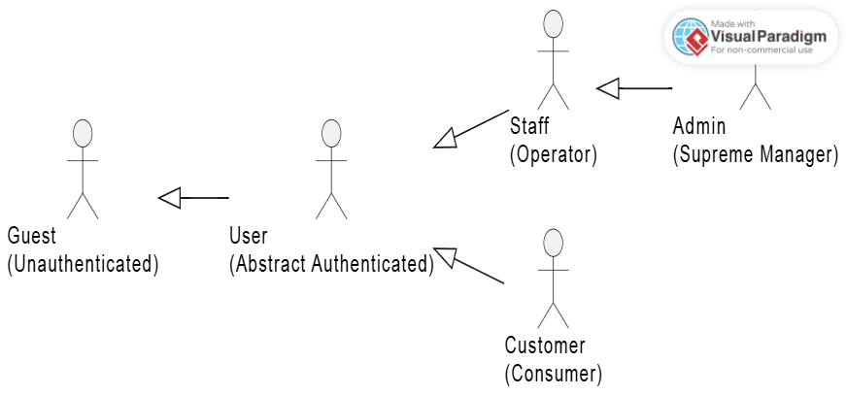The system utilizes the UML Generalization mechanism to establish a structured hierarchical access control system among actors, minimizing redundancy in use case associations.At the foundational layer, the User actor acts as an abstract authenticated entity that inherits from the unauthenticated Guest, ensuring that any logged-in session maintains public browsing capabilities. Moving vertically, the Customer directly inherits from the User, automatically receiving baseline profile-management privileges while extending into consumer-specific features (e.g., cart operations and checkouts).On the operational side, the Staff role inherits from the User to execute back-office operations such as order fulfillment and inventory tracking. Ultimately, the Administrator inherits directly from the Staff. This hierarchical chain implies that the Administrator implicitly possesses all operational capabilities of a Staff member, while explicitly maintaining isolated supreme privileges, including user governance, stock auditing, and AI guardrail moderations.

1.3.2.1 Use Case for Guest

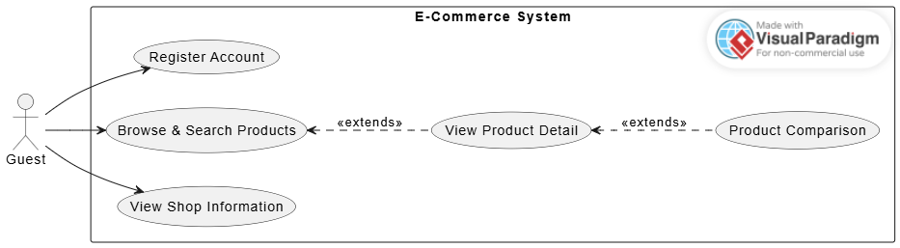
In the E-Commerce system, the Guest is an actor representing unauthenticated users—meaning any individual who accesses the system without an account or before logging in. This use case diagram defines the scope of public interactions available to Guests, which includes viewing informational store content, searching for components, and registering for an account to become an authenticated user.

1.3.2.2 Use Case for Customer
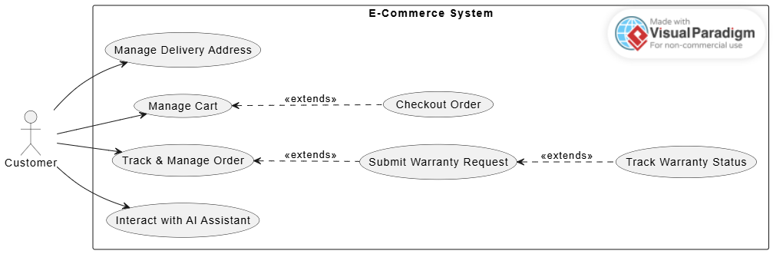
In the E-Commerce system, the Customer is an actor representing authenticated consumers—meaning any individual who has successfully registered a personal account and logged into the system. This use case diagram defines the scope of core post-login interactions available to Customers, which includes managing delivery addresses, controlling shopping carts, tracking orders, and consulting the integrated AI platform. Notably, the <<extend>> relationships in the diagram reflect the optional and situational behaviors of the Customer: transitioning to a complete checkout routine is an extension triggered only when the Customer actively decides to finalize purchase metrics from the active cart interface . Similarly, filing a warranty request extends directly from a historical order verification log , while reviewing tracking metrics serves as an optional monitoring branch triggered only after a specific claim form has been formally submitted , rather than being a mandatory action in every standard consumer interaction session.

1.3.2.3 Use Case for STAFF
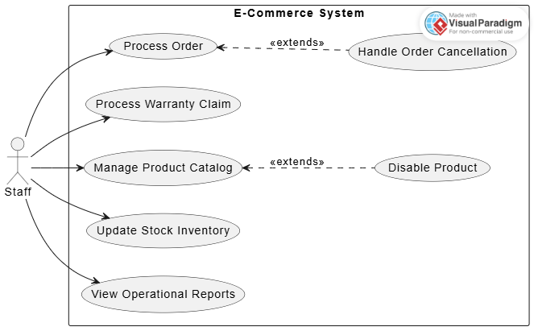
In the E-Commerce system, the Staff is an actor representing internal operational employees—meaning any internal worker responsible for everyday order fulfillment, content maintenance, and inventory auditing. This use case diagram defines the scope of back-office operations available to Staff, which includes validating customer orders, examining media evidence for warranty claims, adjusting physical inventory quantities, and viewing high-level operational statistics. Notably, the two <<extend>> relationships in the diagram reflect the conditional behaviors of the Staff: reviewing and handling a customer's cancellation request is an extension triggered only when an active order in the pending processing queue contains an explicit cancellation flag submitted by a buyer. Similarly, choosing to forcefully hide or disable a component from public view acts as an optional extension triggered from within the active product catalog management wizard when an item becomes discontinued or runs out of stock long-term, rather than being a mandatory action in every standard operational logging session.

1.3.2. 4 Use Case for ADMIN
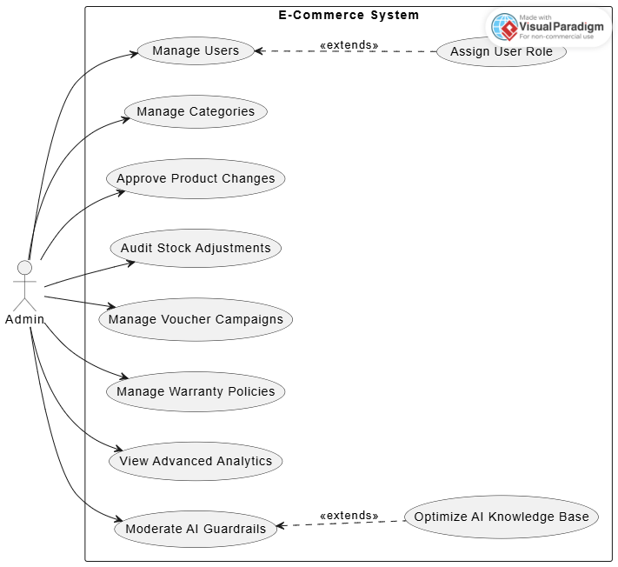
In the E-Commerce system, the Admin is an actor representing supreme administrative managers—meaning any high-level system administrator responsible for overall system governance, operational audit tracking, and security monitoring. This use case diagram defines the scope of high-level system controls available to Admins, which includes browsing user profiles, structuring hardware categories, formally authorizing staff product mutations, tracking stock changes, handling marketing campaigns, reviewing deep business analytics, and managing chatbot frameworks. Notably, the two <<extend>> relationships in the diagram reflect the conditional behaviors of the Admin: altering systemic permissions is an extension triggered only when the Admin actively decides to change user privileges from within a specific account profile inside the global directory. Similarly, inspecting errors or refining underlying vector triages serves as another optional path triggered from the active AI guardrail monitor when inaccurate chatbot responses or user rating drops are detected, rather than being a mandatory action in every standard system governance session.

1.4 System Functionalities

1.4.1 Screens Flow

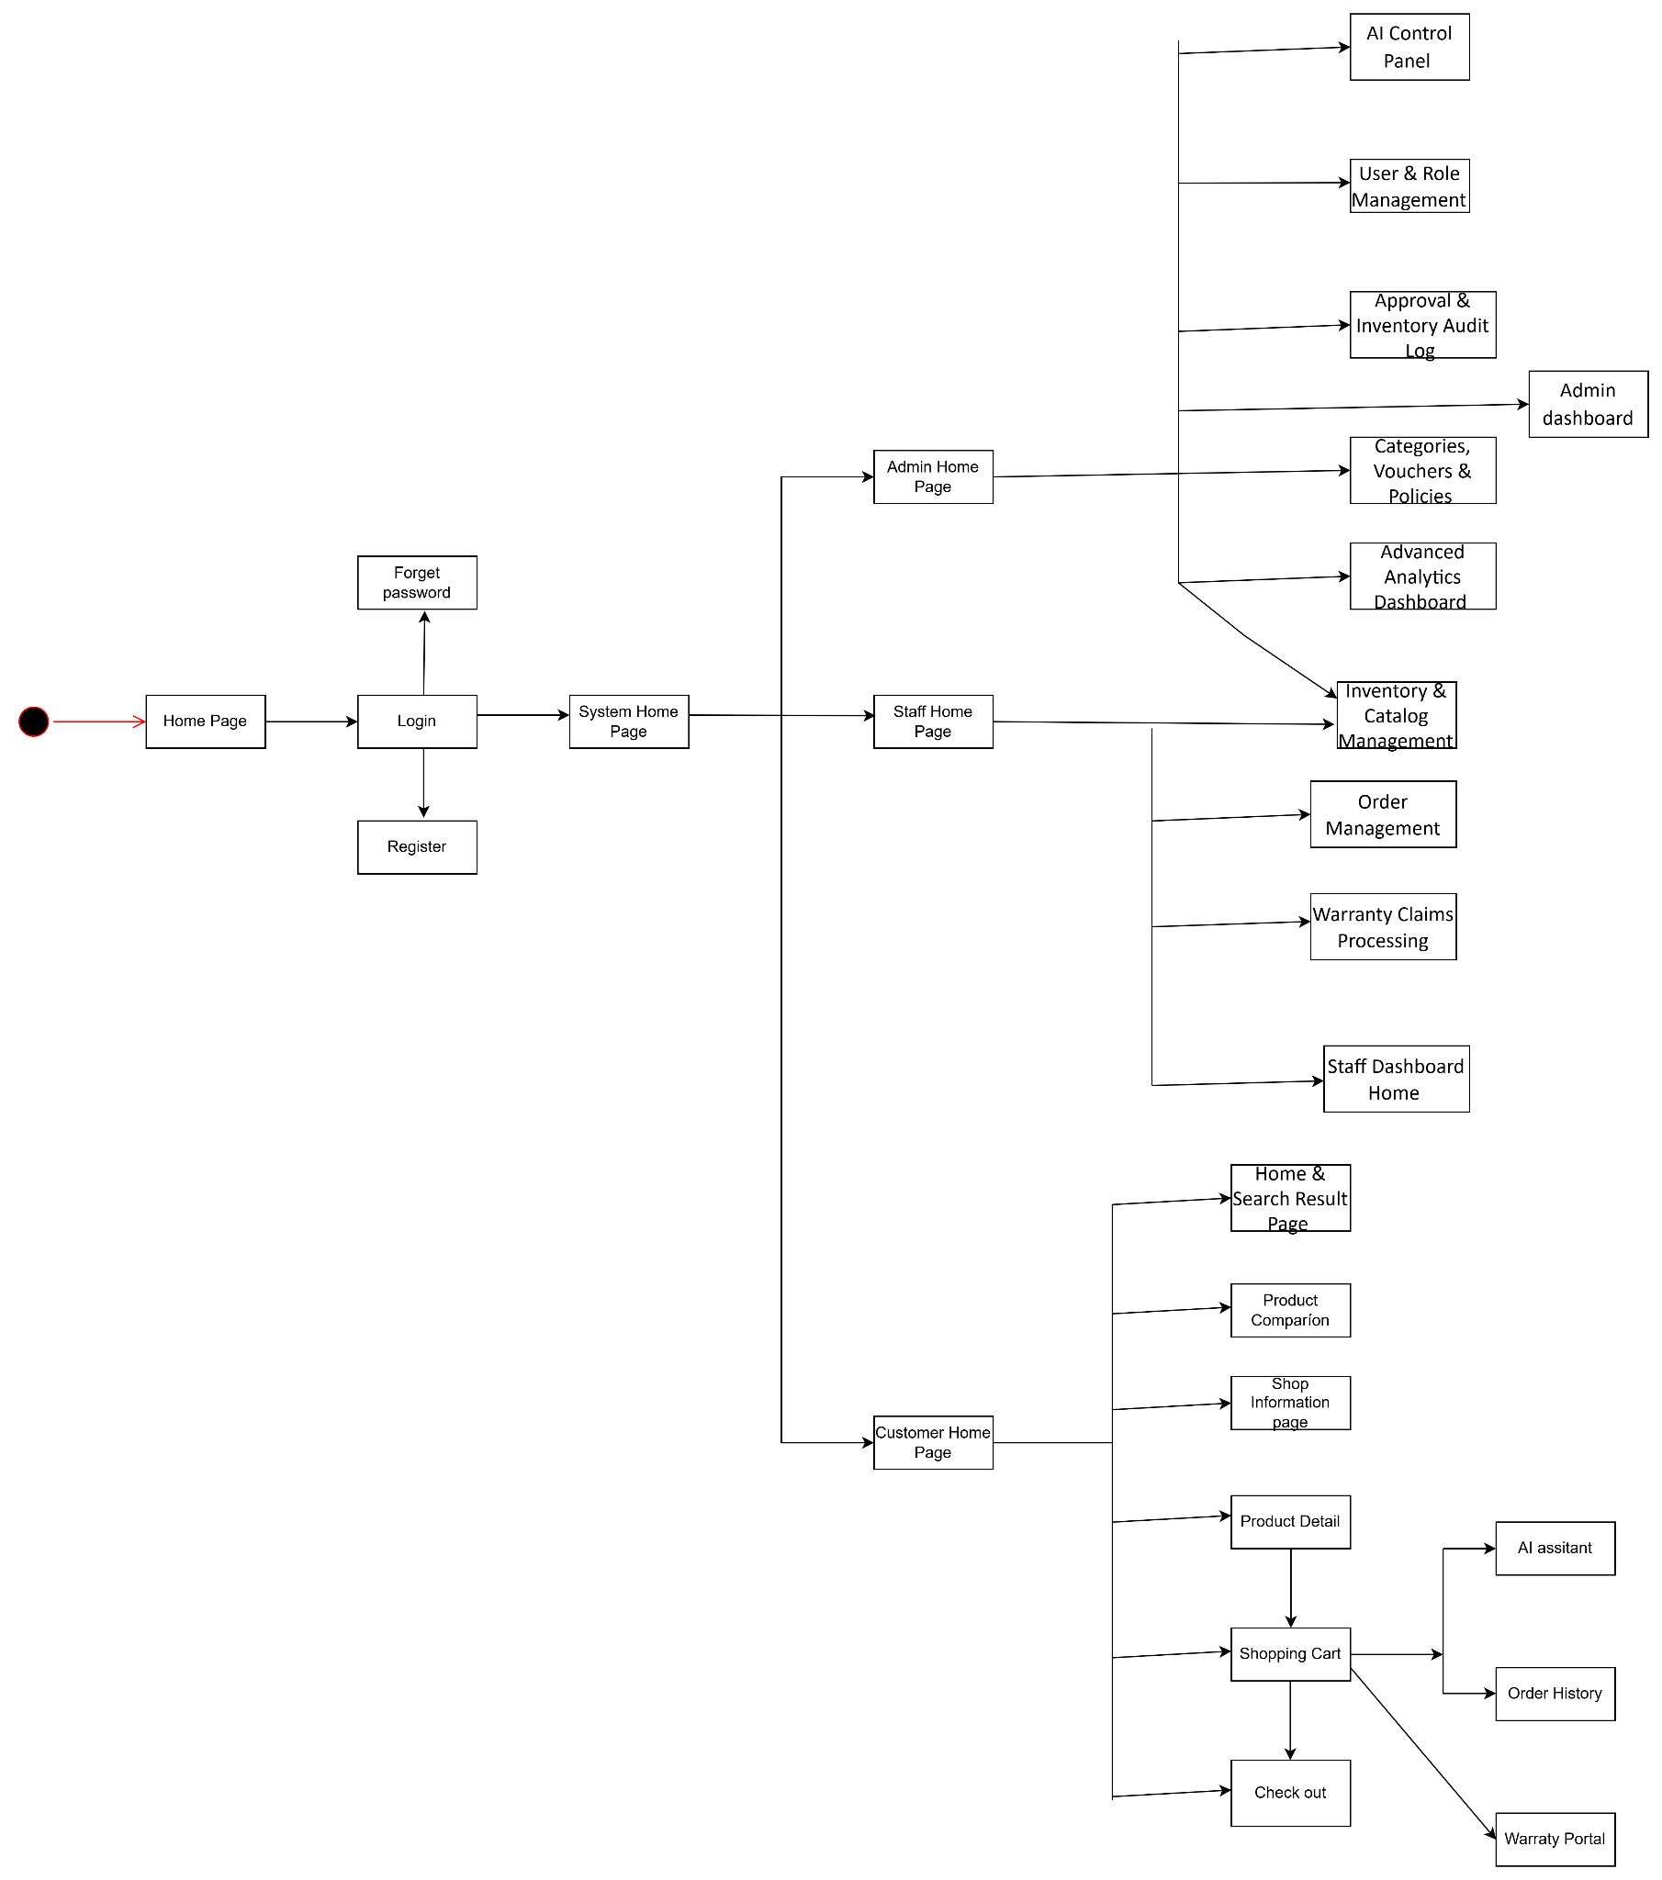

Overview Screen Flow

1.4.1.1 Admin Screen Flow

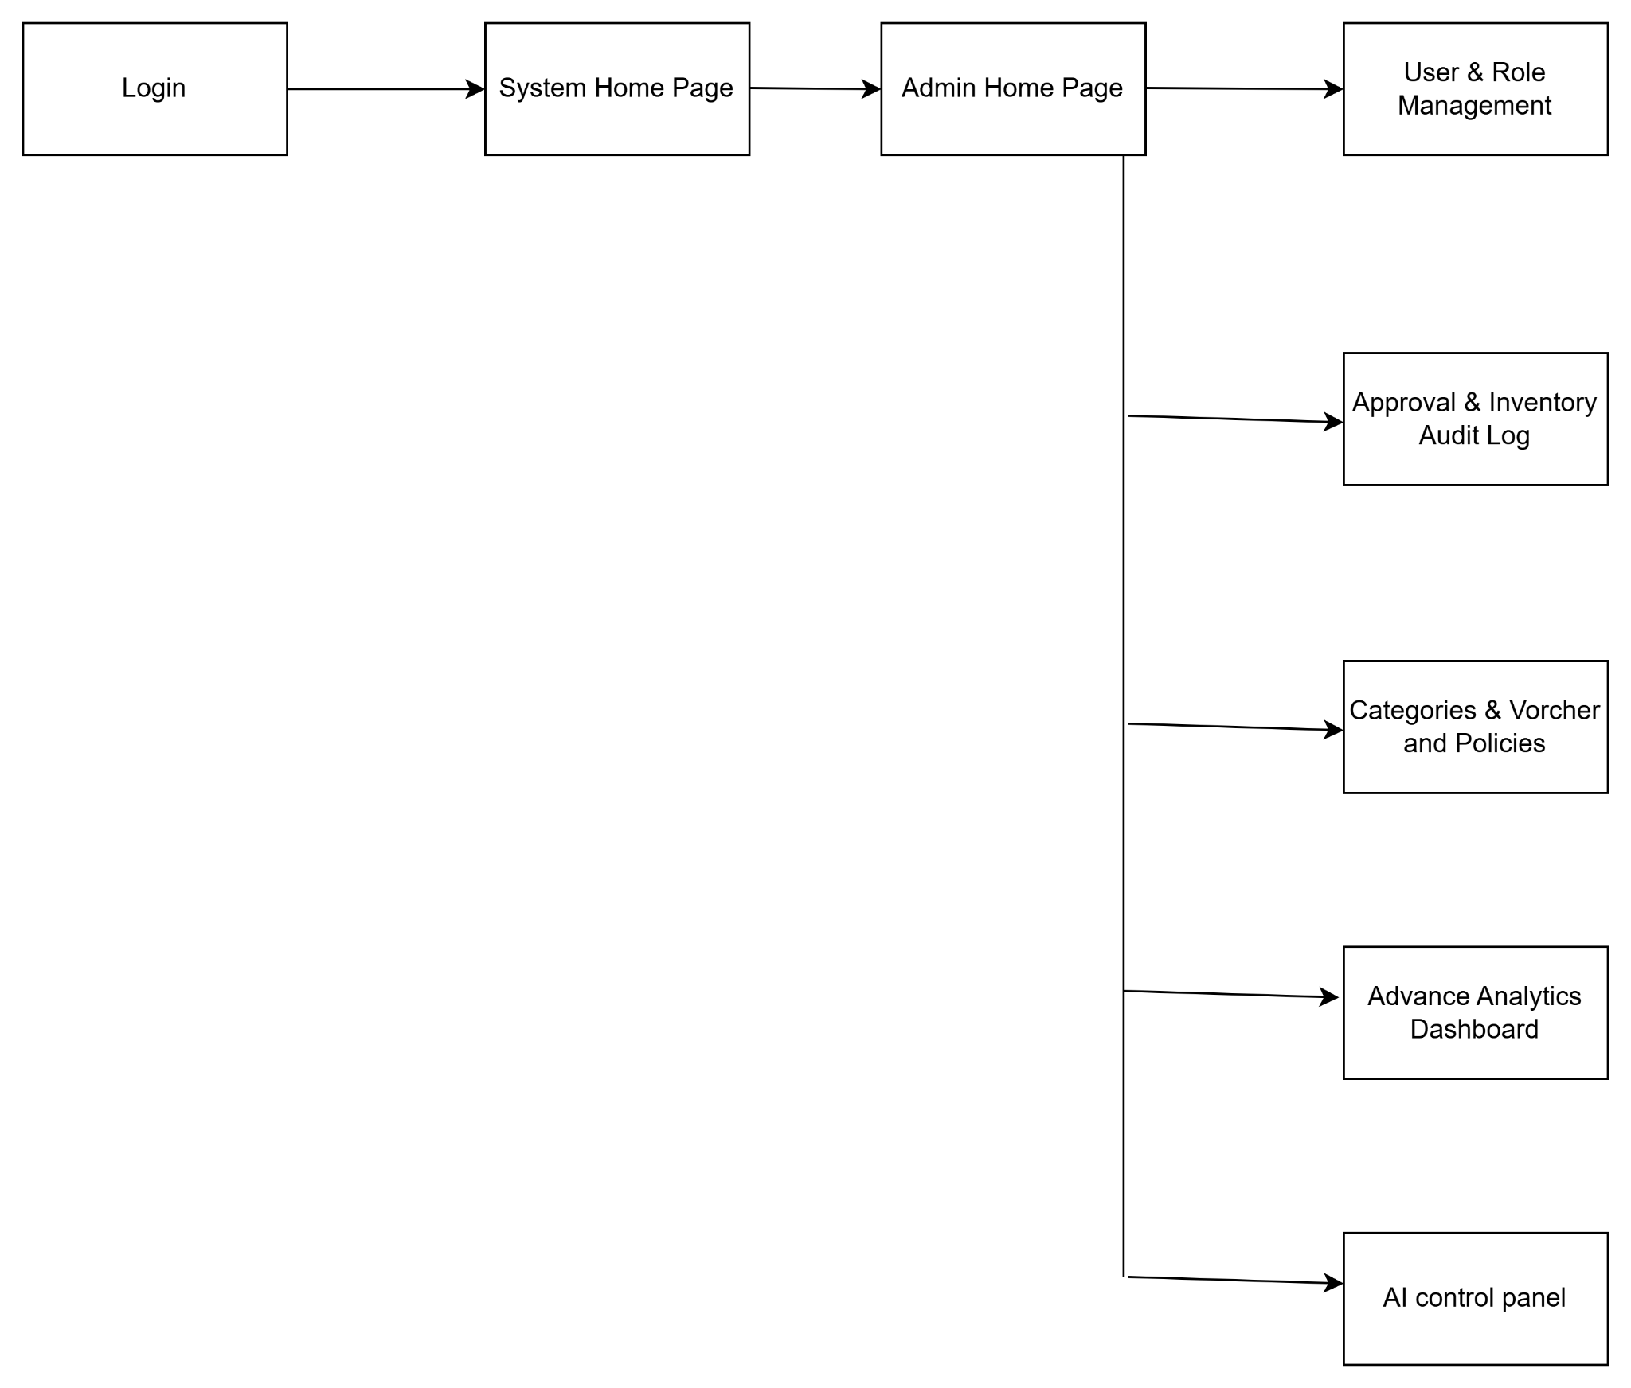
Admin Screen Flow

1.4.1.2 Staff Screen Flow

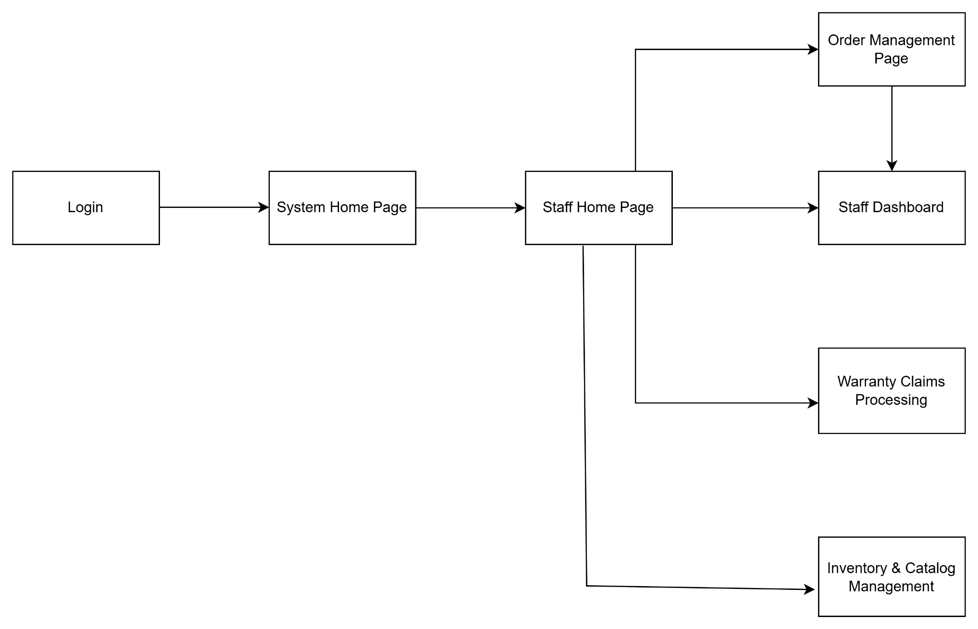
Staff Screen Management

1.4.1.3 Customer Screen Flow
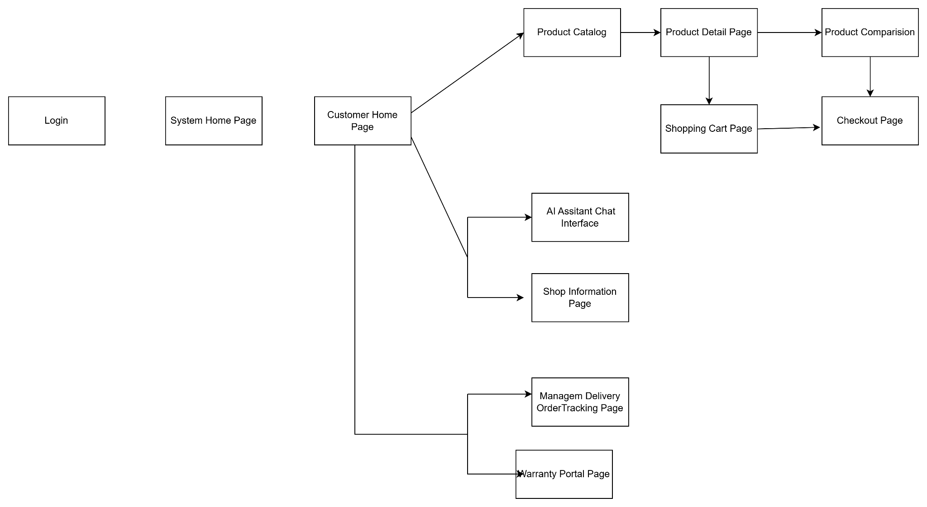
Customer Screen Flow
1.4.1.4 Guest Screen Flow
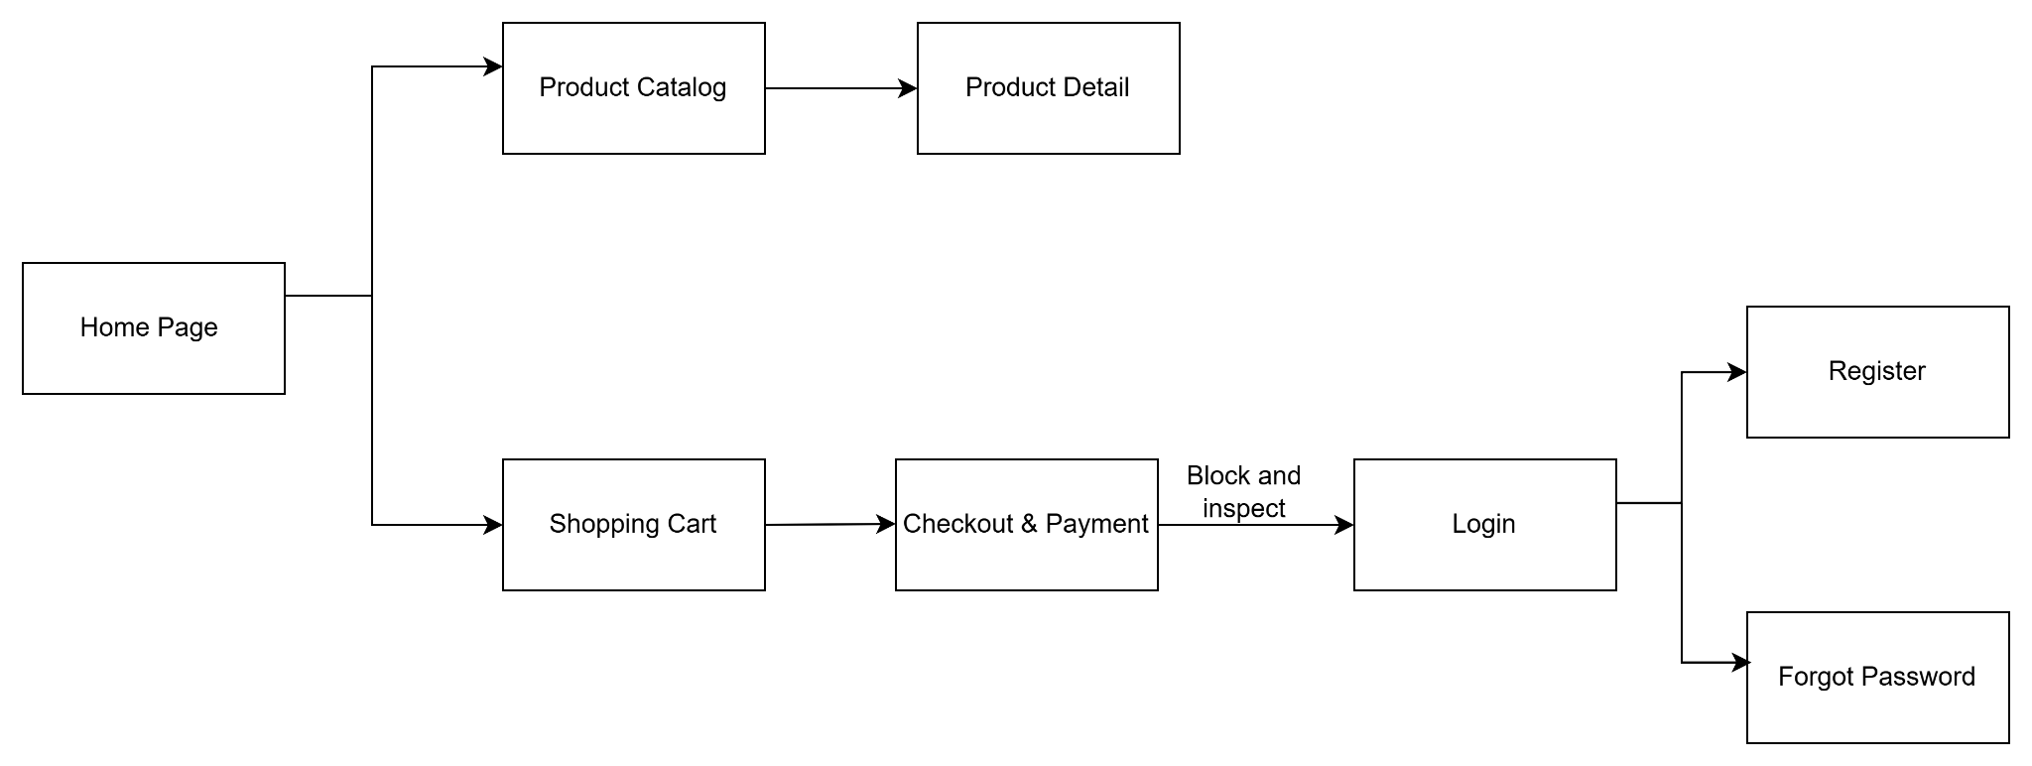
Guest Screen Flow

1.4.2 Screen Authorization

Screen | Guest | Customer | Staff | Administrator
Register Page | X | X
Login |  | X | X | X
Logout |  | X | X | X
Reset Password Page |  | X | X | X
User Profile |  | X | X | X
Manage Delivery Address |  | X
Home & Search Result Page | X | X
Product Detail Page | X | X
Product Comparison Page | X | X
Shopping Cart Page |  | X
Checkout Page |  | X
Shop Information Page | X | X
AI Assistant Chat Interface |  | X
Order History & Tracking |  | X
Warranty Portal |  | X
Staff Dashboard Home |  |  | X
Order Management Page |  |  | X
Warranty Claims Processing |  |  | X
Inventory & Catalog Management |  |  | X | X
Admin dashboard |  |  |  | X
User & Role Management |  |  |  | X
Approval & Inventory Audit Log |  |  |  | X
Categories, Vouchers & Policies |  |  |  | X
Advanced Analytics Dashboard |  |  |  | X
AI Control Panel |  |  |  | X

1.4.3 Non-UI Functions

# | Feature | System Function | Description
1 | Membership & Auth | BcryptCredentialEncryption | Automatically encrypt customer passwords before saving them to the database (users are not able to see this encryption process).
2 | Sales & Order | InventoryLockManager | Automatically and temporarily lock the inventory quantity as soon as a customer places an order, preventing two people from buying the same last item at the same time.
3 | AI Support | ExternalLLMGatewayAPI | Automatically call the API to send data to the OpenAI/Gemini server so the chatbot can process the customer's question and return the result.

1.5 Entity Relationship Diagram
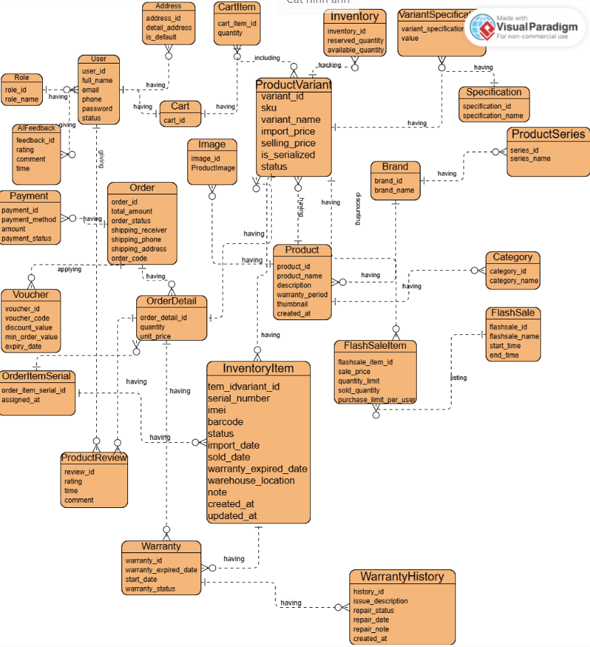
1.5 Logical Entity Relationship Diagram (ERD)

1.5.1 Mô tả các thực thể dữ liệu

1.5.1.1 Roles — Vai trò người dùng

Chức năng: Lưu danh sách các vai trò trong hệ thống để phục vụ phân quyền người dùng.
Thuộc tính | Mô tả
role_id | Mã vai trò
role_name | Tên vai trò (Admin, Staff, Customer)

1.5.1.2 User — Tài khoản người dùng

Chức năng: Quản lý thông tin tài khoản khách hàng và nhân viên.
Thuộc tính | Mô tả
user_id | Mã người dùng
full_name | Họ và tên
email | Email đăng nhập
phone | Số điện thoại
password | Mật khẩu đã mã hóa
status | Trạng thái tài khoản

1.5.1.3 Address — Địa chỉ giao hàng

Chức năng: Lưu địa chỉ nhận hàng của khách hàng.
Thuộc tính | Mô tả
address_id | Mã địa chỉ
detail_address | Địa chỉ chi tiết
is_default | Đánh dấu địa chỉ mặc định

1.5.1.4 Cart — Giỏ hàng

Chức năng: Lưu các sản phẩm khách hàng thêm vào trước khi đặt hàng.
Thuộc tính | Mô tả
cart_id | Mã giỏ hàng

1.5.1.5 CartItem — Chi tiết giỏ hàng

Chức năng: Lưu danh sách sản phẩm và số lượng trong giỏ hàng.
Thuộc tính | Mô tả
cart_item_id | Mã chi tiết giỏ hàng
quantity | Số lượng sản phẩm

1.5.1.6 Brand — Thương hiệu

Chức năng: Quản lý các thương hiệu sản phẩm trong hệ thống.
Thuộc tính | Mô tả
brand_id | Mã thương hiệu
brand_name | Tên thương hiệu

1.5.1.7 Category — Danh mục sản phẩm

Chức năng: Phân loại sản phẩm theo nhóm như Laptop, Chuột, Bàn phím,...
Thuộc tính | Mô tả
category_id | Mã danh mục
category_name | Tên danh mục

1.5.1.8 ProductSeries — Dòng sản phẩm

Chức năng: Quản lý các dòng sản phẩm thuộc từng thương hiệu.
Thuộc tính | Mô tả
series_id | Mã dòng sản phẩm
series_name | Tên dòng sản phẩm

1.5.1.9 Product — Sản phẩm

Chức năng: Lưu thông tin chung của sản phẩm.
Thuộc tính | Mô tả
product_id | Mã sản phẩm
product_name | Tên sản phẩm
description | Mô tả sản phẩm
warranty_period | Thời gian bảo hành
thumbnail | Ảnh đại diện
created_at | Ngày tạo

1.5.1.10 ProductVariant — Phiên bản sản phẩm

Chức năng: Quản lý các biến thể của sản phẩm.
Thuộc tính | Mô tả
variant_id | Mã phiên bản
sku | Mã SKU
variant_name | Tên phiên bản
import_price | Giá nhập
selling_price | Giá bán
is_serialized | Có quản lý serial hay không
status | Trạng thái

1.5.1.11 Image — Hình ảnh sản phẩm

Chức năng: Lưu các hình ảnh minh họa cho sản phẩm.
Thuộc tính | Mô tả
image_id | Mã hình ảnh
product_image | Đường dẫn hình ảnh

1.5.1.12 Inventory — Tồn kho

Chức năng: Theo dõi số lượng tồn kho của từng phiên bản sản phẩm.
Thuộc tính | Mô tả
inventory_id | Mã tồn kho
reserved_quantity | Số lượng đã giữ
available_quantity | Số lượng khả dụng
tracking_level | Mức theo dõi kho

1.5.1.13 InventoryItem — Sản phẩm trong kho

Chức năng: Quản lý từng sản phẩm vật lý riêng lẻ trong kho.
Thuộc tính | Mô tả
idvariant_id | Mã phiên bản
serial_number | Số serial
imei | Mã IMEI
barcode | Mã vạch
status | Trạng thái
import_date | Ngày nhập
sold_date | Ngày bán
warranty_expired_date | Ngày hết hạn bảo hành
warehouse_location | Vị trí trong kho
note | Ghi chú
created_at | Ngày tạo
updated_at | Ngày cập nhật

1.5.1.14 Specification — Thông số kỹ thuật

Chức năng: Lưu danh sách các loại thông số kỹ thuật áp dụng cho sản phẩm như CPU, RAM, Màu sắc, Dung lượng,...
Thuộc tính | Mô tả
specification_id | Mã thông số
specification_name | Tên thông số kỹ thuật

1.5.1.15 VariantSpecificationValue — Giá trị thông số sản phẩm

Chức năng: Lưu giá trị cụ thể của từng thông số cho mỗi Product Variant.
Thuộc tính | Mô tả
variant_specification_id | Mã liên kết
value | Giá trị của thông số

1.5.1.16 FlashSale — Chương trình Flash Sale

Chức năng: Quản lý các chương trình giảm giá trong một khoảng thời gian xác định.
Thuộc tính | Mô tả
flashsale_id | Mã chương trình
flashsale_name | Tên chương trình
start_time | Thời gian bắt đầu
end_time | Thời gian kết thúc

1.5.1.17 FlashSaleItem — Sản phẩm Flash Sale

Chức năng: Liên kết sản phẩm với chương trình Flash Sale và quản lý số lượng khuyến mãi.
Thuộc tính | Mô tả
flashsale_item_id | Mã sản phẩm Flash Sale
sale_price | Giá bán khuyến mãi
quantity_limit | Số lượng giới hạn
sold_quantity | Số lượng đã bán
purchase_limit_per_user | Giới hạn mua cho mỗi khách hàng

1.5.1.18 Voucher — Mã giảm giá

Chức năng: Quản lý các mã khuyến mãi áp dụng cho đơn hàng.
Thuộc tính | Mô tả
voucher_id | Mã voucher
voucher_code | Mã giảm giá
discount_value | Giá trị giảm giá
min_order_value | Giá trị đơn hàng tối thiểu
expiry_date | Ngày hết hạn

1.5.1.19 Order — Đơn hàng

Chức năng: Lưu thông tin tổng quan của các đơn hàng được tạo trong hệ thống.
Thuộc tính | Mô tả
order_id | Mã đơn hàng
total_amount | Tổng giá trị đơn hàng
order_status | Trạng thái đơn hàng
shipping_receiver | Người nhận hàng
shipping_phone | Số điện thoại nhận hàng
shipping_address | Địa chỉ giao hàng
order_code | Mã đơn hàng

1.5.1.20 OrderDetail — Chi tiết đơn hàng

Chức năng: Lưu danh sách sản phẩm thuộc từng đơn hàng.
Thuộc tính | Mô tả
order_detail_id | Mã chi tiết đơn hàng
quantity | Số lượng sản phẩm
unit_price | Đơn giá tại thời điểm mua

1.5.1.21 Payment — Thanh toán

Chức năng: Quản lý các giao dịch thanh toán của khách hàng.
Thuộc tính | Mô tả
payment_id | Mã thanh toán
payment_method | Phương thức thanh toán
amount | Số tiền thanh toán
payment_status | Trạng thái thanh toán

1.5.1.22 OrderItemSerial — Serial sản phẩm đã bán

Chức năng: Ghi nhận serial hoặc IMEI của sản phẩm được giao cho khách hàng trong đơn hàng.
Thuộc tính | Mô tả
order_item_serial_id | Mã bản ghi
assigned_at | Thời điểm gán serial

1.5.1.23 ProductReview — Đánh giá sản phẩm

Chức năng: Lưu đánh giá và phản hồi của khách hàng đối với sản phẩm đã mua.
Thuộc tính | Mô tả
review_id | Mã đánh giá
rating | Điểm đánh giá
time | Thời gian đánh giá
comment | Nội dung nhận xét

1.5.1.24 Feedback — Phản hồi khách hàng

Chức năng: Thu thập ý kiến đóng góp của khách hàng về dịch vụ và hệ thống.
Thuộc tính | Mô tả
feedback_id | Mã phản hồi
rating | Mức độ hài lòng
comment | Nội dung phản hồi
time | Thời gian gửi phản hồi

1.5.1.25 Warranty — Thông tin bảo hành

Chức năng: Quản lý thời gian và trạng thái bảo hành của từng sản phẩm đã bán.
Thuộc tính | Mô tả
warranty_id | Mã bảo hành
warranty_expired_date | Ngày hết hạn bảo hành
start_date | Ngày bắt đầu bảo hành
warranty_status | Trạng thái bảo hành

1.5.1.26 WarrantyHistory — Lịch sử bảo hành

Chức năng: Lưu toàn bộ lịch sử sửa chữa, bảo hành và thay thế linh kiện của sản phẩm trong thời gian bảo hành.
Thuộc tính | Mô tả
history_id | Mã lịch sử bảo hành
description | Nội dung xử lý bảo hành
repair_date | Ngày sửa chữa
repair_note | Ghi chú kỹ thuật
created_at | Ngày tạo bản ghi

2. Use Case Specifications

2.1 Authentication & Access

UC01 – Register Account

UC ID & Name | UC01 - Register
Created By | LUCTV
Date Created | May 26, 2026
Primary Actor | Guest
Secondary Actor | Database System
Trigger | Primary click on the “Register” tab or link
Description | To allow a Guest to create a new customer account in the system by providing their personal information. Upon successful registration, the Guest is recognized as a Customer and can proceed to sign in to access member-only services.
Preconditions | The Guest does not have an existing account associated with the email address or phone number they intend to use.
Postconditions | A new Customer account is created and activated. The user is guided to the Login page.
Normal Flow | - User navigates to Register page  - User enter:full name,email,phone, password and confirm password  - User clicks the Register button  - System validates the inputs  - System checks for duplicate email or phone in the database  - System hash the password using BCrypt  - System insert the user record into database with status ‘active’ and Role_id = 3  - System redirects the user to Login page with successful message
Alternative Flow | None
Exception Flow | - Exception Flow 1: Missing required fields  - System displays error message: "Please fill in all required fields!"  - Exception Flow 2: Invalid Name format (contains numbers/special characters)  - System displays error message:"Full name must only contain letters and spaces!  - Exception Flow 3: Name exceeds maximum length (over 100 characters)  - System displays error message:"Full name must not exceed 100 characters!"  - Exception Flow 4: Passwords mismatch  - System displays error message: "Passwords do not match!"  - Exception Flow 5: Invalid Email format  - System displays error message: "Invalid email address!"  - Exception Flow 6: Invalid Phone format (must be 10 digits starting with 03/05/07/08/09)  - System displays error message:"Invalid phone number!"  - Exception Flow 7: Password is too short (less than 6 characters)  - System displays error message: "Password must be at least 6 characters long!"  - Exception Flow 8: Email already in use  - System displays error message: "This email is already registered!"  - Exception Flow 9: Phone number already in use  - System displays error message: "This phone number is already registered!"
Business Rule | - BR1-Identity Uniquesness  Every registered user account must be identified by a unique Email address and a unique Phone Number. The system must prevent registration if either the Email or the Phone Number already exists in any other account.  - BR2-Default Account Status and Access Level  All new user accounts registered through the public sign-up interface must be automatically set to an Active status and assigned the default Customer role, allowing the user to immediately log in and utilize the platform's services.  - BR3-Credential Protection  To safeguard user privacy and security, all user passwords must be securely encrypted and protected. Storing passwords in plain-text format is strictly prohibited.  - BR4-Input Contraints & Formats  The system must enforce the following validation constraints on user inputs:  • Full Name: Must only consist of alphabetical characters and spaces (including Unicode/accented characters). The length must not exceed 100 characters.  • Password: Must have a minimum length of 6 characters.  • Phone Number: Must consist of exactly 10 digits and begin with standard mobile prefixes (03, 05, 07, 08, 09).  • Email: Must conform to standard email structure formats (e.g., user@domain.com).  - BR5-Mandatory Information  All fields presented in the registration form (Full Name, Email, Phone Number, Password, and Password Confirmation) are mandatory. The system must reject submissions where any of these fields are missing.  - BR6-Password Confirmation Agreement  The values entered in the "Password" and "Confirm Password" fields must be identical. If they do not match, the system must reject the registration request.
Priority | Must Have

UC02 – Login

UC ID & Name | UC02 - Login
Created By | LUCTV
Date Created | May 26, 2026
Primary Actor | Customer, Staff , Admin
Secondary Actor | Google OAuth Service(For Google Login)
Trigger | Primary actor triggers the Login function
Description | Verify credentials(or Google account) and grant access to system features based on role.
Preconditions | User account exists and is active.
Postconditions | User session is created and user is logged in successfully
Normal Flow | - User opens Login page.  - User enters email and password.  - System validates credentials.  - System generates access token/session.  - System redirects user to dashboard based on role.
Alternative Flow | - 1.User click “Continue with google”  - 2.System redirect user to Google’s authentication page  - 3.User successfully authentication their Google account  - 4.Google redirect back to system with an authenticate code  - 5.System exchange the code for user profile(email, name)  - 6.System checks user existence:if new, automatically registers them as Customer  - 7.System establishes user session and redirect to HomePage
Exception Flow | - Invalid email or password.  - Account is disabled or locked.
Business Rule | - BR1-Credential Verification  To gain access via standard sign-in, the user must provide a registered Email and the corresponding Password. If the email is not registered or the password does not match the stored credentials, the system must deny access.  - BR2-Account Status Check  The system must check the status of the account before granting access. Only accounts with an Active status are permitted to log in. Accounts that are locked or disabled must be blocked, and an appropriate lockout message must be displayed.  - BR3-Role-Based Redirection  Upon successful login, the system must dynamically route the user to their designated landing page based on their system role (e.g., Admin is routed to the Admin Dashboard, Staff to the Staff Operational/Inventory Interface, and Customer to the Storefront Home Page).  - BR4-Credential Persistence (Remember Me)  If the user checks the "Remember Me" option during login, the system must securely cache the user credentials on their browser for a maximum period of 7 days to bypass the login form in future sessions. If unchecked, any previously cached credentials must be removed.  - BR5-Automatic Registration via Google  If a user authenticates successfully using a Google account and their email does not exist in the system, the system must automatically register a new account for them under the Customer role with Active status, using their Google profile name and email address.  - BR6-Google Login Authorization  Existing users logging in via Google are subject to the same account status checks. If a user's local account is locked, they must be barred from logging in even if their Google authentication is successful.  - BR7-Mandatory Input Fields  For standard sign-in, both the Email and Password fields are mandatory. Submitting empty or whitespace-only inputs must be rejected by the system.
Priority | Must Have

UC03 – Request Password Reset

UC ID & Name | UC03 - Request Password Reset
Created By | LUCTV
Date Created | June 18, 2026
Primary Actor | Guest, Customer, Staff, Admin
Secondary Actor | Email Service (SMTP Server)
Trigger | Primary actor clicks "Forgot password?" link on the Login page
Description | Users can request a password reset by entering their registered email address. The system will send an OTP code or password reset link to the email to verify identity before allowing the password change.
Preconditions | User account exists in the system with a valid registered email.
Postconditions | An OTP/reset token is generated, stored in the system, and sent to the user's registered email address.
Normal Flow | - User clicks "Forgot password?" link on the Login page.  - System displays the Request Password Reset page with an email input field.  - User enters their registered email address.  - User clicks the "Send OTP" / "Send Reset Link" button.  - System validates the email format.  - System checks if the email exists in the database.  - System generates an OTP code (or reset token) and stores it with an expiration time (e.g., 5 minutes).  - System sends the OTP/reset link to the user's email via SMTP service.  - System displays a success message: "Mã OTP đã được gửi đến email của bạn. Vui lòng kiểm tra hộp thư."  - System redirects user to the OTP verification / Reset Password page.
Alternative Flow | - Resend OTP: User does not receive the OTP within the expected time.  - User clicks "Resend OTP" link on the verification page.  - System invalidates the previous OTP/token.  - System generates a new OTP/token with a new expiration time.  - System resends the new OTP to the user's email.  - System displays: "Mã OTP mới đã được gửi lại."
Exception Flow | - Exception 1: Email is null or invalid  System displays: "Vui lòng nhập địa chỉ email hợp lệ."  - Exception 2: Email is not exist in the system  System displays: "Email không tồn tại trong hệ thống."  - Exception 3: Account is locked/disable  System displays: "Tài khoản của bạn đã bị khóa. Vui lòng liên hệ Admin."  - Exception 4: Sending email is error  System displays: "Có lỗi xảy ra khi gửi email. Vui lòng thử lại sau."  - Exception 5: Seding email to many times  System displays: "Bạn đã yêu cầu quá nhiều lần. Vui lòng thử lại sau X phút."
Business Rule | - BR1-Email Verification  The system must check if the provided email is registered in the system. Password reset requests can only be initiated for existing, registered accounts.  - BR2-Account Status Validation  Only users with active accounts are allowed to request a password reset. If the account is locked or disabled, the reset request must be blocked, and the user must be informed to contact the administrator.  - BR3-Token Generation and Expiration  Upon receiving a valid request, the system must generate a unique security token/OTP. The token must have a strict expiration time (e.g., 5 minutes) from the time of generation to ensure security.  - BR4-Token Invalidation upon Resend  If the user requests to resend the reset token/OTP, the system must immediately invalidate any previously generated active tokens/OTPs for that user before issuing a new one to prevent reuse.  - BR5-Mandatory Input  The email address field is mandatory. The system must reject empty or null inputs and prompt the user to enter a valid email address format.  - BR6-Request Rate Limitining  To prevent system abuse and spamming, the system must enforce a rate limit on password reset requests. Users can only request a new reset token a maximum number of times within a specified timeframe. If exceeded, subsequent requests must be temporarily blocked.
Priority | Must Have

UC04 –Reset Password

UC ID & Name | UC04 - Reset Password
Created By | LUCTV
Date Created | June 18, 2026
Primary Actor | Guest, Customer, Staff, Admin
Secondary Actor | N/A
Trigger | Primary actor clicks the password reset link received in email
Description | Allow user to set a new password by entering and confirming a new password. System validates the reset token, updates the password (hashed via hashPasswordUtil.hashPassword()), and invalidates the token.
Preconditions | 1. User has received a valid password reset email (UC Request Password Reset completed).  2. The reset token is valid and has NOT expired.  3. User account exists and status is "active".
Postconditions | 1. User's password in the [User] table is updated with the new hashed password.  2. The reset token is marked as used / invalidated in the database.  3. User is redirected to Login page with a success message.
Normal Flow | - User clicks the reset link from email  - System validates the token (exists in DB, not expired, not already used).  - System displays the Reset Password form with fields: "New Password" and "Confirm Password".  - User enters new password and confirm password, then clicks "Reset Password".  - System validates:  - New password is not empty.  - New password meets minimum requirements (≥ 6 characters, contains at least 1 uppercase, 1 number).  - New password matches Confirm password.  - System hashes the new password .  - System updates the user's password in the database  - System invalidates/deletes the reset token.  - System redirects user to Login page
Alternative Flow | - User clicks the reset link from email:  - System validates the token and detects it has expired (> 15 minutes).  - System displays error: "Link đặt lại mật khẩu đã hết hạn." with a "Gửi lại link" button.  - User clicks "Gửi lại link".  - System redirects user to Request Password Reset page with email pre-filled.  - User clicks "Send Reset Link" to request a new token.  - System generates a new reset token and sends a new reset email.  - User receives the new email, clicks the new link, and continues the Normal Flow from step 1.
Exception Flow | - Exception 1: OTP is incorrect  System displays error page: "Link đặt lại mật khẩu không hợp lệ." with link back to Login.  - Exception 2: OTP has expired  System displays error: "Link đặt lại mật khẩu đã hết hạn. Vui lòng yêu cầu lại." with link to Request Password Reset page.  - Exception 3: OTP is used  System displays error: "Link đặt lại mật khẩu đã được sử dụng." with link back to Login. Password Reset page.  - Exception 4: New password is too short (< 6 characters)  System displays: "Mật khẩu phải có ít nhất 6 ký tự."  - Exception 5: Confirm password does not match  System displays: "Mật khẩu xác nhận không khớp."  - Exception 6: New password is the same as the old password  System displays: "Mật khẩu mới không được trùng với mật khẩu cũ."
Business Rule | - BR1-Token Validity and Expiration  A password reset token is only valid if it exists in the system, has not expired, and has not been used previously. If any of these conditions are violated, the system must reject the password reset attempt.  - BR2-One-Time Use Token  To maintain account security, a password reset token is strictly a single-use credential. Upon successful password reset, the system must immediately deactivate or invalidate the token, rendering it permanently unusable.  - BR3-Password Complexity Constraints  The new password must conform to system security standards, requiring a minimum length of 6 characters and containing at least one uppercase letter and one numeric character.  - BR4-New Password Validation  The values entered for the new password and the confirm password fields must be identical. If they do not match, the system must reject the submission.  - BR5-Password History Restriction  For enhanced security, the user is prohibited from setting a new password that is identical to their current active password.  - BR6-Pre-Filled Email on Expiration Redirect  If a password reset link is detected as expired, the system must pre-fill the user's registered email address when redirecting them back to the request reset page to improve user experience.
Priority | Must Have

UC05 –Change Password

UC ID & Name | UC05- Change Password
Created By | LUCTV
Date Created | May 26, 2026
Primary Actor | Customer, Staff , Admin
Secondary Actor | N/A
Trigger | Primary actor clicks "Change Password" option in personal profile page
Description | This interface, part of the personal profile page, requires you to enter your old and new passwords to update your security.
Preconditions | 1. User is logged in and has an active session.  2. User account status is "active".  3. User has an existing password (not a Google-only account).
Postconditions | 1. User's password in the database is updated with the new hashed password.  2. User session remains active.  3. System displays success message.
Normal Flow | - User navigates to their Personal Profile page.  - User clicks the "Change Password" option/button.  - System displays the Change Password form with fields: "Current Password", "New Password", and "Confirm New Password".  - User enters current password, new password, and confirm new password, then clicks "Save Changes".  - System validates current password is not empty.  - System verifies the current password matches the existing hashed password in DB  - System validates:  - New password is not empty.  - New password meets minimum requirements (≥ 6 characters, contains at least 1 uppercase, 1 number).  - New password is different from current password.  - New password matches Confirm New Password.  - System hashes the new password .  - System updates the user's password in the database  - User remains on Profile page.
Alternative Flow | - .User navigates to their Personal Profile page.  - User clicks the "Change Password" option/button.  - System detects that the account was registered via Google OAuth (password field is empty/null in DB).  - System displays a modified form with only "New Password" and "Confirm New Password" fields (no "Current Password" field).  - System displays note: "Tài khoản của bạn được đăng ký bằng Google. Hãy tạo mật khẩu để đăng nhập bằng email."  - User enters new password and confirm new password, then clicks "Save Changes"  - System validates new password (same rules as Normal Flow step 7, except no "different from current" check).  - System hashes and saves the new password to DB.  - System displays success message: "Mật khẩu đã được tạo thành công. Bạn có thể đăng nhập bằng email từ bây giờ."
Exception Flow | - E1:current password is blank  System displays error: "Vui lòng nhập mật khẩu hiện tại."  - E2:current password is not correct  System displays error: "Mật khẩu hiện tại không đúng."  - E3:new password is blank  System displays error: "Mật khẩu mới không được để trống."  - E4:new password is match with current password  System displays error: "Mật khẩu mới phải khác mật khẩu hiện tại."  - E5:new password is different with confirm password  System displays error: "Mật khẩu xác nhận không khớp."
Business Rule | - BR1-Session Requirement  The password change feature is only accessible to users who are currently logged into the system with an active and authenticated session.  - BR2-Current Password Authentication  For accounts with a pre-existing password, the user must provide their correct current password. The system must verify this before allowing any changes to the account credentials.  - BR3-Password Complexity Constraints  The new password must conform to the system security standards, requiring a minimum length of 6 characters and containing at least one uppercase letter and one numeric character.  - BR4-New Password Matching  The values entered for the new password and the confirm new password fields must be identical. If they do not match, the system must reject the submission.  - BR5-Password Difference Constraint  The newly selected password must be different from the user's current password to ensure a genuine security update.  - BR6-OAuth Account Password Creation  For accounts created via third-party login (e.g., Google OAuth) that do not have a local password set, the current password validation is bypassed. The user is allowed to set a new password directly, enabling them to log in using their email and password credentials in future sessions.
Priority | Must Have

2.2 Account Management

UC06 –Update Profile

UC ID & Name | UC06-Update Profile
Created By | LUCTV
Date Created | May 26, 2026
Primary Actor | Customer, Staff , Admin
Secondary Actor | N/A
Trigger | Primary actor clicks”Profile" button , admin click “Admin Profile” and staff click “Staff profile” on the Personal Profile page
Description | The interface allows users to edit personal information, update phone numbers or change avatars.
Preconditions | 1. User is logged in and has an active session.  2. User account status is "active".  3. User is on the Personal Profile page.
Postconditions | 1. User's updated information is saved to the [ in the database.  2. Session attributeis updated with the latest data.  3. System displays success message.
Normal Flow | - User navigates to the Personal Profile page.  - System displays current user information: Full Name, Email (read-only), Phone, Avatar.  - User clicks "Edit Profile" button.  - System enables editable fields: Full Name, Phone, and Avatar upload button. Email remains read-only.  - User modifies desired fields (e.g., updates phone number, uploads new avatar).  - User clicks "Save Changes".  - System validates:  - Full Name is not empty.  - Phone format is valid (10-11 digits, starts with 0).  - Phone is not already used by another account  - Avatar file ≤ 2MB and format is JPG/PNG (if uploaded).  - System updates user data in the database  - System updates the object in the current session with the latest data.  - System displays success message: "Thông tin cá nhân đã được cập nhật thành công."  - System returns to view mode (fields become read-only again).
Alternative Flow | - User navigates to the Personal Profile page.  - System detects the account was registered via Google OAuth (phone field is empty/null in DB).  - System displays the profile page with pre-filled Google data (Full Name, Email) and empty Phone field.  - System displays a notification banner: "Vui lòng bổ sung số điện thoại để hoàn tất hồ sơ."  - User clicks "Edit Profile", fills in the missing Phone number, and optionally uploads an avatar.  - User clicks "Save Changes".  - System validates and saves the data  - System removes the notification banner after successful update.
Exception Flow | - E1:fullname is blank  System displays error: "Họ tên không được để trống."  - E2:phone is invalid format  System displays error: "Số điện thoại phải gồm 10-11 chữ số và bắt đầu bằng 0."  - E3:phone is used by another account  System displays error: "Số điện thoại này đã được sử dụng bởi tài khoản khác."  - E4:avatar fils is too large  System displays error: "Ảnh đại diện không được vượt quá 2MB."  - E5:avatar file is invalid format  System displays error: "Chỉ chấp nhận file ảnh định dạng JPG hoặc PNG."
Business Rule | - BR1-Session and Account Status Requirement  Profile updates are restricted to users with active, authenticated sessions. The account must be in an active state to permit modifications.  - BR2-Immutable Account Identifiers  The user's registered Email address is a permanent account identifier and must remain read-only. Users are prohibited from modifying their email address during profile updates.  - BR3-Phone Number Uniqueness  The phone number must be unique across all user accounts. When a user updates their phone number, the system must verify that the new number is not already registered under any other active account in the system.  - BR4-Input Constraints for Profile Data  The system must enforce the following format rules: • Full Name: Cannot be empty or blank. • Phone Number: Must contain between 10 and 11 digits and start with the digit 0.  - BR5-Avatar File Constraints  If a user uploads a new profile picture (avatar), the file must be in either JPG or PNG format, and its size must not exceed 2MB.  - BR6-OAuth Profile Completion Prompt  For accounts logged in via third-party providers (e.g., Google OAuth) that do not have a phone number associated, the system must display an alert banner urging them to complete their contact details. The banner will be removed automatically once a valid phone number is saved.
Priority | Must Have

UC07 –Manage User Account

UC ID & Name | UC07-Manager User Account
Created By | LUCTV
Date Created | May 26, 2026
Primary Actor | Admin
Secondary Actor | N/A
Trigger | Admin clicks “Manager User Account" option in the admin sidebar
Description | This interface is specifically for administrators to monitor the entire list of accounts, search, assign roles, or lock/unlock accounts.
Preconditions | 1. Admin is logged in (roleId = 1) and has an active session.  2. Admin account status is "active".
Postconditions | 1. User account list is displayed with correct data and pagination.  2. If changes were made (role change, lock/unlock), the [User] table is updated accordingly.
Normal Flow | - Admin clicks "Manager User Account" in the admin sidebar.  - System queries all users from the [User] table  - System displays the Manage User Account page with a table containing columns: User ID, Full Name, Email, Phone, Role, Status, Actions.  - Admin views the user list with pagination (e.g., 10 users per page).  - Admin enters a keyword (email or name) in the Search bar and clicks "Search".  - System queries the [User] table with filter  - System displays the filtered results in the user table.
Alternative Flow 1 | - Admin opens the Manage User Account page (Normal Flow steps 1–4).  - Admin clicks "Lock" button on a specific user row (status = "active").  - System displays confirmation dialog: "Bạn có chắc muốn khóa tài khoản [user email]?"  - Admin confirms the action.  - System updates the user's status to "inactive"  - System refreshes the user list and displays success message: "Tài khoản đã được khóa thành công."
Alternative Flow 2 | - Admin opens the Manage User Account page (Normal Flow steps 1–4).  - Admin clicks "Change Role" dropdown on a specific user row.  - System displays available roles: Customer (3), Staff (2), Admin (1).  - Admin selects the new role.  - System displays confirmation dialog: "Bạn có chắc muốn đổi quyền tài khoản [user email] thành [role name]?"  - Admin confirms the action.  - System updates the user's role in the database  - System refreshes the user list and displays success message: "Phân quyền đã được cập nhật thành công."
Exception Flow | - E1:Admin locked admin’s account  System displays error: "Bạn không thể khóa tài khoản của chính mình."  - E2:Admin chane role’s admin  System displays error: "Bạn không thể thay đổi quyền của chính mình."  - E3:There are no result by searching  System displays message: "Không tìm thấy tài khoản nào phù hợp với từ khóa."
Business Rule | - BR1-Administrative Privilege Requirement  Access to the User Account Management interface is strictly restricted to accounts possessing Administrator privileges. Non-admin accounts must be blocked from accessing this feature.  - BR2-Self-Locking Protection  To prevent complete administrative lockouts, the system must prohibit an Administrator from locking or deactivating their own currently logged-in account.  - BR3-Self-Role Modification Restriction  An Administrator is strictly prohibited from modifying or downgrading their own role assignment within the system.  - BR4-Data Presentation and Search Filtering  The user accounts list must support pagination to ensure optimal load times. The system must allow searching of the user directory by matches on name or email address keywords.  - BR5-Role Assignment Constraints  Administrators can reassign user accounts to any valid system role (e.g., Customer, Staff, or Administrator) with the change taking effect immediately after verification.  - BR6-Critical Action Confirmation  Any request to change a user's role or access status (locking/unlocking) must require explicit confirmation from the Administrator before the system processes the request.
Priority | Must Have

UC08 –View Personal Profile

UC ID & Name | UC08-View Personal Profile
Created By | LUCTV
Date Created | May 26, 2026
Primary Actor | Admin
Secondary Actor | N/A
Trigger | Primary actor clicks the “Trang cá nhân” link in the navbar/menu
Description | Personal profile interface, displaying all current account information including full name, email, phone number, role, and avatar. (Giao diện thuộc trang cá nhân, hiển thị toàn bộ thông tin tài khoản hiện tại bao gồm họ tên, email, số điện thoại, vai trò và ảnh đại diện.)
Preconditions | 1. User is logged in and has an active session.  2. User account status is "active".
Postconditions | 1. User's profile details are retrieved from the database and successfully displayed on the UI.  2. Session user object is updated with the latest database records.
Normal Flow | - Actor click”Trang cá nhân” link in navbar menu  - System retrieves the userId from the logged-in user session object.  - System queries the [User] table in the database.  - System updates the user object in the current session with the latest queried data.  - System displays the View Personal Profile page.  - System renders the user's detailed information: Full Name, Email, Phone, Role, and Avatar image.
Alternative Flow | - User navigates to the Personal Profile page (Normal Flow steps 1–5).  - System detects the account was registered via Google OAuth (phone field is empty/null in the database).  - System displays the profile page with the phone number field left blank, showing a warning banner: "Hãy cập nhật số điện thoại của bạn để tăng tính bảo mật."  - System displays an "Edit Profile" or "Update" button next to it to allow the user to quickly navigate to the update form.
Exception Flow | - E1:Session expired  System redirects to the Login page with the message: "Phiên đăng nhập đã hết hạn . Hãy đăng nhập lại."  - E2:Database query error  System displays the error message: Hiện tại không thể truy xuất thông tin tài khoản. Vui lòng thử lại sau!
Business Rule | - BR1-Session Validation Requirement  Access to the personal profile details is restricted to users with active, authenticated sessions. If the session expires, access must be terminated immediately.  - BR2-Active Status Constraint  The system must verify that the user's account is in an active state. Suspended or locked accounts are prohibited from viewing their profile details.  - BR3-Information Synchronization  The profile interface must display the latest information stored in the system. The system must synchronize the current user session with the latest account record upon every profile view request.  - BR4-Missing Contact Information Alert  If a user profile is missing required contact details (such as a phone number for accounts registered via third-party providers like Google OAuth), the system must display a warning banner prompting them to complete their profile.  - BR5-Easy Navigation to Profile Editing  When a profile is incomplete, the system must provide direct, one-click access (e.g., an update button) to the profile modification form from the profile viewing interface.
Priority | Must Have

2.3 E-Commerce Operations

UC09 – Browse Home Products & Search Products
UC ID & Name: UC09 – Browse Home Products & Search Products
Created By | MinhCT
Date Created | 2026-06-02
Primary Actor | Guest/Customer
Secondary Actor | None
Trigger | User accesses the system homepage.
Description | User views featured products on the homepage (Flash Sale, Best Seller, New Products), searches for products via the search bar, filters by category tab, and navigates to the product list or product detail page.
Preconditions | 1. The system is operational.  2. Product data exists in the database.
Postconditions | 1. User can view products by section and selected category tab.  2. System navigates to the product list or product detail page based on user action.
Normal Flow | 1. User accesses the homepage.  2. System displays the advertising banner and a search bar in the navigation bar.  3. System displays product sections: Flash Sale (with countdown timer), Best Seller, and New Products.  4. User performs one of the following actions:  a. Enters a keyword in the search bar → system navigates to the product list page with matching results.  b. Selects a category tab (Laptop / Mouse / Keyboard) within a section → system updates the product list accordingly.  c. Selects a specific product → system opens the product detail page.  d. Clicks "View All" → system navigates to the full product list of that section.
Exception Flow | EF1: Search keyword does not match any product – System navigates to the product list page and displays: "No matching products found."
Priority | High
Business Rules | BR-1. Flash Sale countdown timer is determined by the campaign end time configured by Admin.  BR-2. Best Seller ranking is calculated based on total confirmed order quantity within a rolling period defined by Admin.

UC10 – Browse & Search Product Catalog
UC ID & Name: UC10 – View Product Detail
Created By | MinhCT
Date Created | 2026-06-02
Primary Actor | Guest
Secondary Actor | None
Trigger | User clicks on a product listing from the catalog or search results page.
Description | View comprehensive specifications, explicit pricing, real-time stock availability, and descriptions of a hardware component.
Preconditions | 1. The selected product exists and is active in the system.
Postconditions | 1. The product detail page is displayed with full information including specifications, price, stock status, and images.
Normal Flow | 1. User selects a product from the catalog or search results.  2. System retrieves the product record from the database.  3. System renders the product detail page with images, full specifications, current price, and real-time stock availability.  4. System displays related product recommendations.  5. User reviews the product information.
Exception Flow | EF1: Product has been disabled or deleted – System displays a "Product not available" message and redirects user to the catalog.
Priority | High
Business Rules | - BR-1. Only products with status ACTIVE are displayed in the catalog; disabled products (UC22) are hidden from public view.  - BR-2. Filter options displayed in the left panel are dynamically generated based on the active product attributes within the current category.  - BR-3. Multiple filter criteria within the same panel are combined with AND logic .  - BR-4. "Most popular" sort order is calculated from total confirmed sales volume over a rolling period defined by Admin.

UC11 – View Product Detail
UC ID & Name: UC11 – View Product Detail
Created By | MinhCT
Date Created | 2026-06-17
Primary Actor | Guest / Customer
Trigger | The user clicks a product from the homepage, the product list page (Laptop / Keyboard / Mouse / Accessories) or from the search results.
Description | The user views a product's details: image gallery, name & brand, price block (selling price, original price, % off from Flash Sale), selects a variant (Color / Chip CPU / RAM / SSD), checks real-time stock availability, reads the technical specifications, reads customer reviews and ratings, browses similar products, and performs Add to cart or Buy now.
Preconditions | • PRE-1. The system is operational.  • PRE-2. The selected product exists and is in ACTIVE status.  • PRE-3. The product has at least one valid variant (ProductVariant).
Postconditions | • POST-1. The detail page fully displays the product information for the selected variant.  • POST-2. The selected variant is added to the cart or proceeds to checkout (when the user acts).
Normal Flow | 1.0 View product detail  • 1. The user selects a product.  • 2. The system retrieves the Product along with related ProductVariant, Brand, Category, images, Specification / VariantSpecification, Inventory, FlashSaleItem, and Review/Rating.  • 3. The system displays the breadcrumb, image gallery and main info block: name + code, highlight badge, price block (selling price / struck-through original price / -%), quick spec chips (CPU, GPU, Display…).  • 4. The system displays the variant selector: Color, Chip (CPU), RAM, SSD — together with stock status.  • 5. The system displays the “Add to cart” / “Buy now” buttons.  • 6. The system displays the tabs: Description / Technical specifications / Reviews.  • 7. The system displays the “Similar products” section.  • 8. The user selects all attributes (Color / Chip / RAM / SSD), reviews the information and clicks Add to cart / Buy now.  • 9. The system updates the cart or proceeds to the checkout page.
Alternative Flows | 1.1 Change variant attributes (Color / Chip / RAM / SSD)  • 1. The user selects a different value for any attribute (color, chip, RAM or SSD).  • 2. The system determines the ProductVariant matching the selected combination and updates the price, SKU, stock status and images accordingly in real time, without reloading the page.  • 3. When the Color changes, the system switches the gallery to that color's image set.  1.2 Switch content tabs  • 1. The user switches between Description / Technical specifications / Reviews.  • 2. The system displays the content of the selected tab.  1.3 View similar products  • 1. The user clicks a card in “Similar products”.  • 2. The system opens that product's detail page.  1.4 Buying while not logged in (Guest)  • 1. A guest clicks “Buy now” → the system may require sign in/registration (BA to confirm the behavior).  1.5 View product reviews & ratings  • 1. The user opens the Reviews tab.  • 2. The system displays the average rating (stars), the total number of reviews, the rating distribution (1–5 stars) and the list of reviews (reviewer name, star rating, comment text, review date, optionally images).  • 3. The user may filter reviews by star rating or sort them (e.g. newest, highest/lowest rating, most helpful).  1.6 Submit a product review (Customer who purchased the item)  • 1. A logged-in Customer who has an OrderDetail for this product with order status = Delivered/Completed clicks “Write a review”.  • 2. The user selects a star rating (1–5) and enters a comment (optionally attaches images).  • 3. The system validates and saves the Review, then updates the product's average rating and review count.  • 4. The system shows a confirmation message and displays the new review in the list.
Exception Flow | • EF1: The product is disabled/deleted → the system shows “Product not available” and redirects to the category page.  • EF2: The selected variant is out of stock (Inventory.available_quantity = 0) → the system shows “Out of stock” and disables the “Add to cart” / “Buy now” buttons.  • EF3: The selected attribute combination (Color + Chip + RAM + SSD) has no matching variant → the system disables/hides invalid options or shows “Configuration not available”.  • EF4: An image fails to load → the system shows a placeholder image.  • EF5: The Flash Sale has expired → the system shows the original price and hides the discount badge.  • EF6: There are no similar products → the system hides the suggestion section.  • EF7: The product has no reviews yet → the system shows “No reviews yet – be the first to review this product” and hides the rating distribution chart.  • EF8: A user who has not purchased the product (or is not logged in) tries to submit a review → the system hides/disables the “Write a review” action or shows “Only customers who purchased this product can review it”.  • EF9: A duplicate review attempt for the same order item → the system shows “You have already reviewed this product” and offers to edit the existing review instead.
Priority | High

2.4 Public Information

UC12 – View Shop Information
UC ID & Name: UC12 – View Shop Information
Created By | System Analyst
Date Created | 2026-06-02
Primary Actor | Guest
Secondary Actor | None
Trigger | User navigates to the Shop Information, Policy, or Contact page.
Description | Review general store policies, explicit warranty terms, contact guidelines, and sample electronic invoices.
Preconditions | 1. System is operational.  2. Shop information content has been configured by Admin.
Postconditions | 1. Shop information including policies, warranty terms, and contact details is displayed to the user.
Normal Flow | 1. User clicks on the Information, Policy, or Contact link in the navigation.  2. System loads the relevant information page.  3. System displays store policies, warranty terms, contact information, and sample invoice format.  4. User reads the displayed information.
Exception Flow | EF1: Content not yet configured – System displays a placeholder message indicating the information page is being updated.
Priority | Low

2.5 Account Management (Customer)

UC13 – Manage Delivery Address
UC ID & Name: UC13 – Manage Delivery Address
Created By | System Analyst
Date Created | 2026-06-17
Primary Actor | Customer
Secondary Actor | None
Trigger | Customer navigates to the Address Management section in their account settings.
Description | Add, edit, remove, or set default delivery addresses for subsequent order checkouts.
Preconditions | 1. Customer is logged in with an active session.
Postconditions | 1. The delivery address list is updated with the Customer's changes.  2. The default delivery address is set if specified.
Normal Flow | 1. Customer navigates to the Address Management section.  2. System loads the existing delivery address list.  3. Customer selects an action: Add New Address, Edit Existing Address, Remove Address, or Set Default.  4. For Add/Edit: Customer enters or modifies address fields (recipient name, phone, street, district, city, province).  5. System validates all required address fields.  6. System saves the address changes to the database.  7. System updates the address list and confirms the action.
Exception Flow | EF1: Missing required address field – System highlights the incomplete field and prevents saving.  EF2: Attempting to delete the only/default address while active orders exist – System warns user and prevents deletion.
Priority | High

2.6 E-Commerce Operations (Customer)

UC14 – View Shopping Cart
UC ID & Name: UC14 – View Shopping Cart
Created By | MinhCT
Date Created | 2026-06-17
Primary Actor | Guest / Customer
Trigger | The user clicks “Add to cart”on the product detail page, or opens the Cart page.
Description | The user adds a product variant to the cart (stored in the session), views the cart, updates quantities, removes products, views the total amount and proceeds to checkout.
Preconditions | • PRE-1. The system is operational.  • PRE-2. The product / variant exists and is in ACTIVE status.
Postconditions | • POST-1. The cart (session) correctly reflects the list of variants and quantities.  • POST-2. The total quantity and total amount are computed correctly.
Normal Flow | 1.0 Add & view cart  • 1. The user selects a variant on the detail page and clicks “Add to cart”.  • 2. The system retrieves the variant info (Flash Sale price, stock) and adds it to the cart; if it already exists, the quantity is accumulated (not exceeding stock).  • 3. The system navigates to the cart page showing: image, product name, variant, unit price, quantity, subtotal and grand total.  • 4. The user updates quantities or removes products.  • 5. The system recalculates subtotals and the grand total.  • 6. The user clicks “Proceed to checkout” → navigates to the checkout page.
Alternative Flows | 1.1 Buy now  • 1. The user clicks “Buy now” → the system adds the variant to the cart then goes straight to the checkout page.  1.2 Update quantity  • 1. The user enters a new quantity → the system updates; if the quantity ≤ 0 → the product is automatically removed from the cart.  1.3 Remove product  • 1. The user clicks “Remove” → the system removes the variant from the cart.  1.4 Continue shopping  • 1. When the cart is empty, the system shows a “Continue shopping” link to return to the homepage.
Exception Flow | • EF1: The variant is out of stock (available_quantity = 0) → the system does not add it and shows “Out of stock”.  • EF2: The requested quantity exceeds stock → the system caps the quantity at the available stock.  • EF3: The cart is empty → the system shows “Your cart is empty” with a continue-shopping link.
Priority | High

2.7 Checkout & Place Order

UC15 – Checkout Order
UC ID & Name: UC15 – Checkout & Place Order
Created By | MinhCT
Date Created | 2026-06-17
Primary Actor | Customer
Trigger | The user clicks “Proceed to checkout” from the cart, or “Buy now” from the product detail page.
Description | The user reviews and confirms the order information, selects the delivery method (Home delivery or Store pickup), enters the recipient information + delivery address, applies a discount code / voucher (if any) and chooses a payment method. The system displays the order details (the list of all products, product subtotal, discounts, shipping fee if any and the amount to pay), then creates the order, deducts stock, clears the cart and displays the order-success page.
Preconditions | • PRE-1. The system is operational.  • PRE-2. The cart has at least one product.  • PRE-3. The user is logged in (session user).
Postconditions | • POST-1. One [Order] row and its [OrderDetail] rows are created.  • POST-2. Inventory.available_quantity is decremented by the ordered quantity.  • POST-3. The cart is cleared; the order code / success page is shown.  • POST-4. The amount to pay = product subtotal − discounts + shipping fee (if any), saved to [Order].
Normal Flow | 1.0 Checkout  • 1. The user clicks “Proceed to checkout”.  • 2. The system checks the login; if not logged in → redirects to the login page.  • 3. The system displays the shipping information form, the delivery method selection (Home delivery / Store pickup), the list of all products in the order, the discount code / voucher input, and the payment method (e.g. COD).  • 4. The user selects the delivery method: if Home delivery, they enter the full shipping information (recipient name, phone, address); if Store pickup, no delivery address is required.  • 5. (Optional) The user enters/selects a discount code or voucher → the system validates and applies it if valid (a voucher that reduces the product amount or a voucher that waives/reduces the shipping fee).  • 6. The system displays the total breakdown table: product subtotal (sum of all products in the order) → discounts (discount code / voucher) → shipping fee (if delivered to the address, minus the freeship voucher if any) → amount to pay.  • 7. The user chooses a payment method and confirms the order.  • 8. The system validates the shipping information (all required fields filled, phone in the correct format; if Home delivery is selected the delivery address must not be empty and must be detailed enough; if Store pickup, no delivery address is required) and validates the payment method (a method must be selected; for bank transfer/online the payment info/result must be valid). If anything is invalid, the system shows an error message next to the corresponding field and does not create the order.  • 9. Once valid, the system creates the [Order] (user_id, total amount (including discounts and shipping fee), status, order date, shipping information) and the [OrderDetail] rows (variant_id, quantity, unit price).  • 10. The system decrements Inventory.available_quantity accordingly.  • 11. The system clears the cart (session).  • 12. The system displays the “Order placed successfully” page with the order code.
Alternative Flows | 1.1 Not logged in  • 1. The system redirects to the login page; after logging in it returns to the checkout page.  1.2 Select & validate the payment method  • 1. The user selects COD (cash on delivery) or bank transfer/online (if available).  • 2. The system validates the choice: COD is accepted immediately; for bank transfer/online it verifies the payment info/result before confirming the order.  1.3 Fix invalid data  • 1. The user submits the order with missing or incorrect shipping/payment information → the system marks the erroneous fields, keeps the entered data and lets the user fix it and resubmit.  1.4 Store pickup  • 1. The user selects “Store pickup” → the system hides / does not require the delivery address field.  • 2. The order is created with the store-pickup method (no delivery address required).  1.5 Home delivery  • 1. The user selects “Home delivery” → the system shows and requires the delivery address (must not be empty) before the order can be placed.
Exception Flow | • EF1: The cart is empty → the system redirects to the cart page.  • EF2a: A required shipping field is missing/empty (recipient name, phone; and the address when Home delivery is selected) → the system highlights the missing fields, shows “Please enter complete shipping information” and does not create the order.  • EF2a': Home delivery is selected but the delivery address is empty → the system shows “Please enter the delivery address” next to the address field and does not allow order creation.  • EF2b: The phone is invalid (wrong format / too few digits / contains letters) → the system shows “Invalid phone number” next to the phone field.  • EF2c: The address is too short / not detailed enough → the system shows “Please enter a more detailed address”.  • EF2d: No payment method is selected → the system shows “Please select a payment method” and does not create the order.  • EF2e: A bank transfer/online payment fails or is not confirmed → the system does not create/confirm the order and shows a payment-failed message (skipped for COD).  • EF2f: The discount code / voucher is invalid / expired / not eligible → the system shows “Invalid discount code / voucher” and does not apply it (the order can still proceed).  • EF3: A product becomes out of stock / has insufficient stock during checkout → the system reports an error and stops order creation (rollback).  • EF4: A DB write error → the system rolls back everything and reports an error; the cart is kept intact.
Priority | High
Frequency of Use | Medium–High; occurs whenever a customer completes a purchase.
Business Rules | • BR-1. Only a logged-in Customer can place an order.  • BR-2. The unit price stored in [OrderDetail] is the price at the time of ordering.  • BR-3. The order total = the sum of (unit price × quantity) across the rows.  • BR-4. Creating the order and deducting stock must be within a single transaction (all succeed or rollback).  • BR-5. Ordering is not allowed if stock < the ordered quantity.  • BR-6. The shipping fields (recipient name, phone, address) are required and must be validated on both the client and server side before creating the order.  • BR-7. The phone must be in the correct format (e.g. 10 digits, numbers only) and the address must meet a minimum length.  • BR-8. A payment method must be selected; for online/bank-transfer payments the order is only created/confirmed when the payment result is valid, while COD is accepted immediately.  • BR-9. A delivery method must be selected: for Home delivery the delivery address is required and must not be empty; for Store pickup no delivery address is needed.  • BR-10. A discount code / voucher is only applied when valid (still effective, eligible, correct type); a voucher may reduce the product amount or waive/reduce the shipping fee; applied per the current promotion rules.  • BR-11. The amount to pay = product subtotal − discounts + shipping fee (the shipping fee only applies for home delivery; store pickup = 0).
Other Information | The default method is COD; an online payment gateway can be integrated later.
Assumptions | The [Order], [OrderDetail], [Inventory] tables already exist in the DB. The column structure of [Order] will be confirmed during CN9 implementation.

UC16 – Track & Manage Order
UC ID & Name: UC16 – Track & Manage Order
Created By | System Analyst
Date Created | 2026-06-02
Primary Actor | Customer
Secondary Actor | None
Trigger | Customer navigates to the Order History or Order Detail page.
Description | View order details, monitor real-time shipping progress, or cancel an order if it is within the allowed cancellation timeframe.
Preconditions | 1. Customer is logged in.  2. Customer has at least one existing order.
Postconditions | 1. Order details and current status are displayed.  2. If cancellation is requested: order status is updated and a cancellation request is logged for Staff review.
Normal Flow | 1. Customer navigates to the Order History page.  2. System displays a list of the Customer's orders with status indicators.  3. Customer selects an order to view details.  4. System displays order items, payment info, delivery address, and current shipping progress timeline.  5. If the order status allows cancellation: Customer clicks "Cancel Order" and provides a reason.  6. System validates that the order is within the allowed cancellation window.  7. System updates order status to CANCEL_REQUESTED and notifies Staff.  8. System confirms the cancellation request to Customer.
Exception Flow | EF1: Order has already been shipped or is in a non-cancellable state – System disables the Cancel button and informs Customer the order can no longer be cancelled.  EF2: Order not found – System displays an error message.
Priority | High

2.8 Product Review

UC17 - Submit Product Review
UC ID & Name | UC17 - Submit Product Review
Created By | MINHBQ
Date Created | June 2, 2026
Primary Actor | Customer
Secondary Actor | None
Trigger | Customer opens a completed order detail or eligible product page and selects Submit Review.
Description | Allow customers who have purchased and received a product to submit ratings, written comments, and optional images. The system verifies purchase eligibility, prevents duplicate reviews, and saves the review according to moderation rules.
Preconditions | 1. Customer is logged in.  2. Customer has purchased the product.  3. The related order is delivered, completed, or received.  4. Customer has not reviewed the same product in the same order.
Postconditions | 1. Product review is saved successfully.  2. Review status is set to pending approval or visible based on moderation policy.  3. Product rating information may be updated after approval.
Normal Flow | 1. Customer opens the completed order detail or product detail page.  2. System checks whether the product is eligible for review.  3. System displays the review form.  4. Customer selects a star rating.  5. Customer enters review content.  6. Customer optionally uploads review images.  7. Customer submits the review.  8. System validates rating, content, and image format.  9. System saves the review.  10. System displays a successful submission message.
Alternative Flow | AF1: Submit review without images  1. Customer leaves the image upload field empty.  2. System validates rating and review content only.  3. System saves the review successfully.
Exception Flow | EF1: Customer is not eligible  1. System detects that the customer has not purchased or received the product.  2. System blocks the review submission.  3. System displays an eligibility error message.  EF2: Duplicate review  1. System detects that the customer already reviewed the same product in the same order.  2. System prevents duplicate submission.  3. System displays a duplicate review message.  EF3: Invalid review data  1. Customer submits missing rating, empty content, or invalid image format.  2. System displays validation errors.  3. Customer corrects the form before resubmitting.  EF4: System cannot save review  1. System encounters a database or server error.  2. System displays an error message.  3. Customer may try again later.
Priority | Medium
Business Rules | BR-07, BR-31

UC18 - View Product Reviews
UC ID & Name | UC36 - View Product Reviews
Created By | MINHBQ
Date Created | June 2, 2026
Primary Actor | Guest, Customer
Secondary Actor | None
Trigger | Guest or Customer opens a product detail page and scrolls to the review section.
Description | Allow guests and customers to view product ratings and customer reviews on the product detail page, including average score, review count, comments, images, reviewer information, and review time before making purchase decisions.
Preconditions | 1. Product detail page is accessible.  2. Product exists and is visible to public users.  3. Review data is available or the system can display an empty review state.
Postconditions | 1. Product review list is displayed.  2. Average rating and total review count are shown.  3. User can use review information to support purchase decisions.
Normal Flow | 1. Guest or Customer opens a product detail page.  2. System loads product information.  3. System retrieves approved reviews for the product.  4. System calculates average rating and total review count.  5. System displays review summary.  6. System displays review list with rating, comment, image, reviewer, and review time.  7. User reads reviews before deciding to purchase.
Alternative Flow | AF1: Product has no reviews  1. System finds no approved reviews for the product.  2. System displays a message indicating that no reviews are available.  3. Product detail page remains accessible.
Business Rules | BR-29, BR-30
Exception Flow | EF1: Product not found  1. System cannot find the selected product.  2. System displays a product not found message.  3. User may return to product browsing.  EF2: System cannot load reviews  1. System encounters a database or server error while loading reviews.  2. System keeps the product detail page visible.  3. System displays a review loading error message.  EF3: Review image cannot be loaded  1. System detects an unavailable review image.  2. System hides the broken image or displays a placeholder.  3. Remaining review content is still displayed.
Priority | Medium
Business Rules | BR-29, BR-32, BR-33

UC19 - Manage Product Reviews
UC ID & Name | UC37 - Manage Product Reviews
Created By | MINHBQ
Date Created | June 2, 2026
Primary Actor | Staff, Admin
Secondary Actor | None
Trigger | Staff or Admin opens the Product Review Management page from the administration area.
Description | Allow staff and administrators to search, filter, approve, hide, or delete product reviews. The system supports moderation by checking review content, rating details, approval status, and reviewer information to maintain reliable feedback.
Preconditions | 1. Staff or Admin is logged in.  2. Staff or Admin has permission to access Product Review Management.  3. Product review data exists or the system can display an empty list.
Postconditions | 1. Selected review status is updated successfully.  2. Approved reviews become visible to users.  3. Hidden or deleted reviews are not displayed on the public product detail page.  4. Review moderation history may be recorded.
Normal Flow | 1. Staff or Admin opens the Product Review Management page.  2. System displays review list with product, customer, rating, content, and status.  3. Staff or Admin searches or filters reviews.  4. System returns matching review results.  5. Staff or Admin selects a review.  6. Staff or Admin chooses approve, hide, or delete.  7. System validates permission and selected action.  8. System updates the review status.  9. System displays a successful moderation message.
Alternative Flow | AF1: Search returns no results  1. Staff or Admin enters filter conditions.  2. System finds no matching reviews.  3. System displays an empty result message.  AF2: Staff or Admin cancels moderation  1. Staff or Admin opens a review action.  2. Staff or Admin cancels the action before confirmation.  3. System keeps the review unchanged.
Exception Flow | EF1: Access denied  1. System detects that the current account has no review management permission.  2. System blocks access to the page.  3. System displays an access denied message.  EF2: Review not found  1. System cannot find the selected review.  2. System displays a review not found message.  3. Staff or Admin may refresh the review list.  EF3: Invalid moderation action  1. System receives an invalid or unsupported action.  2. System rejects the request.  3. System displays an invalid action message.  EF4: System cannot update review  1. System encounters a database or server error.  2. System displays an error message.  3. Staff or Admin may try again later.
Priority | High
Business Rules | BR-29, BR-32, BR-33

2.9 AI System Integration

UC20 – Interact with AI Assistant
UC ID & Name: UC14 – Interact with AI Assistant
Created By | System Analyst
Date Created | 2026-06-02
Primary Actor | Customer
Secondary Actor | AI Recommendation Engine
Trigger | Customer opens the AI Assistant chat interface and submits a query.
Description | Query the AI assistant for custom hardware configuration recommendations and component compatibility checks.
Preconditions | 1. Customer is logged in.  2. AI Assistant service is operational.  3. Customer's AI access has not been revoked.
Postconditions | 1. AI assistant returns a response with hardware recommendations, compatibility analysis, or configuration guidance.  2. The interaction session is logged for quality and moderation purposes.
Normal Flow | 1. Customer opens the AI Assistant interface.  2. System loads the chat session and greets Customer.  3. Customer types a query (e.g., hardware build requirements, component compatibility question).  4. System forwards the query to the AI Recommendation Engine with relevant context.  5. AI engine processes the query, checks the knowledge base, and generates a response.  6. System displays the AI-generated recommendations including compatible product suggestions with direct links.  7. Customer may follow up with additional questions; conversation history is maintained within the session.  8. Customer optionally rates the AI response.
Exception Flow | EF1: AI service is unavailable – System displays a service unavailability message and suggests contacting support.  EF2: Query contains prohibited content or prompt injection detected – System blocks the query and warns Customer.  EF3: Customer's AI access has been revoked – System informs Customer that AI assistant access is restricted.
Priority | High

2.10 Warranty Operations (Customer)

UC21 – Submit Warranty Request

ID & Name | UC20 – Submit Warranty Request
Created By | DuyLD
Date Created | 2026-06-07
Primary Actor | Customer
Secondary Actors | Staff
Description | Customer verifies warranty eligibility for a purchased product and submits a formal warranty claim with defect description and media evidence. The system enforces warranty period validation, order ownership verification, and product eligibility before creating the claim record.
Trigger | Customer navigates to the Warranty Portal and selects "Submit New Warranty Request".
Preconditions | • Customer is authenticated and holds an active session.  • The target order exists in the system and was placed by this Customer.  • The product is within its warranty period as defined by the active Warranty Policy.  • The order status is COMPLETED or DELIVERED.
Postconditions | • A warranty claim record is created with status PENDING.  • The warranty audit history log records the creation event with timestamp and actor.  • Staff receives an in-system notification of the new claim.
Normal Flow | 1. Customer opens the Warranty Portal and selects Submit Warranty Request.  2. System displays eligible orders and products covered by an active warranty.  3. Customer selects a product, enters defect details, and uploads supporting evidence.  4. System validates order ownership, warranty eligibility, and uploaded file compliance.  5. Customer reviews the summary and confirms submission.  6. System creates a PENDING claim, records the event in the audit log, and notifies Staff.
Alternative Flow | AF1: Re-upload After File Rejection (triggered at Step 4 when a file fails validation).  1. System highlights the invalid file and displays a descriptive error message.  2. Customer removes the rejected file and uploads a compliant replacement.  3. System re-validates the new file.  4. Flow resumes at Step 5.
Exception Flow | EF1: Warranty Ineligibility Detected (triggered at Step 4).  1. System evaluates eligibility and detects one of the following blocking conditions: (a) warranty period has expired; (b) order does not belong to the authenticated Customer; or (c) no active Warranty Policy is linked to the product.  2. System displays the appropriate ineligibility notice and prevents form submission.  3. Flow ends; no claim record is created.
Priority | High
Frequency of Use | Medium – triggered upon product defect occurrence within the warranty period.
Business Rules | • BR-15, BR-16, BR-17
Assumptions | • Purchase date and warranty duration are accurately stored in the database at order completion.  • The active Warranty Policy record for the product is accessible at claim time.

UC22 – Track Warranty Status
ID & Name | UC21 – Track Warranty Status
Created By | DuyLD
Date Created | 2026-06-07
Primary Actor | Customer
Secondary Actors | None
Description | Customer views all submitted warranty claims and inspects the full details of a selected claim, including uploaded evidence, current status, processing timeline, and Staff resolution remarks. A Customer may also cancel a PENDING claim from within this view.
Trigger | Customer navigates to the Warranty History section of the Warranty Portal.
Preconditions | • Customer is authenticated and holds an active session.  • At least one warranty claim has been submitted by the Customer.
Postconditions | • The system displays the current status and full details of the selected warranty claim.  • No data modification occurs unless the Customer initiates a cancellation (see AF1).
Normal Flow | 1. Customer opens My Warranty Requests.  2. System retrieves and displays all warranty claims associated with the account.  3. Customer selects a claim to view its detail page.  4. System displays claim status, status timeline, uploaded evidence, and Staff remarks.  5. Customer reviews the information.  6. System displays the latest claim status and available actions.
Alternative Flow | AF1: Cancel Pending Warranty Request (triggered at Step 5 when claim status is PENDING).  1. System displays the Cancel Request button only when claim status is PENDING.  2. Customer clicks Cancel Request; system shows a confirmation dialog.  3. Customer confirms cancellation.  4. System performs a server-side re-check to verify the claim is still PENDING.  5. System updates claim status to CANCELLED, appends a CANCELLED entry to the audit log, and displays a success message.  6. System refreshes the claim detail view to reflect the updated CANCELLED status.
Exception Flow | EF1: Cancellation Blocked Due to Status Change (triggered at AF1 Step 4).  1. System detects that the claim status has changed from PENDING (e.g., to IN_PROGRESS) between page load and the commit attempt.  2. System hides the Cancel Request button and displays: "This claim is already being processed and cannot be cancelled."  3. No data modification is committed; flow ends.
Priority | Medium
Frequency of Use | Medium – triggered when a Customer checks claim progress or considers cancellation.
Business Rules | • BR-05, BR-18, BR-19
Assumptions | • Claim status transitions are recorded with accurate timestamps in the warranty audit history log.  • Uploaded media files remain accessible in the file storage system throughout the claim lifecycle.  • The system performs a server-side status re-validation immediately before committing the CANCELLED state to prevent race conditions.

2.11 Service Operations (Staff)

UC23 – Process Order
UC ID & Name: UC22 – Process Order
Created By | System Analyst
Date Created | 2026-06-02
Primary Actor | Staff
Secondary Actor | Customer
Trigger | Staff accesses the Order Management dashboard and reviews pending orders.
Description | Review pending orders, approve or reject them, and progress the execution status (Confirmed, Packed, Shipped).
Preconditions | 1. Staff is logged in with order management permissions.  2. At least one order with PENDING status exists.
Postconditions | 1. Order status is updated to CONFIRMED, PACKED, SHIPPED, or REJECTED.  2. Customer is notified of the status change.
Normal Flow | 1. Staff navigates to the Order Management dashboard.  2. System displays a list of orders filtered by status, with PENDING orders highlighted.  3. Staff selects a pending order to review.  4. System displays order details including items, quantities, customer information, and payment status.  5. Staff verifies stock availability and payment validity.  6. Staff approves the order; System updates status to CONFIRMED.  7. Staff prepares the order and updates status to PACKED.  8. Staff dispatches the order and updates status to SHIPPED with tracking information.  9. System notifies Customer at each status transition.
Exception Flow | EF1: Insufficient stock for order items – Staff rejects the order; System updates status to REJECTED and notifies Customer with reason.  EF2: Payment validation fails (online payment unconfirmed) – Staff places order on hold pending payment confirmation.
Priority | High

UC24 – Handle Order Cancellation
UC ID & Name: UC23 – Handle Order Cancellation
Created By | System Analyst
Date Created | 2026-06-02
Primary Actor | Staff
Secondary Actor | Customer
Trigger | Customer submits a cancellation request, generating a task for Staff review.
Description | Assess customer-submitted order cancellation requests to explicitly approve or deny them based on order status.
Preconditions | 1. Staff is logged in with order management permissions.  2. A cancellation request with CANCEL_REQUESTED status exists.
Postconditions | 1. Cancellation request is approved or denied.  2. If approved: order status is updated to CANCELLED and stock is restored.  3. Customer is notified of the decision.
Normal Flow | 1. Staff receives notification of a new cancellation request.  2. Staff opens the cancellation request in the Order Management panel.  3. System displays the order details and Customer's stated cancellation reason.  4. Staff reviews the current order processing state.  5. Staff approves the cancellation; System updates order to CANCELLED.  6. System restores the reserved stock quantities.  7. System processes any applicable refund if online payment was made.  8. System notifies Customer that the cancellation has been approved.
Exception Flow | EF1: Order has already been shipped prior to Staff review – Staff denies the cancellation; System updates status back and notifies Customer that cancellation is no longer possible.
Priority | High

2.12 Warranty Operations (Staff)

UC25 – Process Warranty Claim

ID & Name | UC24 – Process Warranty Claim
Created By | DuyLD
Date Created | 2026-06-07
Primary Actor | Staff
Secondary Actors | Customer
Description | Staff reviews a submitted warranty claim, evaluates uploaded media evidence, and updates the claim status through the defined state machine: PENDING → IN_PROGRESS → COMPLETED or REJECTED. Every status transition is recorded in the audit log and triggers a customer notification. When resolution involves a refund, Staff initiates the refund lifecycle within this flow.
Trigger | Staff accesses the Warranty Claims Processing queue and selects a claim for review.
Preconditions | • Staff is authenticated with warranty processing permissions.  • At least one warranty claim with PENDING status exists in the processing queue.  • The claim has not been cancelled by the Customer.
Postconditions | • Warranty claim status is updated per the Staff decision: IN_PROGRESS, COMPLETED, or REJECTED.  • Each status transition is recorded in the audit log with event type, actor ID, and timestamp.  • Customer receives an in-system notification of the status change.  • Resolution remarks are saved to the claim record for COMPLETED or REJECTED outcomes.
Normal Flow | 1. Staff opens the Warranty Claims Processing queue.  2. System displays all PENDING claims available for review.  3. Staff selects a claim and reviews its details, evidence, and linked warranty policy.  4. Staff sets status to IN_PROGRESS and enters resolution remarks.  5. Staff selects a final outcome: Approve, Reject, or Refund Resolution.  6. System updates claim status to COMPLETED or REJECTED, records the transition in the audit log, and notifies Customer.
Alternative Flow | AF1: Refund Resolution (triggered at Step 5 when Staff selects Refund as resolution type).  1. Staff selects Refund as the resolution type and clicks Initiate Refund.  2. System validates refund eligibility: confirms the original order was paid via Online Payment; if COD, system displays an ineligibility notice and flow ends.  3. System creates a refund record with status PENDING, linked to the claim, and logs the REFUND_CREATED event.  4. Staff reviews the Refund Summary (Claim ID, Order ID, Customer, Product, Refund Amount) and clicks Approve Refund.  5. System updates refund status to APPROVED, restores product stock by +1 unit, and logs the REFUND_APPROVED event.  6. System notifies Customer of approval; Staff or the payment gateway executes the payment transfer; system updates refund status to PAID and updates the warranty claim to COMPLETED.
Exception Flow | EF1: Claim Processing Failure (triggered at Step 6).  1. Database commit fails during the status update.  2. System displays a retry prompt; the claim status remains unchanged.  3. Staff retries the operation; flow resumes at Step 6.
Priority | High
Frequency of Use | High – processed by Staff for every submitted warranty claim.
Business Rules | • BR-17, BR-20, BR-21, BR-22, BR-23
Assumptions | • Staff has access to the product's active Warranty Policy record at the time of claim processing.  • Customer notification service is operational during claim processing.  • The payment gateway API is operational and capable of processing reverse transactions.  • The refund amount equals the original unit price of the order line item at the time of purchase.

2.13 Inventory Management (Staff)

UC26 – Manage Product Catalog
UC ID & Name: UC26 – Manage Product Catalog
Created By | HuyDQ
Date Created | 2026-06-02
Primary Actor | Staff
Secondary Actor | None
Trigger | Staff accesses the Inventory Management section to create or modify a product.
Description | Create new hardware profiles or modify existing product specifications, pricing, imagery, and structural information.
Preconditions | 1. Staff is logged in with inventory management permissions.  2. Product category exists for new product creation.
Postconditions | 1. New product record is created, or existing product information is updated.  2. Can manipulate product variant
Normal Flow | 1. Staff navigates to the Inventory Management section.  2. Staff selects "Add Product" or selects an existing product to edit.  3. Staff enters or updates product details: name, category, brand, specifications, price, and description.  4. Staff uploads product images.  5. System validates all required fields and image formats.  6. System saves the product record.  7. If approval workflow is active: System submits the change for Admin review.  8. System confirms the save action to Staff.
Exception Flow | EF1: Required product field is missing – System highlights the field and prevents saving.  EF2: Duplicate product name/SKU detected – System alerts Staff and requests a unique identifier.  EF3: Invalid image format uploaded – System rejects the file and requests a supported format.
Priority | High

UC27 – Create Product Variant
UC ID & Name: UC26 – Create Product Variant
Created By | HuyDQ
Date Created | 2026-06-02
Primary Actor | Staff
Secondary Actor | None
Trigger | Staff selects "Add Product" in the Inventory Management section.
Description | Register a new hardware profile including its name, category, brand, description, thumbnail image, and one or more product variants.
Preconditions | 1. Staff is logged in with inventory management permissions.  2. Product category and brand exist in the system.
Postconditions | 1. A new product record is saved to the database.  2. Associated product variants are created.
Normal Flow | 1. Staff navigates to the Inventory Management section.  2. Staff selects "Add Product".  3. Staff enters product details: name, category, brand, and description.  4. Staff uploads a product thumbnail image.  5. Staff adds one or more product variants (specifying unique SKU, import price, selling price, and attributes like RAM or Color).  6. System validates all required fields, image format, and unique SKU.  7. System saves the product and variant records to the database.  8. System redirects the Staff to the Inventory Management section with a success confirmation.
Exception Flow | EF1: Required field missing – System highlights the field and prevents saving.  EF2: Duplicate product name/SKU detected – System alerts Staff and requests a unique identifier.  EF3: Invalid image format uploaded – System rejects the file and requests a supported format.
Priority | High

UC28 – View Inventory List
UC ID & Name: UC27 – View Inventory List
Created By | HuyDQ
Date Created | 2026-06-02
Primary Actor | Staff
Secondary Actor | None
Trigger | Staff accesses the Inventory Management section.
Description | Display a detailed, paginated list of products and variants with stock information, supporting search, sorting, filtering, and deleting/restoring variants.
Preconditions | 1. Staff is logged in with inventory management permissions.
Postconditions | 1. Staff views the product and variant inventory lists
Normal Flow | 1. Staff navigates to the Inventory Management section.  2. System loads and displays two main tabs: "Products" and "Variants".  3. Staff searches by keyword (name, SKU, description) or filters by category, stock status, or item status.  4. Staff selects sorting criteria (name, price, etc.) to reorder results.  5. Staff navigates through the pages using pagination controls.  6. Staff can toggle the active status of any variant (clicks "Delete" to hide or "Restore" to unhide).  7. System performs soft delete/restore in the database, displays confirmation, and refreshes the current tab.
Exception Flow | EF1: No products or variants match search criteria - System displays a "No matching records found" message.
Priority | High
Business Rules | 1. Only soft delete is permitted; variants must remain in the database if referenced by historical transactions.

UC29 – Edit Product
UC ID & Name: UC28 – Edit Inventory
Created By | HuyDQ
Date Created | 2026-06-02
Primary Actor | Staff
Secondary Actor | None
Trigger | Staff selects an existing product to edit in the Inventory Management section.
Description | Modify product specifications, category, brand, description, thumbnail image, or add/update its product variants.
Preconditions | 1. Staff is logged in with inventory management permissions.  2. The target product exists in the system.
Postconditions | 1. The product specifications are updated in the database.  2. Variants of the product are updated or new variants are added.
Normal Flow | 1. Staff navigates to the Inventory Management section.  2. Staff selects an existing product to edit.  3. System retrieves and displays the current product details and list of variants.  4. Staff modifies product details (name, category, brand, description, or thumbnail).  5. Staff modifies existing variants or adds new variants.  6. System validates updated fields, image format (if changed), and unique SKUs.  7. System saves updates to the database.  8. System redirects the Staff with a success confirmation.
Exception Flow | EF1: Required product field is missing - System highlights the field and prevents saving.  EF2: Duplicate SKU detected - System alerts Staff and requests a unique identifier.  EF3: Invalid image format uploaded - System rejects the file and requests a supported format (SVG, PNG, JPG, WEBP).  EF4: Removing all variants - System alerts the Staff that a product must retain at least one variant and blocks saving.
Priority | High
Business Rules | 1. Core specifications (like Name) can be edited, but SKUs of existing variants cannot be updated if they have associated inventory history.  2. The selling price of any variant must remain strictly greater than its import price.  3. A product cannot have its variants reduced to zero.

UC30 – Delete Product (Deactivate Product)
UC ID & Name: UC29 – Delete Product (Deactive Product)
Created By | HuyDQ
Date Created | 2026-06-02
Primary Actor | Staff
Secondary Actor | None
Trigger | Staff selects "Delete Product" on an existing product in the Inventory Management section.
Description | Soft-delete a product catalog profile along with all its associated variants.
Preconditions | 1. Staff is logged in with inventory management permissions.  2. The target product exists in the system.
Postconditions | 1. The product and its variants are soft-deleted (hidden from view).
Normal Flow | 1. Staff navigates to the Inventory Management section.  2. Staff clicks "Delete" on the target product.  3. System checks if any of the product's variants have active inventory items or transactions.  4. System prompts the Staff for confirmation.  5. Staff confirms the deletion.  6. System soft-deletes the product and all associated variants in the database.  7. System refreshes the list with a success notification.
Exception Flow | EF1: Product has associated stock/historical data - System blocks deletion and notifies user.
Priority | Medium
Business Rules | 1. Hard deletion is forbidden if the product or any of its variants have existing inventory items (IMEIs) or transaction logs (e.g. ticket details).  2. When a product is deleted, all its variants must be soft-deleted automatically (is_active = 0).

2.14. Send Import Product Ticket and Process

UC31 – Create Ticket
UC ID & Name: UC30 – Create Ticket
Created By | HuyDQ
Date Created | 2026-06-02
Primary Actor | Staff
Secondary Actor | None
Trigger | Staff initiates a request to import or transfer stock
Description | Create a request ticket listing variants, quantities, and expected prices to get approval from Admin before executing the import
Preconditions | - Staff is logged in  - Product variants exist in the system
Postconditions | 1. A new request ticket is created with status WAITING_FOR _ADMIN REVIEW
Normal Flow | 1. Staff navigates to the Create Ticket section.  2. Staff enters a title for the ticket.  3. Staff adds product variants, specifying the quantity and expected import price for each.  4. System validates that the expected import price does not exceed the fixed import price of the variant.  5. Staff submits the form.  6. System saves the Ticket and TicketDetails records and sets the status to WAITING_FOR_ADMIN_REVIEW.  7. System redirects the Staff to the Ticket List page with a confirmation.
Exception Flow | EF1: Required fields are missing (Title or no variants added) - System highlights fields and prevents submission.  EF2: Expected price exceeds fixed import price - System alerts Staff naming the invalid variant and blocks saving.
Priority | High
Business Rules | 1. Expected import price for any variant in the ticket must not exceed its predefined catalog import price.  2. A ticket must contain at least one product variant.  3. Newly created tickets must always start with the 'WAITING_FOR_ADMIN_REVIEW' status.

UC32 – View and Manage Admin Ticket List
UC ID & Name: UC31 – View and Manage Admin Ticket List
Created By | HuyDQ
Date Created | 2026-06-02
Primary Actor | Admin
Secondary Actor | None
Trigger | Admin accesses the Ticket management section.
Description | Display all request tickets in the system created by all Staff members for review, filtering, and approval.
Preconditions | 1. Admin is logged in.
Postconditions | 1. Admin views the complete list of system tickets.
Normal Flow | 1. Admin navigates to the Admin Ticket List page.  2. System retrieves all tickets from the database.  3. System displays the list including Ticket Title, Status, Author, Created Date, and Detail link.  4. Admin can click on any ticket to access the review details.
Exception Flow | EF1: No tickets found - System displays a "No tickets found" message
Priority | High
Business Rules | 1. Admins have read access to all tickets created by all staff members in the system.

UC33 – Review Ticket
UC ID & Name: UC32 – Review Ticket
Created By | HuyDQ
Date Created | 2026-06-02
Primary Actor | Admin
Secondary Actor | None
Trigger | Admin selects a ticket to review.
Description | Approve or reject a request ticket, providing review reasons/notes.
Preconditions | 1. Admin is logged in.  2. Ticket status is WAITING_FOR_ADMIN_REVIEW.
Postconditions | 1. Ticket status is updated to APPROVED_EXECUTION or REJECTED.
Normal Flow | 1. Admin views the details of a ticket awaiting review.  2. Admin reviews the variants, quantities, and expected import prices.  3. Admin selects "Approve" or "Reject".  4. Admin optionally enters a review note or reason (e.g. rejection reason).  5. System saves the updated status and review note, and redirects to the Admin Ticket List.
Exception Flow | EF1: Ticket is already processed by another action - System alerts Admin and cancels update.
Priority | High
Business Rules | 1. A ticket can only be reviewed if its status is 'WAITING_FOR_ADMIN_REVIEW'.  2. If a ticket is rejected, a rejection reason must be provided.

UC34 – View Ticket List
UC ID & Name: UC31 – View Ticket List
Created By | HuyDQ
Date Created | 2026-06-02
Primary Actor | Staff
Secondary Actor | None
Trigger | Staff accesses the Tickets section.
Description | Display a history of request tickets created by the logged-in staff member, showing status, creation date, and details.
Preconditions | 1. Staff is logged in.
Postconditions | 1. Staff views their own list of created tickets.
Normal Flow | 1. Staff navigates to the Ticket List section.  2. System retrieves the tickets created by the current staff's ID.  3. System displays the list containing Ticket Title, Status (WAITING_FOR_ADMIN_REVIEW, APPROVED_EXECUTION, CARGO_RECEIVED, COMPLETED, CANCELLED, REJECTED), Created Date, and actions.  4. Staff can click on any ticket to view its details and workflow options.
Exception Flow | EF1: No tickets found - System displays a "No tickets found" message.
Priority | Medium
Business Rules | 1. Staff members can only view tickets that they created.

2.15 Reporting & Analytics (Staff)
UC35 – View Operational Reports
UC ID & Name: UC28 – View Operational Reports
Created By | System Analyst
Date Created | 2026-06-02
Primary Actor | Staff
Secondary Actor | None
Trigger | Staff accesses the Reports or Dashboard section.
Description | Access general charts summarizing daily/monthly revenue, total orders processed, and conversion rate indicators.
Preconditions | 1. Staff is logged in with reporting access permissions.  2. Sales and order data exists in the system.
Postconditions | 1. Operational report charts and summaries are displayed for the selected period.
Normal Flow | 1. Staff navigates to the Reports or Dashboard section.  2. System displays the default operational report view.  3. Staff selects a date range or period (daily, weekly, monthly).  4. System queries and aggregates revenue, order count, and conversion data for the selected period.  5. System renders charts and summary metrics.  6. Staff reviews the operational report data.
Exception Flow | EF1: No data exists for the selected period – System displays an empty state with a message indicating no data available.
Priority | Medium

2.16 Access Control

UC36 – Assign User Role
UC ID & Name: UC29 – Assign User Role
Created By | System Analyst
Date Created | 2026-06-02
Primary Actor | Admin
Secondary Actor | None
Trigger | Admin selects a user account and initiates a role assignment from the User Management section.
Description | Modify systemic permissions and reassign specific user roles (Customer, Staff, Administrator).
Preconditions | 1. Admin is logged in.  2. Target user account exists in the system.
Postconditions | 1. User's role is updated.  2. RBAC permissions are recalculated and applied immediately.  3. Role change is logged for audit purposes.
Normal Flow | 1. Admin navigates to the User Management section and selects a user account.  2. System displays the user profile including current assigned role.  3. Admin selects a new role from the available options (Customer, Staff, Administrator).  4. System displays the permissions associated with the selected role for Admin review.  5. Admin confirms the role assignment.  6. System updates the user's role and recalculates RBAC permissions.  7. System logs the role change with Admin ID and timestamp.  8. System confirms the assignment to Admin.
Exception Flow | EF1: Admin attempts to assign Administrator role – System requires secondary confirmation due to elevated privilege.  EF2: User account is inactive – System prevents role assignment and prompts Admin to reactivate the account first.
Priority | High

2.17 Inventory Management (Staff)

UC37 – Manage Product Categories
UC ID & Name: UC30 – Manage Product Categories
Created By | HuyDQ
Date Created | 2026-06-02
Primary Actor | Staff
Secondary Actor | None
Trigger | Staff navigates to the Category Management section.
Description | Create new category names, modify existing category names, or delete unused categories.
Preconditions | 1. Staff is logged in with inventory management permissions.
Postconditions | 1. Category list is updated in the database.
Normal Flow | 1. Staff navigates to the Category Management section.  2. System displays a paginated list of current product categories.  3. Add Category: Staff clicks "Add Category", enters a unique name, and submits.  4. Update Category: Staff clicks "Edit" on a category, modifies the name, and submits.  5. Delete Category: Staff clicks "Delete" on a category to remove it.  6. System validates all inputs (non-empty, unique name) and saves changes to the database.  7. System refreshes the list with a success notification.
Exception Flow | EF1: Category name is empty - System highlights the input field and blocks submission.  EF2: Duplicate category name detected - System alerts Staff and requests a unique category name.  EF3: Deleting a category with active products - System blocks deletion and notifies the user that the category contains products.
Priority | Medium
Business Rules | 1. Category names must be unique (case-insensitive).  2. A category cannot be deleted if there are any products linked to it.

2.18. Access Control – Product Approval

UC38 – Approve Product Changes
UC ID & Name: UC31 – Approve Product Changes
Created By | System Analyst
Date Created | 2026-06-02
Primary Actor | Admin
Secondary Actor | Staff
Trigger | Staff submits a product change request, triggering an Admin approval task.
Description | Review and formally authorize critical product mutations made by Staff before they go live on the storefront.
Preconditions | 1. Admin is logged in.  2. At least one product change request submitted by Staff is pending approval.
Postconditions | 1. Product change is approved and applied to the live catalog, or rejected with feedback provided to Staff.
Normal Flow | 1. Admin receives notification of a pending product change request.  2. Admin navigates to the Product Approval queue.  3. System displays the list of pending change requests with diff view (old vs. new values).  4. Admin reviews the proposed changes including price, specifications, images, and description.  5. Admin approves the change; System publishes the updated product to the live catalog.  6. System notifies Staff of the approval.  7. System logs the approval with Admin ID and timestamp.
Exception Flow | EF1: Admin rejects the change – System reverts to the previous product state and notifies Staff with rejection reason.  EF2: Product has been deleted before approval – System cancels the pending request.
Priority | High

2.19. Facility & Stock Audit

UC39 – Audit Stock Adjustments
UC ID & Name: UC32 – Audit Stock Adjustments
Created By | System Analyst
Date Created | 2026-06-02
Primary Actor | Admin
Secondary Actor | None
Trigger | Admin navigates to the Stock Audit section.
Description | Review structural logs and change histories regarding stock adjustments to ensure team accountability.
Preconditions | 1. Admin is logged in.  2. Stock adjustment log records exist in the system.
Postconditions | 1. Stock adjustment audit log is displayed for the selected period and product.
Normal Flow | 1. Admin navigates to the Inventory Audit section.  2. System displays the stock adjustment log with date, product name, quantity change, reason, and Staff ID.  3. Admin applies filters by product, date range, or Staff member.  4. System retrieves and displays filtered adjustment records.  5. Admin reviews the log entries for irregularities or unauthorized changes.  6. Admin may export the audit log for reporting purposes.
Exception Flow | EF1: No adjustment records match the filter criteria – System displays an empty state message.
Priority | Medium

2.20. Voucher Configuration

UC40 – Manage Voucher Campaigns
UC ID & Name | UC30 – Manage Voucher Campaigns
Created By | MINHBQ
Date Created | June 2, 2026
Primary Actor | Admin
Secondary Actor | None
Trigger | Admin navigates to the Voucher Campaign Management section.
Description | This is a parent use case that groups voucher campaign management functions. It is decomposed into specific use cases for viewing voucher campaigns, creating new campaigns, editing existing campaigns, and forcefully deactivating active campaigns.
Preconditions | 1. Admin is logged in.  2. Admin has permission to access Voucher Campaign Management.
Postconditions | 1. Admin can choose a specific voucher campaign management function.  2. No voucher data is changed by this parent use case alone.
Normal Flow | 1. Admin opens the Admin Dashboard.  2. Admin selects Voucher Campaign Management.  3. System displays the voucher campaign management page.  4. Admin selects one specific function: View Campaign List, Create New Campaign, Edit Campaign, or Force Deactivate Campaign.  5. System continues with the corresponding child use case.
Alternative Flow | None
Exception Flow | EF1: Access denied  1. System detects that the current account does not have Admin permission.  2. System blocks access to Voucher Campaign Management.  3. System displays an access denied message.  EF2: System cannot load the module  1. System displays an error message.  2. Admin may refresh the page or try again later.
Priority | High

UC30.1 – View Voucher Campaign List
UC ID & Name | UC30.1 – View Voucher Campaign List
Created By | MINHBQ
Date Created | June 2, 2026
Primary Actor | Admin
Secondary Actor | None
Trigger | Admin opens the Voucher Campaign Management section.
Description | Admin views current, upcoming, expired, and deactivated voucher campaigns in the system.
Preconditions | 1. Admin is logged in.  2. Admin has permission to manage voucher campaigns.
Postconditions | 1. System displays the voucher campaign list.  2. No voucher campaign information is changed.
Normal Flow | 1. Admin selects Voucher Campaign Management from the Admin Dashboard.  2. System retrieves voucher campaign data from the database.  3. System displays campaign name, voucher code, discount type, discount value, validity dates, usage limit, used quantity, and status.  4. Admin reviews the voucher campaign list.  5. Admin may choose Create New Campaign, Edit Campaign, or Force Deactivate Campaign.
Alternative Flow | 1. Admin enters a keyword or selects a status filter.  2. System filters voucher campaigns by code, name, or status.  3. System displays the filtered voucher campaign list.
Exception Flow | EF1: No voucher campaign exists  1. System displays an empty list message.  2. System provides the Create New Campaign option.  EF2: Failed to load voucher campaign data  1. System displays an error message.  2. System asks Admin to refresh the page or try again later.
Priority | High

UC30.2 – Create New Voucher Campaign
UC ID & Name | UC30.2 – Create New Voucher Campaign
Created By | MINHBQ
Date Created | June 2, 2026
Primary Actor | Admin
Secondary Actor | None
Trigger | Admin clicks the Create New Campaign button.
Description | Admin creates a new voucher campaign by entering campaign information and voucher conditions.
Preconditions | 1. Admin is logged in.  2. Admin has permission to manage voucher campaigns.  3. Admin is on the Voucher Campaign Management page.
Postconditions | 1. A new voucher campaign is created successfully.  2. The new voucher campaign is saved in the database.  3. The new voucher campaign appears in the voucher campaign list.
Normal Flow | 1. Admin clicks Create New Campaign.  2. System displays the Create Voucher Campaign form.  3. Admin enters the campaign name.  4. Admin enters a voucher code.  5. Admin selects the discount type, such as percentage discount or fixed amount discount.  6. Admin enters the discount value.  7. Admin enters the minimum order value required to use the voucher.  8. Admin enters the usage limit of the voucher campaign.  9. Admin selects the start date and end date of the campaign.  10. Admin submits the form.  11. System validates all required fields.  12. System checks whether the voucher code already exists.  13. System validates the campaign date range.  14. System validates the discount value based on the selected discount type.  15. System saves the new voucher campaign into the database.  16. System displays a success message to Admin.  17. System redirects Admin back to the voucher campaign list.
Alternative Flow | 1. Admin clicks Cancel before submitting the form.  2. System discards the entered information.  3. System returns Admin to the voucher campaign list without creating a new campaign.
Exception Flow | EF1: Required fields are missing  1. System highlights the missing fields.  2. System asks Admin to complete all required information.  3. Admin enters the missing information and submits the form again.  EF2: Duplicate voucher code detected  1. System rejects the voucher code.  2. System displays the message: “Voucher code already exists.”  3. Admin enters another unique voucher code.  4. System validates the new code again.  EF3: Invalid date range  1. System detects that the end date is before the start date.  2. System displays a validation error message.  3. Admin corrects the start date or end date.  4. System validates the date range again.  EF4: Invalid discount value  1. System detects that the discount value is invalid.  2. If the discount type is percentage, the value must be greater than 0 and not exceed 100.  3. If the discount type is fixed amount, the value must be greater than 0.  4. System asks Admin to enter a valid discount value.  EF5: Failed to save campaign  1. System displays an error message.  2. The voucher campaign is not created.  3. Admin may submit the form again.
Priority | High

UC30.3 – Edit Voucher Campaign
UC ID & Name | UC30.3 – Edit Voucher Campaign
Created By | MINHBQ
Date Created | June 2, 2026
Primary Actor | Admin
Secondary Actor | None
Trigger | Admin clicks the Edit button for an existing voucher campaign.
Description | Admin updates the information and conditions of an existing voucher campaign.
Preconditions | 1. Admin is logged in.  2. Admin has permission to manage voucher campaigns.  3. The voucher campaign already exists in the system.  4. The voucher campaign has not been permanently removed from the system.
Postconditions | 1. The selected voucher campaign is updated successfully.  2. Updated voucher campaign information is saved in the database.  3. The updated information is displayed in the voucher campaign list.
Normal Flow | 1. Admin opens the Voucher Campaign Management section.  2. System displays the list of voucher campaigns.  3. Admin selects an existing voucher campaign.  4. Admin clicks the Edit button.  5. System displays the Edit Voucher Campaign form with current campaign information.  6. Admin updates one or more fields, such as campaign name, discount type, discount value, minimum order value, usage limit, start date, or end date.  7. Admin submits the updated form.  8. System validates all updated information.  9. System checks whether the voucher code conflicts with another existing voucher code.  10. System validates the updated campaign date range.  11. System saves the updated campaign information into the database.  12. System displays a success message to Admin.  13. System redirects Admin back to the voucher campaign list.
Alternative Flow | 1. Admin clicks Cancel before saving changes.  2. System discards the unsaved changes.  3. System returns Admin to the voucher campaign list.  4. The original voucher campaign information remains unchanged.
Exception Flow | EF1: Campaign does not exist  1. System cannot find the selected voucher campaign.  2. System displays an error message.  3. System redirects Admin back to the voucher campaign list.  EF2: Duplicate voucher code detected  1. System detects that the updated voucher code is already used by another campaign.  2. System rejects the update.  3. System asks Admin to enter a unique voucher code.  EF3: Invalid date range  1. System detects that the end date is before the start date.  2. System displays a validation error message.  3. Admin corrects the date range and submits the form again.  EF4: Invalid discount value  1. System detects that the discount value does not match the selected discount type.  2. System displays a validation error message.  3. Admin corrects the discount value and submits the form again.  EF5: Campaign has already been deactivated  1. System detects that the selected campaign is inactive.  2. System prevents editing if inactive campaigns are not allowed to be modified.  3. System displays a message explaining that the campaign cannot be edited.  EF6: Failed to update campaign  1. System displays an error message.  2. The voucher campaign information remains unchanged.  3. Admin may update the campaign again.
Priority | High
UC30.4 – Force Deactivate Voucher Campaign
UC ID & Name | UC30.4 – Force Deactivate Voucher Campaign
Created By | MINHBQ
Date Created | June 2, 2026
Primary Actor | Admin
Secondary Actor | None
Trigger | Admin clicks the Deactivate button for an active voucher campaign.
Description | Admin forcefully deactivates an active voucher campaign so that customers can no longer redeem the voucher.
Preconditions | 1. Admin is logged in.  2. Admin has permission to manage voucher campaigns.  3. The voucher campaign exists in the system.  4. The voucher campaign is currently active.
Postconditions | 1. The voucher campaign status is changed to inactive or deactivated.  2. Customers can no longer redeem the voucher.  3. Existing completed orders that already used the voucher remain unchanged.  4. The deactivation action is recorded by the system.
Normal Flow | 1. Admin opens the Voucher Campaign Management section.  2. System displays the list of voucher campaigns.  3. Admin selects an active voucher campaign.  4. Admin clicks the Deactivate button.  5. System displays a confirmation message.  6. Admin confirms the force deactivation action.  7. System checks whether the voucher campaign is currently used in any in-progress orders.  8. If there are no blocking issues, system updates the campaign status to deactivated.  9. System prevents the voucher from being redeemed in future orders.  10. System displays a success message to Admin.  11. System updates the voucher campaign list and shows the campaign as deactivated.
Alternative Flow | 1. Admin selects Cancel on the confirmation dialog.  2. System closes the confirmation dialog.  3. System does not deactivate the campaign.  4. The campaign remains active.
Exception Flow | EF1: Campaign does not exist  1. System cannot find the selected voucher campaign.  2. System displays an error message.  3. System redirects Admin back to the voucher campaign list.  EF2: Campaign is already deactivated  1. System detects that the selected campaign is already inactive.  2. System displays a message informing Admin that no further action is needed.  EF3: Campaign is being used in active in-progress orders  1. System detects that some in-progress orders are using the selected voucher campaign.  2. System displays a warning message to Admin.  3. System explains that deactivation may affect future redemption but should not change already submitted orders.  4. Admin chooses whether to continue or cancel the deactivation.  5. If Admin continues, system deactivates the campaign.  6. If Admin cancels, system keeps the campaign active.  EF4: Failed to deactivate campaign  1. System fails to update the campaign status.  2. System displays an error message.  3. The campaign remains active.  4. Admin may try again later.
Priority | High

2.21. Warranty Operations (Admin)

UC41 – View Advanced Analytics

ID & Name | UC30 – Manage Warranty Policies
Created By | DuyLD
Date Created | 2026-06-07
Primary Actor | Admin
Secondary Actors | None
Description | Admin oversees the full lifecycle of global warranty policies: creating new policies, editing existing policy terms, and disabling obsolete or superseded policies. Policies define warranty duration, applicable product categories, and terms and conditions that govern customer claim eligibility.
Trigger | Admin navigates to the Warranty Policy Management section from the Admin sidebar.
Preconditions | • Admin is authenticated with policy management permissions.
Postconditions | • Warranty policy is created, updated, or set to DISABLED status per the Admin's action.  • Existing active customer warranties under a disabled policy remain honoured until their individual expiry dates.
Normal Flow | 1. Admin opens Warranty Policy Management.  2. System retrieves and displays all existing warranty policies with their current status.  3. Admin selects an action: Create New Policy, Edit an existing policy, or Disable a policy.  4. System presents the appropriate form or confirmation dialog.  5. Admin enters or confirms the required information and submits.  6. System validates the input, saves the changes, and displays a success confirmation.
Alternative Flow | AF1: Search or Filter Policy List (triggered at Step 2 before selecting an action).  1. Admin enters a search keyword or selects a category filter in the filter bar.  2. System filters the policy list and displays only matching policies.  3. Flow resumes at Step 3.
Exception Flow | EF1: Validation Failure on Create or Edit (triggered at Step 6).  1. System detects one of the following issues: (a) a required field is empty; or (b) a duplicate policy name is detected.  2. System highlights the affected field and displays an appropriate error message.  3. Admin corrects the input; flow resumes at Step 5.
Priority | High
Frequency of Use | Low – triggered when new products are introduced or warranty terms require revision.
Business Rules | • BR-24, BR-25, BR-15
Assumptions | • Product categories exist in the system and can be associated with a warranty policy at creation time.  • Policy terms and conditions are stored in a rich text format and rendered in the Customer-facing Warranty Portal.

2.22 Reporting & Analytics (Admin)

UC42 – View Advanced Analytics
ID & Name | UC35 – View Advanced Analytics
Created By | DuyLD
Date Created | 2026-06-07
Primary Actor | Admin
Secondary Actors | None
Description | Admin accesses the Advanced Analytics Dashboard to monitor e-commerce performance metrics including Revenue, Orders, Conversion Rate, Average Order Value, Revenue Trend, Inventory Alerts, and Recent High-Value Orders. The dashboard provides data-driven insights for business decision-making and inventory management.
Trigger | Admin navigates to the Analytics section from the Admin sidebar and selects the Advanced Analytics Dashboard.
Preconditions | • Admin is authenticated with analytics access permissions.  • Sufficient order and inventory data exists in the system for metric computation.
Postconditions | • The Advanced Analytics Dashboard is rendered with up-to-date computed metrics.  • No data modification occurs; this is a read-only analytical view.
Normal Flow | 1. Admin opens the Advanced Analytics Dashboard.  2. System computes and displays KPI summary cards: Revenue, Orders, Conversion Rate, and Average Order Value.  3. System renders the Revenue Trend chart for the default date range.  4. System evaluates inventory thresholds and displays active Inventory Alerts.  5. System retrieves and displays the Recent High-Value Orders table (top 10 by order total).  6. Admin reviews the displayed metrics and applies optional date filters if required.
Alternative Flow | AF1: Apply Custom Date Range Filter (triggered at Step 6 when Admin selects a date range).  1. Admin selects a custom start and end date using the date picker controls.  2. System re-queries all metrics for the selected period.  3. System refreshes all KPI cards, the Revenue Trend chart, Inventory Alerts, and the High-Value Orders table.  4. Flow ends; Admin continues reviewing the updated dashboard.
Exception Flow | EF1: Data Unavailable or Service Failure (triggered during Steps 2–5).  1. System encounters one of the following: (a) no data available for the selected period; or (b) analytics service timeout or inventory data retrieval failure.  2. System displays affected metric panels with an appropriate error placeholder or "No data available" notice and a Retry button.  3. Admin retries or adjusts the date range; flow resumes at Step 2.
Priority | Medium
Frequency of Use | Low to Medium – accessed by Admin for periodic business performance reviews.
Business Rules | • BR-26, BR-27, BR-28
Assumptions | • Session tracking data is available and accurate for Conversion Rate computation.  • Inventory stock levels are updated in real time upon order fulfilment and refund stock restoration.  • Admin has permissions to access aggregate order and inventory data across all customers.

UC43 – View System Dashboard
ID & Name | UC-40 View System Dashboard
Created By | DuyLD
Date Created | 2026-06-05
Primary Actor | Admin
Secondary Actors | None
Description | The Admin accesses the Dashboard to monitor overall business performance and system operations. The Dashboard provides key performance indicators (KPIs), revenue analytics, order statistics, top-selling products, top customers, inventory alerts, and recent operational activities.
Trigger | • Admin is redirected to Dashboard after successful login.
Preconditions | • Admin is logged into the system.  • Analytics, Order, Product, User, and Policy services are available.
Postconditions | • Dashboard information is displayed successfully.  • Business metrics and analytics are available for review.  • No system data is modified.
Normal Flow | 1. Admin navigates to the Dashboard page.  2. System validates Admin authorization and Dashboard access permissions.  3. System retrieves dashboard data, including Summary statistics, Revenue analytics, Order statistics, Recent orders, Top-selling products, Top customers, and Inventory alerts.  4. System displays KPI summary cards including Total Users, Total Orders, Total Products, Total Policies, Total Revenue, Pending Orders, and Conversion Rate.  5. System displays revenue analytics and sales trend charts.  6. System displays the Recent Orders table.  7. System displays the Top Selling Products ranking.  8. System displays the Top Customers ranking.  9. System displays Inventory Alerts and operational notifications (if any).  10. Admin reviews dashboard information.  11. Use Case ends.
Alternative Flow | • AF-1 Change Analytics Period:  1. At Step 5, Admin selects a reporting period.  2. System reloads analytics data.  3. System updates KPI values and charts.  4. Return to Step 10.  • AF-2 View Full Orders List:  1. At Step 10, Admin selects Orders Management.  2. System redirects Admin to the Orders page.  3. Use Case ends.
Exception Flow | EF-1 Dashboard Data Retrieval Failure:  1. System cannot retrieve dashboard information.  2. System displays an error message.  3. Use Case ends.
Priority | High
Frequency of Use | Multiple times per day.
Business Rules | • BR-02, BR-23, BR-26, BR-27, BR-28
Assumptions | • Dashboard data services are operational.  • Analytics calculations are available.  • Admin permissions have been configured correctly.

2.23 Threat Monitoring

UC44 – Moderate AI Guardrails
UC ID & Name: UC41 – Moderate AI Guardrails
Created By | System Analyst
Date Created | 2026-06-02
Primary Actor | Admin
Secondary Actor | None
Trigger | Admin accesses the AI Moderation panel or receives an automated abuse alert.
Description | Monitor the AI assistant framework for prompt injection or spam patterns, and revoke AI access for abusive profiles.
Preconditions | 1. Admin is logged in.  2. AI assistant interaction logs are available.
Postconditions | 1. Suspicious AI interactions are flagged or blocked.  2. Abusive user profiles are restricted from further AI access.
Normal Flow | 1. Admin navigates to the AI Moderation panel.  2. System displays AI interaction logs flagged by automated detection (prompt injection attempts, spam, policy violations).  3. Admin reviews flagged interactions and associated user profiles.  4. Admin takes moderation action: dismiss flag, warn user, or revoke AI access.  5. System updates the AI access permission for affected users.  6. System logs all moderation actions with Admin ID and timestamp.
Exception Flow | EF1: No flagged interactions in the queue – System displays an empty moderation queue.  EF2: Admin attempts to revoke access for a user with no AI violations – System requests a stated reason before proceeding.
Priority | Medium

2.24 AI System Integration (Admin)

UC45 – Optimize AI Knowledge Base
UC ID & Name: UC42 – Optimize AI Knowledge Base
Created By | MinhBQ
Date Created | 2026-06-02
Primary Actor | Admin
Secondary Actor | None
Trigger | Admin accesses the AI Knowledge Base management section to review reported inaccuracies.
Description | Audit reported inaccurate AI answers and star ratings to refine underlying vector stores or model response rules.
Preconditions | 1. Admin is logged in.  2. AI error reports or low-rating feedback records exist.
Postconditions | 1. Identified inaccurate AI responses are reviewed and corrective actions are applied to the AI knowledge base or response rules.
Normal Flow | 1. Admin navigates to the AI Knowledge Base management section.  2. System displays a list of reported inaccurate AI answers, flagged by low star ratings or explicit error reports.  3. Admin reviews each reported response along with the original user query.  4. Admin identifies the cause of inaccuracy (outdated data, incorrect knowledge entry, or flawed response rule).  5. Admin updates the relevant knowledge base entry, vector store data, or model response rule.  6. Admin marks the report as resolved.  7. System saves the knowledge base update and logs the change.
Exception Flow | EF1: No reports available for review – System displays an empty state message.  EF2: Knowledge base update conflicts with existing entries – System flags the conflict and requires Admin to resolve it manually.
Priority | Medium

3. Functional Requirements

3.1 Storefront

3.1.1 Home Page

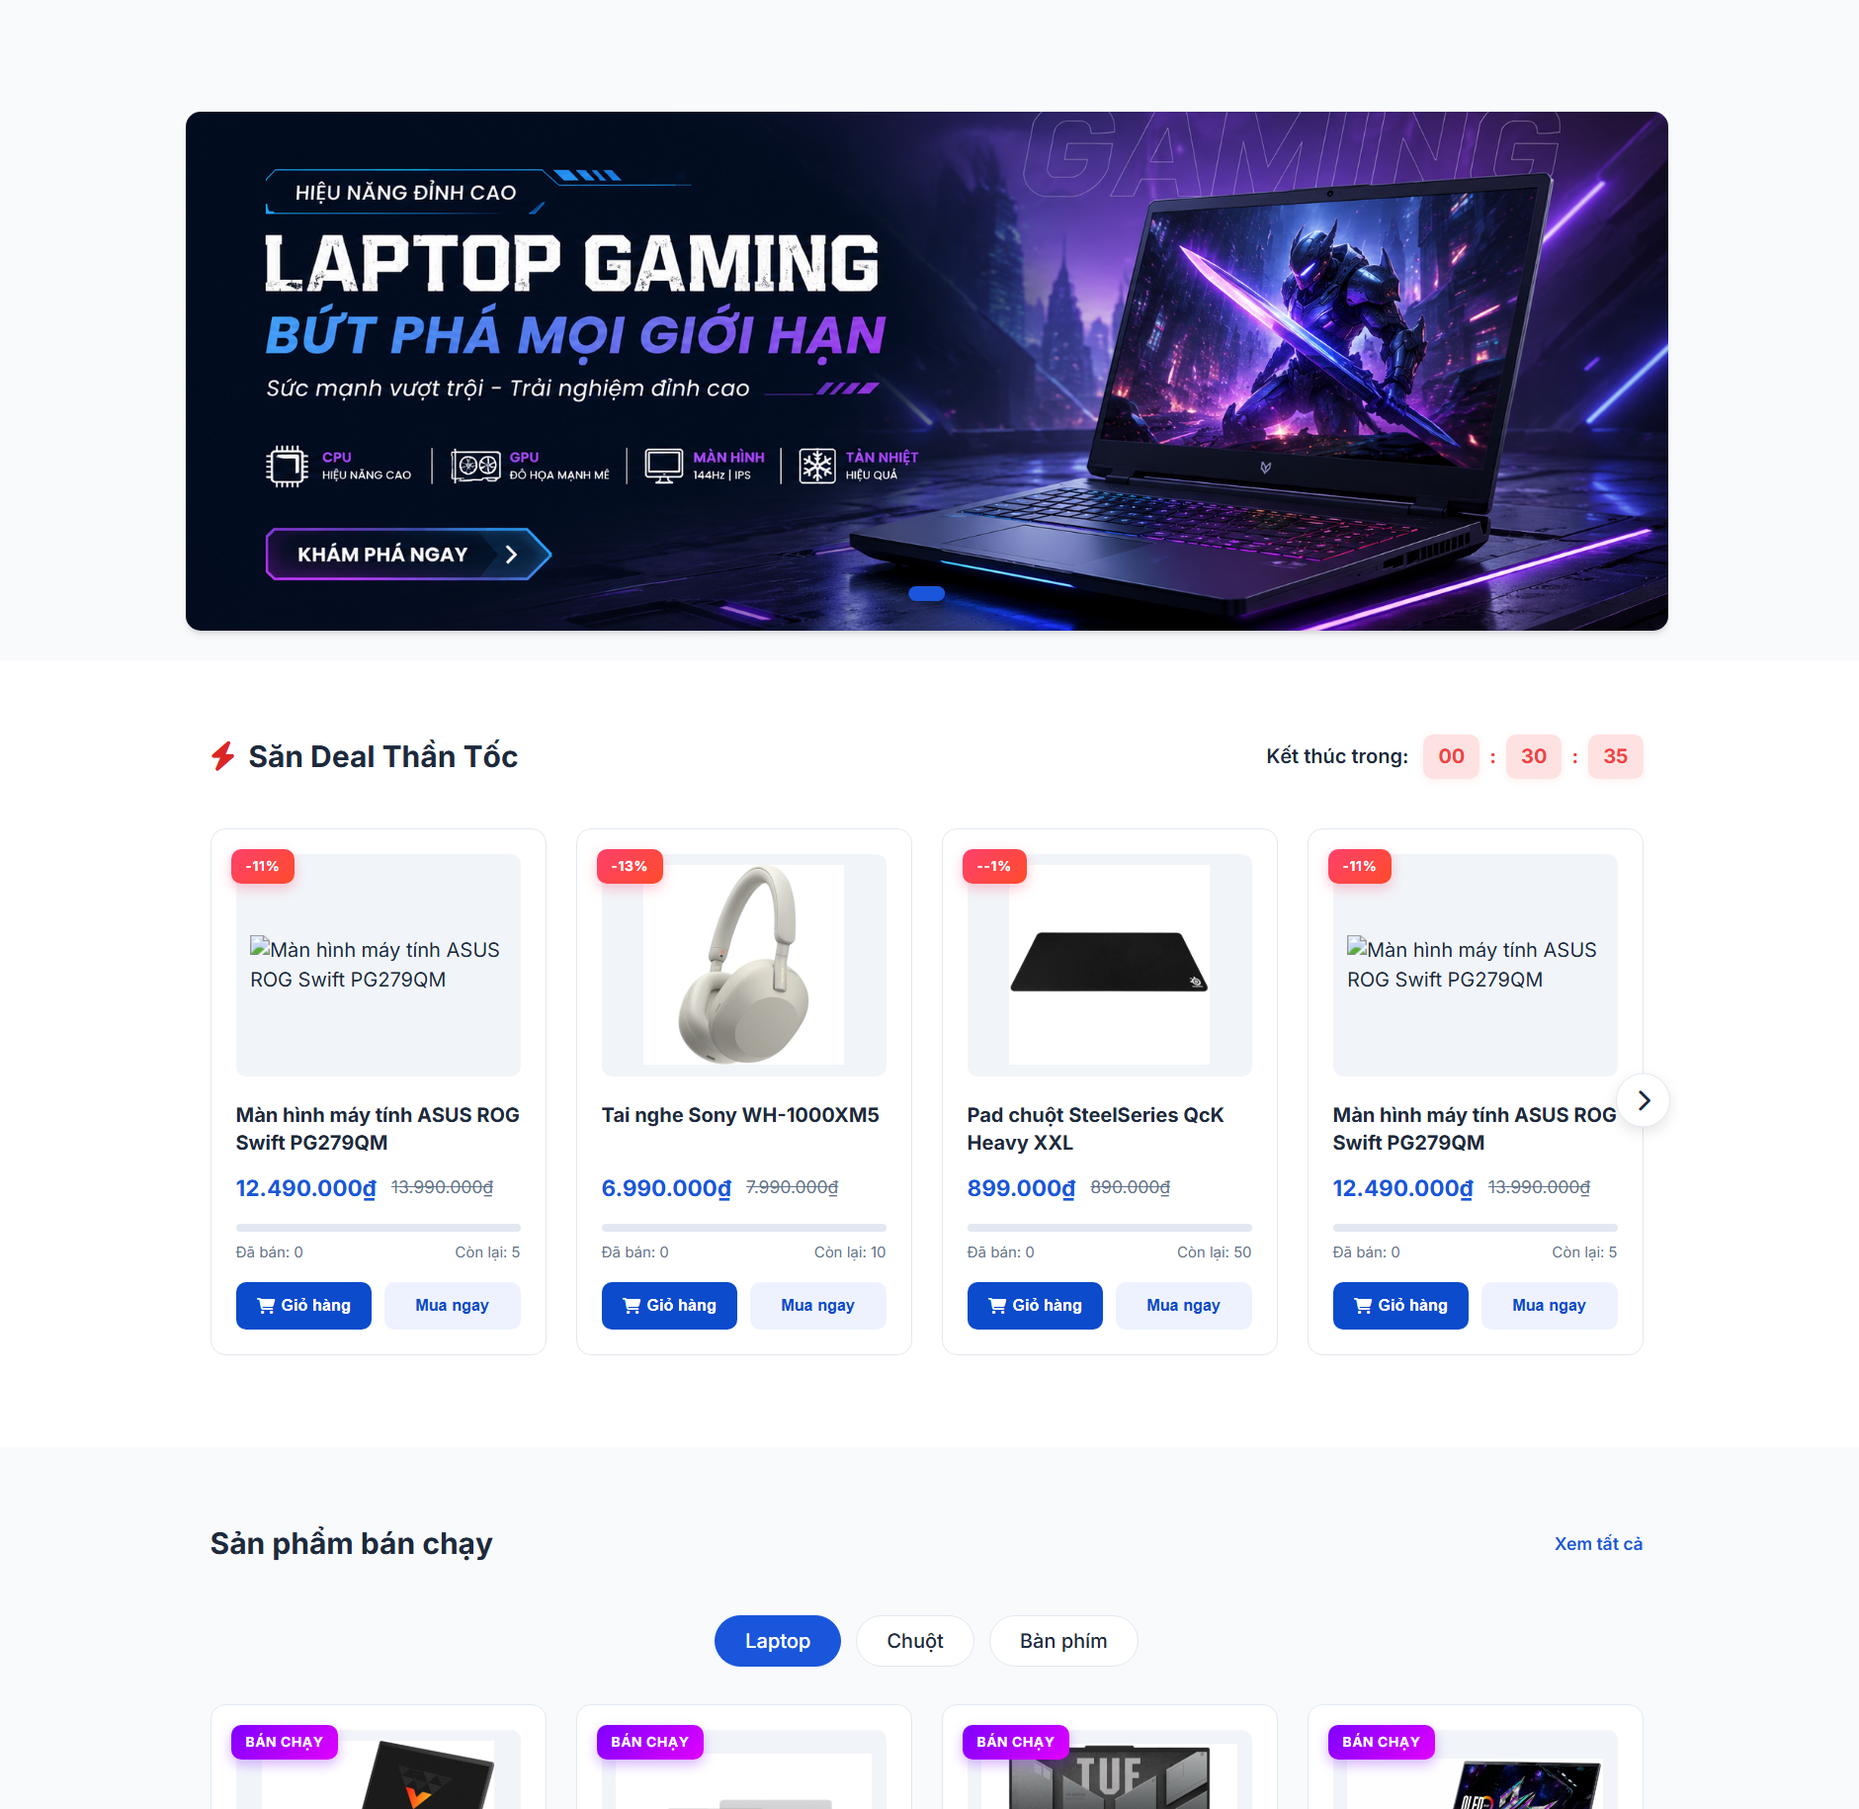

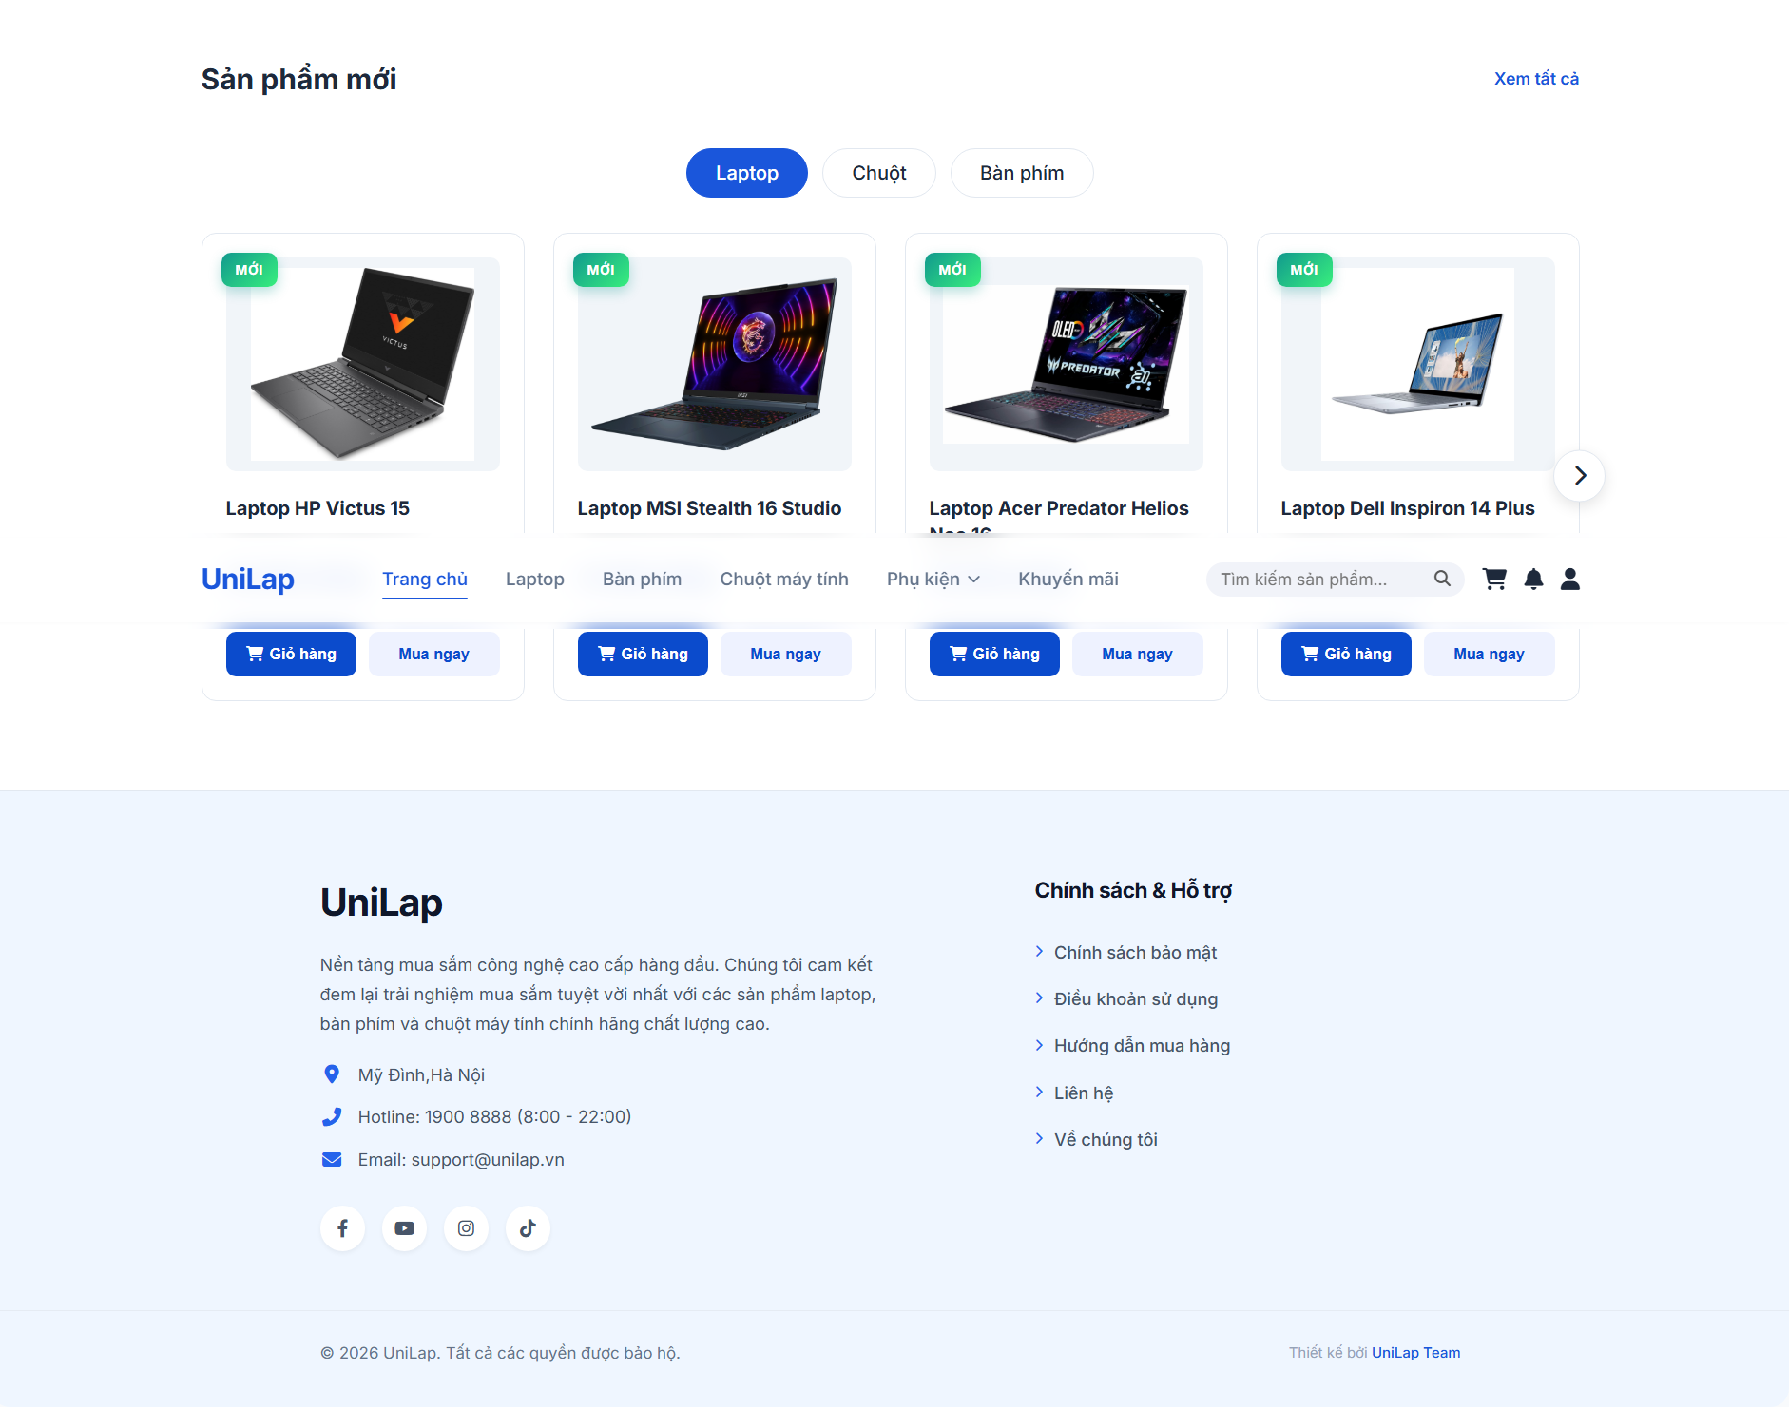

UC ID & Name: UC06 – Browse Home Products & Search Products
Created By | MinhCT
Date Created | 2026-06-02
Primary Actor | Guest/Customer
Trigger | User accesses the UniLap system homepage.
Description | User views featured product sections on the homepage (Flash Sale, Best Seller, New Products), optionally searches via the navigation search bar or filters by category tab, and navigates to the product list or product detail page.
Preconditions | PRE-1. The system is operational and the homepage is accessible.  PRE-2. Product data exists in the database.
Postconditions | POST-1. User has viewed one or more product sections on the homepage.  POST-2. System has navigated the user to the product list page or product detail page based on the selected action.
Normal Flow | 1.0 Browse the Homepage  1. User accesses the homepage.  2. System displays the advertising banner carousel and the navigation bar with a search bar.  3. System displays three product sections: Flash Sale (with countdown timer), Best Seller, and New Products.  4. Each section shows product cards (image, name, price, discounted price if applicable, sold count, remaining stock).  5. User selects a category tab within a section (Laptop / Mouse / Keyboard) → System updates the product list for that section accordingly (see 1.1).  6. User selects a specific product card → System opens the product detail page.  7. User clicks "View All" on a section → System navigates to the full product catalog page of that section.
Alternative Flows | 1.1 Search via Navigation Bar  1. User enters a keyword into the search bar in the navigation bar.  2. System processes the keyword against the product database.  3. System navigates to the product catalog page and displays matching results.  4. User browses the returned product list.
Exception Flow | EF1: Search keyword returns no results  1. System navigates to the product catalog page and displays: "No matching products found."
Priority | High
Frequency of Use | Every visit to the storefront by any Guest or Customer; expected to be the highest-traffic page in the system.
Business Rules | BR-1. Flash Sale countdown timer is determined by the campaign end time configured by Admin.  BR-2. Best Seller ranking is calculated based on total confirmed order quantity within a rolling period defined by Admin.
Other Information | The homepage sections (Flash Sale, Best Seller, New Products) are dynamically populated from the product database; no manual curation is required per session.
Assumptions | The user's browser supports JavaScript for real-time countdown timers and tab-switching interactions. Product images are pre-optimized for fast homepage rendering.

3.1.2 Search & Catalog
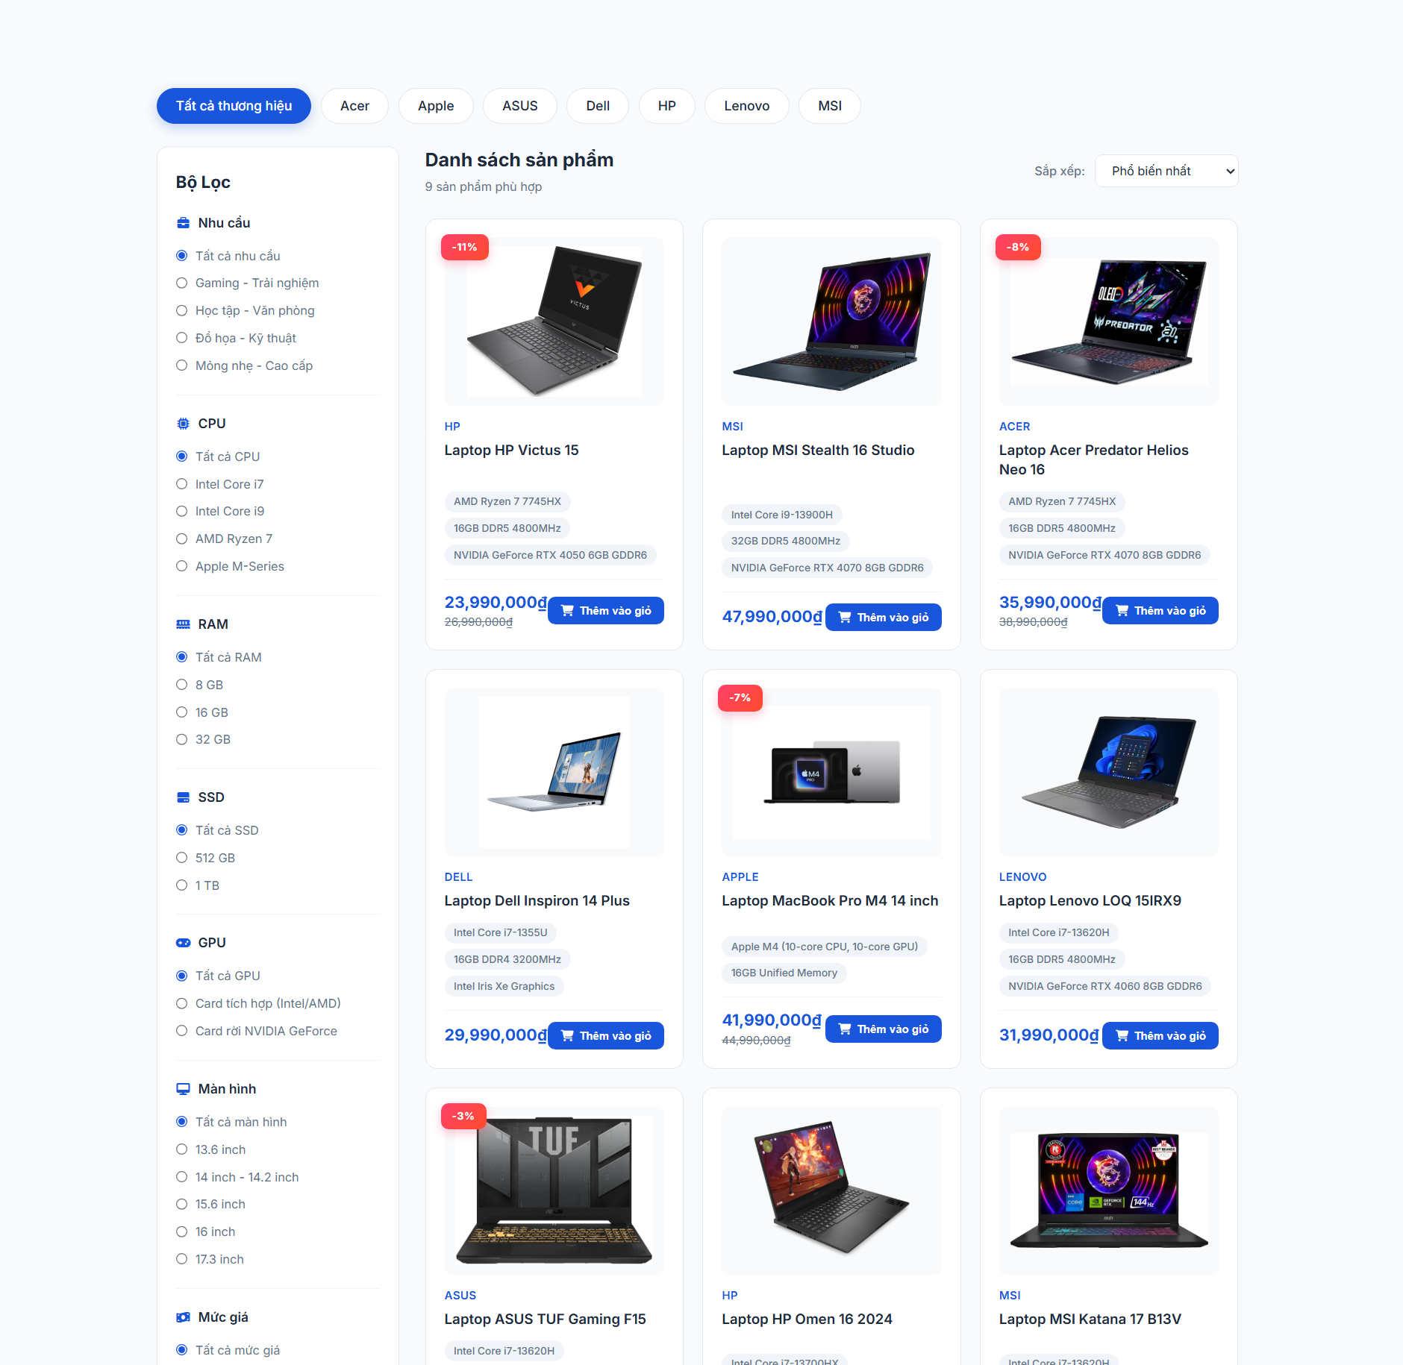
UC ID & Name: UC07 – Browse & Search Product Catalog
Created By | MinhCT
Date Created | 2026-06-02
Primary Actor | Guest/Customer
Trigger | User accesses a product catalog page (Laptop / Keyboard / Mouse / Accessories) or is redirected from the homepage search bar.
Description | User browses the full product catalog, searches by keyword, filters by brand and category-specific hardware specifications, sorts results by price or popularity, and navigates to the product detail page of a selected item.
Preconditions | - PRE-1. The system is operational.  - PRE-2. Product catalog data exists in the database.
Postconditions | - POST-1. A filtered and sorted list of products matching the user's criteria is displayed.  - POST-2. User is navigated to the product detail page upon selecting a product.
Normal Flow | - 1.0 Browse Product Catalog  - 1. User accesses a catalog page  - 2. System displays all active products in the category, a brand chip filter bar at the top, and a left-side filter panel.  - 3. System shows result count and a sort dropdown defaulted to "Most popular".  - 4. User applies one or more filters / search actions  - 5. System processes all active criteria simultaneously and updates the product list in real time.  - 6. User selects a sort option: Most popular / Price ascending / Price descending / Newest.  - 7. System re-orders the list according to the selected sort criterion.  - 8. User clicks on a product card.  - 9. System opens the product detail page
Alternative Flows | - 1.1 Filter by Brand  - 1. User clicks a brand chip in the top filter bar  - 2. System filters the product list to show only items from the selected brand.  - 3. User may click "All Brands" to reset the brand filter.  - 1.2 Filter by Category-Specific Specifications  - 1. User expands the left-side filter panel and selects one or more criteria:  - Laptop: Usage need / CPU / RAM / SSD / GPU / Screen size / Price range.  - Keyboard: Usage need / Connection type / Switch type / Price range.  - Mouse: Usage need/ Connection type / DPI range / Price range.  - 2. System updates the product list to match all active filter conditions.  - 3. User clicks "Clear all filters" to reset the filter panel.  - 1.3 Keyword Search on Catalog Page  - 1. User types a keyword into the search bar in the navigation bar.  - 2. System filters the current catalog to products whose name or specification matches the keyword.  - 3. System updates the result count and product grid accordingly.
Exception Flow | - EF1: No products match the selected filter or search criteria  - 1. System displays: "No matching products found." in the product grid area.
Priority | High
Frequency of Use | High; expected to be triggered on every product browsing session by Guests and Customers across all catalog categories.
Business Rules | - BR-1. Only products with status ACTIVE are displayed in the catalog; disabled products (UC22) are hidden from public view.  - BR-2. Filter options displayed in the left panel are dynamically generated based on the active product attributes within the current category.  - BR-3. Multiple filter criteria within the same panel are combined with AND logic .  - BR-4. "Most popular" sort order is calculated from total confirmed sales volume over a rolling period defined by Admin.
Other Information | The catalog page supports pagination; each page displays a fixed number of products as configured by Admin. The system must return filter results within an acceptable response time to maintain usability.
Assumptions | All product specifications (CPU, RAM, SSD, GPU, screen size, switch type, DPI) are stored in structured, queryable fields in the database. Filter options are pre-indexed for fast query performance.

3.1.3 Product Detail
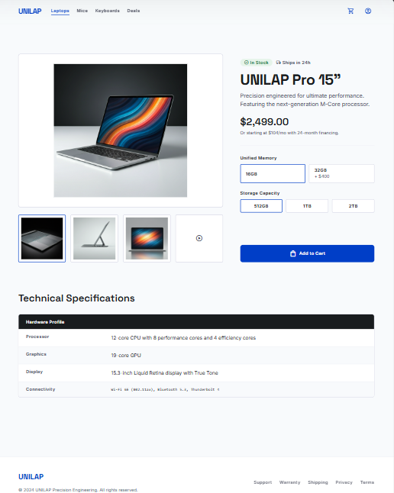

UC ID & Name | G06 - View Product Detail
Created By | MinhCT
Date Created | May 26, 2026
Primary Actor | Guest / Customer
Secondary Actor | None
Trigger | Primary actor triggers the View Product Detail function
Description | View product specifications, price, stock and description.
Preconditions | Product exists.
Postconditions | Product detail page is displayed.
Normal Flow | - User selects a product.  - System loads product detail.  - System displays images, specifications, stock and price.
Exception Flow | - Product no longer available.
Priority | Must Have

3.1.4 Product Comparison
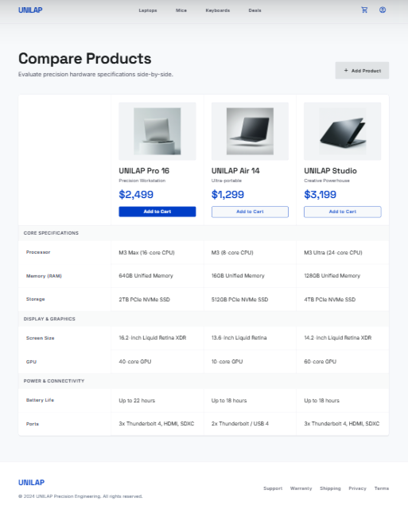

UC ID & Name | G07 - Product Comparison
Created By
Date Created | May 26, 2026
Primary Actor | Guest / Customer
Secondary Actor | None
Trigger | Primary actor triggers the Product Comparison function
Description | Compare products side-by-side based on specifications and price.
Preconditions | At least two products are selected.
Postconditions | Comparison table is displayed.
Normal Flow | - User selects products for comparison.  - System retrieves product specifications.  - System displays comparison interface.
Exception Flow | - Less than two products selected.
Priority | Must Have

3.1.5 Authentication Hub
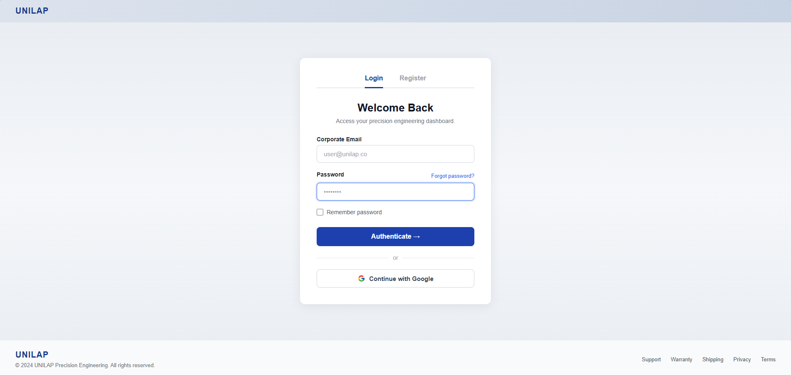

UC ID & Name | G02 - Login
Created By | LUCTV
Date Created | May 26, 2026
Primary Actor | Guest
Secondary Actor | Google OAuth Service(For Google Login)
Trigger | Primary actor triggers the Login function
Description | Verify credentials(or Google account) and grant access to system features based on role.
Preconditions | User account exists and is active.
Postconditions | User session is created and user is logged in successfully
Normal Flow | - User opens Login page.  - User enters email and password.  - System validates credentials.  - System generates access token/session.  - System redirects user to dashboard based on role.
Alternative Flow | - 1.User click “Continue with google”  - 2.System redirect user to Google’s authentication page  - 3.User successfully authentication their Google account  - 4.Google redirect back to system with an authenticate code  - 5.System exchange the code for user profile(email, name)  - 6.System checks user existence:if new, automatically registers them as Customer  - 7.System establishes user session and redirect to HomePage
Exception Flow | - Invalid email or password.  - Account is disabled or locked.
Priority | Must Have

3.1.6 Register
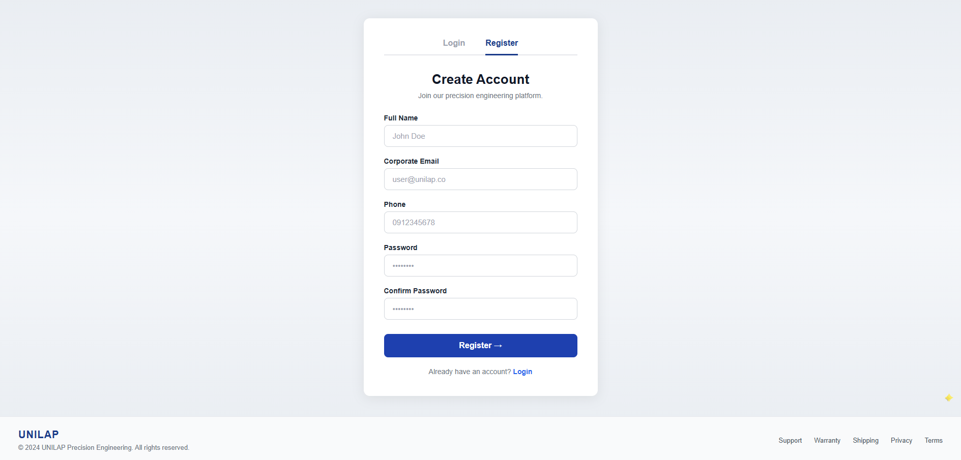

UC ID & Name | G03 - Register
Created By | LUCTV
Date Created | May 26, 2026
Primary Actor | Guest
Secondary Actor | Database System
Trigger | Primary click on the “Register” tab or link
Description | Allow guest to create customer account in the system by providing their detail
Preconditions | Guest does not have an active account with the provided email or phone number
Postconditions | A new customer account is created in the database with status ‘active’ and default role Customer(role_id = 3).Uer is redirected to Login Page
Normal Flow | - User navigates to Register page  - User enter:full name,email,phone, password and confirm password  - User clicks the Register button  - System validates the inputs  - System checks for duplicate email or phone in the database  - System hash the password using BCrypt  - System insert the user record into database with status ‘active’ and Role_id = 3  - System redirects the user to Login page with successful message
Alternative Flow | None
Exception Flow | - Exception Flow 1: Missing required fields  - - System displays error message: "Please fill in all required fields!"  - Exception Flow 2: Invalid Name format (contains numbers/special characters)  - - System displays error message:"Full name must only contain letters and spaces!  - Exception Flow 3: Name exceeds maximum length (over 100 characters)  - - System displays error message:"Full name must not exceed 100 characters!"  - Exception Flow 4: Passwords mismatch  - - System displays error message: "Passwords do not match!"  - Exception Flow 5: Invalid Email format  - - System displays error message: "Invalid email address!"  - Exception Flow 6: Invalid Phone format (must be 10 digits starting with 03/05/07/08/09)  - - System displays error message:"Invalid phone number!"  - Exception Flow 7: Password is too short (less than 6 characters)  - - System displays error message: "Password must be at least 6 characters long!"  - Exception Flow 8: Email already in use  - - System displays error message: "This email is already registered!"  - Exception Flow 9: Phone number already in use  - - System displays error message: "This phone number is already registered!"
Priority | Must Have

3.1.7 User Profile & Settings
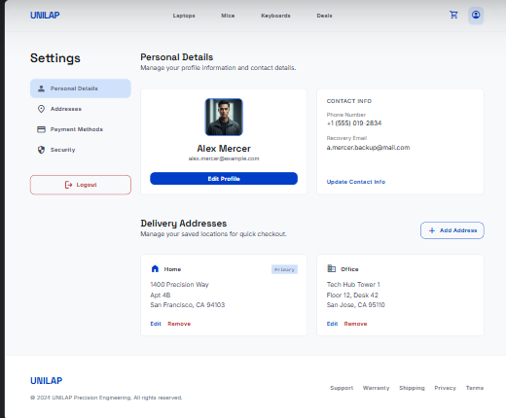

UC ID & Name | C02 - Update Profile
Created By | DuyLD
Date Created | May 26, 2026
Primary Actor | Customer / Admin / Staff
Secondary Actor | None
Trigger | Primary actor triggers the Update Profile function
Description | Update user personal information and password.
Preconditions | User is logged in.
Postconditions | User profile information is updated successfully.
Normal Flow | - User accesses Profile page.  - User edits personal information.  - User clicks Save.  - System validates information.  - System updates profile data.
Exception Flow | - Invalid phone/email format.  - Incorrect current password.
Priority | Must Have

3.1.8 Shopping Cart
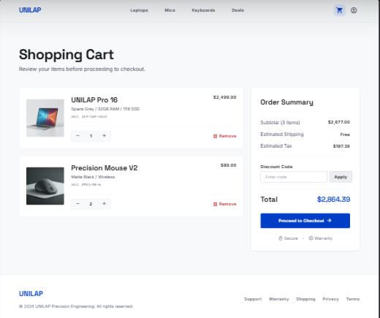

UC ID & Name | C07 - Add Product To Cart
Created By | MinhCT
Date Created | May 26, 2026
Primary Actor | Customer
Secondary Actor | None
Trigger | Primary actor triggers the Add Product To Cart function
Description | Add selected product to shopping cart.
Preconditions | Product is available in stock.
Postconditions | Product is added to cart successfully.
Normal Flow | - Customer selects product.  - Customer clicks Add To Cart.  - System validates stock quantity.  - System updates shopping cart.
Exception Flow | - Product out of stock.
Priority | Must Have

UC ID & Name | C08 - Update Product Quantity
Created By | MinhCT
Date Created | May 26, 2026
Primary Actor | Customer
Secondary Actor | None
Trigger | Primary actor triggers the Update Product Quantity function
Description | Change quantity of products in shopping cart.
Preconditions | Product already exists in cart.
Postconditions | Cart quantity and subtotal are updated.
Normal Flow | - Customer opens shopping cart.  - Customer changes quantity.  - System validates inventory.  - System recalculates total price.
Exception Flow | - Quantity exceeds stock.
Priority | Must Have

UC ID & Name | C09 - Remove Product From Cart
Created By | MinhCT
Date Created | May 26, 2026
Primary Actor | Customer
Secondary Actor | None
Trigger | Primary actor triggers the Remove Product From Cart function
Description | Remove unwanted products from cart.
Preconditions | Product exists in cart.
Postconditions | Product is removed from cart.
Normal Flow | - Customer opens cart.  - Customer clicks Remove.  - System removes product.  - System updates total amount.
Exception Flow | N/A
Priority | Must Have

3.1.9 Warranty Center
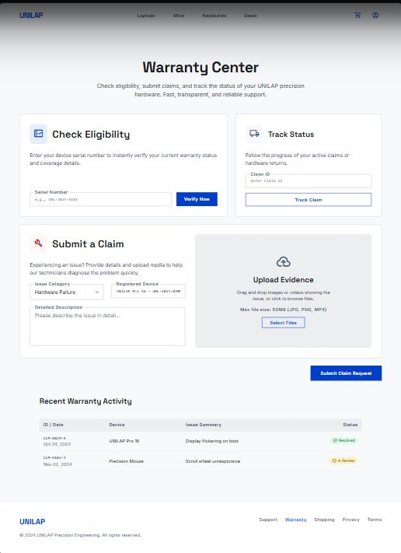

ID and Name | UC15 – Submit Warranty Request / UC16 – Track Warranty Status
Created By | DuyLD
Date Created | 29/05/2026
Primary Actor | Customer
Secondary Actors | Staff
Description | UC15: Verify warranty eligibility for past orders and submit a claim form with attached media evidence (images/videos). UC16: Monitor the evaluation progress of a warranty claim or cancel the request before staff processing begins.
Trigger | UC15: Customer navigates to the Warranty Request section and selects an eligible order item to submit a claim. UC16: Customer navigates to the Warranty History page.
Preconditions | UC15: 1. Customer is logged in. 2. The target product order exists and was purchased by the Customer. 3. The product is within its warranty period. | UC16: 1. Customer is logged in. 2. At least one warranty request has been submitted by the Customer.
Postconditions | UC15: 1. A warranty claim request is created in the system with PENDING status. 2. Staff receives a notification of the new warranty claim. | UC16: 1. The current status of the warranty claim is displayed. 2. If cancellation is requested and the claim is still PENDING: the warranty request status is updated to CANCELLED.
Normal Flow | UC15: 1. Customer navigates to the Warranty Request section. 2. Customer selects an order item to claim warranty for. 3. System checks and confirms the product's warranty eligibility and remaining warranty period. 4. Customer fills in the claim form with a description of the defect or issue. 5. Customer uploads supporting media evidence (images or videos of the defect). 6. System validates file types and sizes of uploaded evidence. 7. System creates the warranty claim record with PENDING status. 8. System notifies the Staff team of the new claim. | UC16: 1. Customer navigates to the Warranty History page. 2. System retrieves and displays all warranty requests submitted by the Customer. 3. Customer selects a warranty request to view details. 4. System displays the claim details, uploaded evidence, current processing status, and any Staff remarks. 5. If the claim is still PENDING: Customer may click "Cancel Request". 6. System validates that the claim has not yet been processed by Staff. 7. System updates the warranty request status to CANCELLED and confirms to Customer.
Alternative Flows | UC15 EF1: Product warranty period has expired – System displays ineligibility notice and prevents submission. EF2: Uploaded file type or size is invalid – System rejects the file and requests a compliant format. EF3: Required claim fields are incomplete – System highlights missing fields and prevents submission. | UC16 EF1: Warranty request has already been processed by Staff – System disables the cancel option and informs Customer. EF2: No warranty requests found – System displays an empty state message.
Exceptions | UC15 EF1: Product warranty period has expired. EF2: Uploaded file type or size is invalid. EF3: Required claim fields are incomplete. | UC16 EF1: Warranty request has already been processed by Staff. EF2: No warranty requests found.
Priority | High (UC15) / Medium (UC16)
Frequency of Use | UC15: High. UC16: Medium.
Business Rules | N/A
Other Information | None.
Assumptions | The warranty period and purchase date data are accurately recorded in the system at the time of order completion.

3.1.10 Order

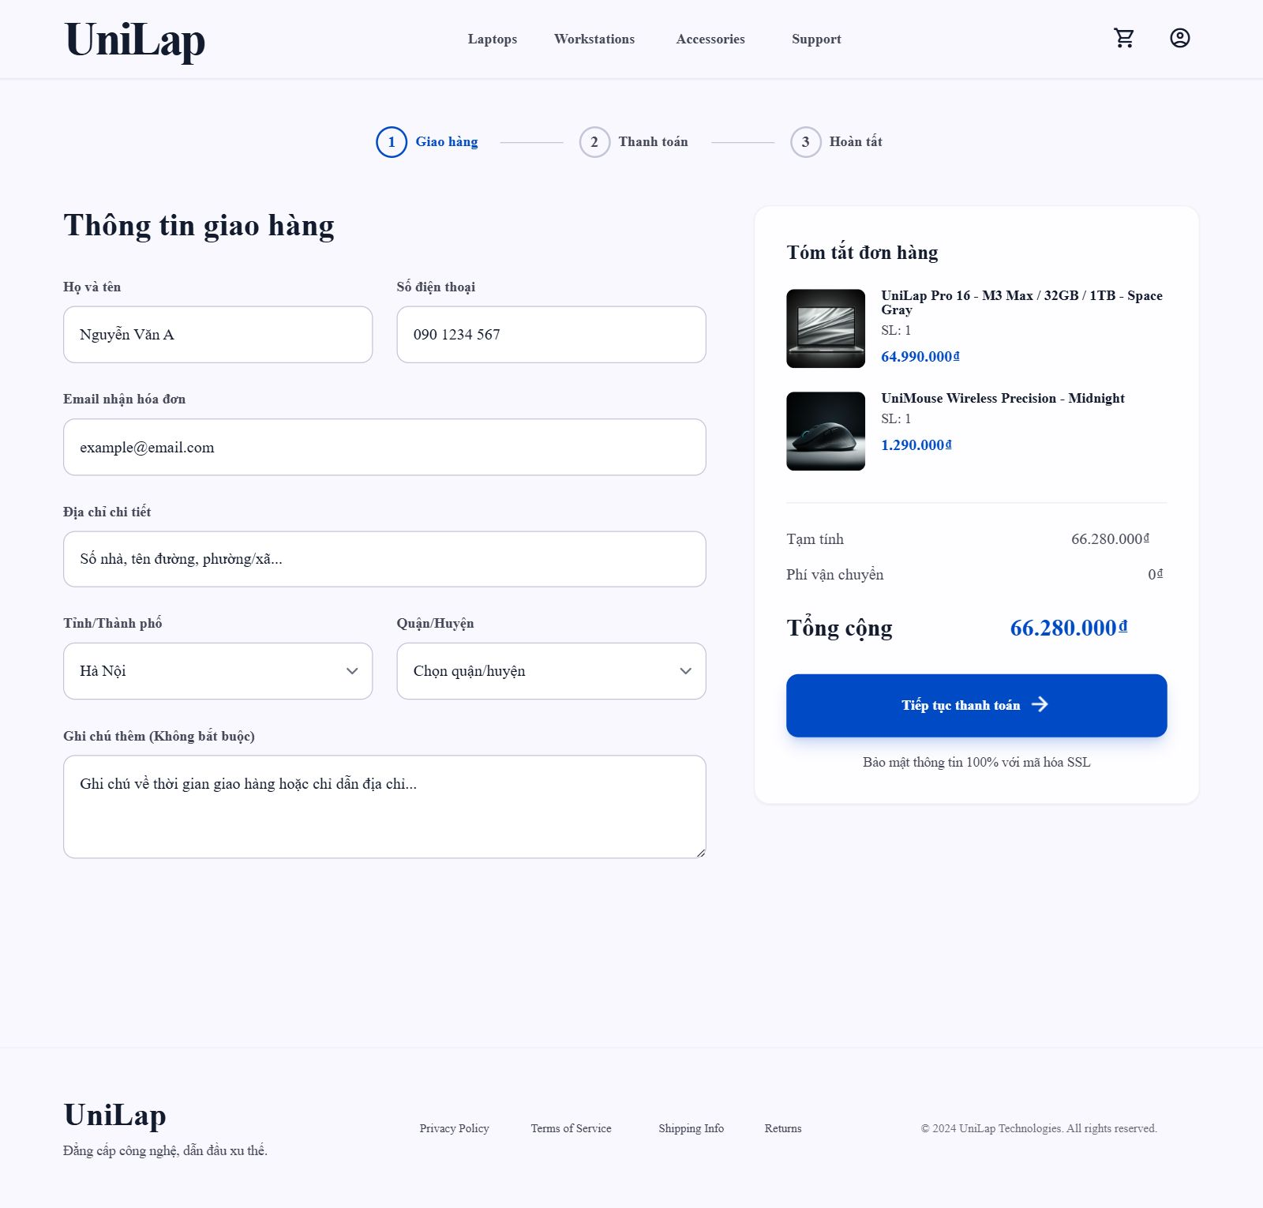

3.1.11 Payment

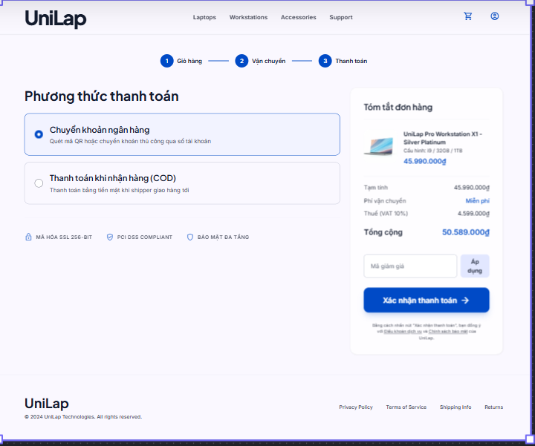

3.1.12 AI Assistant Interface
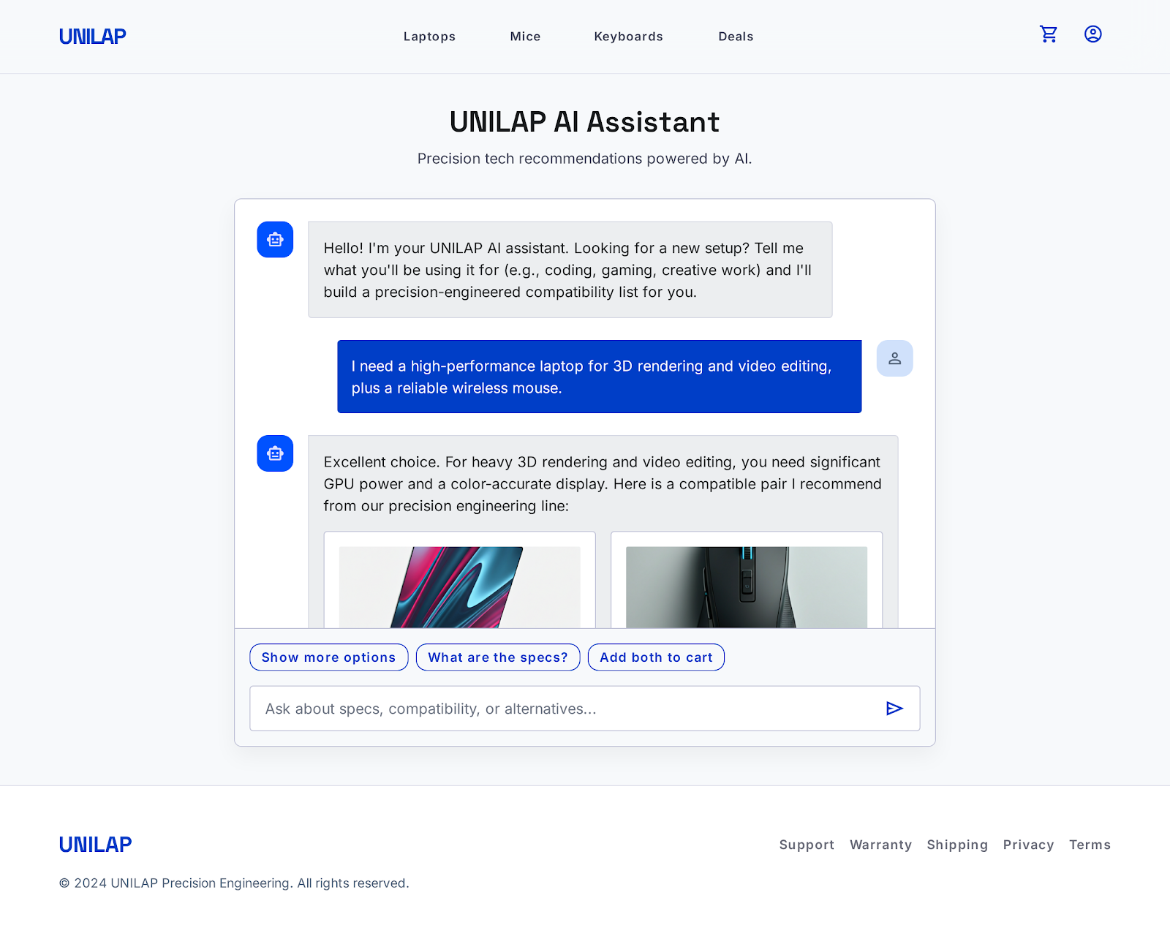

UC ID & Name | C05 - Receive Recommended Products
Created By | DuyLD
Date Created | May 26, 2026
Primary Actor | Customer
Secondary Actor | AI Recommendation Engine
Trigger | Primary actor triggers the Receive Recommended Products function
Description | AI suggests compatible products and components.
Preconditions | Customer is logged in.
Postconditions | Recommended products are displayed.
Normal Flow | - Customer submits requirements or selected components.  - AI engine analyzes compatibility.  - System returns recommended products.  - Customer reviews suggestions.
Exception Flow | - AI service unavailable.
Priority | Must Have

3.2 Admin

3.2.0 Admin Dashboard
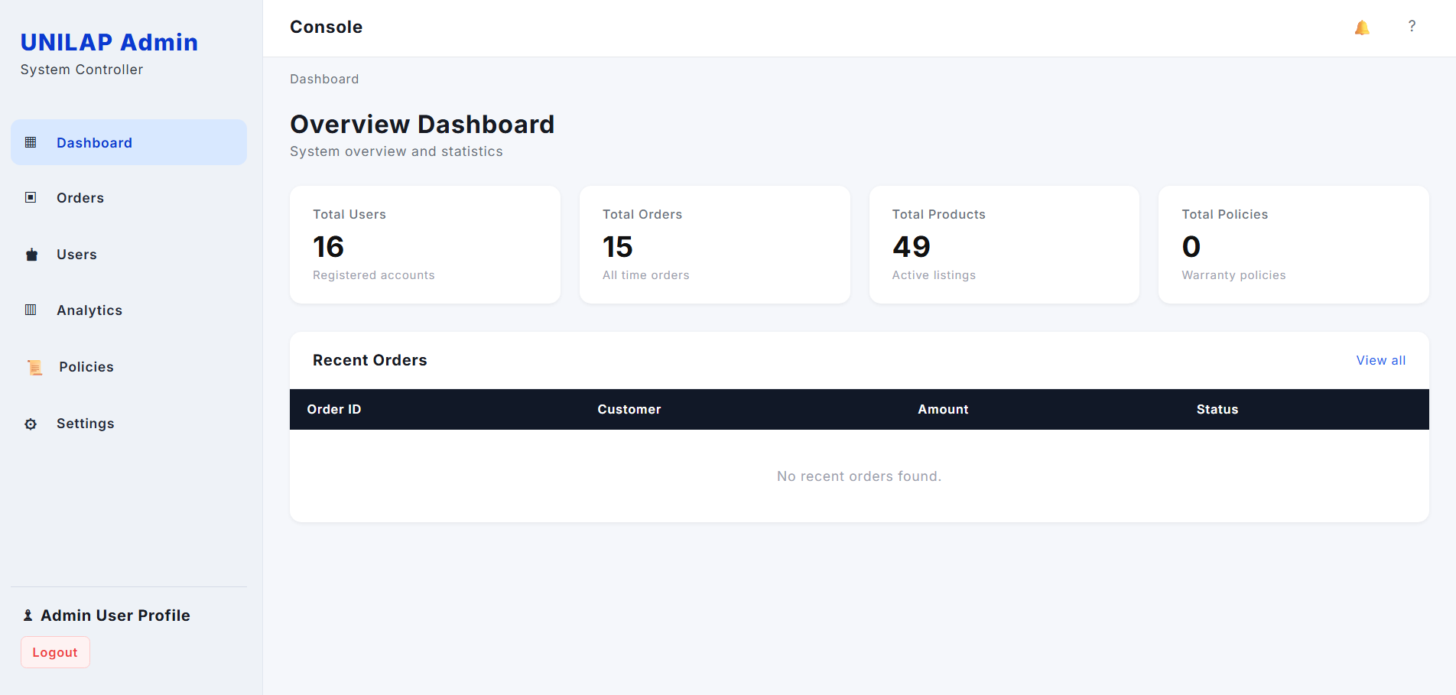

ID and Name: UC-16 View Overview Dashboard
Created By | DuyLD | Date Created | 2026-06-05
Primary Actor | Admin | Secondary Actors | None
Description: | The Admin accesses the Console Dashboard to obtain a real-time overview of the system. The system displays aggregated statistics (Total Users, Total Orders, Total Products, Total Policies) and a table of the most recent orders, allowing the Admin to monitor platform health at a glance.
Trigger: | Admin navigates to the Dashboard page from the sidebar or logs in and is redirected there by default.
Preconditions: | PRE-1. Admin is authenticated and has an active admin session.  PRE-2. The Admin account has Dashboard view permission.
Postconditions: | POST-1. The system displays up-to-date summary statistics.  POST-2. The Recent Orders table is populated (or shows an empty-state message if no orders exist).
Normal Flow: | 2.0 View Overview Dashboard  1. Admin clicks 'Dashboard' in the left sidebar (or is redirected after login).  2. System retrieves aggregated statistics: Total Users, Total Orders, Total Products, Total Policies.  3. System displays four summary cards with the retrieved statistics.  4. System retrieves the most recent orders (up to a configurable limit, e.g. 10).  5. System renders the Recent Orders table with columns: Order ID, Customer, Amount, Status.  6. If no recent orders exist, System displays 'No recent orders found.' in the table body.  7. Admin reviews the dashboard data.  8. Admin may click 'View all' to navigate to the full Orders list .
Alternative Flows: | 2.1 Navigate to Full Orders List  1. At Step 8 of Normal Flow, Admin clicks 'View all'.  2. System redirects Admin to the Orders management page.  3. Flow ends.
Exceptions: | EF1: Statistics service is unavailable – System displays a loading error and prompts Admin to refresh.  EF2: Admin session has expired – System redirects Admin to the Login page.  EF3: Admin lacks sufficient permission – System displays an access-denied message.
Priority: | High | Frequency of Use: | Multiple times per day; every admin login session
Business Rules: | BR-01, BR-07, BR-10
Other Information: | Statistics counters are pulled in real time on each page load. The Recent Orders table shows only the latest N orders; full list is accessible via the Orders module.
Assumptions: | The Admin user account has been granted Dashboard access rights.  All data services (user, order, product, policy) are available and respond within the configured timeout.

3.2.1 Sales & Analytics Dashboard
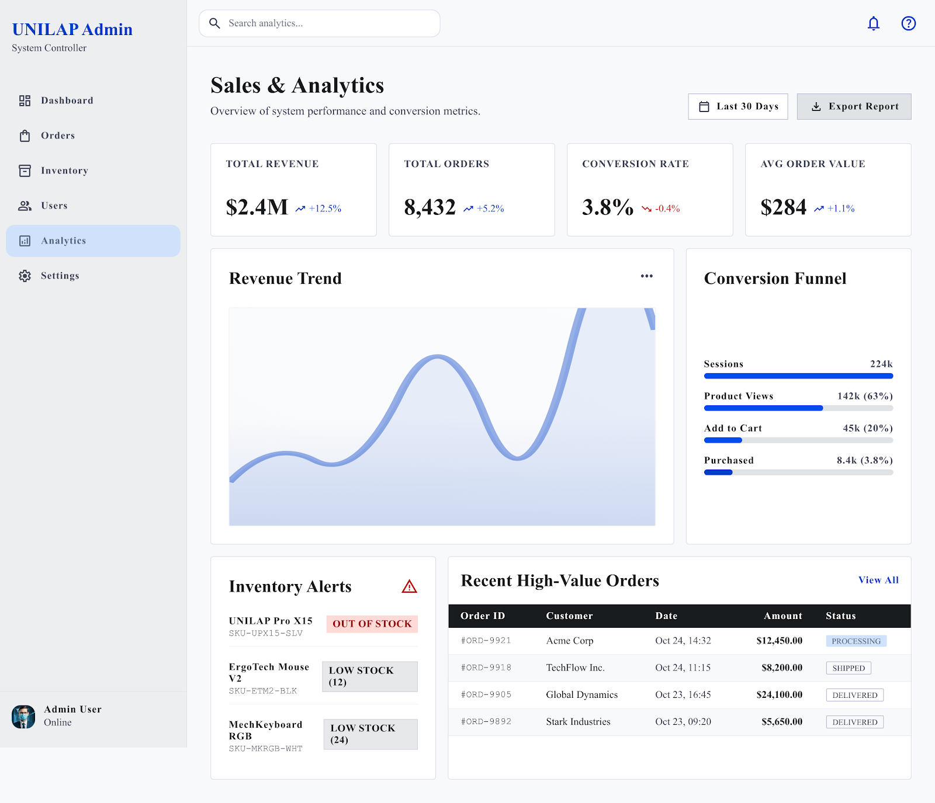

UC ID & Name | A14 - View Sales Dashboard
Created By | DuyLD
Date Created | May 26, 2026
Primary Actor | Admin
Secondary Actor | None
Trigger | Primary actor triggers the View Sales Dashboard function
Description | View overall revenue, orders and inventory performance.
Preconditions | Dashboard data exists.
Postconditions | Dashboard displayed successfully.
Normal Flow | - Admin accesses dashboard.  - System aggregates business data.  - System displays charts and KPIs.
Exception Flow | N/A
Priority | Must Have

3.2.2 Order Fulfillment
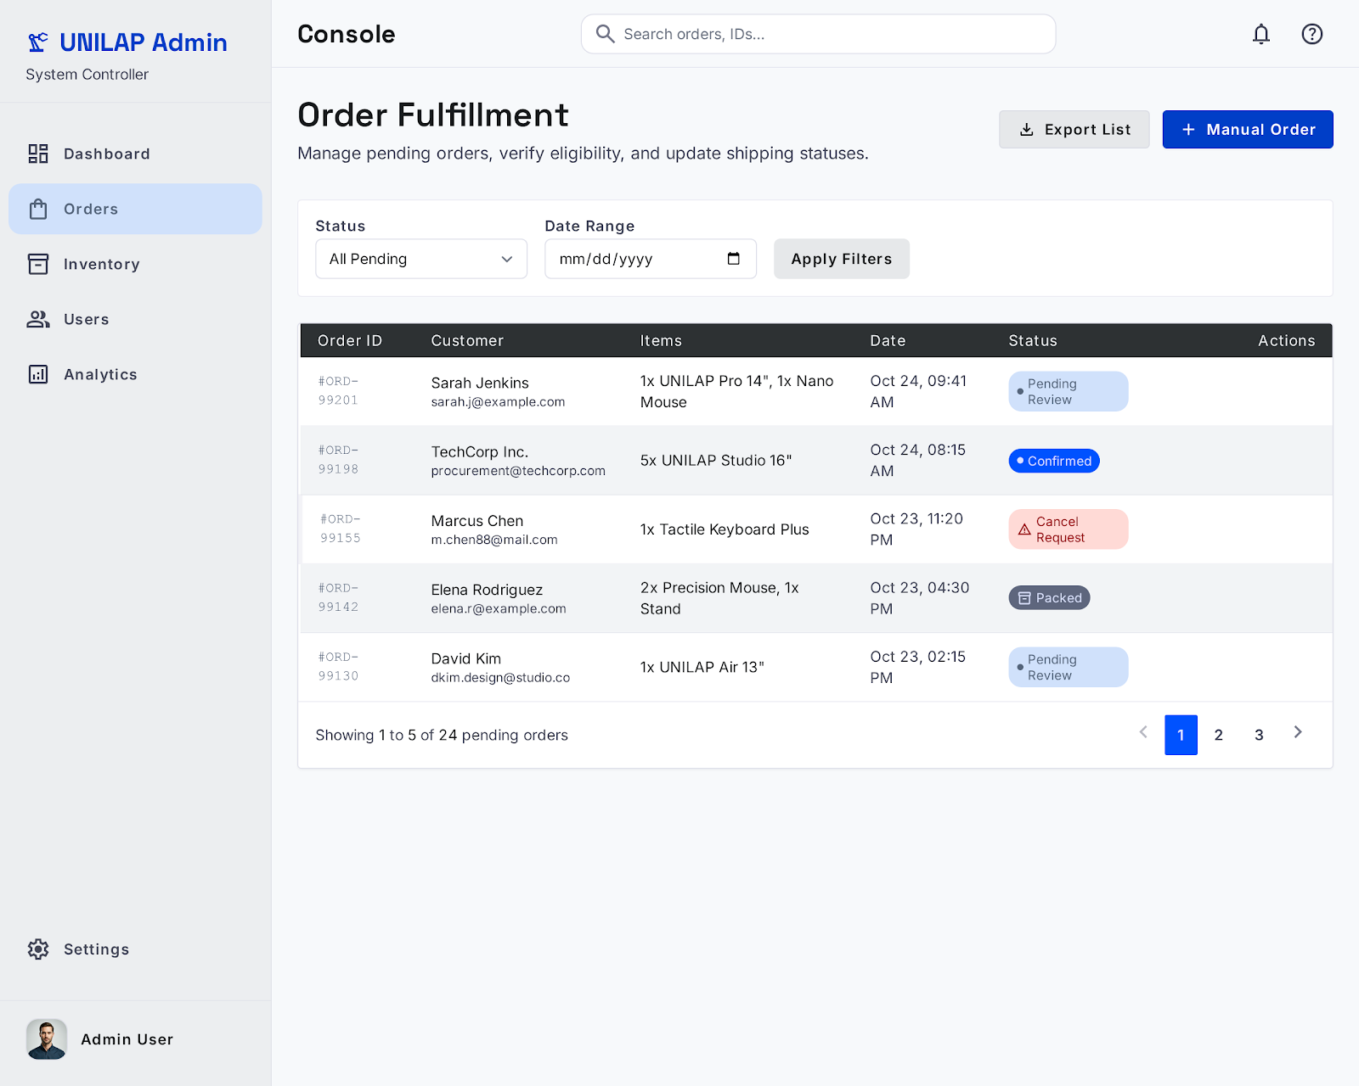

3.2.3 Inventory Management
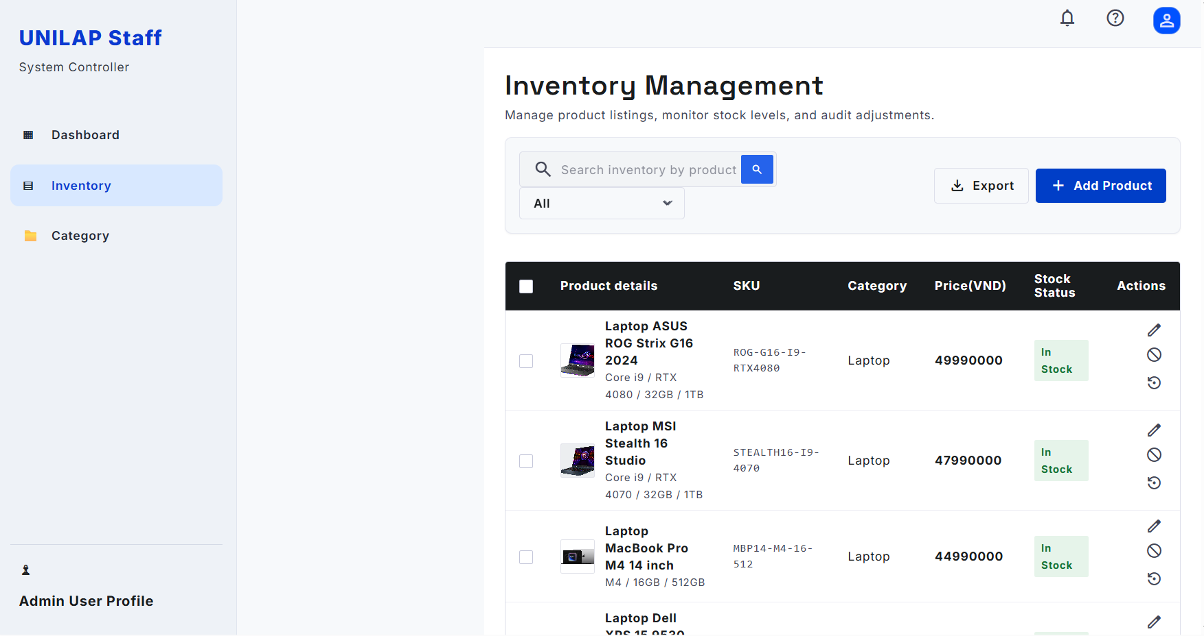

UC ID & Name | S06 / S07 / S08 / S10 - Manage Product Inventory
Created By | HuyDQ
Date Created | May 26, 2026
Primary Actor | Staff
Secondary Actor | None
Trigger | Primary actor selects the Inventory module from the side navigation menu.
Description | Allows Staff to manage tech products and warehouse stock levels, initialize new component files, adjust baseline quantities via manual entries or bulk spreadsheet uploads, and override catalog visibility toggles.
Preconditions | The user is logged into the administrative console and holds active warehouse operations or catalog permissions.
Postconditions | Inventory quantities and product metadata parameters are committed to the secure database, instantly updating stock status layouts across the public store.
Normal Flow | 1. Actor opens the Inventory Management interface page.  2. System displays the inventory summary grid containing basic metadata: Item ID, Title, SKU/Barcode, Price, Stock Level progress indicators, and Visibility Status tags.  3. [Staff Action - Manual Creation] Staff can click "+ New Product" to enter baseline technical specs, initial product pricing values, and initialize serial tracking mappings (BR-09).  5. [Staff Action - Inline Edit] Staff can click "Edit" on a product row to update the general description, adjust quantities, or trigger the Visibility Toggle (Active/Hidden) to force-disable an unavailable component (S10).  6. Actor clicks "Save Inventory Changes" to commit.  7. System validates data integrity (VR-04), updates the database indices using secure real-time record locks, logs the operations history to the Audit Log table, and triggers a success notification.
Exception Flow | Step 4 / Step 7: Spreadsheet Data Corruption or Serial Conflict  - Condition 1: Staff uploads a stock sheet containing corrupted rows or formatting errors.  - Action 1: System interrupts the full execution, processes a partial commit for valid rows only, compiles a row-level error log, and provides a download report link.  - Condition 2: Staff enters a Serial Number or IMEI code that already exists in the system index.  - Action 2: System halts the table updates, marks the conflicted fields in red, and displays an error message toast: "Duplicate email/serial code found."
Priority | Must Have

3.2.4 Category Configuration
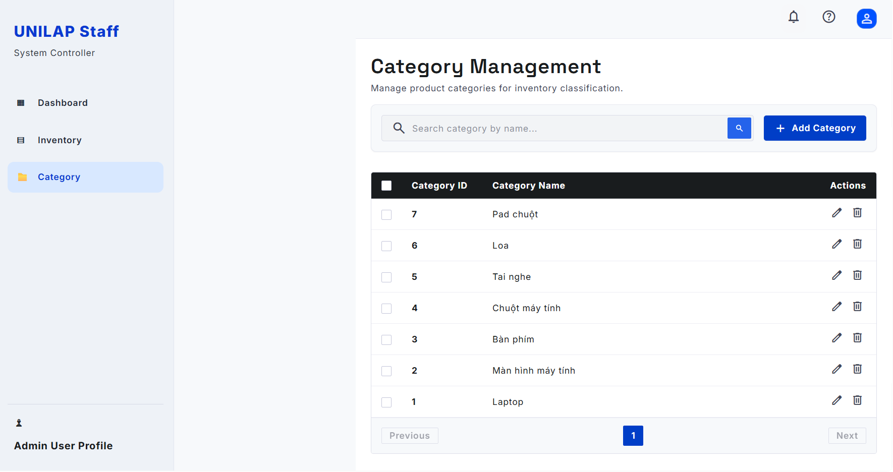

UC ID & Name | A06 / A07 / A08 - Manage Categories
Created By | HuyDQ
Date Created | May 26, 2026
Primary Actor | Staff
Secondary Actor | None
Trigger | Primary actor selects the Settings module and navigates to the Category Configuration console view.
Description | Allows the Administrator to configure laptop and hardware classifications, inject new categories, edit meta attributes (slug, description, order), or delete categories not tied to active items.
Preconditions | Admin has logged in successfully with valid session credentials and holds supreme configuration permissions.
Postconditions | Hardware classifications are modified in the system database and instantly updated across the storefront search and filter catalog grids.
Normal Flow | 1. Admin navigates to the Category Configuration management console panel.  2. System displays the Categories listing column (including Laptops, Mice, Keyboards) featuring descriptions, database item counts, and display order markers.  3. Admin can click "+ Add Category" to append a clean record or click any active category card to open the Edit Category setup pane on the right.  4. Admin fills in or adjusts fields: Category Name, Identifier (Slug), Description, Display Order, and Status selection dropdown.  5. Admin hits the "Save Changes" action button.  6. System validates the dataset inputs, auto-generates clean routing slug text if empty, locks the configuration index tables, commits updates, and presents a success message toast.
Exception Flow | Step 5: Dependency Conflict or Missing Input fields (VR-08 / BR-09)  - Condition 1: Admin attempts to save a record leaving critical required layout fields empty, or duplicate slugs conflict with existing database records.  - Action 1: System interrupts the database commit flow, flashes red inline validation warnings under the input boxes, and retains values for user editing.  - Condition 2: Admin attempts to delete or clear a category block that is currently linked to active, available hardware product listings.  - Action 2: System completely blocks the delete request execution, calculates the dependencies, and presents a warning dialog: "Category still linked to products."

3.2.5 Warranty Operations
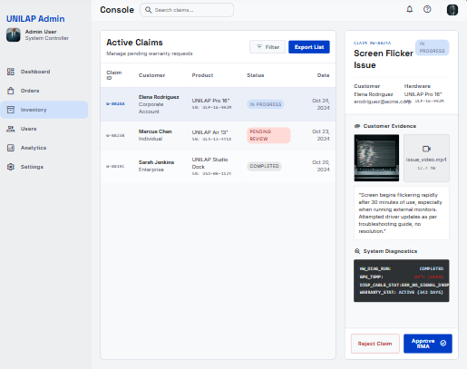

UC ID & Name | S04/S06_W - Process Warranty Request
Created By | LUCTV
Date Created | May 26, 2026
Primary Actor | Staff / Admin
Secondary Actor | None
Trigger | Primary actor navigates to the Inventory/Warranty section and selects the Active Claims dashboard.
Description | Allows Staff or Administrator to view pending warranty requests, evaluate digital evidence uploaded by customers, check system logs/diagnostics, and approve or reject claims.
Preconditions | Staff/Admin has logged into the console with valid session permissions, and customer warranty claims exist in the system.
Postconditions | The claim status is updated (In Progress, Pending Review, Completed, or Rejected), and the customer is notified of the operational decision.
Normal Flow | 1. Actor accesses the Warranty Operations dashboard via the side menu.  2. System displays the Active Claims grid containing Claim ID, Customer details, Product model, current Status, and Date.  3. Actor selects a specific claim from the list.  4. System renders the detailed claim information pane on the right, including:  - Claim Details & Status (e.g., Screen Flicker Issue).  - Customer Evidence (Image/Video files and customer symptom descriptions).  - System Diagnostics (Hardware status, error logs, and warranty validation days).  5. Actor evaluates the details and clicks either "Approve RMA" to accept or "Reject Claim" to deny the request.  6. System updates the pipeline marker database, saves the tracking history, and dispatches a notification to the customer.
Exception Flow | Step 5: Operational Action Failure (Network/Database Timeout)  - Condition: The connection to the backend service drops while committing the approval/rejection.  - Action: System halts the pipeline update, retains the current view, and displays an action error message toast asking the actor to retry.
Priority | Must Have

3.2.6 Voucher & Promotion
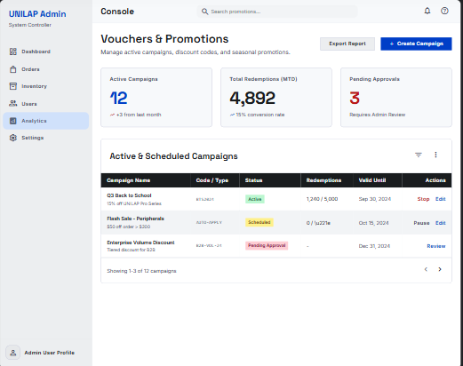
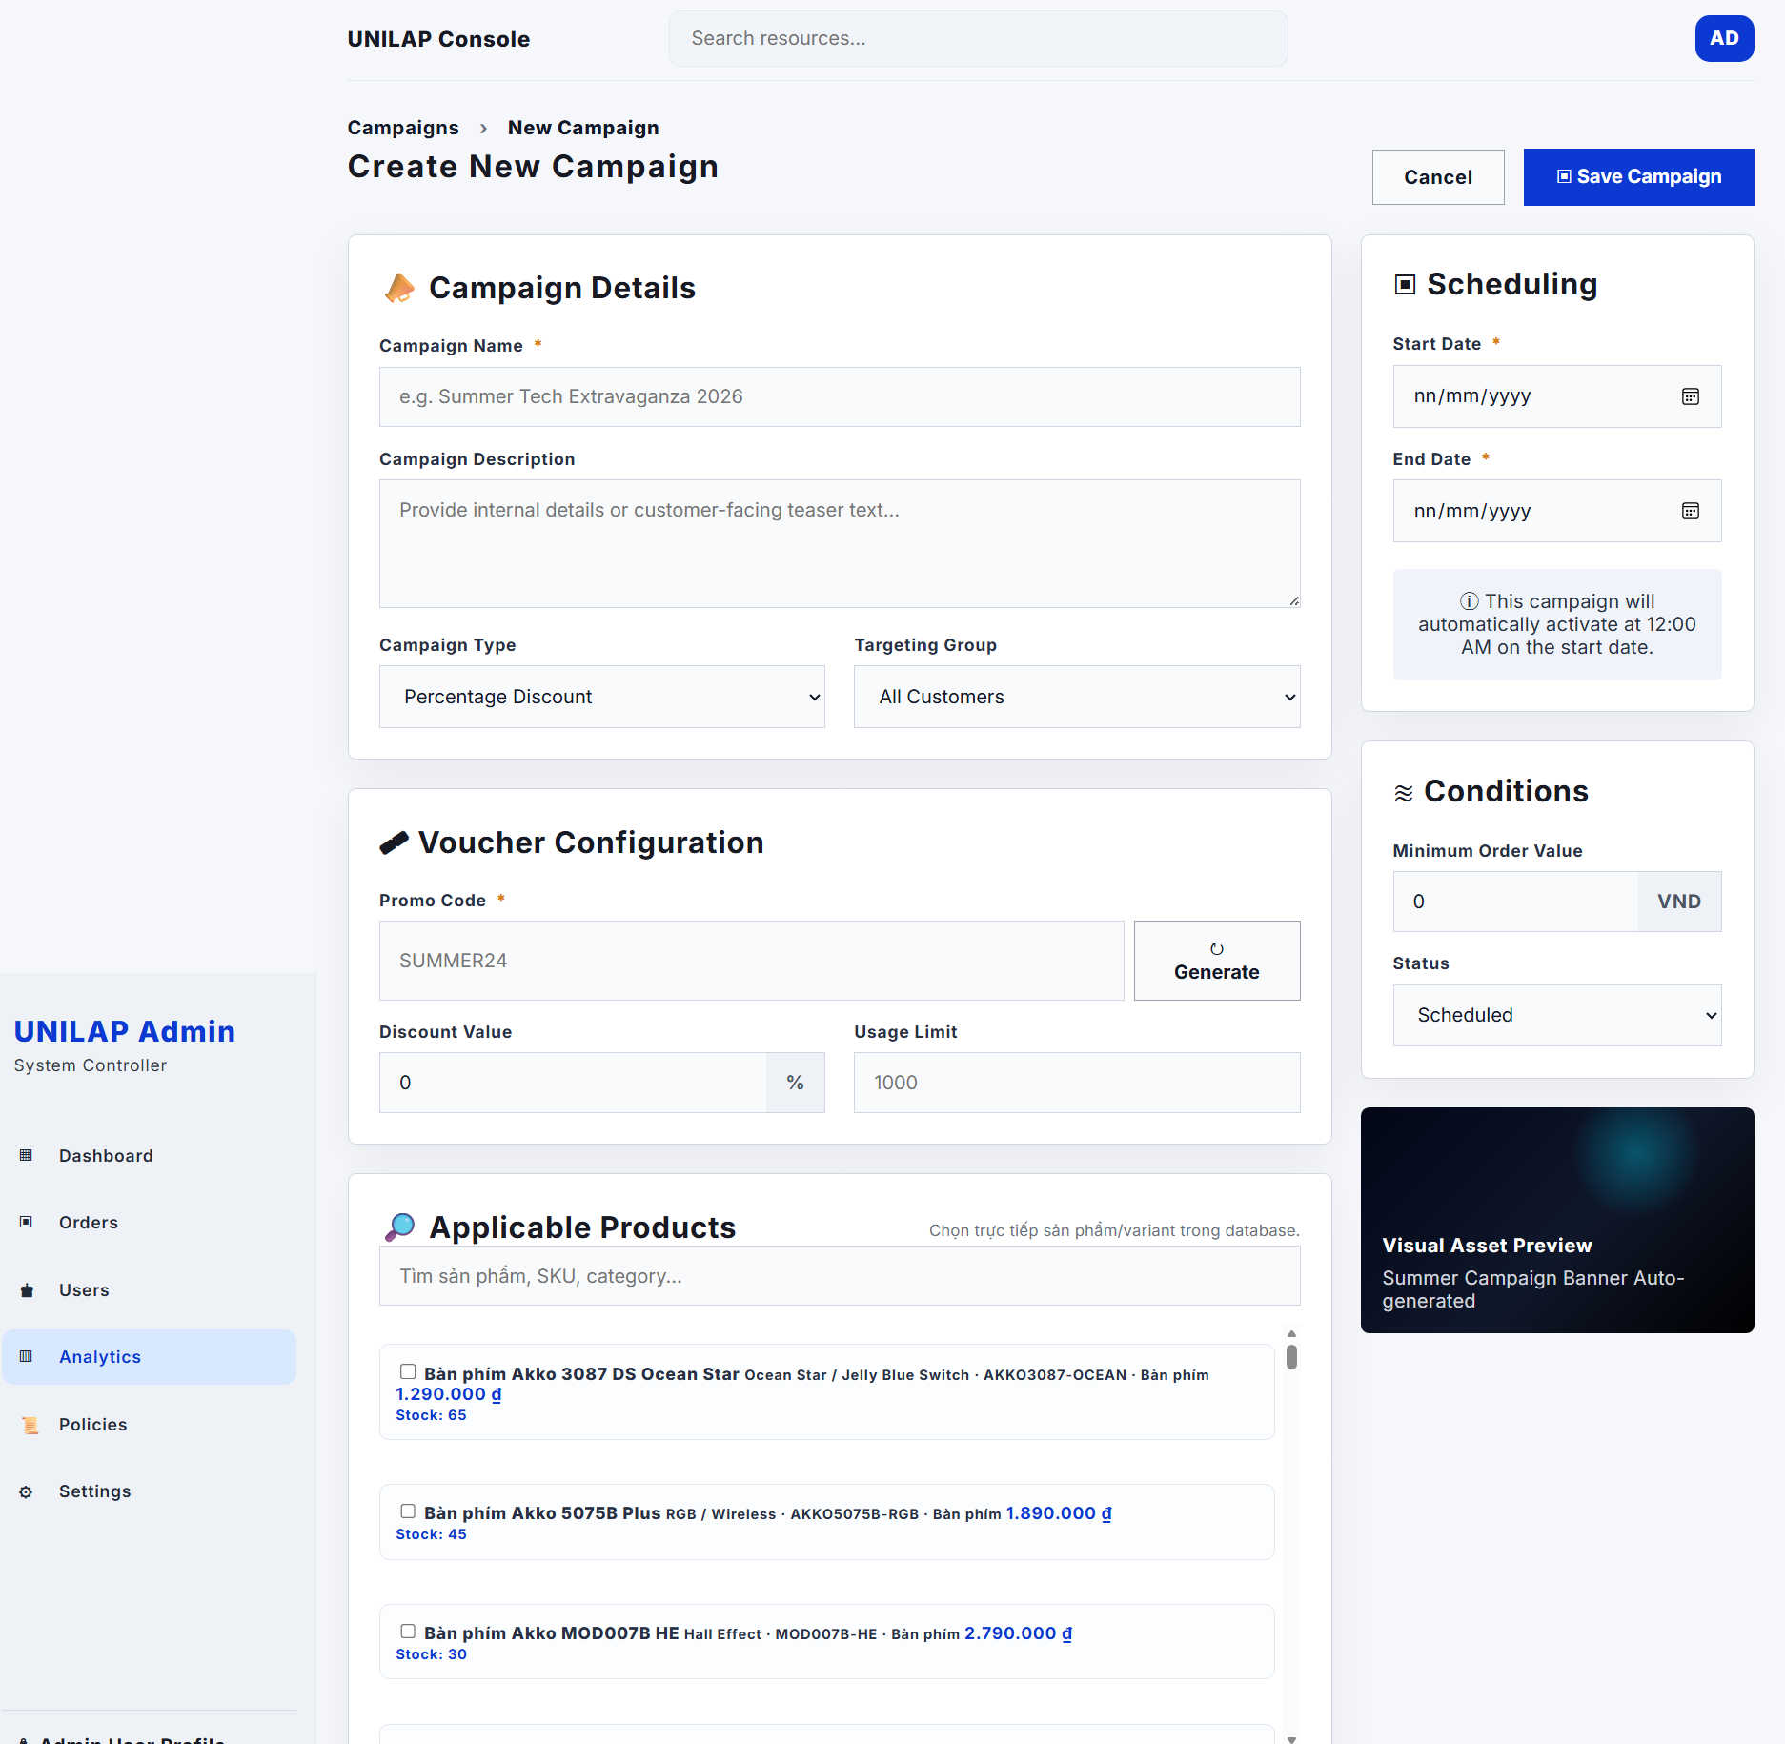
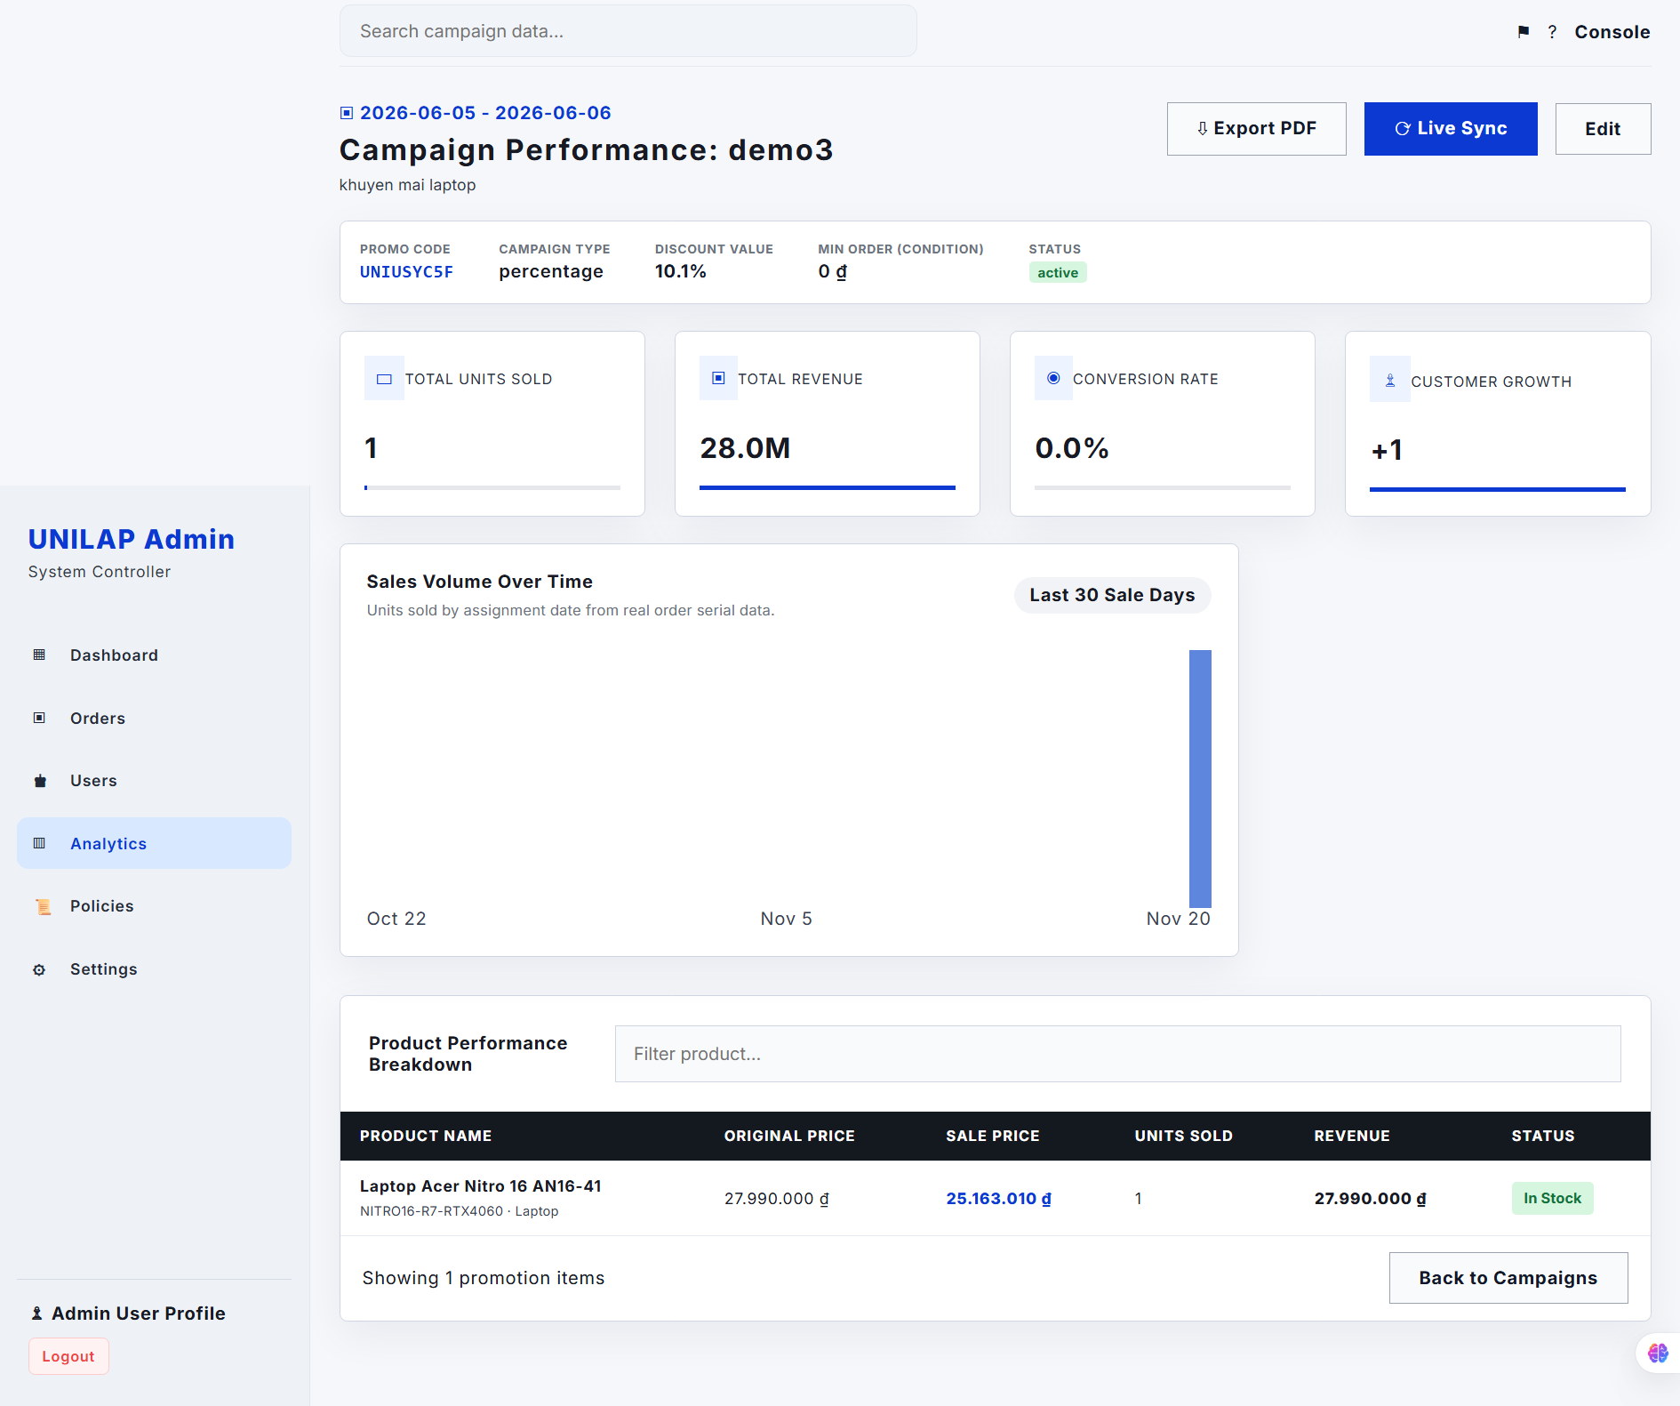
UC ID & Name | S11 / S12 / A12 / A13 - Manage Vouchers & Promotions
Created By | minhbq
Date Created | May 26, 2026
Primary Actor | Staff / Admin
Secondary Actor | Staff
Trigger | Primary actor selects the Analytics/Promotions module from the dashboard navigation menu.
Description | Allows Staff to configure and edit promotional campaigns, and allows the Administrator to review high-impact vouchers, approve pending campaigns, or immediately halt/deactivate campaigns.
Preconditions | The user is authenticated with proper operation/administrative rights, and promotion logs exist.
Postconditions | Marketing campaigns are initialized, modified, approved, or terminated, changing baseline pricing layers across the customer storefront.
Normal Flow | 1. Actor accesses the Vouchers & Promotions dashboard view.  2. System aggregates and displays key metric cards: Active Campaigns, Total Redemptions (MTD) with conversion rate, and Pending Approvals requiring review.  3. System renders the Active & Scheduled Campaigns data table listing Campaign Name, Code/Type, Status, Redemptions count, Validity, and actionable items.  4. [Staff Action] Staff can click "+ Create Campaign" to enter new voucher rules, limits, and values, or click "Edit" on a row to update existing settings.  5. [Admin Action] Admin can select "Review" on a row marked with Pending Approval status to execute a campaign validation approval, or click "Stop / Deactivate" to immediately cancel an active promotion.  6. System updates the campaign state parameters, recalculates active storefront cost values, and pops up a completion toast notification.
Exception Flow | Step 4 / Step 5: Violation of Policy Controls  - Condition: Staff attempts to deploy a voucher without required limits, or a campaign expires mid-checkout.  - Action: System rejects the request execution line, flashes an interactive field alert box, and falls back to baseline cost configurations.
Priority | Must Have

3.2.7 User Management
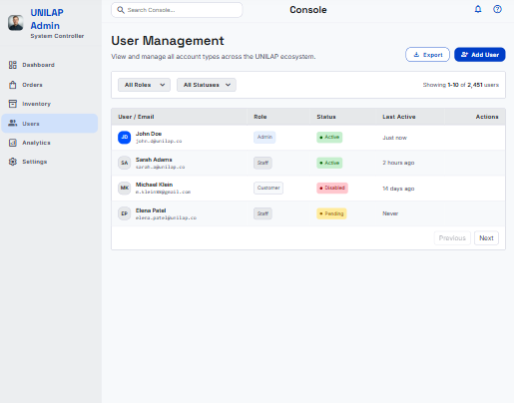

3.2.8 Policy Management
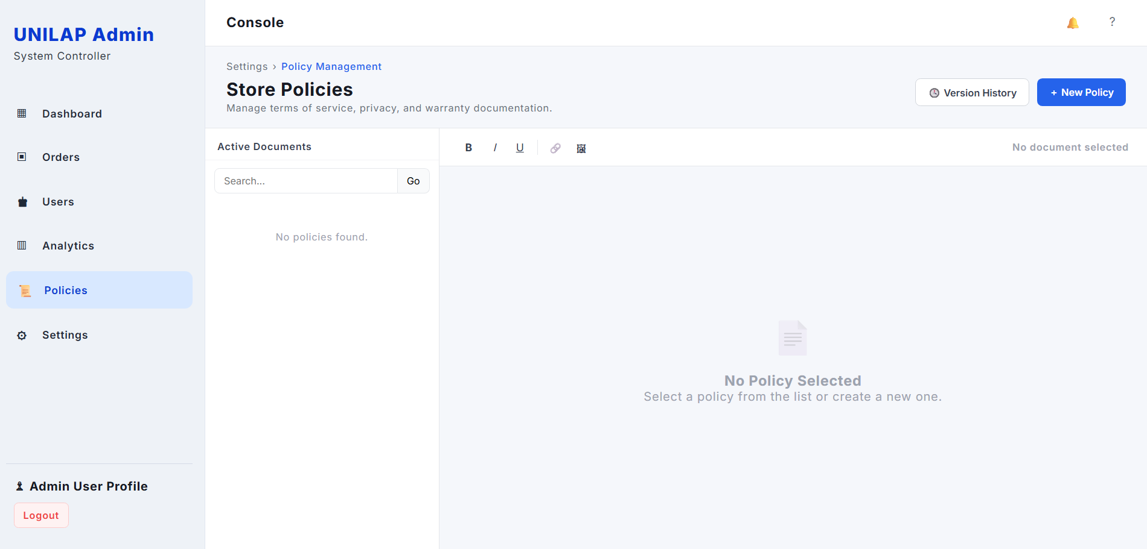

Created By | DuyLD | Date Created | 2026-06-05
Primary Actor | Admin | Secondary Actors | None
Description: | The Admin navigates to the Policies section to create, view, edit, and deactivate warranty policies. Each policy defines the warranty duration and terms applied to one or more product variants.
Trigger: | Admin clicks 'Policies' in the left sidebar navigation menu.
Preconditions: | PRE-1. Admin is authenticated and has an active admin session.  PRE-2. Admin has Policies management permission.
Postconditions: | POST-1. New or updated warranty policies are saved and immediately applied to matching product variants.  POST-2. Deactivated policies no longer apply to new warranty claims.
Normal Flow: | 6.0 Manage Warranty Policies  1. Admin clicks 'Policies' in the left sidebar.  2. System retrieves and displays all warranty policies (paginated): Policy ID, Name, Duration, Applicable Products, Status.  3. Admin reviews the list. If Total Policies = 0, System shows an empty-state notice.  4. Admin clicks 'Create New Policy'.  5. System displays the policy creation form: name, duration (months), applicable product variants, terms description.  6. Admin fills in the form and clicks 'Save'.  7. System validates the input, creates the policy record with Draft status, and links it to the selected product variants.  8. System displays a success notification and refreshes the policy list.
Alternative Flows: | 6.1 Edit Existing Policy  1. At Step 3 of Normal Flow, Admin clicks 'Edit' on an existing policy.  2. System populates the edit form with current policy data.  3. Admin updates fields and clicks 'Save'.  4. System validates, saves changes, and refreshes the list.  5. Flow ends.  6.2 Deactivate a Policy  1. Admin clicks toggle status on policy screen  2. System prompts for confirmation.  3. Admin confirms; System sets policy status to Disabled.  4. Policy no longer applies to new warranty claims.  5. Flow ends.
Exceptions: | EF1: Required policy fields are incomplete – System highlights missing fields and prevents saving.  EF2: A duplicate policy name is entered – System rejects the submission with a uniqueness error.  EF3: Policy service is unavailable – System displays an error banner and a retry option.
Priority: | High | Frequency of Use: | As needed; approximately monthly policy reviews
Business Rules: | BR-05, BR-08, BR-09
Other Information: | Warranty policy data is referenced by UC-15 (Submit Warranty Request) to determine claim eligibility. Policy duration is stored in months.
Assumptions: | Product variant data is available and correctly maintained in the product inventory service.  Admin understands that deactivating a policy does not invalidate existing open warranty claims.

3.2.9 AI Governance
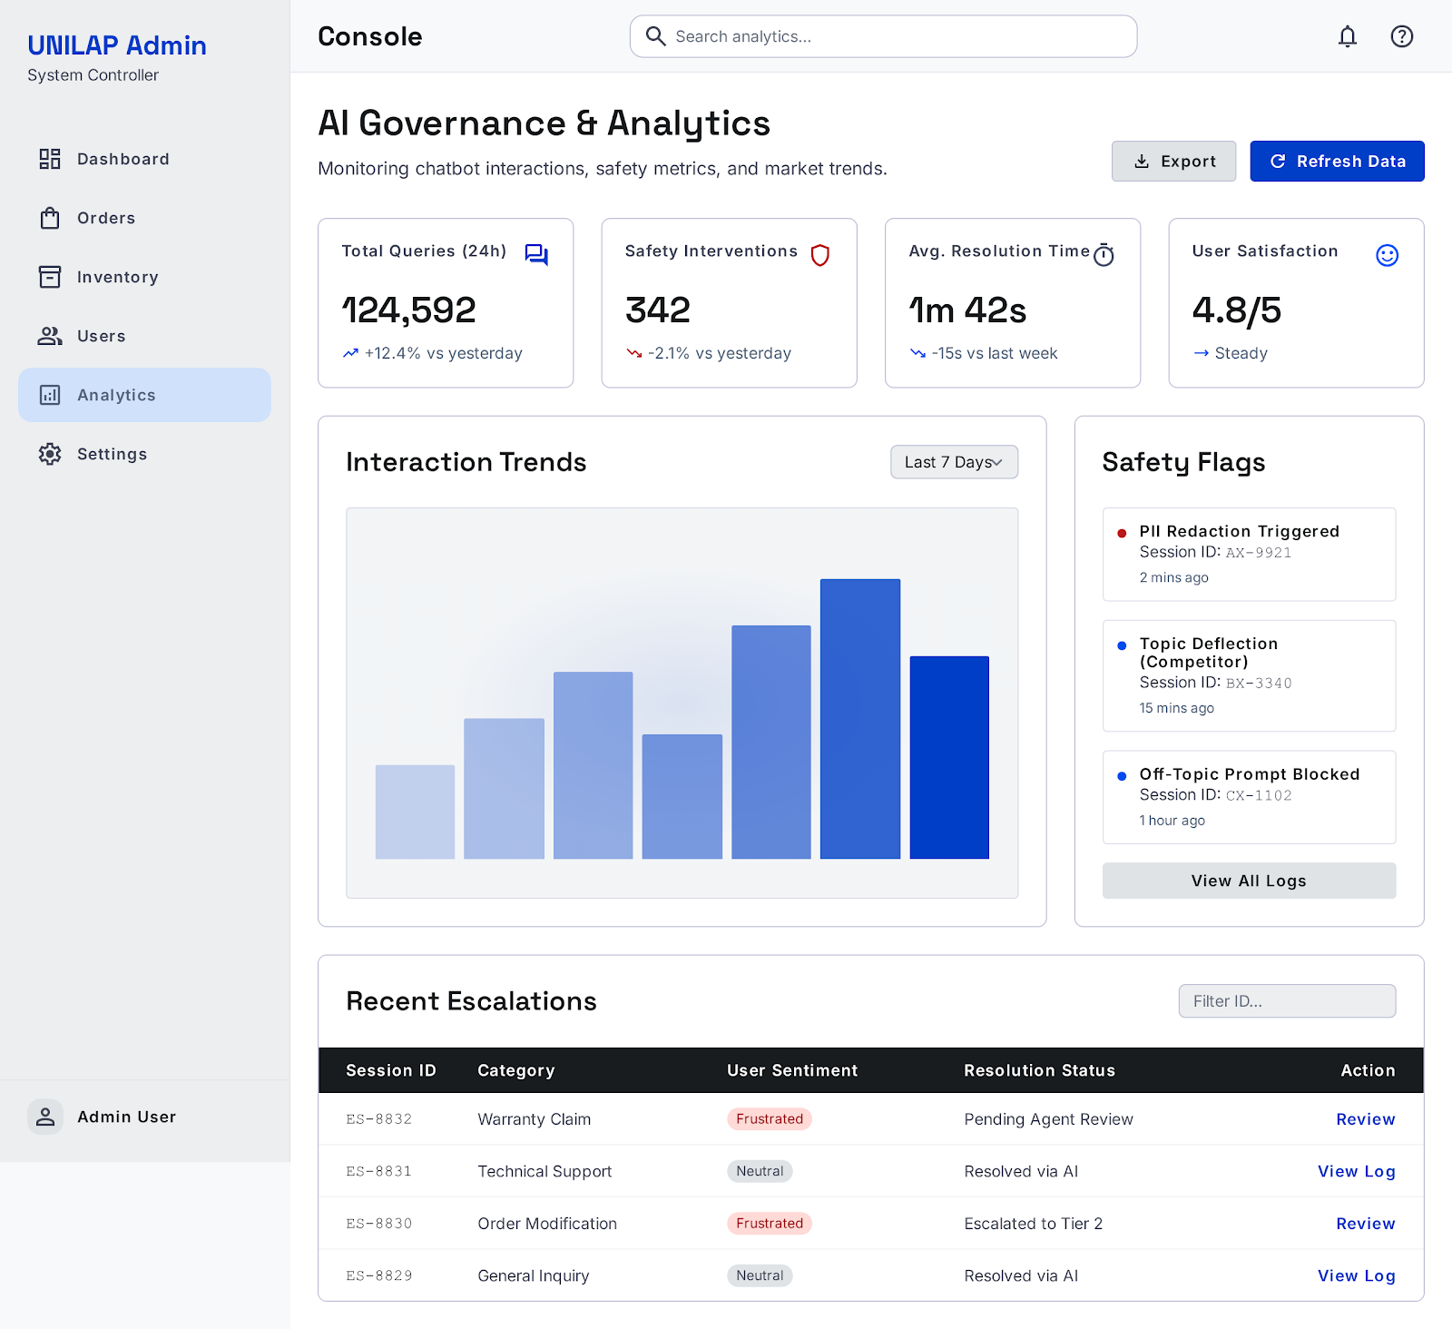

UC ID & Name | A18 - Moderate AI Abuse
Created By | LUCTV
Date Created | May 26, 2026
Primary Actor | Admin
Secondary Actor | AI Moderation Service
Trigger | Primary actor triggers the Moderate AI Abuse function
Description | Detect spam, prompt injection and unsafe AI usage.
Preconditions | AI logs exist.
Postconditions | Abuse cases are flagged or blocked.
Normal Flow | - Admin reviews AI activity logs.  - System detects suspicious patterns.  - Admin takes moderation action.
Exception Flow | N/A
Priority | Must Have

4. Non-Functional Requirements

4.1 External Interfaces

4.1.1 User Interface
The system provides a responsive web interface that supports desktop and laptop devices.
The user interface shall:
- Support Google Chrome, Mozilla Firefox, and Microsoft Edge browsers
- Maintain a consistent layout and navigation structure
- Provide user-friendly interactions and clear feedback messages
- Allow users to easily search, compare products, and place orders
- Display responsive layouts for different screen resolutions

4.1.2 Hardware Interface
The system requires:
- Web application server
- Database server
- Stable internet connection
The application server communicates with the database server to store and retrieve system data.
4.1.3. Software Interface
External System | Description
Email Service API | Send account verification and order confirmation emails
Payment Gateway API | Process online payment transactions
Chatbot Recommendation Service | Provide product recommendations based on customer preferences

4.2 Quality Attributes
4.2.1 Usability

Requirement | Description
User Learning Time | New users complete ordering process within 5 minutes
Navigation Efficiency | Users can access main functions within 3 clicks
Error Visibility | Validation and error messages displayed clearly

4.2.2 Performance

Requirement | Description
Homepage loading time | < 3 seconds
Search response time | < 2 seconds
Order processing time | < 5 seconds
Concurrent users | ≥ 100 users

4.2.3 Security
Requirement | Description
Password encryption | BCrypt hashing
Data transmission | TLS 1.3
Authorization | Role-Based Access Control (RBAC)
Login protection | Lock account after 5 failed attempts
Session management | Automatic logout after inactivity

.4.2.4 Reliability
Requirement | Description
Data consistency | No order data loss
Transaction integrity | Payment and order information remain synchronized
Backup recovery | System backup available daily

4.2.5 Availability
Requirement | Description
System uptime | ≥ 99%
Service availability | System accessible 24/7 except maintenance periods

4.2.6 Scalability
Requirement | Description
Product expansion | Support unlimited categories and products
User scalability | Support increasing numbers of users
Database scalability | Allow future database growth

4.2.7 Maintainability
Requirement | Description
Architecture | MVC or 3-Layer Architecture
Source code | Modular and reusable
Documentation | Technical documentation maintained

4.2.8 Compatibility
Requirement | Description
Browser support | Chrome, Firefox, Edge
Device support | Desktop and laptop
Screen compatibility | Responsive UI for common resolutions

5. Requirement Appendix

5.1 Business Rules

ID | Rule Definition
BR-01 | Customers are only allowed to select a minimum of 2 and a maximum of 4 products simultaneously to use the configuration and price comparison feature.
BR-02 | Product inventory quantity shall be automatically updated and deducted when an order reaches the confirmed status.
BR-03 | The system only accepts payments via the following methods: Cash on Delivery (COD), Bank Transfer
BR-04 | Invoice must be automatically generated and sent via email to the customer immediately after a successful payment transaction.
BR-05 | Customers are only allowed to cancel a warranty request when the request is still in an unprocessed state by the staff.
BR-06 | Customers are only allowed to cancel an order if the order is still within the allowable cancellation period.
BR-07 | Customers are only allowed to leave a review (5-star system) and personal comments for products they have successfully purchased.
BR-08 | All online warranty requests submitted by customers must include valid evidence (images, videos, or documents).
BR-09 | The management and tracking of product quantity and status (from the warehouse to the customer), as well as warranties, must be identified via Serial/IMEI codes.
BR-10 | High-impact discount campaigns (Voucher Campaigns) created by staff must be approved by the Administrator (Admin) before being applied to the system.
BR-11 | The application of discount codes (Vouchers/Coupons) must satisfy binding conditions including: expiration date, spending limit, usage limit, and application scope or bundle purchase conditions.
BR-12 | Users who abuse the AI (spam, prompt injection, unsafe usage patterns) will be detected by the system, and the Admin has the right to disable (Block) that account's AI access.
BR-13 | Passwords of all users in the system must be encrypted using the MD5 standard before being stored in the database to ensure security.
BR-14 | Only the Administrator (Admin) has the authority to assign, change roles, deactivate, or reactivate user accounts (Customer, Staff, Accounter).
BR-15 | Warranty eligibility requires all three conditions to pass: (a) warranty period not expired, (b) order owned by the authenticated Customer, and (c) product linked to an ACTIVE Warranty Policy.
BR-16 | A warranty claim must be created with initial status PENDING.
BR-17 | Every warranty claim event and status transition must be recorded in the warranty audit history log with actor identity, event type, and timestamp.
BR-18 | Staff resolution remarks are visible to the Customer only when claim status is COMPLETED or REJECTED.
BR-19 | CANCELLED is a terminal status; a cancelled warranty claim cannot be re-activated or re-submitted for the same order item within the same warranty period.
BR-20 | Warranty claim status transitions are strictly enforced: PENDING → IN_PROGRESS → COMPLETED or REJECTED; direct transitions from PENDING to terminal states are not permitted.
BR-21 | Resolution remarks are mandatory when closing a warranty claim with status COMPLETED or REJECTED.
BR-22 | Only orders paid via Online Payment are eligible for automated system refunds; COD orders are ineligible for system-initiated refunds.
BR-23 | Refund lifecycle transitions are strictly enforced: PENDING → APPROVED → PAID; product stock restoration of +1 unit must occur atomically with the APPROVED transition.
BR-24 | A Warranty Policy must define at minimum: policy name, at least one applicable product category, warranty duration in months, and terms and conditions text.
BR-25 | Disabling a Warranty Policy does not retroactively invalidate active customer warranties; existing warranties remain valid until their individually computed expiry dates.
BR-26 | Revenue and Orders KPIs are computed from confirmed and completed orders only; cancelled and refunded orders are excluded from revenue totals.
BR-27 | Conversion Rate is calculated using the total number of unique user sessions in the selected period as the denominator.
BR-28 | An Inventory Alert is triggered when a product’s stock quantity falls below the defined low-stock threshold.
BR-29 | Only approved product reviews are displayed on the public product detail page; pending, hidden, rejected, or deleted reviews must not be visible to public users.
BR-30 | Product average rating and total review count must be calculated from approved reviews only.
BR-31 | A customer can submit only one review for the same product in the same completed order.
BR-32 | Product review moderation actions such as approve, hide, or delete can only be performed by Staff or Admin accounts with review management permission.
BR-33 | Every product review moderation status change should be recorded with actor identity, action type, and timestamp.
BR-34 | Voucher code must be unique when a campaign uses a promo code.
BR-35 | Campaign start date and end date must form a valid time range, where the end date is later than the start date.
BR-36 | Discount value must be valid according to discount type: percentage discount must be greater than 0 and not exceed 100, while fixed amount discount must be greater than 0.
BR-37 | Deactivated voucher campaigns must not be applied to new checkout orders and must not modify completed historical orders.
BR- | Only Admin accounts with voucher campaign management permission can create, edit, view, or forcefully deactivate voucher campaigns.

5.2 System Messages
# | Message Code | Message Type | Context | Content
1 | MSG01 | In line | Search empty | No products found.
2 | MSG02 | In red, under the text box | Required field | This field is required.
3 | MSG03 | Toast message | Login success | Login successfully.
4 | MSG04 | Toast message | Order success | Order placed successfully.
5 | MSG05 | Toast message | Registration success | Account created successfully.
6 | MSG06 | In red, under the text box | Max length | Exceed maximum length of  {max_length}.
7 | MSG07 | In red, under the text box | Out of stock | Product is out of stock.
8 | MSG08 | In red, under the text box | Payment failed | Payment failed. Please try again.
9 | MSG09 | In red, under the text box | Invalid login | Incorrect email or password.
10 | MSG10 | In red, under the text box | Invalid email | Invalid email format.
11 | MSG11 | In red, under the text box | Email not verified | Email has not been verified.
12 | MSG12 | In red, under the text box | Account blocked | Account has been blocked.
13 | MSG13 | In red, under the text box | Account locked | Account locked for 30 minutes.
14 | MSG14 | In red, under the text box | Duplicate email | Email already exists.
15 | MSG15 | In red, under the text box | Password mismatch | Password confirmation does not match.
16 | MSG16 | In red, under the text box | Invalid quantity | Product quantity exceeds stock.
17 | MSG17 | Toast message | Profile updated | Profile updated successfully.
18 | MSG18 | In red, under the text box | Validation error | Please check highlighted fields.
19 | MSG19 | In red, under the text box | Invalid voucher | Voucher code is invalid or expired.
20 | MSG20 | In red, under the text box | AI service unavailable | AI service is temporarily unavailable.

5.3 Validation Rule

ID | Rule Definition
VR-01 | Email must follow valid email format
VR-02 | Password minimum 8 characters
VR-03 | Password must contain uppercase, lowercase, and number
VR-04 | Product quantity cannot exceed inventory quantity
VR-05 | Cart quantity cannot be less than 1
VR-06 | Compare function accepts only 2–4 products
VR-07 | Phone number must contain 10 digits
VR-08 | Required fields cannot be empty

