**PFP - Labwork 03**

**Q1 (2.5 marks). Dice Throws**

You are required to develop a program that will throw two dice until the top faces of the two dice total to a specified number (use random function to generate Dice).

The output from your program looks something like:

Dice Thrower

============

Total sought : 11

Result of throw 1 : 1 + 3

Result of throw 2 : 4 + 4

Result of throw 3 : 6 + 2

Result of throw 4 : 5 + 6

You got your total in 4 throws!

**Q2 (2.5 marks). String manipulation**

Write a program that permits user entering some characters until the ENTER key is pressed. The program will print out the number of digits, number of letters, number of other keys were pressed

Example : abc1234fGH+-*/?(ENTER)

**Question 3 (2.5 marks) Write a program that performs the following tasks:**

1. Removal all characters from a string except integers

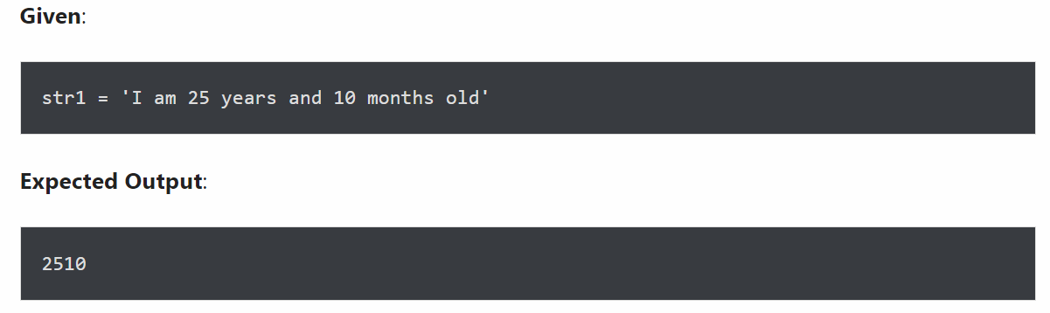

1. Remove special symbols / punctuation from a string

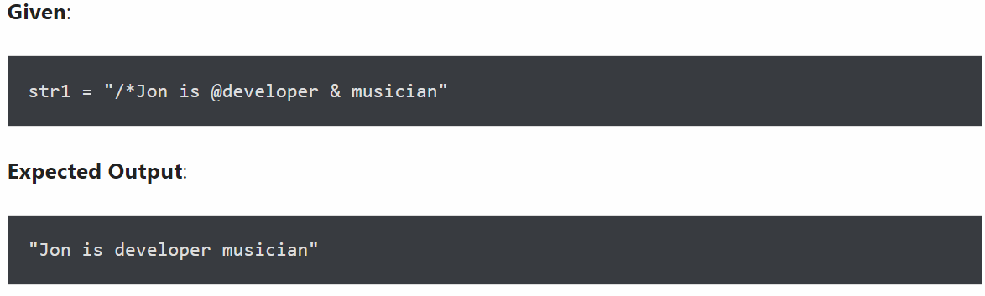

Reference link : https://www.askpython.com/python/string/remove-character-from-string-python

**Question 4 (2.5 marks) Reverse Word Order:**

Write a program (using functions) that requires the user to provide a long string containing many words. Print back to the user a new string with the word order reversed from the original list. For example, when the user enters the string:

My name is Nguyen Van An

then they will get back a result like this:

An Van Nguyen is name My