Sample Title
This is just some plain, old, sample text. Lorem ipsum, etc. Need more content here. Hey, here is some bolded text. And back to normal again. And last but not least here is some italic text. We'll see if that actually works.
This paragraph will feature a bulleted list. So here we go
- This is our first bullet point
- And here is our second
- This is not the fourth point

And back to a normal paragraph style again.

Picture testing

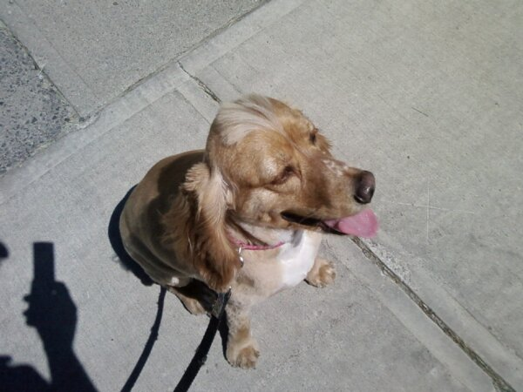

This is a longer paragraph and fairly boring as well. It will be last paragraph of my sample document. Eventually along with the text and lists we will have some tables as well, and if we get really lucky then some images as well. God help me. There should be some header and footer testing as well. Well that would be a good idea anyway. Now some of this text will repeat just to flesh this last paragraph out. This is a longer paragraph and fairly boring as well. It will be last paragraph of my sample document. Eventually along with the text and lists we will have some tables as well, and if we get really lucky then some images as well.
Here is a numbered list
- First point
- Second point
- Third and last point

Table testing
Column A | Column B
Some content | And some other content
Duplicate values | Sigh

Color testing

Red

Green

Blue

Purple

