  L2 Spr25

Software Requirements Specification

FU Exam360 FPT University

Version 1.0 approved

Prepared by Nguyen Van A

FPT University

Da Nang, July 2025

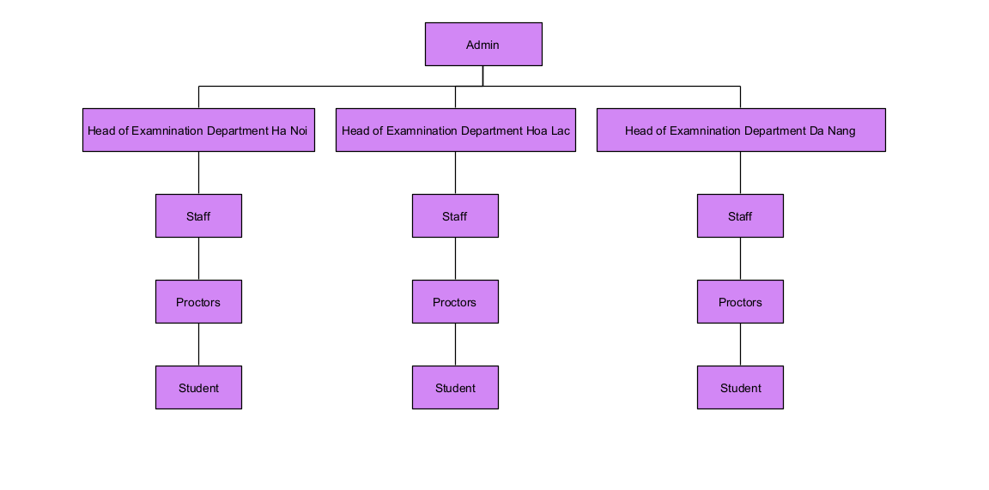

Which type of user of the website in this exam has the largest number?

* Student is type of user hash largest number in this system.

Q3:

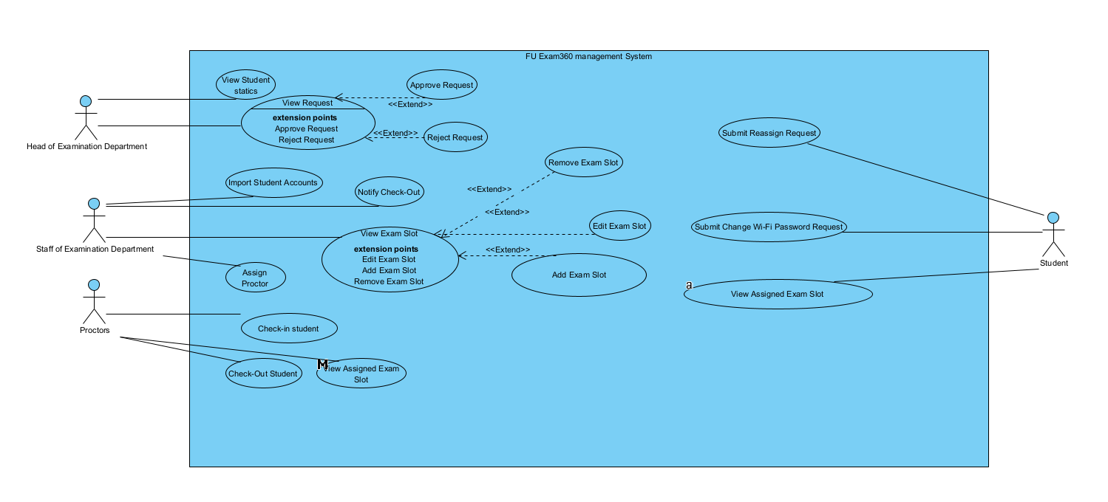

|  |  |  |  |
| --- | --- | --- | --- |
| UC ID and Name: | UC_AddExamSlot | | |
| Created By: | Nguyenvana@gmail.com | Date Created: | 22/07/2025 |
| Primary Actor: | Staff of Examination Department | Secondary Actors: | Head of Examination Department (optional for approval or notification) |
| Trigger: | Staff clicks the “Add Slot” button on the Slot Management screen. | | |
| Description: | This use case describes how a staff member adds a new exam slot into the FUE360 system. | | |
| Preconditions: | 1. Staff has successfully logged in with valid credentials. 2. Staff is on the Exam Slot Management screen. | | |
| Post conditions: | 1 A new exam slot is saved to the system.  2 The slot is visible in the list of exam slots.  3 Notification may be sent to relevant parties. | | |
| Normal Flow: | 1. Staff navigates to the “Slot Management” screen. 2. Staff clicks on “Add Exam Slot” button. 3. System displays the “Add Slot” form. 4. Staff fills in required fields: date, time, room, class, etc. 5. Staff clicks “Save”. 6. System validates the data and saves the new slot. 7. System displays confirmation message. | | |
| Alternative Flows: | 1. Staff enters an invalid date or time → System highlights the error. 2. Staff selects a room that is already assigned for that slot → System shows a conflict warning. 3. Staff clicks “Cancel” → System discards input and returns to slot list. 4. If network lost before saving → system caches locally or warns to retry. 5. If Staff enters duplicate slot info → System blocks and displays duplication message. | | |
| Exceptions: | 1. Database error occurs → System shows "Unable to save, try again later." 2. Session expired → System redirects to login. 3. Required fields left empty → System prompts to fill all mandatory info. 4. User doesn't have permission → System blocks access and logs event. | | |
| Priority: | High – Adding exam slots is core functionality and must be available early. | | |
| Frequency of Use: | Very frequent – Staff add slots at the beginning of each exam cycle, often daily during planning periods. | | |
| Business Rules: | Each exam slot must be unique by time-room combination.  A room cannot be used by two slots at the same time.  Only active classes and rooms can be selected. | | |
| Other Information: | System should auto-fill some default data (e.g., current semester or staff's default campus). | | |
| Assumptions: | Room and class data are already imported from FAP.  Staff is trained in the system's UI for slot creation. | | |

**Q5:**

Most important non-functional requirement: Performance

1. The FUE360 system must support at least 200 concurrent users performing actions such as check-in, check-out, and slot assignment without exceeding 1 second response time per request.

2. The system shall process and save a new exam slot within 2 seconds after clicking the "Save" button, under a standard load of 100 users.

Second most important non-functional requirement: Availability

1. The FUE360 system must be available at least 99.5% of the time during each exam period (including weekends), ensuring uninterrupted access for students and staff.

2. Scheduled maintenance of the FUE360 website must not exceed 1 hour per month, and must be announced at least 24 hours in advance.