DATA VISUALISATION
COS30045

Agri-Environmental Sustainability: Global Indicators and Trends Leading into Adaptive Policies

STUDENT NAME : LE DUC TRI
STUDENT ID: 104182054
GROUP: Alone
DUE DATE: 15/8/2025
TUTOR : Trung Nguyen

[Link to website]

PROCESSED BOOK

Contents
Agri-Environmental Sustainability: Global Indicators and Trends Leading into Adaptive Policies 1
1. RESEARCHING AND ANALYZING 4
1.1 Data Exploration and Preparation 4
1.2 Analyzing dataset 5
1.3 Cleaning the dataset 7
2. DATA ANALYSIS 10
2.1 Key Factor in-depth research 10
2.2 Research Report 11
2.2.1 REFERENCE AREA 11
2.2.2 MEASUREMENT METHODS 14
2.2.3 EROSION TYPE 18
2.2.4 WATER TYPE 20
2.2.5 NUTRIENTS 23
2.2.6 UNIT MEASUREMENT 29
2.2.7 TIME PERIOD 31
2.3 Assignment Required Research Conclusion 33
5. REFERENCE 36

"Analyzing Agricultural-Environmental Interactions Through Indicators for Policy Development"
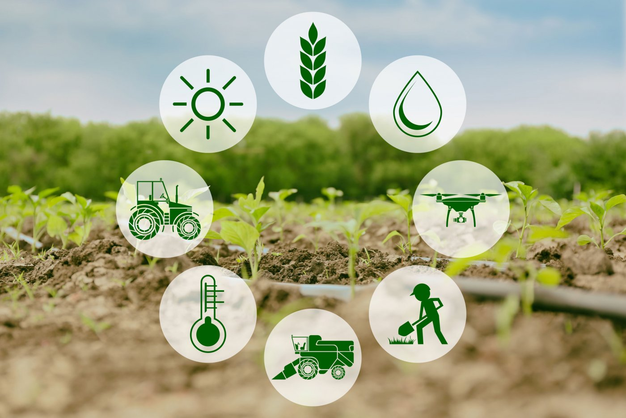
Image source: https://www.gruber-genetti.it/en/blog/b/smart-farming-agriculture-4-0-part-i_22

RESEARCHING AND ANALYZING

1.1 Data Exploration and Preparation

I have downloaded the dataset and took some quick notes on the OECD website description page to understand the context of the dataset and so is what we are analyzing.
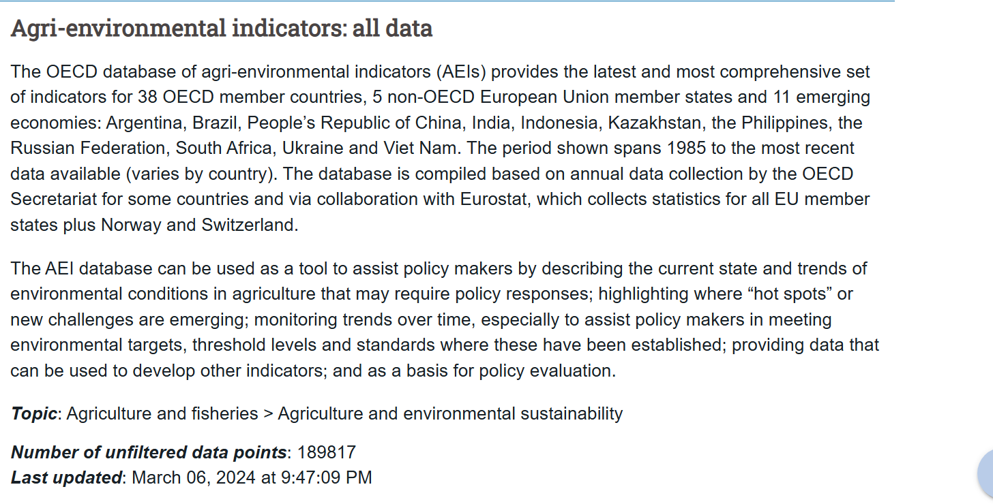

After that I extract the zip file and read the dataset csv file open with Excel
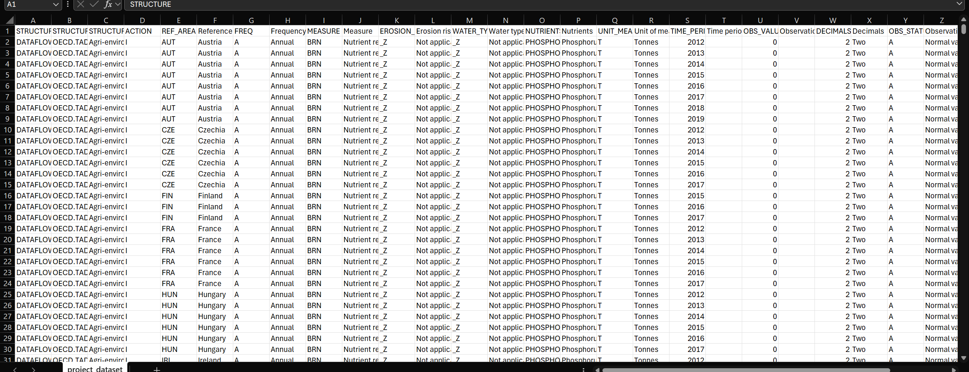

Update: The Assignment provided additional material

Analyzing dataset

Here is what I’ve summarized from the dataset description
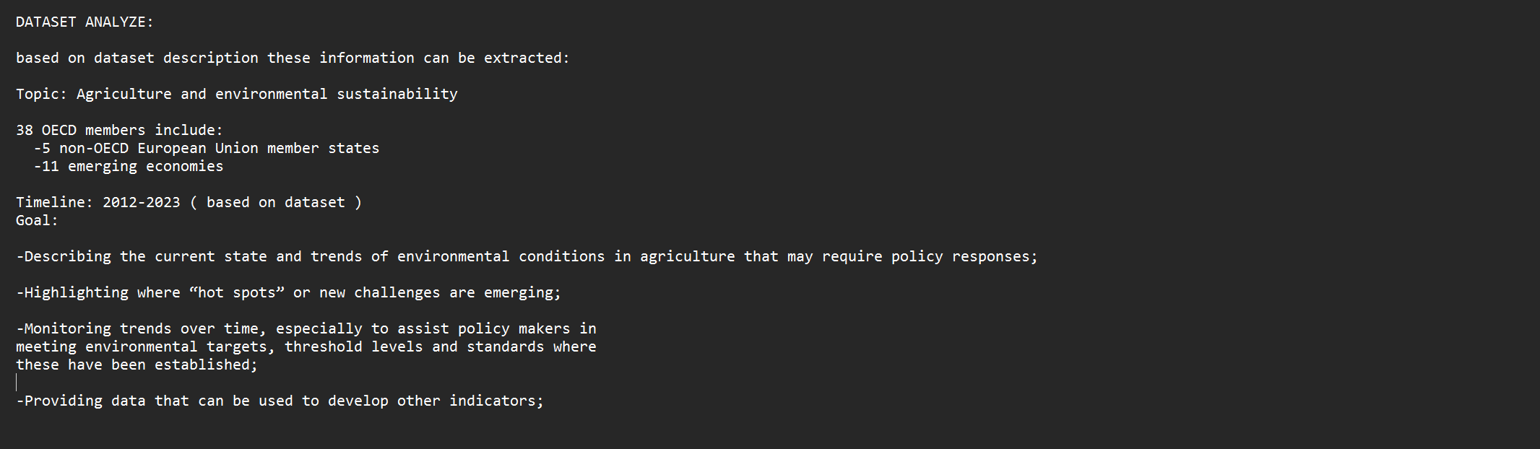
Here is what I conclude from the OECD dataset:
The dataset comprises of :
-OECD files intel which include STRUCTURE ( mostly DATAFLOW), STRUCTURE_ID( this are systematically named by OECD naming system which is irrelevant) and STRUCTURE_NAME( which state the context and what it is providing in the dataset and specifically in this case is “Agri-environmental indicators: all data”)
- It has a total of 30 Columns that contain multiple indicators, methods and unit and its mapped ones ( for example we have “viet nam” as region, then the mapped column would be “VNM” and be right next to it. I have read the dataset and identified key variables that affect the OECD scores ( OBS_VALUE or observation value in terms of dataset):
+REFERENCE AREA: country geographic location undoubtedly the major factor on affecting factors like temperature, soil type, rainfall or even water availability.
+MEASUREMENT METHODS: There are multiple methods provided with different way of measuring them, for example “nutrients removal by crop residues burned on the field” which measure the loss of vital nutrients like phosphorus and nitrogen. There are many other columns that I will go in depth later.
+EROSION RISK TYPE: This is preferring to the how vulnerable the soil is to erosion. Erosion process will prevent the land absorbing nutrients by vanishing the topsoil layers where the fertilizer and nutrients that farm put togethers stays. The correlation between this variable ( if exists) will be discovered later while analyzing.
+WATER TYPE: This is about what type of water the header stated, it could be from underground and through lakes, reservoirs or both factors. This matters because where you take the water will provide different soil pH . Low pH or high pH will provide different levels of Alkaline which can be damaging to the growths of plants and agricultural in general.
+NUTRIENTS: Nutrients are undoubtedly vitals components of the crop’s growth. It’s comprised of Nitrogen and Phosphorus which affected the developments of multiple components of plants such as roots, stem and leaves. Extensive or lack of fertilizing on both nutrients will severely damage the growth of crops.
+UNIT OF MEASUREMENTS: it’s comprised of multiple measurements metrics both relevant and in some cases. There are some wildly used metrics such as Hectare(HA) and Tons(T) to quantify areas, kilogramme to quantify weights, Cubic metres(m³) and some percentage metrics like the ratios of nutrients emission , agricultural lands. These metrics are used to evaluate the impacts of several aspects during the growths of crops which help reach some quantitative conclusions.
+ TIME PERIODS: This column might not necessarily be meaningful to the context of the assignment but to be fair, in this time there could be some sort of catastrophe which leads to some unfortunate declines in productivity and could also explain some weathers condition where crops are dying.
+ OBS_VALUE: These columns comprise of numbers that are calculated by the above key factors which go through the OECD calculation and provided quantitative meanings. Positive mean through the provided indicators( above one), there is a growth in goal value( could be productivity, or anything else based on OECD goals). 0 mean no impacts and negative there is a reduction in goal value based on factors evaluated.

Cleaning the dataset
This process is being done by using Python Jupyter Notebook. Using this help enhances step by step dataset cleaning to see what is working and what is not as well as displaying the result while processing it.
Step 1: Filter out Key columns and unnecessary factors.
Key columns is the above categories that I have mentioned and unnecessarily factors comprise of duplicate columns ( columns that are the same value which are mostly used for mapping data), formatted columns ( columns that are processed by OECD that I have some OECD formatting logs on in like STRUCTURE_ID or STRUCTURE_NAME) and duplicated row value( row with the same value that not really state anything meaningful aside from being redundant for example DECIMALS row)
Step 2: Processing
Drop unnecessary columns
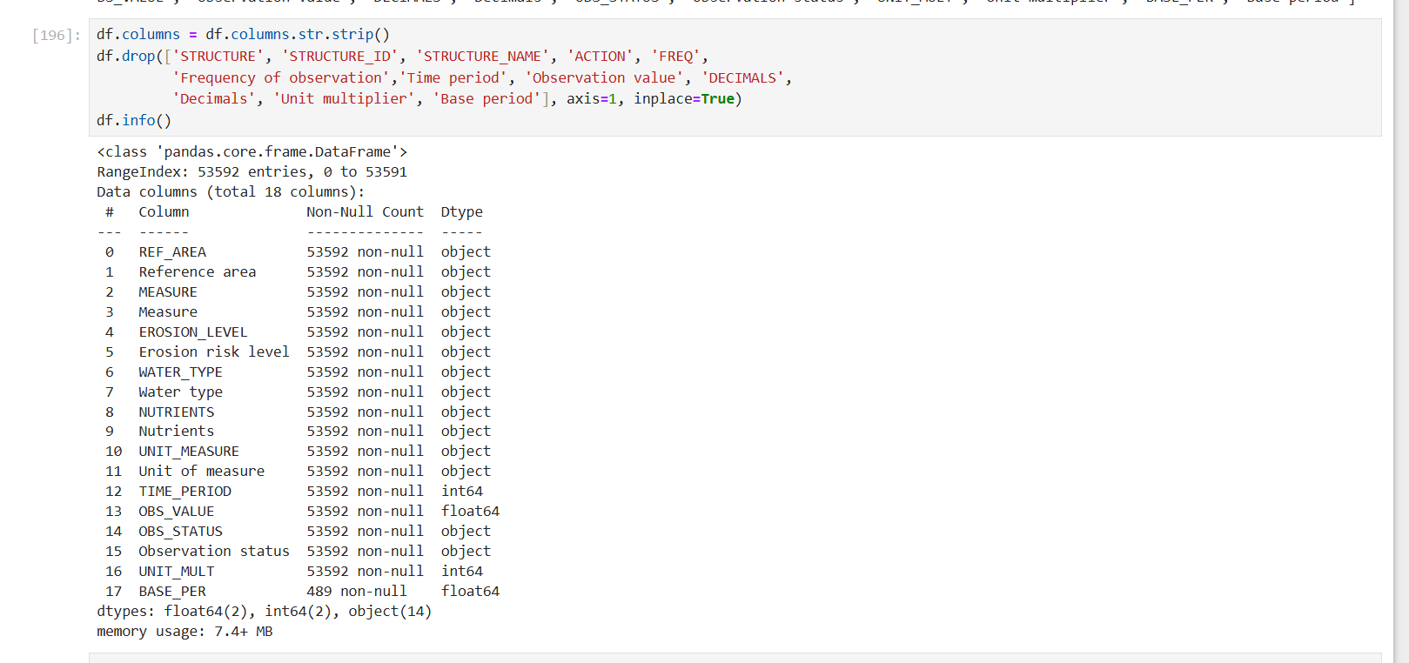
Check the result 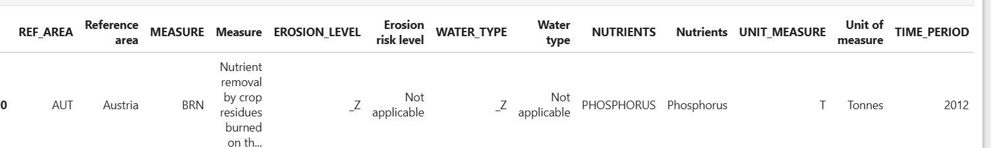
Checking for null value and unique value in each column
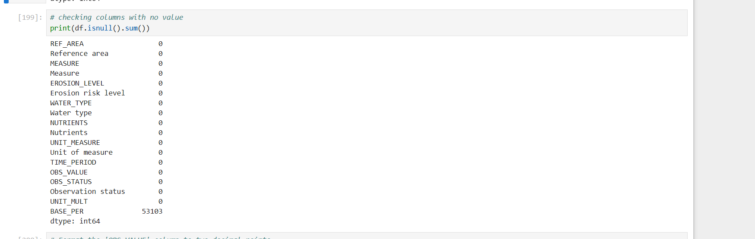
BASE_PER column have a lot of duplicates without removing the entire columns because there are some metrics such as Tonnes of oils/CO2 in equivalents which need to be multiplied by 3 and I have no proper methods yet to solve this, so I keep this column.

I remove decimals rows and change the formatted of displaying OBS_VALUE to .00 on decimals 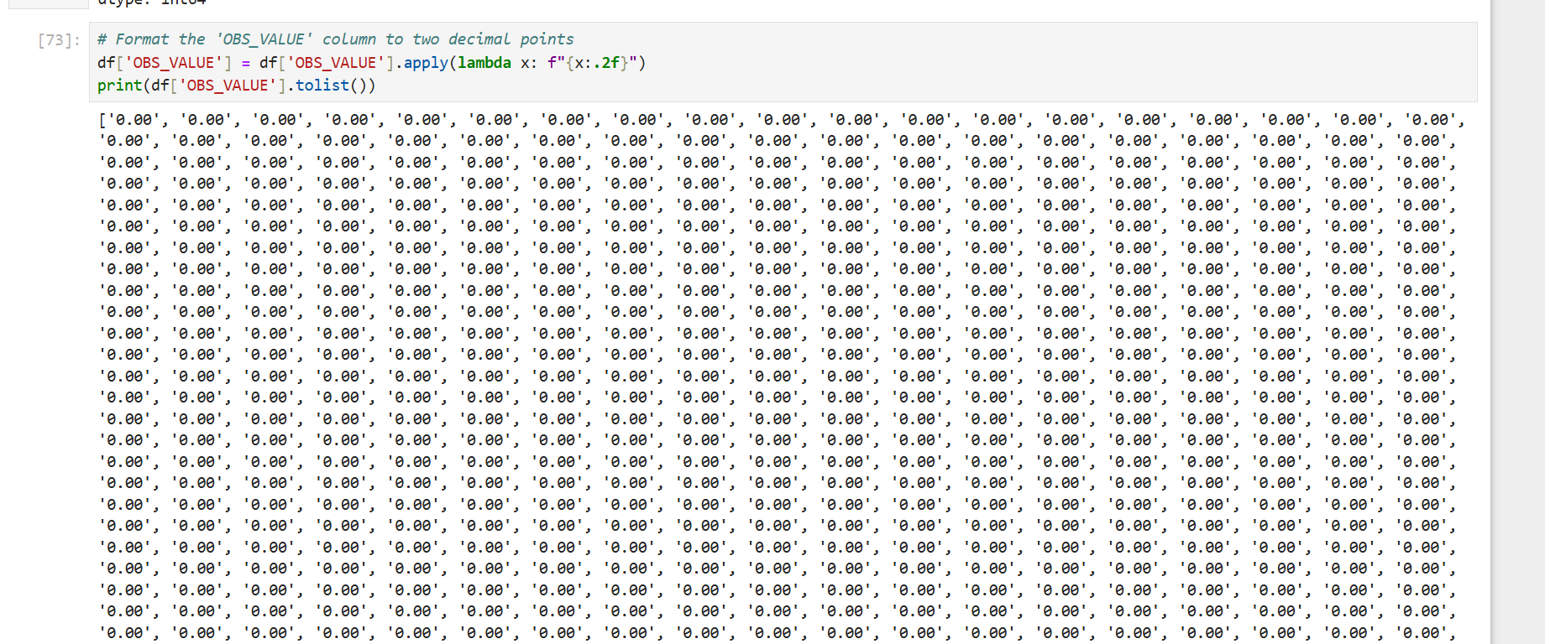
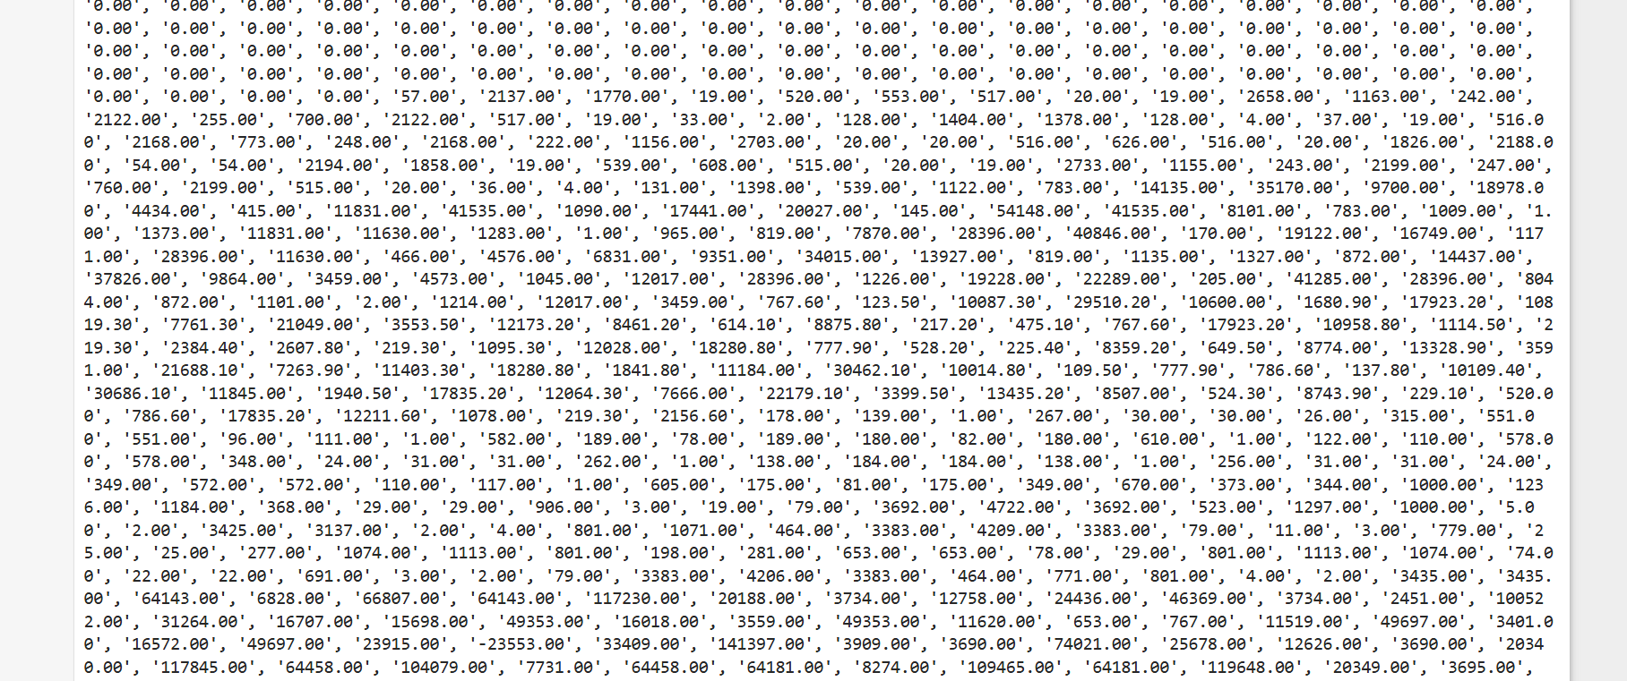

Change the _Z , NaN and Not Applicable to N/A and set blanks to NULL for better classification and display and save the file.
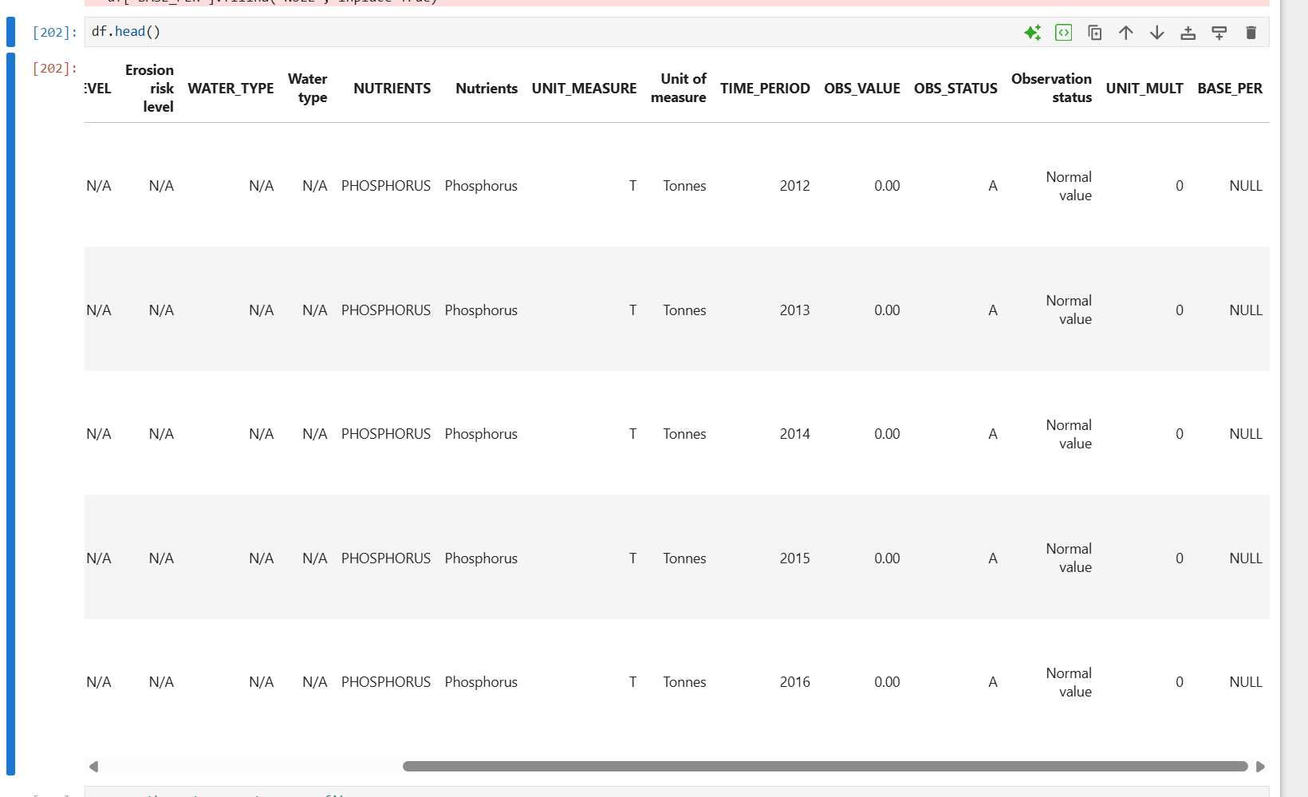

From here we could now dig deeper into the columns meaning by doing some extensive research on the columns impact as well as the correlation between them if exist.
NOTE: because there are no such ‘requirements’ other than “filter relevant countries, years” and there is no description of what is consider ‘relevant’ in the Assignment that I need to filter out OECD members or relating country that match the description of the dataset and there is also the presence of non-involved countries in sub dataset ( 4 new datasets added later in the assignment description) provided later so I’ll not filter out the country and keep it the same.

Assignment requirements:
Dataset description:
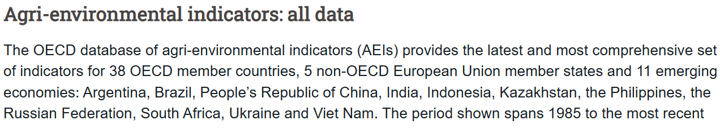

THIS IS THE END OF CHAPTER 1

DATA ANALYSIS

2.1 Key Factor in-depth research
As stated above we are going to hang around on the internet and see what these factors contribute to through studies and research.
Research List :
- REFERENCE AREA
- MEASUREMENT METHODS
- EROSION RISK TYPE
- WATER TYPE
- NUTRIENTS
- UNIT OF MEASUREMENT
- TIME PERIOD ( Optional Extensive Research for deeper understanding)

Research Report

REFERENCE AREA
OECD provides us with access data to all around the world which means it was around 200+ countries. Describing them one by one seems impossible, so we are going to observe the world’s map and group them by continents.
Research:
This image describes the proportion of lands that are accessible to agriculture and other areas. According to a report from the World Map, around 11% of the world’s total area are ideal to grow crops, spreading diverse around the globes. Based on the map below, we can observe some interesting facts:
-North America: While the area around America and Canada are filled with Dark green and purple and which are productive to grow crops and cereal, the larger major parts are covered with jungle and unproductive land.
-Asia: To be more particular, Southeast Asia, covered with dark green and orange which are the most ideal region to grows crops as well as rich resources from the jungle, we can expected magnificent statistic in this region, while the area around Siberia and Russia are mostly filled in yellow and orange.
-Europe: Western and Central Europe are blessed with a majority of are Dark green with some parts are purple which are accessible to cereals.
-Africa: This is one of the best examples we can pull out. While the large part of North Africa is covered in yellow because of its Sahara Desert, the central and southern part are covered in dark green and purple which used to grow cereal and crops.
Conclusion: Agriculture of a region are so heavily dependent on the area which have so many factors that could affect them like region climates for example Russia or Siberia are colds regions while Southeast Asia have insane number in annual precipitation of rainfall which explain a lot about their region “colors”. This makes each region/country have different data on indicators and statistic.
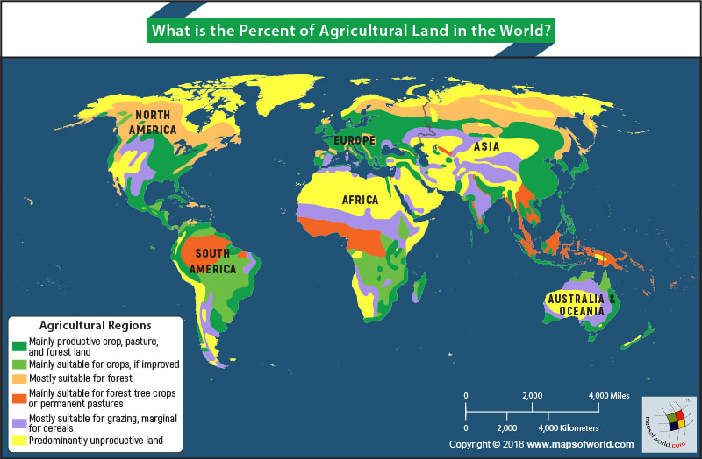
Image source: https://www.mapsofworld.com/answers/world/percent-agricultural-land-world/amp/

The image below shows some majors factor like rainfalls could affect a region’s agriculture productivity compared to the above images.
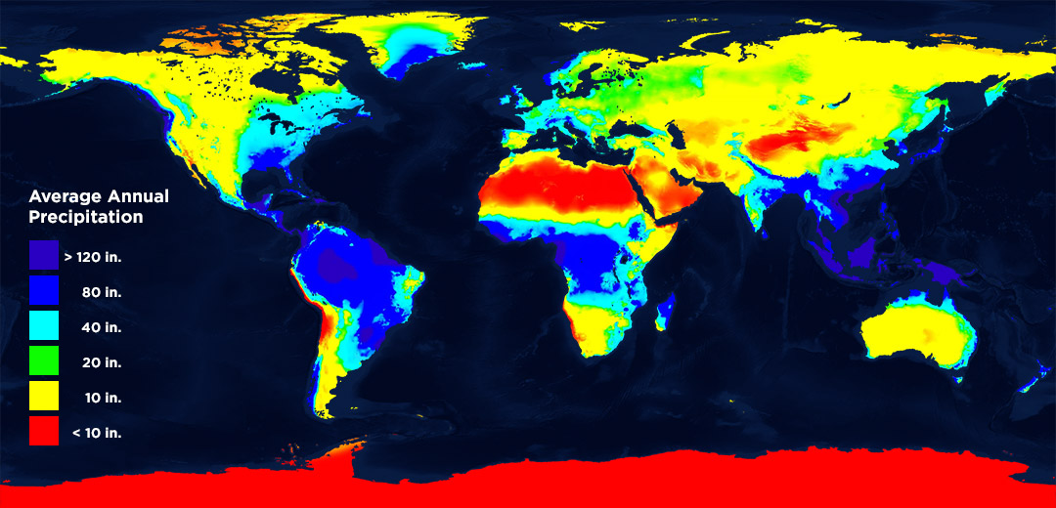
Image source: https://learn.weatherstem.com/modules/learn/lessons/57/index.html

Comparison to the given dataset:
The assignment provided with a sub-dataset named “Agricultural land area” consists of filtered information that should be some undeniable facts:
Measurement methods: this method named “Total agricultural land area” which sum up the total agriculture area of the country by unit Hectare(HA).
Reference area: The dataset contains numerous countries which can be divided into multiple parts southeast Asia countries like Viet Nam, Philippines, Indonesia. There is also large number of European countries that are called in general EU_27 and some part that state specific like Norway, Sweden...etc. There are also some North America countries like Argentina and Brazil that appear on the list. In summary, if we compare it in parallel to the World Map, we can see that most of this country belongs to the dark green zone. This dataset mainly shows how environmental geography significantly impacts the output of agriculture and act as an essential indicator.
Nutrient type, Erosion risk level and water type: This are also classified as not applicable which means this use mainly for other columns statistic.
OBS_VALUE: Describe the value of agricultural by Hectare unit(HA) and multiply by thousands
Dataset Statistic( agriculture land area sub dataset):
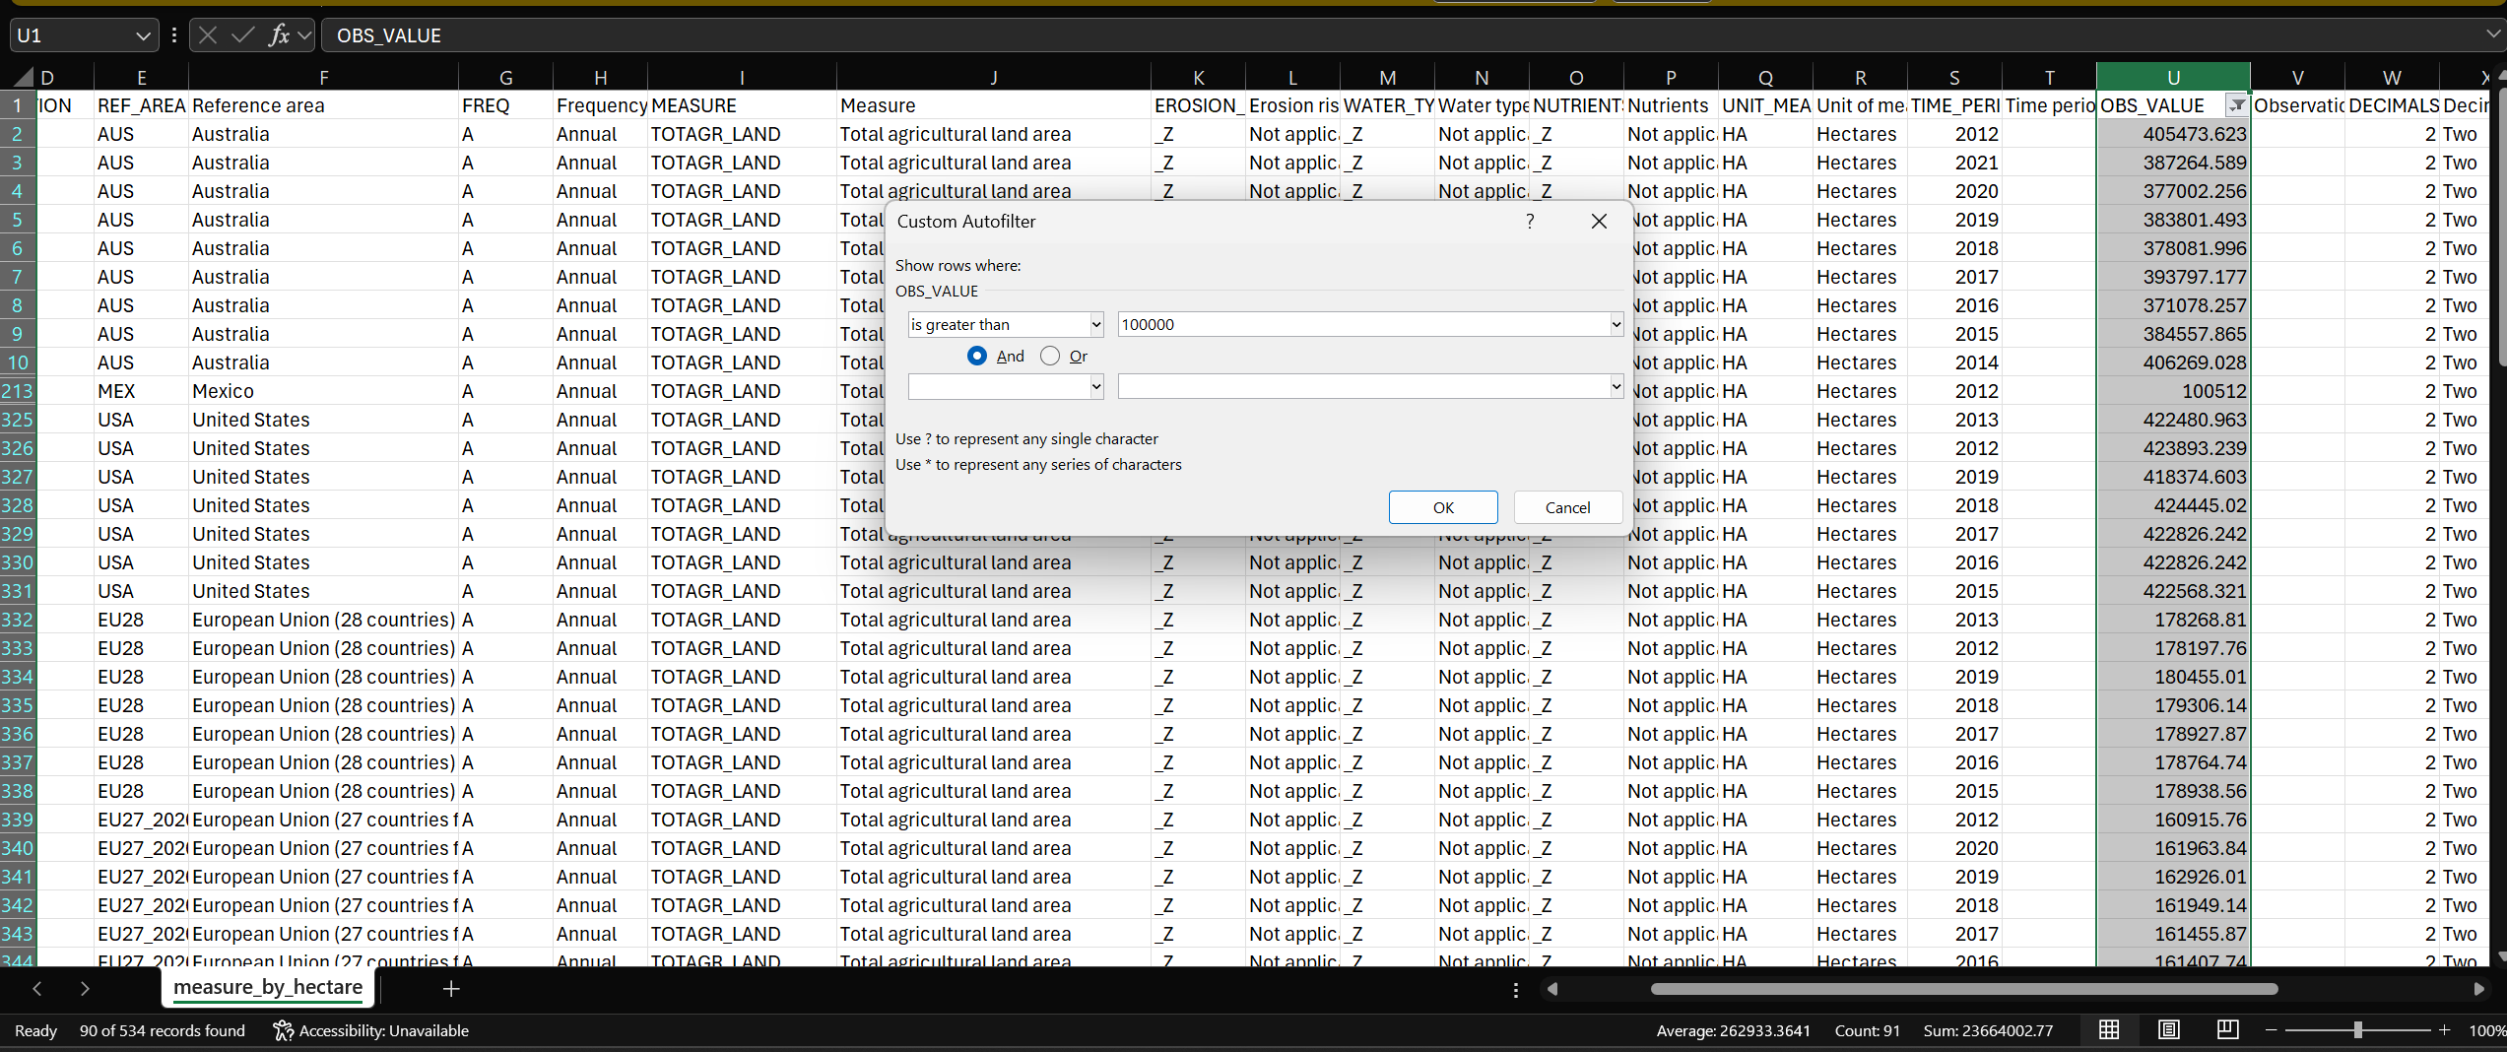
The image above shows an impressive statistic where more than 17%(90/534 records) are larger than 100,000 which proves this country has high agricultural potential.

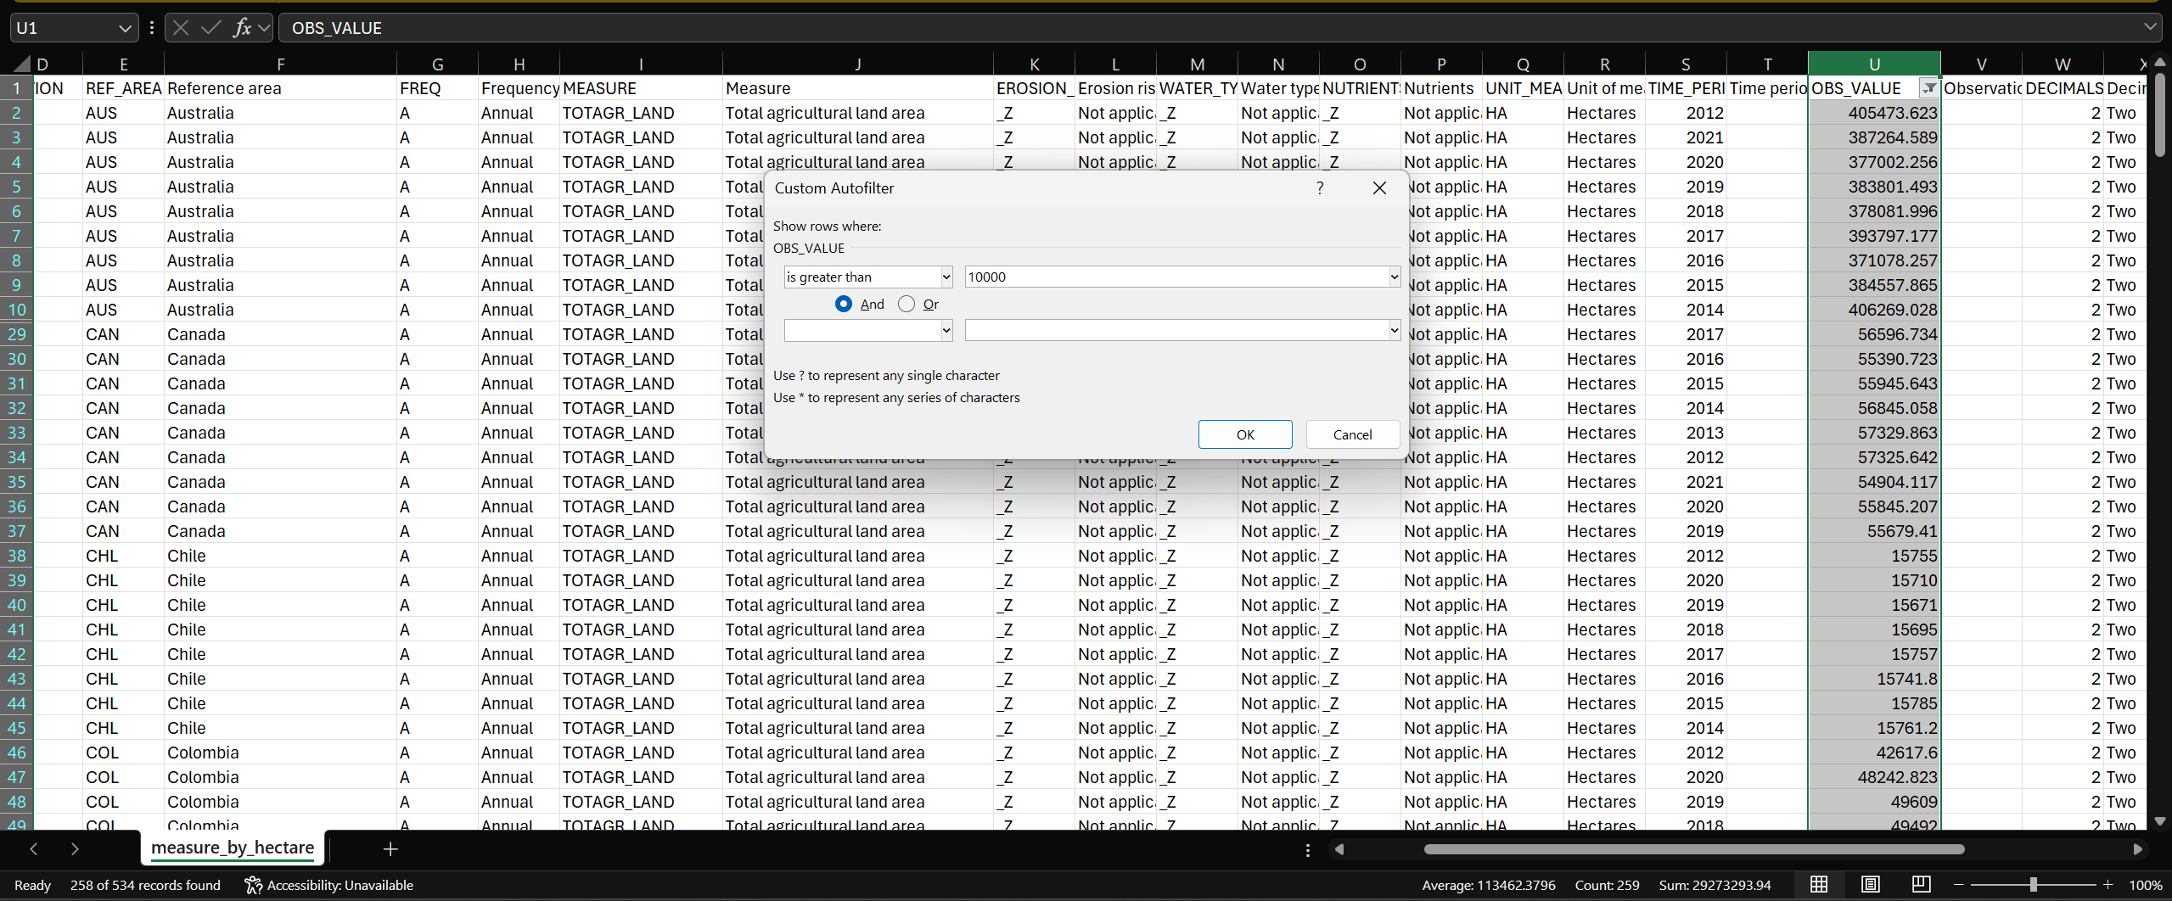
This shows that almost half of the records are larger than 10,000 which is the concrete evidence that tightens the relationship between regions with large agricultural lands and concludes that : region with large numbers of agricultural lands measured by Hectare(HA) will have significant impact on agriculture productivity and act as a clear indicator.

MEASUREMENT METHODS
What are Measurement methods ?
Answer: According to Meal DPro, it will determine how the data being gathered to measure progress of a studying project.
This implementation of measurement can be divided into 2 types : qualitative and quantitative
Quantitative methods: these methods are used to measure thing in quantity. It’s also used to gather statistical number like proportion averages, ranges and variances.
From a quick skim that have been done on the dataset, I can confidently tell that most of the methods are quantitative methods simply because it’s more reliable, it provides metrics that are “matter”, a real figure to observe and evaluate. For example, some of them are:
Methods: Cattle ; Unit of Measure: Tonnes ; Available key column : Nutrients( Nitrogen)
Methods: Poultry ; Unit of Measure: Tonnes ; Available key column : Nutrients( Nitrogen)
Methods: Share of monitoring sites in agricultural areas that exceed recommended drinking water limits for pesticides; Unit of Measure: Percentage of monitoring sites ; Available key column: WATER_TYPE( Surface Water)
- From the above 3 examples we can see that they are pretty much assigned with a key column which displays output in observation value. There are different metrics as well as multipliers, so we are going through that when we research.
Qualitative methods: these methods measure quality because they are based on the participants’ feedback or experience. This method is more focused on answering questions rather than gathering something that are “matter”.
There is a method in this assignment use metrics “ Index” which I believe it could be through both qualitative and quantitative ones or going through complex procedure to produce outcome.
There are more than 100+ ways of measuring methods in this dataset which make it redundant to explain each of them. Measuring methods have a deep correlation with unit of measure and some key columns in the datasets which we will examine.
Methods : Forest/Farmland birds index; Unit of Measure: Index
- Through short research, these methods are used to examine the environment as well as the habitat qualities. So, it can be considered a qualitative method.
How are These methods split into categories on agriculture context ?
Answer: Based on reports made by FAO organizations, it’s split into these categories:
-Vegetation : There are multiple ways to do this, some of popular methods are measuring the frequency and the density of crops.
-Soil : Measuring condition of soil. Because its condition could lead to compaction and erosion which strongly impact the agricultural
-Water : measure the amount of nitrate content as well as bacteria in multiples source of water
-Socio-economic: comprises of 4 different competitions :
+ Land competitions: action that led to growth of economies in numbers.
+Crops residue competitions: measure pasture and fodder to reflect actual agricultural deficiency.
+Labor availability competitions: reports on earnings to reflect labor productivity.
+Draught Animal Power competitions: Basically, comparing animal powers to technologies initiatives to observe the gap between them.

Dataset Analysis( energy used sub dataset):
Key thing before analyzing the sub dataset:
Measure: Total final energy consumption ; unit of measure: oil equivalent => this means that this use to calculate the energy consumption of activities to run a farm like electricity, oil for running vehicles and machinery for farming methods depending on context.
Measure: Total final energy consumption ; unit of measure: oil equivalent => this that this use to calculate total energy consumption on all sources possible : vehicles, machinery, fertilizer energy and other energy related activities
OBS_VALUE: calculate by energy consumption calculated by crude oil burned in tonnes in a period of 2012 to 2021
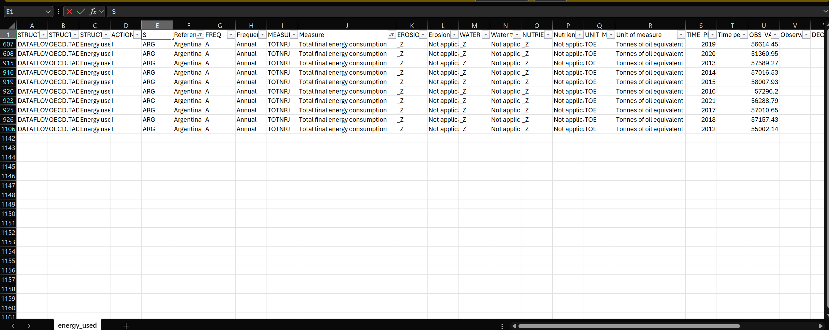

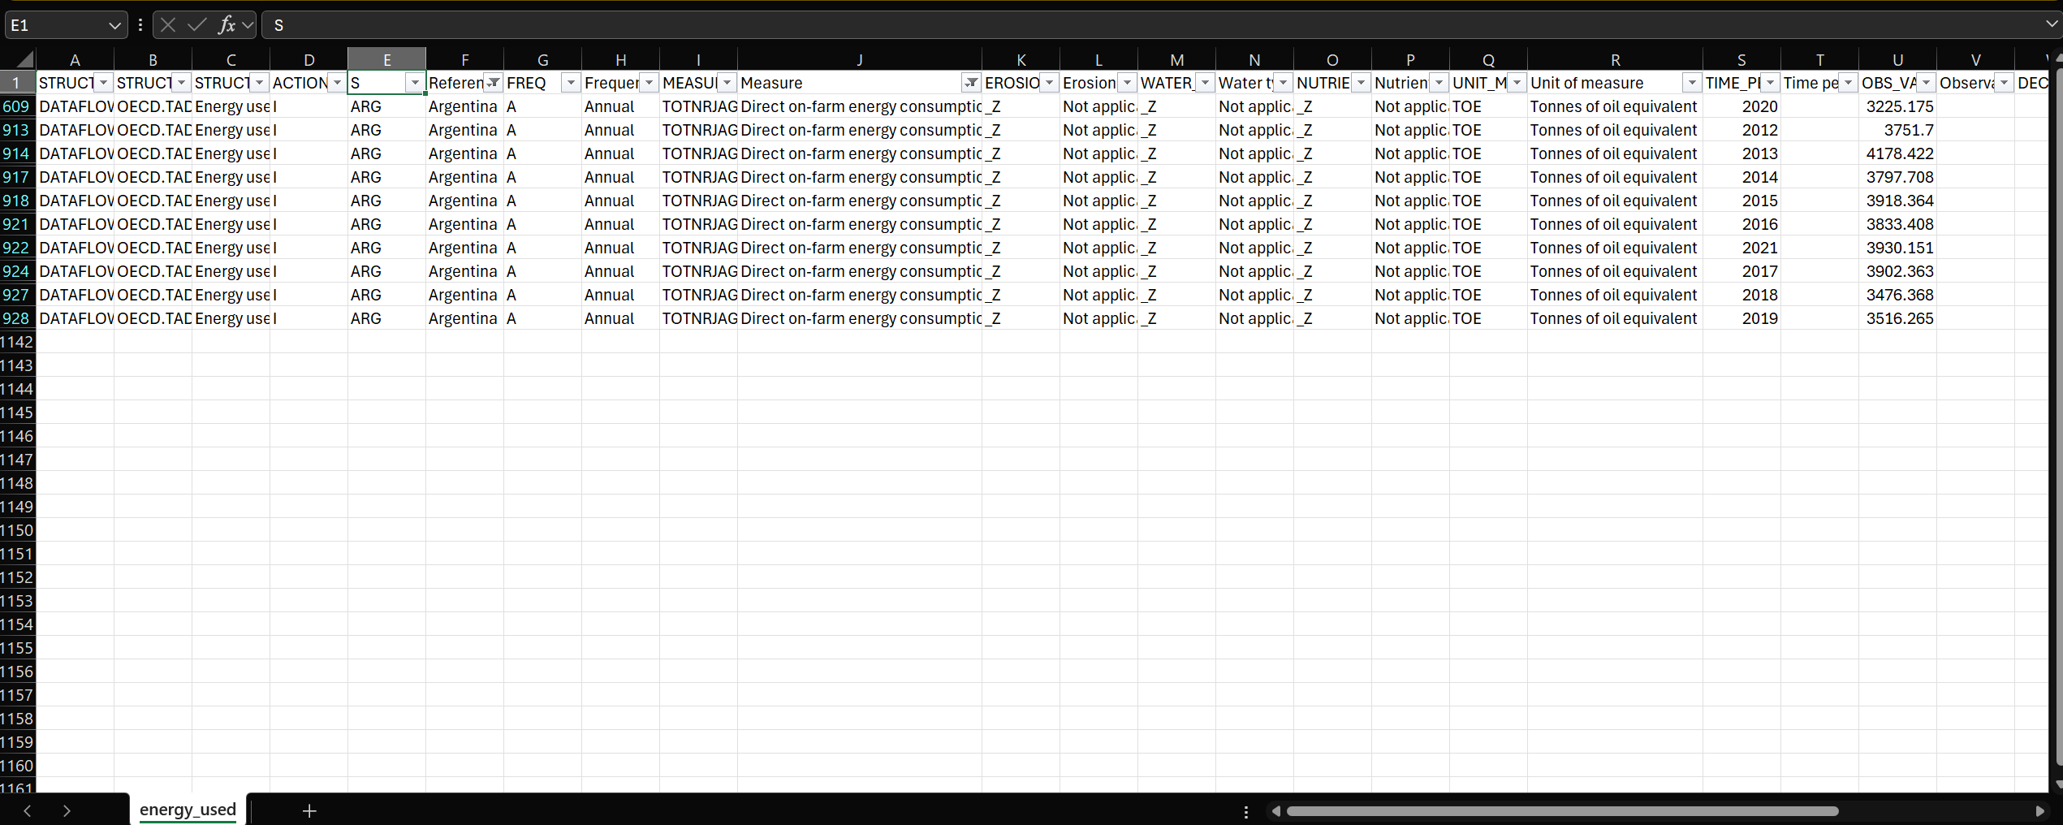

Based on these filtered methods, we can see the 2 things:
-Direct on-farm measurement only account for 5-7% of total energy consumption need to run a whole thing( 3-4 ~/56-57 Tonnes of oil equivalent). Which means running farming methods is not that costly, the cost is on something different.
-There are the same trends of increasing from 2012 to 2019 with a huge loss in 2020 and spiking back again in 2021. This proves that there are correlations between’ Direct on-farm energy consumption’ methods and ‘Total final energy consumption’ methods. It’s also indicated that there is numerous factor reductions in 2020 which mean that’s these methods showing the full picture consumption in agriculture. This is a good indicator if we speak in terms of informative.

EROSION TYPE
- DEFINITION
What is soil erosion ?
Answer: Soil erosion, according to Wikipedia, is a natural process that damages the top layers of soil, this occurred when the winds and water gradually impact the lands mostly the surface layers, causing soil particles to vanish. This is classified as a form of soil degradation.
How is it causing damage to the agricultural environment ?
Answer: According to HOLGANIX, when soil eroded, it is removing the topsoil layer which provides essential nutrients and organic matters for plants. It’s also leading to 4 challenges that are well-described in the image below:
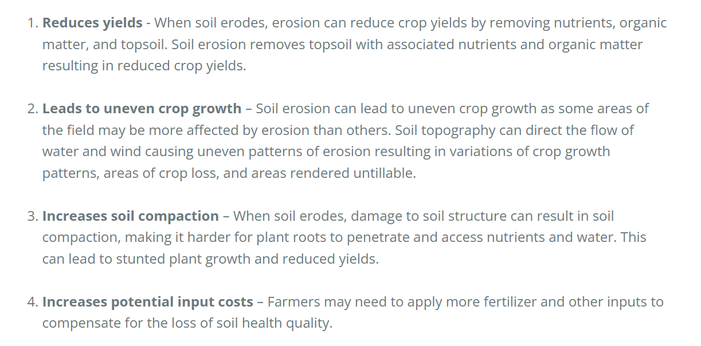
Image source: https://www.holganix.com/blog/how-does-soil-erosion-affect-crop-productivity-how-do-you-fight-it

What is the leading cause of soil erosion ?
Answer: There are multiple factors but from what I’ve researched and read, there are 4 major factors that have appeared to cause this problem significantly:
Water: Water impact, especially from heavy rain or strong stream from a river, for example could heavily damage the soil’s particles due to the impact it causes.
Wind: Wind pressure could loosen the soils, which carried away soil’s particles and make it vulnerable to many other factors from the environment.
Deforestation: Removing trees which means removing their root systems, the system that is accountable for holding soil’s particles together.
Construction activities: Removing the lands for building without proper measurement from authorities on lands type is also a major factor that led to the unfortunate erosion of soils.

How do we assess erosion level ?
Answers: erosion risk level is measured by soil loss which calculates by the following equation
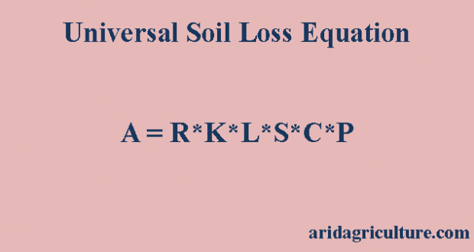
Image source: https://aridagriculture.com/2018/03/11/universal-soil-loss-equation/
The level of damage will be determined by the value of soil loss. The image below is a result of research done by ResearchGate.
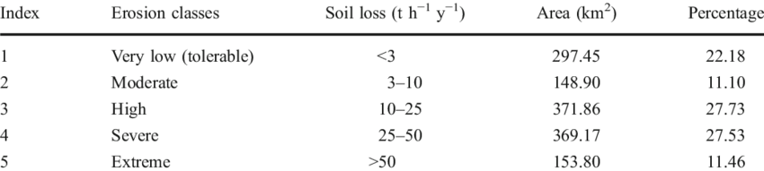
Image source: https://www.researchgate.net/figure/Soil-erosion-severity-zones-with-erosion-rate-and-area-covered_tbl1_225666016
This image shows there actually 5 levels of soil erosion which are: very low( tolerable), moderate, high, severe and extreme which are slightly different compared to the dataset, which is tolerable, low, moderate, severe and total( I believe total are Extreme if compared to the above statistic).

- STATISTIC
In the U.S Midwest alone, soil erosion account for 6%, which is the total of 2 billion in economic loss. Isaac Larsen, UMass Amhert Professor stated that this natural incident causes a total of 60 billion metric tons of topsoil from the past 160 years, the report from HOLGANIX described.
The report also states some additional information such as FAO( Food and Agriculture organizations) report a worldwide loss of 400 billion US dollars due to this matter.

- CONCLUSION
Answer: It’s a natural occurrence that causes a huge loss of agricultural productivity and clearly major factors in context such as environmental indicators that affect productivity. We can also notice there is a relationship between water type and soil erosion which we will discover in the next key categories.

WATER TYPE
- Definition and differences
According to Wikipedia:
Ground Water is preferred to the source of water under the Earth’s surfaces. This water goes through soils and rocks. This water is lower in contaminants because it’s not exposed to above-surface biology and many environmental factors.
Surface Water is preferred to the sources of water beneath the Earth’s surfaces. This water is available through lake, river and streams and is a lifeline for many ecosystems including us humans. Because of its high availability, it is exposed to everything and so it’s facing contaminants more frequently.
Differences: although they are the same, they have almost the same characteristics. ground have taken a larger proportion, less contaminated than surface water but less accessible than surface water based on fact that it was underground

- Research
Based on the research on Sensorex research on differences between water there are some noticeable characteristics and conclusion:
-Ground Water is under the surface, but mostly accessible through rainfall and snowmelt. This points out an essential fact that without the rainfall conditions, it greatly affects the agriculture of a region.
-Surface water refers to any water that sends it lands which are indicated through rivers, lake, and stream systems. This makes them a more reliable option for agriculture based on its accessibility.
=> This summarizes an important key which is : Region with high availability to both types of water will have more resources to increase productivity. Ground water is mostly through rainfall and surface water is mostly from rivers. And since both are contaminated so there will be an irrigation system to remove contaminants that might damage the crops.
3. Dataset analysis and conclusion (water use sub dataset)
This sub dataset aims to discover the relationship between country with different volume of water.
REF_AREA : refer to countries which list probably the same with the previous sub-dataset we have worked on.
WATER_TYPE: Comprise of surface water, groundwater and total water which is the sum of ground and surface water from the same country and the same year.
MEASUREMENT METHODS: “Total freshwater abstraction” which mean total water consumption of a specific type of water in all agricultural activities classified in WATER_TYPE.
Nutrient type, Erosion risk level and water type: This are also classified as not applicable which means this use mainly for other columns statistic.
OBS_VALUE: volume of water calculated by cubic meters(m³) which also multiply by 1 million.
Discover relationships:
For example, we select a country and discover the amount of water that country use in a specific year on agricultural activities
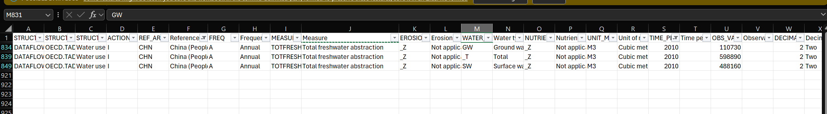
In this table we can see that: Total is calculated by surface and ground water totals volume as intended. It’s shown the incredible amount of water China have use in a single year. It also indicates that most of China agriculture activities come from surface water which mean it has come from rivers and some locals stream systems…etc. the ratio between surface water and groundwater could also be interpreted as less “rainfall” in this particular year. Let’s find out if this is true or not.
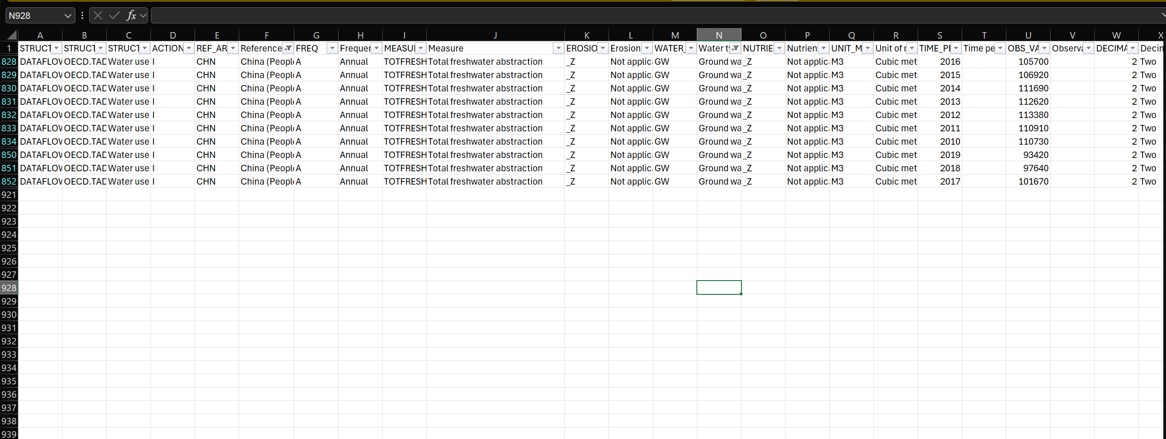
To solve the question is whether the amount of groundwater is normal or it’s less rainfall will do a query to filter out groundwater to all years. It’s shown that there is no significant deviation between years. There is also that there is around 20,000,000 m³ gap between min value year(2019) and max value year(2012).
=> I believe this is the best interpretation between relationships of WATER_TYPE, REFERENCE_AREA and OBS_VALUE.

2.2.5 NUTRIENTS
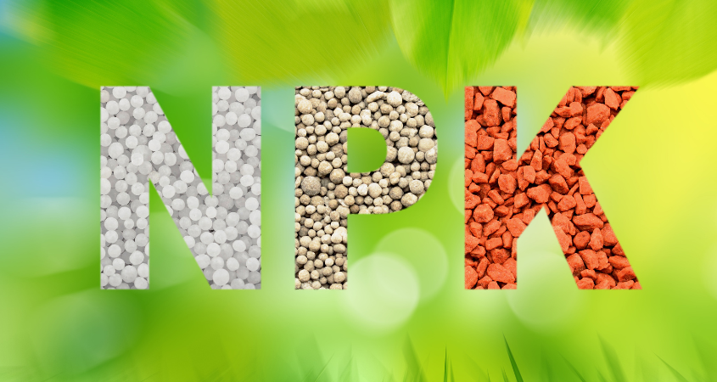
Image source: https://cropnuts.com/nitrogen-phosphorus-potassium-npk-fertilizers/
NPK with each letter stands for Nitrogen(N), Phosphorus(P) and Potassium (K). are the pillars of essential fertilizer in agriculture, according to Cropnuts.
- Nitrogen: Essential component that plays a role in plant development. It acts as a key component of chlorophyll. It’s also used to create protein, enzymes,…
Extensive consumption : plant growth too fast it becomes overgrowth. Which could be harmful to human when consuming those crops or plants. It’s also reported that nitrogen has several aspects that harm the environment like creating greenhouse emissions, leaking through earth and soils to contaminate whatever is below the surface.
Lack of nitrogen: Leaf turn yellow and refuse to grow.

- Phosphorus: essential in root development and seed production. Increase plant immunity to disease. It also acts as a component that creates ATP ( which acts like human calories in plants).
Extensive consumption: reduce nutrients transportation in plants.
Lack of phosphorus: Root not growing, leaves turn purple, and slow down growth speed.
Note: Since the dataset is not providing potassium so I’m going to skip it.
- Implementation of Nitrogen and Phosphorus in agriculture
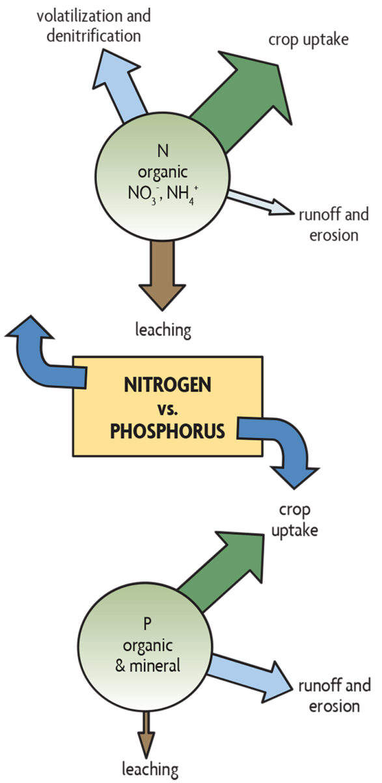
Image source: https://www.sare.org/publications/building-soils-for-better-crops/management-of-nitrogen-and-phosphorus/
According to the information from SARE organization(sare.org), here are the available sources of nitrogen and phosphorus uses:
Organic sources:
+Nitrogen: Animal manure, waste like crop residues will be a good source of nitrogen
+Phosphorus: Animal manure, bone and rocks that contain phosphate.
Synthetic fertilizer:
According to data from EOS,
Nitrogen:
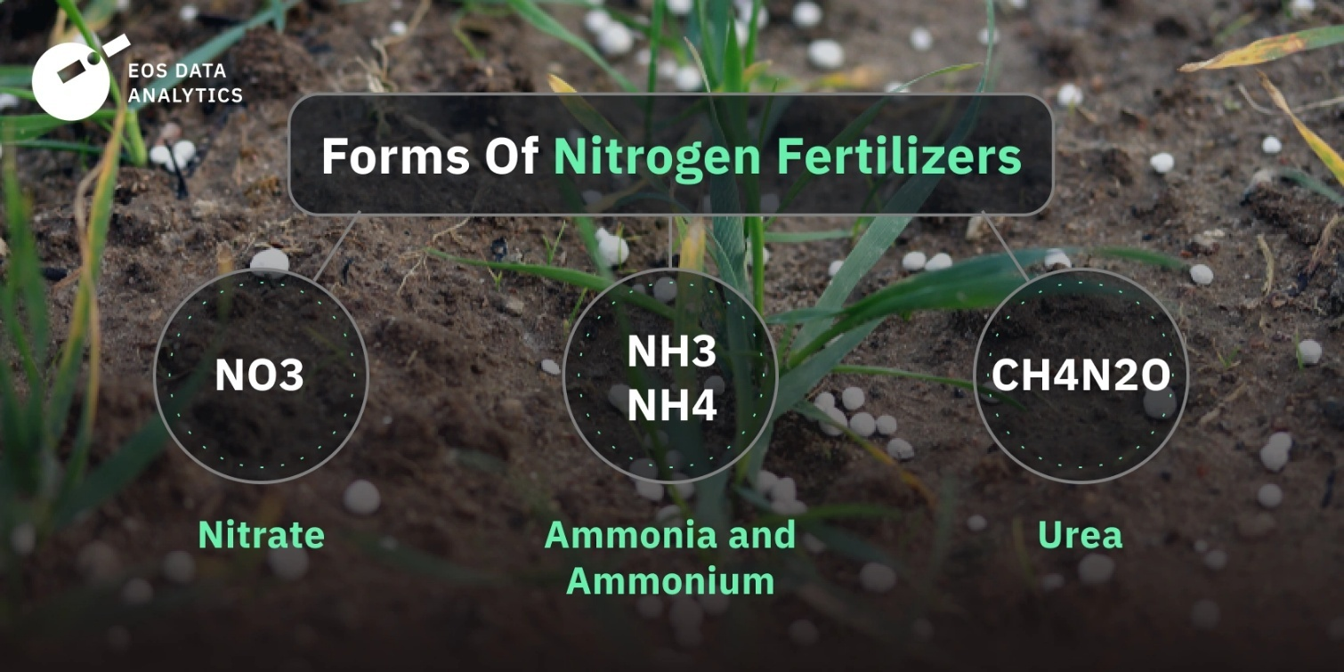
Image source: https://eos.com/blog/nitrogen-fertilizers/#:~:text=Nitrogen%20fertilizer%20is%20a%20nitrogen,produce%20energy%20in%20their%20cells.
+Phosphorus:
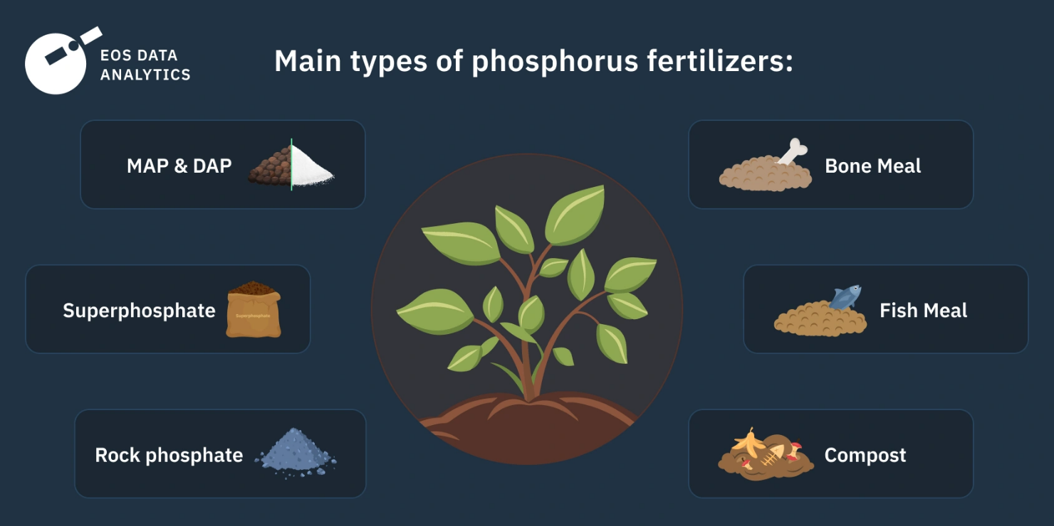
Image source: https://eos.com/blog/phosphorus-fertilizers/#:~:text=Phosphorus%20fertilizer%20is%20a%20nutrient,macronutrients%20essential%20for%20plant%20growth.
NPK Fertilizer:
This is the combination of NPK that are list above with a considered ratio to help plants developments.
Negative impact:
Excessive use of any of that fertilizer could heavily damage the growth of crops as well as the surrounding environments. It also increases the expense which leads to revenue loss to farmer.
- Dataset comparison and relationship discovery(Nutrient balance sub dataset)
There are 3 keys we must mention here which are the following:
REF_AREA: The same as many sub datasets but are important to mention
MEASUREMENT METHODS: Balance per hectare, which means the amount of the above nutrients being used.
NUTRIENTS: Nitrogen and Phosphorus ( no potassium)
OBS_VALUE: the amount of nutrients being consumed per hectare measure in kilograms in a time periods of the same country.

This dataset is used to measure the excess amount of nutrients in farming for various reasons. We will start with China again by filter out country name : China, we can see most columns don’t change except the nutrients value of Phosphorus and Nitrogen. We can observe that each year there is always a pair of nutrients(P/N) each year. It seems like phosphorus is always smaller than the amount of nitrogen.

There is also a trend that shows a lot of intended adjustment in these nutrients’ usage. We can see a highly used trend from 2012-2016 which average is around 46 kg/hectare and then significantly reduce to 30 kg/hectare from 2017 to 2020. There is also a gradual decline in phosphorus use per hectare from 2012 to 2020 which also could mean that they are not regulated at the same time. To see if this is odd or not, we must move to another country to test it out.
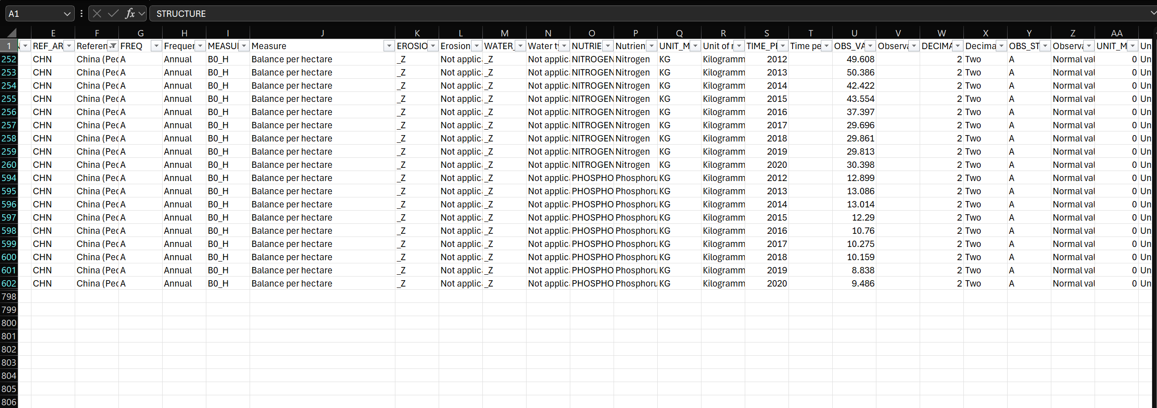

At first, I thought it’s going to be the relationship where phosphorus always larger than nitrogen just like the WATER_TYPE and then, I curiously searching for the maximum negative numbers on both nutrients and the first thing I see a -66 on nitrogen of Indonesia. There are 2 things we can point out:

Gap: There are a massive gap between nitrogens and phosphorus in terms of “nutrients balance” this can be different from each country, farming methods, variations on crops, unregulated practices. We will need to examine more on these data to explain the gap.

Trends: Phosphorus are getting balance from 2012 to 2018 with the change from -1.6 to 1.8 which is a huge improvement. Meanwhile Nitrogen measurement are being fluctuated from 2012 to 2016 and then facing a major deficit from 2017 to 2020 which could be explained from policies being done by the government, expand in agriculture lands
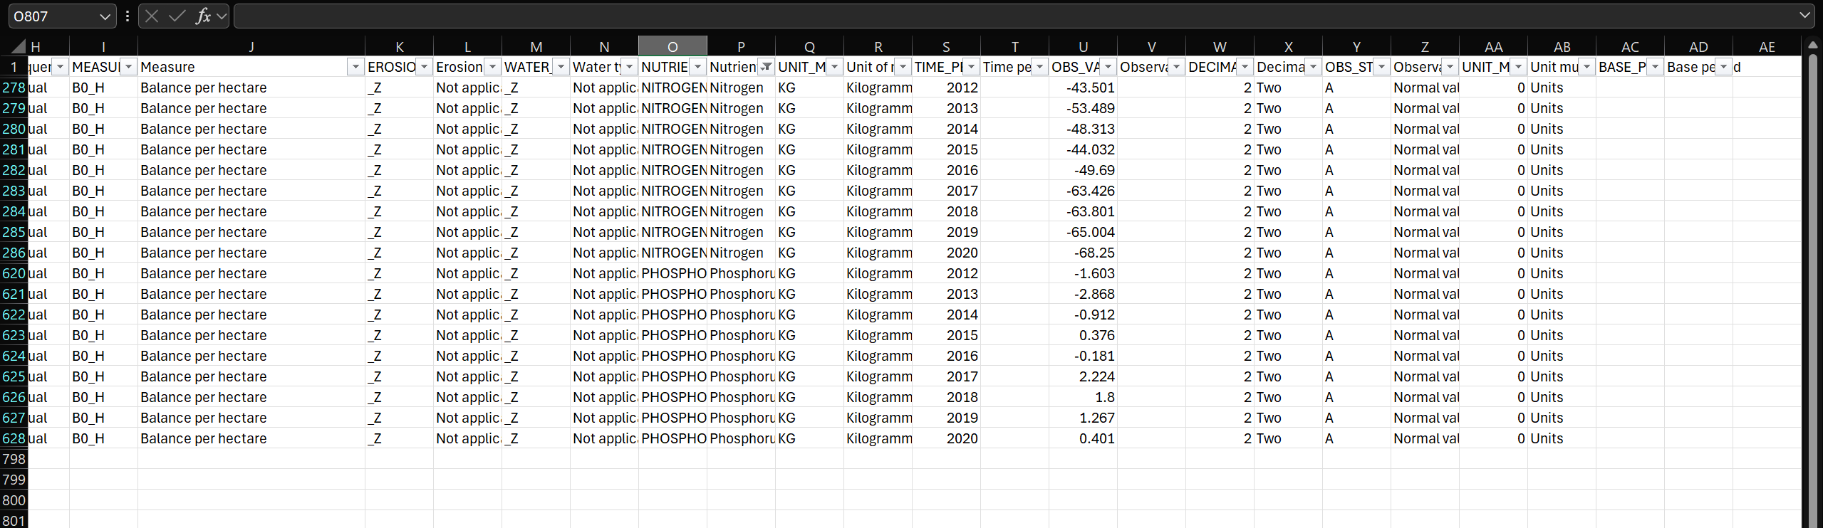

What a strange coincidence that both countries have a reduction in nitrogen usage in 2016-2017, so I search for more countries and notify with this
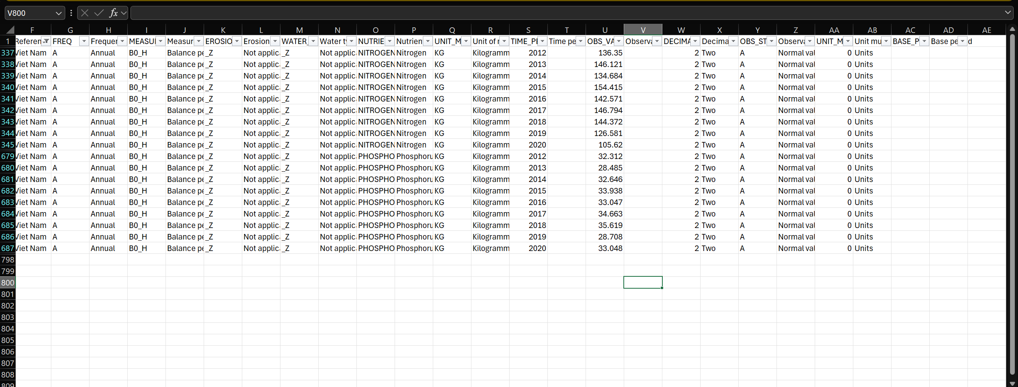
Vietnam will being the agricultural countries did not have the same “2016” incident. We could see an unclear trend is going on here. The usage of nitrogen has been flip-flopping while the phosphorus remains stable with deviation around 5 kg/hectare each year.

Philippines are even the same as Viet Nam so we can clear a probability of a wide implementation of new policies on southeast Asia agriculture. The fun fact is that the trend is even going up in nitrogen and phosphorus usage per hectare. From here I conclude that this is just coincidence and decide to search on an extensive question.

Conclusion: I conclude that the nutrients consumption can be varied depending on various factors such as country, policies…etc. Overuse these nutrients could severely damage the agriculture environment as well as release more emissions cause air pollution. From the trend of some countries, we can see the efforts of countries to negate the extensive use of nutrients.

UNIT MEASUREMENT
What is unit of measure ?
Answer: According to cuemath, a standardized way of representing measurement methods. It’s present different scale as well as type of various data provide insight, ensure data transformation and clarity
What can we conclude from unit of measure ?
Answer: According to cuemath, we weigh different things , context so it will be expressed differently based on what we are doing exactly. The image below from cue math will explain what we are doing:
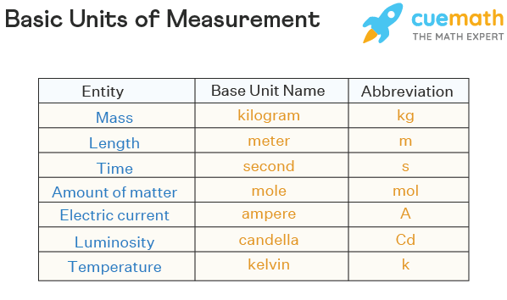
Image source: https://www.cuemath.com/measurement/units-of-measurement/
Based on a study from Indeed, unit of measurement this import part on data visualization:
+Accuracy: provide precise metrics for further information processing like measure or calculation. It provides clear intel of context on what and how we are analyzing dataset
+Interpretation: can be covert to other unit of measurement ( for example : centimeter to meter, milliliter to liter)
+Comparability: ensure data from different sources can be united in 1 metrics for normalizing data comparison.

Unit of measure in dataset context :
Tonnes(T): 1 tons = 1,000 kilogramme, measure by weighting.

Kilogramme(kg): 1 kilogramme = 1000 grams, measure by weighting.

Hectares(HA): 1 Hectare = 10,000 square metres (m²), measuring by calculating total area of target lands.

Index(IX): scaled or normalized index that describes complex relationships of data, measure by methods based purely on context of what it’s about.

Cubic metres(m³): 1 Cubic metres = 1,000 liters, measure the volume of something relating to context.

Tonnes of CO2-equivalent: calculation of all possible existing gas that might cause global warming in mass of particles ( from what I research it is mole mass but there is no number for mole mass).

Tonnes of oil equivalent: an energy unit that measured by a ton of crude oil.
Percentage of agricultural land area(%): proportion of agricultural land area that are being measured.

Percentage of monitoring sites(%): proportion of agricultural land area that are monitored and by condition like exceeding the capability of water limit for phosphorus, nitrate and pesticide. It’s also monitor sites where multiples monitoring site are being implemented.

Percentage of phosphate emissions(%):proportion the amount of phosphate emissions that came from phosphate-relating activities or product in agriculture.
Percentage of nitrate emissions(%): proportion the amount of nitrogen emissions that. came from phosphate-relating activities or product in agriculture.

TIME PERIOD
Time periods will provide 2 key things :

- Create a timeline with multiples checkpoint named “year” to observe a possible trends or characteristics of a value.
- Provide a historical spark of data which are changed and varied because of numerous factors like weathers, politics, or natural catastrophe,…
Some important
Based on a report by the Food and Agriculture Organization , there are some remarkable statistics that relate to dataset timeline (2012-2021):
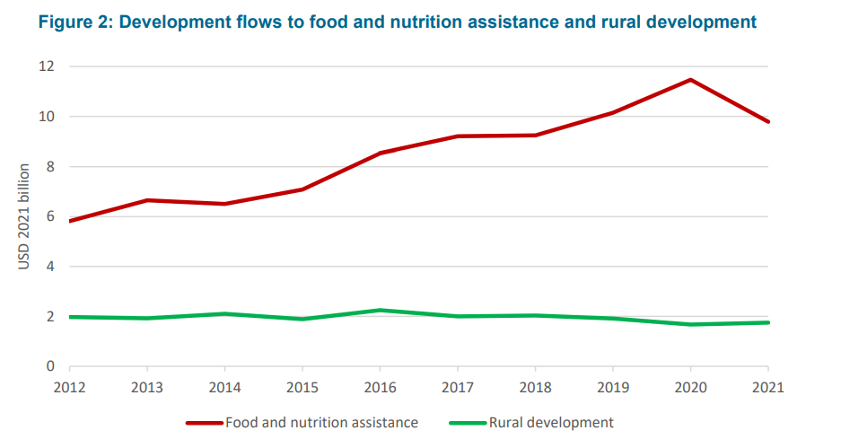

Image source: https://openknowledge.fao.org/server/api/core/bitstreams/5eadaca4-6b0b-43b4-a8d3-5ce44cedf222/content

There is a major development in the flow of food and nutrition in agriculture while remote areas remain the same. The graph indicates that there is a gradual but significant increase in food and nutrition assistance from 2012 to 2020 with a major reduction in 2021 due to covid-19. Meanwhile, rural development facing a “line” trend which mean barely change. The graph was meant to show the significant increase in the assistance fund of nutrition and food at the first point which can be clearly seen through the timeline.

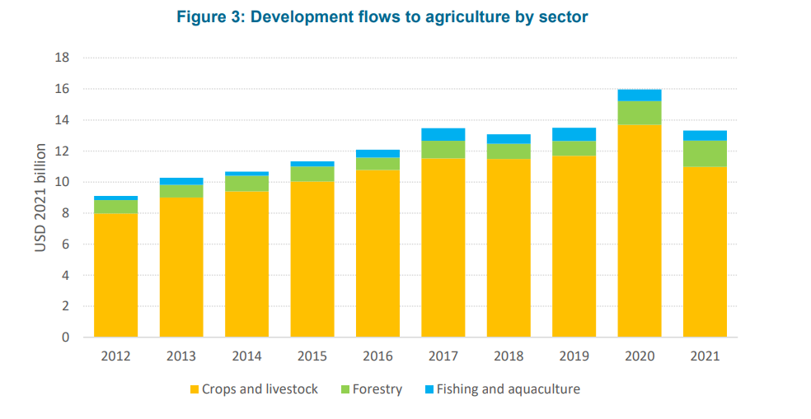
Image source: https://openknowledge.fao.org/server/api/core/bitstreams/5eadaca4-6b0b-43b4-a8d3-5ce44cedf222/content

There is a consistent rise of crop and livestock, with great peek display at 2020 with around 16 billion USD and a decline in 2021 due to covid-19. Forestry seems to barely change from the period 2012 to 2019 and reach a new discovery in 2020 with almost double the previous years measurement. Fish and aquaculture are consistent and remain small deviation through years.

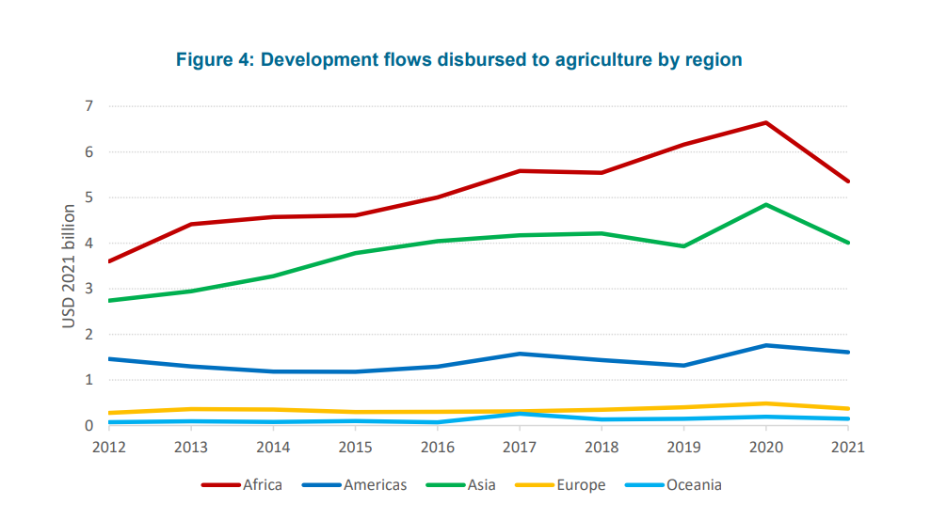
Image source: https://openknowledge.fao.org/server/api/core/bitstreams/5eadaca4-6b0b-43b4-a8d3-5ce44cedf222/content

Africa shows a significant flow which increase from 2012 to 2020 and reduce in 2021 due to covid-19. Asia has a noticeable increase during 2012 to 2018, a slight drop in 2019 and skyrocketing in 2020, with a major decline in 2021 due to similar reason. America seems to barely make progress with small deviation throughout all the years mentioned. Europe and Oceania and Europe are mostly unchanged. This graph was meant to show how each region put their resources and money into agriculture throughout the years, and we see different characteristics in the graph.

2.3 Assignment Required Research Conclusion
First Question: Answered in part 4 of 2.2.4
Second Question:
-Livestock Density provided data about all livestock exist, in which I came up with some questions such as
What are these animals consuming ?
Their manure provides how much organic nutrients ?
-Crop types raise me 2 keys which are Productivity and crops residue
How much nutrient are crop residues generated ?
-And when it comes to nutrients, I raise the question of
What is the ratio of input and output in farming activities ?
=> To sum up these questions I realize that I need to explore how much nutrient is used in this agricultural aspect.
=> This leads me to find research about this and find statistics of dataset provided on the assignment.
1. Research
Based on a very well-documented report that has been done by Science Direct, it has pointed out this key information:
-> The growths of crops are heavily dependent on soil fertility, which leads to question of both fertilizers ( organic / NPK for example).
-> Organic fertilizers are a good source of fertilizers for farmers which came from livestock, which means the larger the livestock density, the greater the amount of livestock manure going to be generated.
-> This process of analyzing according to the website mentioned above, can be done by ‘spatial decoupling of livestock and crop farm’. This concludes the relationship between crop and livestock density through manure which can be interpreted as nutrients.
FINAL CONCLUSION: Livestock density and crop are collated with each other through nutrients that are generated by livestock manure or organic fertilizer. So, the denser the livestock is, it will help crops to generate more nutrients
- Statistic (the main dataset)
To prove that the above conclusion is True, I will show statistic proves that crops with large nutrients usage + high livestock density ( => high in manure production) will indicate country have high nutrients input and output

Stock density( Live manure production measurement methods)
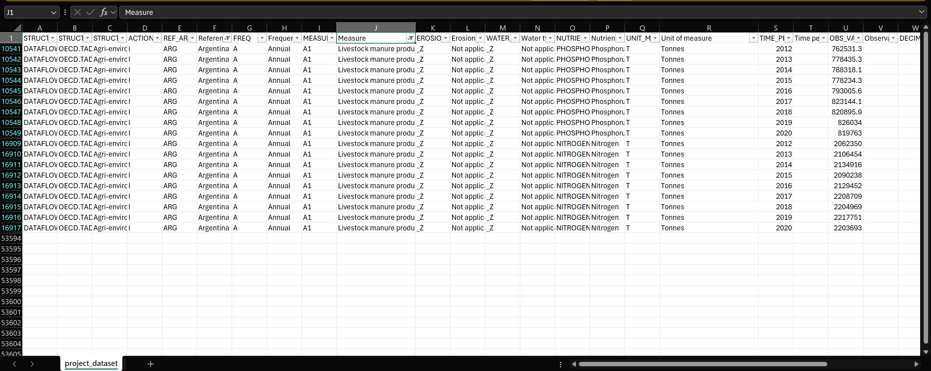
Argentina, in this example, have ridiculous figures of manure production on both Nitrogen(~21,000,000 Tonnes) and phosphorus( ~800,000 Tonnes). There is also a gradual increase in both in the 2012-2020 period which indicates that livestock density is increasing.
Crops productivity( total harvested crops)
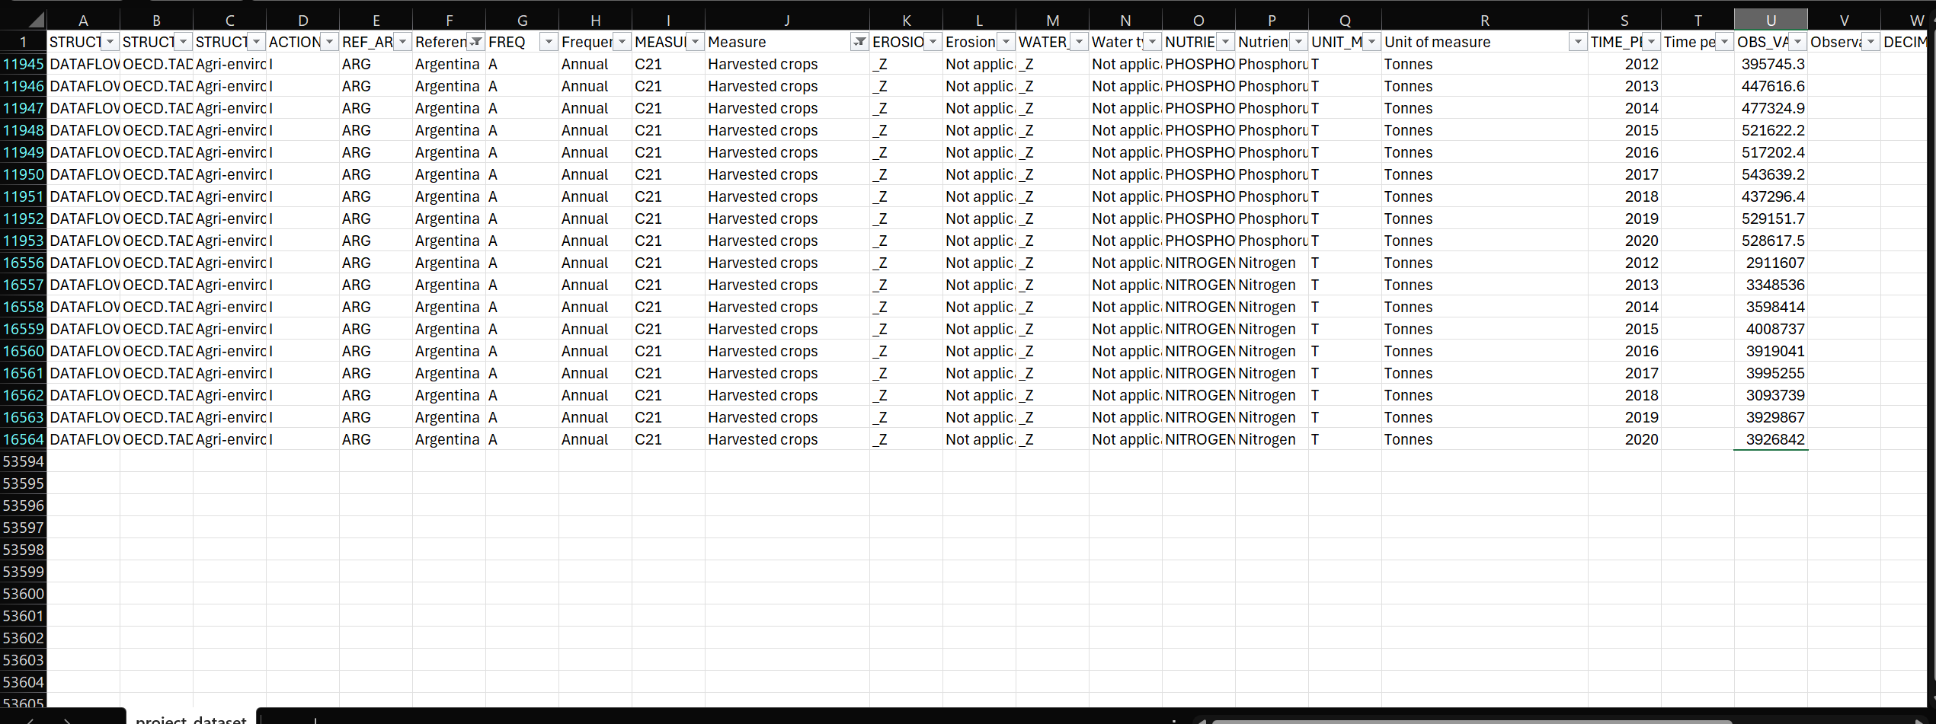

We can see that the trends of harvested crops through years are the same as the livestock manure production which indicates the bonds that we mentioned earlier. It’s also impressive number on usage of these nutrients ( phosphorus: ~500,000 tonnes, Nitrogen: ~ 4,000,000 tonnes)
Nutrients input and output
The relationship between them can also be explained by inputs and outputs of nutrients
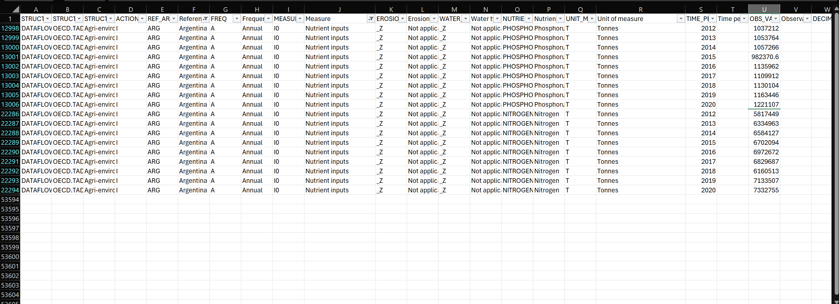

As you can see, There is also a gradual increase trends that appear to be similar to those previous indicators on nutrients inputs and outputs with 6,000,000 tonnes on nitrogen and 900,000 tonnes on phosphorus.

5. REFERENCE

Adika, O., Adika, O., & Adika, O. (2024, October 11). Understanding the big three: nitrogen, phosphorus, and potassium. Cropnuts - Crop Nutrition Laboratory Services Ltd. https://cropnuts.com/nitrogen-phosphorus-potassium-npk-fertilizers/
Cherlinka, V. (2025, July 16). Phosphorus fertilizers: Types and role in agriculture. EOS Data Analytics. https://eos.com/blog/phosphorus-fertilizers/#:~:text=Phosphorus%20fertilizer%20is%20a%20nutrient,macronutrients%20essential%20for%20plant%20growth.
CH 19. Management of Nitrogen and Phosphorus - SARE. (2021, July 9). SARE. https://www.sare.org/publications/building-soils-for-better-crops/management-of-nitrogen-and-phosphorus

Ersek, K. (n.d.). How does soil erosion affect crop productivity & how do you fight it? https://www.holganix.com/blog/how-does-soil-erosion-affect-crop-productivity-how-do-you-fight-it

FAO . Development flows to agriculture 2012–2021 . https://openknowledge.fao.org/server/api/core/bitstreams/5eadaca4-6b0b-43b4-a8d3-5ce44cedf222/content

Indeed Editorial Team. Measures vs. Metrics (Definitions, Similarities and Differences). https://www.indeed.com/career-advice/career-development/measures-vs-metrics

MEAL DPro Starter. (n.d.). Measurement Methods. https://mealdprostarter.org/measurementmethods/

FAO organization. MEASUREMENT OF INDICATORS. (n.d.-b). https://www.fao.org/4/x6108e/x6108e09.htm

O’Donnell, D. (2023, March 27). Groundwater vs. Surface Water – What’s the Difference? Sensorex Liquid Analysis Technology. https://sensorex.com/groundwater-vs-surface-water/?srsltid=AfmBOoo_Veo-kcKsdH1hv__cBZve8YFJWvo9G9iMUMsvReJRawBkir95

Relationships between livestock density and soil phosphorus contents – County and farm level analyses. https://www.sciencedirect.com/science/article/abs/pii/S0341816222008037

Units of measurement - list, chart, length, mass, examples. (n.d.). Cuemath. https://www.cuemath.com/measurement/units-of-measurement/

Vijith H. Regional Scale Erosion Assessment of a Sub-tropical Highland Segment in the Western Ghats of Kerala, South India. https://www.researchgate.net/figure/Soil-erosion-severity-zones-with-erosion-rate-and-area-covered_tbl1_225666016

World Map. (2023, January 29). What is the percentage of agricultural land in the world? Answers. https://www.mapsofworld.com/answers/world/percent-agricultural-land-world/amp/

WeatherSTEM. (n.d.). Where does it rain? WeatherSTEM. https://learn.weatherstem.com/modules/learn/lessons/57/index.html

