**Format of a IEEE Std 1058-1998 for Software Project Management Plan**

1. Overview

1.1 Project summary

1.1.1 Purpose, scope, and objectives

1.1.2 Assumptions and constraints

1.1.3 Project deliverables

1.1.4 Schedule and budget summary

1.2 Evolution of the plan

2. References

3. Definitions

4. Project organization

4.1 External interfaces

4.2 Internal structure

4.3 Roles and responsibilities

5. Managerial process plans

5.1 Start-up plan

5.1.1 Estimation plan

5.1.2 Staffing plan

5.1.3 Resource acquisition plan

5.1.4 Project staff training plan

5.2 Work plan

5.2.1 Work activities

5.2.2 Schedule allocation

5.2.3 Resource allocation

5.2.4 Budget allocation

5.3 Control plan

5.3.1 Requirements control plan

5.3.2 Schedule control plan

5.3.3 Budget control plan

5.3.4 Quality control plan

5.3.5 Reporting plan

5.3.6 Metrics collection plan

5.4 Risk management plan

5.5. Closeout plan

6. Technical process plans

6.1 Process model

6.2 Methods, tools, and techniques

6.3 Infrastructure plan

6.4 Product acceptance plan

7. Supporting process plans

7.1 Configuration management plan

7.2 Verification and validation plan

7.3 Documentation plan

7.4 Quality assurance plan

7.5 Reviews and audits

7.6 Problem resolution plan

7.7 Subcontractor management plan

7.8 Process improvement plan

8. Additional plans

Annexes

Index

**5. Managerial process plans**

**5.1 Start-up plan**

**5.1.1 Estimation plan**

* Contact client to ascertain their vision of the project and develop the technical specifications for the application.
* Learn the ins and outs of the application in order to implement the client’s desired changes as seamlessly as possible.
* Maintain lines of communications with team members and schedule weekly meetings to track the progress of the project.
* Create guidelines for phase 1 and phase 2 of the rollout of new/updated features for the application.

**5.1.2 Staffing plan**

While the project manager and assistant project manager positions were filled by the professor/TAs, the rest of the team was free to pick and choose the portions of the project they were most comfortable working on.

**5.1.3 Resource acquisition plan**

All the software tools involved in the development of the application are free of charge except for an Apple Developer Program membership fee in order to publish the app on the App Store. The MacOS development environment was provided for by the CSE professor for all members of the development team.

**5.1.4 Project staff training plan**

All group members will complete a set of both Android Studio and iOS tutorials provided by the CSE 455 TAs during the first three weeks of class. On top of the tutorials, all staff members are required to familiarize themselves with current version of the Know&Vote application.

**5.2 Work Plan**

**5.2.1 Work activities**

* **Phase 1:**
  + Update User Interface
    - Scroll Feed
      * Be able to scroll up and down the feed in each category
    - Home Screen
      * Toggle between News, Petitions, Location, and Representatives
      * Navigation Bar
      * Update color scheme to meet client’s new specifications
* **Phase 2:**
  + Improve and Implement APIs
    - News APIs
    - Ballots APIs
    - Congress APIs
    - Candidates APIs
    - Polling Information APIs
    - Voting Record APIs
    - Candidate Platform APIs
* Documentation: All members will make sure that all the code that they write is properly documented.

**5.2.2 Schedule Allocation**

|  |  |
| --- | --- |
| 4/13/2020 - 4/17/2020 | Android Studio/iOS Staff Training |
| 4/20/2020 - 4/24/2020 | Android Studio/iOS Staff Training  SRS Development |
| 4/27/2020 - 5/1/2020 | Current Know&Vote Staff Familiarization  Resource Acquisition |
| 5/4/2020 - 5/8/2020 | Development of Phase 1 Updates |
| 5/11/2020 - 5/15/2020 | Rollout of Phase 1 Updates |
| 5/18/2020 - 5/22/2020 | Delivery and QA testing of Phase 1 Updates |
| 5/25/2020 - 5/29/2020 | Development of Phase 2 Updates |
| 6/1/2020 - 6/5/2020 | Rollout and QA testing of Phase 2 Updates |
| 6/8/2020 - 6/12/2020 | Phase 2 Delivery and Presentation |

**5.2.3 Resource Allocation**

Each Know&Vote team member will be given access to the same set of resources including a Mac Laptop for iOS application development.

**5.2.4 Budget Allocation**

No budget has been allocated for this project.

**5.2 Control Plan**

**5.3.1 Requirements Control Plan**

Every Know&Vote team member is required to attend a biweekly online Slack meeting where they will deliver progress updates on their assignments. Each member is required to document their code and submit their assignments in a timely manner as dictated by the SRS and SPMP documentation for this project. Any unexpected issues, technical difficulties or requests by the clients will be assessed by the Managing team and decided upon.

**5.3.2 Schedule Control Plan**

Outside of the regular biweekly assigned lab time, the team members might be required to attend additional online meetings in order to coordinate the compilation and delivery of the product. The team Manager and Assistant Manager will coordinate with the Know&Vote team members in order to ensure the timely development and delivery of the project.

**5.3.3 Budget Control Plan**

There is no budget allocated to the Know&Vote team.

**5.3.4 Quality Control Plan**

The management and development team will perform weekly quality checks on the application to ensure the continued successful development of the application in accordance to the client’s expectations. The management team will stay in contact with the client during the development process to ensure the project reflects their vision.

**5.3.5 Reporting Plan**

The managing team will notify Dr. Concepcion of the weekly meetings and group participation. The project manager will send an attendance report and a project development report after said meetings.

**5.3.6 Metrics Collection Plan**

The managing team will make sure that every developer stays on track for their weekly progress report. The managing team will ensure that the application code is compliant with all the standards set forth in the SRS.

**5.4 Risk Management Plan**

**Development**

* The team will attend a weekly Slack meeting to ensure the timely development of the project.
* The team will conform to scheduled delivery deadlines for each stage of the project.
* All team members will be informed of their responsibilities for the week, project deadlines, and deliver their progress reports during the weekly Slack meetings.
* The source code for Know&Vote iOS application will be updated as new features are tested and implemented.
* Know&Vote team members that fail to meet their weekly deadlines without sufficient justification will be reported to the CSE 455 teaching staff.
* If a team member is struggling with an assigned task they are encouraged to ask for help immediately so as not to delay the project.

**5.4 Risk Management Plan**

The Know&Vote team will submit all deliverables on BitBucket along with a maintenance manual. The team will present a demonstration of the Know&Vote application on finals day.

**6. Technical process plans**

**6.1 Process Model**

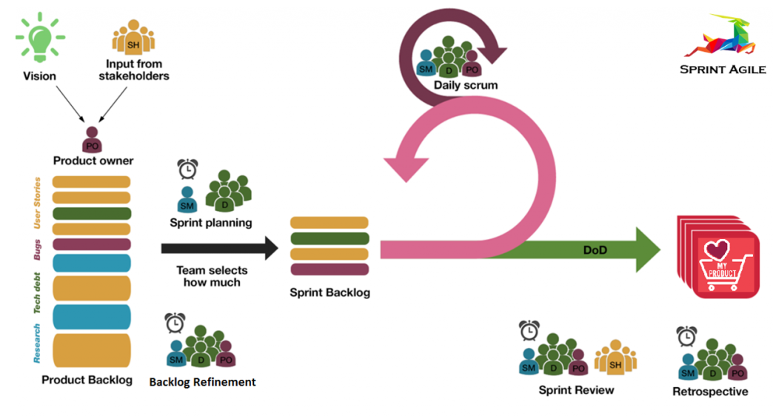

Scrum is a framework within which people can address complex adaptive problems, while productively and creatively delivering products of the highest possible value. Scrum itself is a simple framework for effective team collaboration on complex products. Scrum co-creators Ken Schwaber and Jeff Sutherland have written The Scrum Guide to explain Scrum clearly and succinctly. Team Know&Vote plans to complete two 3-week cycles for the Know&Vote application update consisting of the rollouts of Phase 1 and Phase 2 updates.

**6.2 Method, tools, and techniques**

* Method:
  + Scrum Development Model
* Tools:
  + Xcode
  + Bitbucket
  + Slack
  + Google Drive
  + Lucidchart
* Techniques
  + Weekly meetings with client
  + Weekly meetings and progress reports with development team

**6.3 Infrastructure Plan**

There is currently no need for an infrastructure plan as the features that require a server are not yet implemented and are not the in the purview of the current development phase.

**6.4 Product Acceptance Plan**

The Know&Vote team managers will be in contact with the client throughout the development of the Know&Vote application. Once the requested updates are completed, the application will be handed off to the QA team that will rigorously test the application to ensure that it meets all the criteria set in the SRS.

**7. Supporting Process Plans**

**7.1 Configuration Management Plan**

The Know&Vote team will be using Bitbucket to manage the development of the Know&Vote application for the duration of the project.

**7.2 Verification and Validation Plan**

The verification and validation for the Know&Vote application will be done in three stages.

* **Stage 1: Unit Testing**
  + Each software developer will test their own code as they develop their assigned software component. Most major bugs should be resolved at this stage.
* **Stage 2: Integration Testing** 
  + Once a software developer submits their software component, it will be integrated into the Know&Vote application and testing by the whole team.
* **Stage 3: System Testing**
  + Once the protype software is completed, the application will be tested by the project manager, assistant project manager, the QA team and the client. All remaining bugs should be caught and resolved by the end of this stage of test.

**7.3 Documentation Plan**

The Know&Vote project manager and assistant manager will prepare the SRS and SPMP. The development team will write the documentation for the design and architecture.

**7.4 Quality Assurance Plan**

The QA team will ensure that the Know&Vote application performs to spec as detailed in the SRS.

**7.5 Reviews and Audits**

Every member of the Know&Vote team will participate in testing the Know&Vote application throughout the development process. Any bugs or deficiencies found in the application will be documented, reported, and fixed as soon as possible.

**7.6 Problem Resolution Plan**

All members of team Know&Vote are required to report any issues that will in any way hamper development to the management team as soon as they come up. Once the management team is made aware of the issue, they will decide on the appropriate course of action and reassign tasks as necessary.

**7.7 Subcontractor Management Plan**

There is no plan to hire subcontractors at this time.

**7.8 Process Improvement Plan**

A detailed, accurate, and up-to-date documentation of the source code will be produced as the project is worked on. By preemptively writing a comprehensive documentation of the source code and a maintenance manual, implementing any further changes and improvements into the application will be significantly easier. The same documents can also be used to keep the client aware of what changes are being made to the application in a timely manner. Every member of the Know&Vote team will be required to create and submit the documentation for all their work to the team managers during the weekly Slack meetings. Should a member fall behind in their work, a team manager will work closely with them to remedy the situation as soon as possible. All team members will be evaluated based on their contributions to the project by 6/10/2020.