ADP470S Programming Assignment: Report
Rorisang Makgana · Java 21 (object-oriented) · source organised by part (parta to parte) with 114 JUnit tests · the code links below open the files in the project folder, and the main snippets are collected in Appendix A.

Assignment Overview
The core aspect of this assignment is based around the evaluation of my ability to apply various solutions towards real world problems using the appropriate data structures and algorithms.
- Data Structures: These are the components used to manage how data is stored and accessed
- Algorithms: Algorithms define the manner in which we process that stored data, based on certain factors such as the efficiency to which we might be accessing the information being stored and this is calculated on the basis of Big-O notation
A brief segue into Big-O notation requires a breakdown of the Time and Space Complexity required to complete an algorithm programmatically.
- Time Complexity: how the number of operations grows with the input size $n$ (dominant term only, constants dropped).
- Space Complexity: how much extra memory, including the recursion call stack, is needed as $n$ grows.
Notation | Name | Example in this assignment
$O(1)$ | Constant | Stack push / pop
$O(logn)$ | Logarithmic | Binary Search, balanced BST
$O(n)$ | Linear | Factorial, linked list search
$O(nlogn)$ | Linearithmic | Quick Sort (average), Heap Sort
$O(n^{2})$ | Quadratic | Selection Sort, BFS / DFS on a matrix ($V^{2}$)
$O(2^{n})$ | Exponential | Recursive Fibonacci

Algorithmic Sections

Part A: Recursive Algorithms
1. Defining what Recursive Algorithms are Recursive algorithms are algorithms that are performed through the concept of a function that makes reference to itself and by doing so allows us to complete a task by breaking it into smaller sections.
2. The Applications behind Recursion Recursion is the approach taken when a computational problem that requires a large series of steps can be simplified through a self-referencing function. A recursive algorithm is built from:
- A Base Case: the condition that stops the function from calling itself indefinitely, usually by returning a set value,
- The Recursive Case: the definition of the problem in terms of smaller subproblems,
- The Code Execution: the calls keep going until the base case is reached,
- Combination of Results: each returning call combines its sub-answer (multiplied for factorial, added for Fibonacci) on the way back up the call stack.
3. Recursion Applied to Retrieve a Factorial Number 3.1 What is Factorial in the First Place Factorial multiplies a positive value by every positive whole number before it, with the base case $0!=1!=1$ controlling the execution:
$$n!=n×(n−1)! 0!=1$$
Code: parta/Factorial.java (snippet A1 in the appendix)
3.2 The Fibonacci Sequence done Recursively Each number is the sum of the two before it, with $0$ and $1$ as the base cases:
$$F(n)=F(n−1)+F(n−2) F(0)=0, F(1)=1$$
Code: parta/Fibonacci.java (snippet A2). Both classes extend parta/RecursiveAlgorithm.java, which counts every call so the visualiser can draw the call tree.
4. The Time Complexity and Space Complexity behind Factorial and Fibonacci 4.1 Factorial: Iterative VS Recursive Time and Space Complexity
- Iterative: one loop and one accumulator.
$$\text{Time: }O(n) \text{Space: }O(1)$$
- Recursive: exactly $n$ calls, each waiting for the smaller call to return, so $n$ stack frames are alive at the deepest point.
$$\text{Time: }O(n) \text{Space: }O(n)$$
4.2 Fibonacci: Iterative VS Recursive Time and Space Complexity
- Iterative: two variables walk from $F(0)$ up to $F(n)$ once.
$$\text{Time: }O(n) \text{Space: }O(1)$$
- Recursive: every call spawns two more and the same subproblems are solved again and again. The call count is $2F(n+1)−1$, growing as $φ^{n}$. Only the deepest chain ($n$ frames) exists at once.
$$\text{Time: }O(2^{n}) \text{Space: }O(n)$$
n | Recursive calls | Time (recursive) | Time (iterative)
10 | 177 | n/a | n/a
20 | 21,891 | n/a | n/a
30 | 2,692,537 | n/a | n/a
35 | n/a | ≈ 93 ms | ≈ 26 µs
40 | n/a | ≈ 1,149 ms | ≈ 5 µs
Recursion makes both algorithms easy to express, but for Fibonacci the loop is about 200,000 times faster at $n=40$. A long limits the results to $20!$ and $F(92)$. ____ ### Part B: Searching and Sorting 1. The Algorithms: Selection Sort, Quick Sort, Heap Sort & Binary Search All three sorters extend partb/AbstractSorter.java, which routes every comparison and swap through a listener so each step can be animated and counted by partb/OperationCounter.java.
1a. Selection Sort done Iteratively Find the smallest element of the unsorted part and swap it into the next position, moving the sorted boundary one place right each time. Two nested loops always scan the whole unsorted part:
$$\text{Time: }O(n^{2})\text{ (best, average and worst)} \text{Space: }O(1)$$
Exactly $n(n−1)/2$ comparisons are made whatever the input. Code: partb/SelectionSort.java (snippet B1).
1b. Quick Sort done Recursively Divide and conquer: pick a pivot (random here), partition the collection into smaller and larger values, and recursively sort each side. The pivot is already in its final place after each partition.
$$\text{Average: }O(nlogn) \text{Worst: }O(n^{2}) \text{Space: }O(logn)\text{ average, }O(n)\text{ worst}$$
A random pivot makes the quadratic worst case (a pivot that is always the smallest or largest value) extremely unlikely. Code: partb/QuickSort.java (snippet B2).
1c. Heap Sort Build a max-heap inside the array, then repeatedly swap the root (the largest value) to the end, shrink the heap and sift the new root down.
$$\text{Time: }O(nlogn)\text{ (all cases)} \text{Space: }O(1)$$
Code: partb/HeapSort.java (snippet B3).
2. Binary Search - Done Recursively and Iteratively On a sorted array, look at the middle element and continue in the half that can contain the key. The iterative version uses $O(1)$ space and the recursive version $O(logn)$ for its call stack; both take $O(logn)$ time (at most 10 probes for 1,000 elements). Code: partb/BinarySearch.java (snippet B4).
3. Experimental Comparison on 1,000 Random Integers 3.1 Method. The same 1,000 random integers (seed 470) were given to every algorithm, each sorted 1,000 times after 100 warm-up runs and timed with System.nanoTime(). Comparisons and swaps were counted in a separate run. The Java benchmark (partb/BenchmarkCli.java, partb/Benchmark.java) wrote CSV files, which Python’s matplotlib pyplot plotted (benchmarks/plot_sorts.py).
3.2 Results (n = 1,000, 1,000 samples each)
Algorithm | Mean (µs) | Median (µs) | Best (µs) | Comparisons | Swaps
Selection Sort | 344.8 | 354.9 | 285.4 | 499,500 | 987
Quick Sort | 93.8 | 89.0 | 69.7 | 11,433 | 5,987
Heap Sort | 122.3 | 98.6 | 66.4 | 16,867 | 9,089
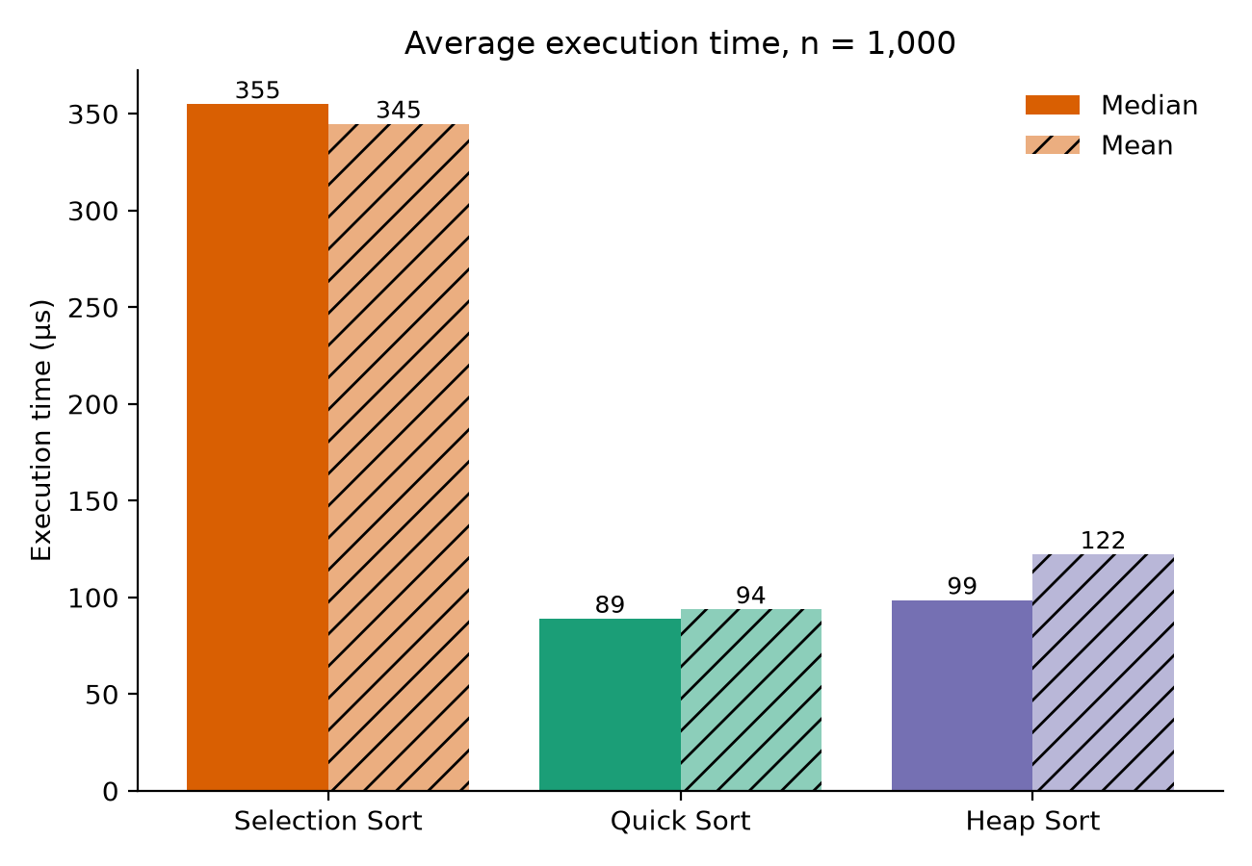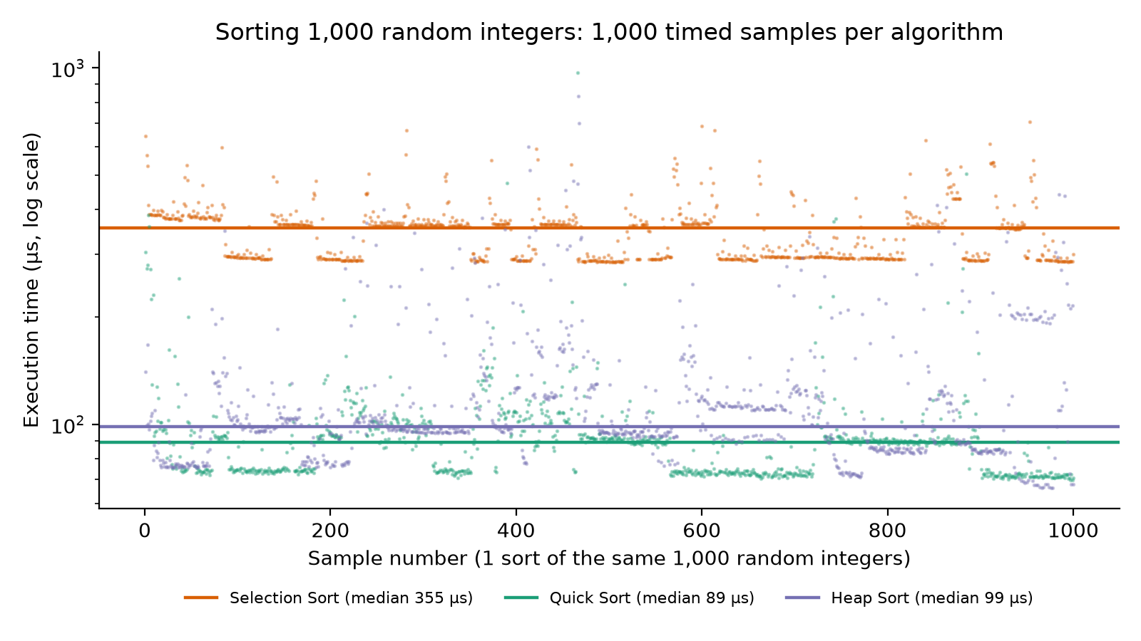
3.3 Growth with input size
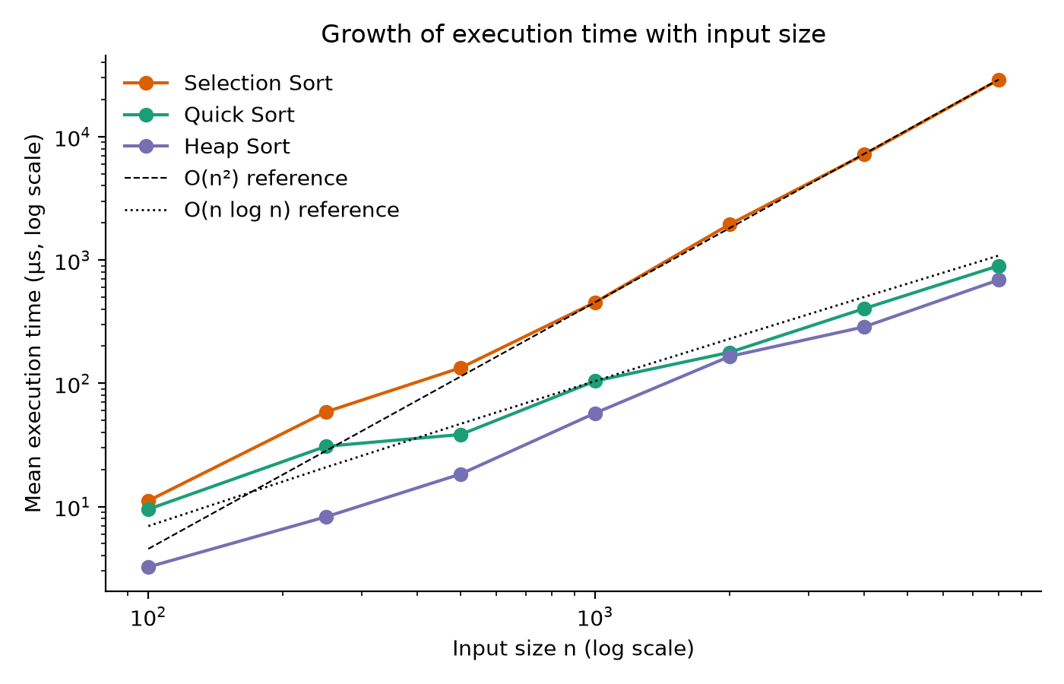
3.4 Analysis: Big-O versus practical performance. Selection Sort’s comparison count is exactly $n(n−1)/2=499,500$ and multiplying $n$ by 8 multiplied its time by about 64 ($8^{2}$), confirming $O(n^{2})$. Quick Sort and Heap Sort need 1.1 to 1.7 times $n\log_{2}n≈9,966$ comparisons; Quick Sort is about 4 times faster than Selection Sort at $n=1000$ and about 32 times faster at $n=8000$. Heap Sort makes about 1.5 times more comparisons and swaps than Quick Sort, so Quick Sort has the lower median, but the two are close and the scatter of the samples (JIT compilation, garbage collection) is as large as the gap. Because the pivot is random, Quick Sort showed no slowdown on sorted or reversed input. ____ ### Part C: Elementary Data Structures All three were written from scratch with no java.util collections inside.
1. Singly Linked List. Nodes hold data and a next reference; only the head is kept. insertFirst is $O(1)$; insertLast, insertAt, delete and search walk the chain, $O(n)$. Code: partc/SinglyLinkedList.java (snippet C1).
2. Stack (array-based). Last in, first out with a top index; push, pop and peek are $O(1)$ and throw on overflow or underflow. Code: partc/ArrayStack.java (snippet C2). Application: partc/StringReverser.java pushes every character and pops them ("javascript" becomes "tpircsavaj", $O(n)$).
3. Queue (circular array implementation). First in, first out; front and rear wrap round with % capacity and a count field separates full from empty, so enqueue and dequeue are $O(1)$. Code: partc/CircularQueue.java (snippet C3). Application: partc/BankSimulation.java simulates one teller and one line with random arrivals and reports customers served and the average wait.
4. Test cases. One JUnit class per structure covers empty and full structures, FIFO / LIFO order, wrap-around, bad indexes, missing values and repeatable seeded runs (see src/test). ____ ### Part D: Trees 1. Binary Search Tree (BST). Every left key is smaller and every right key larger than a node’s key. insert and search walk one path; delete handles a leaf, a node with one child (replaced by that child), and a node with two children (takes the in-order successor’s key); in-order (sorted), pre-order and post-order traversals are recursive. Code: partd/BinarySearchTree.java (snippet D1).
2. Average case $O(logn)$ versus worst case $O(n)$. Each operation costs $O(h)$ for tree height $h$. Random insertion keeps the tree bushy ($h≈logn$); inserting sorted keys builds a chain ($h=n−1$). Measured on 1,000 insertions:
Insertion order | Keys stored | Height | Cost per operation
Random integers | 946 (duplicates rejected) | 21 | $O(logn)$ average
0, 1, 2 … 999 (sorted) | 1,000 | 999 | $O(n)$ worst
A self-balancing tree (AVL, red-black) would guarantee $O(logn)$ by rebalancing. ____ ### Part E: Graphs 1. Representing a graph with an Adjacency Matrix. adj[u][v] = adj[v][u] = 1 for each two-way road: $O(V^{2})$ space, $O(1)$ edge test, $O(V)$ to list neighbours. Code: parte/Graph.java (snippet E1).
2. Traversal algorithms. Code: parte/GraphTraversal.java (snippet E2); both traversals take $O(V^{2})$ time and $O(V)$ space on a matrix.
- 2a. Depth-First Search (DFS), recursive: visit a vertex, then recursively its first unvisited neighbour, going as deep as possible before backtracking.
- 2b. Breadth-First Search (BFS), using a queue: visit vertices level by level using the Part C CircularQueue.
3. Real-world problem: the fewest-edge route between two cities. parte/TransportNetwork.java models 11 South African cities joined by 16 two-way routes. parte/ShortestPathFinder.java (snippet E3) runs BFS and records each vertex’s parent; BFS reaches vertices in order of edge count, so the first path to the destination has the fewest edges and is rebuilt from the parents.
From | To | Route | Edges
Cape Town | Mbombela | Cape Town, Kimberley, Johannesburg, Durban, Mbombela | 4
George | Polokwane | George, Cape Town, Kimberley, Johannesburg, Pretoria, Polokwane | 5
“Fewest edges” is not shortest distance in km, which would need weighted edges and Dijkstra’s algorithm. ____ ## Reflections: Theory versus Practice
- Big-O predicted the shape of the results but not the stopwatch: at 1,000 elements differences were microseconds and noisy, and constants separated Quick Sort from Heap Sort although both are $O(nlogn)$.
- Worst cases depend on implementation: a random pivot removes Quick Sort’s sorted-input trap, and a BST is only logarithmic if it stays balanced.
- Recursion is elegant but costs stack space, and naive recursive Fibonacci was about 200,000 times slower than the loop at $n=40$.
- Choosing the structure for the access pattern matters: linked lists for cheap front insertion, circular arrays for $O(1)$ queue ends, matrices for constant edge tests.
- Testing mattered: 114 JUnit tests pin down the base cases and boundaries that the first drafts got wrong. ____ ## Appendix A: Key Code Each snippet is copied directly from the file named above it (full Javadoc comments are in the source).

Part A
A1 · parta/Factorial.java
public long recursive(int n) {
if (n < 0) {
throw new IllegalArgumentException("n must be >= 0");
}
enter(n);
// Base case: 0! = 1! = 1 stops the recursion
if (n <= 1) {
return exit(n, 1);
}
// Recursive case: combine this n with the result of the smaller problem
return exit(n, n * recursive(n - 1));
}
public long iterative(int n) {
if (n < 0) {
throw new IllegalArgumentException("n must be >= 0");
}
long result = 1;
for (int i = 2; i <= n; i++) {
result *= i;
}
return result;
}
A2 · parta/Fibonacci.java
public long recursive(int value) {
if (value < 0) {
throw new IllegalArgumentException("value must be >= 0");
}
enter(value);
// Base cases: F(0) = 0 and F(1) = 1
if (value <= 1) {
return exit(value, value);
}
// Recursive case: two smaller sub-problems
return exit(value, recursive(value - 1) + recursive(value - 2));
}
public long iterative(int value) {
if (value < 0) {
throw new IllegalArgumentException("value must be >= 0");
}
long previous = 0;
long current = 1;
for (int i = 0; i < value; i++) {
long next = previous + current;
previous = current;
current = next;
}
return previous;
}

Part B
B1 · partb/SelectionSort.java
public void sort(int[] a, SortListener l) {
int n = a.length;
for (int i = 0; i < n; i++) {
// Assume the first unsorted position holds the minimum
int minimumIndex = i;
for (int j = i + 1; j < n; j++) {
// A smaller value means we have a new candidate minimum
if (less(a, j, minimumIndex, l)) {
minimumIndex = j;
}
}
// Only swap when the minimum is not already in place
if (minimumIndex != i) {
swap(a, i, minimumIndex, l);
}
// Everything up to and including i is now in its final position
markSorted(i, l);
}
}
B2 · partb/QuickSort.java
private void quickSort(int[] a, int lo, int hi, SortListener l) {
// Base case: an empty range needs no work
if (lo > hi) {
return;
}
// Base case: a single element is already in its final position
if (lo == hi) {
markSorted(lo, l);
return;
}
// The pivot ends up at its final position, then each side is sorted recursively
int pivotIndex = partition(a, lo, hi, l);
markSorted(pivotIndex, l);
quickSort(a, lo, pivotIndex - 1, l);
quickSort(a, pivotIndex + 1, hi, l);
}
private int partition(int[] a, int lo, int hi, SortListener l) {
// Move a randomly chosen pivot to the end of the range
int randomIndex = lo + random.nextInt(hi - lo + 1);
if (randomIndex != hi) {
swap(a, randomIndex, hi, l);
}
// Boundary of the "smaller than pivot" region
int boundary = lo - 1;
for (int j = lo; j < hi; j++) {
if (less(a, j, hi, l)) {
boundary++;
if (boundary != j) {
swap(a, boundary, j, l);
}
}
}
// Place the pivot between the two regions
if (boundary + 1 != hi) {
swap(a, boundary + 1, hi, l);
}
return boundary + 1;
}
B3 · partb/HeapSort.java
public void sort(int[] a, SortListener l) {
int n = a.length;
buildMaxHeap(a, l);
for (int end = n - 1; end > 0; end--) {
// The root is the largest remaining element: move it to its final slot
swap(a, 0, end, l);
markSorted(end, l);
siftDown(a, 0, end, l);
}
if (n > 0) {
markSorted(0, l);
}
}
private void siftDown(int[] a, int i, int heapSize, SortListener l) {
while (true) {
int largest = i;
int left = 2 * i + 1;
int right = 2 * i + 2;
if (left < heapSize && less(a, largest, left, l)) {
largest = left;
}
if (right < heapSize && less(a, largest, right, l)) {
largest = right;
}
if (largest == i) {
return;
}
swap(a, i, largest, l);
i = largest;
}
}
B4 · partb/BinarySearch.java
public int iterative(int[] a, int key, SearchListener l) {
int lo = 0;
int hi = a.length - 1;
while (lo <= hi) {
// Written this way to avoid int overflow of (lo + hi)
int mid = lo + (hi - lo) / 2;
if (l != null) {
l.onProbe(lo, mid, hi);
}
if (a[mid] == key) {
return mid;
} else if (a[mid] < key) {
lo = mid + 1;
} else {
hi = mid - 1;
}
}
return -1;
}
private int recursive(int[] a, int key, int lo, int hi, SearchListener l) {
// Base case: an empty range means the key is not present
if (lo > hi) {
return -1;
}
int mid = lo + (hi - lo) / 2;
if (l != null) {
l.onProbe(lo, mid, hi);
}
if (a[mid] == key) {
return mid;
}
// Recursive case: continue in the half that can contain the key
return a[mid] < key
? recursive(a, key, mid + 1, hi, l)
: recursive(a, key, lo, mid - 1, l);
}

Part C
C1 · partc/SinglyLinkedList.java
public void insertAt(int index, T value) {
if (index < 0 || index > size) {
throw new IndexOutOfBoundsException("Index: " + index + ", size: " + size);
}
if (index == 0) {
insertFirst(value);
return;
}
// Walk to the node just before the insertion point
Node<T> previous = head;
for (int i = 0; i < index - 1; i++) {
previous = previous.next;
}
Node<T> node = new Node<>(value);
node.next = previous.next;
previous.next = node;
size++;
}
public int search(T value) {
Node<T> current = head;
int index = 0;
while (current != null) {
if (current.data == null ? value == null : current.data.equals(value)) {
return index;
}
current = current.next;
index++;
}
return -1;
}
C2 · partc/ArrayStack.java
public void push(T item) {
if (isFull()) {
throw new IllegalStateException("Stack is full");
}
items[top++] = item;
}
public T pop() {
if (isEmpty()) {
throw new IllegalStateException("Stack is empty");
}
T item = (T) items[--top];
// Drop the reference so it can be garbage collected
items[top] = null;
return item;
}
C3 · partc/CircularQueue.java
public void enqueue(T item) {
if (isFull()) {
throw new IllegalStateException("Queue is full");
}
items[rear] = item;
rear = (rear + 1) % items.length;
count++;
}
public T dequeue() {
if (isEmpty()) {
throw new IllegalStateException("Queue is empty");
}
T item = (T) items[front];
items[front] = null;
front = (front + 1) % items.length;
count--;
return item;
}

Part D
D1 · partd/BinarySearchTree.java
private BSTNode insert(BSTNode node, int key) {
// Base case: found the empty spot
if (node == null) {
return new BSTNode(key);
}
if (key < node.key) {
node.left = insert(node.left, key);
} else if (key > node.key) {
node.right = insert(node.right, key);
}
return node;
}
private BSTNode delete(BSTNode node, int key) {
if (node == null) {
return null;
}
if (key < node.key) {
node.left = delete(node.left, key);
} else if (key > node.key) {
node.right = delete(node.right, key);
} else {
// Case 1 and 2: a leaf or a node with one child is replaced by that child (or null)
if (node.left == null) {
return node.right;
}
if (node.right == null) {
return node.left;
}
// Case 3: two children. Copy in the in-order successor, then delete it from the right side
BSTNode successor = findMin(node.right);
node.key = successor.key;
node.right = delete(node.right, successor.key);
}
return node;
}

Part E
E1 · parte/Graph.java
public void addEdge(int u, int v) {
adj[u][v] = 1;
adj[v][u] = 1;
}
E2 · parte/GraphTraversal.java
private void dfs(int v, boolean[] visited, List<Integer> order, TraversalListener l) {
visited[v] = true;
order.add(v);
l.onVisit(v);
for (int next : graph.neighbours(v)) {
if (!visited[next]) {
l.onEdge(v, next);
// Recursive case: go as deep as possible before backtracking
dfs(next, visited, order, l);
}
}
}
public List<Integer> bfs(int start, TraversalListener l) {
TraversalListener listener = l == null ? new TraversalListener() { } : l;
boolean[] seen = new boolean[graph.vertexCount()];
List<Integer> order = new ArrayList<>();
CircularQueue<Integer> queue = new CircularQueue<>(graph.vertexCount());
seen[start] = true;
queue.enqueue(start);
listener.onEnqueue(start);
while (!queue.isEmpty()) {
int v = queue.dequeue();
listener.onDequeue(v);
order.add(v);
listener.onVisit(v);
for (int next : graph.neighbours(v)) {
if (!seen[next]) {
// Mark when queued, so a vertex is never queued twice
seen[next] = true;
listener.onEdge(v, next);
queue.enqueue(next);
listener.onEnqueue(next);
}
}
}
return order;
}
E3 · parte/ShortestPathFinder.java
public List<Integer> findPath(int src, int dst, TraversalListener l) {
TraversalListener listener = l == null ? new TraversalListener() { } : l;
int[] parent = new int[graph.vertexCount()];
Arrays.fill(parent, -1);
boolean[] seen = new boolean[graph.vertexCount()];
CircularQueue<Integer> queue = new CircularQueue<>(graph.vertexCount());
seen[src] = true;
queue.enqueue(src);
listener.onEnqueue(src);
while (!queue.isEmpty()) {
int v = queue.dequeue();
listener.onDequeue(v);
listener.onVisit(v);
if (v == dst) {
return buildPath(parent, src, dst);
}
for (int next : graph.neighbours(v)) {
if (!seen[next]) {
seen[next] = true;
// Remember how we got here so the path can be rebuilt backwards
parent[next] = v;
listener.onEdge(v, next);
queue.enqueue(next);
listener.onEnqueue(next);
}
}
}
return new ArrayList<>();
}
private List<Integer> buildPath(int[] parent, int src, int dst) {
List<Integer> path = new ArrayList<>();
for (int v = dst; v != -1; v = parent[v]) {
path.add(v);
}
Collections.reverse(path);
return path;
}

