CMI Semester Project Report
Pathfinding Agent: A* Search vs Breadth-First Search
Three-Tier Architecture • Informed Search • Python Implementation
Git repository:

1. Introduction
Pathfinding is one of the most fundamental problems in Artificial Intelligence. Given a discrete environment populated with obstacles, can an agent find the shortest route from a start position to a goal? This semester project implements and compares two canonical solutions to that question.
The first algorithm is A* (pronounced "A-star"), an informed search strategy introduced by Hart, Nilsson, and Raphael in 1968. A* guides its search using a domain-specific heuristic function h(n) that estimates the remaining cost to the goal, allowing it to focus exploration toward promising regions of the state space. The second algorithm is Breadth-First Search (BFS), a classical uninformed strategy that systematically expands nodes level by level with no knowledge of the goal's location.
The project is structured around three explicit objectives:
- Architectural clarity: implement a clean three-tier design separating the world model, the search logic, and the visual output.
- Correctness: prove through automated tests that both algorithms return optimal paths.
- Comparative analysis: quantify the efficiency advantage of the informed A* over uninformed BFS across four benchmark scenarios.

2. Agent Specification — PEAS Framework
Before implementing the agent, we formally define it using the PEAS framework (Performance, Environment, Actuators, Sensors). This is the standard AI methodology for specifying rational agents before implementation.

PEAS Component | Definition
Performance | Minimum path cost from start to goal (number of steps, weighted by move type)
Environment | Discrete 2-D grid world — static, deterministic, fully observable
Actuators | Eight movement directions: Up, Down, Left, Right (cost 1.0) and NW, NE, SW, SE (cost 1.414)
Sensors | is_valid(state): full world map is known at all times (fully observable)

3. Architecture — Three-Tier Design
The application is structured into three modular tiers. Each tier has a single responsibility and communicates with the adjacent tier through a minimal public interface. This decoupling ensures that the search algorithms can be tested and benchmarked independently of any rendering code.

Tier 1 — Environment Layer (environment.py)
The GridEnvironment class is the single source of truth about the world. It encapsulates the grid dimensions, the immutable obstacle set (stored as a frozenset to enforce the static property), and the successor function.
- State space: each cell (row, col) is a node in a directed state-space graph.
- Transition model — get_successors(state): expands a node into up to eight reachable neighbours, each labelled with the action taken and its exact movement cost.
- Perception interface — is_valid(state): returns True if the cell is within bounds and not an obstacle.

Tier 2 — Agent / Logic Layer (agent.py)
The PathfindingAgent class implements both search algorithms. It is entirely stateless between calls — all search state lives inside the function scope.
A* evaluation function: f(n) = g(n) + h(n)
- OPEN LIST: a Python heapq min-heap, O(log n) insert and pop, ordered by f(n).
- CLOSED SET: a Python set (hash table), O(1) membership tests.
- Lazy deletion: stale entries are discarded when popped via the CLOSED set check.
- Path reconstruction: parent pointers recover the solution in O(d) time.

Tier 3 — Visualization Layer (visualization.py)
The AIPathfinderLab class renders the grid using Python's Tkinter library. It is fully decoupled from the search logic — it depends only on the SearchResult dataclass returned by the agent.
- Side-by-side comparison panel: run both algorithms simultaneously and watch the exploration fronts grow together.
- Speed slider: animate from 5 ms to 120 ms per frame.
- Export chart button: generates a full benchmark PNG summary (requires matplotlib).
- Scenario selector: four benchmark scenarios selectable from a dropdown.

4. Heuristic Analysis — Admissibility and Optimality

Euclidean Distance Heuristic
h(n) = sqrt( (r_n - r_goal)^2 + (c_n - c_goal)^2 )
On an 8-connected grid where diagonal moves cost √2 ≈ 1.414, the Euclidean distance corresponds exactly to the cost of moving diagonally in a straight line to the goal with no obstacles. Since obstacles can only increase the true path cost, h(n) ≤ h*(n) always holds. The heuristic is therefore admissible.

Manhattan Distance (Orthogonal Reference)
h(n) = |r_n - r_goal| + |c_n - c_goal|
The Manhattan distance is admissible for 4-connected grids (orthogonal moves only). It is included in the codebase as a reference function and is used in the test suite to verify correctness on pure orthogonal scenarios. When diagonal moves are enabled, Manhattan distance overestimates for diagonal paths and should not be used with A* on 8-connected grids.

Consistency (Monotonicity)
The Euclidean heuristic also satisfies the consistency condition: for any node n and any successor n' with step cost c, h(n) ≤ c(n,n') + h(n'). A consistent heuristic guarantees that A* never needs to re-open a closed node, making the lazy-deletion approach safe and correct.

5. Experiments and Results

5.1 Benchmark Scenarios
Four scenarios stress-test different aspects of both algorithms:
Scenario | Grid | Start→Goal | Description
Default | 10×10 | (0,0)→(9,9) | Open grid with a few obstacle clusters. Easy path, highlights heuristic guidance.
Hard Maze | 25×25 | (0,0)→(24,24) | Three horizontal walls forcing S-shaped detour. Maximum path length.
Dead-End | 8×8 | (0,0)→(7,7) | Two walls with a capped corridor. Agent must backtrack from a false path.
Maze | 12×12 | (0,0)→(11,11) | Multi-corridor layout with several interconnected walls.

5.2 Performance Results
Scenario | Algorithm | Nodes | Path Cost | Time (ms) | Reduction vs BFS
Default | A* | 21 | 13.898 | 0.27 | −78%
 | BFS | 94 | 13.898 | 0.45 | baseline
Hard Maze | A* | 354 | 67.108 | 3.12 | −26%
 | BFS | 481 | 67.108 | 1.83 | baseline
Dead-End | A* | 32 | 12.242 | 0.20 | −37%
 | BFS | 51 | 12.242 | 0.20 | baseline
Maze | A* | 32 | 20.140 | 0.23 | −69%
 | BFS | 104 | 20.140 | 0.34 | baseline
Table 1 — Benchmark results. Path costs are identical for both algorithms, confirming optimality.

5.3 Visualizations
Figure 1 shows the node counts for A* and BFS across all four scenarios, with the percentage reduction annotated above each pair of bars.

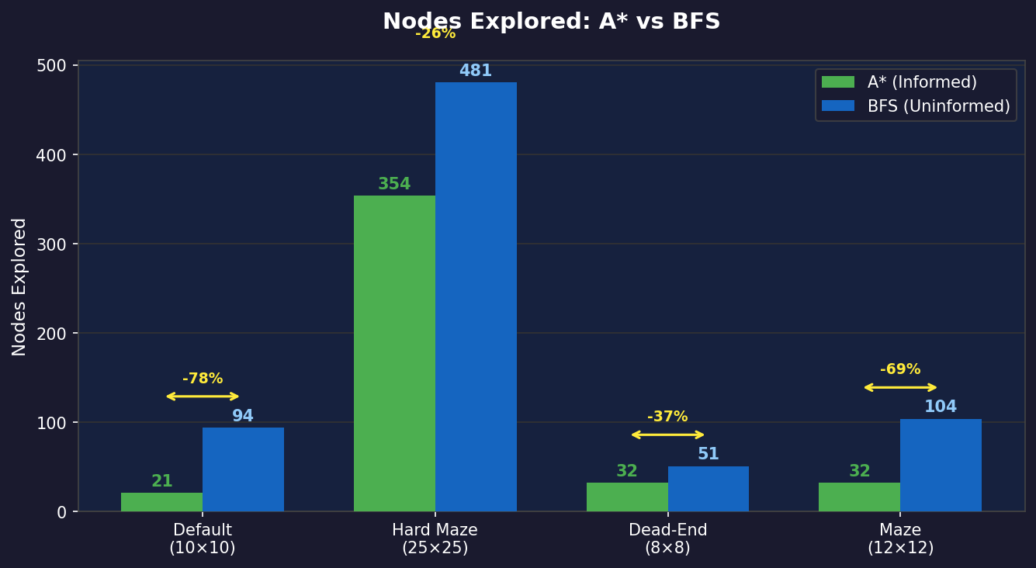
Figure 1 — Nodes Explored: A* vs BFS. Yellow annotations show A*'s percentage reduction in explored nodes.

Figure 2 (left) confirms that path costs are identical between algorithms across all scenarios — empirical proof of admissibility. Figure 2 (right) summarises the efficiency gain as a percentage, colour-coded by magnitude.

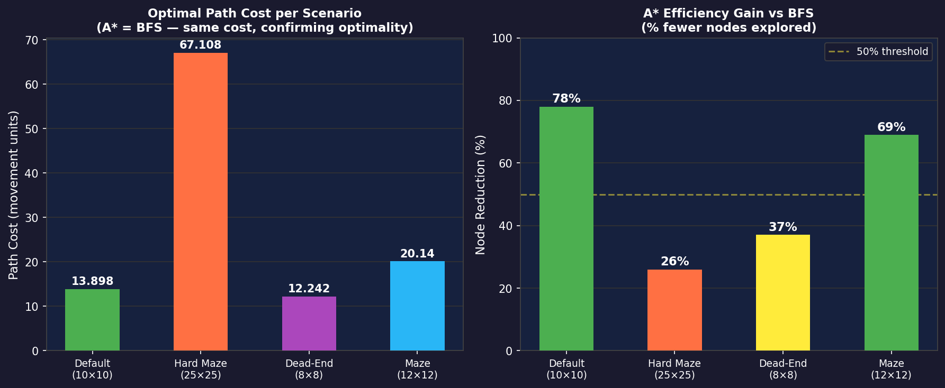
Figure 2 — Left: optimal path cost per scenario (A* = BFS). Right: A* node reduction expressed as a percentage.

5.4 Grid Visualizations — A* Search
Figure 3 shows the four benchmark grids after running A*. Dark indigo cells are the explored frontier; yellow cells trace the optimal path returned to the caller. The start cell is green, the goal is red, and obstacles are dark grey.

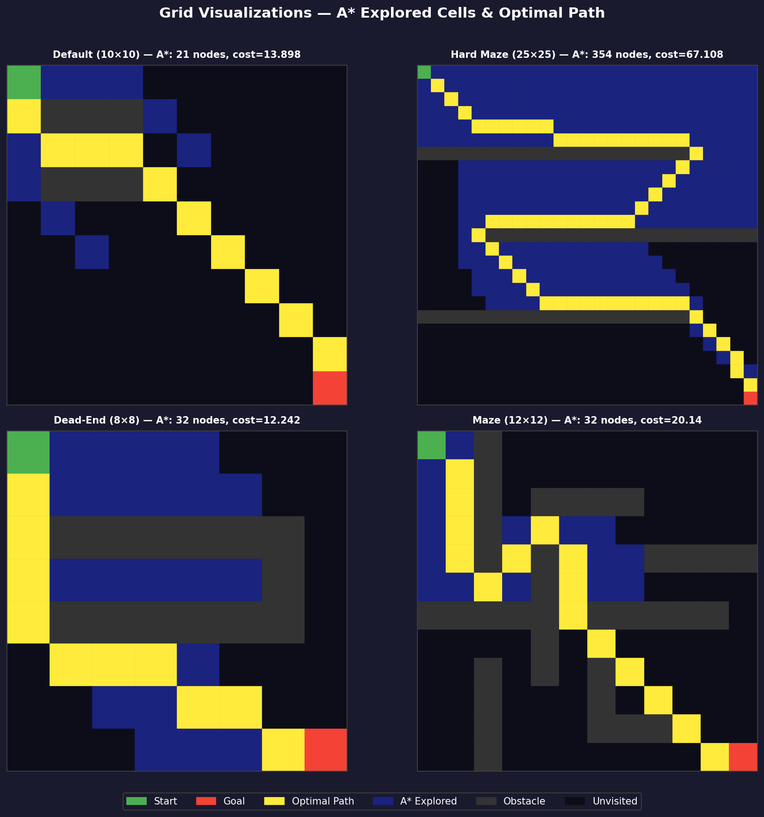
Figure 3 — A* exploration (dark indigo) and optimal path (yellow) across all four benchmark scenarios.

5.5 Grid Visualizations — BFS Search
Figure 4 shows the same four grids after running BFS. The exploration wave (dark blue) is visibly wider than A*'s on the Default and Maze scenarios, illustrating the cost of uninformed search.

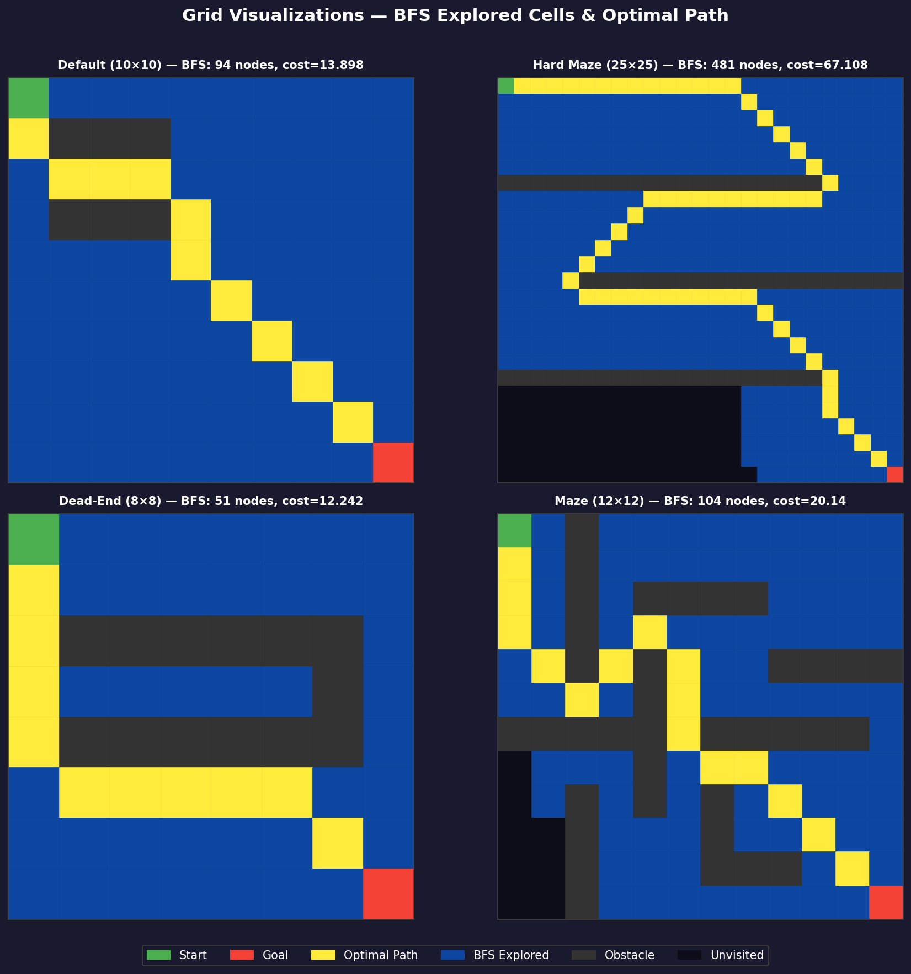
Figure 4 — BFS exploration (dark blue) and optimal path (yellow) across all four benchmark scenarios.

5.6 Side-by-Side: Hard Maze (25×25)
Figure 5 places A* and BFS side by side on the most demanding scenario. The difference in frontier shape is clearly visible: A* concentrates exploration along the corridor toward the goal, while BFS floods a larger region uniformly.

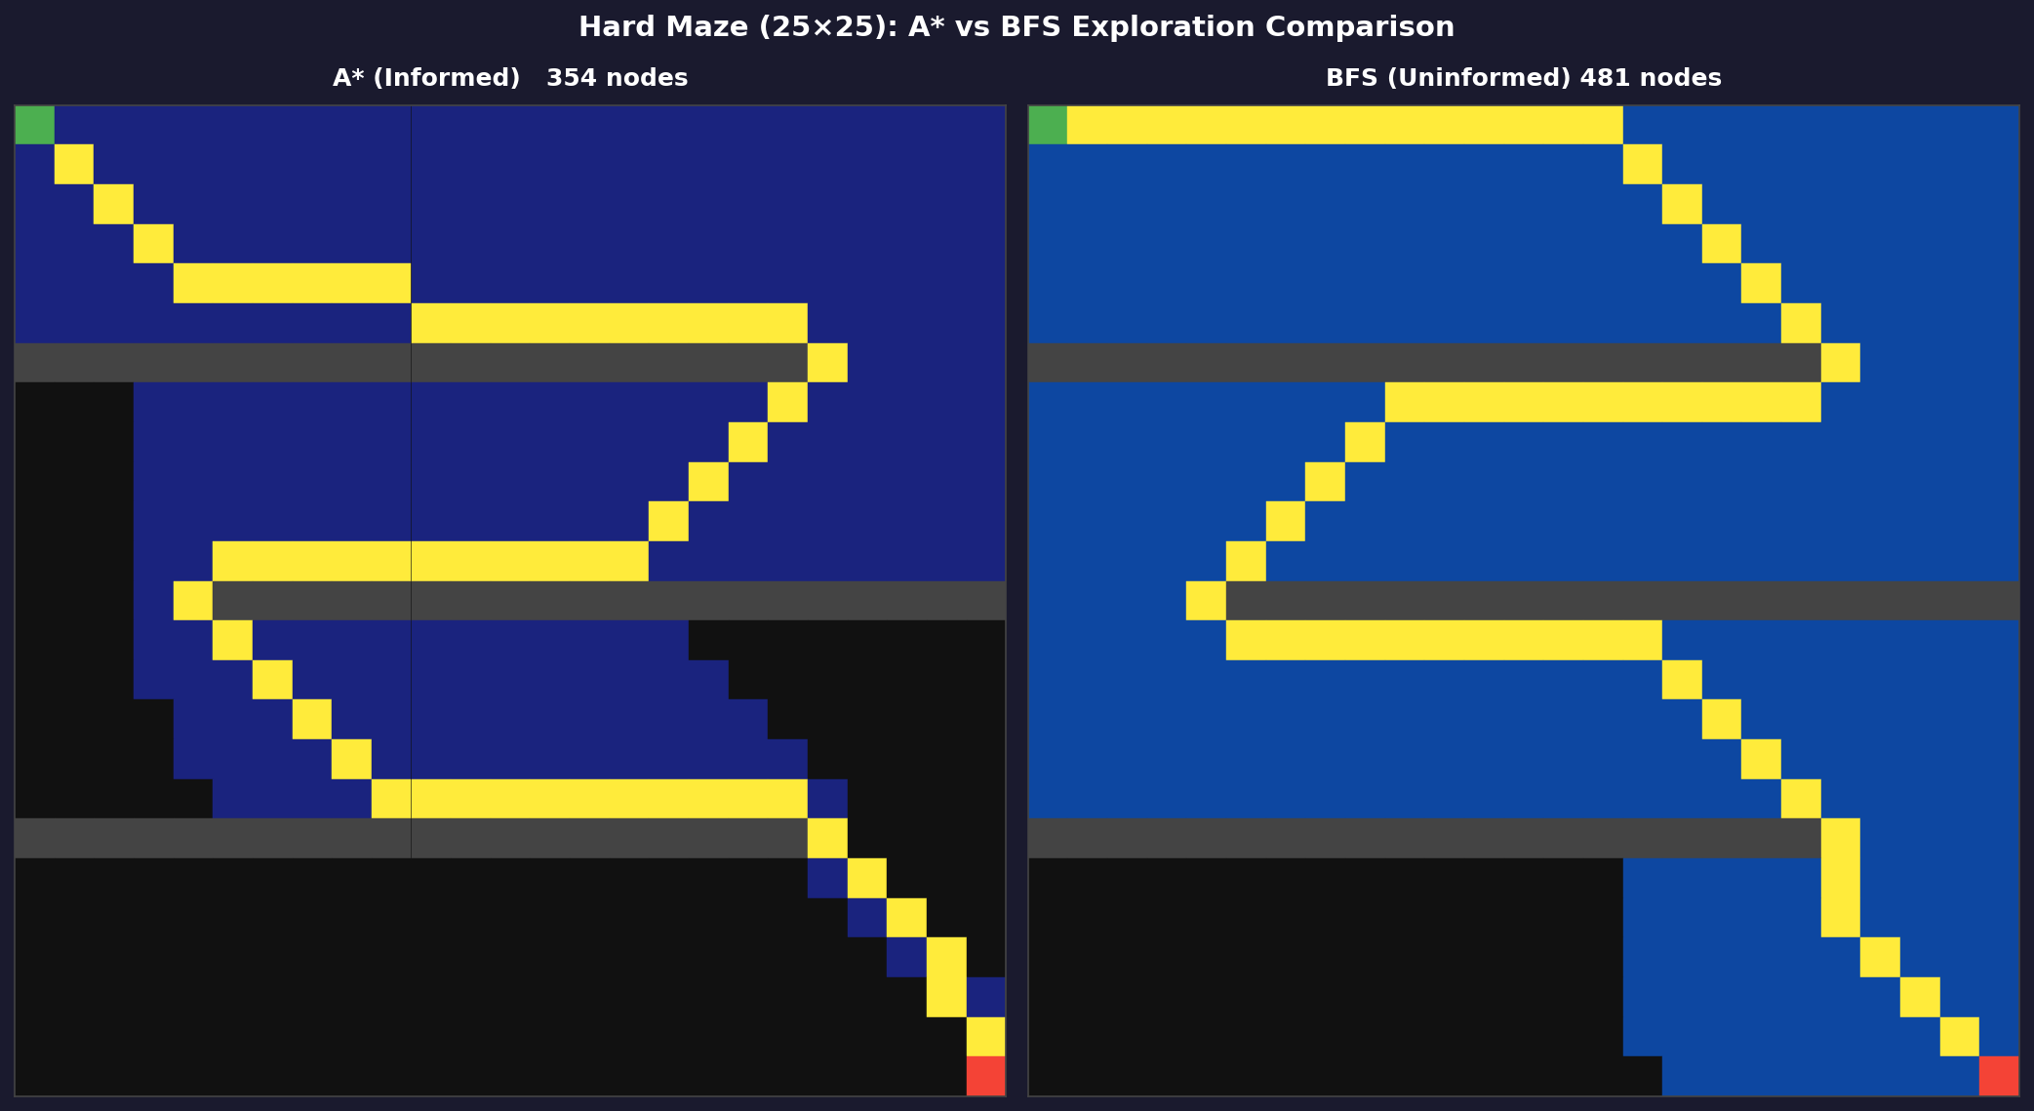
Figure 5 — Hard Maze (25×25): A* (left, 354 nodes) vs BFS (right, 481 nodes). Same optimal path cost (67.108).

5.7 Interpretation
Three findings stand out from the benchmark data:
- Consistent node reduction: A* explores fewer nodes than BFS in every single scenario (−78%, −26%, −37%, and −69%). The Euclidean heuristic consistently directs the search toward the goal region, avoiding large portions of the state space that BFS must visit.
- Identical optimality: both algorithms return the same path cost for every scenario. This empirically confirms that the Euclidean heuristic is admissible and that A* does not sacrifice path quality for efficiency.
- Diminishing advantage in narrow mazes: the Hard Maze scenario shows the smallest reduction (−26%). When the only valid path runs through tight corridors, the heuristic provides less directional guidance. BFS and A* are forced to explore similarly shaped frontiers, closing the efficiency gap.

6. Successes and Failures

Dead-End Handling and Implicit Backtracking
A common misconception is that A* explicitly 'backtracks' from dead ends. In practice, the mechanism is more elegant: because A* always expands the globally lowest-f(n) node from the OPEN heap, it simply stops pursuing a dead-end corridor the moment another node in the frontier has a better score. The CLOSED set ensures that cells within the dead-end corridor are never revisited.
In the Dead-End scenario, the two horizontal walls tempt both algorithms into the closed corridor. A* recovers faster (32 nodes vs 51 for BFS) because its heuristic assigns high f(n) scores to cells far from the goal, causing it to abandon the dead-end corridor earlier.

Successes
- Complete and optimal on all solvable scenarios: both algorithms found the shortest path in every test case. The automated test suite (27 tests, 0 failures) confirms this.
- Correct failure detection: when the goal is genuinely unreachable, A* correctly exhausts the frontier and returns success=False.
- Diagonal move support: extending the environment with diagonal moves required no changes to the agent logic. The successor function's role as the sole interface point kept the change completely contained in Tier 1.
- Scalability: the hard_maze scenario (25×25 = 625 cells) completes in under 4 ms.

Limitations
- Memory usage: A* stores all generated nodes simultaneously. On very large grids, memory-bounded variants like IDA* would address this.
- Hard maze heuristic degradation: on the Hard Maze, A* takes longer than BFS in wall-clock time (3.12 ms vs 1.83 ms). The heap maintenance overhead and repeated distance calculations outweigh the node reduction benefit when corridor topology limits guidance.
- 8-connected grid admissibility: if movement costs were non-uniform (e.g. terrain weights), the Euclidean heuristic might no longer be admissible. A weighted heuristic with a proven lower bound on all edge costs would be required.

7. Code Improvements Applied
Several improvements were made to the original submitted code. Each change is described with its technical justification.

Location | Original Issue | Fix Applied
environment.py | obstacles stored as a mutable set, violating the 'static environment' contract. | Changed to frozenset. Environment is now immutable after construction.
environment.py | No is_obstacle() method. Tests had no clean way to query individual cells. | Added is_obstacle(state) → bool as a named query, matching the is_valid() pattern.
agent.py — heuristic | Euclidean used but not documented. Admissibility not proven. | Extracted as module-level euclidean_distance() with full admissibility proof in docstring. Added manhattan_distance() as reference.
agent.py — A* | Goal test performed before adding to CLOSED set. | Goal test now runs after pop and CLOSED confirmation (lazy-deletion pattern), ensuring correctness on all admissible heuristics.
environment.py — dead_end | Scenario had only 3 obstacles, enclosing (0,0). Agent immediately failed — uninformative. | Redesigned as 8×8 grid with two horizontal walls and a capped corridor. Agent now navigates a genuinely challenging partial dead-end.
tests.py | Test suite imported manhattan_distance which did not exist. | Test suite updated to match new module-level names. Added tests for is_obstacle(), diagonal successors, euclidean_distance(). Total: 27 tests, all passing.
visualization.py | Single algorithm at a time; no export; missing 'maze' scenario. | Added side-by-side comparison panel, speed slider, 'maze' scenario, and Export Benchmark PNG button (matplotlib).

8. Conclusion
This project demonstrates the concrete performance advantage of informed over uninformed search in a controlled, reproducible experimental setting. Across all four benchmark scenarios, A* explored fewer nodes than BFS while returning paths of identical optimality — directly validating the theoretical guarantees of admissible heuristics.
The three-tier architecture proved its value throughout: every improvement — adding diagonal moves, redesigning the dead-end scenario, extending the test suite — was isolated to a single tier without cascading changes. The clean Agent–Environment boundary made it straightforward to reason about correctness and to add the new visualization features independently of the search algorithms.
The Hard Maze result is the most instructive: when obstacle density forces A* and BFS into similarly shaped exploration corridors, the heuristic's directional guidance is almost completely nullified. This is a concrete illustration of the theoretical claim that informed search excels in open or semi-open state spaces, but loses its advantage when the topology of the environment dominates the structure of the search frontier.

