Collective benefits function

To get started, see "Selecting tasks" you should choose the method by which the problem will be solved

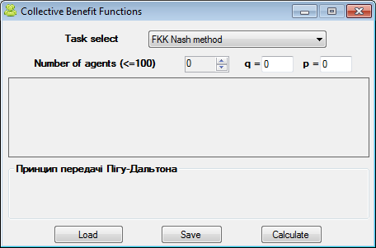

Then go directly to the input data:

Once all the necessary data is being pu in, we obtain a solution. Besides, there is the option to save or load the data:

