# SQL-SERVER CONFIG FOR AUTHENTICATION

Step 1: Set mode

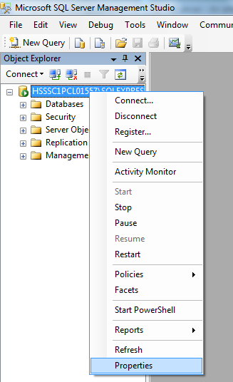

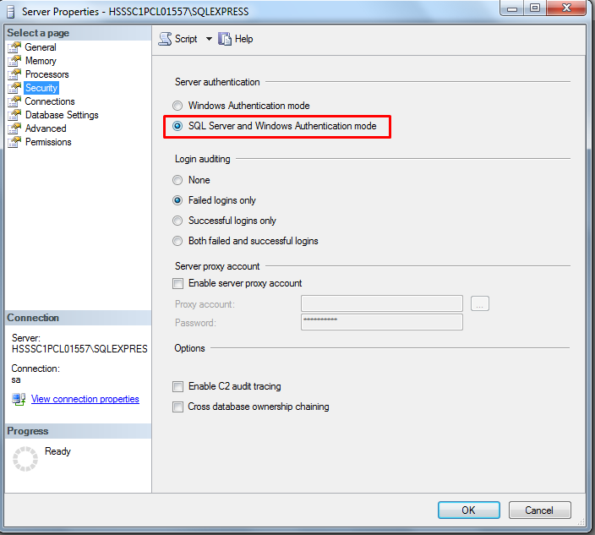

Click OK for all. Then restart the Server: right click on Server -> Restart

Step 2: Enable the sa login

In Object Explorer, expand **Security**, expand Logins, right-click **sa**, and then click **Properties**.

On the **General** page, you might have to create and confirm a password for the login.

On the **Status** page, in the **Login** section, click **Enabled**, and then click **OK**.

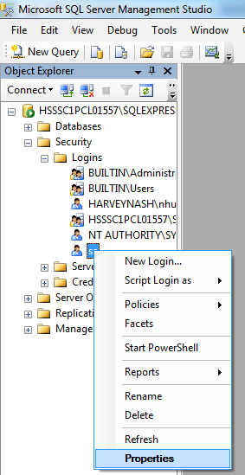

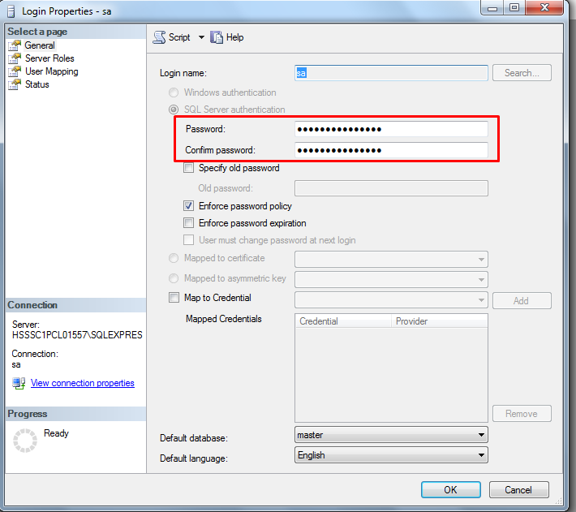

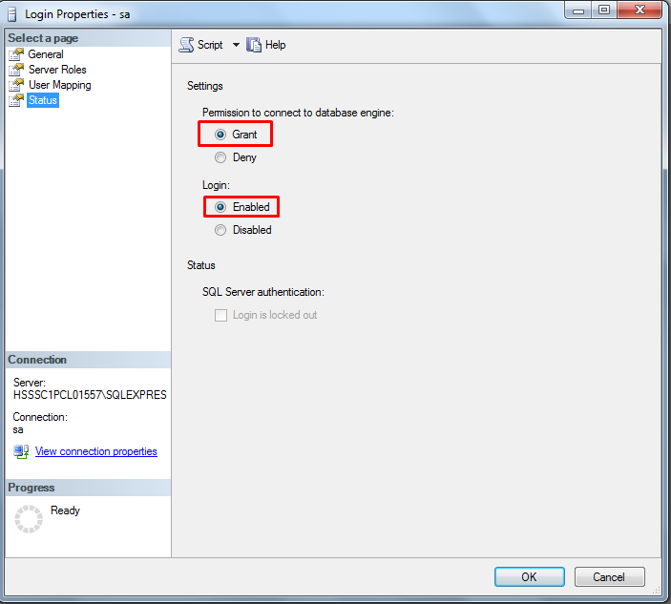

*Or you can use the T-SQL to do this:*

**ALTER LOGIN sa ENABLE ;**

**GO**

**ALTER LOGIN sa WITH PASSWORD = '<enterStrongPasswordHere>' ;**

**GO**

**Finally restart the server.**12/126 Đào Duy Anh - P9 - Phú Nhuận