# JAVA CONNECT TO SQL-SERVER

Step 1: Download **sqljdbc_4.0.2206.100_enu.exe** library

Step 2: Unzip downloaded file to **sqljdbc_4.0** folder

Step 3:

Create folder under project name and named “libs”

Copy **sqljdbc_4.0\enu\sqljdbc4.jar** to libs

Copy **sqljdbc_4.0\enu\auth\x64** to libs and rename x64 to dll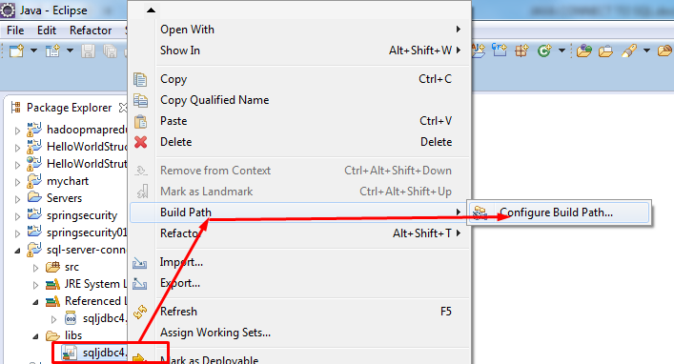

Step 4: Set **sqljdbc_auth.dll** **to java.library.path**

Right click on project select properties then do the following steps

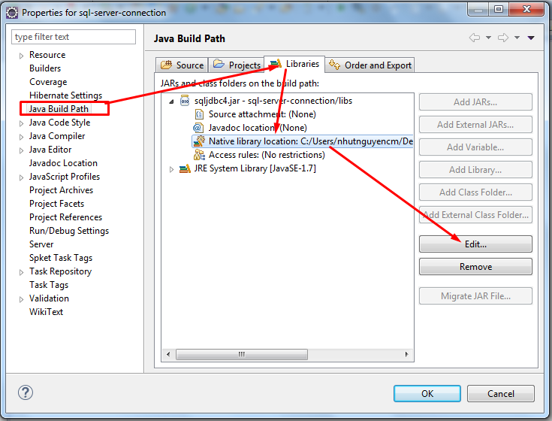

References to path: **projectname/libs/dll** finally click OK button

Step 5: Enalbling TCP/IP

Do the following steps

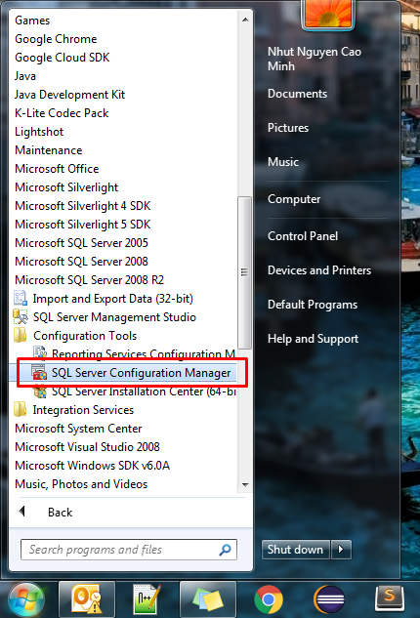

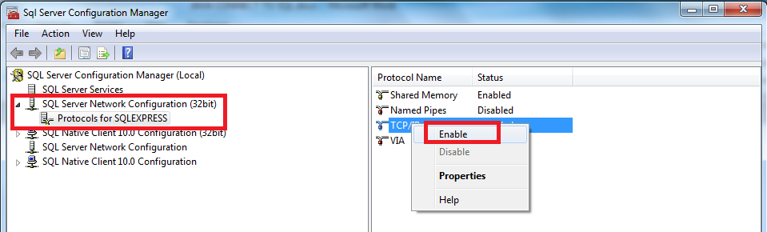

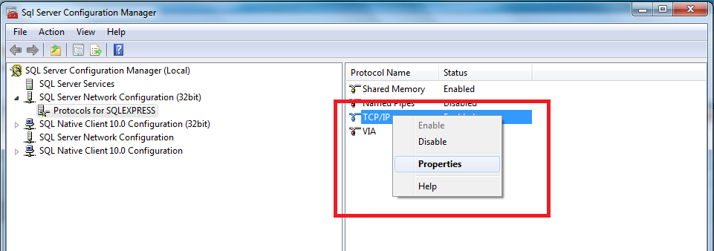

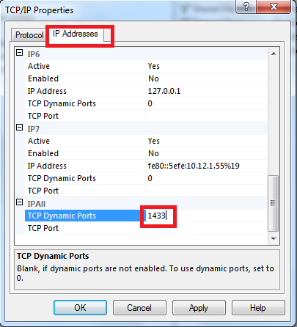

Finally restart SQL-SERVER

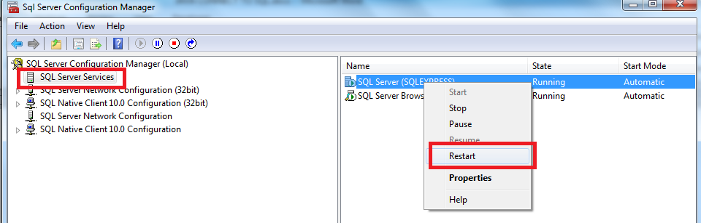

OK back to the java project and code for example