Lab1-CSE453 TestResult ScreenShot

Q1

Input “1” – Input “abc”

Q2

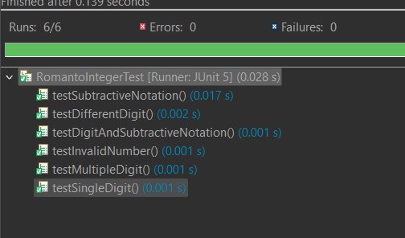

Q3

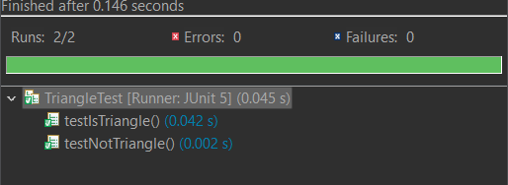

Q4

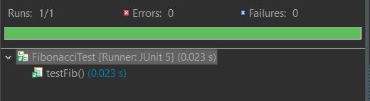

Q5

Point

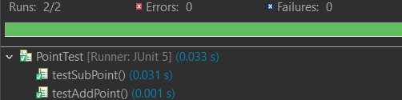

Line