Wireframes

Driessen

Sanchez, FRANCISCO; THOMAS, GILTON; PESTANA, Cristiano; Werneck Roale, Miguel; Le, Minh

2024

# 1. Wireframes

## 1.1 Sign In

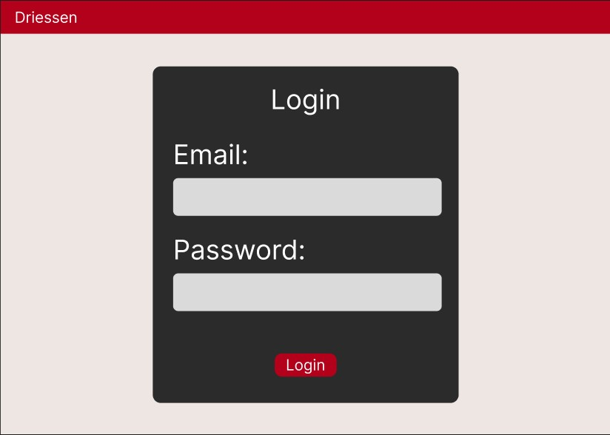

Figure 1: Office Reservation System - Sign In

## 1.2 Side Menu

Figure 2: Office Reservation System – Side Menu

Figure 3: Office Reservation System – Reservation System

## 1.4 Schedule Overview

Figure 1: Office Reservation System – Schedule Overview

Figure 1: Office Reservation System – User Overview

## 1.6 User Page

Figure 1: Office Reservation System – User Page