Isaias Rivera

CS 480 Fall 2022 Written Assignment #03

Due: Sunday, November 6, 11:00 PM CST Points: 45

Instructions:

1. Use this document template to report your answers. Name the completedocument as follows:

LastName_FirstName_CS480_Written03.doc or pdf

1. Submit the final document to Blackboard Assignments section before the duedate. No late submissions will be accepted.

Objectives:

1. (25 points) Demonstrate your understanding of First-Order Logic syntax.
2. (20 points) Demonstrate your understanding of Bayes’ Rule.

Problem 1 [25 pts]:

Convert English sentences to FOL. Write each of the following English sentences using First Order Logic. Use the following predicates and constants only.

■ Position(x, y): Predicate. Person x has position y. You can also read it as x holds y or x is y.

■ Friend(p1, p2): Predicate. Person p1 is a friend of person p2.

■ WorksFor(z1, z2): Predicate. Person z1 works for person z2.

■ Professor, Judge, Footballer, Athlete: Constants denoting some positions. This list is not comprehensive. There are also other positions not mentioned here.

■ Chris, Penelope: Constants denoting some people. This list is not comprehensive. There are also other people not mentioned in this list.

1. Penelope is neither a professor nor a footballer [5 pts].

|  |
| --- |
| Your solution: |
| ¬(Position(Penelope, Professor) ∨ Position(Penelope, Footballer)) |

|  |
| --- |
| Your solution: |
| ¬Position(Chris, Professor) ∧ ∀x ¬WorksFor(Chris, x) |

1. Chris is not a professor and he works for no one [5 pts].
2. Not all athletes are footballers [5 pts].

|  |
| --- |
| Your solution: |
| ¬(∀x Position(x, Athletes) ⇒ Position(x, Footballer)) |

1. Chris does not work for any of Penelope’s friends [5 pts].

|  |
| --- |
| Your solution: |
| ¬(∃x Friend(x, Penelope) ∧WorksFor(Chris, x)) |

1. Being a judge sometimes means that you have friends [5 pts].

|  |
| --- |
| Your solution: |
| ∃x Position(x, Judge) ∧ ∃y Friend(y, x) |

Problem 2 [20 pts]:

We are given the following joint distribution for variables A, B, and C. Please compute the requested probabilities. Show each probability distribution as a table/vector.

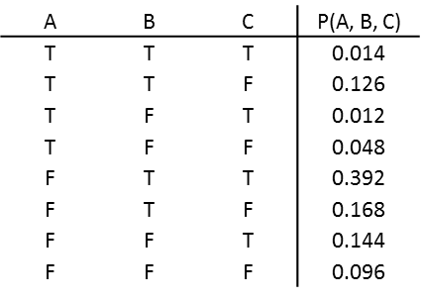

|  |
| --- |
| Your solution: |
| |  |  |  | | --- | --- | --- | | A | C | P(A, C) | | T | T | 0.014 + 0.012 = 0.026 | | T | F | 0.126 + 0.048 = 0.174 | | F | T | 0.392 + 0.144 = 0.536 | | F | F | 0.168 + 0.096 = 0.264 | |

1. P(A, C) [5 pts]
2. P(C) – you can use your answer to part a to compute the answer to this question.

[5 pts]

|  |
| --- |
| Your solution: |
| |  |  | | --- | --- | | C | P(C) | | T |  | | F | $$1 - 0.562 =0.438$$ | |

1. P(A|C) – you can use your answers to parts a and b to compute the answer to

this question. [5 pts]

|  |
| --- |
| Your solution: |
| |  |  |  | | --- | --- | --- | | A | C |  | | T | T |  | | T | F |  | | F | T |  | | F | F | $$=\frac{0.264}{.438}≈0.603$$ | |

1. P(A, B | C) – you can use your answers from previous parts if they are relevant.

[5 pts]

|  |
| --- |
| Your solution: |
| |  |  |  |  | | --- | --- | --- | --- | | A | B | C |  | | T | T | T |  | | T | T | F |  | | T | F | T |  | | T | F | F |  | | F | T | T |  | | F | T | F |  | | F | F | T |  | | F | F | F | $$=\frac{0.096}{.438}≈0.219$$ | |