HW2 Report

Isaias Rivera

10/7/2021

CS 528

Task 1

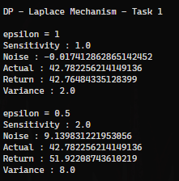

Task 2

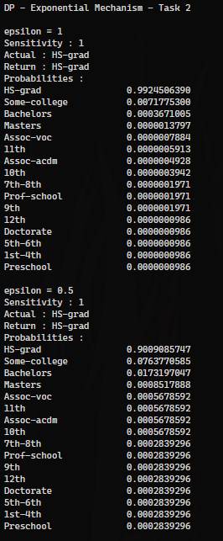

Task 3

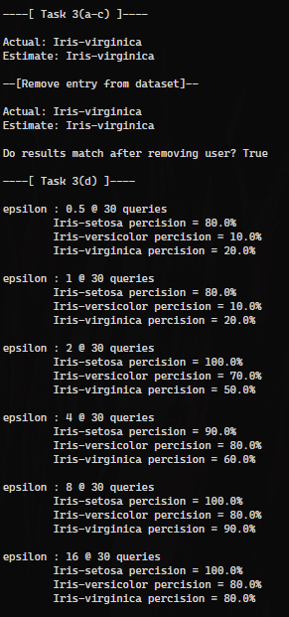

Task 4

b)

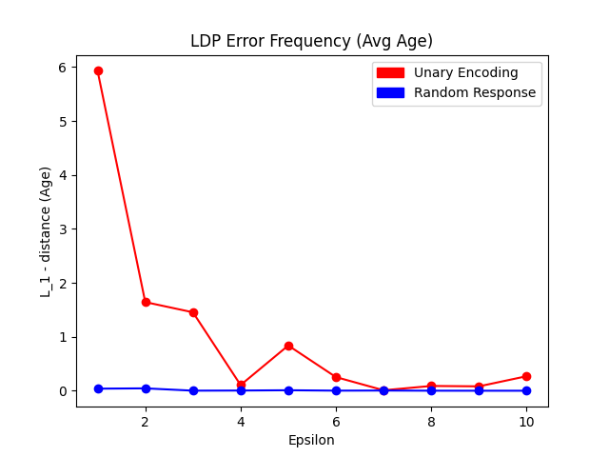

The error for RR remained relatively constant while UE’s error improved with a bigger epsilon value.

C)

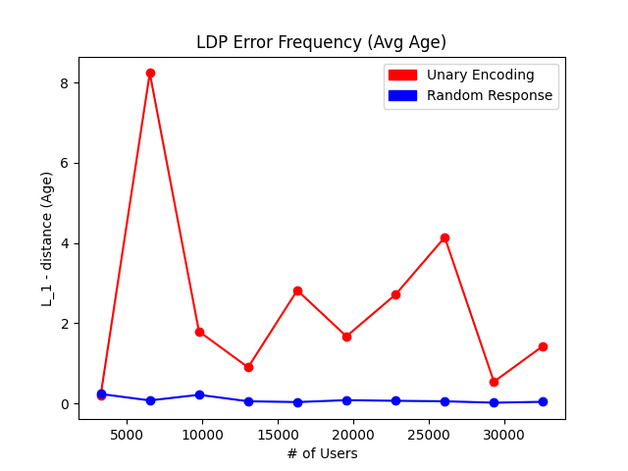

The error for RR still remained relatively constant while UE’s error was somewhat sporadic but still showed a trend of less error as the # of users increased.

Task 4 Full Terminal Output

Local differential privacy

----[ Task 4(a,b) ]----

> Unary Encoding | epsilon = 1 | n = 32561

Probabilites:

Keep 0.622459

Flip 0.377541

Actual: 38.581647

Return: 1469.079819

Unbiased:32.653417

> Unary Encoding | epsilon = 2 | n = 32561

Probabilites:

Keep 0.731059

Flip 0.268941

Actual: 38.581647

Return: 1057.873253

Unbiased:36.938582

> Unary Encoding | epsilon = 3 | n = 32561

Probabilites:

Keep 0.817574

Flip 0.182426

Actual: 38.581647

Return: 731.415344

Unbiased:40.035595

> Unary Encoding | epsilon = 4 | n = 32561

Probabilites:

Keep 0.880797

Flip 0.119203

Actual: 38.581647

Return: 490.779522

Unbiased:38.687552

> Unary Encoding | epsilon = 5 | n = 32561

Probabilites:

Keep 0.924142

Flip 0.075858

Actual: 38.581647

Return: 327.01078

Unbiased:39.420332

> Unary Encoding | epsilon = 6 | n = 32561

Probabilites:

Keep 0.952574

Flip 0.047426

Actual: 38.581647

Return: 218.689444

Unbiased:38.834871

> Unary Encoding | epsilon = 7 | n = 32561

Probabilites:

Keep 0.970688

Flip 0.029312

Actual: 38.581647

Return: 149.749639

Unbiased:38.572604

> Unary Encoding | epsilon = 8 | n = 32561

Probabilites:

Keep 0.982014

Flip 0.017986

Actual: 38.581647

Return: 106.886152

Unbiased:38.670594

> Unary Encoding | epsilon = 9 | n = 32561

Probabilites:

Keep 0.989013

Flip 0.010987

Actual: 38.581647

Return: 80.173305

Unbiased:38.499828

> Unary Encoding | epsilon = 10 | n = 32561

Probabilites:

Keep 0.993307

Flip 0.006693

Actual: 38.581647

Return: 64.232425

Unbiased:38.851142

> Random Response | epsilon = 1 | n = 32561

Probabilites:

True Answer 0.731059

False Answer 0.268941

Actual: 38.581647

Return: 38.542919

Unbiased:38.542855

> Random Response | epsilon = 2 | n = 32561

Probabilites:

True Answer 0.880797

False Answer 0.119203

Actual: 38.581647

Return: 38.537023

Unbiased:38.53695

> Random Response | epsilon = 3 | n = 32561

Probabilites:

True Answer 0.952574

False Answer 0.047426

Actual: 38.581647

Return: 38.58352

Unbiased:38.583448

> Random Response | epsilon = 4 | n = 32561

Probabilites:

True Answer 0.982014

False Answer 0.017986

Actual: 38.581647

Return: 38.577562

Unbiased:38.57749

> Random Response | epsilon = 5 | n = 32561

Probabilites:

True Answer 0.993307

False Answer 0.006693

Actual: 38.581647

Return: 38.59129

Unbiased:38.591218

> Random Response | epsilon = 6 | n = 32561

Probabilites:

True Answer 0.997527

False Answer 0.002473

Actual: 38.581647

Return: 38.583827

Unbiased:38.583756

> Random Response | epsilon = 7 | n = 32561

Probabilites:

True Answer 0.999089

False Answer 0.000911

Actual: 38.581647

Return: 38.577562

Unbiased:38.577492

> Random Response | epsilon = 8 | n = 32561

Probabilites:

True Answer 0.999665

False Answer 0.000335

Actual: 38.581647

Return: 38.580541

Unbiased:38.580475

> Random Response | epsilon = 9 | n = 32561

Probabilites:

True Answer 0.999877

False Answer 0.000123

Actual: 38.581647

Return: 38.581217

Unbiased:38.581159

> Random Response | epsilon = 10 | n = 32561

Probabilites:

True Answer 0.999955

False Answer 0.000045

Actual: 38.581647

Return: 38.582077

Unbiased:38.582033

----[ Task 4(a,c) ]----

> Unary Encoding | epsilon = 2 | n = 3256

Probabilites:

Keep 0.731059

Flip 0.268941

Actual: 38.884828

Return: 944.244165

Unbiased:38.390628

> Unary Encoding | epsilon = 2 | n = 6512

Probabilites:

Keep 0.731059

Flip 0.268941

Actual: 38.613483

Return: 993.05344

Unbiased:46.821516

> Unary Encoding | epsilon = 2 | n = 9768

Probabilites:

Keep 0.731059

Flip 0.268941

Actual: 38.433559

Return: 1011.276515

Unbiased:36.787382

> Unary Encoding | epsilon = 2 | n = 13024

Probabilites:

Keep 0.731059

Flip 0.268941

Actual: 38.467982

Return: 1011.690725

Unbiased:37.683712

> Unary Encoding | epsilon = 2 | n = 16280

Probabilites:

Keep 0.731059

Flip 0.268941

Actual: 38.547666

Return: 1013.408477

Unbiased:41.400847

> Unary Encoding | epsilon = 2 | n = 19536

Probabilites:

Keep 0.731059

Flip 0.268941

Actual: 38.597973

Return: 1011.333282

Unbiased:36.910223

> Unary Encoding | epsilon = 2 | n = 22792

Probabilites:

Keep 0.731059

Flip 0.268941

Actual: 38.593542

Return: 1013.360258

Unbiased:41.296504

> Unary Encoding | epsilon = 2 | n = 26048

Probabilites:

Keep 0.731059

Flip 0.268941

Actual: 38.62811

Return: 1033.320946

Unbiased:34.440506

> Unary Encoding | epsilon = 2 | n = 29304

Probabilites:

Keep 0.731059

Flip 0.268941

Actual: 38.591592

Return: 1035.483552

Unbiased:39.120285

> Unary Encoding | epsilon = 2 | n = 32560

Probabilites:

Keep 0.731059

Flip 0.268941

Actual: 38.581235

Return: 1059.294748

Unbiased:40.014631

> Random Response | epsilon = 2 | n = 3256

Probabilites:

True Answer 0.880797

False Answer 0.119203

Actual: 38.884828

Return: 38.820639

Unbiased:38.815482

> Random Response | epsilon = 2 | n = 6512

Probabilites:

True Answer 0.880797

False Answer 0.119203

Actual: 38.613483

Return: 38.656173

Unbiased:38.654679

> Random Response | epsilon = 2 | n = 9768

Probabilites:

True Answer 0.880797

False Answer 0.119203

Actual: 38.433559

Return: 38.369165

Unbiased:38.368484

> Random Response | epsilon = 2 | n = 13024

Probabilites:

True Answer 0.880797

False Answer 0.119203

Actual: 38.467982

Return: 38.530559

Unbiased:38.530157

> Random Response | epsilon = 2 | n = 16280

Probabilites:

True Answer 0.880797

False Answer 0.119203

Actual: 38.547666

Return: 38.550123

Unbiased:38.549866

> Random Response | epsilon = 2 | n = 19536

Probabilites:

True Answer 0.880797

False Answer 0.119203

Actual: 38.597973

Return: 38.661548

Unbiased:38.661371

> Random Response | epsilon = 2 | n = 22792

Probabilites:

True Answer 0.880797

False Answer 0.119203

Actual: 38.593542

Return: 38.64527

Unbiased:38.64514

> Random Response | epsilon = 2 | n = 26048

Probabilites:

True Answer 0.880797

False Answer 0.119203

Actual: 38.62811

Return: 38.633484

Unbiased:38.633378

> Random Response | epsilon = 2 | n = 29304

Probabilites:

True Answer 0.880797

False Answer 0.119203

Actual: 38.591592

Return: 38.565861

Unbiased:38.565777

> Random Response | epsilon = 2 | n = 32560

Probabilites:

True Answer 0.880797

False Answer 0.119203

Actual: 38.581235

Return: 38.619963

Unbiased:38.619891