LINUX: SSH không dùng password

Tạo public và private key bằng lệnh ssh-keygen

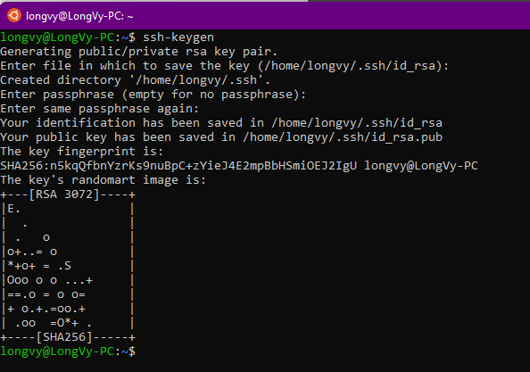

DOCKER:

Pull nginx docker image.

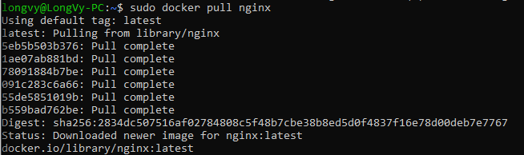

Create folder for storing the file index.html and modify its content.

Run nginx container in detached mode and link the container to the local filesystem.

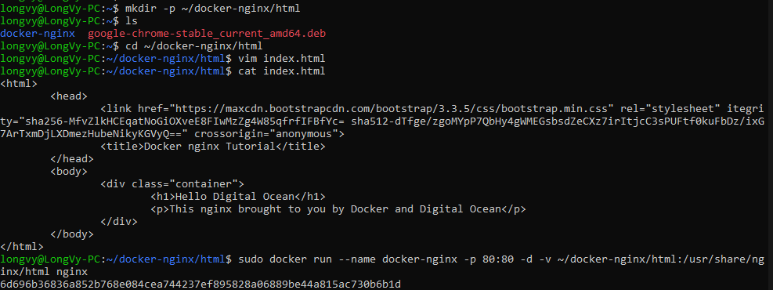

Result:

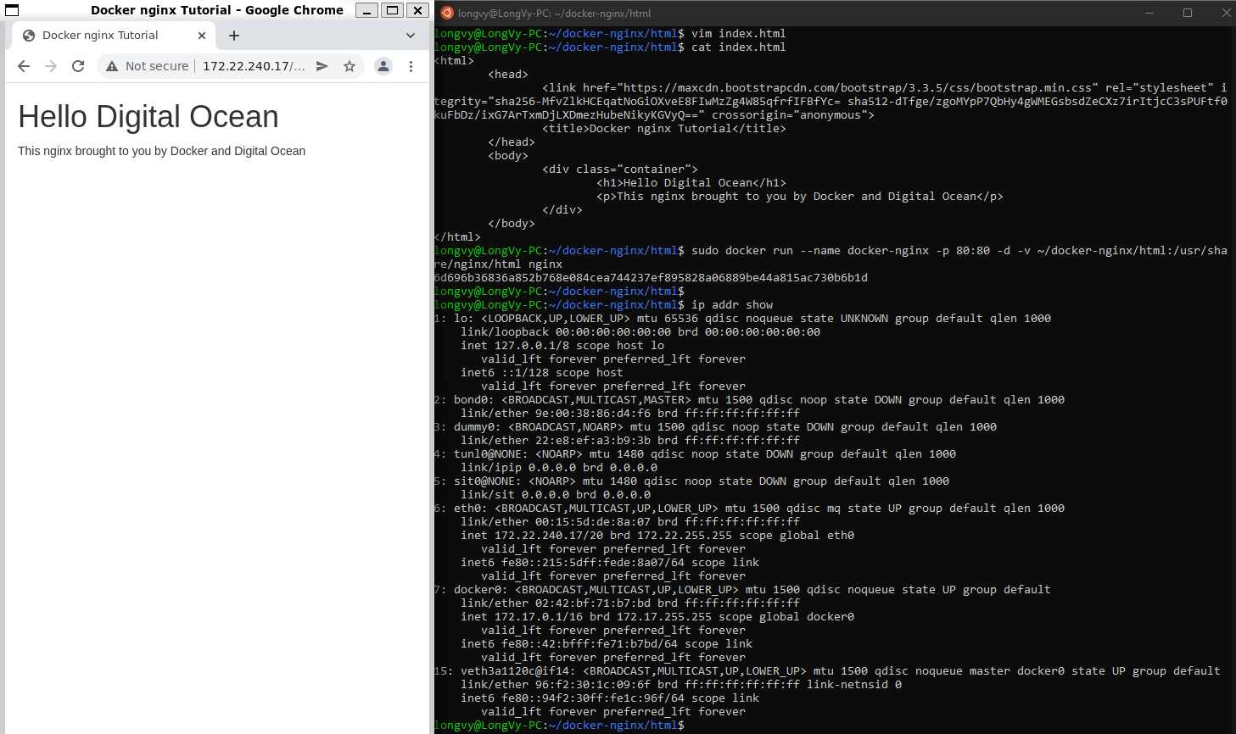

List the containers:



Commit the container docker-nginx:



Push the image to docker hub:

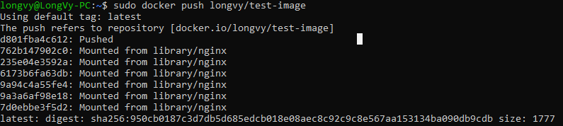

GIT:

