# YOLOv8 Training Report

Run directory: runs\train\logo_experiment

Generated: 2025-09-06 16:42:25

## Hyperparameters

**model:** yolov8n.pt  
**data:** logoCar/dataset/data.yaml  
**epochs:** 100  
**imgsz:** 640  
**batch:** 16  
**device:** 0

## Per-epoch metrics (sample)

|  |  |  |  |  |  |  |  |  |  |  |  |  |  |  |
| --- | --- | --- | --- | --- | --- | --- | --- | --- | --- | --- | --- | --- | --- | --- |
| epoch | time | train/box_loss | train/cls_loss | train/dfl_loss | metrics/precision(B) | metrics/recall(B) | metrics/mAP50(B) | metrics/mAP50-95(B) | val/box_loss | val/cls_loss | val/dfl_loss | lr/pg0 | lr/pg1 | lr/pg2 |
| 1.0 | 49.3784 | 2.43143 | 7.73048 | 1.32899 | 0.241 | 0.12261 | 0.05542 | 0.02402 | 2.06663 | 3.30838 | 1.12295 | 8.74096e-05 | 8.74096e-05 | 8.74096e-05 |
| 2.0 | 95.5988 | 2.14709 | 5.13052 | 1.12746 | 0.31226 | 0.19472 | 0.14679 | 0.06863 | 1.96104 | 2.68808 | 1.10254 | 0.000173343 | 0.000173343 | 0.000173343 |
| 3.0 | 142.255 | 2.07489 | 4.06693 | 1.11553 | 0.37777 | 0.30097 | 0.25922 | 0.12048 | 1.93753 | 2.39372 | 1.10231 | 0.000257541 | 0.000257541 | 0.000257541 |
| 4.0 | 189.153 | 2.02462 | 3.39104 | 1.11057 | 0.40393 | 0.33987 | 0.30892 | 0.14107 | 1.89329 | 2.13875 | 1.09412 | 0.000255189 | 0.000255189 | 0.000255189 |
| 5.0 | 235.851 | 2.02458 | 2.94459 | 1.1054 | 0.39588 | 0.39039 | 0.37214 | 0.16962 | 1.87221 | 2.0515 | 1.10179 | 0.000252585 | 0.000252585 | 0.000252585 |
| 6.0 | 283.238 | 1.97922 | 2.63106 | 1.08964 | 0.48561 | 0.42228 | 0.42291 | 0.19805 | 1.86074 | 1.90422 | 1.0815 | 0.000249981 | 0.000249981 | 0.000249981 |
| 7.0 | 331.216 | 1.96157 | 2.39604 | 1.08584 | 0.52635 | 0.44267 | 0.45404 | 0.20917 | 1.84472 | 1.84118 | 1.07912 | 0.000247378 | 0.000247378 | 0.000247378 |
| 8.0 | 377.936 | 1.92105 | 2.24557 | 1.07488 | 0.5739 | 0.43508 | 0.47405 | 0.22863 | 1.81532 | 1.80577 | 1.06265 | 0.000244774 | 0.000244774 | 0.000244774 |
| 9.0 | 424.478 | 1.9287 | 2.12821 | 1.07479 | 0.60539 | 0.44874 | 0.50743 | 0.24431 | 1.83166 | 1.7151 | 1.07172 | 0.00024217 | 0.00024217 | 0.00024217 |
| 10.0 | 471.113 | 1.9075 | 2.02853 | 1.07611 | 0.59951 | 0.46087 | 0.51321 | 0.2336 | 1.8532 | 1.6878 | 1.07718 | 0.000239567 | 0.000239567 | 0.000239567 |
| 11.0 | 517.7 | 1.90168 | 1.94916 | 1.06709 | 0.55382 | 0.45597 | 0.50448 | 0.24045 | 1.80295 | 1.67937 | 1.06689 | 0.000236963 | 0.000236963 | 0.000236963 |
| 12.0 | 566.384 | 1.87242 | 1.87013 | 1.06316 | 0.64929 | 0.48325 | 0.54484 | 0.25476 | 1.79302 | 1.62203 | 1.06523 | 0.000234359 | 0.000234359 | 0.000234359 |
| 13.0 | 617.26 | 1.87156 | 1.80549 | 1.06349 | 0.62545 | 0.50473 | 0.55596 | 0.26019 | 1.78482 | 1.62965 | 1.05737 | 0.000231756 | 0.000231756 | 0.000231756 |
| 14.0 | 664.844 | 1.85345 | 1.75103 | 1.05709 | 0.65495 | 0.49505 | 0.57062 | 0.26789 | 1.80248 | 1.57111 | 1.06621 | 0.000229152 | 0.000229152 | 0.000229152 |
| 15.0 | 711.759 | 1.85655 | 1.73214 | 1.05144 | 0.67138 | 0.53202 | 0.60002 | 0.28018 | 1.828 | 1.51361 | 1.07358 | 0.000226548 | 0.000226548 | 0.000226548 |
| 16.0 | 758.949 | 1.8327 | 1.66258 | 1.04493 | 0.62478 | 0.5206 | 0.57593 | 0.26838 | 1.82617 | 1.53105 | 1.07122 | 0.000223945 | 0.000223945 | 0.000223945 |
| 17.0 | 805.865 | 1.84054 | 1.64016 | 1.04555 | 0.60647 | 0.54201 | 0.56983 | 0.26731 | 1.81918 | 1.55668 | 1.07111 | 0.000221341 | 0.000221341 | 0.000221341 |
| 18.0 | 852.472 | 1.82812 | 1.61481 | 1.04933 | 0.6472 | 0.55285 | 0.61767 | 0.28499 | 1.82066 | 1.47384 | 1.07593 | 0.000218737 | 0.000218737 | 0.000218737 |
| 19.0 | 900.286 | 1.81041 | 1.56374 | 1.04057 | 0.64973 | 0.55761 | 0.60239 | 0.28252 | 1.79418 | 1.49368 | 1.07419 | 0.000216133 | 0.000216133 | 0.000216133 |
| 20.0 | 947.477 | 1.81683 | 1.55628 | 1.03853 | 0.6848 | 0.57765 | 0.6301 | 0.3018 | 1.77783 | 1.44793 | 1.05915 | 0.00021353 | 0.00021353 | 0.00021353 |
| 21.0 | 994.683 | 1.8063 | 1.53961 | 1.03318 | 0.65863 | 0.55638 | 0.62203 | 0.29089 | 1.79111 | 1.46867 | 1.06336 | 0.000210926 | 0.000210926 | 0.000210926 |
| 22.0 | 1041.3 | 1.80742 | 1.50443 | 1.03671 | 0.6929 | 0.55611 | 0.63549 | 0.29359 | 1.78501 | 1.42525 | 1.06704 | 0.000208322 | 0.000208322 | 0.000208322 |
| 23.0 | 1088.46 | 1.79031 | 1.48999 | 1.03354 | 0.66778 | 0.57713 | 0.63337 | 0.3039 | 1.77275 | 1.42125 | 1.05525 | 0.000205719 | 0.000205719 | 0.000205719 |
| 24.0 | 1136.1 | 1.77852 | 1.4655 | 1.02457 | 0.71543 | 0.59948 | 0.66575 | 0.31217 | 1.78608 | 1.39918 | 1.05634 | 0.000203115 | 0.000203115 | 0.000203115 |
| 25.0 | 1183.38 | 1.76985 | 1.42342 | 1.02569 | 0.73023 | 0.55906 | 0.64949 | 0.30552 | 1.78611 | 1.42159 | 1.05454 | 0.000200511 | 0.000200511 | 0.000200511 |
| 26.0 | 1230.54 | 1.76319 | 1.41012 | 1.02625 | 0.74803 | 0.56379 | 0.64998 | 0.30468 | 1.79078 | 1.42586 | 1.05945 | 0.000197907 | 0.000197907 | 0.000197907 |
| 27.0 | 1308.96 | 1.74705 | 1.39087 | 1.02272 | 0.71342 | 0.56869 | 0.6543 | 0.30629 | 1.772 | 1.37846 | 1.04981 | 0.000195304 | 0.000195304 | 0.000195304 |
| 28.0 | 1355.59 | 1.75599 | 1.37298 | 1.02598 | 0.73841 | 0.59249 | 0.67542 | 0.31866 | 1.7689 | 1.33452 | 1.04901 | 0.0001927 | 0.0001927 | 0.0001927 |
| 29.0 | 1402.72 | 1.73564 | 1.34162 | 1.01881 | 0.72727 | 0.60065 | 0.66657 | 0.31751 | 1.76808 | 1.36342 | 1.04979 | 0.000190096 | 0.000190096 | 0.000190096 |
| 30.0 | 1449.91 | 1.73997 | 1.3396 | 1.01898 | 0.71886 | 0.59147 | 0.67817 | 0.32092 | 1.76981 | 1.33632 | 1.04848 | 0.000187493 | 0.000187493 | 0.000187493 |
| 31.0 | 1497.02 | 1.74014 | 1.31432 | 1.01658 | 0.72979 | 0.60335 | 0.69229 | 0.32913 | 1.77612 | 1.30072 | 1.05675 | 0.000184889 | 0.000184889 | 0.000184889 |
| 32.0 | 1545.21 | 1.72999 | 1.30497 | 1.01248 | 0.74008 | 0.5902 | 0.67016 | 0.31322 | 1.78694 | 1.34741 | 1.05967 | 0.000182285 | 0.000182285 | 0.000182285 |
| 33.0 | 1593.71 | 1.71654 | 1.2826 | 1.01206 | 0.75666 | 0.60826 | 0.69426 | 0.32556 | 1.77502 | 1.31009 | 1.06401 | 0.000179682 | 0.000179682 | 0.000179682 |
| 34.0 | 1641.66 | 1.70969 | 1.26403 | 1.00698 | 0.75899 | 0.61615 | 0.698 | 0.32864 | 1.78429 | 1.27496 | 1.05999 | 0.000177078 | 0.000177078 | 0.000177078 |
| 35.0 | 1689.45 | 1.72977 | 1.28561 | 1.01246 | 0.75321 | 0.63126 | 0.70654 | 0.33662 | 1.77497 | 1.29536 | 1.0494 | 0.000174474 | 0.000174474 | 0.000174474 |
| 36.0 | 1737.26 | 1.70427 | 1.246 | 1.0026 | 0.74609 | 0.62127 | 0.7007 | 0.33744 | 1.7825 | 1.26984 | 1.0546 | 0.000171871 | 0.000171871 | 0.000171871 |
| 37.0 | 1784.8 | 1.71326 | 1.23977 | 1.00229 | 0.75006 | 0.61111 | 0.69838 | 0.33217 | 1.76729 | 1.27509 | 1.05136 | 0.000169267 | 0.000169267 | 0.000169267 |
| 38.0 | 1831.96 | 1.70002 | 1.22616 | 1.00127 | 0.76839 | 0.60692 | 0.70193 | 0.33401 | 1.77204 | 1.26507 | 1.0544 | 0.000166663 | 0.000166663 | 0.000166663 |
| 39.0 | 1879.49 | 1.68601 | 1.20854 | 1.00391 | 0.75387 | 0.62084 | 0.71015 | 0.33666 | 1.79446 | 1.24935 | 1.05953 | 0.000164059 | 0.000164059 | 0.000164059 |
| 40.0 | 1926.68 | 1.66381 | 1.18279 | 0.99737 | 0.77375 | 0.62416 | 0.69963 | 0.33052 | 1.79405 | 1.25067 | 1.06399 | 0.000161456 | 0.000161456 | 0.000161456 |
| 41.0 | 1973.77 | 1.68114 | 1.18704 | 0.99846 | 0.77303 | 0.62157 | 0.70731 | 0.33084 | 1.78911 | 1.24037 | 1.05929 | 0.000158852 | 0.000158852 | 0.000158852 |
| 42.0 | 2021.62 | 1.64982 | 1.16097 | 0.99318 | 0.75115 | 0.63479 | 0.7073 | 0.33417 | 1.79386 | 1.24856 | 1.06381 | 0.000156248 | 0.000156248 | 0.000156248 |
| 43.0 | 2069.84 | 1.65759 | 1.16472 | 0.99222 | 0.76299 | 0.62078 | 0.70002 | 0.33488 | 1.79097 | 1.24617 | 1.05942 | 0.000153645 | 0.000153645 | 0.000153645 |
| 44.0 | 2117.69 | 1.65153 | 1.14481 | 0.98833 | 0.76802 | 0.64563 | 0.72486 | 0.33675 | 1.76997 | 1.20428 | 1.05487 | 0.000151041 | 0.000151041 | 0.000151041 |
| 45.0 | 2166.39 | 1.65434 | 1.13983 | 0.99098 | 0.78389 | 0.64112 | 0.71817 | 0.33999 | 1.7923 | 1.1873 | 1.06584 | 0.000148437 | 0.000148437 | 0.000148437 |
| 46.0 | 2232.43 | 1.63371 | 1.12943 | 0.97878 | 0.74394 | 0.65141 | 0.71938 | 0.3444 | 1.79179 | 1.19475 | 1.06468 | 0.000145834 | 0.000145834 | 0.000145834 |
| 47.0 | 2282.75 | 1.64264 | 1.11855 | 0.98788 | 0.7707 | 0.64099 | 0.72164 | 0.34679 | 1.7848 | 1.19326 | 1.05993 | 0.00014323 | 0.00014323 | 0.00014323 |
| 48.0 | 2330.19 | 1.62857 | 1.11099 | 0.98689 | 0.7635 | 0.66105 | 0.72972 | 0.3422 | 1.79876 | 1.18735 | 1.06514 | 0.000140626 | 0.000140626 | 0.000140626 |
| 49.0 | 2377.58 | 1.6271 | 1.10552 | 0.98359 | 0.79879 | 0.61684 | 0.70986 | 0.33746 | 1.78468 | 1.19531 | 1.06026 | 0.000138022 | 0.000138022 | 0.000138022 |
| 50.0 | 2425.03 | 1.60612 | 1.08829 | 0.98128 | 0.79916 | 0.62193 | 0.7195 | 0.34743 | 1.7895 | 1.18013 | 1.06169 | 0.000135419 | 0.000135419 | 0.000135419 |
| 51.0 | 2472.52 | 1.6198 | 1.08828 | 0.98002 | 0.81776 | 0.63008 | 0.72783 | 0.34712 | 1.7912 | 1.16527 | 1.06507 | 0.000132815 | 0.000132815 | 0.000132815 |
| 52.0 | 2521.04 | 1.60539 | 1.0728 | 0.97652 | 0.79807 | 0.65414 | 0.73265 | 0.3557 | 1.78735 | 1.15651 | 1.07043 | 0.000130211 | 0.000130211 | 0.000130211 |
| 53.0 | 2570.24 | 1.58723 | 1.06662 | 0.97384 | 0.79812 | 0.66746 | 0.73744 | 0.35579 | 1.78654 | 1.1433 | 1.06547 | 0.000127608 | 0.000127608 | 0.000127608 |
| 54.0 | 2618.11 | 1.59357 | 1.05608 | 0.97618 | 0.82279 | 0.66157 | 0.73957 | 0.35349 | 1.78716 | 1.1542 | 1.06395 | 0.000125004 | 0.000125004 | 0.000125004 |
| 55.0 | 2665.85 | 1.58454 | 1.05083 | 0.97182 | 0.83913 | 0.65523 | 0.74599 | 0.35507 | 1.79106 | 1.14217 | 1.06319 | 0.0001224 | 0.0001224 | 0.0001224 |
| 56.0 | 2713.79 | 1.56697 | 1.02066 | 0.97022 | 0.81577 | 0.6616 | 0.74061 | 0.35081 | 1.79499 | 1.12686 | 1.07083 | 0.000119796 | 0.000119796 | 0.000119796 |
| 57.0 | 2761.46 | 1.58264 | 1.02973 | 0.96976 | 0.8025 | 0.67223 | 0.73311 | 0.34828 | 1.79733 | 1.14373 | 1.06618 | 0.000117193 | 0.000117193 | 0.000117193 |
| 58.0 | 2809.64 | 1.56774 | 1.01164 | 0.96459 | 0.78094 | 0.67815 | 0.74171 | 0.35144 | 1.79696 | 1.12754 | 1.07098 | 0.000114589 | 0.000114589 | 0.000114589 |
| 59.0 | 2857.32 | 1.56627 | 1.00681 | 0.97142 | 0.81984 | 0.64042 | 0.73364 | 0.3474 | 1.8089 | 1.13065 | 1.0736 | 0.000111985 | 0.000111985 | 0.000111985 |
| 60.0 | 2904.81 | 1.55989 | 1.00597 | 0.96591 | 0.82153 | 0.65324 | 0.73965 | 0.355 | 1.79686 | 1.11699 | 1.07277 | 0.000109382 | 0.000109382 | 0.000109382 |
| 61.0 | 2952.12 | 1.55457 | 1.00119 | 0.96118 | 0.82361 | 0.65597 | 0.7464 | 0.34854 | 1.80566 | 1.11576 | 1.07279 | 0.000106778 | 0.000106778 | 0.000106778 |
| 62.0 | 2999.39 | 1.55989 | 0.99456 | 0.96498 | 0.79646 | 0.67736 | 0.7506 | 0.35595 | 1.80101 | 1.11011 | 1.07243 | 0.000104174 | 0.000104174 | 0.000104174 |
| 63.0 | 3046.8 | 1.54035 | 0.9788 | 0.95988 | 0.81985 | 0.66847 | 0.75115 | 0.35362 | 1.80393 | 1.11239 | 1.0706 | 0.000101571 | 0.000101571 | 0.000101571 |
| 64.0 | 3095.07 | 1.53469 | 0.9798 | 0.96217 | 0.83063 | 0.66496 | 0.75263 | 0.35856 | 1.79041 | 1.09812 | 1.06421 | 9.89669e-05 | 9.89669e-05 | 9.89669e-05 |
| 65.0 | 3144.2 | 1.53087 | 0.9739 | 0.95556 | 0.8342 | 0.67331 | 0.75911 | 0.35551 | 1.79908 | 1.09291 | 1.07689 | 9.63632e-05 | 9.63632e-05 | 9.63632e-05 |
| 66.0 | 3192.43 | 1.53994 | 0.97245 | 0.9577 | 0.83675 | 0.65089 | 0.74841 | 0.35298 | 1.80535 | 1.10575 | 1.07488 | 9.37595e-05 | 9.37595e-05 | 9.37595e-05 |
| 67.0 | 3240.62 | 1.51177 | 0.95325 | 0.95053 | 0.81654 | 0.67776 | 0.74827 | 0.35434 | 1.80806 | 1.09843 | 1.07599 | 9.11558e-05 | 9.11558e-05 | 9.11558e-05 |
| 68.0 | 3288.61 | 1.52462 | 0.96152 | 0.95382 | 0.83384 | 0.6606 | 0.74669 | 0.35359 | 1.81022 | 1.10684 | 1.07628 | 8.85521e-05 | 8.85521e-05 | 8.85521e-05 |
| 69.0 | 3336.7 | 1.49745 | 0.95147 | 0.94984 | 0.8173 | 0.67167 | 0.74747 | 0.34851 | 1.81086 | 1.10486 | 1.08138 | 8.59484e-05 | 8.59484e-05 | 8.59484e-05 |
| 70.0 | 3384.93 | 1.48205 | 0.93235 | 0.95001 | 0.79452 | 0.67045 | 0.74529 | 0.35485 | 1.79764 | 1.08446 | 1.07398 | 8.33447e-05 | 8.33447e-05 | 8.33447e-05 |
| 71.0 | 3433.17 | 1.49247 | 0.92327 | 0.94834 | 0.80057 | 0.68025 | 0.75499 | 0.35978 | 1.80146 | 1.08196 | 1.07224 | 8.0741e-05 | 8.0741e-05 | 8.0741e-05 |
| 72.0 | 3481.18 | 1.48596 | 0.92272 | 0.94727 | 0.82607 | 0.66761 | 0.75387 | 0.35924 | 1.79203 | 1.07872 | 1.07303 | 7.81373e-05 | 7.81373e-05 | 7.81373e-05 |
| 73.0 | 3529.54 | 1.50005 | 0.9225 | 0.95133 | 0.82681 | 0.65707 | 0.75239 | 0.36024 | 1.80528 | 1.08998 | 1.07682 | 7.55336e-05 | 7.55336e-05 | 7.55336e-05 |
| 74.0 | 3577.06 | 1.48535 | 0.92154 | 0.94434 | 0.81531 | 0.67356 | 0.75239 | 0.35818 | 1.81222 | 1.07087 | 1.07735 | 7.29299e-05 | 7.29299e-05 | 7.29299e-05 |
| 75.0 | 3625.35 | 1.47201 | 0.90585 | 0.94189 | 0.81363 | 0.6776 | 0.7576 | 0.36133 | 1.80104 | 1.07176 | 1.07304 | 7.03262e-05 | 7.03262e-05 | 7.03262e-05 |
| 76.0 | 3673.59 | 1.47569 | 0.90242 | 0.944 | 0.77751 | 0.68111 | 0.75161 | 0.35896 | 1.80824 | 1.08076 | 1.07839 | 6.77225e-05 | 6.77225e-05 | 6.77225e-05 |
| 77.0 | 3721.58 | 1.48099 | 0.91019 | 0.94174 | 0.81183 | 0.67853 | 0.74696 | 0.36019 | 1.806 | 1.07763 | 1.07546 | 6.51188e-05 | 6.51188e-05 | 6.51188e-05 |
| 78.0 | 3769.2 | 1.44658 | 0.87796 | 0.93972 | 0.84851 | 0.65786 | 0.75568 | 0.36105 | 1.8005 | 1.07129 | 1.07407 | 6.25151e-05 | 6.25151e-05 | 6.25151e-05 |
| 79.0 | 3817.2 | 1.4669 | 0.89789 | 0.94455 | 0.80371 | 0.7015 | 0.75934 | 0.36291 | 1.8006 | 1.06132 | 1.07355 | 5.99114e-05 | 5.99114e-05 | 5.99114e-05 |
| 80.0 | 3865.72 | 1.44599 | 0.88417 | 0.93346 | 0.8264 | 0.68569 | 0.75983 | 0.36215 | 1.80184 | 1.05824 | 1.07437 | 5.73077e-05 | 5.73077e-05 | 5.73077e-05 |
| 81.0 | 3913.67 | 1.44199 | 0.87872 | 0.9346 | 0.81091 | 0.68742 | 0.75863 | 0.36053 | 1.80818 | 1.06416 | 1.07535 | 5.4704e-05 | 5.4704e-05 | 5.4704e-05 |
| 82.0 | 3961.66 | 1.44295 | 0.88189 | 0.93695 | 0.81848 | 0.68282 | 0.75255 | 0.3592 | 1.80141 | 1.05914 | 1.0769 | 5.21003e-05 | 5.21003e-05 | 5.21003e-05 |
| 83.0 | 4009.76 | 1.44654 | 0.87525 | 0.94317 | 0.81884 | 0.68341 | 0.76049 | 0.36234 | 1.80339 | 1.05486 | 1.07926 | 4.94966e-05 | 4.94966e-05 | 4.94966e-05 |
| 84.0 | 4057.69 | 1.43433 | 0.87696 | 0.93234 | 0.82276 | 0.69089 | 0.76581 | 0.36431 | 1.80673 | 1.05497 | 1.07805 | 4.68929e-05 | 4.68929e-05 | 4.68929e-05 |
| 85.0 | 4105.56 | 1.42881 | 0.86494 | 0.93448 | 0.82786 | 0.68223 | 0.76013 | 0.36346 | 1.80076 | 1.04359 | 1.07743 | 4.42892e-05 | 4.42892e-05 | 4.42892e-05 |
| 86.0 | 4153.81 | 1.40619 | 0.85916 | 0.92607 | 0.84003 | 0.66825 | 0.75777 | 0.36559 | 1.80444 | 1.04396 | 1.07682 | 4.16855e-05 | 4.16855e-05 | 4.16855e-05 |
| 87.0 | 4201.36 | 1.41255 | 0.85128 | 0.92688 | 0.80971 | 0.69437 | 0.75978 | 0.36563 | 1.79788 | 1.0441 | 1.07462 | 3.90818e-05 | 3.90818e-05 | 3.90818e-05 |
| 88.0 | 4248.96 | 1.41839 | 0.84935 | 0.93005 | 0.82456 | 0.6788 | 0.75589 | 0.36483 | 1.79693 | 1.04746 | 1.07667 | 3.64781e-05 | 3.64781e-05 | 3.64781e-05 |
| 89.0 | 4296.73 | 1.40424 | 0.84638 | 0.92891 | 0.84029 | 0.67475 | 0.75869 | 0.3647 | 1.79909 | 1.04975 | 1.07663 | 3.38744e-05 | 3.38744e-05 | 3.38744e-05 |
| 90.0 | 4344.27 | 1.40079 | 0.83882 | 0.9239 | 0.84516 | 0.66921 | 0.76133 | 0.3664 | 1.79448 | 1.04215 | 1.07514 | 3.12707e-05 | 3.12707e-05 | 3.12707e-05 |
| 91.0 | 4415.12 | 1.41972 | 0.82705 | 0.95382 | 0.83043 | 0.66919 | 0.74134 | 0.35571 | 1.80528 | 1.06417 | 1.08252 | 2.8667e-05 | 2.8667e-05 | 2.8667e-05 |
| 92.0 | 4462.54 | 1.38028 | 0.7915 | 0.93884 | 0.83622 | 0.6692 | 0.74561 | 0.35463 | 1.8051 | 1.06785 | 1.0826 | 2.60633e-05 | 2.60633e-05 | 2.60633e-05 |
| 93.0 | 4509.73 | 1.35478 | 0.77102 | 0.93239 | 0.84038 | 0.665 | 0.74277 | 0.35639 | 1.80565 | 1.06527 | 1.08341 | 2.34596e-05 | 2.34596e-05 | 2.34596e-05 |
| 94.0 | 4556.66 | 1.35488 | 0.76215 | 0.93519 | 0.82731 | 0.67135 | 0.74341 | 0.35767 | 1.80163 | 1.05837 | 1.08274 | 2.08559e-05 | 2.08559e-05 | 2.08559e-05 |
| 95.0 | 4603.75 | 1.348 | 0.7591 | 0.93029 | 0.83915 | 0.66557 | 0.74797 | 0.36044 | 1.79593 | 1.05769 | 1.08098 | 1.82522e-05 | 1.82522e-05 | 1.82522e-05 |
| 96.0 | 4650.97 | 1.33584 | 0.75218 | 0.93075 | 0.85042 | 0.65713 | 0.75026 | 0.35972 | 1.79611 | 1.05608 | 1.08226 | 1.56485e-05 | 1.56485e-05 | 1.56485e-05 |
| 97.0 | 4697.92 | 1.32913 | 0.752 | 0.92926 | 0.83243 | 0.67838 | 0.75365 | 0.35825 | 1.79905 | 1.0529 | 1.08137 | 1.30448e-05 | 1.30448e-05 | 1.30448e-05 |
| 98.0 | 4745.67 | 1.33173 | 0.74156 | 0.9293 | 0.83026 | 0.67683 | 0.75161 | 0.35965 | 1.79819 | 1.0499 | 1.08133 | 1.04411e-05 | 1.04411e-05 | 1.04411e-05 |
| 99.0 | 4792.76 | 1.32326 | 0.7425 | 0.92745 | 0.8287 | 0.67637 | 0.75367 | 0.36138 | 1.79773 | 1.04857 | 1.08106 | 7.8374e-06 | 7.8374e-06 | 7.8374e-06 |
| 100.0 | 4840.05 | 1.32766 | 0.74868 | 0.92672 | 0.839 | 0.67089 | 0.75276 | 0.36049 | 1.79909 | 1.04948 | 1.08312 | 5.2337e-06 | 5.2337e-06 | 5.2337e-06 |

## Per-class AP

|  |  |  |  |  |  |  |  |
| --- | --- | --- | --- | --- | --- | --- | --- |
| Class | Images | Instances | Box-P | Box-R | Box-F1 | mAP50 | mAP50-95 |
| Audi | 62 | 62 | 0.92728 | 0.90323 | 0.9151 | 0.91412 | 0.53578 |
| Chrysler | 15 | 15 | 0.60051 | 0.4 | 0.48016 | 0.37934 | 0.13681 |
| Citroen | 10 | 12 | 0.70121 | 0.75 | 0.72479 | 0.75729 | 0.36315 |
| GMC | 29 | 29 | 0.87607 | 0.73154 | 0.79731 | 0.82289 | 0.38986 |
| Honda | 84 | 88 | 0.85486 | 0.55682 | 0.67438 | 0.71928 | 0.3111 |
| Hyundai | 52 | 52 | 0.74438 | 0.56007 | 0.6392 | 0.69776 | 0.34513 |
| Infiniti | 28 | 29 | 0.76991 | 0.57724 | 0.6598 | 0.70613 | 0.25437 |
| Mazda | 38 | 38 | 0.80636 | 0.57895 | 0.67399 | 0.69726 | 0.37258 |
| Mercedes | 69 | 69 | 0.79596 | 0.73913 | 0.76649 | 0.79325 | 0.35156 |
| Mercury | 12 | 12 | 0.80545 | 0.5 | 0.61699 | 0.5949 | 0.28606 |
| Mitsubishi | 20 | 20 | 0.83978 | 0.45 | 0.58599 | 0.6526 | 0.17337 |
| Nissan | 92 | 92 | 0.89748 | 0.66304 | 0.76265 | 0.81186 | 0.39472 |
| Renault | 38 | 43 | 0.8578 | 0.72093 | 0.78343 | 0.79559 | 0.3522 |
| Toyota | 100 | 119 | 0.83501 | 0.70588 | 0.76504 | 0.79039 | 0.40269 |
| Volkswagen | 42 | 42 | 0.80308 | 0.67988 | 0.73637 | 0.76811 | 0.37477 |
| acura | 33 | 33 | 0.81199 | 0.51515 | 0.63038 | 0.73125 | 0.37923 |
| bmw | 49 | 49 | 0.88017 | 0.65306 | 0.74979 | 0.78509 | 0.31997 |
| cadillac | 40 | 40 | 0.93446 | 0.9 | 0.91691 | 0.94008 | 0.65183 |
| chevrolet | 97 | 101 | 0.80593 | 0.58416 | 0.67736 | 0.70938 | 0.25566 |
| dodge | 29 | 30 | 0.86175 | 0.76667 | 0.81143 | 0.79673 | 0.52049 |
| ford | 64 | 65 | 0.7716 | 0.75385 | 0.76262 | 0.76929 | 0.37487 |
| jeep | 45 | 45 | 0.80407 | 0.62222 | 0.70155 | 0.72556 | 0.31253 |
| kia | 26 | 26 | 0.70549 | 0.65385 | 0.67869 | 0.7036 | 0.31985 |
| lexus | 64 | 65 | 0.80256 | 0.6 | 0.68665 | 0.68293 | 0.28171 |
| lincoln | 30 | 32 | 0.94312 | 0.8125 | 0.87295 | 0.8873 | 0.35951 |
| mini | 16 | 17 | 0.85252 | 0.70588 | 0.7723 | 0.81798 | 0.43838 |
| no class | 15 | 15 | 0.70392 | 0.16314 | 0.26489 | 0.37237 | 0.22414 |
| porsche | 17 | 18 | 0.96773 | 0.83333 | 0.89552 | 0.84989 | 0.44404 |
| ram | 32 | 32 | 1.0 | 0.92566 | 0.96139 | 0.93705 | 0.55027 |
| range rover | 37 | 40 | 0.95099 | 0.9 | 0.92479 | 0.93927 | 0.45124 |
| skoda | 16 | 17 | 0.87775 | 0.84554 | 0.86134 | 0.92528 | 0.32187 |
| subaru | 30 | 30 | 0.70426 | 0.63333 | 0.66691 | 0.67733 | 0.34012 |
| suzuki | 17 | 17 | 0.8738 | 0.70588 | 0.78092 | 0.87866 | 0.46155 |
| volvo | 12 | 12 | 0.98783 | 0.83333 | 0.90403 | 0.854 | 0.42786 |

## Plots

time.png

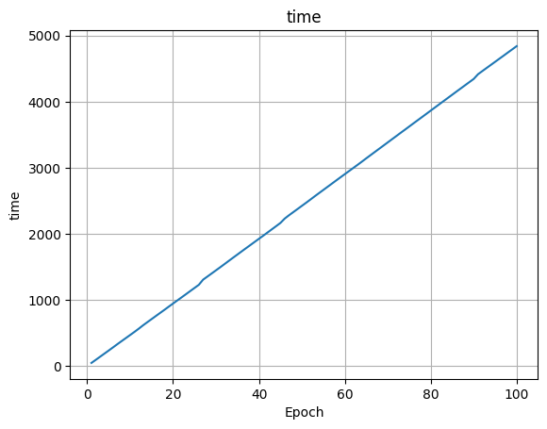

train_box_loss.png

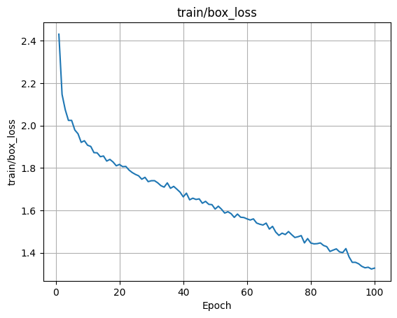

train_cls_loss.png

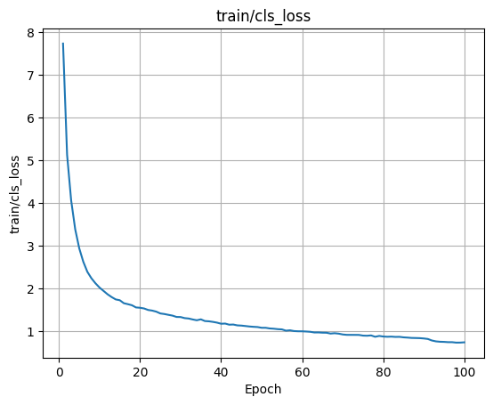

train_dfl_loss.png

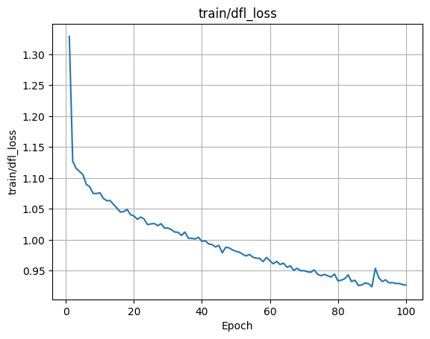

metrics_precision(B).png

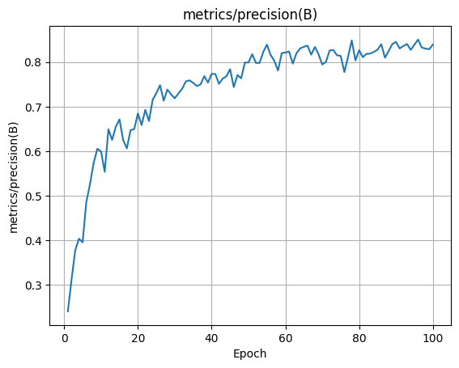

metrics_recall(B).png

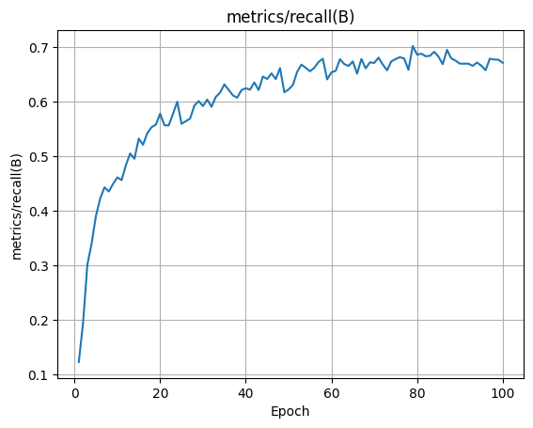

metrics_mAP50(B).png

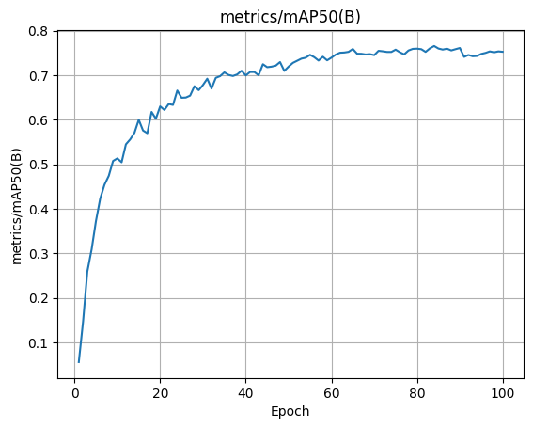

metrics_mAP50-95(B).png

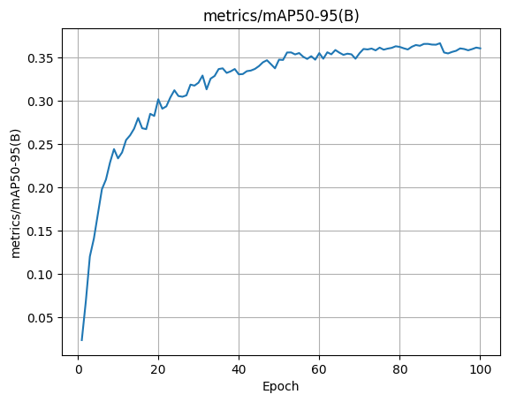

val_box_loss.png

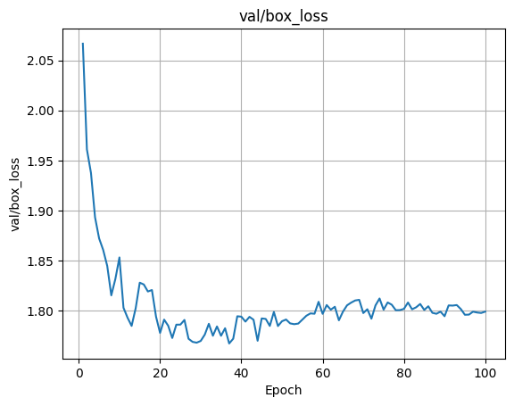

val_cls_loss.png

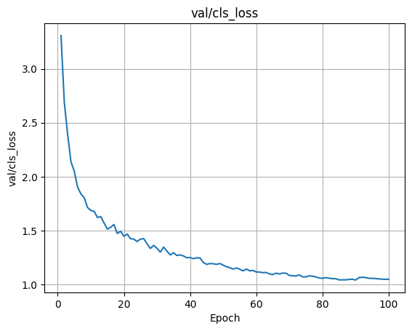

val_dfl_loss.png

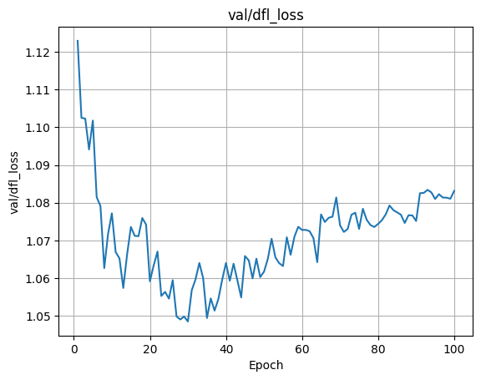

lr_pg0.png

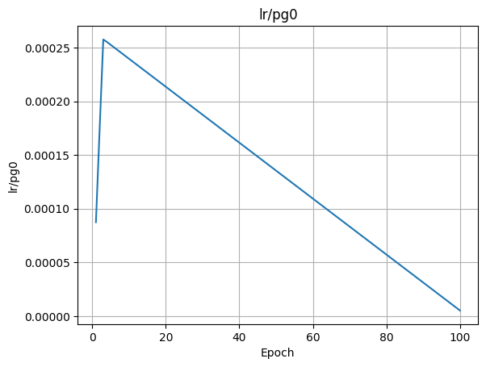

lr_pg1.png

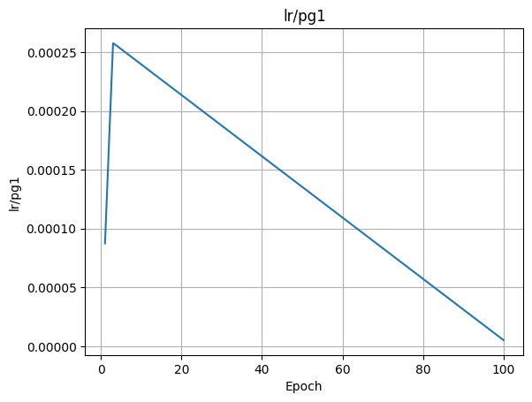

lr_pg2.png

