**CST4060 – Visualisation Analytics.**

**Data Visualisation with Tableau – Course Work I.**

**YAHAYA, Suleyman Olushola.**

**M00736597**

[**Sy423@live.mdx.ac.uk**](mailto:Sy423@live.mdx.ac.uk)

**ANALYSIS GOALS**

* **ANALYSIS 1** - Is there any pattern for each of the measurement over time, and across different countries/regions?
* **ANALYSIS 2** - Is there any relationship between two or three measurements over time and across different areas?

**ANALYSIS 1**

**Finding:**

The analysis is a Storyboard which shows the pattern of Diabetes Prevalence across West Africa (Region) by Gender and Year. The Storyboard comprises of three worksheets, each containing different findings. These findings include:

* **The Trend of Diabetes Prevalence Over Time In West Africa.**

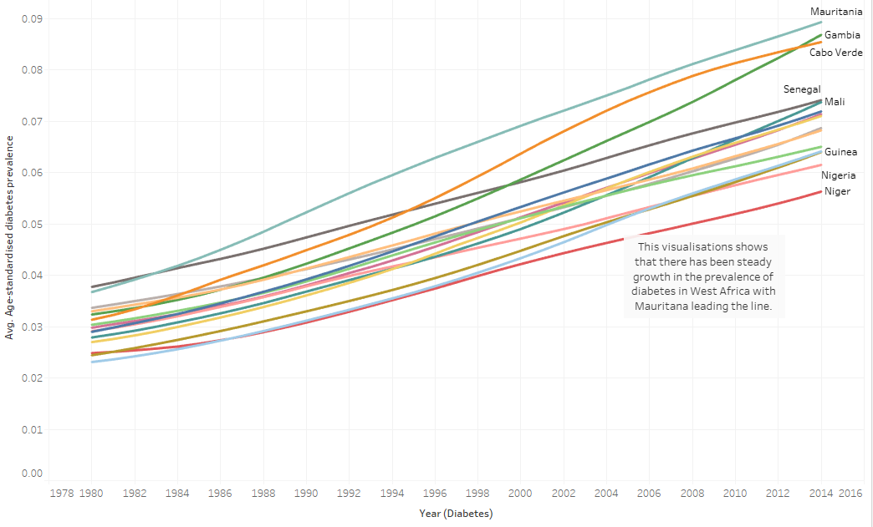

The image above shows a steady rise in Diabetes prevalence over the years in the West African Region, with Mauritania consistently leading the chart from 1984 to 2014.

* **Forecast of the Prevalence of Diabetes in Top 5 countries in West Africa.**

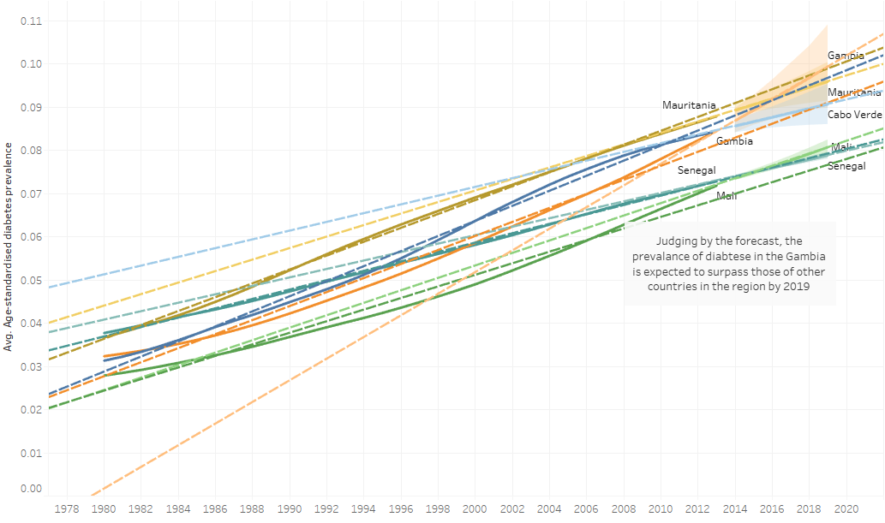

The forecast shows that The Gambia is to expect an upturn in the rise of Diabetes in the Country. The estimates would make it the Country with the highest Prevalence of Diabetes in the West African Region.

* **Diabetes Prevalence by Gender in Mauritania**

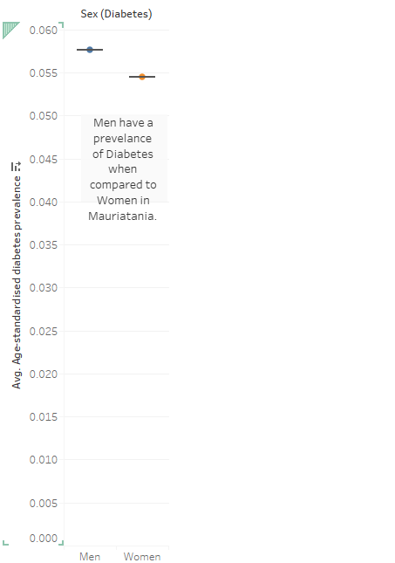

Digging further by exploring the Prevalence of Diabetes in Mauritania, the image above shows that men have a higher chance of being diabetic compared to women.

**Quality of Finding:**

The analysis shows that Mauritania, as a country, has the highest Prevalence of Diabetes in West Africa and that women are healthier than men in the Country. Furthermore, The Gambia should expect to surpass every other Country in the region by 2019.

**What?:**

* **Type of Dataset:**

The dataset used for this analysis is a combination of three tables merged using the inner join, where the Diabetes Table was the primary focus of the investigation.

* **Data and Attribute Type:**

The Diabetes table is made up of four attributes which are Year, Sex, Country/Region and Age Standardised Diabetes Prevalence, and each attribute contains 16401 items. The Sex, Country and Year are categorical variables, while the ‘Age Standardised Diabetes Prevalence’ attribute is quantitative.

**Why?:**

* **Aim of Analysis:**

The goal of the analysis is to determine if there are any discernible patterns in the Prevalence of Diabetes in West Africa. As shown with visualisations shown above, some interesting insights were derived using a storyboard, titled ‘Finding 1’. The Storyboard consists of three worksheets which portrayed the trend of the Prevalence of Diabetes in thirteen West African countries. The insights were derived using averages as the measure ‘Age Standardised Diabetes Prevalence’ was a ratio. This approach helped to provide a proper analysis.

* **Action:**

The insights were derived using averages as the measure ‘Age Standardised Diabetes Prevalence’ was a ratio. This approach helped to provide a proper analysis while search and query were used to select countries of note.

* **Target:**

The aim was to identify West African Countries with the highest Prevalence in Diabetes.

**How?:**

In the worksheet titled ‘Trend of Diabetes Prevalence over Time’, the countries are mapped to the Colour and Detail marks for easier identification. Lines were used in depicting the trajectory of each Country on the graph, and ‘countries’ were mapped to the filter card to select the West African countries.

In the ‘Top 5’ worksheet, Trendlines were used to show the trajectory of each nation; the ‘Country’ attribute was mapped to Colour and Detail on the Marks card for easier identification.

A Forecast Indicator was applied to show projections of Diabetes Prevalence and mapped to Colour on the mark.

In the third worksheet named ‘Gender DB trend in Mauritania’, the Box and Whisker plot was used for analysis with ‘Country’ mapped to the Filter Card to select Mauritania and Sex was mapped to both Colour and Detail on the Marks Card.

Annotations were also utilised on all worksheets to explain the visualisations.

The mappings were employed to facilitate more comfortable compression.

**How?:**

* **Marks:**

The marks used for “Trend of Diabetes Prevalence Over Time” and “Forecast of the Prevalence of Diabetes in Top 5 countries in West Africa” are lines while circles were used for “Diabetes Prevalence by Gender in Mauritania”.

* **Channels:**

The Sex attribute being a Categorical Attribute was mapped to the Colour and Country/Region was mapped to both Detail and Label to identify positions and motions.

Sorts and Filters were applied to the Country/Region attribute to select the West African countries on all worksheets.

* **Target:**

The target was to use the average prevalence of Diabetes to discover patterns over time and across different countries/regions.

**ANALYSIS 2**

**Finding:**

The analysis is a Worksheet which depicts the impact of Body Mass Index on Raised Blood Pressure.

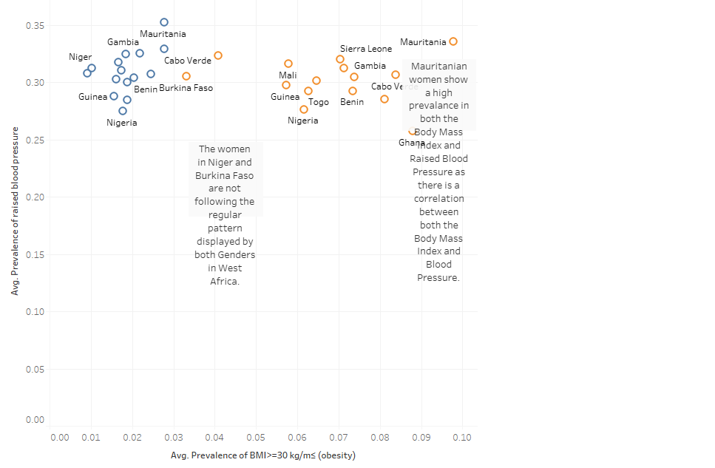

**Quality of Finding:**

In West Africa, the Male gender follows a pattern of forming a cluster on the top left corner of the graph when investigating the relationship between Blood Pressure and Body Mass Index. The analysis shows that men with lesser body mass are likely to have higher blood pressure, while women with higher body mass are prone to high blood pressure as they for a cluster on the top right side of the graph. One key thing that stands out is that women in Niger and Burkina Faso are outliers, as they follow the trend set by West African Men. Mauritanian men and women lead both categories as shown by the graph above.

**What?:**

* **Type of Dataset:**

The dataset is made up of three tables, BMI, Raised Blood Pressure and Diabetes. All merged using Inner join with corresponding keys across each table, keys such as Country, Year and Sex. The BMI and Raised Blood Pressure tables are the primary tables for this Visualisation.

* **Data and Attribute Type:**

The BMI table consists of four attributes which are Year, Sex, and Country/Region and Prevalence of BMI>=30 kg/m≤ (obesity). All attributes in the BMI all have 16801 items While the Raised Blood Pressure table contains attributes such as Sex, Country, Year, and ‘Prevalence of raised blood. All attributes are made up of 16401 items.

**Why?:**

* **Aim of Analysis:**

This analysis aims to ascertain if there is any relationship between the Body Mass Index and Blood Pressure of the People of West Africa.

* **Action:**

The insights were derived by computing the averages of both measures (Raised Blood Pressure and Body Mass Index) and plotting them on the Symbols Map and using circles to display the Visualisation and to show the data points.

* **Target:**

The target was to calculate the average of the BMI and Raised Blood Pressure Attributes to create a visualisation.

**How?:**

* **Marks:**

The marks used for this Visualisation are Shapes as they are the most suited to the aim of the findings.

* **Channels:**

The Sex attribute being a Categorical Attribute was mapped to the Colour and Country was mapped to both Detail and Label to identify positions and motions. The insights were derived by computing the averages of both measures (Raised Blood Pressure and Body Mass Index) and plotting them on the Symbols Map and using circles to display the Visualisation and to show the data points.

Filters and sorts were applied to the “country/region” attribute to select countries.

The choice visualisation used for this analysis proved useful as it captured the intent of the investigation.