**CST4060 – Visualisation Analytics.**

**Image Processing – Course Work III.**

**YAHAYA, Suleyman Olushola.**

**M00736597**

[**Sy423@live.mdx.ac.uk**](mailto:Sy423@live.mdx.ac.uk)

This work describes the edge detection approaches selected to detect all the edges present in the image.

Edge Detection is a technique for processing images. It finds the lines of objects present in a photo by detecting discontinuities in brightness. Edge detection is used for image segmentation and data extraction in image processing, computer vision, and machine vision.

My Graphical User Interface consists of two axes and five buttons. The first axis displays the actual image, and the other shows the effect of the edge detection technique applied.

The first button selects the image, and other buttons show the edge detection techniques applied to the selected image.

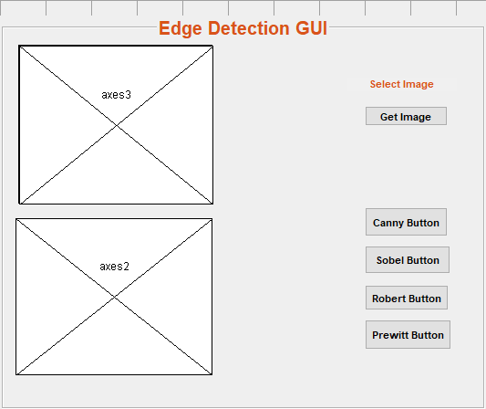

The image is a digitised JPG file that contains four bananas with hexagonal grids and varying colour gradients, and Therefore I have applied the following Edge Detection algorithms :

1. Canny Edge Detection
2. Sobel Edge Detection
3. Robert Edge Detection
4. Prewitt Edge Detection

**Canny Edge Detection**

The canny method utilises two threshold levels to detect edges classified as weak and strong.

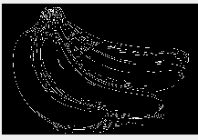

It detected almost all the edges present in the image and clearly showed the bananas' outlines displayed in the photo.

**Sobel Edge Detection**

Sobel Edge Detector calculates an image's vertical and horizontal approximations using two convolved 3 x 3 masks.

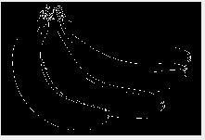

The Sobel detector method makes it difficult to tell the actual content of the image.

**Roberts Edge Detector**

The Roberts Edge detector performs a simple 2-D spatial measurement of gradients on an image which is easy to process.

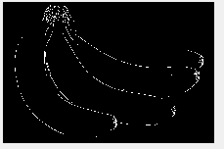

This method detected fewer edges than the canny and Sobel methods.

**Prewitt Edge Detection**

The Prewitt edge detector is a gradient-based technique that computes an approximation of an image’s intensity function’s angles through 3 x 3 masks.

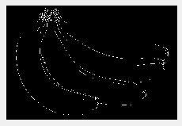

The Prewitt technique shows almost all the edges present in the image with significantly less intensity.

From the displayed results, the Canny method performed better than the other algorithms when compared.

In conclusion, I have found the challenges in detecting edges by using the Sobel, Prewitt and Roberts edge detection methods. The Canny Edge Detection technique is the most effective when compared to the other methods.

More work should be conducted to improve existing techniques and develop more sophisticated and streamlined methods.