Q2.
a)
Eclid_p1 = $\sqrt[2]{{(-1.4+1)}^{2}+{(2.3-2.2)}^{2}+{(0.2-0.1)}^{2}}$ = 0.42
Eclid_p2 = $\sqrt[2]{{(-1.4+4)}^{2}+{(2.3-7)}^{2}+{(0.2-0.6)}^{2}}$ = 5.3
Vậy p1 gần nhất

b)
∆P_{win}= 0.5 [ (-1.4+1) , (2.3 – 2.2) , (0.2 – 0.1)]
∆P_{win} = [-0.2 , 0.05, 0.05]
P_{win} = X + ∆P_{win}
= [ -1.00, 2.20, 0.10] + [-0.2 , 0.05, 0.05]
= [-0.80, 2.15, 0.05]

Q3.
Weight = 8 * 100 = 800

Q5.
= ½ (20)(20-1) = 190
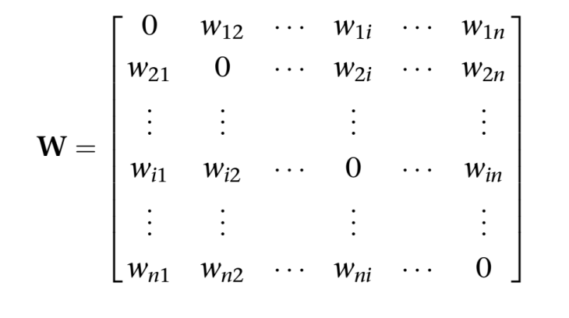

Q7.
𝐖 = 𝐘𝟏𝐘𝟏^{T} – 𝐈
a)$\left[\begin{matrix}1 \\ -1 \\ 1 \\ -1\end{matrix}\right]$ [1 -1 1 -1] - $\left[\begin{matrix}1 & 0 & 0 & 0 \\ 0 & 1 & 0 & 0 \\ 0 & 0 & 1 & 0 \\ 0 & 0 & 0 & 1\end{matrix}\right]$ = $\left[\begin{matrix}1 & -1 & 1 & -1 \\ -1 & 1 & -1 & 1 \\ 1 & -1 & 1 & -1 \\ -1 & 1 & -1 & 1\end{matrix}\right]$ - $\left[\begin{matrix}1 & 0 & 0 & 0 \\ 0 & 1 & 0 & 0 \\ 0 & 0 & 1 & 0 \\ 0 & 0 & 0 & 1\end{matrix}\right]$ = $\left[\begin{matrix}0 & -1 & 1 & -1 \\ -1 & 0 & -1 & 1 \\ 1 & -1 & 0 & -1 \\ -1 & 1 & -1 & 0\end{matrix}\right]$
b)
𝐖 = 𝐘𝟏𝐘𝟏^{T}+ 𝐘2𝐘2^{T} –2* 𝐈
$\left[\begin{matrix}1 \\ -1 \\ 1 \\ -1\end{matrix}\right]$ [1 -1 1 -1] +$\left[\begin{matrix}-1 \\ -1 \\ -1 \\ 1\end{matrix}\right]$ [-1 -1 -1 1] - 2* $\left[\begin{matrix}1 & 0 & 0 & 0 \\ 0 & 1 & 0 & 0 \\ 0 & 0 & 1 & 0 \\ 0 & 0 & 0 & 1\end{matrix}\right]$
= $\left[\begin{matrix}1 & -1 & 1 & -1 \\ -1 & 1 & -1 & 1 \\ 1 & -1 & 1 & -1 \\ -1 & 1 & -1 & 1\end{matrix}\right]$ + $\left[\begin{matrix}1 & 1 & 1 & -1 \\ 1 & 1 & 1 & -1 \\ 1 & 1 & 1 & -1 \\ -1 & -1 & -1 & 1\end{matrix}\right]$ - $\left[\begin{matrix}2 & 0 & 0 & 0 \\ 0 & 2 & 0 & 0 \\ 0 & 0 & 2 & 0 \\ 0 & 0 & 0 & 2\end{matrix}\right]$
= $\left[\begin{matrix}2 & 0 & 2 & -2 \\ 0 & 2 & 0 & 0 \\ 2 & 0 & 2 & -2 \\ -2 & 0 & -2 & 2\end{matrix}\right]$ – $\left[\begin{matrix}2 & 0 & 0 & 0 \\ 0 & 2 & 0 & 0 \\ 0 & 0 & 2 & 0 \\ 0 & 0 & 0 & 2\end{matrix}\right]$
= $\left[\begin{matrix}0 & 0 & 2 & -2 \\ 0 & 0 & 0 & 0 \\ 2 & 0 & 0 & -2 \\ -2 & 0 & -2 & 0\end{matrix}\right]$
c)
$$sign\left\{\left[\begin{matrix}0 & 0 & 2 & -2 \\ 0 & 0 & 0 & 0 \\ 2 & 0 & 0 & -2 \\ -2 & 0 & -2 & 0\end{matrix}\right]\left[\begin{matrix}-1 \\ -1 \\ 1 \\ -1\end{matrix}\right]-\left[\begin{matrix}0 \\ 0 \\ 0 \\ 0\end{matrix}\right]\right\}$$
= $sign\left\{\left[\begin{matrix}4 \\ 0 \\ 0 \\ 0\end{matrix}\right]-\left[\begin{matrix}0 \\ 0 \\ 0 \\ 0\end{matrix}\right]\right\}$
x= $\left[\begin{matrix}4 \\ 0 \\ 0 \\ 0\end{matrix}\right]$ y=$\left[\begin{matrix}1 \\ -1 \\ -1 \\ -1\end{matrix}\right]$
Repeat n lần nhân X với W
x= $\left[\begin{matrix}0 \\ 0 \\ 8 \\ -8\end{matrix}\right]$ y=$\left[\begin{matrix}-1 \\ -1 \\ 1 \\ -1\end{matrix}\right]$

x= $\left[\begin{matrix}32 \\ 0 \\ 16 \\ -16\end{matrix}\right]$ y= $\left[\begin{matrix}1 \\ -1 \\ 1 \\ -1\end{matrix}\right]$

x= $\left[\begin{matrix}64 \\ 0 \\ 96 \\ -96\end{matrix}\right]$ y= $\left[\begin{matrix}1 \\ -1 \\ 1 \\ -1\end{matrix}\right]$
ổn định vậy y = [1 -1 1 -1]

Q8.
80

