

**HaPPy ProGraming**

**Software Requirement Specification**

– HCMC, August 2022 –

**Table of Contents**

I. Overview 4

1. Introduction 4

2. System Functions 5

3. Common Requirements 6

II. Functional Requirements 7

1. Public 7

a. Sign Up 7

b. Sign In 7

c. View profile-cv of mentor 7

d. View all skills 7

2. Common 7

a. Change Password 7

b. Reset Password 7

c. User Authorization 7

3. Mentee 8

a. Update Mentee profile 8

b. Create request 8

c. List request by me 8

d. Statistic request by me 8

e. Update request 8

f. Rate & comment mentor 8

g. List Mentor suggestion (for Mentee) 8

4. Mentor 8

a. View list following Request 8

b. Create CV of mentor 8

c. Update CV of mentor 8

d. View statistic request 8

5. Admin 8

a. View list all mentor 8

b. View list all request 8

c. Statistic of all mentee 8

d. View list of skills 8

e. Create skill 8

f. Update skill 8

# Overview

## 

## Introduction

Happy Programming is a Web Application that will allow learners to gain new knowledge and skill in the programming field with the help of other mentors. The web application is expected to grow through several updates and the end goal will be providing new learners with a place that will guide them through the forest of knowledge with the help of mentors and other mentees.

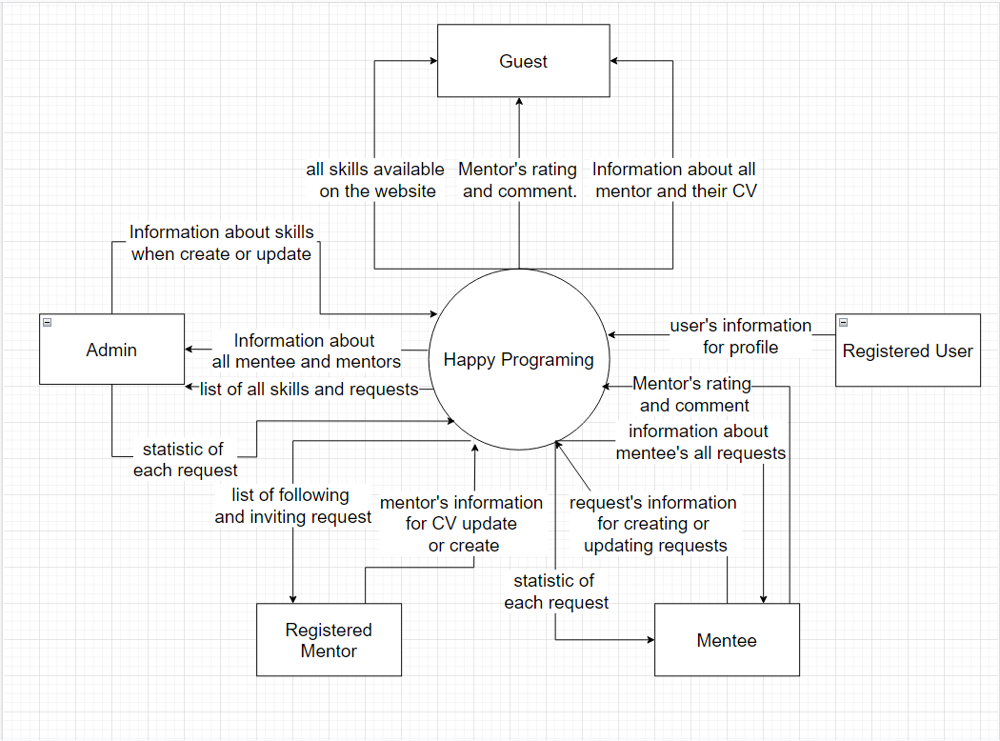

## 

## 2. System Functions

#### a. Screen Flow

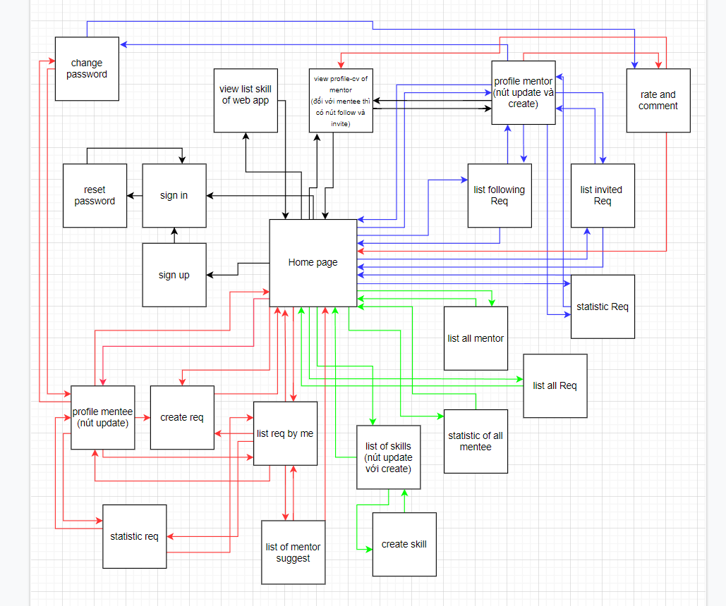

#### b. Screen Details

|  |  |  |  |
| --- | --- | --- | --- |
| **#** | **Feature** | **Screen** | **Description** |
| 1 | Sign up | Sign up | This page allows User to enter information to create account |
| 2 | Sign in | Sign in | This page allows User to enter username and password to login |
| 3 | Reset password | Reset password | This page allows User to reset their password if they forgot |
| 4 | View profile-cv of mentor | View profile-cv of mentor | This page allows User to view profile of a specific mentor |
| 5 | View all skills | View list skill of web app | This page allows User to view all skills available in the web app |
| 6 | Change Password | Change password | This page allows User to change their password |
| 7 | Update Mentee profile | Profile mentee | This page allows Mentee to update their profile |
| 8 | Create request | Create request | This page allows Mentee to create request to solve their needs |
| 9 | List request by me | List request by me | This page allows Mentee to view all of their requests |
| 10 | Statistic request by me | Statistic request | This page allows Mentee to view statistic of their request |
| 11 | Update request | Update request | This page allows Mentee to update existing requests |
| 12 | View list following Request | View list following Request | This page Show the list of requests may be one or more mentees following the Mentor |
| 13 | List of inviting requests | List of invited requests | This page Show the list of requests may be one or more mentees invite the Mentor. |
| 14 | Rate & comment mentor | Rate and comment | This page allows Mentee to rate and comment about mentor that they had hired |
| 15 | Create CV of mentor | Create CV of mentor | This page allows the Mentor user to declare the skills he can training the Mentee users |
| 16 | Update CV of mentor | Update CV of mentor | This page allows the Mentor user to update the skills he can training the Mentee users |
| 17 | List Mentor suggestion (for Mentee) | List Mentor suggestion | This page allows Mentee to view the list of mentors mapping the skills created request |
| 18 | View statistic request | View statistic request | This page allows the mentor to see all about the request belong to him |
| 19 | View list all mentor | List all mentors | This page shows all mentors in the system |
| 20 | View list all request | List all request | This page shows all requests in the system |
| 21 | Statistic of all mentee | Statistic of all mentee | This page shows Statistic of all mentee in the system |
| 22 | View list of skills | List of skills | This page shows all skills available in the system |
| 23 | Create skill | Create skill | This page use to create new skill in the system |
| 24 | Update skill | Update skill | This page use to update existing skills in the system |

#### c. User Authorization

|  |  |  |  |  |  |
| --- | --- | --- | --- | --- | --- |
| **Screen** | Guest | Registered User | Mentee | Mentor | Admin |
| Guest Home Page | X | X | X | X | X |
| Sign up | X |  |  |  |  |
| Sign in |  | X | X | X | X |
| View all skills | X | X | X | X | X |
| View profile-cv of mentor | X | X | X | X | X |
| Sign Up | X |  |  |  |  |
| Enter information | X |  |  |  |  |
| Chose role | X |  |  |  |  |
| Sign up account | X |  |  |  |  |
| Confirm Sign Up | X |  |  |  |  |
| Go to sign in | X |  |  |  |  |
| Sign In |  | X | X | X | X |
| Enter username and password |  | X | X | X | X |
| Reset password |  | X | X | X |  |
| Sign in |  | X | X | X | X |
| Forgot Password |  | X | X | X |  |
| Send reset link |  | X | X | X |  |
| Go to sign in |  | X | X | X |  |
| Mentee Home Page |  |  | X |  |  |
| View request |  |  | X |  |  |
| View profile |  |  | X |  |  |
| View all skills |  |  | X |  |  |
| View profile-cv of mentor |  |  | X |  |  |
| Change password |  |  | X |  |  |
| Log out |  |  | X |  |  |
| Change Password |  |  | X |  |  |
| Change password |  |  | X |  |  |
| Profile mentee |  |  | X |  |  |
| Update profile |  |  | X |  |  |
| Update profile |  |  | X |  |  |
| Add avatar |  |  | X |  |  |
| List New Request |  |  | X |  |  |
| Update request |  |  | X |  |  |
| Delete request |  |  | X |  |  |
| Mentor suggestion |  |  | X |  |  |
| Statistic request |  |  | X |  |  |
| Create request |  |  | X |  |  |
| Mentee Create Request |  |  | X |  |  |
| Create request |  |  | X |  |  |
| Mentee statistic request |  |  | X |  |  |
| Go to mentee create request |  |  | X |  |  |
| Mentee Update Request |  |  | X |  |  |
| Update request |  |  | X |  |  |
| Mentor Suggestion |  |  | X |  |  |
| Invite mentor |  |  | X |  |  |
| Rating mentor |  |  | X |  |  |
| Mentee Rate Mentor |  |  | X |  |  |
| Rating mentor |  |  | X |  |  |
| Mentor Home Page |  |  |  | X |  |
| View request |  |  |  | X |  |
| View CV |  |  |  | X |  |
| View all skills |  |  |  | X |  |
| View profile-cv of mentor |  |  |  | X |  |
| Change password |  |  |  | X |  |
| Log out |  |  |  | X |  |
| Mentor View CV |  |  |  | X |  |
| Create CV |  |  |  | X |  |
| Update CV |  |  |  | X |  |
| Go to homepage |  |  |  | X |  |
| Mentor Create CV |  |  |  | X |  |
| Chose skills |  |  |  | X |  |
| Create CV |  |  |  | X |  |
| Mentor Update CV |  |  |  | X |  |
| Chose skills |  |  |  | X |  |
| Update CV |  |  |  | X |  |
| Mentor Change Password |  |  |  | X |  |
| Change password |  |  |  | X |  |
| Mentor view request |  |  |  | X |  |
| View following request |  |  |  | X |  |
| View inviting request |  |  |  | X |  |
| View statistic request |  |  |  | X |  |
| Mentor Inviting Request |  |  |  | X |  |
| Accept request |  |  |  | X |  |
| Reject request |  |  |  | X |  |
| Admin Home Page |  |  |  |  | X |
| View available skill |  |  |  |  | X |
| View mentee Statistic |  |  |  |  | X |
| View mentor |  |  |  |  | X |
| View all request |  |  |  |  | X |
| Log out |  |  |  |  | X |
| Admin View Mentor |  |  |  |  | X |
| Search for mentor |  |  |  |  | X |
| Enable skills |  |  |  |  | X |
| Disable skills |  |  |  |  | X |
| Admin View Request |  |  |  |  | X |
| Filter request |  |  |  |  | X |
| Admin View Skill |  |  |  |  | X |
| Enable skills |  |  |  |  | X |
| Disable skills |  |  |  |  | X |
| Update skills |  |  |  |  | X |
| Add skills |  |  |  |  | X |
| Admin Create Skill |  |  |  |  | X |
| Chose skill’s status |  |  |  |  | X |
| Create skills |  |  |  |  | X |
| Admin Update Skill |  |  |  |  | X |
| Chose skill’s status |  |  |  |  | X |
| Update skills |  |  |  |  | X |

In which:

* Guest who is new to the website and haven’t registered yet
* Registered User who had registered or logged into the system
* Mentee who is able to create request
* Mentor who responsible to answer mentee question
* Admin who oversees and manage everything

#### d. Non-Screen Functions

|  |  |  |  |
| --- | --- | --- | --- |
| **#** | **Feature** | **System Function** | **Description** |
| 1 | Common | User Authorization | Authorization mechanism specifies the role of logged-in user, his/her authorized page links and preventing unauthorized access via enter the links directly |

## 3. Common Requirements

* Always stick to the original vision
* Understand the Business Process before defining Software Requirements
* Buildwhat the stakeholders want
* Prepare a Requirement Management Plan
* Develop Requirements Iteratively

# Functional Requirements

## Public

### Sign Up

* *Function trigger: The function will be triggered when guest want to create an account, The navigation path is homepage -> sign up*
* *Function description: The guest click sign up to register an account, after filling in all requested field the information will be forwarded down to database for storage*
* *Screen layout*

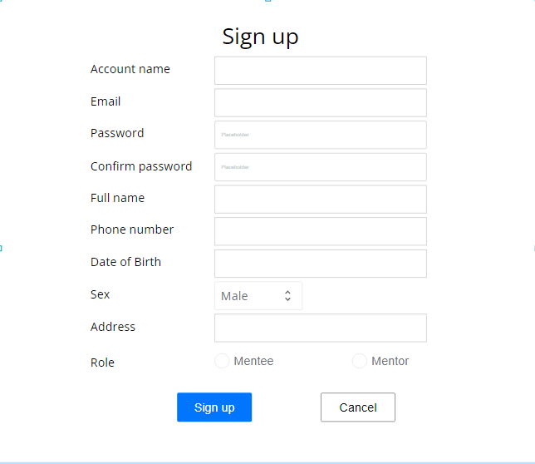

* *Function Details:*

*Normal cases: After having filled in the necessity field, the system will check whether the account exists or not. If the account doesn’t exist, the information will be stored in the database for future uses*

*Abnormal cases: If any of the information filled is missing a popup will alert the guest and allow them to enter the information again. If the email already existed in the database, then guest will be alerted by a popup and are required to try another email*

### b. Sign In

* *Function trigger: The function will be triggered when guest want to sign in using an account, The navigation path is homepage -> sign in*
* *Function description: The guest clicks sign in to gain access to the system, after filling in their email and password correctly they will be able to use the system*
* *Screen layout*

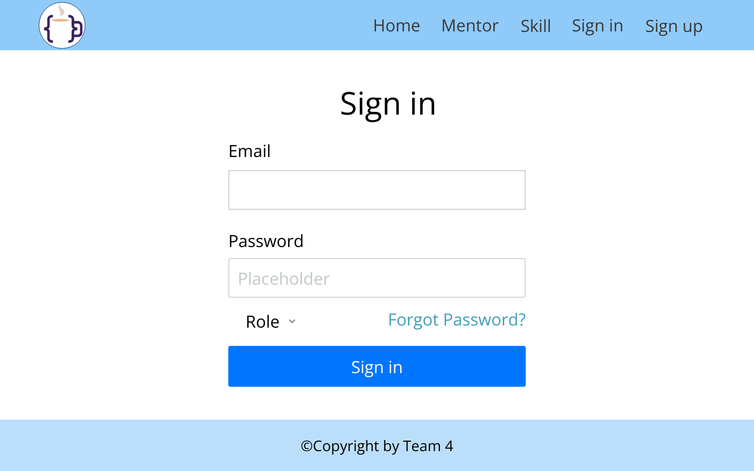

* *Function Details:*

*Normal cases: After filled in email and password, the system will check whether the account is correct or not. If the account is correct user will be able to gain access to the system*

*Abnormal cases: If the email or password is incorrect the user will be informed and they will have to enter the incorrect filed again to enter*

### c. View profile-cv of mentor

* *Function trigger: The function will be triggered when guest want to find information about a specific mentor. The navigation path is homepage -> mentor*
* *Function description: The guest click mentor on the navigation bar to see profile and click on the profile to view the CV of that mentor*
* *Screen layout*





* *Function Details:*

*System displays profile-cv of that mentor, including: full name, account, avatar, job, introduction, rating star & comment, statistic rating of each skill, service, achievement*

### d. View all skills

* *Function trigger: The function will be triggered when guest want to view all available skills that can be learned using the system. The navigation path is homepage -> skill*
* *Function description: The guest click skill on the navigation bar to view all skill that are available to learn*
* *Screen layout*

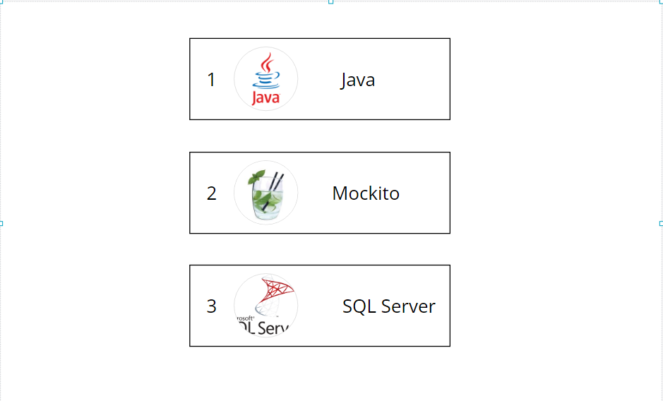

* *Function Details:*

*Display all skills the Happy Programming Academy can training. On the screen include STT, Skill name (order by skill name)*

## 2. Common

### a. Change Password

* *Function trigger: The function will be triggered when registered user/mentee/mentor change their password. The navigation path is mentee/mentor homepage -> change password*
* *Function description: The guest registered user/mentee/mentor click on change password when they want to change their password*
* *Screen layout*

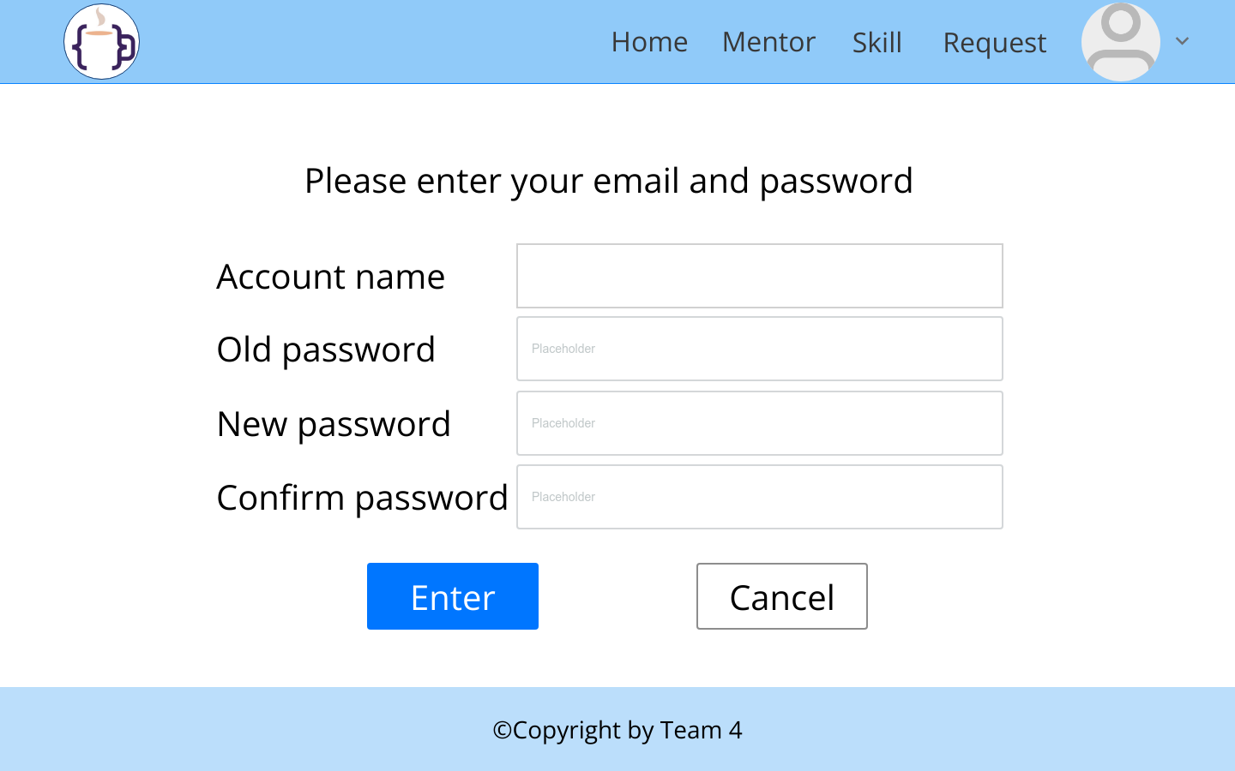

* *Function Details:*

*Allow registered user to input account name, old password, new password, confirm new password and change password.*

### b. Reset Password

* *Function trigger: The function will be triggered when registered user/mentee/mentor forgot their password. The navigation path is homepage -> sign in -> forgot password*
* *Function description: The guest click on forgot password when their want to reset password and after filling in their information a link will be sent to their email*
* *Screen layout*

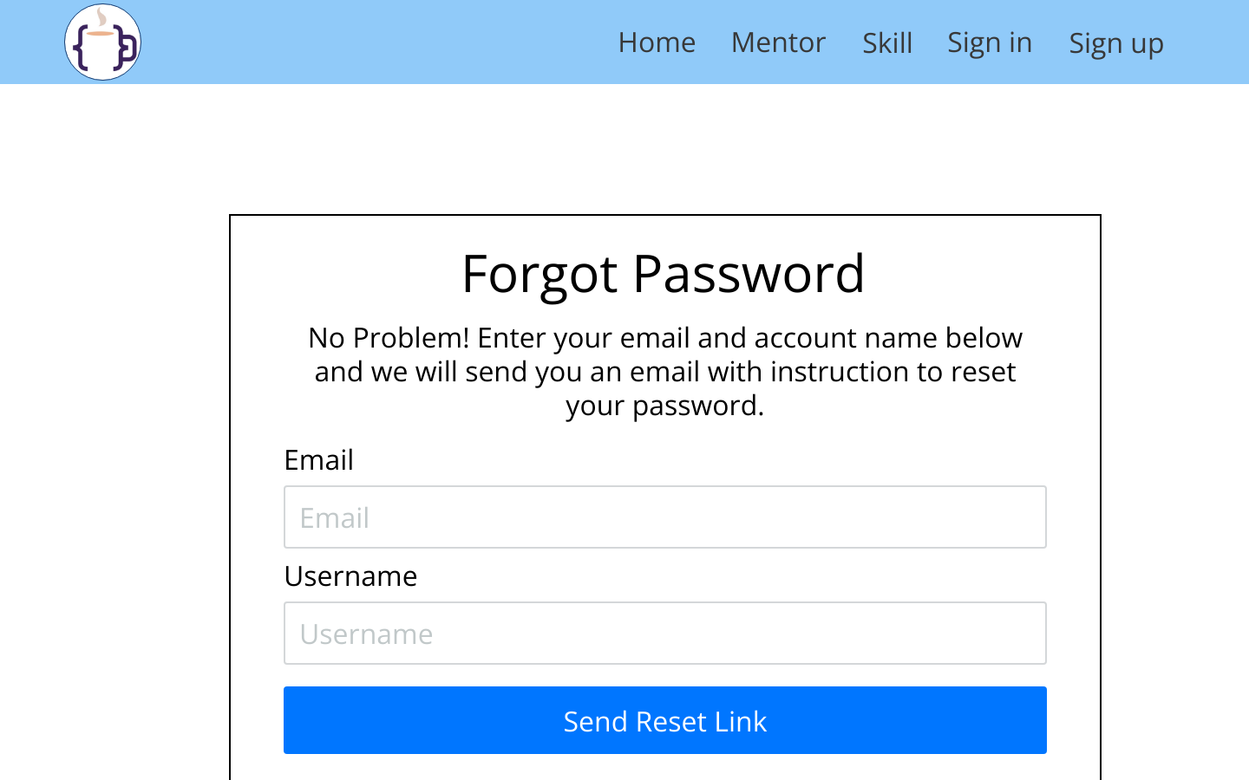

* *Function Details:*

*Allow registered user to input account name, email and reset password.*

*Note that the default password send email to user is only available for a specific time duration as configured in the system config file.*

## 3. Mentee

### a. Update Mentee profile

* *Function trigger: The function will be triggered when mentee want to change their profile. The navigation path is homepage-> sign in -> mentee homepage -> Profile*
* *Function description: The mentee clicks on their avatar, chooses profile and fills in the field to update their profile*
* *Screen layout*

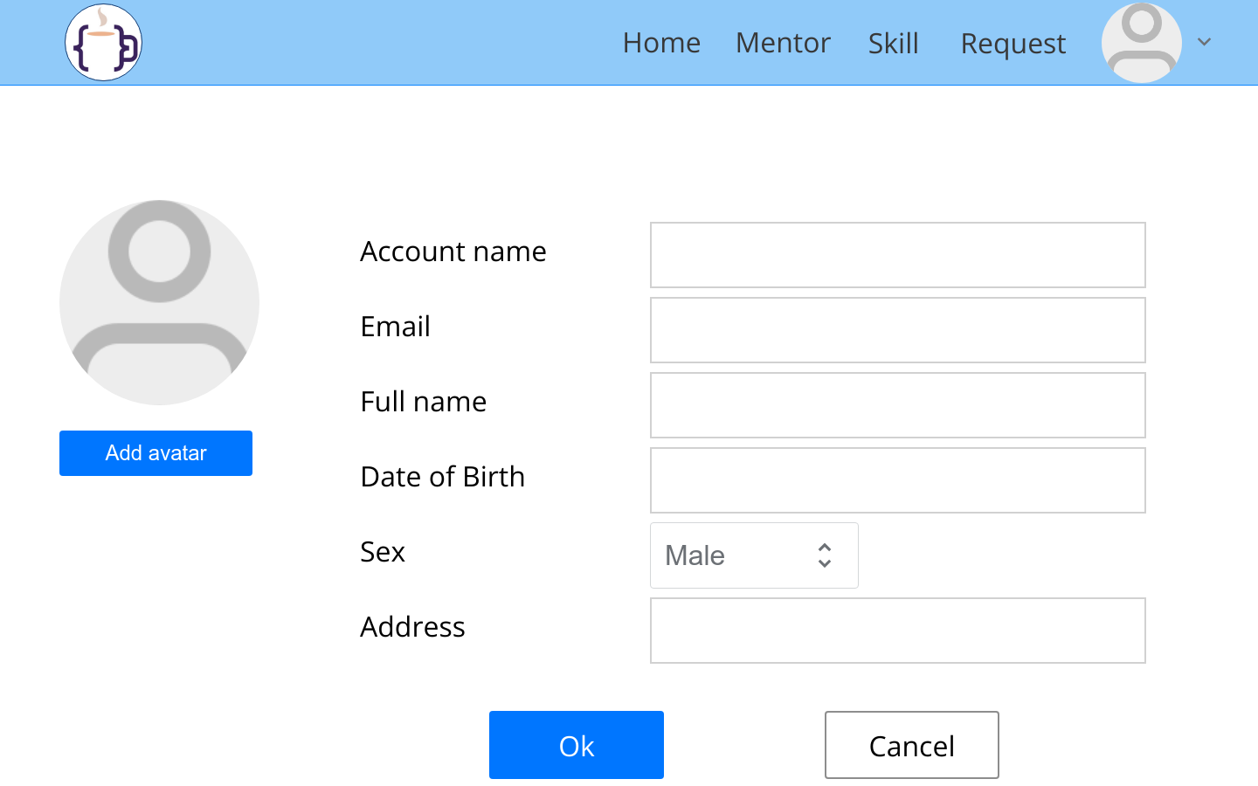

* *Function Details:*

*This page allow Mentee to update his profile including avatar (link avatar of mentee), account name, full name, date of birth, email (only show, not allow to change the email), sex, address and click update to update*

### b. Create request

* *Function trigger: The function will be triggered when mentee want to create a request. The navigation path is homepage -> sign in -> mentee homepage -> request -> create request*
* *Function description: The mentee clicks on request when they want to create a request to hired a mentor to help them*
* *Screen layout*

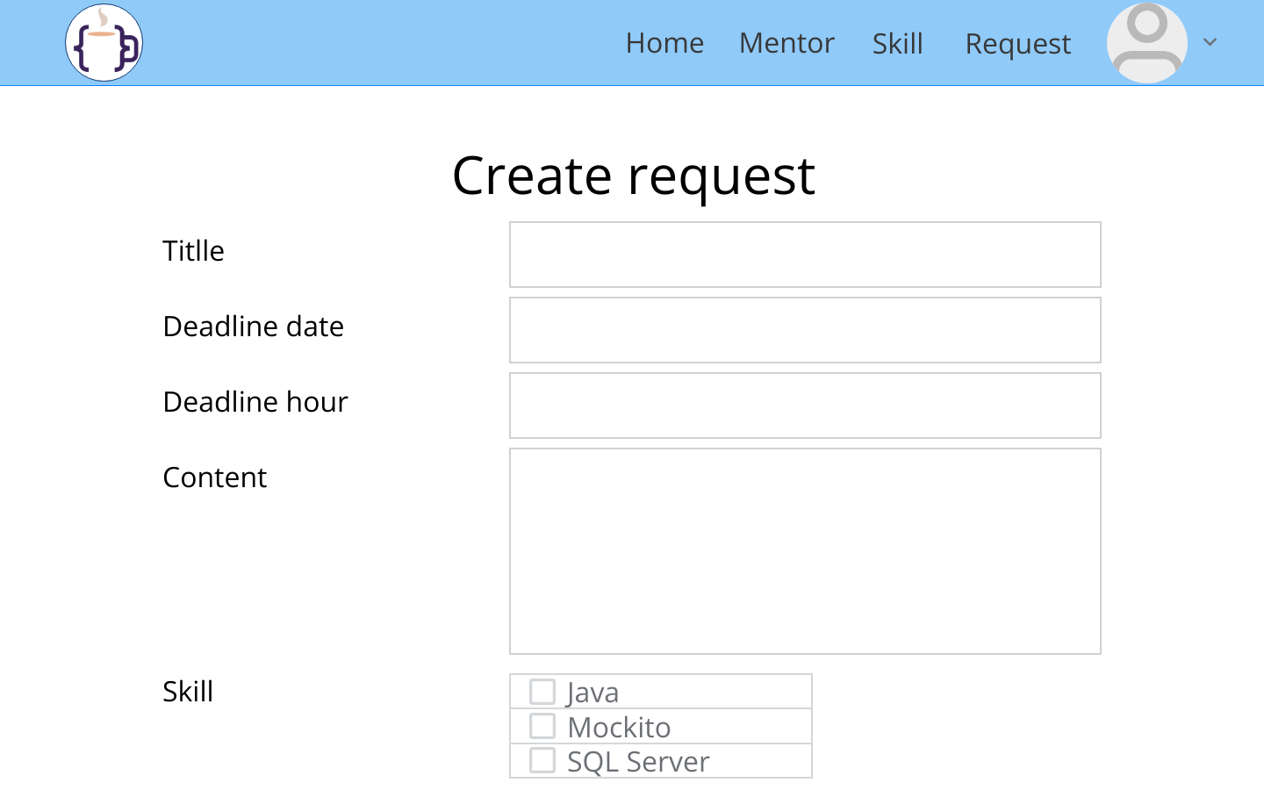

* *Function Details:*

*This page allows Mentee user to create new request to get support from Mentor.*

*Allow Mentee input Title of request, deadline date, deadline hour, content of request, select skills, the programming language the Mentee want to learn and create request.*

*The request will have status: Open, Processing, Cancel, Closed*

### c. List request by me

* *Function trigger: The function will be triggered when mentee want to view all of their request. The navigation path is homepage -> sign in -> mentee homepage -> request*
* *Function description: The mentee clicks on request when they want to view all requests that have been made*
* *Screen layout*

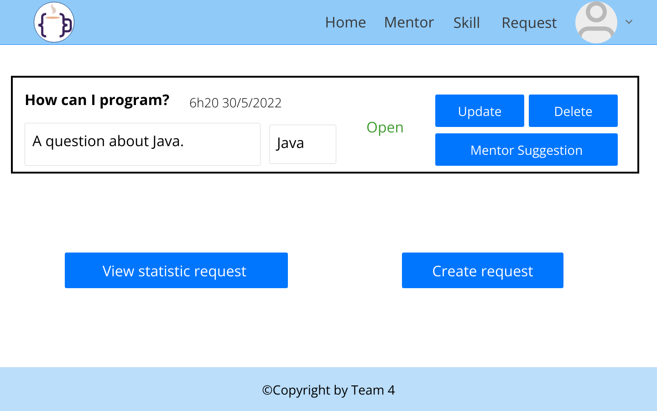

* *Function Details:*

*This page allows Mentee user to see all new requests of his/her.*

*Show the Title of request, deadline date, deadline hour, description of request, skills selected on create request screen and the, Update, Delete button.*

### d. Statistic request by me

* *Function trigger: The function will be triggered when mentee want to view statistic of a specific request. The navigation path is homepage -> sign in -> mentee homepage -> request -> mentee statistic request*
* *Function description: The mentee clicks on view statistic request to view request’s statistic*
* *Screen layout*

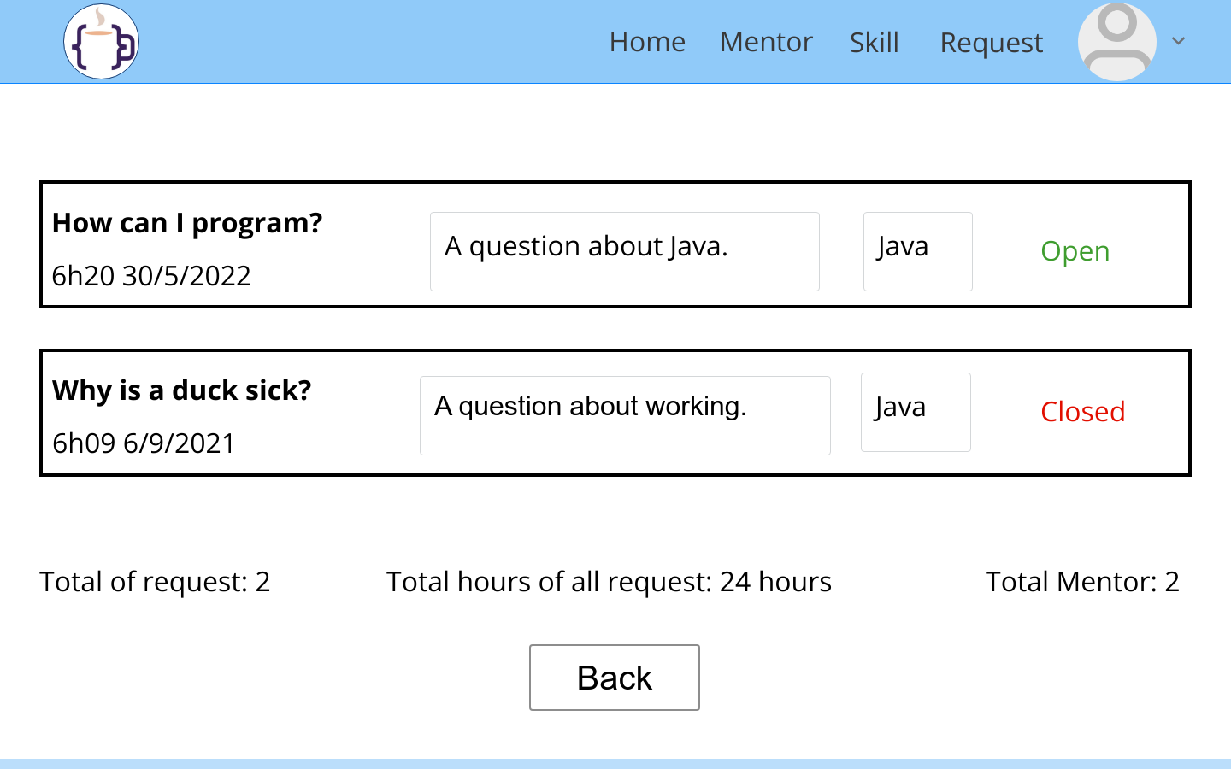

* *Function Details:*

*This page allows Mentee user to see statistic of all requests of his/her.*

*Show the Title of request, Total of request, total hours of all request, total Mentor.*

### e. Update request

* *Function trigger: The function will be triggered when mentee want to update a specific request. The navigation path is homepage -> sign in -> mentee homepage -> request -> mentee update request*
* *Function description: The mentee clicks on update when they need to change something about their request*
* *Screen layout*

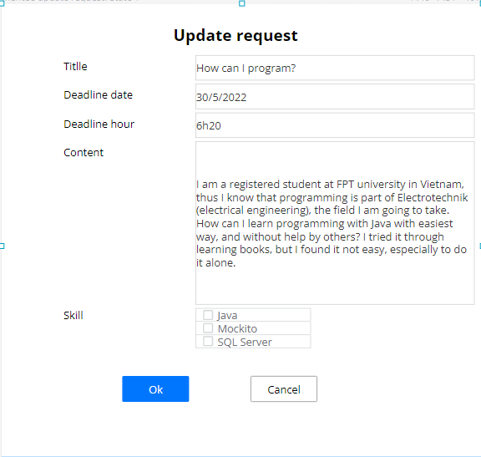

* *Function Details:*

*This page allows Mentee user to update new request to get support training from Mentor.*

*Allow Mentee input Title of request, deadline date, deadline hour, content of request, select skills the programming language the Mentee want to learn and update.*

### f. Rate & comment mentor

* *Function trigger: The function will be triggered when mentee want to leave a comment and rating about a mentor. The navigation path is homepage->sign in-> mentee homepage-> request-> mentee update request*
* *Function description: The mentee give mentor a rating and comment about a mentor to let others know*
* *Screen layout*

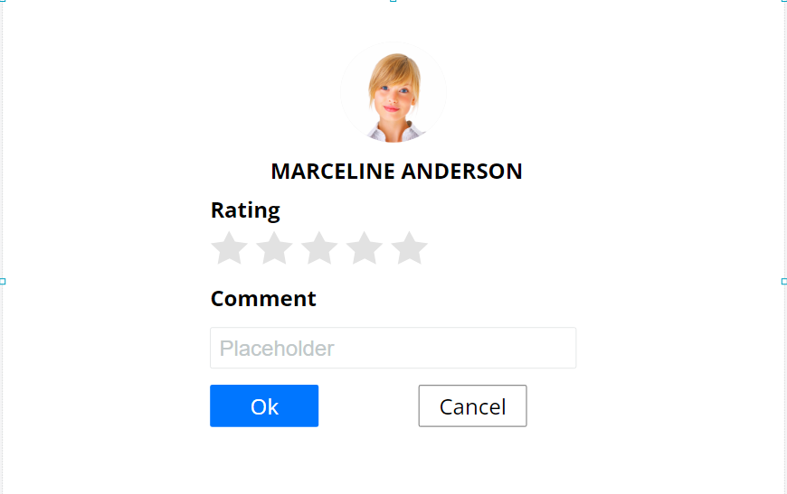

* *Function Details:*

*This page allows mentee to rate using star, leave a comment using text.*

### g. List Mentor suggestion (for Mentee)

* *Function trigger: The function will be triggerered after mentee created a request. The navigation path is homepage->sign in-> mentee homepage-> request-> mentor suggestion.*
* *Function description: The mentee will be able to get a list of mentor suggestion for their request*
* *Screen layout*

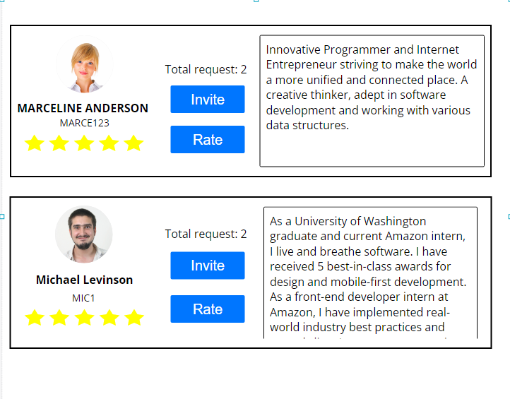

* *Function Details:*

*This page shows the list of mentors mapping the skills created request. The page include: Full name of mentor, account name, rating star, the number of requests the Mentor currently has and the Invite button to allow mentee to invite the Mentor he wants to get training service from.*

## 4. Mentor

### a. View inviting Request

* *Function trigger: The function will be triggered when mentor need to view invited request. The navigation path is homepage -> sign in -> mentor homepage -> request -> inviting request*
* *Function description: The mentor will be about to view statistic of all requests that invite them*
* *Screen layout*

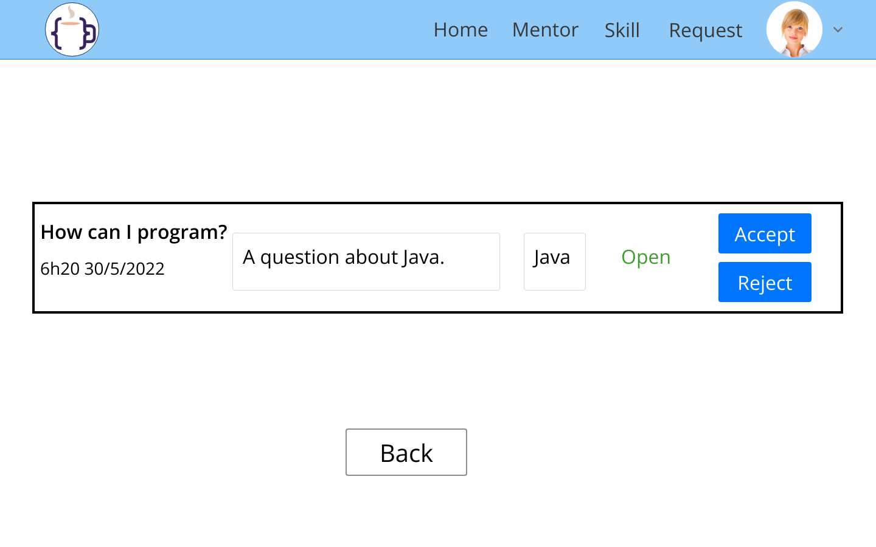

* *Function Details:*

*This page shows the list of mentor’s invited request, statistic request including title, deadline date, deadline hour, content of request, skill of the request and accept, reject button of the request.*

### b. View following Request

* *Function trigger: The function will be triggered when mentor need to view following request. The navigation path is homepage -> sign in -> mentor homepage -> request -> following request*
* *Function description: The mentor will be about to view statistic of all requests that they are following*
* *Screen layout*



* *Function Details:*

*This page shows the list of mentor’s following request, statistic request including title, deadline date, deadline hour, content of request, skill of the request and accept, reject button of the request.*

### c. Create CV of mentor

* *Function trigger: The function will be triggered when mentor need to view all requests, following request, statistic request. The navigation path is homepage->sign in-> mentor homepage-> mentor view CV-> mentor create CV*
* *Function description: The mentor will be able to fill in their CV and create a CV*
* *Screen layout*

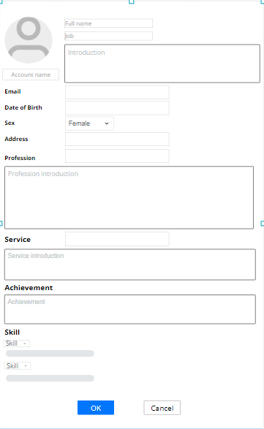

* *Function Details:*

*This page allows Mentor to declare the skills with which he can train the Mentee.*

*account name, full name, date of birth, email, sex, address, Profession, profession introduction, select skills, service description, achievements, the programming the Mentor can training the Mentee and create CV*

### d. Update CV of mentor

* *Function trigger: The function will be triggered when mentor need to update existing CV. The navigation path is homepage -> sign in -> mentor homepage -> mentor view CV -> mentor update CV*
* *Function description: The mentor will be about to change their CV and update CV*
* *Screen layout*

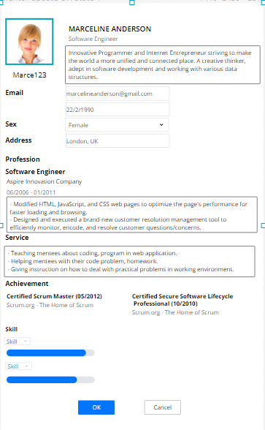

* *Function Details:*

*This page allows the Mentor user to update the skills he can training the Mentee users.*

*Avatar, account name, full name, date of birth, email, sex, address,*

*Profession, profession introduction, select skills, service description, achievements description, the programming (framework) the Mentor can training the Mentee and update CV*

### e. View statistic request

* *Function trigger: The function will be triggered when mentor need to view request summary. The navigation path is homepage -> sign in -> mentor homepage -> request -> Statistic request*
* *Function description: The mentor will be about to view statistic about the number of accepted requests, completed request, cancelled request*
* *Screen layout*

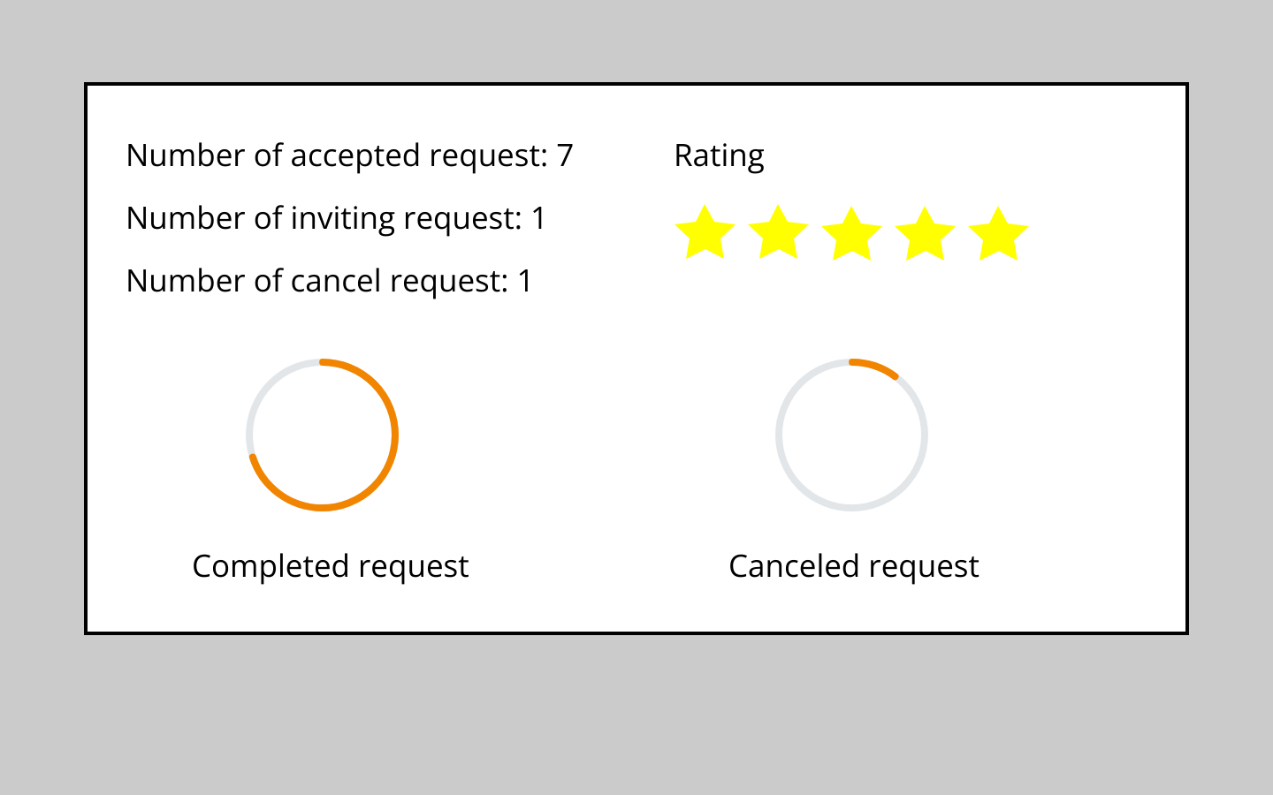

* *Function Details:*

*This is a pop-up screen which allow the mentor to see all about the requests belong to him include the number of currently accepted requests, number of currently invited requests, number of cancelled requests, percentage of cancel request, percentage of completed request, ratings.*

## 5. Admin

### a. View list all mentor

* *Function trigger: The function will be triggered when admin need to have list of all mentor. The navigation path is homepage -> sign in -> admin homepage -> admin view mentor*
* *Function description: The mentor will be about get list of all mentor available in the system, search for a specific mentor and switch their status*
* *Screen layout*

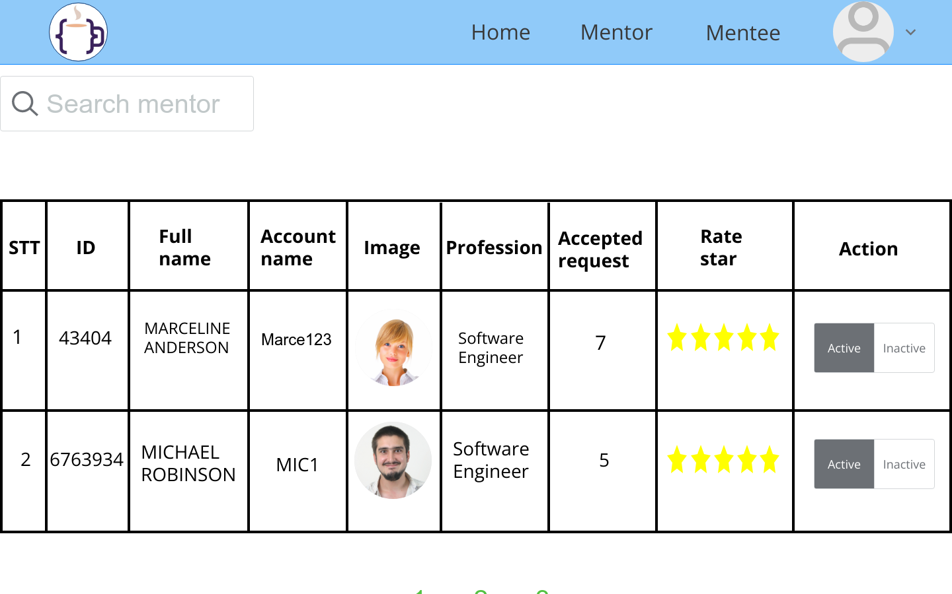

* *Function Details:*

*This page sas textbox and search button. Show the list mentor information in table format include STT, ID, Full name, account name, profession, number of currently accepted request, percentage completed, rate star and allow active/inactive mentor. Need paging this page.*

### b. View list all request

* *Function trigger: The function will be triggered when admin need to have list of all requests. The navigation path is homepage -> sign in -> admin homepage -> admin view request*
* *Function description: The admin will be able to get list of all requests available in the system and search for a request using date and status*
* *Screen layout*

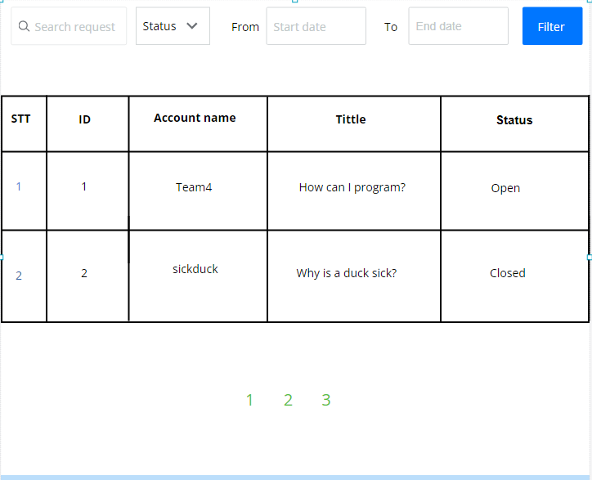

* *Function Details:*

*This page show all request of all mentees. On this page has search text box, button search, combobox of request status to allow admin to choose and filter, choose start date, end date of request. The information of the list of request include: STT, ID, accountname, title of request, status. When admin user clicks on the ID of the request, the request detail page will display. Need paging this page.*

### c. Statistic of all mentee

* *Function trigger: The function will be triggered when admin need to have list of all mentee. The navigation path is homepage->sign in-> admin homepage-> admin view mentee*
* *Function description: The mentor will be about get list of all mentee available in the system and the number of mentees*
* *Screen layout*

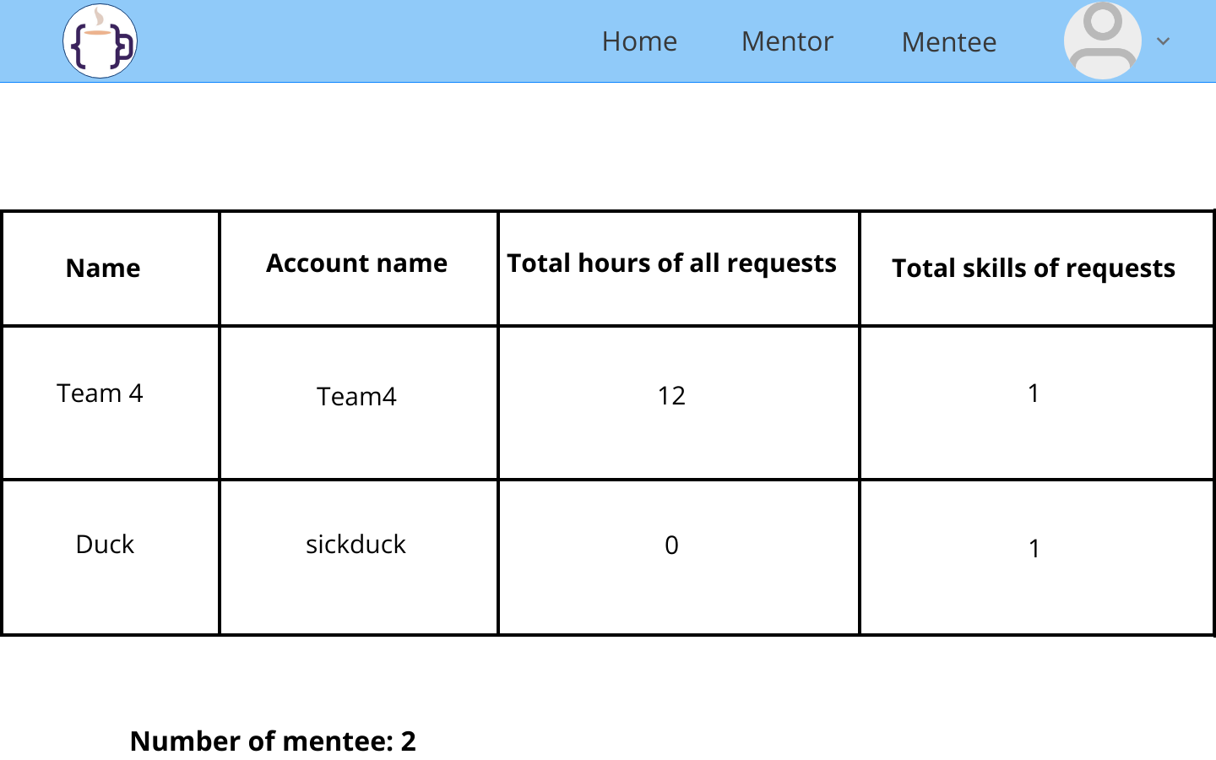

* *Function Details:*

*This page show statistic of all Mentee include: Name of Mentee, accountname, Nummber of Mentee, Total hours of all request, Total of skills of all requests.*

### d. View list of skills

* *Function trigger: The function will be triggered when admin need to see thelist of all skills. The navigation path is homepage -> sign in -> admin homepage -> admin view skill*
* *Function description: The mentor will be able to get the list of all skills available in the system, switch skill’s status, update information and add new skill*
* *Screen layout*

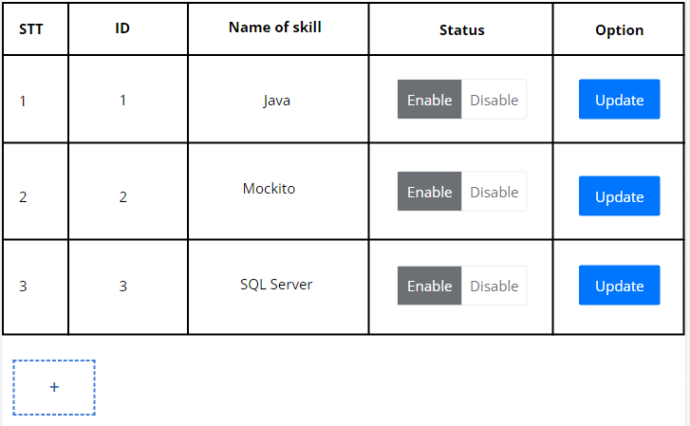

* *Function Details:*

*This page shows all the currently technical skills the Happy Programming Academy can service the mentee. The skill info include: STT, ID, Name of skill, allow to enable/disable skill, allow to update skill. allow go to create skill to add new skill.*

### e. Create skill

* *Function trigger: The function will be triggered when admin have to create a new skill. The navigation path is homepage->sign in-> admin homepage-> admin view skill-> admin create skill*
* *Function description: The mentor will be able to create new skill, set its status and name*
* *Screen layout*

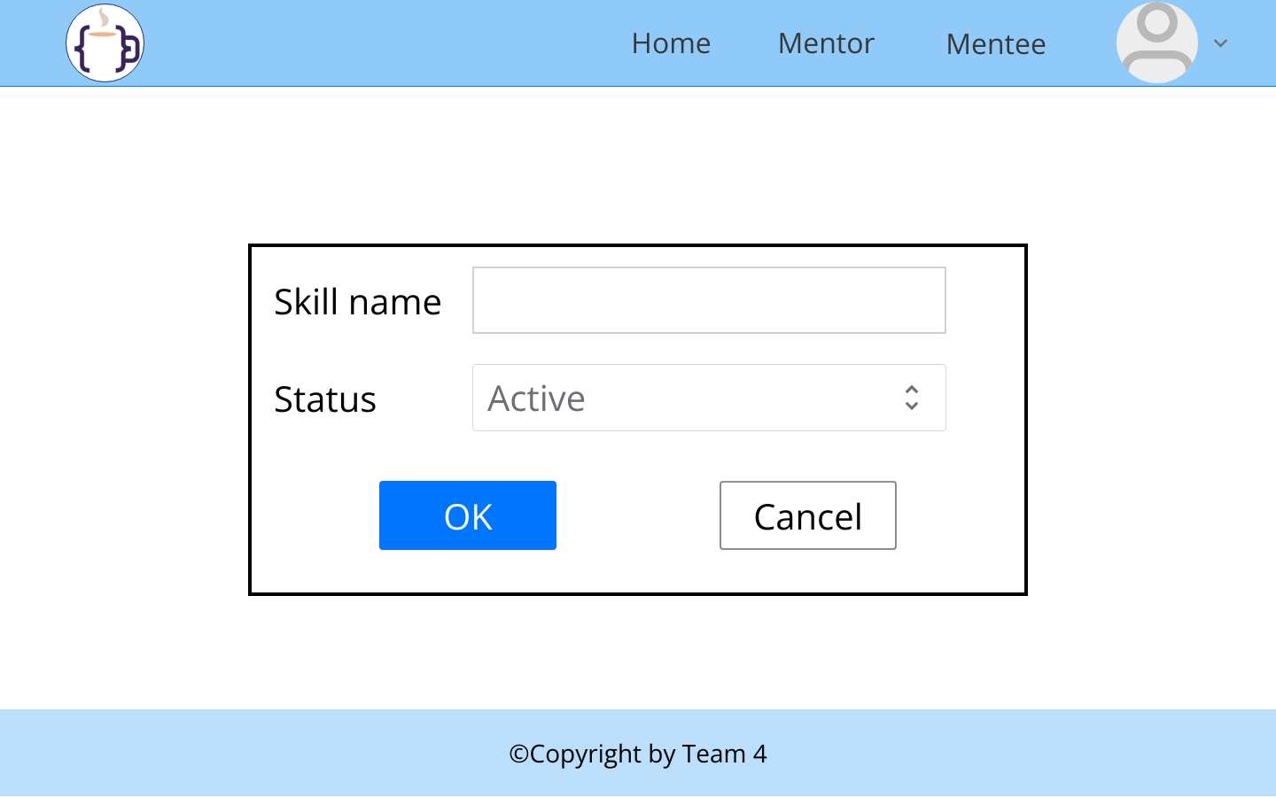

* *Function Details:*

*This page allows admin to add new skill include name of skill, default status is active and create skill.*

### f. Update skill

* *Function trigger: The function will be triggered when admin have to update an existed skill. The navigation path is homepage->sign in-> admin homepage-> admin view skill-> admin update skill*
* *Function description: The mentor will be able to update existed skill, set its status and name*
* *Screen layout*

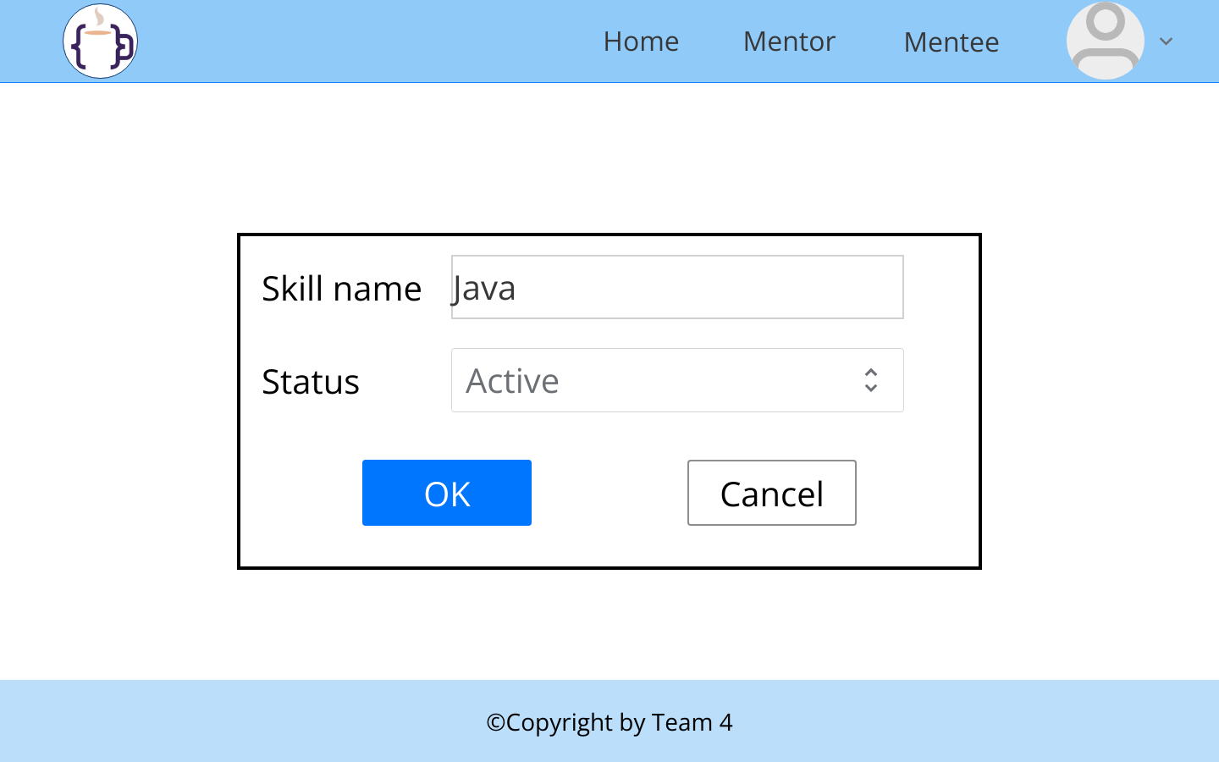

* *Function Details:*

*This page allows admin to update selected skill to update name of skill, choose status of skill in combobox and update. Skill has active/inactive status.*