STORE MANAGER

Software design features

Contents

1. Introduction: 3

1.1 Objectives and goals 3

1.2 Scope statement 3

1.3 Software context 3

1.4 Main limitations 3

2. Data Design 2.0 4

2.1 Internal software data structures 4

2.2 Global data structure 4

2.3 Temporary data structures 4

3. Component Level Design 5

3.1 Description for Homepage 5

3.1 Description for Homepage 5

3.1.1 Narrative Processing for Homepage 5

3.1.2 Description of the Home page interface 5

3.1.3 Homepage processing details 5

3 . 3 Descriptions for individual functions 6

3 . 3.1 Narrative processing for individual functions 6

3 . 3.2 Description of individual functional interfaces. 6

3 . 3.3 Personal function handling details 7

4 The application has all 7 functions: 8

1 . Login and logout function 8

2. Registration function 10

3 . Customer management function 11

4. Supplier management function 12

5. Goods management function 12

6 . Invoice creation function 14

7 . Invoice list view function 15

5. Restrictions, restrictions and constraints 16

6. Test Issues 17

6.1 Types of test 17

6.2 Expected response of the software 17

# 1. Introduction:

This document sets forth the requirements for the cargo management of the cargo.

Hang Hoa store management application is an application for stores, supermarkets, temporary trading business such as: soft drinks, milk, kitchen utensils, daily living items, household appliances, etc.

With this application, the store can easily manage the goods in terms of quantity and quality.

## 1.1 Objectives and goals

The goal of the project is to create an application to manage goods easily in terms of quantity as well as quality.

## 1.2 Scope statement

The only inputs to this project are user attention and strategic moves; and the only output is entertainment as a consequence of the input.

## 1.3 Software context

The big picture of this project will be to provide entertainment to anyone with access to the device

## 1.4 Main limitations

Since this project can easily be broken down into several smaller pieces, there are some major constraints.

# 2. Data Design 2.0

## 2.1 Internal software data structures

The data of each product to be managed will be stored in the application. Will use the most appropriate method to store their data. All data will be stored in function specific variables or as files on the phone memory card.

## 2.2 Global data structure

The system will be very modular with each game generating and storing data independent of each other and the overall system. Each function will store its own data about high scores, game status, preferences, etc. All this persistent data will be stored on the phone memory card as a flat file or in its own database. for each game.

## 2.3 Temporary data structures

Each function will also need to store temporary information like current score, user selections, etc. While this information will be temporarily stored as variables during this process, they will be saved to the phone's memory card in case the user exits mid-match.

# 3. Component Level Design

Our system is based on a home page through which individual games can be accessed. Anytime the user can exit the game, it will return them to the main menu.

## 3.1 Description for Homepage

The home page is the first thing a user sees when launching an app on their phone running on their phone.

## 3.1 Description for Homepage

The home page is the first thing a user sees when launching an app on their phone running on their phone.

### 3.1.1 Narrative Processing for Homepage

From the home page, the user can choose one of the functions or choose to exit the application. When a function is selected, that application-specific activity is launched. If the user chooses to exit the application will be closed and the user will return to the operating system interface.

### 3.1.2 Description of the Home page interface

The home page will include a simple list of buttons corresponding to each game as well as a button to choose to exit the application.

### 3.1.3 Homepage processing details

#### 3.1.3.1 Performance issues

The home page will use relatively few resources, as it will just be a list of buttons.

#### 3.2.3.2 Design Constraints

The homepage should be simple and easy to use to access individual games.

## 3 . 3 Descriptions for individual functions

The individual functional components will be launched from the home page and will run independently of each other.

### 3 . 3.1 Narrative processing for individual functions

When each game is launched, the user is given a choice such as choosing a word in word search or choosing a column to place chips for connect four. Using this option will lead to an increase in happiness or a chip placed in the function table for example. The process by which the user makes selections and the results are processed will continue until the game is completed, successfully or otherwise, or the user chooses to exit or restart the game. Users will also have the option to restart the game, which will result in the process starting all over again.

### 3 . 3.2 Description of individual functional interfaces.

Each game will have on-screen buttons that the user can press to use the function. In the case of connecting functions, users will be able to press one of the buttons at the top of the board to select the column to place their chips. In addition, there will be a home button for each function, which will provide additional options such as exit or restart.

### 3 . 3.3 Personal function handling details

#### 3 . 3.3.1 performance issues

Each function responds quickly to user input via on-screen buttons. Delayed response can lead users to frustration or believe that the application is frozen.

#### 3 . 3.3.2 Modular design

The interface design of the game should be simple and intuitive so that users can easily determine what options they have available to develop the application.

# 4 The application has all 7 functions:

## 1 . Login and logout function

To be able to manage store goods, you must first log in to the system by entering your email and password.

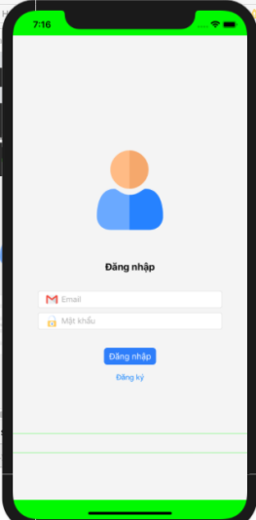

#### Figure 1. Login function interface

After successful login will lead to the main interface of the application, when you want to log out you just need to press the logout button to return to the login function.

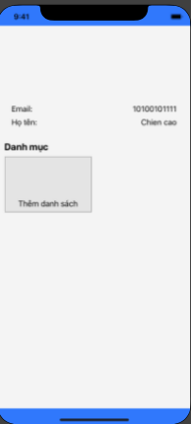

#### Figure 2.Main interface of building materials management application.

* Home page
* Category
* customer management
* Supplier Management
* List of goods
* Receipt
* List of invoices

## 2. Registration function

When you want to manage documents but do not have an account, you need to register by entering your email, password, full name and address.

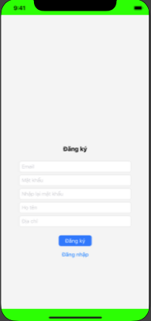

#### Figure 3.Registration function interface

• Enter email

• Enter password

• Enter password

• Enter your first and last name

• Enter address

## 3 . Customer management function

At the customer management function, we can add customers by entering information and pressing the add button, customer information will be saved into the system.

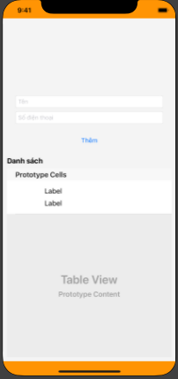

#### Figure 4.Customer management function interface

• Enter name

• Enter your phone number

• Delete button

## 4. Supplier management function

To add a supplier, you need to fill in all the information, then press the add supplier button, it will be saved in the system.

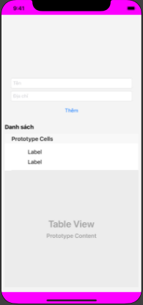

#### Figure 5.Supplier management function interface

## 5. Goods management function

When clicking on the material management function, the check will display a list of supplies already in the system.

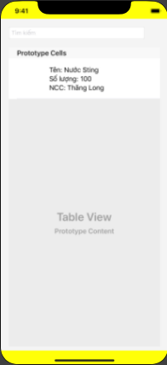

#### Figure 6.Commodity list interface

Enter the name of the material you want to search for

When you want to add ingredients, users just need to click on the plus sign, then fill in the information and press the add button, the ingredients will be added to the system.

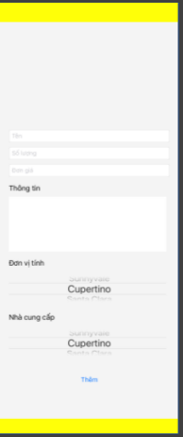

#### Figure 7.Commodity add function interface

• Enter name

• Insert information

• enter unit price

• Enter information

• Unit

## 6 . Invoice creation function

When a customer comes to buy, after entering the customer's information, the user needs to create an invoice.

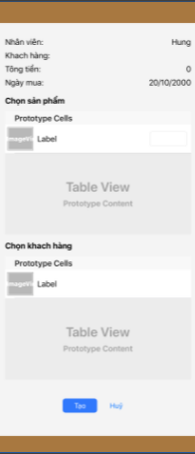

#### Figure 8. Invoice creation function interface.

## 7 . Invoice list view function

After creating invoices, users need to review the invoice editing schedule, then click on the invoice DS item to review the created invoices.

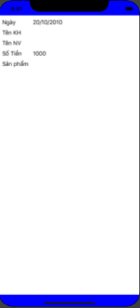

#### Figure 9.Invoice list view function

# 5. Restrictions, restrictions and constraints

Allows the download and installation of the Suite management application. All development for the Game Suite is done in the Eclipse Integrated Development Environment (IDE) on Windows XP and Vista machines with the Software Development Kit (SDK).

# 6. Test Issues

## 6.1 Types of test

We will conduct the first tests of individual functionality in the Suite as separate entities using the iOS Simulator provided by the iOS Software Development Kit (SDK). After each individual game is thoroughly tested, this pack is built together and tested as a whole. All known valid input will be checked as well as known invalid input. A more comprehensive overview of our testing strategies will be included in our test specification document.

## 6.2 Expected response of the software

Every test performed will be clearly observed as failure or success.